5.3.3 Decision services
A decision service defines reusable logic within the decision model. A decision service exposes one or more decisions from a decision model as a reusable element, a service, which might be consumed (for example) internally by another decision in the decision model, or externally by a task in a BPMN process model. When the service is called with the necessary input data and decision results, it returns the outputs of the exposed decisions. Any decision service encapsulating a DMN decision model will be stateless and have no side effects.
There are two important uses of DMN with respect to Decision Services: defining decisions to be implemented in a Decision Service, and modeling decisions made by existing deployed services.

5.3.3.1 Defining decisions to be implemented in a Decision Service

One use of DMN will be to define decision-making logic to be automated using decision services. When the decision service is invoked externally, it might be implemented, for example, as a web service. DMN does not specify how such services should be implemented, but it allows the functionality of a service to be defined against a decision model. A fully specified decision service therefore must be defined in a DRD. When invoked internally from a decision, the decision service is invoked similarly to a BKM, by binding expressions in the logic of the calling decision to parameters in the invoked decision service.
It is assumed that the client requires a certain set of decisions to be made, and that the service is created to meet that requirement. The sole function of the decision service is to return the results of evaluating that set of decisions (the
“output decisions”). The service may be provided with the results of decisions evaluated externally to the service (the “input decisions”). The service must encapsulate not just the output decisions but also any decisions in the DRG directly or indirectly required by the output decisions which are not provided in the input decisions (the “encapsulated decisions”).
The interface to the decision service will consist of:
• Input data: instances of all the input data required by the encapsulated decisions.
• Input decisions: instances of the results of all the input decisions.
• Output decisions: the results of evaluating (at least) all the output decisions, using the provided input decisions and input data.
When the service is called, providing the input data and input decisions, it returns the output decisions.
Note that to define a decision service it is only necessary to specify the output decisions and either the input decisions or the encapsulated decisions. The remaining attributes (the required input data, and whichever of the encapsulated or input decisions was not specified) may then be inferred from the decision model against which the service is defined. Alternatively, if more attributes are defined than are strictly necessary, they may be validated against the decision model.
Figure 5-10 shows a decision service defined against a decision model that includes three decisions. The output decisions for this service are {Decision 1}, and the input decisions are {}, that is, the service returns the result of Decision 1 and is not provided with the results of any external decisions. Since Decision 1 requires Decision 2, which is not provided to the service as input, the service must also encapsulate Decision 2. Decision 3 is not required to be encapsulated. The encapsulated decisions are therefore {Decision 1, Decision 2}. The service requires Input data 1 and Input data 2, but not Input data 3.
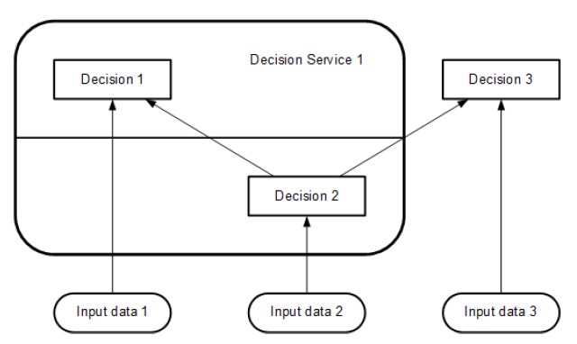
Figure 5-10: A decision service
Multiple decision services may be defined against the same decision model. Figure 5-11shows a decision service defined against the same decision model, whose output decisions are {Decision 1} and whose input decisions are {Decision 2}. The encapsulated decisions for this service are {Decision 1}. The service requires Input data 1, but not Input data 2 or Input data 3.
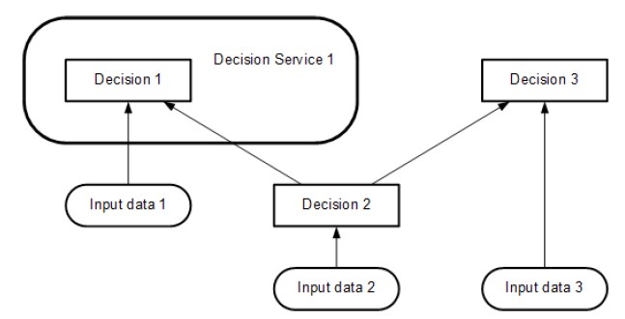
Figure 5-11: A decision service taking a decision as input
In its simplest form a decision service would always evaluate all the decisions in the output set, set and return all their results.
For computational efficiency various improvements to this basic interpretation can be imagined, for example:
• An optional input parameter specifying a list of “requested decisions” (a subset of the minimal output set). Only the results of the requested decisions would be returned in the output context.
• An optional input parameter specifying a list of “known decisions” (a subset of the encapsulation set), with their results. The decision service would not evaluate these decisions but would use the provided input values directly.
All such implementation details are left to the software provider.
A decision service is “complete” if it contains decision logic for evaluating all the encapsulated decisions on all possible input data values. A request to the service is “valid” if instances are provided for all the input decisions and input data required by those decisions which need to be evaluated, i.e., (in the simple case) all the encapsulated decisions, or (assuming the optional parameters above) any requested decisions and any encapsulated decisions required by them which are not already known.

5.3.3.2 Modeling decisions made by existing deployed services

Decision Services representing existing deployed services may be incompletely defined, either because the publisher wishes to obscure some of the structure (to protect proprietary approaches) or because the service was originally designed without a decision model and so it is not (currently) possible to define a complete DRD for the decision service.
In such cases, it may not be possible to link the external dependencies of the Decision Service to particular Decisions in the service. Instead, these dependencies may be shown on a DRD as information requirements of the Decision Service as a whole, rather than any specific encapsulated Decision. For example, Figure x shows how Decision Service 1 in figure 5-10 might be modelled by someone who did not have access to the full decision model. Such diagrams may be used to show dependencies between services without fully defining the contents of those services.
<Figure x: showing DS1 with dependencies on ID1 and ID2>
A decision service that has information requirements cannot be invoked as its execution semantics are not fully defined.

6.2.2 DRD Requirements

6.2.2.1 Information Requirement notation
Information Requirements may be drawn from Input Data elements to Decisions or Decision Services, and from Decisions to other Decisions or Decision Services. They represent the dependency of a Decision on information from input data or the results of other Decisions. They may also be interpreted as data flow: a DRD displaying only Decisions, Input Data and Information Requirements is equivalent to a dataflow diagram showing the communication of information between those elements at evaluation time. The Information Requirements of a valid DRG form a directed acyclic graph.
An Information Requirement is represented in a DRD as an arrow drawn with a solid line and a solid arrowhead, as shown in Table 1. The arrow is drawn in the direction of information flow, i.e., towards the Decision that requires the information.

6.2.2.2 Knowledge Requirement notation
Knowledge Requirements may be drawn from invocable elements (Business Knowledge Models or Decision Services) to Decisions and from invocable elements to Business Knowledge Models. They represent the invocation of an invocable element when making a decision. If e is a decision or a BKM in some DRD, and e contains a knowledge requirement on some invocable element b, then the logic of e must contain an invocation expression of b, including expressions for each of b's parameters.
A Knowledge Requirement is represented in a DRD as an arrow drawn with a dashed line and an open arrowhead, as shown in Table 1. The arrows are drawn in the direction of the information flow of the result of evaluating the function, i.e., toward the element that requires the business knowledge.

6.2.2.3 Authority Requirement notation
Authority Requirements may be used in two ways:
a) They may be drawn from Knowledge Sources to Decisions, invocable elements (Business Knowledge Models or Decision Services), and other Knowledge Sources, where they represent the dependence of the DRD element on the knowledge source. This might be used to record the fact that a set of business rules must be consistent with a published document (e.g., a piece of legislation or a statement of business policy), or that a specific person or organizational group is responsible for defining some decision logic, or that a decision is managed by a person or group. An example of this use of Knowledge Sources is shown in Figure 6-3: in this case the Business Knowledge Model requires two sources of authority – a policy document and legislation – and the policy document requires the authority of a policy group.

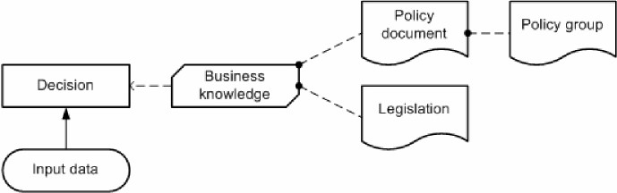
Figure 6-3: Knowledge Sources representing authorities
b) They may be drawn from Input Data and Decisions to Knowledge Sources, where, in conjunction with use (a), they represent the derivation of Business Knowledge Models from instances of Input Data and Decision results, using analytics. The Knowledge Source typically represents the analytic model (or modeling process); the Business Knowledge Model represents the executable logic generated from or dependent on the model. An example of this use of a Knowledge Source is shown in Figure 6-4: in this case a business knowledge model is based on an analytic model which is derived from input data and the results of a dependent decision.
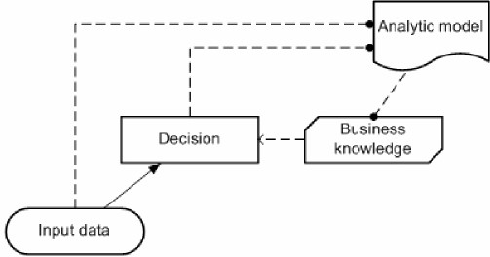
Figure 6-4: Knowledge source representing predictive analytics
However, the figures above are only examples. There are many other possible use cases for Authority Requirements (and since Knowledge Sources and Authority Requirements have no execution semantics their interpretation is necessarily vague), so this specification leaves the details of their application to the implementer.
An Authority Requirement is represented in a DRD as an arrow drawn with a dashed line and a filled circular head, as shown in Table 1. The arrows are drawn from the source of authority to the element governed by it.

6.2.3 Connection rules
The rules governing the permissible ways of connecting elements with requirements in a DRD are described in Clause 6.2.2 above and summarized in Table 2. For clarity, a simple DRD is shown for each permissible connection. In each of these diagrams, the upper (“to”) element requires the lower (“from”) element.
Note that no requirements may be drawn terminating in Input Data, that is, input data may have no requirements. Note also that the type of the requirement is uniquely determined by the types of the two elements connected.

Table 2: Requirements connection rules
From | To (Required by) | Requirement | Diagram
Decision | Decision | Information | 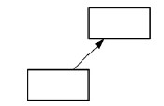
Decision | Decision Service | Requirement
Decision | Knowledge Source | Authority | 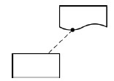
Business Knowledge Model | Decision | Knowledge | 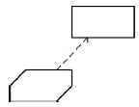
Business Knowledge Model | Business Knowledge Model | Knowledge | 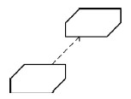
Decision Service | Decision | Knowledge | 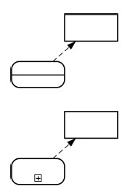
Decision Service | Business Knowledge Model | Knowledge | 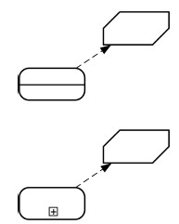
From | To (Required by) | Requirement | Diagram
Input data | Decision | Information | 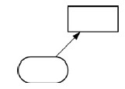
Input data | Decision Service | Information
Input data | Knowledge Source | Authority | 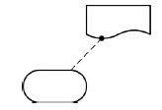
Knowledge Source | Decision | Authority | 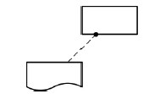
Knowledge Source | Business Knowledge Model | Authority | 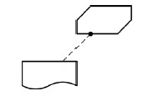
Knowledge Source | Decision Service | Authority
Knowledge Source | Knowledge Source | Authority | 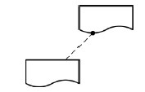

6.2.5 Decision service
A Decision Service is represented in a DRD as rectangle with rounded corners, drawn with a heavy solid border. The Name of the Decision Service MUST be displayed inside the shape unless it is overridden by the text attribute of the associated DMNDI:DMNLabel element, which MUST be displayed instead. The border SHALL enclose all the encapsulated decisions, and no other decisions or input data. The border MAY enclose other DRG elements, but these will not form part of the definition of the Decision Service.
If the set of output decisions is smaller than the set of encapsulated decisions, the Decision Service SHALL be divided into two parts with a straight solid line. One part SHALL enclose only the output decisions and the Decision Service's Name; the other part SHALL enclose all the encapsulated decisions which are not in the set of output decisions. Either part MAY enclose other DRG elements, but these will not form part of the definition of the Decision Service.
Figure 6-6 shows a Decision Service with two output decisions; other examples (with a single output decision) are shown in Figure 5-10 and Figure 5-11.
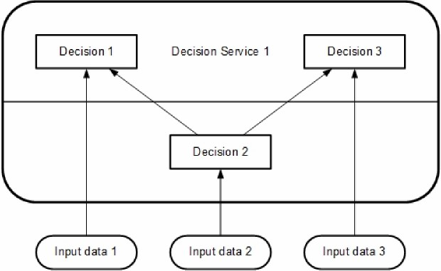
Figure 6-6: Decision Service notation
A decision service may be defined in one DRD and then shown in a different DRD when invoked internally within the decision model by another decision. In the case of a decision service invocation internal to the decision model, a decision service may also be shown without the details of its definition, as in a “collapsed state”. Figure 6-7 consists of two separate diagrams: DRD 1 shows the definition of Decision service 1. In DRD 2, the same Decision service 1 is shown as invoked by Decision 5. In DRD 2, Decision service 1 is shown in a collapsed form.
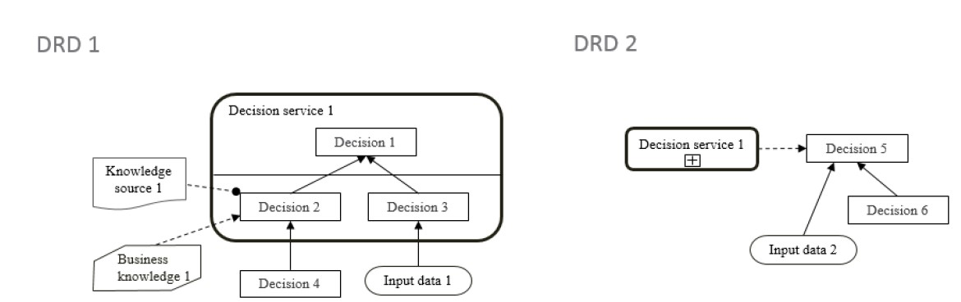
Figure 6-7: A decision service in expanded and collapsed form
DRD 1 in Figure 6-7 shows that Decision service 1 has 2 inputs: Decision 4 and Input data 1. It is therefore inferred that Decision Service 1 has 2 input parameters with matching characteristics to Decision 4 and Input data 1. DRD 2 in Figure 6-7 shows that Decision 5 has 2 dependencies but whether these are mapped as parameters for the invocation of Decision Service 1 cannot be determined from the diagram.
The information and authority requirements defined on Decision 2 in DRD 1 are not depicted in the collapsed form of Decision Service 1 shown in DRD 2.
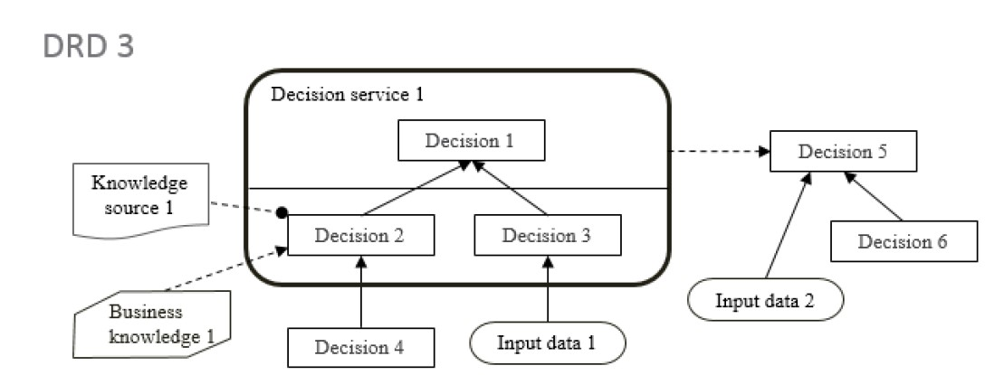
Figure 6-8: A decision service invoked in an expanded form
DRDs 1 and 2 in Figure 6-7 and DRD 3 in Figure 6-8 are all congruent within the same DRG. They all show different aspects of Decision Service 1. DRD 3 shows an expanded form Decision service 1 being invoked by Decision 5.
The constraint imposed on the rendering of decision services within a DRD is that the same decision service MUST NOT be rendered both expanded and collapsed within the same DRD. This stems from the general restriction disallowing the same DMN Element to be present twice in the same diagram.
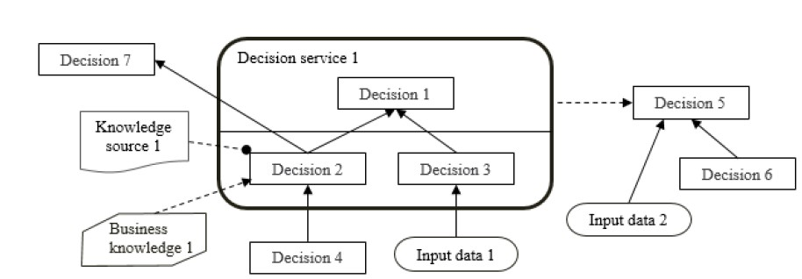
Figure 6-9: A decision service defined as an overlay
Decision services are defined as overlays and therefore do not encapsulate the decisions within them. Therefore, the richness of connections depicted in Figure 6-9 is allowed. In this DRD, Decision 7 is dependent on Decision 2.
If the encapsulated decisions are not completely known (as described in section 5.3.3.2) , Information Requirements may link Input data and Decisions to the Decision Service directly. Such Information Requirements shall be removed once an encapsulated Decision is identified as the target of an Information Requirement from that Input data or Decision.

6.3.9 Business Knowledge Model metamodel
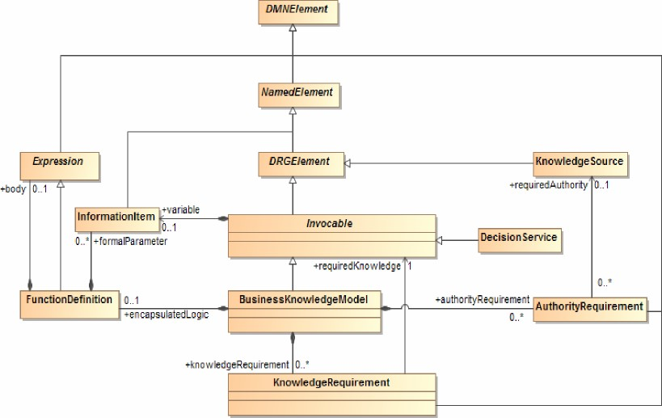
Figure 6-15: BusinessKnowledgeModel class diagram
A business knowledge model has an abstract part, representing reusable, invocable decision logic, and a concrete part, which mandates that the decision logic must be a single FEEL boxed function definition. A decision service is also an invocable element, and thus can be invoked as required knowledge from other decisions and business knowledge models.
The class Invocable is used to model an invocable element and the class BusinessKnowledgeModel is used to model a business knowledge model.
Invocable is a specialization of DRGElement and it inherits the name and optional id, description, and label attributes from NamedElement. The name of an Invocable must be different from the name of any other invocable, input data, decision, or import in the decision model. BusinessKnowledgeModel is a specialization of Invocable from which it additionally inherits the variable attribute.
A BusinessKnowledgeModel element may have zero or more knowledgeRequirement, which are instance of KnowledgeRequirement. An Invocable element may have zero or more authorityRequirement, which are instances of AuthorityRequirement. These model elements are described below.
The requirement subgraph of a BusinessKnowledgeModel element is the directed graph composed of the
BusinessKnowledgeModel element itself, its knowledgeRequirement elements, and the union of the requirement subgraphs of all the requiredKnowledge elements that are referenced by its knowledgeRequirements.
An instance of BusinessKnowledgeModel is said to be well-formed if and only if, either it does not have any knowledgeRequirement, or all of its knowledgeRequirement elements are well-formed. That condition entails, in particular, that the requirement subgraph of a BusinessKnowledgeModel element SHALL be acyclic, that is, that a BusinessKnowledgeModel element SHALL not require itself, directly or indirectly.
At the decision logic level, a BusinessKnowledgeModel element contains a FunctionDefinition, which is an instance of Expression containing zero or more parameters, which are instances of Information Item. The FunctionDefinition that is contained in a BusinessKnowledgeModel element is the reusable module of decision logic that is represented by this BusinessKnowledgeModel element. An Invocable element contains an InformationItem that holds an invocable reference to the abstract business knowledge, which allows a Decision to invoke it by name. The name of that InformationItem SHALL be the same as the name of the Invocable element. Invocable inherits all the attributes and model associations from DRGElement.
Table 15 presents the additional attributes and model associations of the Invocable class. Table 16 presents the additional attributes and model associations of the BusinessKnowledgeModel class.
Table 15: Invocable attributes and model associations
Attribute | Description
variable: InformationItem | This attribute defines a variable that is bound to the function defined by the FunctionDefinition, allowing decision logic to invoke the function by name.
authorityRequirement: AuthorityRequirement [*] | This attribute lists the instances of  AuthorityRequirement that compose this Invocable.

Table 16: BusinessKnowledgeModel attributes and model associations
Attribute | Description
encapsulatedLogic: FunctionDefinition [0.. 1] | The function that encapsulates the logic encapsulated by this BusinessKnowledgeModel.
knowledgeRequirement: KnowledgeRequirement [*] | This attribute lists the instances of KnowledgeRequirement that compose this BusinessKnowledgeModel.

6.3.10 Decision service metamodel
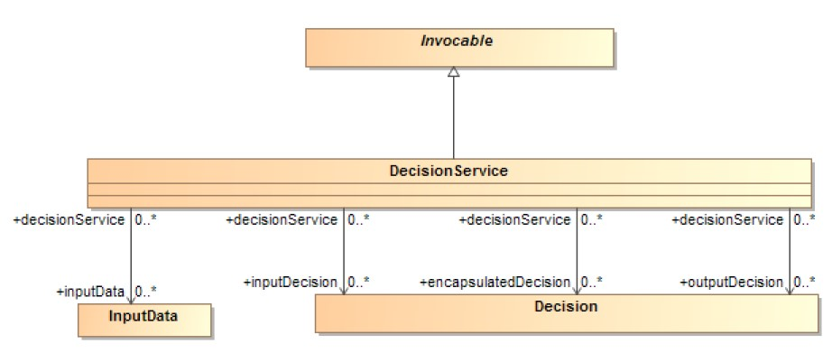
Figure 6-16: DecisionService class diagram
The DecisionService class is used to define named decision services against the decision model contained in an instance of Definitions.
DecisionService is a kind of Invocable element, from which an instance of DecisionService inherits the name and optional id, description, and label attributes, which are Strings, and a variable, which is an InformationItem. The id of a DecisionService element SHALL be unique within the containing instance of Definitions. The name of the variable and the name of the DecisionService SHALL be the same. This name may be used to invoke a DecisionService from the decision logic of another decision or business knowledge model.
A DecisionService element has one or more associated outputDecisions, which are the instances of Decision required to be output by this DecisionService, i.e., the Decisions whose results the Decision Service must return when called.
A DecisionService element has zero or more encapsulatedDecisions, which are the instances of Decision required to be encapsulated by this DecisionService, i.e., the Decisions to be evaluated by the Decision Service when it is called.
A DecisionService element has zero or more inputDecisions, which are the instances of Decision required as input by this DecisionService, i.e., the Decisions whose results will be provided to the Decision Service when it is called.
A DecisionService element has zero or more inputData, which are the instances of InputData required as input by this DecisionService, i.e., the Input Data which will be provided to the Decision Service when it is called.
A DecisionService element has zero or more informationRequirement elements, which are instances of InformationRequirement.
The encapsulatedDecisions, inputDecisions and inputData attributes are optional. At least one of the encapsulatedDecisions and inputDecisions attributes SHALL be specified.
The requirement subgraph of a DecisionService element is the directed graph composed of the DecisionService element itself and the union of the requirement subgraphs of all the Decision elements that are referenced by its encapsulatedDecisions and outputDecisions.
An instance of DecisionService is said to be well-formed if and only if its requirement subgraph is acyclic, that is, that a DecisionService element SHALL not require itself, directly or indirectly and if it is not involved directly in any Information Requirements .
DecisionService inherits all the attributes and model associations from Invocable. Table 17 presents the additional attributes and model associations of the DecisionService element.
Table 17: DecisionService attributes and model associations
Attribute | Description
outputDecisions: Decision [1..*] | This attribute lists the instances of Decision required to be output by this DecisionService.
encapsulatedDecisions: Decision [0..*] | If present, this attribute lists the instances of Decision to be encapsulated in this DecisionService
inputDecisions: Decision [0..*] | If present, this attribute lists the instances of Decision required as input by this DecisionService.
inputData: InputData [0..*] | If present, this attribute lists the instances of InputData required as input by this DecisionService
informationRequirement: InformationRequirement [*] | This attribute lists the instances of  InformationRequirement that compose this DecisionService.

6.3.13 Information Requirement metamodel
The class InformationRequirement is used to model an information requirement, as represented by a plain arrow in a DRD. InformationRequirement is a specialization of DMNElement, from which it inherits the optional id, description, and label attributes.
An InformationRequirement element is a component of either a Decision or DecisionService element, and it associates that requiring element with a requiredDecision element, which is an instance of Decision, or a requiredInput element, which is an instance of InputData.
An InformationRequirement element references an instance of either a Decision or InputData, which defines a variable. That variable, which is an instance of InformationItem, represents the InformationRequirement element at the decision logic level.
Notice that an InformationRequirement element must reference the instance of Decision or InputData that it associates with the requiring element, not contain it: instances of Decision or InputData can only be contained in Definitions elements.
An instance of InformationRequirement is said to be well-formed if and only if all of the following are true:
• It references a requiredDecision or a requiredInput element, but not both.
• The referenced requiredDecision or requiredInput element is well-formed.
• A Decision element that contains the instance of InformationRequirement is not in the requirement subgraph of the referenced requiredknowledge element, if this InformationRequirement element references one.
• The referenced requiredDecision or requiredInput element is defined in the same decision model or in an imported decision model.
Table 20 presents the attributes and model associations of the InformationRequirement element.
Table 20: InformationRequirement attributes and model associations
Attribute | Description
requiredDecision: Decision [0..1] | The instance of Decision that this  InformationRequirement associates with its containing element.
requiredInput: InputData [0..1] | The instance of InputData that this  InformationRequirement associates with its containing element.

6.3.15 Authority Requirement metamodel
The class AuthorityRequirement is used to model an authority requirement, as represented by an arrow drawn with a dashed line and a filled circular head in a DRD. AuthorityRequirement is a specialization of DMNElement, from which it inherits the optional id, description, and label attributes.
An AuthorityRequirement element is a component of a Decision, Invocable or KnowledgeSource element, and it associates that requiring Decision, Invocable or KnowledgeSource element with a requiredAuthority element, which is an instance of KnowledgeSource, a requiredDecision element, which is an instance of Decision, or a requiredInput element, which is an instance of InputData.
Notice that an AuthorityRequirement element must reference the instance of KnowledgeSource, Decision or InputData that it associates with the requiring element, not contain it: instances of Knowledge Source, Decision or InputData can only be contained in Definitions elements.
Table 22 presents the attributes and model associations of the AuthorityRequirement element.
Table 22: AuthorityRequirement attibutes and model associations
Attribute | Description
requiredAuthority: KnowledgeSource [0.. 1] | The instance of KnowledgeSource that this  AuthorityRequirement associates with its containing  KnowledgeSource, Decision or  Invocable element.
requiredDecision: Decision [0..1] | The instance of Decision that this  AuthorityRequirement associates with its containing KnowledgeSource element.
requiredInput: InputData [0.. 1] | The instance of InputData that this  AuthorityRequirement associates with its containing KnowledgeSource element.

10.4 Execution Semantics of Decision Services
FEEL gives execution semantics to decision services defined in decision models where FEEL is the expression language. A decision service is semantically equivalent to a FEEL function whose parameters are the decision service inputs, and whose logic is a context assembled from the decision service's decisions and knowledge requirements.
Decision service implementations SHALL return a result as described above, and MAY return additional information such as intermediate results, log records, debugging information, error messages, rule annotations, etc. The format of any additional information is left unspecified.
Every FEEL expression in a decision model has execution semantics. LiteralExpression (FEEL text) semantics is defined in 10.3. Boxed expressions described in 10.2.2 can be mapped to FEEL text and thus also have execution semantics.
Recall that a DecisionService is defined by four lists: inputData, inputDecisions, outputDecisions, and encapsulatedDecisions. The lists are not independent and thus not all required to be specified, e.g., each required decision (direct and indirect) of the outputDecisions must be an encapsulatedDecision, an inputDecision, or required by an inputDecision. For simplicity in the following, we assume that all four lists are correctly and completely specified.
A DecisionService that has any informationRequirements cannot be given execution semantics as it is by definition incomplete.
A DecisionService is given execution semantics by mapping it to a FEEL function F. Let S be a
DecisionService with input data id1, id2, ..., input decisions di1, di2, ..., encapsulated decisions de1, de2, ..., and output decisions do1, do2, .... Each input data idi has a qualified name nid_{i}. Each decision di has a qualified name nd_{i} and a decision logic expression ed. The decisions may have knowledge requirements. In particular the decisions may require BusinessKnowledgeModels bkm1, bkm2, ... and DecisionServices s1, s2, .... BusinessKnowledgeModels have qualified names nbkm_{i} and encapsulatedLogic f_{bkmi}. DecisionServices have qualified names nsi and equivalent logic fs_{i}, where the equivalent logic is defined recursively, binding si to S.

