2.4 STPA-Sec
The STPA-Sec method example describes a vehicle headlamp system. This example does not provide guidance on how to conduct a STPA-Sec analysis but describes how to represent it in a model form. The content below follows the process defined in the STPA Handbook [ref] and SAE J3307 System Theoretic Process Analysis (STPA) Standard for All Industries [ref].
Figure# shows the hierarchy of Losses and Hazards as applied from the specifications.
Figure# – Losses and Hazards

System-level constraints are modeled as <<designConstraint>> and mapped to Hazards using the <<trace>> relationship in a requirements diagram, as shown in Figure# below.
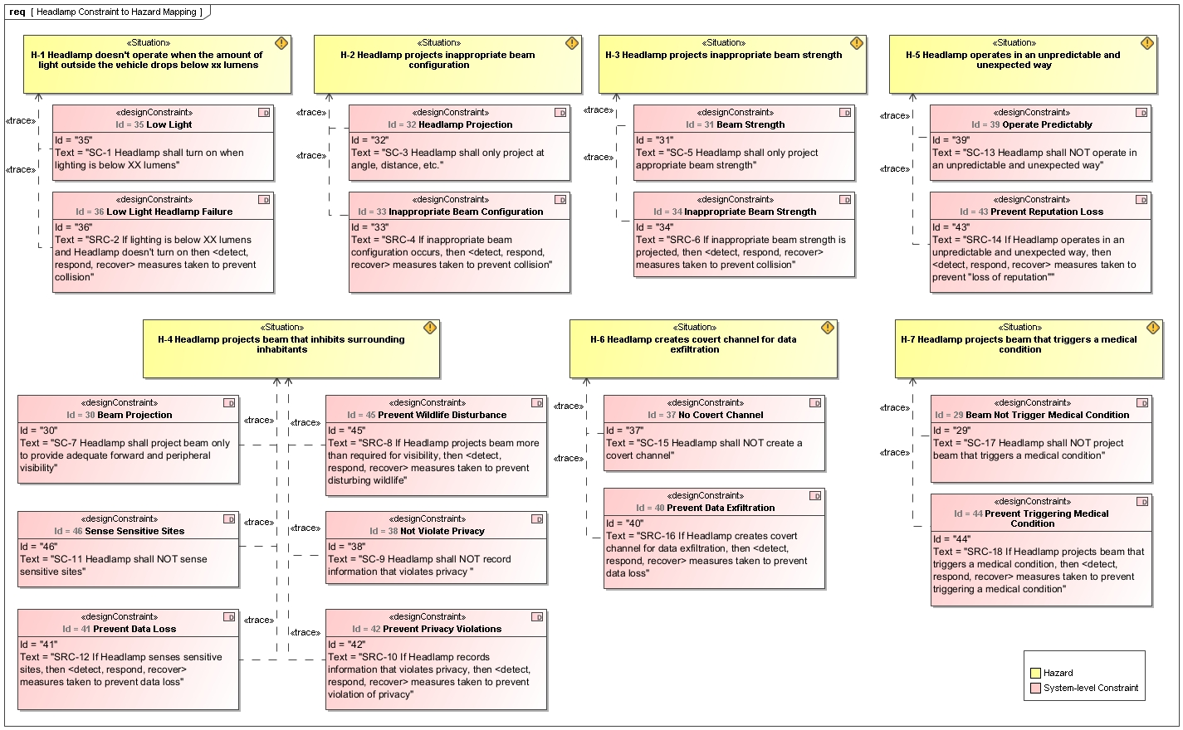
Figure – Hazard to System-level Constraint

Losses are mapped to Hazards in an internal block diagram (Figure#) using connectors between the usage of the previously defined elements as shown Figure# below.

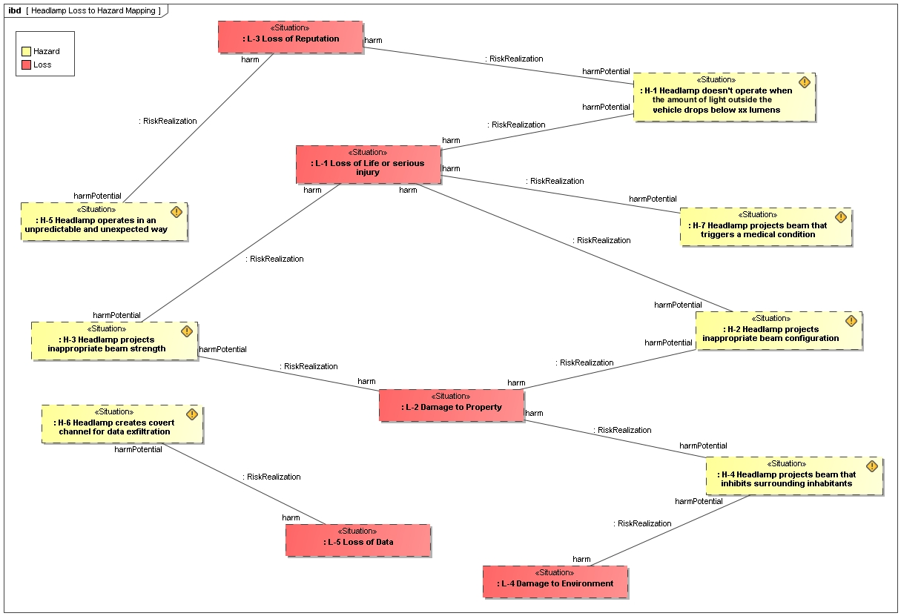
Figure # – Mapping of losses and hazards

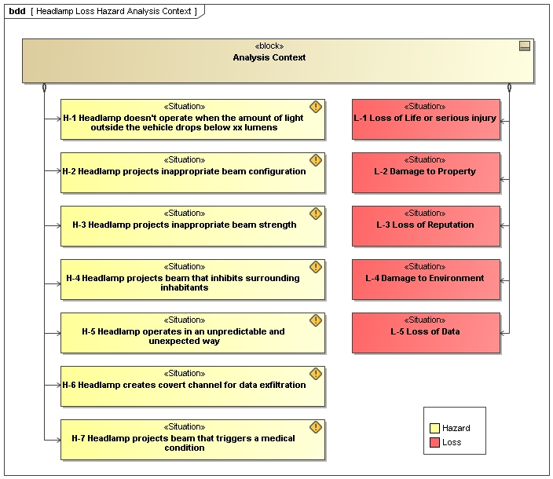
Figure # – Headlamp Loss Hazard Analysis context

The Control Structure is is initially constructed using a block definition diagram (Figure#) that shows the defined elements needed for the internal block diagram (Figure#) that represents the Headlamp Control Structure with the Control Actions and Feedback.
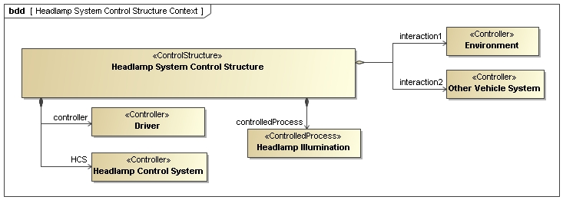
Figure# – Headlamp System Control Structure Context

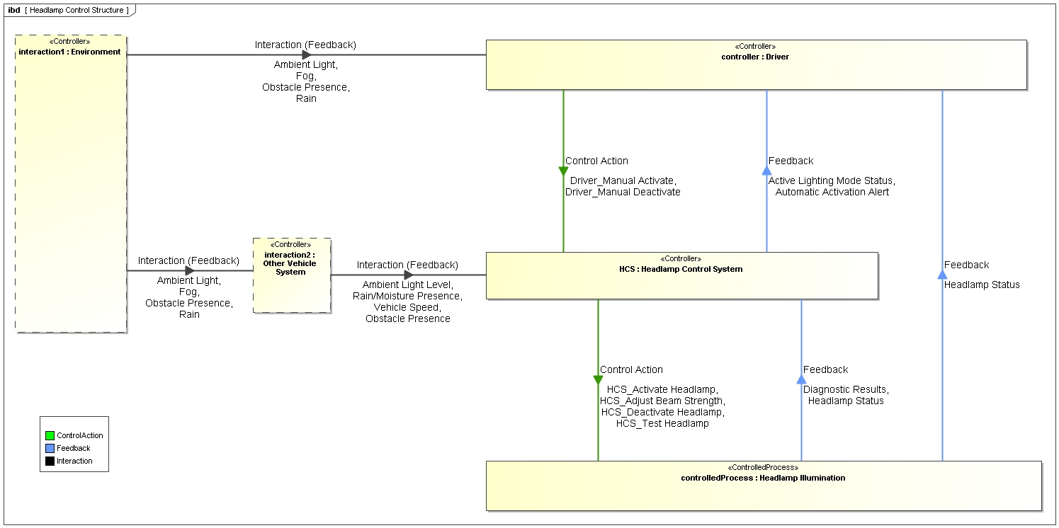
Figure# – Headlamp System Control Structure

Undesired Control Actions (UCA), to include the operational context of the UCA, are modeled in a block definition diagram as shown in (Figure#) below. UCA elements are associated with a Control Action using the <<RelevantTo>> dependency.

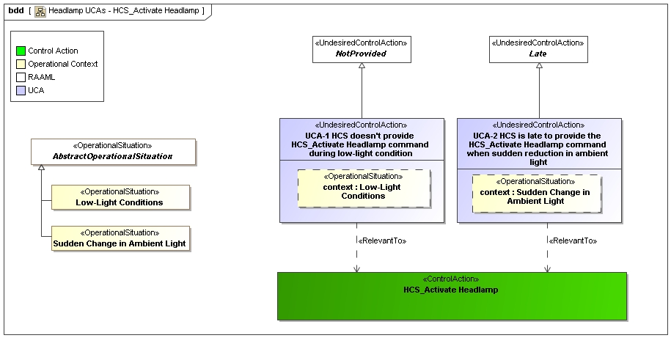
Figure – Undesired Control Actions

UCAs, Hazards, and Losses are mapped in an internal block diagram (Figure#) using connectors between the usage of the previously defined elements as shown Figure# below.

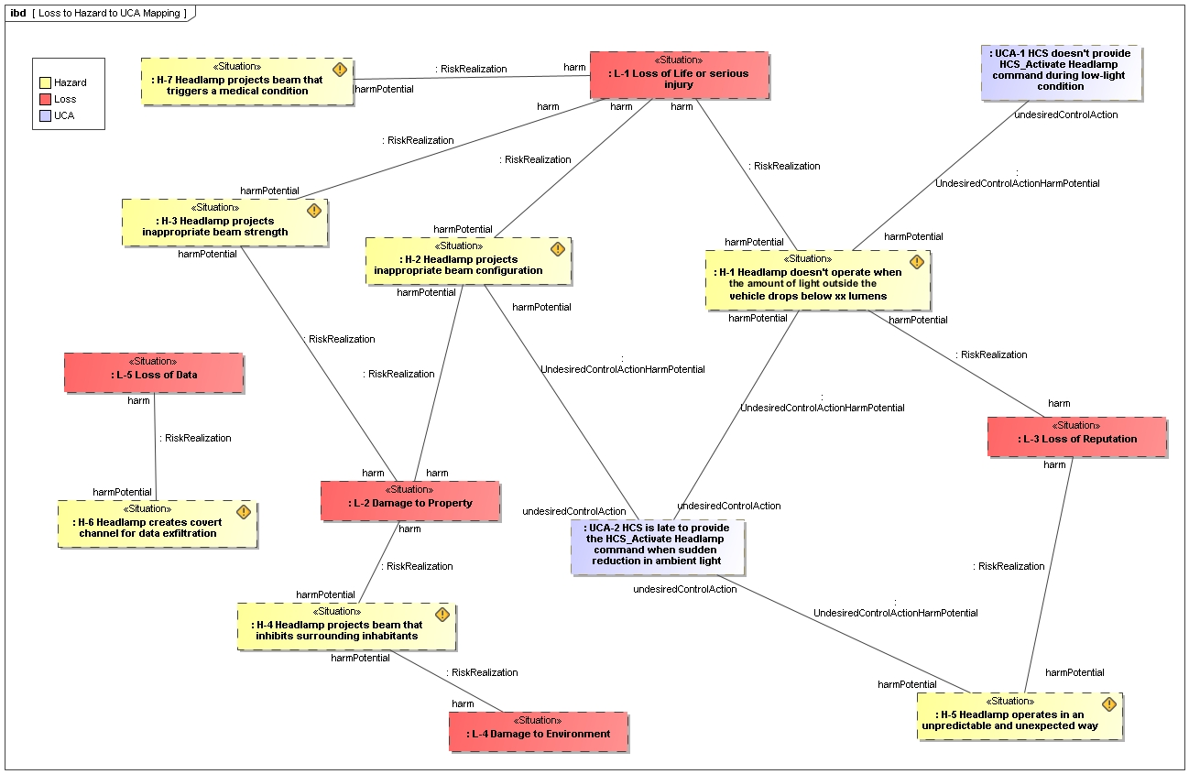
Figure # – Mapping of undesired control actions, hazards, and losses

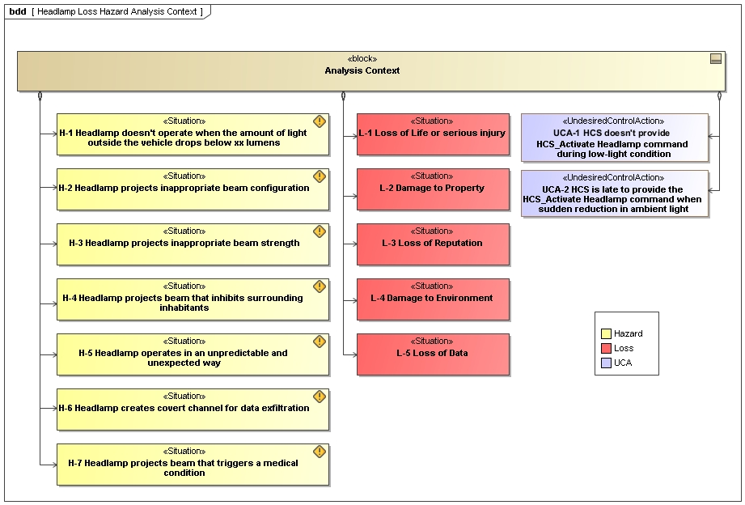
Figure # – Analysis context

STPA-Sec causal analysis is defined using a block definition diagram. A Loss Scenario element is related to the relevant UCA element, and the Loss Scenario is composed of Factors and a Control Flaw as shown in Figure# below.

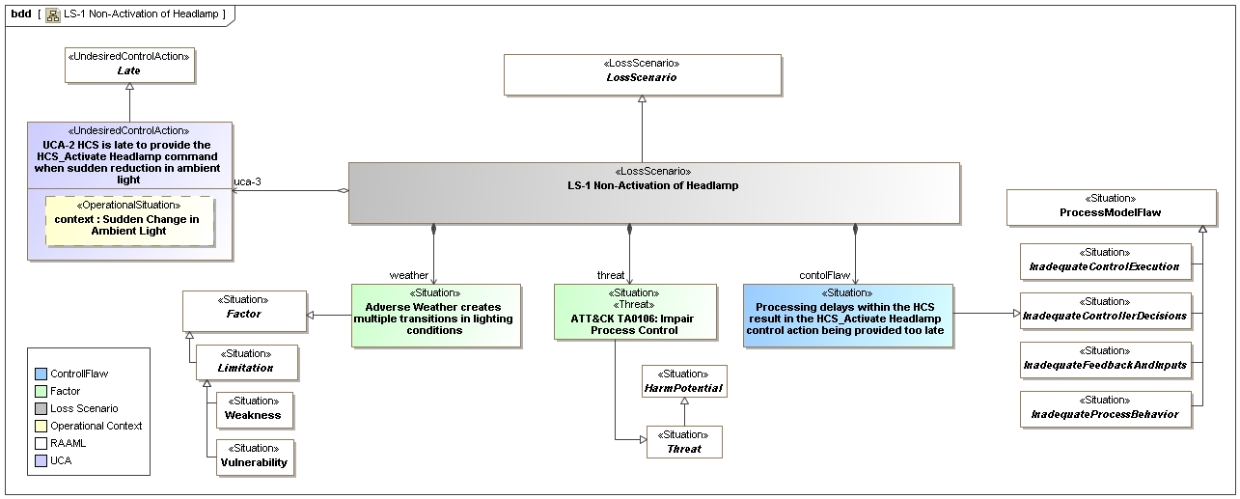
Figure# – Loss Scenario Causal Analysis Context

The internal block diagram (Figure#) represents a lower level of granularity of the loss scenario that further specifies the UCA, Control Flaw of interest, and associated Factors relevant to the analysis.

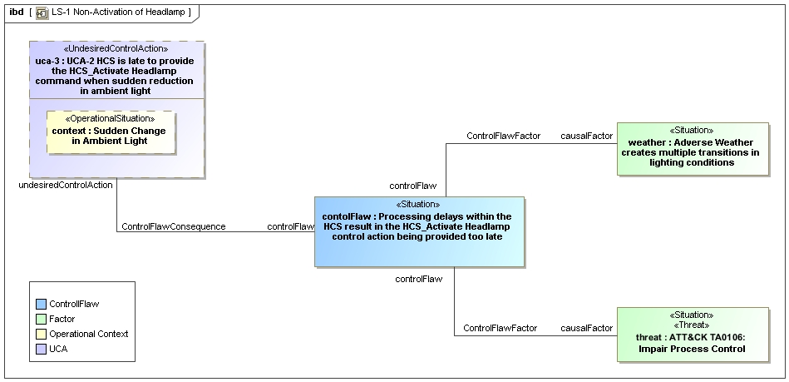
Figure 2.17 – Loss scenario

