Date: March 2024

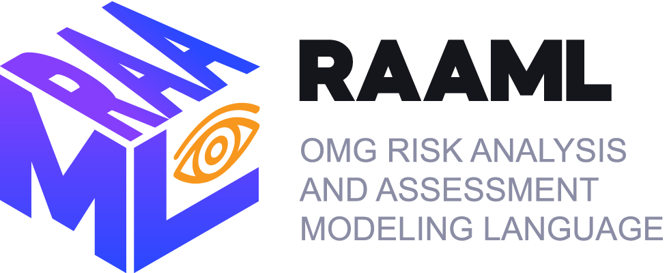

Risk Analysis and Assessment Modeling Language (RAAML)
Libraries and Profiles
Version 1.1 Beta 2
__________________________________________________
OMG Document Number: ptc/24-03-02
Standard document URL: http://www.omg.org/spec/RAAML/
__________________________________________________

Copyright © 2021, Dassault Systemes
Copyright © 2021, Ford Motor Company
Copyright © 2021, Gesellschaft für Systems Engineering
Copyright © 2022, Object Management Group, Inc.

USE OF SPECIFICATION - TERMS, CONDITIONS & NOTICES
The material in this document details an Object Management Group specification in accordance with the terms, conditions and notices set forth below. This document does not represent a commitment to implement any portion of this specification in any company's products. The information contained in this document is subject to change without notice.

LICENSES
The companies listed above have granted to the Object Management Group, Inc. (OMG) a nonexclusive, royalty-free, paid up, worldwide license to copy and distribute this document and to modify this document and distribute copies of the modified version. Each of the copyright holders listed above has agreed that no person shall be deemed to have infringed the copyright in the included material of any such copyright holder by reason of having used the specification set forth herein or having conformed any computer software to the specification.
Subject to all of the terms and conditions below, the owners of the copyright in this specification hereby grant you a fully-paid up, non-exclusive, nontransferable, perpetual, worldwide license (without the right to sublicense), to use this specification to create and distribute software and special purpose specifications that are based upon this specification, and to use, copy, and distribute this specification as provided under the Copyright Act; provided that: (1) both the copyright notice identified above and this permission notice appear on any copies of this specification; (2) the use of the specifications is for informational purposes and will not be copied or posted on any network computer or broadcast in any media and will not be otherwise resold or transferred for commercial purposes; and (3) no modifications are made to this specification. This limited permission automatically terminates without notice if you breach any of these terms or conditions. Upon termination, you will destroy immediately any copies of the specifications in your possession or control.

PATENTS
The attention of adopters is directed to the possibility that compliance with or adoption of OMG specifications may require use of an invention covered by patent rights. OMG shall not be responsible for identifying patents for which a license may be required by any OMG specification, or for conducting legal inquiries into the legal validity or scope of those patents that are brought to its attention. OMG specifications are prospective and advisory only. Prospective users are responsible for protecting themselves against liability for infringement of patents.

GENERAL USE RESTRICTIONS
Any unauthorized use of this specification may violate copyright laws, trademark laws, and communications regulations and statutes. This document contains information which is protected by copyright. All Rights Reserved. No part of this work covered by copyright herein may be reproduced or used in any form or by any means--graphic, electronic, or mechanical, including photocopying, recording, taping, or information storage and retrieval systems--without permission of the copyright owner.

DISCLAIMER OF WARRANTY

WHILE THIS PUBLICATION IS BELIEVED TO BE ACCURATE, IT IS PROVIDED "AS IS" AND MAY CONTAIN ERRORS OR MISPRINTS. THE OBJECT MANAGEMENT GROUP AND THE COMPANIES LISTED ABOVE MAKE NO WARRANTY OF ANY KIND, EXPRESS OR IMPLIED, WITH REGARD TO THIS PUBLICATION, INCLUDING BUT NOT LIMITED TO ANY WARRANTY OF TITLE OR OWNERSHIP, IMPLIED WARRANTY OF MERCHANTABILITY OR WARRANTY OF FITNESS FOR A PARTICULAR PURPOSE OR USE. IN NO EVENT SHALL THE OBJECT MANAGEMENT GROUP OR ANY OF THE COMPANIES LISTED ABOVE BE LIABLE FOR ERRORS CONTAINED HEREIN OR FOR DIRECT, INDIRECT, INCIDENTAL, SPECIAL, CONSEQUENTIAL, RELIANCE OR COVER DAMAGES, INCLUDING LOSS OF PROFITS, REVENUE, DATA OR USE, INCURRED BY ANY USER OR ANY THIRD PARTY IN CONNECTION WITH THE FURNISHING, PERFORMANCE, OR USE OF THIS MATERIAL, EVEN IF ADVISED OF THE POSSIBILITY OF SUCH DAMAGES.
The entire risk as to the quality and performance of software developed using this specification is borne by you. This disclaimer of warranty constitutes an essential part of the license granted to you to use this specification.

RESTRICTED RIGHTS LEGEND
Use, duplication or disclosure by the U.S. Government is subject to the restrictions set forth in subparagraph (c) (1) (ii) of The Rights in Technical Data and Computer Software Clause at DFARS 252.227-7013 or in subparagraph (c)(1) and (2) of the Commercial Computer Software - Restricted Rights clauses at 48 C.F.R. 52.227-19 or as specified in 48 C.F.R. 227-7202-2 of the DoD F.A.R. Supplement and its successors, or as specified in 48 C.F.R. 12.212 of the Federal Acquisition Regulations and its successors, as applicable. The specification copyright owners are as indicated above and may be contacted through the Object Management Group, 9C Medway Road, PMB 274, Milford, MA 01757, U.S.A.

TRADEMARKS
CORBA®, CORBA logos®, FIBO®, Financial Industry Business Ontology®, FINANCIAL INSTRUMENT GLOBAL IDENTIFIER®, IIOP®, IMM®, Model Driven Architecture®, MDA®, Object Management Group®, OMG®, OMG Logo®, SoaML®, SOAML®, SysML®, UAF®, Unified Modeling Language®, UML®, UML Cube Logo®, VSIPL®, and XMI® are registered trademarks of the Object Management Group, Inc.
For a complete list of trademarks, see: http://www.omg.org/legal/tm_list.htm. All other products or company names mentioned are used for identification purposes only, and may be trademarks of their respective owners.

COMPLIANCE
The copyright holders listed above acknowledge that the Object Management Group (acting itself or through its designees) is and shall at all times be the sole entity that may authorize developers, suppliers and sellers of computer software to use certification marks, trademarks or other special designations to indicate compliance with these materials.
Software developed under the terms of this license may claim compliance or conformance with this specification if and only if the software compliance is of a nature fully matching the applicable compliance points as stated in the specification. Software developed only partially matching the applicable compliance points may claim only that the software was based on this specification, but may not claim compliance or conformance with this specification. In the event that testing suites are implemented or approved by Object Management Group, Inc., software developed using this specification may claim compliance or conformance with the specification only if the software satisfactorily completes the testing suites.

Table of Contents

Preface 1
1. Scope 4
1.1 Introduction 4
1.2 RAAML Background 4
1.3 Intended Usage 5
1.4 Related Documents 5
2. Conformance 7
3. References 8
3.1 Normative References 8
3.2 OMG Documents (Normative References) 8
3.3 Other Normative References 8
3.4 Informative References 8
4. Acknowledgements 9
5. Terms and Definitions 10
6. Acronyms and Abbreviations 11
7. Additional Information (non-normative) 12
7.1 Language Architecture 12
7.2 Philosophy 12
7.3 Principles of Creating, Editing, and Displaying of Composite Situations in Diagrammatic and Tabular Views 12
7.3.1 Diagrammatic Situation Specification 13
7.3.2 Tabular Situation Specification 15
8. Diagram Legend (non-normative) 18
9. Risk Analysis and Assessment Modeling Language (RAAML) Library and Profile 20
9.1 Core 20
9.1.1 Core::Core Library 21
9.1.2 Core::Core Profile 23
9.2 General 25
9.2.1 General::General Concepts Library 26
9.2.2 General::General Concepts Profile 37
9.3 General Security 43
9.3.1 General Security::General Security Concepts Library 43
9.3.2 General Security::General Security Concepts Profile 45
9.4 Methods::FMEA 47
9.4.1 Methods::FMEA::FMEALibrary 48
9.4.2 Methods::FMEA::FMEAProfile 52
9.5 Methods::FTA 53
9.5.1 Methods::FTA::FTALibrary 53
9.5.2 Methods::FTA::FTAProfile 65
9.6 Methods::STPA 78
9.6.1 Methods::STPA::STPA Library 78
9.6.2 Methods::STPA::STPA Profile 88
9.7 GSN 91
9.7.1 GSN::GSN Profile 92
9.8 Methods::ISO 26262 99
9.8.1 Methods::ISO 26262::ISO 26262 Library 99
9.8.2 Methods::ISO 26262::ISO 26262 Profile 113
9.9 Methods::FHA 122
9.9.1 Methods::FHA::FHA Library 122
9.9.2 Methods::FHA::FHA Profile 133
9.10 Methods::RBD 134
9.10.1 Methods::RBD::RBD Library 135
9.10.2 Methods::RBD::RBD Library::ConstraintBlocks 146
9.10.3 Methods::RBD::RBD Profile 169
10. Views 174
10.1 Core 174
10.1.1 Core::Core Library 174
10.1.2 Core::Core Profile 174
10.2 General 175
10.2.1 General::General Concepts Library 175
10.2.2 General::General Concepts Profile 175
10.3 General Security 176
10.3.1 General Security::General Security Concepts Library 176
10.3.2 General Security::General Security Concepts Profile 177
10.4 Methods::FMEA 178
10.4.1 Methods::FMEA::FMEA Library 178
10.4.2 Methods::FMEA::FMEA Profile 179
10.5 Methods::FTA 179
10.5.1 Methods::FTA::FTALibrary 179
10.5.2 Methods::FTA::FTAProfile 181
10.6 Methods::STPA 183
10.6.1 Methods::STPA::STPA Library 183
10.6.2 Methods::STPA::STPA Profile 185
10.7 GSN 186
10.7.1 GSN::GSN Profile 186
10.8 Methods::ISO 26262 188
10.8.1 Methods::ISO 26262::ISO 26262 Library 188
10.8.2 Methods::ISO 26262::ISO 26262 Profile 189
10.9 Methods::FHA 191
10.9.1 Methods::FHA::FHA Library 191
10.9.2 Methods::FHA::FHA Profile 192
10.10 Methods::RBD 193
10.10.1 Methods::RBD::RBD Library 193
10.10.2 Methods::RBD::RBD Library::ConstraintBlocks 197
10.10.3 Methods::RBD::RBD Profile 199

Table of Figures

Figure 7.1 – Fundamental situation modeling principles 13
Figure 7.2 – Typical Automotive Situation definition in the ISO26262 Library 14
Figure 7.3 – User Model Defining Operational Situation “Highway Driving Straight at Speed” 15
Figure 7.4 – HazardousEvent Definition in the ISO26262 Library 16
Figure 8.1 – Legend of color codes 18
Figure 8.2 – An example of using a legend 18
Figure 9.1 – Core concepts domain model 20
Figure 9.2 – AnySituation 22
Figure 9.3 – Causality 22
Figure 9.4 – Situation 23
Figure 9.5 – RelevantTo 23
Figure 9.6 – ControllingMeasure 24
Figure 9.7 – Violates 25
Figure 9.8 – IDCarrier 25
Figure 9.9 – AbstractEvent 26
Figure 9.10 – AbstractCause 27
Figure 9.11 – Cause 27
Figure 9.12 – DysfunctionalEvent 28
Figure 9.13 – AbstractFailureMode 28
Figure 9.14 – FailureMode 29
Figure 9.15 – AbstractEffect 30
Figure 9.16 – Effect 30
Figure 9.17 – Activation 31
Figure 9.18 – ErrorPropagation 32
Figure 9.19 – ErrorRealization 32
Figure 9.20 – HarmPotential 33
Figure 9.21 – Hazard 33
Figure 9.22 – Scenario 34
Figure 9.23 – AbstractRisk 34
Figure 9.24 – UndesiredState 35
Figure 9.24 – Limitation 35
Figure 9.24 – Loss 36
Figure 9.24 – Factor 36
Figure 9.25 – FailureMode 37
Figure 9.26 – Error 37
Figure 9.27 – Fault 38
Figure 9.28 – Detection 38
Figure 9.29 – Prevention 39
Figure 9.30 – Mitigation 39
Figure 9.31 – Recommendation 40
Figure 9.32 – FailureState 40
Figure 9.32 – Hazard 41
Figure 9.32 – Item 41
Figure 9.32 – PresentIn 42
Figure 9.32 – SingleElementItem 42
Figure 9.32 – ElementGroupBasedItem 43
Figure 9.41 - Threat 44
Figure 9.42 - Weakness 44
Figure 9.43 - Vulnerability 44
Figure 9.44 - Threat 45
Figure 9.45 - Impacts 45
Figure 9.46 - Asset 46
Figure 9.47 - Valuates 46
Figure 9.48 - SecurityActor 47
Figure 9.49 - PresentedBy 47
Figure 9.33 – AbstractFMEAItem 48
Figure 9.34 – FMEAItem 49
Figure 9.35 – LossOfFunction 50
Figure 9.36 – DegradationOfFunction 51
Figure 9.37 – IntermittentFunction 51
Figure 9.38 – PartialFunction 51
Figure 9.39 – UnintendedFunction 52
Figure 9.40 – ExceedingFunction 52
Figure 9.41 – DelayedFunction 52
Figure 9.42 – FMEAItem 53
Figure 9.43 – FTAElement 54
Figure 9.44 – FTATree 54
Figure 9.45 – Event 55
Figure 9.46 – BasicEvent 55
Figure 9.47 – IntermediateEvent 56
Figure 9.48 – TopEvent 56
Figure 9.49 – ConditionalEvent 57
Figure 9.50 – DormantEvent 57
Figure 9.51 – UndevelopedEvent 57
Figure 9.52 – HouseEvent 58
Figure 9.53 – ZeroEvent 58
Figure 9.54 – Gate 59
Figure 9.55 – AND 59
Figure 9.56 – OR 60
Figure 9.57 – NOT 60
Figure 9.58 – XOR 61
Figure 9.59 – SEQ 61
Figure 9.60 – INHIBIT 62
Figure 9.61 – MAJORITY_VOTE 62
Figure 9.62 – Tree 66
Figure 9.63 – Gate 66
Figure 9.64 – Event 66
Figure 9.65 – DormantEvent 67
Figure 9.66 – BasicEvent 68
Figure 9.67 – ConditionalEvent 69
Figure 9.68 – ZeroEvent 69
Figure 9.69 – HouseEvent 70
Figure 9.70 – AND 71
Figure 9.71 – OR 72
Figure 9.72 – SEQ 72
Figure 9.73 – XOR 73
Figure 9.74 – INHIBIT 74
Figure 9.75 – MAJORITY_VOTE 75
Figure 9.76 – NOT 75
Figure 9.77 – IntermediateEvent 76
Figure 9.78 – TopEvent 77
Figure 9.79 – TransferIn 77
Figure 9.80 – TransferOut 78
Figure 9.81 – OutOfSequence 79
Figure 9.82 – Late 79
Figure 9.83 – Early 79
Figure 9.84 – TooLong 80
Figure 9.85 – TooShort 80
Figure 9.86 – Provided 80
Figure 9.87 – NotProvided 81
Figure 9.88 – LossScenario 81
Figure 9.89 – ProcessModelFlaw 82
Figure 9.89 – InadequateControllerDecisions 83
Figure 9.90 – InadequateControlExecution 83
Figure 9.91 – InadequateProcessBehavior 83
Figure 9.92 – InadequateFeedbackAndInputs 84
Figure 9.93 – UndesiredControlAction 85
Figure 9.95 – RiskRealization 86
Figure 9.95 – ProcessModelFlawFactor 86
Figure 9.95 – ProcessModelFlawConsequence 87
Figure 9.95 – UndesiredControlActionHarmPotential 87
Figure 9.96 – ControlAction 88
Figure 9.97 – Feedback 88
Figure 9.98 – UndesiredControlAction 89
Figure 9.98 – UnsafeControlAction 89
Figure 9.99 – ControlledProcess 89
Figure 9.100 – Actuator 90
Figure 9.101 – Sensor 90
Figure 9.102 – Controller 90
Figure 9.103 – ControlStructure 91
Figure 9.104 – LossScenario 91
Figure 9.105 – Standard UML notation for stereotyped elements (from UML 2.5.1, Figure 12.25) 92
Figure 9.106 - Strategy notation 92
Figure 9.107 - Combined notation 92
Figure 9.108 – GSNNode 93
Figure 9.109 – GSNArgumentNode 93
Figure 9.110 – Solution 94
Figure 9.111 – Goal 94
Figure 9.112 – Strategy 95
Figure 9.113 – ContextualInformation 95
Figure 9.114 – ContextStatement 95
Figure 9.115 – Assumption 96
Figure 9.116 – Justification 96
Figure 9.117 – InContextOf 97
Figure 9.118 – SupportedBy 98
Figure 9.119 – TrafficAndPeople 99
Figure 9.120 – VehicleUsage 99
Figure 9.121 – RoadCondition 100
Figure 9.122 – Location 100
Figure 9.123 – EnvironmentalCondition 101
Figure 9.124 – OperationalCondition 101
Figure 9.125 – AbstractOperationalSituation 102
Figure 9.126 – TypicalAutomotiveSituation 102
Figure 9.127 – Exposure 103
Figure 9.128 – Severity 103
Figure 9.129 – ASIL 104
Figure 9.130 – Controllability 104
Figure 9.131 – Less 105
Figure 9.132 – More 105
Figure 9.133 – No 105
Figure 9.134 – Intermittent 106
Figure 9.135 – Unintended 106
Figure 9.136 – Early 107
Figure 9.137 – Late 107
Figure 9.138 – Inverted 107
Figure 9.139 – HazardousEvent 108
Figure 9.140 – AnyMalfunction 109
Figure 9.141 – AutomotiveEffect 109
Figure 9.142 – ISO26262SafetyRequirementTemplate 110
Figure 9.143 – AccidentScenario 110
Figure 9.144 – AnyTrafficAndPeople 111
Figure 9.145 – AnyVehicleUse 111
Figure 9.146 – AnyRoadCondition 112
Figure 9.147 – AnyLocation 112
Figure 9.148 – AnyEnvironmentalCondition 112
Figure 9.149 – SystemLevelEffect 113
Figure 9.150 – VehicleLevelEffect 113
Figure 9.151 – OperationalSituation 114
Figure 9.152 – MalfunctioningBehavior 114
Figure 9.153 – IndependenceRequirement 115
Figure 9.154 – ASILDecompose 115
Figure 9.155 – SafeState 116
Figure 9.156 – UserInfoRequirement 116
Figure 9.157 – RecoveryRequirement 116
Figure 9.158 – OperatingMode 117
Figure 9.159 – FunctionalSafetyRequirement 117
Figure 9.160 – SoftwareSafetyRequirement 118
Figure 9.161 – HardwareSafetyRequirement 118
Figure 9.162 – TechnicalSafetyRequirement 119
Figure 9.163 – SafetyGoal 119
Figure 9.164 – DependabilityRequirement 119
Figure 9.165 – Verified 120
Figure 9.166 – Confirmed 120
Figure 9.167 – HazardAndRiskAssessment 121
Figure 9.168 – LessonLearned 121
Figure 9.169 – ASILAssignment 121
Figure 9.170 – ASILOverrideRationale 122
Figure 9.192 - ExternalEvent 123
Figure 1.1 - DevelopmentAssuranceLevel 124
Figure 1.1 - OperationalCondition 125
Figure 1.1 - FunctionalFailure 126
Figure 1.1 - Assumption 127
Figure 1.1 - EnvironmentalCondition 128
Figure 1.1 - FDAL 128
Figure 1.1 - FailureEffect 129
Figure 1.1 - FlightPhase 130
Figure 1.1 - FailureCondition 130
Figure 1.1 - IDAL 132
Figure 1.1 - OperationalEvent 132
Figure 1.1 - FunctionalFailure 134
Figure 9.192 - AbstractReliabilitySituation 135
Figure 9.193 - Restorable 136
Figure 9.194 - ComponentReliabilitySituation 137
Figure 9.195 - RestorableComponentReliabilitySituation 138
Figure 9.196 - NonRestorableComponentReliabilitySituation 139
Figure 9.197 - SystemReliabilitySituation 140
Figure 9.198 - RestorableSystemReliabilitySituation 141
Figure 9.199 - InSeries 142
Figure 9.200 - RestorableInSeries 142
Figure 9.201 - InParallel 143
Figure 9.202 - RestorableInParallel 143
Figure 9.203 - HomogeneousKofN 144
Figure 9.204 - RestorableHomogeneousKofN 145
Figure 9.205 - HeterogenerousKofN 145
Figure 9.206 - RestorableHeterogeneousKofN 146
Figure 10.1 – Core Library 174
Figure 10.2 – CoreProfile 174
Figure 10.3 - General Concepts Library 175
Figure 10.4 – General Concepts Profile 176
Figure 10.5 - General Security Concepts Library 176
Figure 10.6 - General Security Concepts Profile 177
Figure 10.7 – FMEA Library 178
Figure 10.8 – FMEA Profile 179
Figure 10.9 – Events 180
Figure 10.10 – FTA Library 181
Figure 10.11 – FTA Profile 182
Figure 10.12 – STPA Library 185
Figure 10.13 – STPA Profile 186
Figure 10.14 – GSN Profile 187
Figure 10.15 – ISO 26262 Library 188
Figure 10.16 – All-Encompassing Operational Situations 189
Figure 10.17 – RequirementManagement 190
Figure 10.18 – ISO 26262 Profile 191
Figure 0.1 - FHA Library 192
Figure A.1 - FHA Profile 193
Figure 10.19 - RBD Library 193
Figure 10.20 - AbstractReliabilitySituation 194
Figure 10.21 - ComponentReliabilitySituation 194
Figure 10.22 - InSeries 194
Figure 10.23 - RestorableInSeries 195
Figure 10.24 - InParallel 195
Figure 10.25 - RestorableInParallel 195
Figure10.26 - HomogeneousKofN 195
Figure 10.27 - RestorableHomogeneousKofN 196
Figure 10.28 - HeterogeneousKofN 196
Figure 10.29 - RestorableHeterogeneousKofN 197
Figure 10.30 - Distributions 198
Figure 10.31 - ReliabilityParameterDistribution 199
Figure 10.32 - RBD Profile 199
Figure 10.33 - NonRestorableComponentReliabilitySituation 200
Figure 10.34 - RestorableComponentReliabilitySituation 200

Table of Tables
Table 1.1 – Table of Related Documents 5
Table 5.1 – Description of terms and definitions used in this specification 10
Table 6.1 – Description of acronyms used in this specification 11
Table 7.1 – Table for Specifying Operational Situations with Situation “Highway Driving Straight at Speed” Defined 15
Table 7.2 – Hazardous Event Table with Grouped Columns 17
Table 9.1 – Mapping of core concepts to the SysML/UML language 21

Preface
OMG
Founded in 1989, the Object Management Group, Inc. (OMG) is an open membership, not-for-profit computer industry standards consortium that produces and maintains computer industry specifications for interoperable, portable and reusable enterprise applications in distributed, heterogeneous environments. Membership includes Information Technology vendors, end users, government agencies and academia. OMG member companies write, adopt, and maintain its specifications following a mature, open process. OMG's specifications implement the Model Driven Architecture® (MDA®), maximizing ROI through a full-lifecycle approach to enterprise integration that covers multiple operating systems, programming languages, middleware and networking infrastructures, and software development environments. OMG's specifications include: UML® (Unified Modeling Language™); CORBA® (Common Object Request Broker Architecture); CWM™ (Common Warehouse Metamodel); and industry-specific standards for dozens of vertical markets. More information on the OMG is available at https://www.omg.org/.
OMG Specifications
As noted, OMG specifications address middleware, modeling, and vertical domain frameworks. All OMG Specifications are available from this URL: https://www.omg.org/spec.
Specifications are organized by the following categories:
Domain Categories
Platform Categories
Other Categories
All of OMG’s formal specifications may be downloaded without charge from our website. (Products implementing OMG specifications are available from individual suppliers.) Copies of specifications, available in PDF format, may be obtained from the Specifications Catalog cited above or by contacting the Object Management Group, Inc. at:
OMG Headquarters
92 Medway Road, PMB 274
Milford, MA 01757 USA
Tel: +1- 781-444-0404
Fax: +1-781-444-0320
Email: pubs@omg.org
Certain OMG specifications are also available as ISO standards. Please consult https://www.iso.org

Typographical Conventions
The type styles shown below are used in this document to distinguish programming statements from ordinary English. However, these conventions are not used in tables or section headings where no distinction is necessary.
Times/Times New Roman - 10 pt.: Standard body text
Helvetica/Arial - 10 pt. Bold: OMG Interface Definition Language (OMG IDL) and syntax elements.
Courier - 10 pt. Bold: Programming language elements.
Helvetica/Arial - 10 pt: Exceptions
Note – Terms that appear in italics are defined in the glossary. Italic text also represents the name of a document, specification, or other publication.

Issues
All OMG specifications are subject to continuous review and improvement. As part of this process, we encourage readers to report any ambiguities, inconsistencies, or inaccuracies they may find by completing the Issue Reporting Form listed on the main web page https://www.omg.org, under Documents, Report a Bug/Issue (https://issues.omg.org/issues/create-new-issue).

- Scope
- Introduction
There are two parts to this specification, one being normative and another informative. The normative part is:
- The Risk Analysis and Assessment Modeling Language (RAAML) Library and Profile (this document) defines concepts and relationships for capturing safety and reliability aspects of a system in the library and profile form.
The informative part is:
- The RAAML Example Model, Annex A (see document ad/2020-11-01), which illustrates practical usages of RAAML.
- RAAML Background
Model-Based Systems Engineering (MBSE) is gaining popularity in organizations creating complex systems where it is crucial to collaborate in a multi-disciplinary environment. SysML, being one of the key MBSE components, has a good foundation for capturing requirements, architecture, constraints, views, and viewpoints. However, SysML does not provide the constructs to capture safety, reliability and security information in the system model. A group of industry experts at the OMG has been working since 2016 to define a new specification providing the necessary capabilities.
The need for a standardized UML profile/library for addressing safety, reliability and security aspects emerged long ago. Working group members have seen multiple commercial-grade model-based safety, reliability and security solution implementations being developed during the recent years and successfully used in practice. While the various safety, reliability and security implementations may fit the needs for a specific purpose, there are many instances where information needs to be traced and shared across multiple organizations. These inconsistent model-based solutions prohibit direct model sharing between organizations and across the various tools. One of the key goals for the working group is to reconcile these different approaches to alleviate the industry from repeatedly formulating safety, reliability and security constructs in their tools. The specification provides the modeling capabilities for tool vendors to build safety, reliability and security modeling tools that provide traditional representations (e.g., trees, tables, etc.) while using a modern model-based approach.
This RAAML 1.1 specification defines extensions to SysML needed to support safety, reliability and security analysis. It describes:
- the core concepts and shows how the simple concepts are powerful enough to unite all safety, reliability and security information across a variety of analysis methods
- the approach to automating several safety and reliability analyses, which is built on leveraging existing SysML functionalities to ensure that the profile and library is usable with existing tooling
- specific safety and reliability analysis methods and application domains that are supported
  - Failure Mode and Effect Analysis (FMEA)
  - Fault Tree Analysis (FTA)
  - Systems Theoretic Process Analysis (STPA)
  - Goal Structuring Notation (GSN)
  - ISO 26262 Road Vehicles - Functional Safety
  - Reliability Block Diagrams (RBD)
  - Functional Hazard Assessment (FHA)
- extension mechanisms that are typically needed by the industry to apply the specification in practice
- Intended Usage
The RAAML specification provides the foundation for conducting various safety and quality engineering activities including safety and reliability analysis methods. Besides the method support, linkages to the SysML model-of-interest are provided, enabling integration with and traceability to the analyses. The specification can be used for modeling safety, reliability and security aspects directly in the model or as a standard language to import and export from external safety and reliability tools.
The organization of RAAML facilitates tailoring the methodologies to specific engineering domains and industries to support the various assessment and certification agencies.
- Related Documents
The specification is delivered as a set of related documents. The primary normative document is this document, while a set of additional machine-readable documents is provided to specify the UML profiles and model libraries, specified by this standard.
For each safety/reliability domain, supported by this standard (FMEA, FTA, ISO-26262, STPA, RBD and FHA) there is a pair of profile and library.
In addition to that there is a pair of profile and library for the concepts used in multiple domains – General and General Security; and a pair of profile and library for the very core concepts that might be useful for the implementers of other standards in the safety/reliability/security domain.
GSN stands separately, as it is an add-on, which can be used with any of the aforementioned domains for additional substantiation of the safety models. It consists of just the profile; no library is necessary. The GSN profile only covers the GSN version 2 standard core notation.
Non-normative examples document is also provided, illustrating how to apply RAAML for capturing safety and reliability data.
Table 1.1 – Table of Related Documents
Document Number | Description | File Name | Nor-mative | Machine Readable
ptc/24-03-04 | Core portion of the RAAML. | CoreRAAML.xmi | Y | Y
ptc/24-03-05 | Library portion of the RAAML. | CoreRAAMLLib.xmi | Y | Y
ptc/24-03-06 | General portion, shared across domains of the RAAML. | GeneralRAAML.xmi | Y | Y
ptc/24-03-07 | General Library portion, shared across domains of the RAAML. | GeneralRAAMLLib.xmi | Y | Y
ptc/24-03-08 | Goal Structuring Notation profile. | GSN.xmi | Y | Y
ptc/24-03-09 | FMEA portion of the RAAML. | FMEA.xmi | Y | Y
ptc/24-03-10 | FMEA Library portion of the RAAML. | FMEALib.xmi | Y | Y
ptc/24-03-11 | FTA (Fault Tree Analysis) portion of the RAAML. | FTA.xmi | Y | Y
ptc/24-03-12 | FTA (Fault Tree Analysis) Library portion of the RAAML. | FTALib.xmi | Y | Y
ptc/24-03-13 | ISO26262 Functional Safety Standard portion of the RAAML | ISO26262.xmi | Y | Y
ptc/24-03-14 | ISO26262 Functional Safety Standard Library portion of the RAAML | ISO26262Lib.xmi | Y | Y
ptc/24-03-15 | STPA (Systems Theoretic Process Analysis) portion of the RAAML | STPA.xmi | Y | Y
ptc/24-03-16 | STPA (Systems Theoretic Process Analysis) Library portion of the RAAML | STPALib.xmi | Y | Y
ptc/24-03-17 | Security profile portion of the RAAML | GeneralRAAMLSecurity.xmi | Y | Y
ptc/24-03-18 | Security library portion of the RAAML | GeneralRAAMLSecurityLib.xmi | Y | Y
ptc/24-03-19 | RBD (Reliability Block Diagram) profile portion of the RAAML | RBD.xmi | Y | Y
ptc/24-03-20 | RBD (Reliability Block Diagram) library portion of the RAAML | RBDLib.xmi | Y | Y
ptc/25-TBD-TBD | FHA (Functional Hazard Assessment) profile portion of RAAML | FHA.xmi | Y | Y
ptc/25-TBD-TBD | FHA (Functional Hazard Assessment) library portion of RAAML | FHALib.xmi | Y | Y
ptc/24-03-21 | MagicDraw model from which all XMIs and images were produced | Safety and Reliability Library and Profile.583.mdzip | N | Y
ptc/21-11-22 | Risk Analysis and Assessment Modeling Language 1.1 Examples | OMG RAAML Examples 1.1.docx | N | N
- Conformance
RAAML specifies two types of conformance.
- Type 1 Conformance: RAAML model interchange conformance. A tool demonstrating model interchange conformance can import and export conformant XMI for all valid RAAML models.
- Type 2 Conformance: RAAML View specification conformance. A tool demonstrating view specification conformance shall implement the views specified in RAAML specification.
A tool vendor may choose to implement one method supported by the specification (FMEA, FTA, STPA, GSN, ISO 26262, RBD or FHA) and claim conformance to it.
- References
- Normative References
The following normative documents contain provisions which, through reference in this text, constitute provisions of this specification. For dated references, subsequent amendments to, or revisions of, any of these publications do not apply.
- OMG Documents (Normative References)
- Unified Modeling Language (UML), 2.5.1, December 2017, https://www.omg.org/spec/UML
- Object Constraint Language (OCL), 2.4, February 2014, https://www.omg.org/spec/OCL
- System Modeling Language (SysML) ,1.6, December 2019, https://www.omg.org/spec/SysML
- XMI Metadata Interchange (XMI), 2.5.1, June 2015, https://www.omg.org/spec/XMI
- Other Normative References
- IEC 60812 for FMEA, https://webstore.iec.ch/publication/26359 [accessed on October 28, 2020]
- IEC 61025 for FTA, https://webstore.iec.ch/publication/4311 [accessed on October 28, 2020]
- IEC 61508:2010 for Functional safety of electrical/electronic/programmable electronic safety-related systems, https://webstore.iec.ch/publication/22273 [accessed on October 28, 2020]
- International Standardization Organization. ISO PAS 21448:2019(en) Road vehicles – Safety of the intended functionality, https://www.iso.org/standard/70939.html [accessed on October 28, 2020]
- International Standardization Organization. ISO 26262-1:2018 Road vehicles Functional safety - Part 1, Part 3. https://www.iso.org/standard/68383.html [accessed on June 19, 2023]
- N. Leveson and J. Thomas, STPA Handbook, Boston, MA: MIT, March 2018, https://psas.scripts.mit.edu/home/get_file.php?name=STPA_handbook.pdf [accessed on October 28, 2020]
- GSN specification 2, document number SCSC-141B https://scsc.uk/gsn?page=gsn%202standard [accessed on September 29, 2021]
- GSN metamodel mapping to SACM, https://scsc.uk/file/gc/GSN_metamodelV2-2-1210.pdf [accessed on October 7, 2021]
- IEC 61078:2016, Reliability Block Diagrams, https://webstore.iec.ch/publication/25647 [accessed on October 21, 2023]
- ARP4761A, Guidelines for Conducting the Safety Assessment Process on Civil Aircraft, Systems, and Equipment, https://www.sae.org/standards/content/arp4761a/ [accessed on October 28, 2024]
- Informative References
- ISO/IEC 15288:2015, Systems Engineering - Systems Life Cycle Processes,
https://www.iso.org/iso/home/store/catalogue_tc/catalogue_detail.htm?csnumber=63711 [accessed on October 28, 2020]
- International Council On Systems Engineering (INCOSE), Systems Engineering Handbook V4, 2015, https://www.incose.org/products-and-publications/se-handbook [accessed on October 28, 2020]
- National Institute of Standards and Technology, “NIST/Sematech Engineering Statistics Handbook”, https://www.itl.nist.gov/div898/handbook/ [accessed on October 21, 2023]
- Acknowledgements
The following companies and organizations submitted or supported parts of the original version of this standard:

Industry
- Dassault Systemes (submitter)
- Ford Motor Company (submitter)
- The Aerospace Corporation

Government
- NASA/Jet Propulsion Laboratory
- Commissariat à l’énergie atomique
- German Aerospace Center
- National Institute of Advanced Industrial Science and Technology (AIST)

Vendors
- No Magic owned by Dassault Systemes

Academia
- Massachusetts Institute of Technology

Liaisons
- Gesellschaft für Systems Engineering (submitter)
- MACE
- Assystem

The following persons were members of the team that designed and wrote this International Standard: Achim Weiss, Andreas Knapp, Andrius Armonas, Annelisa Sturgeon, Axel Berres, Christian Lalitsch-Schneider, Christoph Barchanski, Christopher Davey, Damun Mollahassani, Dave Banham, Edith Holland, Geoffrey Biggs, George Walley, Ilse Adamek, Jean-Francois Castet, Jianlin Shi, John Thomas, Kyle Post, Laura Hart, Manfred Koethe, Mark Sampson, Matthias Nagorni, Myron Hecht, Nataliya Yakymets, Rajiv Murali, Regis Casteran, Sarra Yako, Stephan Boutenko, Thomas Krynicki, Tim Weilkiens, Tomas Juknevicius, Vanessa Sehon, Victor Arcos Barraquero, Yan Liu.

For the final edition of the standard, the following people contributed: Andrius Armonas, Axel Berres, Dave Banham, Kyle Post, George Walley, Tomas Juknevicius.
- Terms and Definitions
New terms and definitions have been required to create this specification. They are listed in the table below.

Table 5.1 – Description of terms and definitions used in this specification
Situation | A situation describes a set of situation occurrences of some type. The system, place, time, and state parameters are described by classifiers rather than individual descriptions. A situation occurrence is a system being in a given place at given time and in a given state.  For example, “Boeing 747 with S/N 12305 is being refueled at Gate 7 of Amsterdam Schiphol at 11:45 on Monday, 30th of July 2018.”
Causality | Identifies cause-effect relationship between two situations. Causality could be direct (non-conditional), conditional, probabilistic or any other inter-situation relationship, defined by the user. Multiple situations can cause one situation and vice versa - one situation can cause multiple other situations.  For example, a car in frequent contact with salt, causing safety-critical parts to corrode, which causes leaks in the brake line, causing the brakes to fail, causing a car accident, causing a passenger injury.
Relevant To | The Relevant To relationship is used to link situations to system model elements to provide context and relevance for the Situation.  For example, in an insulin pump, a Situation where the insulin pump cannot be charged would be related to the main battery element in the system model.
Controlling Measure | A measure taken to address (mitigate severity, reduce probability of occurrence, increase probability of detection) a potential or real adverse situation.
- Acronyms and Abbreviations
For the purposes of this specification, the following List of acronyms and abbreviations apply.

Table 6.1 – Description of acronyms used in this specification
AC | Advisory Circular
AMC | Acceptable Means of Compliance
ARP | Aerospace Recommended Practice
ASIL | Automotive Safety Integrity Level
CDF | Cumulative Distribution Function
DAL | Development Assurance Level
DET | Detectability
FDAL | Function Development Assurance Level
FHA | Functional Hazard Assessment
FMEA | Failure Mode and Effect Analysis
FTA | Fault Tree Analysis
GSN | Goal Structuring Notation
HARA | Hazard Analysis and Risk Assessment
HAZOP | A hazard and operability study
HIRF | High-Intensity Radiated Fields
IDAL | Item Development Assurance Level
MBSE | Model-Based Systems Engineering
MTBF | Mean Time Between Failures
MTTF | Mean Time to Failure
MTTR | Mean Time to Restore
ISO | International Standardization Organization
OCC | Occurrence
OMG | Object Management Group
PDF | Probability Density Function
RAAML | Risk Analysis and Assessment Modeling Language
RBD | Reliability Block Diagram
RPN | Risk priority number
SEV | Severity
STPA | Systems Theoretic Process Analysis
SysML | Systems Modeling Language
UAF | Universal Architecture Framework
UML | Unified Modeling Language

- Additional Information (non-normative)
- Language Architecture
The RAAML specification reuses a subset of UML 2.5.1 and SysML 1.6 and provides additional extensions needed to address the Safety and Reliability for UML RFP (ad/2017-03-05) requirements. Those requirements form the basis for this specification. This document specifies the language architecture in terms of UML 2.5.1 and SysML 1.6. It explains the design principles and how they are applied to implement RAAML.
- Philosophy
The RAAML working group uses a library approach heavily with a light UML profile support. Using model libraries has several significant benefits compared with implementing everything in a profile:
- It makes use of the full UML structural modeling capabilities instead of just using metamodeling, which are further limited by the UML prescriptions for stereotyping. The tools with good support for UML/SysML class and composite structure diagrams can make use of their existing generic functionality for modeling safety and reliability aspects of a system.
- It enables end users to extend the libraries and profiles provided by the specification because safety and reliability practices vary across domains (automotive, aerospace, nuclear, etc.) and organizations.
- Finally, it is typically easier to make modifications and extensions to model libraries than to profiles, as extensions occur at lower metalevels.
The RAAML development uses a model-driven approach. A simple description of the work process is:
- The specification is generated from the UML model used to describe RAAML. This approach allows the working group members to concentrate on architecture issues rather than documentation production. The UML tool automatically maintains consistency.
- Principles of Creating, Editing, and Displaying of Composite Situations in Diagrammatic and Tabular Views
This standard uses UML/SysML structural modeling capabilities to capture safety and reliability data. The safety and reliability data are captured by a collection of scenarios and situations as shown in
Figure 7.1.
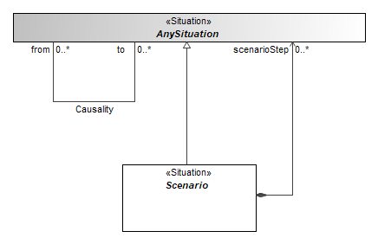
Figure 7.1 – Fundamental situation modeling principles
Complex scenarios can be built by inheriting from other scenarios and composing other situations as parts. Scenarios defined in libraries of this standard provide template scenarios from which to be inherited from. This way multilevel composite situations can be built.
- Situations are UML Classes, SysML Blocks.
- Scenario steps are captured using SysML parts - UML Properties with aggregation set to composite, and type set to sub-situation (which is UML Class, SysML Block); usually an association is also created for this property.
- Situation attribute values are captured using value properties - UML properties with type describing possible values (which is UML DataType, SysML ValueType) with the value specified in the defaultValue field.
When inheriting from library situations the properties of the user defined situations redefine or subset the properties of the library situation.
Note that user’s model can have additional properties (including sub situations, and attributes and other kinds of properties), beyond those defined in the library. However, from the viewpoint of this standard, they carry user-specific extensions and are not relevant.
Situation in the user model can be inherited from the situation in the standard library indirectly through intermediate situations. This can be used to capture generality/specificity between the real-world situations being described and introduce user-specific library extensions.
Creation and Displaying of situation and scenario models can be done in diagrams, usual for UML/SysML tools, e.g., Class or Block Definition and Composite Structure or Internal Block diagrams. This suits rather well for the safety and reliability domains, which are used to graphical information input such as Fault Tree Analysis and Reliability Block Diagrams.However, users of many safety and reliability domains such as FMEA, STPA or ISO26262 are accustomed to tabular information input. Therefore, the principles of how these models can be described in a tabular format are explained in section §7.3.2.
- Diagrammatic Situation Specification
Taking the operational situation TypicalAutomotiveSituation from ISO26262 library as an example, here is how the situation “Highway Driving Straight as Speed” would be defined in a diagram.
The ISO26262 library shown in (Figure 7.2) stipulates, that TypicalAutomotiveSituation is described by specifying trafficAndPeople, vehicleUsage, roadCondition, location, and environmentalCondition sub-situations and an Exposure attribute.
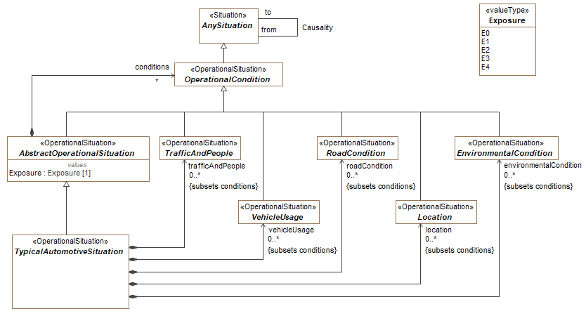
Figure 7.2 – Typical Automotive Situation definition in the ISO26262 Library
The “Highway Driving Straight at Speed” situation, in the user model (Figure 7.3) specifies, that Exposure level is E4 (chosen from the level enumeration defined in the library), trafficAndPeople is “Traffic Free Flow” (another situation defined by the user or coming from a library of operational conditions), the vehicleUsage is “Driving at Speed”, location is “City Roads” and “Highway” (two values), while roadCondition and environmentalCondition are left unspecified.
Note that:
- The scenario and sub-situations are inherited from the situations defined in the library.
- Exposure, which is a value attribute (i.e., an attribute, whose type is not a situation, but some data type instead a numeric or enumerated value) is specified by redefining a library attribute and specifying a default value.
- The trafficAndPeople and vehicleUsage attributes, which specify sub-situations, are redefining corresponding library attributes, and specifying a different type. The normal rules for UML attribute redefinition apply, i.e., redefined attribute type must be narrower that the parent attribute type.
- The roadCondition and environmentalCondition are not redefined, therefore they are left unspecified. The attributes type remains the maximally wide, library type (“RoadCondition” and “EnvironmentalCondition” library types).
- Two values are being specified for location attribute. Therefore, two attributes location1 and location2 are defined in the situation. These attributes are sub-setting the parent location attribute instead of redefining, as in case 3 above. Note that, according to UML rules, names of the sub-setting attributes are not regulated and therefore they can be anything. However, it is strongly recommended that the tool vendor adopt some intuitive, user-friendly naming scheme like parent_attribute_name+number.
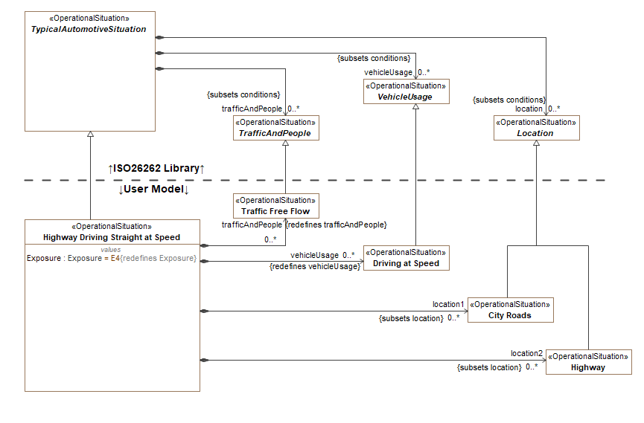
Figure 7.3 – User Model Defining Operational Situation “Highway Driving Straight at Speed”
- Tabular Situation Specification
The same TypicalAutomotiveSituation, defined by the ISO26262 library and again shown in Figure 7.2, can also define a table format for entering automotive situation user model data in a tabular format.
The table for specifying typical automotive situations comprises the main Name column for defining the situation itself, plus one column per each attribute. A table for typical automotive situations, as defined by TypicalAutomotiveSituation library situation class would then have columns for Exposure, vehicleUsage, trafficAndPeople, location, roadCondition, and environmentalCondition. The column’s name does not need to follow library attributes strictly. They can be beautified, for the sake of user-friendliness. It is important that when the user adds or edits rows in this table, the underlying model data must be created in accordance with the chapters above.
The table below (Table 7.1) shows the same “Highway Driving Straight as Speed” situation defined in tabular format as in the previous chapter. Therefore, the underlying UML model structures must be the same as those shown in diagrammatic format (
Figure 7.1).
Table 7.1 – Table for Specifying Operational Situations with Situation “Highway Driving Straight at Speed” Defined
# | Name | Exposure | Vehicle Usage | Traffic and People | Location | Road Condition | Environmental Condition
1 | Highway Driving Straight at Speed | E4 | Driving at Speed | Traffic Free Flow | Highway, City Roads
1.1 | Highway Driving Straight at Speed, Dangerous Conditions | E3 | Driving at Speed | Traffic Free Flow | Highway, City Roads | Wet,  Ice | Reduced Visibility

A typical safety and reliability domain such as ISO26262 will then use multiple tables, one for each of the structures defined in the library for that domain.
The tables can have additional columns, at the vendor’s discretion, for specifying additional data about the situation, being described in a row. An example of such data could be a description (realized by e.g., UML Comment) of the situation.
Sub-classing by using a generalization relationship between situations can be expressed in tabular format, using hierarchical indented text in table row. In the above table, the “Highway Driving Straight at Speed, Dangerous Conditions” situation is a subclass of the “Highway Driving Straight at Speed” situation. Therefore, a generalization relationship is created between the two in the model. Note that the more specific situation can narrow down the field types of the parent. In this example, the sub-classing situation provides additional data for road and environmental conditions by using attributes and redefining attributes from the library. Using UML redefinition overrides the parent exposure to E3. The vehicle use, traffic and people, and location settings are inherited from the parent and do not require additional model elements.
In case of multiple composition levels between the situations defined the in the library, it is possible to show multi-level composite situation data in a single table instead of the multiple interrelated tables by using hierarchical grouped column approach.
An example of using this hierarchical approach is shown for the main situation - HazardousEvent - in the library for ISO26262 standard (Figure 7.4):
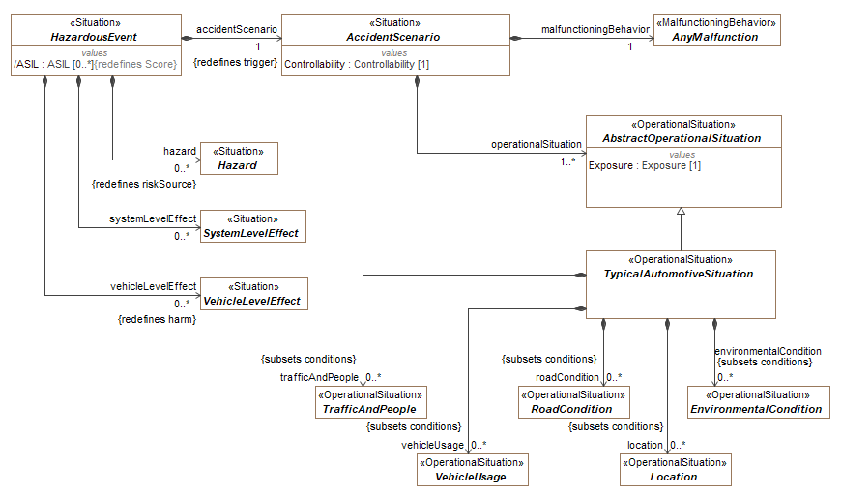
Figure 7.4 – HazardousEvent Definition in the ISO26262 Library
The HazardousEvent comprises sub-situations hazard, systemLevelEffect, vehicleLevelEffect which are elementary and an accidentScenario which is a composite sub-situation. AccidentScenario is composed of the elementary malfunctioningBehavior and operationalSituation. OperationalSituation is composed of a multitude of operational condition sub-situations vehicleUsage, trafficAndPeople, location, roadCondition, and environmentalCondition.
If tabular format is used for entering this information, there could be 3 simple tables:
- Table for operational situations, having columns for vehicleUsage, trafficAndPeople, location, roadCondition, and environmentalCondition.
- Table for accident scenarios, having columns for malfunctioningBehavior and operationalSituation.
- Table for hazardous events, having columns for hazard, systemLevelEffect, vehicleLevelEffect, and accidentScenario.
Alternatively, all this data can be entered in a single table, as shown in Table 7.2:
- Table for hazardous events, having columns for hazard, systemLevelEffect, vehicleLevelEffect, and an accidentScenario.
  - Accident scenario is a column group, comprising of columns malfunctioningBehavior and operationalSituation.
    - Operational situation is a column group comprising of columns vehicleUsage, trafficAndPeople, location, roadCondition, and environmentalCondition.

Table 7.2 – Hazardous Event Table with Grouped Columns
Name | Hazard | Accident Scenario |  |  |  |  |  |  |  | System Level Effect | Vehicle Level Effect
Name | Hazard | Malfunctioning Behavior | Operational Situation |  |  |  |  |  | Controllability | System Level Effect | Vehicle Level Effect
Name | Hazard | Malfunctioning Behavior | Vehicle Usage | Traffic and People | Location | Road Condition | Environmental Condition | Exposure | Controllability | System Level Effect | Vehicle Level Effect
Note – some columns (like ASIL level, or names of accident scenario, operational situation) have been skipped in the table for compactness reasons; in the actual tool that is not limited by page width they would be present.
- Diagram Legend (non-normative)
The section 9 is comprised of diagrams that represent elements from the RAAML 1.0 specification. The diagrams are color-coded to help the reader to understand the model easier. Please refer to the legend in Figure 8.1 to understand the diagrams.
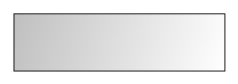 | Diagram shapes color-coded using gray color represent elements belonging to other packages than the one being specified in the current diagram.
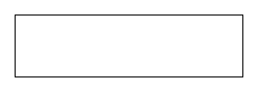 | Diagram shapes color-coded using white color represent elements belonging to packages that are being specified in the current diagram.
Figure 8.1 – Legend of color codes
An example in Figure 8.2 demonstrates how legends are used. Elements that belong to FTA (Fault Tree Analysis) library will be represented in white color in diagrams which belong to FTA method specification. Other elements like DysfunctionalEvent will be represented in gray since they belong to the General part of the specification.
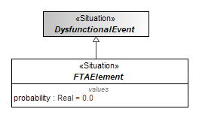
Figure 8.2 – An example of using a legend

This page intentionally left blank.

- Risk Analysis and Assessment Modeling Language (RAAML) Library and Profile
The RAAML library and profile imports the entire SysML profile. The use of this import is intended to provide more seamless integration with system modeling using SysML and to be able to fully leverage the capabilities of SysML.
- Core
The core concepts domain model is depicted in Figure 9.1. The submission team uses this domain model to derive the CoreLibrary and CoreProfile packages (specified in sections 9.1.1 and 9.1.2 respectively). The other libraries and profiles of the specification are based on the CoreLibrary and CoreProfile packages and contain elements and relationships representing concepts common across safety and reliability analysis methods.
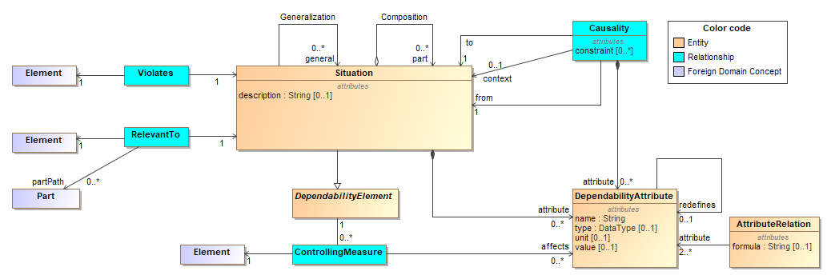
Figure 9.1 – Core concepts domain model
The central element in the core concepts domain model is the “Situation” concept. A situation occurrence is defined as a system being in a given place at given time and in a given state. For example, “Boeing 747 with S/N 12305 is being refueled at Gate 7 of Amsterdam Schiphol at 11:45 on Monday, 30th of July 2018.” An elementary situation is a classifier. It describes a set of situation occurrences of some type. The system, place, time, and state parameters are described by classifiers rather than individual descriptions.
When describing a situation, some of its parameters may be omitted if the situation does not need to be specific with respect to that parameter. For example:
- Fire in the engine compartment of the ship.
- Finger injury of the circular saw operator.
Different Situations can have generalization/specialization relationships between them. Generalization between two situations expresses the subset/superset relationship between the sets of occurrences that these situations represent. For example, “bone fracture” may be defined as a subtype of “Injury”.
Situations can have quantitative attributes, such as probability of occurrence. These are defined using the DependabilityAttribute class. Quantitative attributes can be related to each other and to attributes of the system by formulae using the AttributeRelation class. Formulae can be expressed in any language that the modeling tool can compute, including OCL and other executable languages. For example:
FMEAItem.RiskPriorityNumber = Cause.Occurrence × FailureMode.Detectability ×
Effect.Severity
Different Situations can be associated with each other using the Causality class, expressing semantic relationships between situations such as simple causality, conditional causality, and probabilistic connections. These relations may also have quantitative attributes, such as the probability of occurrence of the “to” situation if the “from” situation occurs. For example, a car in frequent contact with salt, causing safety-critical parts to corrode, which causes leaks in the brake line, causing the brakes to fail, causing a car accident, causing a passenger injury.
A non-elementary situation (the “Composition” relationship in Figure 9.1) is a concept encompassing multiple elementary situations: a single system or combination of several systems in a mutable layout, flowing in time through a sequence of states. The choice of whether to use a composite situation with parts described by subsituations, or to use a single situation, is at the discretion of the modeler. It depends on the modeler's needs, such as the depth of analysis required.
Situations can violate requirements, constraints defined/prescribed for the system, or other specifications describing how the system should operate. For example, a Situation where the system can-not detect glucose level violates the requirement that “the insulin pump must work for 1 week without the need to replace batteries”.
The RelevantTo relationship is used to link situations to system model elements to provide context and relevance for the Sitution. For example, in the aforementioned insulin pump, a Situation where the insulin pump cannot be charged would be related to the main battery element in the system model.
Situations can be mitigated, detected, and prevented via the ControllingMeasure. The use of this relationship introduces new safety requirements.
It was decided early on to reuse as many concepts from the SysML language as possible and only add concepts that are missing in SysML to address safety and reliability aspects of systems. This avoids duplication between two languages that will typically be used together. It also enables tool vendors to implement the new profile and library without requiring new tool capabilities, assuming SysML is supported. This leads to a very small library and profile on top of SysML/UML being sufficient to cover all core concepts. The core domain model is covered by SysML/UML concepts as shown in Table 1. The CoreLibrary package is specified in section 9.1.1. The CoreProfile package is shown in 9.1.2. The Core profile and library are used by all domain-specific methods in the specification.

Table 9.1 – Mapping of core concepts to the SysML/UML language
Core concept | SysML/UML concept
Situation | A specialization of a Block in SysML and a new stereotype «Situation »
DependabilityAttribute | SysML Value Property
AttributeRelation | SysML Constraint Block
Generalization | UML Generalization relationship
Composition | UML Composition relationship
Violates | A stereotyped UML dependency
RelevantTo | A stereotyped UML dependency
Causality | An association/connector combination
ControllingMeasure | A stereotyped UML dependency
- Core::Core Library

AnySituation
Package: Core Library
isAbstract: Yes
Applied Stereotype: «Situation»

Description
AnySituation is the universal root of all situations. All situations inherit from AnySituation. A situation describes a set of situation occurrences of some type. The system, place, time, and state parameters are described by classifiers rather than individual descriptions. A situation occurrence is a system being in a given place at given time and in a given state.
For example, “Boeing 747 with S/N 12305 is being refueled at Gate 7 of Amsterdam Schiphol at 11:45 on Monday, 30th of July 2018.”
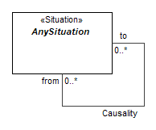
Figure 9.2 – AnySituation

Attributes
from : AnySituation[0..*] (member end of Causality association) | A situation which precedes the one at the other end of the Causality relationship.
to : AnySituation[0..*] (member end of Causality association) | A situation which follows the one at the other end of the Causality relationship.

Causality
Package: Core Library

Description
Universal root relationship between situations. All situation relationships inherit from this relationship. Identifies cause and effect relationship between two situations. Causality could be direct (non-conditional), conditional or probabilistic or any other inter-situation relationship, defined by the user. Multiple situations can cause one situation and vice versa - one situation can cause multiple other situations.
For example, a car in frequent contact with salt, causing safety-critical parts to corrode, which causes leaks in the brake line, causing the brakes to fail, causing a car accident, causing a passenger injury.
Figure 9.3 – Causality

Association ends
to : AnySituation[0..*] (member end of Causality association) | A situation which follows the one at the other end of the Causality relationship.
from : AnySituation[0..*] (member end of Causality association) | A situation which precedes the one at the other end of the Causality relationship.
- Core::Core Profile

Situation
Package: Core Profile
isAbstract: No
Generalization: Block
Extension: Class

Description
A situation is a SysML v1.6 Block. The situation reuses the following functionality from the Block concept: generalizations, parts, value properties, and Parametrics. The situation stereotype is only needed to distinguish situations from other types of blocks. See AnySituation for the definition of a situation concept.
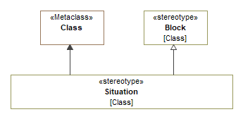
Figure 9.4 – Situation

RelevantTo
Package: Core Profile
isAbstract: No
Generalization: DirectedRelationshipPropertyPath
Extension: Dependency

Description
The RelevantTo relationship is used to link situations to system model elements to provide context and relevance for the Situation. For example, in an insulin pump, a Situation where the insulin pump cannot be charged would be related to the main battery element in the system model. The RelevantTo relationship reuses the following functionality from the DirectedRelationshipPropertyPath concept: targetContext and targetPropertyPath.
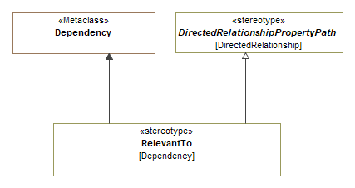
Figure 9.5 – RelevantTo

Constraints
[1] ClientIsSituation | -- client of the RelevantTo must be a Situation  Situation.allInstances().base_Class->includesAll(self.base_Dependency.client)

ControllingMeasure
Package: Core Profile
isAbstract: Yes
Generalization: DirectedRelationshipPropertyPath
Extension: Dependency

Description
A measure taken to address (mitigate severity, reduce probability of occurrence, increase probability of detection) a potential or real adverse situation.
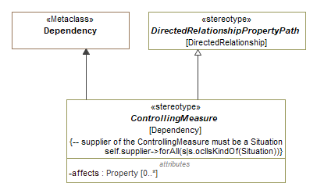
Figure 9.6 – ControllingMeasure

Attributes
affects : Property[0..*] | Indicates that this controlling measure influences (typically improves) a particular quantitative attribute of the situation.
Constraints
[1] SupplierIsSituation | -- supplier of the ControllingMeasure must be a Situation  Situation.allInstances().base_Class->includesAll(self.base_Dependency.supplier)

Violates
Package: Core Profile
isAbstract: No
Extension: Dependency

Description
The violates relationship indicates a situation where a system is violating a prescription (requirement, constraint, etc.). It is used to connect situations to requirements, design constraints and any other elements of system models which prescribe a characteristic of the system.
For example, a Situation where the insulin pump drains the battery in 3 days violates the requirement that “The system must work for 1 week without the need to replace batteries”.
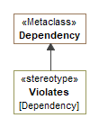
Figure 9.7 – Violates

Constraints
[1] ClientIsSituation | -- client of the Violates must be a Situation  Situation.allInstances().base_Class->includesAll(self.base_Dependency.client)

IDCarrier
Package: ISO 26262 Profile
isAbstract: No
Extension: Element

Description
Additional stereotype for carrying human-readable identification data.
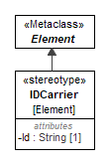
Figure 9.8 – IDCarrier

Attributes
Id : String[1] | Human readable identifier.
- General
The specification includes a general safety and reliability package that extends the core package. It defines common concepts that are used or extended in the method- and domain-specific reliability and safety packages. The package provides a model library, specified in section 9.2.1, and a profile, specified in section 9.2.2.
The general concepts contained in this package can be used as-is to model the safety and reliability related aspects of a system. However, the intended purposes of the package are as follows:
- Provide a common base for the method- and domain-specific reliability and safety modeling packages. The same concepts are used in a number of safety and reliability techniques (such as FMEA and FTA), so the role of this package is to prevent duplication of common concepts in other packages. This also enables movement of information between domains for cross-domain issues. This is particularly important as different domains may use the same concepts with different vocabulary. A common foundation provides a way to translate between these.
- Provide traceability links between safety and reliability artefacts across the system life cycle. For example, the failure modes defined during Hazard Analysis and Risk Assessment (HARA, defined in the ISO 26262 package) and in an FMEA could be traced and considered during an FTA.
- Provide a foundation on which additional methods, techniques and domains with safety and reliability concerns not currently included in the profile can be built by users. For example, a tool vendor could build an additional package for the railway domain by building on the general safety and reliability foundation. This both reduces effort to introduce an additional domain and allows additional domain packages to be compatible with the existing specification content.

- General::General Concepts Library

AbstractEvent
Package: General Concepts Library
isAbstract: Yes
Generalization: AnySituation
Applied Stereotype: «Situation»

Description
Anything that causes a change in a system under analysis or environment. Event has an identifiable starting point in time.

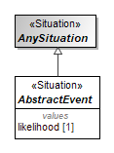
Figure 9.9 – AbstractEvent

Attributes
likelihood : [1] | A placeholder attribute for indicating likelihood of occurrence of an event. It is intentionally left without a type. Method developers can derive more specialized ways to characterize likelihood.

AbstractCause
Package: General Concepts Library
isAbstract: Yes
Generalization: AbstractEvent, Factor
Applied Stereotype: «Situation»

Description
An AbstractCause is a precursor event that activates other events. The AbstractCause is a root class for all kinds of causes; method developers should derive from it more specific kinds of causes with specific types for occurrence property. One case is demonstrated in the Cause element that redefines the occurrence property of the AbstractCause with the type Real.
See the diagram GeneralConceptsLibrary.
See also: fault association end of the Activation association.

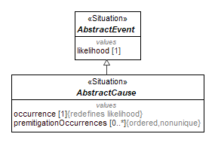
Figure 9.10 – AbstractCause

Attributes
occurrence : [1], redefines likelihood | A placeholder attribute without a type declared, for indicating how often this situation occurs. It is a redefinition of likelihood.
premitigationOccurrences : [0..*] | A placeholder attribute for indicating how often this situation occurred prior to mitigation. This property can have more than one value.

Cause
Package: General Concepts Library
isAbstract: Yes
Generalization: AbstractCause
Applied Stereotype: «Situation»

Description
A Cause is a specific implementation of AbstractCause that defines occurrence property with the type Real.
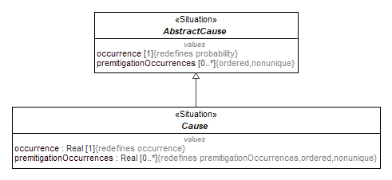
Figure 9.11 – Cause

Attributes
occurrence : Real[1], redefines occurrence | An attribute with the type Real, for indicating how often this situation occurs.
premitigationOccurrences : Real[0..*], redefines premitigationOccurrences | An attribute for indicating how often this situation occurred prior to mitigation. This property can have more than one value.

DysfunctionalEvent
Package: General Concepts Library
isAbstract: Yes
Generalization: AbstractEvent
Applied Stereotype: «Situation»

Description
An event whose occurrence can cause a dysfunctional behavior of a system or a part of the system.
The DysfunctionalEvent concept is a generalization of such concepts as failure, feared event, etc. that are considered in the domain-specific safety standards. It might be extended for introducing new safety and reliability methods and techniques.
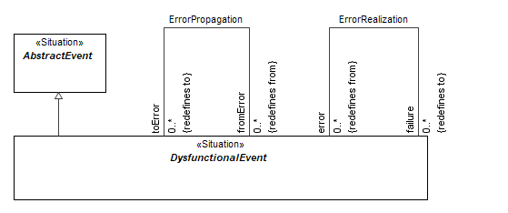
Figure 9.12 – DysfunctionalEvent

AbstractFailureMode
Package: General Concepts Library
isAbstract: Yes
Generalization: UndesiredState
Applied Stereotype: «FailureMode»

Description
The manner in which a system or part of a system (e.g., functions, components, hardware, software, hardware parts, software units), can fail (ISO 26262-1:2018, definition 3.51, modified).
The AbstractFailureMode is a root class for all failure modes; method developers should derive more specific kinds of failure modes with specific types for the detectability property. One case is demonstrated in the FailureMode element that redefines the detectability property of the AbstractFailureMode with the type Real.
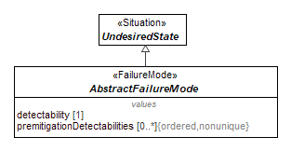
Figure 9.13 – AbstractFailureMode

Attributes
detectability : [1] | A placeholder attribute without a type declared, for indicating how easy it is to detect this failure mode.
premitigationDetectabilities : [0..*] | A placeholder attribute for indicating how easy it would have been to detect the situation with the previous design iteration. This property can have more than one value.

FailureMode
Package: General Concepts Library
isAbstract: Yes
Generalization: AbstractFailureMode
Applied Stereotype: «FailureMode»

Description
FailureMode is a specific implementation of AbstractFailureMode that defines the detectability property with the type Real.
A failure is an instance of a FailureMode.
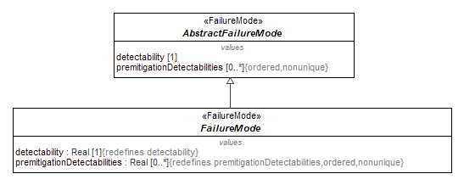
Figure 9.14 – FailureMode

Attributes
detectability : Real[1], redefines detectability | An attribute with the type Real, for indicating how easy it is to detect the situation.
premitigationDetectabilities : Real[0..*], redefines premitigationDetectabilities | An attribute for indicating how easy it would have been to detect the situation with the previous design iteration. This property can have more than one value.

AbstractEffect
Package: General Concepts Library
isAbstract: Yes
Generalization: DysfunctionalEvent
Applied Stereotype: «Situation»

Description
An AbstractEffect is a DysfunctionalEvent that is a result or a consequence of another Situation. The AbstractEffect is a root class for all effects; method developers should derive more specific kinds of effects with specific types for the severity property.
One case is demonstrated in the Effect element that redefines the severity property of the AbstractEffect with the type Real.
See the diagram GeneralConceptsLibrary.
See also: ErrorPropagation, ErrorRealization associations.
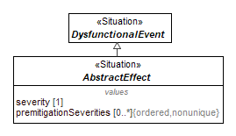
Figure 9.15 – AbstractEffect

Attributes
severity : [1] | A placeholder attribute without a type declared, for indicating the estimate of the extent of harm.
premitigationSeverities : [0..*] | A placeholder attribute for indicating the estimate of the extent of harm that would have resulted from the previous design iterations. This property can have more than one value.

Effect
Package: General Concepts Library
isAbstract: Yes
Generalization: AbstractEffect
Applied Stereotype: «Situation»

Description
An Effect is a specific implementation of AbstractEffect that defines the severity property with the type Real.
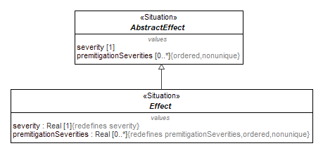
Figure 9.16 – Effect

Attributes
severity : Real[1], redefines severity | An attribute with the type Real, for indicating the estimate of the extent of harm.
premitigationSeverities : Real[0..*], redefines premitigationSeverities | An attribute for indicating the estimate of the extent of harm that would have resulted from the previous design iterations. This property stores more than one value.

Activation
Package: General Concepts Library
Generalization: Causality

Description
A causal relationship describing the propagation of the initial AbstractCause situation to the DysfunctionalEvent situation in the system.
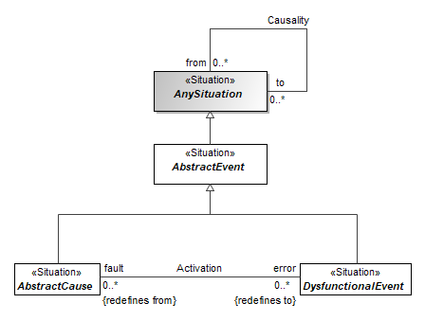
Figure 9.17 – Activation

Association ends
error : DysfunctionalEvent[0..*] (member end of Activation association, redefines to) | The dysfunctional situation (error) of the system.
fault : AbstractCause[0..*] (member end of Activation association, redefines from) | The causal fault.

ErrorPropagation
Package: General Concepts Library
Generalization: Causality

Description
A causal relationship describing the propagation of errors (one error leading to another) throughout the system.
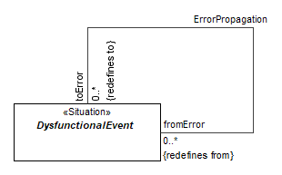
Figure 9.18 – ErrorPropagation

Association ends
toError : DysfunctionalEvent[0..*] (member end of ErrorPropagation association, redefines to) | The successor error.
fromError : DysfunctionalEvent[0..*] (member end of ErrorPropagation association, redefines from) | The predecessor error.

ErrorRealization
Package: General Concepts Library
Generalization: Causality

Description
A causal relationship describing the propagation of an error to a failure.
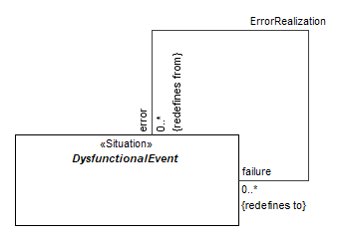
Figure 9.19 – ErrorRealization
Association ends
failure : DysfunctionalEvent[0..*] (member end of ErrorRealization association, redefines to) | The resulting failure.
error : DysfunctionalEvent[0..*] (member end of ErrorRealization association, redefines from) | The predecessor error.

HarmPotential
Package: General Concepts Library
isAbstract: Yes
Generalization: AnySituation
Applied Stereotype: «Situation»

Description
A state where there is the potential of harm. This includes all types of harm arising from malicious or non-malicious causes.
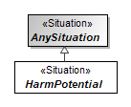
Figure 9.20 – HarmPotential

Hazard
Package: General Concepts Library
isAbstract: Yes
Generalization: HarmPotential
Applied Stereotype: «Situation»

Description
A potential source of harm (IEC 61508-4, 3.1.2). Source of harm is non-malicious.
The term includes danger to persons arising within a short time scale (for example, fire and explosion) and also those that have a long-term effect on a person’s health (for example, release of a toxic substance).
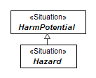
Figure 9.21 – Hazard

Scenario
Package: General Concepts Library
isAbstract: Yes
Generalization: AnySituation
Applied Stereotype: «Situation»

Description
A composite situation, consisting of multiple steps (that are themselves situations). Steps should have causal ordering, indicated by Causality relationships or sub-types thereof.
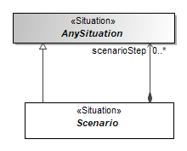
Figure 9.22 – Scenario

Attributes
scenarioStep : AnySituation[0..*] (member end of association) | A situation which is a part of a bigger situation - scenario.

AbstractRisk
Package: General Concepts Library
isAbstract: Yes
Generalization: Scenario
Applied Stereotype: «Situation»

Description
An AbstractRisk is a Scenario - combination of harm potential (Hazard or Vulnerability), triggering event (AbstractEvent), and resulting harm (AbstractEffect).
The AbstractRisk is a placeholder to enable modelers to specify methodology-specific kinds of risks.
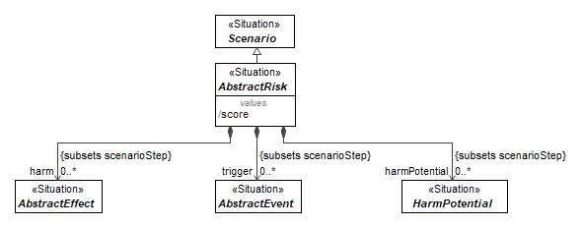
Figure 9.23 – AbstractRisk
Attributes
score : | Combination of the probability of occurrence of abstract event resulting from abstract harm and the severity of that harm (IEC 61508-4, 3.1.5, modified).  An example could be risk priority number (RPN) in FMEA analysis.
trigger : AbstractEvent[0..*] (member end of association, subsets scenarioStep) | Triggering event (AbstractEvent) which causes harm to materialize.
harm : AbstractEffect[0..*] (member end of association, subsets scenarioStep) | Resulting harm (AbstractEffect).
harmPotential : HarmPotential[0..*] (member end of association, subsets scenarioStep) | Pre-existing risk (HarmPotential).

UndesiredState
Package: General Concepts Library
isAbstract: Yes
Generalization: DysfunctionalEvent
Applied Stereotype: «Situation»

Description
An element's condition as a specific time which represents an unintended situation.
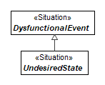
Figure 9.24 – UndesiredState

Limitation
Package: General Concepts Library
isAbstract: Yes
Generalization: Factor
Applied Stereotype: «Situation»
Description
A limiting condition; restrictive weakness; lack of capacity; inability or handicap.
Limitation is a restriction of Capability.
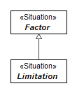
Figure 9.25 – Limitation

Loss
Package: General Concepts Library
isAbstract: Yes
Generalization: AbstractEffect
Applied Stereotype: «Situation»
Description
In STPA, is any effect that is unacceptable and should be prevented. Some factors such as environmental conditions may contribute to a loss but are outside our control. Examples for losses are:
- Loss of human life or injury
- Vehicle/property damage
- Mission loss (inadequate transportation)
- Loss of customer satisfaction
- Financial loss
- Loss of public image
- Environmental pollution
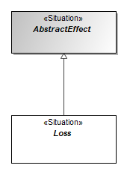
Figure 9.26 – Loss

Factor
Package: General Concepts Library
isAbstract: Yes
Generalization: AnySituation
Applied Stereotype: «Situation»
Description
A situation that contributes to a result or outcome
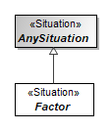
Figure 9.27 – Factor

- General::General Concepts Profile

FailureMode
Package: General Concepts Profile
isAbstract: No
Generalization: Situation
Extension: Class

Description
See FailureMode library class for the definition of a situation concept.
The FailureMode stereotype is only needed to distinguish FailureModes from other types of situations.
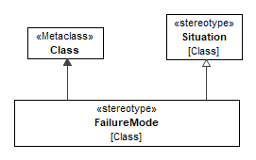
Figure 9.28 – FailureMode

Error
Package: General Concepts Profile
isAbstract: No
Generalization: Situation
Extension: Class

Description
The discrepancy between a computed, observed, or measured value or condition and the true, specified or theoretically correct value or condition. [IEC 61508-4, 3.6.11].
The Error stereotype is needed to distinguish this type of situations.
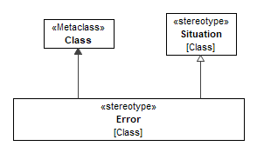
Figure 9.29 – Error

Fault
Package: General Concepts Profile
isAbstract: No
Generalization: Situation
Extension: Class

Description
Abnormal condition that may cause a reduction in, or loss of, the capability of a functional unit to perform a required function. [IEC 61508-4, 3.6.1].
Abnormal or undesired condition that can cause an element or a system to fail. [ISO 26262-1:2018, 3.54, modified]
The Fault stereotype is needed to distinguish this type of situations.
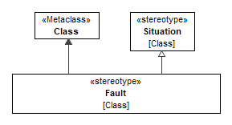
Figure 9.30 – Fault

Detection
Package: General Concepts Profile
isAbstract: No
Generalization: ControllingMeasure
Extension: Dependency

Description
A kind of ControllingMeasure taken to increase probability of detecting the situation under analysis. In hardware these measures may include built-in diagnostic tests, or physical inspection and manual tests.
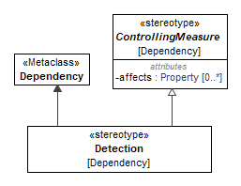
Figure 9.31 – Detection

Prevention
Package: General Concepts Profile
isAbstract: No
Generalization: ControllingMeasure
Extension: Dependency

Description
A kind of ControllingMeasure taken to reduce probability of occurrence of the situation under analysis.
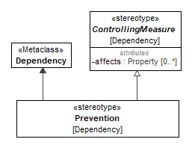
Figure 9.32 – Prevention

Mitigation
Package: General Concepts Profile
isAbstract: No
Generalization: ControllingMeasure
Extension: Dependency

Description
A kind of ControllingMeasure taken to reduce severity of the situation under analysis.
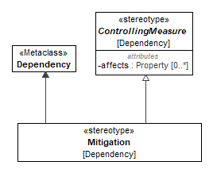
Figure 9.33 – Mitigation

Recommendation
Package: General Concepts Profile
isAbstract: No
Generalization: ControllingMeasure
Extension: Dependency

Description

Recommendation is used to connect the situation to an action item.
An action item is normally a Requirement, but it can be a less "strong" type of advice - comment, rationale, etc.
The requirement is further managed by the requirements management system - it can have responsible persons, due date, verification properties etc.
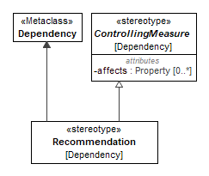
Figure 9.34 – Recommendation

FailureState
Package: General Concepts Profile
isAbstract: No
Extension: State

Description
State, which the system or a part of the system enters after occurrence of FailureMode (failure).
The Failure state concept might be used in various formal safety and reliability analysis methods based on the state machine notation. Failure states could be tied to FailureModes via the RelevantTo dependency.
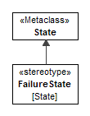
Figure 9.35 – FailureState

Undeveloped
Package: General Concepts Profile
isAbstract: No
Extension: Element

Description
Undeveloped stereotype is meant to identify incomplete concepts.
This stereotype can be applied in combination with Goal or Strategy stereotype to express the fact that the goal or strategy is not fully developed, and therefore may lack crucial details.
This stereotype can also be applied to basic event in fault trees to express the fact that it is not fully developed.

Hazard
Package: General Concepts Profile
isAbstract: No
Generalization: Situation
Extension: Class
Description
A marker stereotype for hazards (see the Hazard library element for definition).
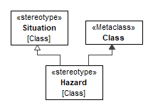
Figure 9.36 – Hazard

Item
Package: General Concepts Profile
isAbstract: Yes
Extension: Element
Description
An item defines a notional boundary for a risk analysis.
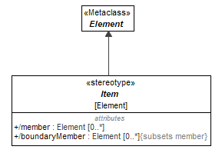
Figure 9.37 – Item

Attributes
member : Element[0..*] | Elements that are inside the boundary of an item.
boundaryMember : Element[0..*], subsets member | Elements that are on the boundary of an item. They act as interaction points between inside and outside of the item.

PresentIn
Package: General Concepts Profile
isAbstract: No
Generalization: RelevantTo
Extension: Dependency
Description
Declares that a specific situation (e.g. weakness, vulnerability) is persistent when the part/block is included in the system.
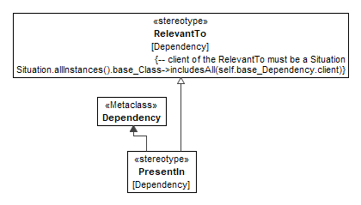
Figure 9.38 – PresentIn

SingleElementItem
Package: General Concepts Profile
isAbstract: No
Generalization: Item
Extension: Class
Description
An item that is defined by an individual block.
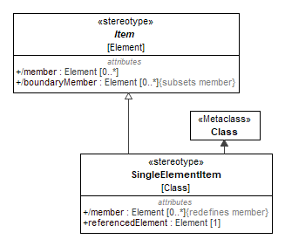
Figure 9.39 – SingleElementItem

Attributes
member : Element[0..*], redefines member | This is a redefinition of Item::member. When the item is defined by an individual block, this property collects features of this block.
referencedElement : Element[1] | A reference to a block defining the item.

ElementGroupBasedItem
Package: General Concepts Profile
isAbstract: No
Generalization: ElementGroup, Item
Extension: Comment
Description
An item that is defined by a set of elements using the SysML element goup mechanism.
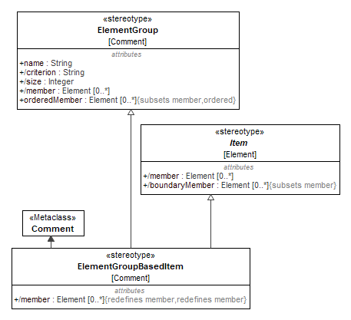
Figure 9.40 – ElementGroupBasedItem

Attributes
member : Element[0..*], redefines member, member | The members of the group are specified by SysML ElementGroup::member.

Assumption
Package: General Concepts Profile
isAbstract: No
Extension: Constraint

Description
Statements, principles and/or premises offered without proof. An evaluation process which may include one or more types of analysis and experience. [Source: ARP 4761A]
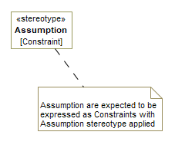
Figure 9.196 - Assumption

- General Security
- General Security::General Security Concepts Library

Threat
Package: General Security Concepts Library
isAbstract: Yes
Generalization: HarmPotential
Applied Stereotype: «Situation»
Description
A Threat is any circumstance or event (Situation in RAAML) with the potential to adversely impact Assets.
A Threat is the potential cause of unacceptable asset loss and the undesirable consequences or impact of such a loss.
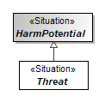
Figure 9.41 - Threat

Weakness
Package: General Security Concepts Library
isAbstract: No
Generalization: Limitation
Applied Stereotype: «Situation»
Description
A “weakness” is a condition under certain circumstances, could contribute to the introduction of Vulnerabilities.
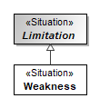
Figure 9.42 - Weakness

Vulnerability
Package: General Security Concepts Library
isAbstract: No
Generalization: Limitation
Applied Stereotype: «Situation»
Description
A Weakness that can be exploited or triggered by a SecurityActor to produce an undesirable behavior (DysfunctionalEvent).
Vulnerability can then be used as a (exploit)scenario step.
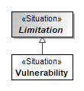
Figure 9.43 - Vulnerability
- General Security::General Security Concepts Profile

Threat
Package: General Security Concepts Profile
isAbstract: No
Generalization: Situation
Extension: Class
Description
A marker stereotype for Threat.
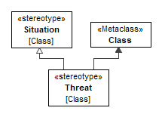
Figure 9.44 - Threat

Impacts
Package: General Security Concepts Profile
isAbstract: No
Generalization: RelevantTo
Extension: Dependency
Description
How a particular Situation affects the properties of an Asset.
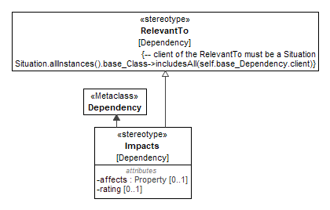
Figure 9.45 - Impacts
Attributes
affects : Property[0..1] | Indicates which aspect of the asset (e.g. financial, or operational etc.) is being impacted.
rating : [0..1] | Rating of the Impact on the Asset

Asset
Package: General Security Concepts Profile
isAbstract: No
Extension: Class
Description
An Asset represents anything that has value to a person or organization.

Asset can be contextualized by the Item.

For that, the recommended way is to create Asset-typed property in the appropriate Item.
Note: this only works for the Item flavors that are based on UML Class. If there are methodologies that have custom kinds of items, not based on UML Class, those methodologies need to specify their own mechanisms to contextualize the Asset
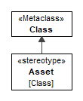
Figure 9.46 - Asset

Valuates
Package: General Security Concepts Profile
isAbstract: No
Generalization: DirectedRelationshipPropertyPath
Extension: Dependency
Description
Relationship connecting Asset description with the underlying system model element.
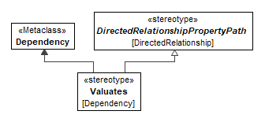
Figure 9.47 - Valuates

SecurityActor
Package: General Security Concepts Profile
isAbstract: No
Extension: Classifier
Description
A SecurityActor represents an entity that has the potential to affect a Risk - typically a threat actor.
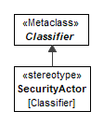
Figure 9.48 - SecurityActor

PresentedBy
Package: General Security Concepts Profile
isAbstract: No
Generalization: RelevantTo
Extension: Dependency
Description
Presentation/Initiation of a Situation by a SecurityActor.
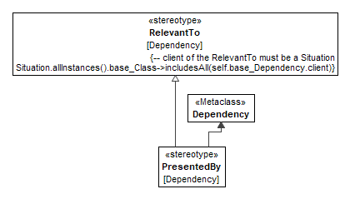
Figure 9.49 - PresentedBy

- Methods::FMEA
The Failure Mode and Effects Analysis (FMEA) is a method of inspecting a system to analyze potential failures. Therefore, as many components, assemblies, and subsystems as possible are examined in order to identify these failure modes in a system and their causes and effects.
- Methods::FMEA::FMEALibrary

AbstractFMEAItem
Package: FMEALibrary
isAbstract: Yes
Generalization: AbstractRisk
Applied Stereotype: «FMEAItem»

Description
An AbstractFMEAItem is a scenario (more specifically - AbstractRisk scenario) composed of a failure mode, (potentially multiple) cause(s) and effect(s). It stores assessed and mitigated risk priority numbers.
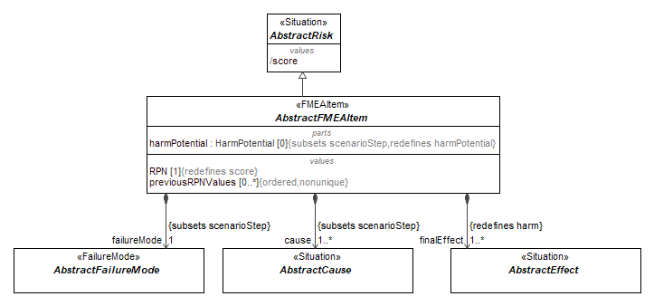
Figure 9.50 – AbstractFMEAItem

Attributes
RPN : [1], redefines score | The risk priority number ranks the risk of the FMEA item. It is a specialization of AbstractRisk::score.
failureMode : AbstractFailureMode[1] (member end of association, subsets scenarioStep) | Represents the failure mode which is reached if a system element fails.
cause : AbstractCause[1..*] (member end of association, subsets scenarioStep) | Represents the cause of the failure of a system element.
finalEffect : AbstractEffect[1..*] (member end of association, redefines harm) | Represents the effect which occurs on the system border.
previousRPNValues : [0..*] | Represents the assessed risk priority number before mitigating the risk of a failure.
harmPotential : HarmPotential[0] (member end of association, redefines harmPotential, subsets scenarioStep) | Pre-existing risk. Not used in FMEA method, therefore redefined in this library with multiplicity [0]

FMEAItem
Package: FMEALibrary
isAbstract: Yes
Generalization: AbstractFMEAItem
Applied Stereotype: «FMEAItem»

Description
A FMEAItem is a specialization of AbstractFMEAItem with the Real implementation of quantitative attributes.
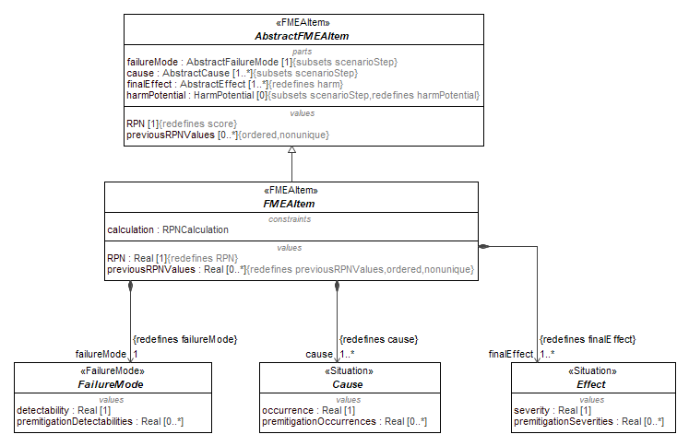
Figure 9.51 – FMEAItem

Attributes
finalEffect : Effect[1..*] (member end of association, redefines finalEffect) | The specialization of AbstractFMEAItem :: finalEffect with the implementation of Effect with Real severity.
cause : Cause[1..*] (member end of association, redefines cause) | The specialization of AbstractFMEAItem :: cause with the implementation of Cause with Real occurrence.
RPN : Real[1], redefines RPN | The specialization of AbstractFMEAItem :: RPN with the type Real.
failureMode : FailureMode[1] (member end of association, redefines failureMode) | The specialization of AbstractFMEAItem :: failureMode with the implementation of FailureMode with Real detectability.
calculation : RPNCalculation | Link to a formula for RPN calculation.
previousRPNValues : Real[0..*], redefines previousRPNValues | The specialization of AbstractFMEAItem :: previousRPNValues with the type Real.

RPNCalculation
Package: FMEALibrary
isAbstract: No
Applied Stereotype: «ConstraintBlock»

Description
A formula for RPN calculation. This implementation uses multiplication of Occurrence x Detectability x Severity to calculate RPN.

Attributes
RPN : | Risk priority number
SEV : | Severity
OCC : Real | Occurrence
DET : | Detectability

Constraints
[1] | Reduced priority number is calculated by simple multiplication of Severity, Detectability and Occurrence.

LossOfFunction
Package: FMEALibrary
isAbstract: Yes
Generalization: FailureMode
Applied Stereotype: «FailureMode»

Description
A failure mode representing loss of function e.g., the function is inoperable, or suddenly fails.
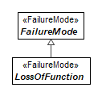
Figure 9.52 – LossOfFunction

DegradationOfFunction
Package: FMEALibrary
isAbstract: Yes
Generalization: FailureMode
Applied Stereotype: «FailureMode»

Description
A failure mode representing a degradation of function or loss of function over time.
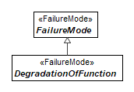
Figure 9.53 – DegradationOfFunction

IntermittentFunction
Package: FMEALibrary
isAbstract: Yes
Generalization: FailureMode
Applied Stereotype: «FailureMode»

Description
A failure mode representing an intermittent function or the random stops and starts of a function.
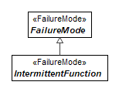
Figure 9.54 – IntermittentFunction

PartialFunction
Package: FMEALibrary
isAbstract: Yes
Generalization: FailureMode
Applied Stereotype: «FailureMode»

Description
A failure mode representing a partial function or loss of performance.
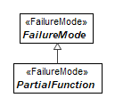
Figure 9.55 – PartialFunction

UnintendedFunction
Package: FMEALibrary
isAbstract: Yes
Generalization: FailureMode
Applied Stereotype: «FailureMode»

Description
A failure mode representing an unintended function, function operating at the wrong time, with unintended direction, or unequal performance.
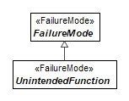
Figure 9.56 – UnintendedFunction

ExceedingFunction
Package: FMEALibrary
isAbstract: Yes
Generalization: FailureMode
Applied Stereotype: «FailureMode»

Description
A failure mode representing a function exceeding the acceptable operational performance.
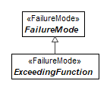
Figure 9.57 – ExceedingFunction

DelayedFunction
Package: FMEALibrary
isAbstract: Yes
Generalization: FailureMode
Applied Stereotype: «FailureMode»

Description
A failure mode representing a delayed function or function operating after an unintended time interval.
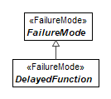
Figure 9.58 – DelayedFunction
- Methods::FMEA::FMEAProfile

FMEAItem
Package: FMEAProfile
isAbstract: No
Generalization: Block
Extension: Class

Description
See AbstractFMEAItem library class for the definition of a FMEA Item concept.
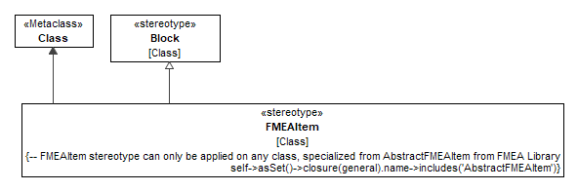
Figure 9.59 – FMEAItem

Constraints
[1] FMEAItemIsAbstractFMEAItem | -- FMEAItem stereotype can only be applied on any class, specialized from AbstractFMEAItem from FMEA Library  self.base_Class->asSet()->closure(general).name->includes('AbstractFMEAItem')
- Methods::FTA
Fault Tree Analysis (FTA) is a top-down failure analysis in which an undesired state of a system is analyzed using Boolean logic to combine a series of lower-level (basic) events. This analysis method is used to understand how systems can fail, to identify the best ways to reduce risk and to determine event rates of a safety accident or a functional failure.
The FTA package contains all required elements to implement this analysis. Support for Fault Tree Analysis (FTA) modeling is based on the IEC 61025:2006 standard. Using this standard ensures that the specification offers a form of FTA that is based on best practices and accepted by practitioners. It is also possible for a user to extend the capabilities of the FTA package to enable, for example, dynamic fault tree analysis and component fault tree modeling while still remaining compatible with other information modeled using the specification.
In order to combine FMEA and FTA analysis, a connection between a failure mode and a fault tree event needs to be made. Therefore, the Cause of an FMEAItem can be interpreted as the event which leads to a failure of a system item. By combining FMEAs and FTAs, both analyses can be used to verify the analysis results. This may lead to a better understanding of the behavior of a system during erroneous behavior.
- Methods::FTA::FTALibrary

FTAElement
Package: FTALibrary
isAbstract: Yes
Generalization: DysfunctionalEvent
Applied Stereotype: «Situation»

Description
Any of the Events and Gates needed for the evaluation of the TopEvent probability.

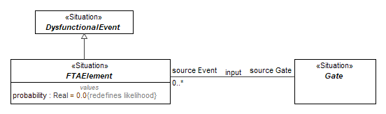
Figure 9.60 – FTAElement

Attributes
probability : Real, redefines likelihood | The probability that the event represented by the owning FTA element occurs. Probability is a Real value between 0 and 1.
source Gate : Gate (member end of input association)

FTATree
Package: FTALibrary
isAbstract: No
Generalization: FTAElement, Scenario
Applied Stereotype: «Tree»

Description
A collection of FTAElements and their interrelationships for the evaluation of the top event probability.
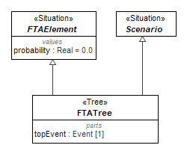
Figure 9.61 – FTATree

Attributes
topEvent : Event[1] (member end of association) | Undesired event which lead to the failure of the system.

Methods::FTA::FTALibrary::Events
Package of events for building fault trees.

Event
Package: Events
isAbstract: Yes
Generalization: FTAElement
Applied Stereotype: «Situation»

Description
The Event is a base class for all types of fault tree events. It is a kind of DysfunctionalEvent.

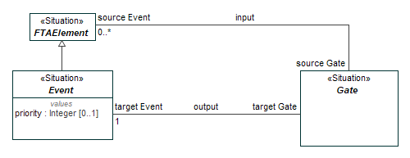
Figure 9.62 – Event

Attributes
priority : Integer[0..1] | The priority field is only used to indicate the order of this event when multiple events are inputs of Priority AND (SEQ) gate.
target Gate : Gate (member end of output association)

BasicEvent
Package: Events
isAbstract: No
Generalization: Event
Applied Stereotype: «BasicEvent»

Description
A basic initiating failure requiring no further development.
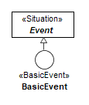
Figure 9.63 – BasicEvent

IntermediateEvent
Package: Events
isAbstract: No
Generalization: Event
Applied Stereotype: «IntermediateEvent»

Description
An intermediate event is a failure which occurs because of one or more antecedent events acting through logic gates.
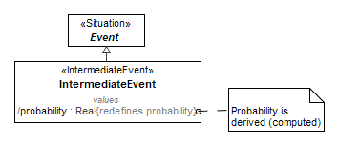
Figure 9.64 – IntermediateEvent

Attributes
probability : Real, redefines probability | Probability of the intermediate event is derived. It is calculated by the gate from the probabilities of the more basic events.

TopEvent
Package: Events
isAbstract: No
Generalization: Event
Applied Stereotype: «TopEvent»

Description
Undesired event - failure or effect - at the top of the fault tree.
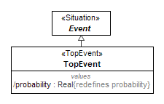
Figure 9.65 – TopEvent

Attributes
probability : Real, redefines probability | The (derived) probability of the top event is the result of the fault tree calculation.

ConditionalEvent
Package: Events
isAbstract: No
Generalization: Event
Applied Stereotype: «ConditionalEvent»

Description
Specific conditions or restrictions that apply to any logic gate (used primarily with PRIORITY AND and INHIBIT gates).
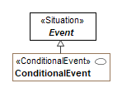
Figure 9.66 – ConditionalEvent

DormantEvent
Package: Events
isAbstract: No
Generalization: Event
Applied Stereotype: «DormantEvent»

Description
The dormant event is similar to BasicEvent but indicates the latent failure which is discovered by periodical tests.
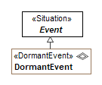
Figure 9.67 – DormantEvent

UndevelopedEvent
Package: Events
isAbstract: No
Generalization: Event
Applied Stereotype: «BasicEvent», «Undeveloped»

Description
An event which is not further developed either because it is of insufficient consequence or because information is unavailable.
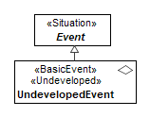
Figure 9.68 – UndevelopedEvent

HouseEvent
Package: Events
isAbstract: No
Generalization: Event
Applied Stereotype: «HouseEvent»

Description
An event which can be set to occur or not occur.
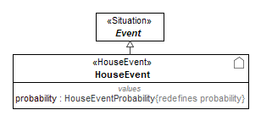
Figure 9.69 – HouseEvent

Attributes
probability : HouseEventProbability, redefines probability | Probability of the house event is 0 or 1. It is set before doing a fault tree evaluation.

ZeroEvent
Package: Events
isAbstract: No
Generalization: Event
Applied Stereotype: «ZeroEvent»

Description
An event which represents a condition or an event that will never occur.
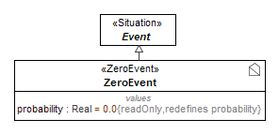
Figure 9.70 – ZeroEvent

Attributes
probability : Real, redefines probability | The probability of zero event is always 0.

Methods::FTA::FTALibrary::Gates
Package of logical conditions for building fault trees.

Gate
Package: Gates
isAbstract: Yes
Applied Stereotype: «Situation»

Description
An FTAElement that combines input Event probabilities in a prescribed manner to determine output Event probability. The output event occurs if the combination of input events is satisfied. The gate subtypes specify the necessary combination.

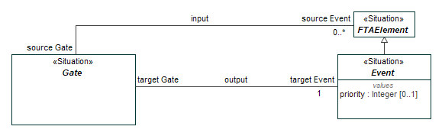
Figure 9.71 – Gate

Attributes
source Event : Event[0..*] (member end of input association)
target Event : Event[1] (member end of output association)

AND
Package: Gates
isAbstract: No
Generalization: Gate
Applied Stereotype: «Block», «AND»

Description
The output event occurs only if all input events occur.
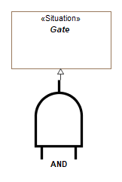
Figure 9.72 – AND

OR
Package: Gates
isAbstract: No
Generalization: Gate
Applied Stereotype: «Block», «OR»

Description
The output event occurs if at least one of input event occurs.
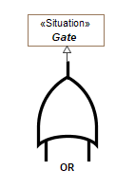
Figure 9.73 – OR

NOT
Package: Gates
isAbstract: No
Generalization: Gate
Applied Stereotype: «Block», «NOT»

Description
The output event occurs if the input event does not occur.
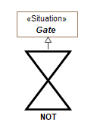
Figure 9.74 – NOT

XOR
Package: Gates
isAbstract: No
Generalization: Gate
Applied Stereotype: «Block», «XOR»

Description
The output event occurs if exactly one of the input events occurs.
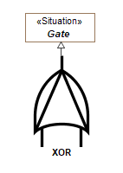
Figure 9.75 – XOR

SEQ
Package: Gates
isAbstract: No
Generalization: Gate
Applied Stereotype: «Block», «SEQ»

Description
The output event occurs if all the input events occur in a specific sequence.
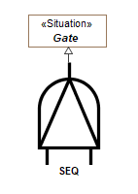
Figure 9.76 – SEQ

INHIBIT
Package: Gates
isAbstract: No
Generalization: Gate
Applied Stereotype: «INHIBIT», «Block»

Description
The output event occurs if the (single) input event occurs in the presence of an enabling condition.

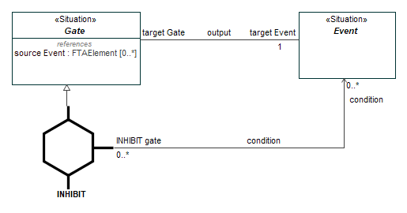
Figure 9.77 – INHIBIT

Attributes
condition : Event[0..*] (member end of condition association)

MAJORITY_VOTE
Package: Gates
isAbstract: No
Generalization: Gate
Applied Stereotype: «Block», «MAJORITY_VOTE»

Description
The output event occurs if the majority of the input events occurs. It has a threshold parameter m.
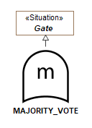
Figure 9.78 – MAJORITY_VOTE

Attributes
m : Integer | The m parameter defines the number of input events that form a majority. It is not necessarily ceil(number_of_inputs / 2). It is possible to stipulate that e.g., 5 (or 2) input events have to occur out of total of 7 events for majority gate to fire.

Methods::FTA::FTALibrary::Gates::ConstraintBlocks
Reference implementation for the FTA gates.

ANDConstraintBlock
Package: ConstraintBlocks
isAbstract: No
Applied Stereotype: «ConstraintBlock»

Description
Reference implementation for the AND gate.

Attributes
output :
input : [0..*]

Constraints
[1] | Probability of AND node is simply a multiplication of probabilities of incoming nodes.  Note - this simplistic calculation assumes that incoming node events are mutually independent.

ORConstraintBlock
Package: ConstraintBlocks
isAbstract: No
Applied Stereotype: «ConstraintBlock»
Description
Reference implementation for the OR gate.

Attributes
output :
input : [0..*]

Constraints
[1] | Probability of OR node is calculated as opposite probability of the event where neither of the input events happen.  This follows De Morgan's theorem - OR(input1, input2, input3...) is equal to NOT AND (NOT input1, NOT input2, NOT input3...).  Note - this simplistic calculation assumes that incoming node events are mutually independent.

SEQConstraintBlock
Package: ConstraintBlocks
isAbstract: No
Applied Stereotype: «ConstraintBlock»

Description
Reference implementation for the SEQ gate.

Attributes
output :
input : Real[0..*]

Constraints
[1] | Probability of SEQ node is calculated the same way as AND node - it is simply a multiplication of probabilities of incoming nodes.  This simplistinc calculation cannot capture time-dependency of the events; only more complex simulations can estimate this probability.

XORConstraintBlock
Package: ConstraintBlocks
isAbstract: No
Applied Stereotype: «ConstraintBlock»

Description
Reference implementation for the XOR gate.

Attributes
output :
input : [0..*]

Constraints
[1] | In case of two inputs, XOR probability is calculated by ORing of two event combintation probabilities -  probability that first event happened and second did not ORed with probability that second event happened while first did not.  Input1 XOR Input2 = Input1 AND NOT Input2 OR Input2 AND NOT Input1  Since combinations are mutually exclusive, simple (+) operation can be used for ORing them. Therefore  Input1 XOR Input2 = Input1 AND NOT Input2 + Input2 AND NOT Input1  Further expanding ANDs and NOTs using their corresponding formulas, we get  Input1 XOR Input2 = Input1*(1 - Input2) + Input2*(1 - Input1) = Input1 + Input2 - 2 * Input1 * Input2  This formula can be iteratively applied for the case with number of inputs greater than two.  Note - this simplistic calculation assumes that incoming node events are mutually independent.

INHIBITConstraintBlock
Package: ConstraintBlocks
isAbstract: No
Applied Stereotype: «ConstraintBlock»

Description
Reference implementation for the INHIBIT gate.

Attributes
output :
input : [0..*]
condition : Real

Constraints
[1] | Probability of INHIBIT node is calculated the same way as AND node - it is simply a multiplication of probabilities of input nodes and condition nodes.  Note - this simplistic calculation assumes that incoming node events and conditions are mutually independent.

MAJORITY_VOTEConstraintBlock
Package: ConstraintBlocks
isAbstract: No
Applied Stereotype: «ConstraintBlock»

Description
Reference implementation for the MAJORITY_VOTE gate.

Attributes
output :
input : [0..*]
m :

Constraints
[1] | Majority Vote probability can be calculated by iteratively examining all the combinations of input events, taking those combinations that satisfy the condition that at least m input events happen, then calculating probability of each combination using AND formula (multiplying all individual event probabilities in that combination) and then calculating cumulative probability of all combinations by ORing them.  Note - this simplistic calculation assumes that incoming node events are mutually independent.

NOTConstraintBlock
Package: ConstraintBlocks
isAbstract: No
Applied Stereotype: «ConstraintBlock»

Description
Reference implementation for the NOT gate.

Attributes
output :
input : [1]

Constraints
[1] | Probability of NOT node is calculated as probability of the event opposite to the input event.  Thereby it is unity minus probability of input event.
- Methods::FTA::FTAProfile

Tree
Package: FTAProfile
isAbstract: No
Generalization: Situation
Extension: Class

Description
A marker stereotype for fault trees. See FTATree library class for definition.
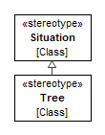
Figure 9.79 – Tree

Constraints
[1] TreeIsFTATree | -- Tree stereotype can only be applied on any class specialized from FTATree from FTA Library  self.base_Class->asSet()->closure(general).name->includes('FTATree')

Gate
Package: FTAProfile
isAbstract: Yes
Extension: Class, Property

Description
A marker stereotype for fault tree gates. See Gate library class for definition.

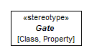
Figure 9.80 – Gate

Event
Package: FTAProfile
isAbstract: Yes
Extension: Class, Property

Description

A marker stereotype for fault tree events. See Event library class for definition.
If the Event stereotype is applied to a class, then that class also must have the Situation stereotype (or its descendants) applied.

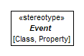
Figure 9.81 – Event

DormantEvent
Package: FTAProfile
isAbstract: No
Generalization: Event
Extension: Class, Property

Description
A marker stereotype, carrying icon for dormant events. See DormantEvent library class for definition.

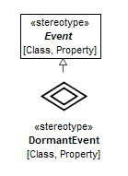
Figure 9.82 – DormantEvent

Constraints
[1] DormantEventIsDormantEvent | if not self.base_Class->isEmpty() then  --DormantEvent stereotype can only be applied on any class specialized from DormantEvent from FTA Library  self.base_Class->asSet()->closure(general).name->includes('DormantEvent')  else  --DormantEvent stereotype can only be applied on any property whose type is specialized from DormantEvent from FTA Library  self.base_Property.type->asSet()->closure(general).name->includes('DormantEvent')  endif

BasicEvent
Package: FTAProfile
isAbstract: No
Generalization: Event
Extension: Class, Property

Description
A marker stereotype, carrying icon for basic events. See BasicEvent library class for definition.

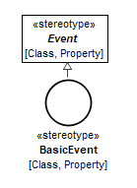
Figure 9.83 – BasicEvent

Constraints
[1] BasicEventIsBasicEvent | if not self.base_Class->isEmpty() then  --BasicEvent stereotype can only be applied on any class specialized from BasicEvent from FTA Library  self.base_Class->asSet()->closure(general).name->includes('BasicEvent')  else  --BasicEvent stereotype can only be applied on any property whose type is specialized from BasicEvent from FTA Library  self.base_Property.type->asSet()->closure(general).name->includes('BasicEvent')  endif
[2] UndevelopedEventIsUndevelopedEvent | --BasicEvent + Undeveloped stereotype combination can be applied on any class specialized from UndevelopedEvent from FTA Library  Undeveloped.allInstances().base_Element->includesAll(self.base_Class)  implies  self.base_Class->asSet()->closure(general).name->includes('UndevelopedEvent')

ConditionalEvent
Package: FTAProfile
isAbstract: No
Generalization: Event
Extension: Class, Property

Description
A marker stereotype, carrying icon for conditional events. See ConditionalEvent library class for definition.

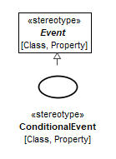
Figure 9.84 – ConditionalEvent

Constraints
[1] ConditionalEventIsConditionalEvent | if not self.base_Class->isEmpty() then  --ConditionalEvent stereotype can only be applied on any class specialized from ConditionalEvent from FTA Library  self.base_Class->asSet()->closure(general).name->includes('ConditionalEvent')  else  --ConditionalEvent stereotype can only be applied on any property whose type is specialized from ConditionalEvent from FTA Library  self.base_Property.type->asSet()->closure(general).name->includes('ConditionalEvent')  endif

ZeroEvent
Package: FTAProfile
isAbstract: No
Generalization: Event
Extension: Class, Property

Description
A marker stereotype, carrying icon for zero events. See ZeroEvent library class for definition.

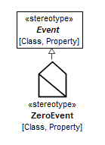
Figure 9.85 – ZeroEvent

Constraints
[1] ZeroEventIsZeroEvent | if not self.base_Class->isEmpty() then  --ZeroEvent stereotype can only be applied on any class specialized from ZeroEvent from FTA Library  self.base_Class->asSet()->closure(general).name->includes('ZeroEvent')  else  --ZeroEvent stereotype can only be applied on any property whose type is specialized from ZeroEvent from FTA Library  self.base_Property.type->asSet()->closure(general).name->includes('ZeroEvent')  endif

HouseEvent
Package: FTAProfile
isAbstract: No
Generalization: Event
Extension: Class, Property

Description
A marker stereotype, carrying icon for house events. See HouseEvent library class for definition.

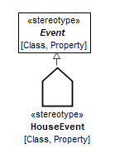
Figure 9.86 – HouseEvent

Constraints
[1] HouseEventIsHouseEvent | if not self.base_Class->isEmpty() then  --HouseEvent stereotype can only be applied on any class specialized from HouseEvent from FTA Library  self.base_Class->asSet()->closure(general).name->includes('HouseEvent')  else  --HouseEvent stereotype can only be applied on any property whose type is specialized from HouseEvent from FTA Library  self.base_Property.type->asSet()->closure(general).name->includes('HouseEvent')  endif

AND
Package: FTAProfile
isAbstract: No
Generalization: Gate
Extension: Class, Property

Description
A marker stereotype, carrying icon for AND gates. See AND library class for definition.

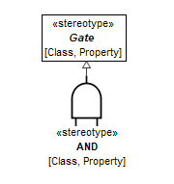
Figure 9.87 – AND

Constraints
[1] ANDIsAND | if not self.base_Class->isEmpty() then  --AND stereotype can only be applied on any class specialized from AND gate from FTA Library  self.base_Class->asSet()->closure(general).name->includes('AND')  else  --AND stereotype can only be applied on any property whose type is specialized from AND from FTA Library  self.base_Property.type->asSet()->closure(general).name->includes('AND')  endif

OR
Package: FTAProfile
isAbstract: No
Generalization: Gate
Extension: Class, Property

Description
A marker stereotype, carrying icon for OR gates. See OR library class for definition.

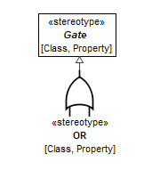
Figure 9.88 – OR

Constraints
[1] ORIsOR | if not self.base_Class->isEmpty() then  --OR stereotype can only be applied on any class specialized from OR gate from FTA Library  self.base_Class->asSet()->closure(general).name->includes('OR')  else  --OR stereotype can only be applied on any property whose type is specialized from OR from FTA Library  self.base_Property.type->asSet()->closure(general).name->includes('OR')  endif

SEQ
Package: FTAProfile
isAbstract: No
Generalization: Gate
Extension: Class, Property

Description
A marker stereotype, carrying icon for SEQ gates. See SEQ library class for definition.

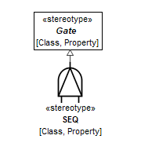
Figure 9.89 – SEQ

Constraints
[1] SEQIsSEQ | if not self.base_Class->isEmpty() then  --SEQ stereotype can only be applied on any class specialized from SEQ gate from FTA Library  self.base_Class->asSet()->closure(general).name->includes('SEQ')  else  --SEQ stereotype can only be applied on any property whose type is specialized from SEQ from FTA Library  self.base_Property.type->asSet()->closure(general).name->includes('SEQ')  endif

XOR
Package: FTAProfile
isAbstract: No
Generalization: Gate
Extension: Class, Property

Description
A marker stereotype, carrying icon for XOR gates. See XOR library class for definition.

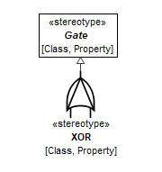
Figure 9.90 – XOR

Constraints
[1] XORIsXOR | if not self.base_Class->isEmpty() then  --XOR stereotype can only be applied on any class specialized from XOR gate from FTA Library  self.base_Class->asSet()->closure(general).name->includes('XOR')  else  --XOR stereotype can only be applied on any property whose type is specialized from XOR from FTA Library  self.base_Property.type->asSet()->closure(general).name->includes('XOR')  endif

INHIBIT
Package: FTAProfile
isAbstract: No
Generalization: Gate
Extension: Class, Property

Description
A marker stereotype, carrying icon for INHIBIT gates. See INHIBIT library class for definition.

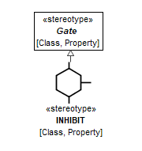
Figure 9.91 – INHIBIT

Constraints
[1] INHIBITIsINHIBIT | if not self.base_Class->isEmpty() then  --INHIBIT stereotype can only be applied on any class specialized from INHIBIT gate from FTA Library  self.base_Class->asSet()->closure(general).name->includes('INHIBIT')  else  --INHIBIT stereotype can only be applied on any property whose type is specialized from INHIBIT from FTA Library  self.base_Property.type->asSet()->closure(general).name->includes('INHIBIT')  endif

MAJORITY_VOTE
Package: FTAProfile
isAbstract: No
Generalization: Gate
Extension: Class, Property

Description
A marker stereotype, carrying icon for MAJORITY_VOTE gates. See MAJORITY_VOTE library class for definition.

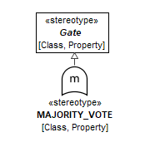
Figure 9.92 – MAJORITY_VOTE

Constraints
[1] MAJORITY_VOTEIsMAJORITY_VOTE | if not self.base_Class->isEmpty() then  --MAJORITY_VOTE stereotype can only be applied on any class specialized from MAJORITY_VOTE gate from FTA Library  self.base_Class->asSet()->closure(general).name->includes('MAJORITY_VOTE')  else  --MAJORITY_VOTE stereotype can only be applied on any property whose type is specialized from MAJORITY_VOTE from FTA Library  self.base_Property.type->asSet()->closure(general).name->includes('MAJORITY_VOTE')  endif

NOT
Package: FTAProfile
isAbstract: No
Generalization: Gate
Extension: Class, Property
Description
A marker stereotype, carrying icon for NOT gates. See NOT library class for definition.

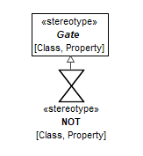
Figure 9.93 – NOT

Constraints
[1] NOTIsNOT | if not self.base_Class->isEmpty() then  --NOT stereotype can only be applied on any class specialized from NOT gate from FTA Library  self.base_Class->asSet()->closure(general).name->includes('NOT')  else  --NOT stereotype can only be applied on any property whose type is specialized from NOT from FTA Library  self.base_Property.type->asSet()->closure(general).name->includes('NOT')  endif

IntermediateEvent
Package: FTAProfile
isAbstract: No
Generalization: Event
Extension: Class, Property

Description
A marker stereotype, carrying icon for intermediate events. See IntermediateEvent library class for definition.

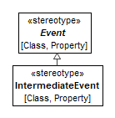
Figure 9.94 – IntermediateEvent

Constraints
[1] IntermediateEventIsIntermediateEvent | if not self.base_Class->isEmpty() then  --IntermediateEvent stereotype can only be applied on any class specialized from IntermediateEvent from FTA Library  self.base_Class->asSet()->closure(general).name->includes('IntermediateEvent')  else  --IntermediateEvent stereotype can only be applied on any property whose type is specialized from IntermediateEvent from FTA Library  self.base_Property.type->asSet()->closure(general).name->includes('IntermediateEvent')  endif

TopEvent
Package: FTAProfile
isAbstract: No
Generalization: Event
Extension: Class, Property

Description
A marker stereotype, carrying icon for top events. See TopEvent library class for definition.

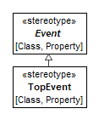
Figure 9.95 – TopEvent

Constraints
[1] TopEventIsTopEvent | if not self.base_Class->isEmpty() then  --TopEvent stereotype can only be applied on any class specialized from TopEvent from FTA Library  self.base_Class->asSet()->closure(general).name->includes('TopEvent')  else  --TopEvent stereotype can only be applied on any property whose type is specialized from TopEvent from FTA Library  self.base_Property.type->asSet()->closure(general).name->includes('TopEvent')  endif

TransferIn
Package: FTAProfile
isAbstract: No
Extension: Property

Description
The node of the current fault tree that indicates that the tree is developed further as a separate fault tree - TransferOut.
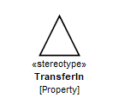
Figure 9.96 – TransferIn

Constraints
[1] TypeIsTransferOut | -- type of TransferIn property must be TransferOut FTA Tree  TransferOut.allInstances().base_Class->includesAll(self.base_Property.type)

TransferOut
Package: FTAProfile
isAbstract: No
Generalization: Tree
Extension: Class

Description
A marker stereotype for partial fault trees. It indicates that this tree is used as a part of another fault tree through TransferIn. The computed probability of the top event of the TransferOut tree is used as a probability of the TransferIn node.
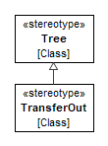
Figure 9.97 – TransferOut
- Methods::STPA
The System Theoretical Process Analysis (STPA) is a hazard analysis technique based on control and system theory. In comparison, most existing hazard analysis techniques are based on reliability theory. In STPA, however, the easy goals are pursued as in any hazard analysis, i.e., collecting information on how hazards may occur. For further information on this approach the handbook describes the method and show the application.
- Methods::STPA::STPA Library

OutOfSequence
Package: STPA Library
isAbstract: Yes
Generalization: UndesiredControlAction
Applied Stereotype: «UndesiredControlAction»

Description
STPA Guideword, describing kind of control.
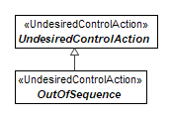
Figure 9.98 – OutOfSequence

Late
Package: STPA Library
isAbstract: Yes
Generalization: UndesiredControlAction
Applied Stereotype: «UndesiredControlAction»

Description
STPA Guideword, describing kind of control.
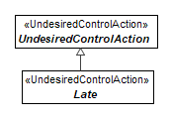
Figure 9.99 – Late

Early
Package: STPA Library
isAbstract: Yes
Generalization: UndesiredControlAction
Applied Stereotype: «UndesiredControlAction»

Description
STPA Guideword, describing kind of control.
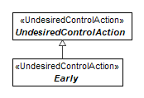
Figure 9.100 – Early

TooLong
Package: STPA Library
isAbstract: Yes
Generalization: UndesiredControlAction
Applied Stereotype: «UndesiredControlAction»

Description
STPA Guideword, describing kind of control.

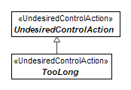
Figure 9.101 – TooLong

TooShort
Package: STPA Library
isAbstract: Yes
Generalization: UndesiredControlAction
Applied Stereotype: «UndesiredControlAction»

Description
STPA Guideword, describing kind of control.
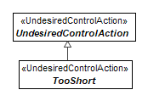
Figure 9.102 – TooShort

Provided
Package: STPA Library
isAbstract: Yes
Generalization: UndesiredControlAction
Applied Stereotype: «UndesiredControlAction»

Description
STPA Guideword, describing a kind of control.
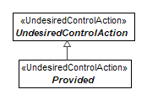
Figure 9.103 – Provided

NotProvided
Package: STPA Library
isAbstract: Yes
Generalization: UndesiredControlAction
Applied Stereotype: «UndesiredControlAction»

Description
STPA Guideword, describing kind of control.
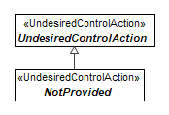
Figure 9.104 – NotProvided

LossScenario
Package: STPA Library
isAbstract: Yes
Generalization: Scenario

Applied Stereotype: «LossScenario

Description
A sequence of situations starting from causalFactors, that (through Process Model deficiencies) leads to an UndesiredControlAction (which further leads to risks and possibly losses).

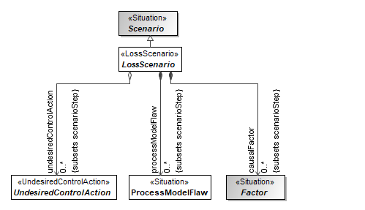
Figure 9.105 – LossScenario

Attributes
causalFactor : Factor[0..*] (member end of association, subsets scenarioStep) | A causalFactor can be used to further refine Process Model inadequacies - specifying causes of deficiencies in the process model and/or other contributing factors.
undesiredControlAction : UndesiredControlAction[0..*] (member end of association, subsets scenarioStep) | Undesired control action related to the loss scenario.
processModelFlaw : ProcessModelFlaw[0..*] (member end of association, subsets scenarioStep) | Process model flaw related to the loss scenario.

ProcessModelFlaw
Package: STPA Library
isAbstract: No
Applied Stereotype: «Situation»

Description
A ProcessModelFlaw describes a process / control loop model that may lead to an Undesired Control Action. The four high level kinds of process model deficiencies can be used to specify the section of the control loop.
Process model deficiencies are often called (high level) Scenario in STPA theory.
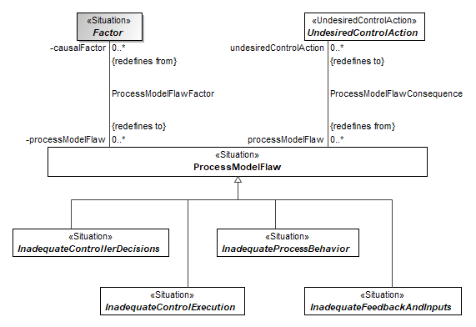
Figure 9.106 – ProcessModelFlaw

Attributes
undesiredControlAction : UndesiredControlAction[0..*] (member end of ProcessModelFlawConsequence association, redefines to) | Undesired control action related to process model flaw.

InadequateControllerDecisions
Package: STPA Library
isAbstract: Yes
Generalization: ProcessModelFlaw
Applied Stereotype: «Situation»

Description
A kind of ProcessFlaw.

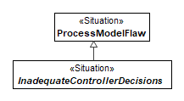
Figure 9.107 – InadequateControllerDecisions

InadequateControlExecution
Package: STPA Library
isAbstract: Yes
Generalization: ProcessModelFlaw
Applied Stereotype: «Situation»

Description
A kind of ProcessFlaw.

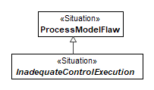
Figure 9.108 – InadequateControlExecution

InadequateProcessBehavior
Package: STPA Library
isAbstract: Yes
Generalization: ProcessModelFlaw
Applied Stereotype: «Situation»

Description
A kind of ProcessFlaw.

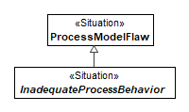
Figure 9.109 – InadequateProcessBehavior

InadequateFeedbackAndInputs
Package: STPA Library
isAbstract: Yes
Generalization: ProcessModelFlaw
Applied Stereotype: «Situation»

Description
A kind of ProcessFlaw.

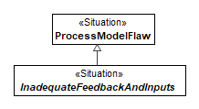
Figure 9.110 – InadequateFeedbackAndInputs

UndesiredControlAction
Package: STPA Library
isAbstract: Yes
Generalization: UndesiredState
Applied Stereotype: «UndesiredControlAction»

Description
An Undesired Control Action (UCA), used in STPA, describes in what context providing / not providing a Control Action might lead to an undesired result.

A UCA generally consist of four parts:
- Controller (Subject) that issues the Control Action - inferred from Control Action and model of the system (block/part producing the control action).
- Guideword (provides, does not provide, etc.) - indicated using Generalization relationship
- Control Action - connected with RelevantTo relationship.
- Context in which Control Action leads to undesired outcome - sub situation of (part of) UCA situation.
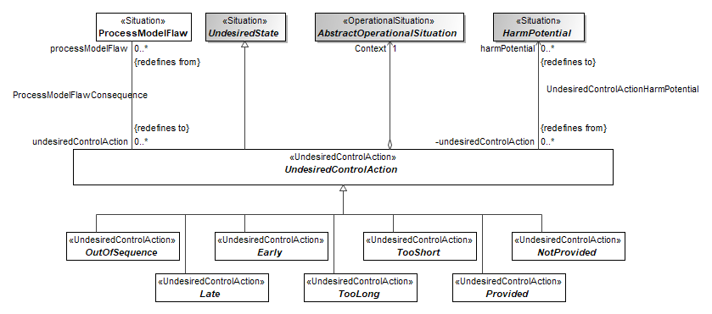
Figure 9.111 – UndesiredControlAction

Attributes
Context : AbstractOperationalSituation[1] (member end of association) | The context of the undesired control action.
processModelFlaw : ProcessModelFlaw[0..*] (member end of ProcessModelFlawConsequence association, redefines from) | Process model flaw related to the undesired control action.
harmPotential : HarmPotential[0..*] (member end of UndesiredControlActionHarmPotential association, redefines to) | Harm potential related to the undesired control action.

HarmRealization
Package: STPA Library
isAbstract: No
Generalization: AbstractRisk, Causality
Applied Stereotype: «Block»

Description
Association between the Loss and Hazard (potential harm).
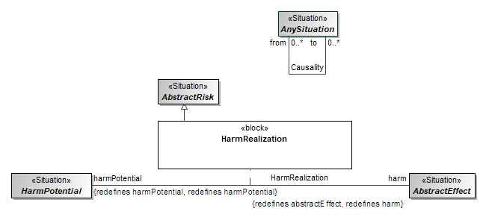
Figure 9.112 – HarmRealization

ProcessModelFlawFactor
Package: STPA Library
Generalization: Causality

Description
Causal relationship between CausalFactor and ProcessFlaw
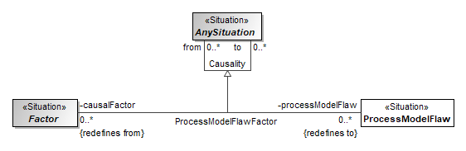
Figure 9.113 – ProcessModelFlawFactor

Association ends
processModelFlaw : ProcessModelFlaw[0..*] (member end of ProcessModelFlawFactor association, redefines to) | Process model flaw related to the process model flaw factor.
causalFactor : Factor[0..*] (member end of ProcessModelFlawFactor association, redefines from) | A causalFactor can be used to further refine Process Model inadequacies - specifying causes of deficiencies in the process model and/or other contributing factors.

ProcessModelFawConsequence
Package: STPA Library
Generalization: Causality

Description
Causal relationship between ProcessModelFlaw and UndesiredControlAction
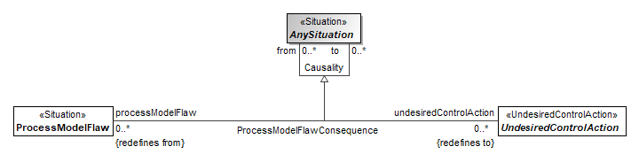
Figure 9.114 – ProcessModelFlawConsequence

Association ends
undesiredControlAction : UndesiredControlAction[0..*] (member end of ProcessModelFlawConsequence association, redefines to) | Undesired control action related to process model flaw.
processModelFlaw : ProcessModelFlaw[0..*] (member end of ProcessModelFlawConsequence association, redefines from) | Process model flaw related to the undesired control action.

UndesiredControlActionHarmPotential
Package: STPA Library
Generalization: Causality

Description
Causal relationship between UndesiredControlAction and HarmPortential.
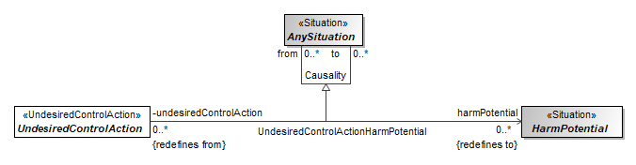
Figure 9.115 – UndesiredControlActionHarmPotential

Association ends
harmPotential : HarmPotential[0..*] (member end of UndesiredControlActionHarmPotential association, redefines to) | Harm potential related to the undesired control action.
undesiredControlAction : UndesiredControlAction[0..*] (member end of UndesiredControlActionHarmPotential association, redefines from) | Harm potential (or hazard, or threat) related to the undesired control action.
- Methods::STPA::STPA Profile

ControlAction
Package: STPA Profile
isAbstract: No
Extension: Signal, Class, DataType

Description
A Control Action (CA) is an output signal from a functional / logical Controller to a ControlledProcess (via the Actuator), that determines the receiving process behaviour.
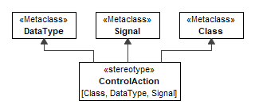
Figure 9.116 – ControlAction

Feedback
Package: STPA Profile
isAbstract: No
Extension: Signal, Class, DataType

Description
A Feedback is an input signal to a functional / logical Controller from a ControlledProcess (via the Sensor), that characterizes the current processes behavior (or the environment).

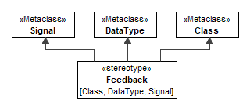
Figure 9.117 – Feedback

UndesiredControlAction
Package: STPA Profile
isAbstract: No
Generalization: Situation
Extension: Class

Description
Stereotype used to demarcate all the UndesiredControlActions.

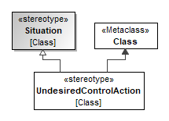
Figure 9.118 – UndesiredControlAction

UnsafeControlAction
Package: STPA Profile
isAbstract: No
Generalization: UndesiredControlAction
Extension: Class

Description
Stereotype used to demarcate all the UnsafeControlActions.

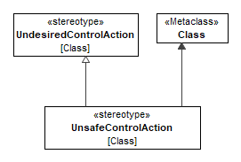
Figure 9.119 – UnsafeControlAction

ControlledProcess
Package: STPA Profile
isAbstract: No
Extension: Property, Class

Description
An abstract representation of the system and its behaviours that need to be supervised and governed.
Controller is controlling this process through the ControlAction via the Actuator.
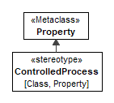
Figure 9.120 – ControlledProcess

Actuator
Package: STPA Profile
isAbstract: No
Extension: Property, Class

Description
Actuator receives ControlActions from Controller and influences the ControlledProcess in some way.
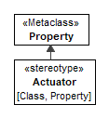
Figure 9.121 – Actuator

Sensor
Package: STPA Profile
isAbstract: No
Extension: Property, Class

Description
Sensor assesses the ControlledProcess (also environment or other controllers) and gives Feedback to the Controller.
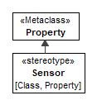
Figure 9.122 – Sensor

Controller
Package: STPA Profile
isAbstract: No
Extension: Property, Class

Description
Controller sends the ControlActions and receives Feedback.
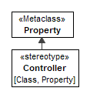
Figure 9.123 – Controller

ControlStructure
Package: STPA Profile
isAbstract: No
Generalization: Block
Extension: Class

Description
ControlStructure is a system-of-systems composed of ControlledProcess, Controller and their functional relationships - ControllActions, Feedbacks, describing feedback control loops.
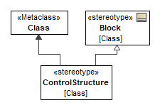
Figure 9.124 – ControlStructure

LossScenario
Package: STPA Profile
isAbstract: No
Generalization: Situation
Extension: Class

Description
Stereotype used to demarcate all the LossScenarios.
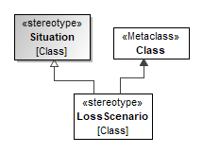
Figure 9.125 – LossScenario

- GSN
The GSN profile is an implementation of the core notation described in the GSN version 2 standard. The GSN standard is made available under creative commons licence version 4:
“To view a copy of this license, visit http://creativecommons.org/licenses/by/4.0/ or send a letter to Creative Commons, PO Box 1866, Mountain View, CA 94042, USA.”.
The OMG acknowledges the work of the SCSC ACWG in the production of the GSN standard.
Whilst GSN is an extension of the OMG SACM standard, which has a defined meta-model based on the OMG MOF standard, the objectives of RAAML to integrate with SysML 1.6 necessitate the use of a UML profile interpretation of the GSN standard.
- GSN::GSN Profile

Notation
Most of the stereotypes in GSN profile have stereotype images specified. Displaying the stereotyped GSN elements in UML Class diagram may follow the UML standard prescription (UML 2.5.1, Chapter 12.3.4.1 Icon presentation) for displaying elements having stereotypes with icons, namely:
- Showing model element as an image with element name below
- Showing model element as a box with the iconic form image inside the box at the top left
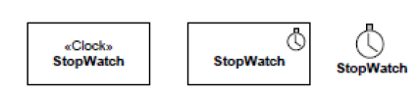
Figure 9.126 – Standard UML notation for stereotyped elements (from UML 2.5.1, Figure 12.25)
However, in addition to the notation described in UML standard, this standard allows additional notation. Namely – using stereotype image as a (resizable) outline/shape of the box, with the same compartments that are prescribed by the UML standard (including name/stereotype/tag values compartment) inside. This notation is recommended i.e., preferred over the standard UML notation.
An example of the SCSC/GSN standard representation of the GSN extension is shown in Figure 9.127. See the SCSC/GSN standard for the shapes and text placement to be used for various model element types.
S1
Strategy
Figure 9.127 - Strategy notation

Combined Stereotype Notation
The UML standard allows a combination of several stereotypes applied on the model element. Namely – the combination of Goal+Undeveloped stereotypes and Strategy+Undeveloped stereotypes is being used. An example of this notation is depicted in Figure 9.128. See the SCSC/GSN standard for the shapes and text placement to be used for various model element types.
Undeveloped
Goal

Figure 9.128 - Combined notation

GSNNode
Package: GSN Profile
isAbstract: Yes
Extension: Element

Description
Root type for all the different kinds of nodes in GSN.

Note: name versus human-readable ID

GSN domain elements frequently have both a short phrase, describing the element and human-readable identifier. For example:
G1 Control System is acceptably safe to operate
In this example “Control System is acceptably safe to operate” is a short phrase, describing the goal, while G1 is a human-readable identifier of the goal.
In this standard, the short phrase shall be captured as UML model element name – NamedElement::name field. Human-readable identifier shall be stored in a separate tag, defined in the Core profile – IDCarrier::id..

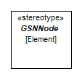
Figure 9.129 – GSNNode

Attributes
id : String[0..1]

GSNArgumentNode
Package: GSN Profile
isAbstract: Yes
Generalization: GSNNode
Extension: Element

Description
A Goal or a Strategy.

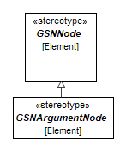
Figure 9.130 – GSNArgumentNode

Solution
Package: GSN Profile
isAbstract: No
Generalization: GSNNode
Extension: Class

Description
A solution presents a reference to an evidence item or items.

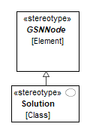
Figure 9.131 – Solution

Goal
Package: GSN Profile
isAbstract: No
Generalization: GSNArgumentNode
Extension: Class

Description
A goal presents a claim forming part of the argument.
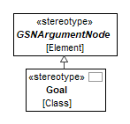
Figure 9.132 – Goal

Strategy
Package: GSN Profile
isAbstract: No
Generalization: GSNArgumentNode
Extension: Class

Description
A strategy describes the nature of the inference that exists between a goal and its supporting goal(s).
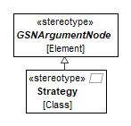
Figure 9.133 – Strategy

ContextualInformation
Package: GSN Profile
isAbstract: Yes
Extension: Element

Description
A Context or an Assumption or a Justification.

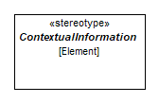
Figure 9.134 – ContextualInformation

Attributes
id : String[0..1]

Context
Package: GSN Profile
isAbstract: No
Generalization: ContextualInformation
Extension: Class

Description
A context presents a contextual artefact. This can be a reference to contextual information, or a statement.

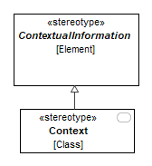
Figure 9.135 – ContextStatement

Assumption
Package: GSN Profile
isAbstract: No
Generalization: SupportingInformation
Extension: Class

Description
An assumption presents an intentionally unsubstantiated statement.

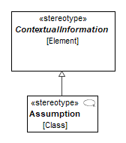
Figure 9.136 – Assumption

Justification
Package: GSN Profile
isAbstract: No
Generalization: ContextualInformation
Extension: Class

Description
A justification presents a statement of rationale.

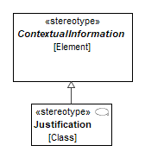
Figure 9.137 – Justification

InContextOf
Package: GSN Profile
isAbstract: No
Extension: Dependency

Description
InContextOf declares a contextual relationship.
Permitted connections are: goal-to-context, goal-to-assumption, goal-to-justification, strategy-to-context,
strategy-to-assumption and strategy-to-justification.

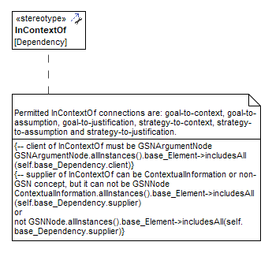
Figure 9.138 – InContextOf

Constraints
[1] ClientIsArgumentNode | -- client of InContextOf must be GSNArgumentNode  GSNArgumentNode.allInstances().base_Element->includesAll(self.base_Dependency.client)
[2] SupplierIsNotGSNNode | -- supplier of InContextOf can be ContextualInformation or non-GSN concept, but it can not be GSNNode  ContextualInformation.allInstances().base_Element->includesAll(self.base_Dependency.supplier)  or  not GSNNode.allInstances().base_Element->includesAll(self.base_Dependency.supplier)

SupportedBy
Package: GSN Profile
isAbstract: No
Extension: Dependency

Description
SupportedBy allows inferential or evidential relationships to be documented. Inferential relationships declare that there is an inferencebetween goals in the argument. Evidential relationships declare the link between a goal and the evidence used to substantiate it. Permitted supported by connections are: goal-to-goal, goal-to-strategy, goal-to-solution, strategy to goal.

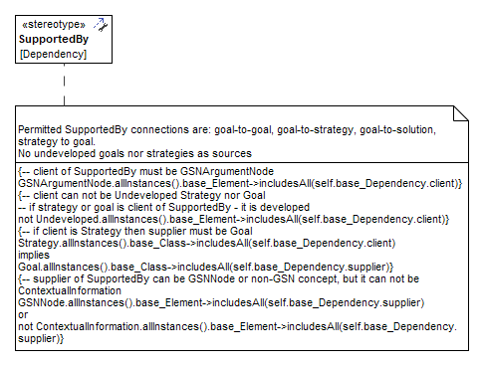
Figure 9.139 – SupportedBy

Constraints
[1] ClientIsGSNArgumentNode | -- client of SupportedBy must be GSNArgumentNode  GSNArgumentNode.allInstances().base_Element->includesAll(self.base_Dependency.client)
[2] StrategyToGoal | -- if client is Strategy then supplier must be Goal  Strategy.allInstances().base_Class->includesAll(self.base_Dependency.client)  implies  Goal.allInstances().base_Class->includesAll(self.base_Dependency.supplier)
[3] SupplierIsNotContextualInformation | -- supplier of SupportedBy can be GSNNode or non-GSN concept, but it can not be ContextualInformation  GSNNode.allInstances().base_Element->includesAll(self.base_Dependency.supplier)  or  not ContextualInformation.allInstances().base_Element->includesAll(self.base_Dependency.supplier)
[4] ClientIsNotUndeveloped | -- client can not be Undeveloped Strategy nor Goal  -- if strategy or goal is client of SupportedBy - it is developed  not Undeveloped.allInstances().base_Element->includesAll(self.base_Dependency.client)

- Methods::ISO 26262
The ISO 26262 package contains elements supporting the analysis and requirement specification aspects of Functional Safety, as specified by ISO 26262 standard for automotive applications. ISO 26262 is a risk-based standard derived from IEC 61508. The ISO 26262 package redefines or extends concepts from the Core concepts package and the General Concepts package.
The ISO 26262 package enables modeling a HAZOP, which is typically used to identify malfunctioning behaviors. The failure modes concept is used from the General Concepts and specialized as a malfunctioning behavior. This allows the malfunctioning behavior to be related to the system behaviors through the HAZOP guidewords for construction of the HAZOP table. The risk analysis is performed by identifying Hazards that could result from the MalfunctioningBehavior, which in combination with a particular OperationalSituation could result in an AccidentScenario. This information is contained in the HazardousEvent which provides the risk level assessment for the event. Each of these concepts are modeled using elements defined in the ISO 26262 package as extensions of the Core and General concepts. This means that the same elements can be used in other analyses in the model, such as in an FMEA.
- Methods::ISO 26262::ISO 26262 Library

TrafficAndPeople
Package: ISO 26262 Library
isAbstract: Yes
Generalization: OperationalCondition
Applied Stereotype: «OperationalSituation»

Description
TrafficAndPeople extends the <<situation>> class and is used to describe the presence and behaviour of any motorists or non-motorists considered in a hazardous event.
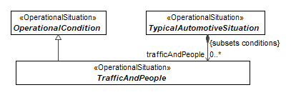
Figure 9.140 – TrafficAndPeople

VehicleUsage
Package: ISO 26262 Library
isAbstract: Yes
Generalization: OperationalCondition
Applied Stereotype: «OperationalSituation»

Description
VehicleUsage extends the <<situation>> class and is used to describe the usage of a vehicle during a hazardous event.
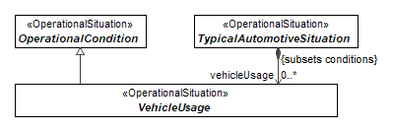
Figure 9.141 – VehicleUsage

RoadCondition
Package: ISO 26262 Library
isAbstract: Yes
Generalization: OperationalCondition
Applied Stereotype: «OperationalSituation»

Description
RoadConditions extends the <<situation>> class, and is used to describe the conditions or state of the surface a vehicle is driving on (Low-traction, Grade(Slope), etc.) during a hazardous event.
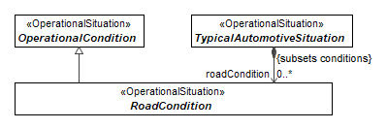
Figure 9.142 – RoadCondition

Location
Package: ISO 26262 Library
isAbstract: Yes
Generalization: OperationalCondition
Applied Stereotype: «OperationalSituation»

Description
VehicleLocation extends the <<situation>> class and is used to describe the physical location (high speed road, intersection, parking lot, etc.) of a vehicle during a hazardous event.
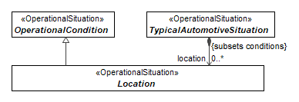
Figure 9.143 – Location

EnvironmentalCondition
Package: ISO 26262 Library
isAbstract: Yes
Generalization: OperationalCondition
Applied Stereotype: «OperationalSituation»

Description
EnvironmentalConditions extends the <<situation>> class and is used to describe the environmental conditions at the time of vehicle operation in a hazardous event.
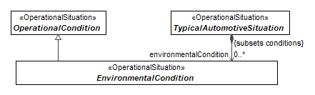
Figure 9.144 – EnvironmentalCondition

OperationalCondition
Package: ISO 26262 Library
isAbstract: Yes
Generalization: AbstractEvent
Applied Stereotype: «OperationalSituation»

Description
Component/part of operational situation.

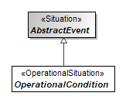
Figure 9.145 – OperationalCondition

AbstractOperationalSituation
Package: ISO 26262 Library
isAbstract: Yes
Generalization: OperationalCondition
Applied Stereotype: «OperationalSituation»

Description
Operational situation is a scenario that can occur in vehicle's life.

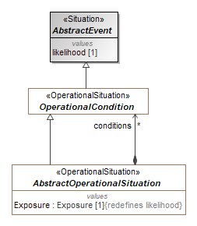
Figure 9.146 – AbstractOperationalSituation

Attributes
conditions : OperationalCondition[*] (member end of association)
Exposure : Exposure[1] , redefines likelihood | Likelihood of being in a particular operational situation.  Must have a Rationale attached.

TypicalAutomotiveSituation
Package: ISO 26262 Library
isAbstract: Yes
Generalization: AbstractOperationalSituation
Applied Stereotype: «OperationalSituation»

Description
A grouping of operational conditions, including traffic and people, vehicle usage, road conditions, location, and environmental conditions.
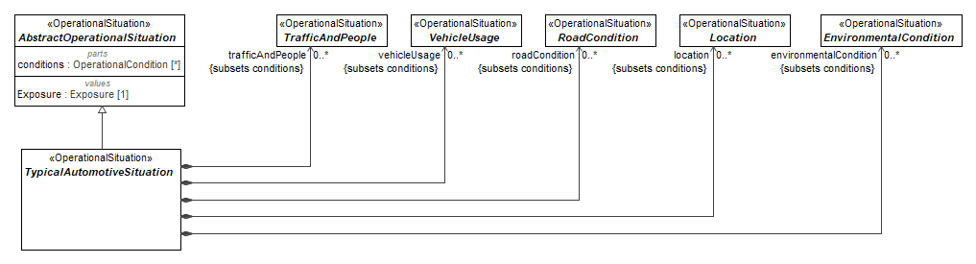
Figure 9.147 – TypicalAutomotiveSituation

Attributes
trafficAndPeople : TrafficAndPeople[0..*] (member end of association, subsets conditions)
vehicleUsage : VehicleUsage[0..*] (member end of association, subsets conditions)
roadCondition : RoadCondition[0..*] (member end of association, subsets conditions)
location : Location[0..*] (member end of association, subsets conditions)
environmentalCondition : EnvironmentalCondition[0..*] (member end of association, subsets conditions)

Exposure
Package: ISO 26262 Library
isAbstract: No
Applied Stereotype: «ValueType»

Description
Possible values of exposure.
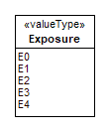
Figure 9.148 – Exposure

Severity
Package: ISO 26262 Library
isAbstract: No
Applied Stereotype: «ValueType»

Description
Possible values for severity.
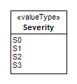
Figure 9.149 – Severity

ASIL
Package: ISO 26262 Library
isAbstract: No
Applied Stereotype: «ValueType»

Description
Possible ASIL values.
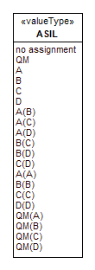
Figure 9.150 – ASIL

Controllability
Package: ISO 26262 Library
isAbstract: No
Applied Stereotype: «ValueType»

Description
Possible values of controllability.
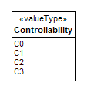
Figure 9.151 – Controllability

Less
Package: ISO 26262 Library
isAbstract: Yes
Generalization: AnyMalfunction
Applied Stereotype: «MalfunctioningBehavior»

Description
A subclass of malfunctioning behaviour used for classification purposes. Must be connected to a behavioural element (Use Case or Function). This kind of malfunctioning behaviour represents a failure resulting from providing less output/behaviour than required.
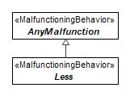
Figure 9.152 – Less

More
Package: ISO 26262 Library
isAbstract: Yes
Generalization: AnyMalfunction
Applied Stereotype: «MalfunctioningBehavior»

Description
A subclass of malfunctioning behaviour used for classification purposes. Must be connected to a behavioural element (Use Case or Function). This kind of malfunctioning behaviour represents a failure resulting from providing more output/behaviour than required.
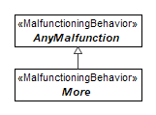
Figure 9.153 – More

No
Package: ISO 26262 Library
isAbstract: Yes
Generalization: AnyMalfunction
Applied Stereotype: «MalfunctioningBehavior»

Description
A subclass of malfunctioning behaviour used for classification purposes. Must be connected to a behavioural element (Use Case or Function). This kind of malfunctioning behaviour represents a failure resulting from the behaviour not being performed when required.
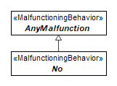
Figure 9.154 – No

Intermittent
Package: ISO 26262 Library
isAbstract: Yes
Generalization: AnyMalfunction
Applied Stereotype: «MalfunctioningBehavior»

Description
A subclass of malfunctioning behaviour used for classification purposes. Must be connected to a behavioural element (Use Case or Function). This kind of malfunctioning behaviour represents a failure from the behaviour being performed intermittently.
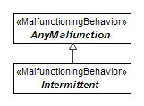
Figure 9.155 – Intermittent

Unintended
Package: ISO 26262 Library
isAbstract: Yes
Generalization: AnyMalfunction
Applied Stereotype: «MalfunctioningBehavior»

Description
A subclass of malfunctioning behaviour used for classification purposes. Must be connected to a behavioural element (Use Case or Function). This kind of malfunctioning behaviour represents a failure resulting from the behaviour being provided when not required.
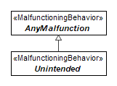
Figure 9.156 – Unintended

Early
Package: ISO 26262 Library
isAbstract: Yes
Generalization: AnyMalfunction
Applied Stereotype: «MalfunctioningBehavior»

Description
A subclass of malfunctioning behaviour used for classification purposes. Must be connected to a behavioural element (Use Case or Function). This kind of malfunctioning behaviour represents a failure resulting from the behaviour being performed earlier than required.
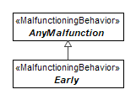
Figure 9.157 – Early

Late
Package: ISO 26262 Library
isAbstract: Yes
Generalization: AnyMalfunction
Applied Stereotype: «MalfunctioningBehavior»

Description
A subclass of malfunctioning behaviour used for classification purposes. Must be connected to a behavioural element (Use Case or Function). This kind of malfunctioning behaviour represents a failure resulting from the behaviour being performed later than required.
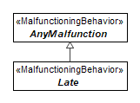
Figure 9.158 – Late

Inverted
Package: ISO 26262 Library
isAbstract: Yes
Generalization: AnyMalfunction
Applied Stereotype: «MalfunctioningBehavior»

Description
A subclass of malfunctioning behaviour used for classification purposes. Must be connected to a behavioural element (Use Case or Function). This kind of malfunctioning behaviour represents a failure resulting from the behaviour providing an inverted output.
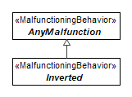
Figure 9.159 – Inverted

HazardousEvent
Package: ISO 26262 Library
isAbstract: Yes
Generalization: AbstractRisk
Applied Stereotype: «Situation»

Description
Combination of hazard and operational situation to identify automotive safety integrity level.
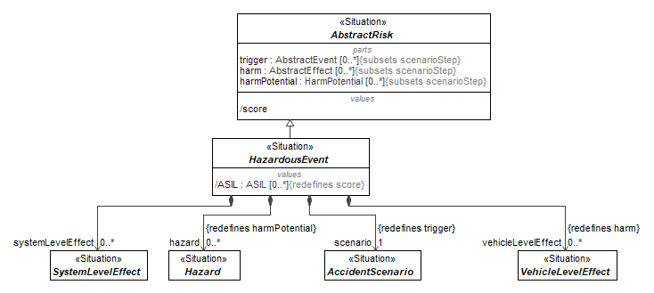
Figure 9.160 – HazardousEvent

Attributes
scenario : AccidentScenario[1] (member end of association, redefines trigger)
hazard : Hazard[0..*] (member end of association, redefines harmPotential)
systemLevelEffect : SystemLevelEffect[0..*] (member end of association)
vehicleLevelEffect : VehicleLevelEffect[0..*] (member end of association, redefines harm)
ASIL : ASIL[0..*], redefines score | Automotive Safety Integrity Level value - one of four levels to specify necessary requirements for ISO-26262 and safety measures for avoiding unreasonable risks.

AnyMalfunction
Package: ISO 26262 Library
isAbstract: Yes
Generalization: UndesiredState
Applied Stereotype: «MalfunctioningBehavior»

Description
Root of all malfunctioning behaviours.
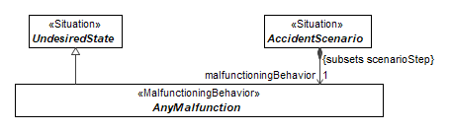
Figure 9.161 – AnyMalfunction

AutomotiveEffect
Package: ISO 26262 Library
isAbstract: Yes
Generalization: AbstractEffect
Applied Stereotype: «Situation»

Description
System- or vehicle-level effect which is or could result in harm.
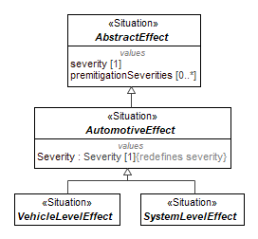
Figure 9.162 – AutomotiveEffect

Attributes
Severity : Severity[1], redefines severity | Estimate of the extent of harm.  Must have a Rationale attached.

ISO26262SafetyRequirementTemplate
Package: ISO 26262 Library
isAbstract: No
Applied Stereotype: «DependabilityRequirement»

Description
A template for dependability requirements.
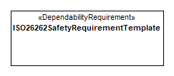
Figure 9.163 – ISO26262SafetyRequirementTemplate

Attributes
ASIL : ASIL[1] | ASIL value of the requirement.
FTTI : time[1] | Fault Tolerant Time Interval.

AccidentScenario
Package: ISO 26262 Library
isAbstract: Yes
Generalization: DysfunctionalEvent, Scenario
Applied Stereotype: «Situation»

Description
A combination of operational situation and malfunctioning behaviour.
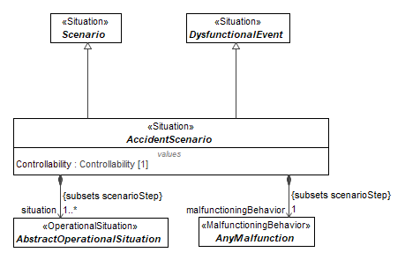
Figure 9.164 – AccidentScenario

Attributes
situation : AbstractOperationalSituation[1..*] (member end of association, subsets scenarioStep)
Controllability : Controllability[1] | Ability to avoid a specified harm or damage through timely reactions of individuals involved in the scenario.  Must have a Rationale attached.
malfunctioningBehavior : AnyMalfunction[1] (member end of association, subsets scenarioStep)

AnyTrafficAndPeople
Package: ISO 26262 Library
isAbstract: No
Generalization: OperationalCondition, TrafficAndPeople
Applied Stereotype: «OperationalSituation»

Description
TrafficAndPeople extends the <<situation>> class and is used to describe the presence and behaviour of any motorists or non-motorists considered in a hazardous event.
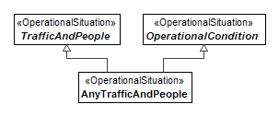
Figure 9.165 – AnyTrafficAndPeople

AnyVehicleUse
Package: ISO 26262 Library
isAbstract: No
Generalization: OperationalCondition, VehicleUsage
Applied Stereotype: «OperationalSituation»

Description
TrafficAndPeople extends the <<situation>> class and is used to describe the presence and behaviour of any motorists or non-motorists considered in a hazardous event.
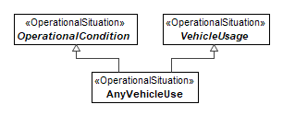
Figure 9.166 – AnyVehicleUse

AnyRoadCondition
Package: ISO 26262 Library
isAbstract: No
Generalization: OperationalCondition, RoadCondition
Applied Stereotype: «OperationalSituation»

Description
TrafficAndPeople extends the <<situation>> class and is used to describe the presence and behaviour of any motorists or non-motorists considered in a hazardous event.
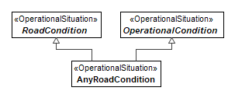
Figure 9.167 – AnyRoadCondition

AnyLocation
Package: ISO 26262 Library
isAbstract: No
Generalization: Location, OperationalCondition
Applied Stereotype: «OperationalSituation»

Description
TrafficAndPeople extends the <<situation>> class and is used to describe the presence and behavior of any motorists or non-motorists considered in a hazardous event.
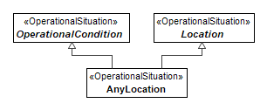
Figure 9.168 – AnyLocation

AnyEnvironmentalCondition
Package: ISO 26262 Library
isAbstract: No
Generalization: EnvironmentalCondition, OperationalCondition
Applied Stereotype: «OperationalSituation»

Description
TrafficAndPeople extends the <<situation>> class and is used to describe the presence and behaviour of any motorists or non-motorists considered in a hazardous event.
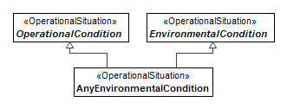
Figure 9.169 – AnyEnvironmentalCondition

SystemLevelEffect
Package: ISO 26262 Library
isAbstract: Yes
Generalization: AutomotiveEffect
Applied Stereotype: «Situation»

Description
System- or vehicle-level effect which is or could result in harm.
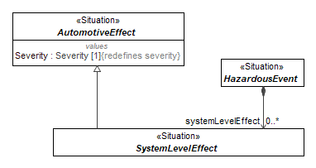
Figure 9.170 – SystemLevelEffect

VehicleLevelEffect
Package: ISO 26262 Library
isAbstract: Yes
Generalization: AutomotiveEffect
Applied Stereotype: «Situation»

Description
System- or vehicle-level effect which is or could result in harm.
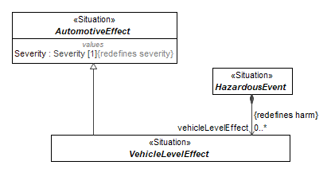
Figure 9.171 – VehicleLevelEffect

Methods::ISO 26262::ISO 26262 Library::Diagrams by elements
- Methods::ISO 26262::ISO 26262 Profile

OperationalSituation
Package: ISO 26262 Profile
isAbstract: No
Generalization: Situation
Extension: Class

Description
A situation describes the operational scenario or driving scenario which is considered in a hazardous event, as part of the Hazard Analysis and Risk Assessment process.
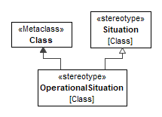
Figure 9.172 – OperationalSituation

MalfunctioningBehavior
Package: ISO 26262 Profile
isAbstract: No
Generalization: FailureMode
Extension: Class

Description
A malfunctioning behaviour describes a failure or unintended behaviour of an item with respect to its design intent. It is a subtype of failure mode.
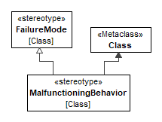
Figure 9.173 – MalfunctioningBehavior

Methods::ISO 26262::ISO 26262 Profile::RequirementManagement

IndependenceRequirement
Package: RequirementManagement
isAbstract: No
Generalization: DeriveReqt
Extension: Abstraction

Description
A relationship between requirement elements indicating that the child requirement specifies an independence criterion that needs to be satisfied in order for an ASIL decomposition to be valid. The decomposition between the parent requirement and 2 other children requirements.
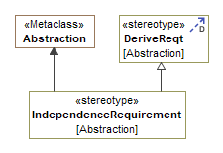
Figure 9.174 – IndependenceRequirement

ASILDecompose
Package: RequirementManagement
isAbstract: No
Generalization: DeriveReqt
Extension: Abstraction

Description
An ASIL decompose relation is used to connect two safety requirements for the purposes of performing ASIL decomposition. The target requirement (supplier) should be of a higher abstraction than the source (client). ASIL decompose relations shall be applied in pairs (e.g., a requirement cannot be the supplier of a single ASIL decompose relation).
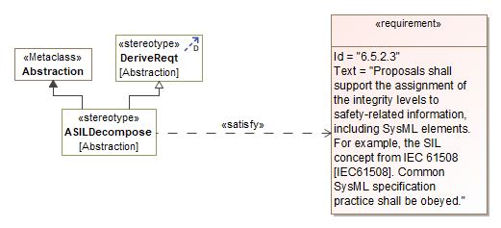
Figure 9.175 – ASILDecompose

SafeState
Package: RequirementManagement
isAbstract: No
Extension: Dependency

Description
A state of function realized by one or more architectural components. May be composed of serval subfunctions or called by other functions. Associated with safety specific behaviours, typically (but not necessarily) triggered by a failure mode.
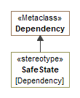
Figure 9.176 – SafeState

UserInfoRequirement
Package: RequirementManagement
isAbstract: No
Generalization: Satisfy
Extension: Abstraction

Description
A UserInfoRequirement relationship is a dependency which links a State to a requirement. The arrow direction points from a state (client) to a FSR or TSR (supplier). Linked requirements specify information that must be presented to vehicle occupants when the vehicle enters a safe state.
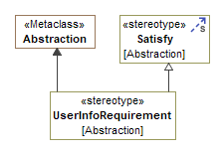
Figure 9.177 – UserInfoRequirement

RecoveryRequirement
Package: RequirementManagement
isAbstract: No
Generalization: Satisfy
Extension: Abstraction

Description
A RecoveryRequirement relationship is a dependency between a safe state and requirement where the requirement indicates the criteria to recover from the safe state to another operational mode.
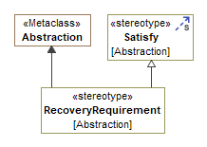
Figure 9.178 – RecoveryRequirement

OperatingMode
Package: RequirementManagement
isAbstract: No
Extension: Dependency

Description
A state of function realized by one or more architectural components. May be composed of serval subfunctions or called by other functions. Associated with specific behaviours.
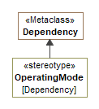
Figure 9.179 – OperatingMode

FunctionalSafetyRequirement
Package: RequirementManagement
isAbstract: No
Generalization: DependabilityRequirement, Requirement
Extension: Class

Description
A functional safety requirement specifies an implementation independent safety behaviour, or an implementation independent safety measure, required for achievement of a safety goal from which it is derived.
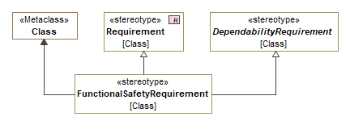
Figure 9.180 – FunctionalSafetyRequirement

SoftwareSafetyRequirement
Package: RequirementManagement
isAbstract: No
Generalization: DependabilityRequirement, Requirement
Extension: Class

Description
A software safety requirement provides implementation details for software. They can express behaviours or specific software mechanisms which realize the technical safety requirements from which they are derived.
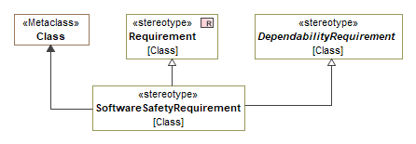
Figure 9.181 – SoftwareSafetyRequirement

HardwareSafetyRequirement
Package: RequirementManagement
isAbstract: No
Generalization: DependabilityRequirement, Requirement
Extension: Class

Description
A hardware safety requirement specifies hardware behaviours or hardware specific details necessary for implementing the safety concept. Hardware safety requirements are implementation specific and assigned to components or subcomponents.
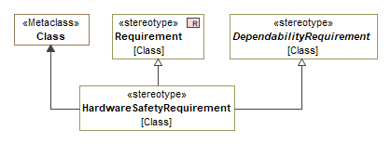
Figure 9.182 – HardwareSafetyRequirement

TechnicalSafetyRequirement
Package: RequirementManagement
isAbstract: No
Generalization: DependabilityRequirement, Requirement
Extension: Class

Description
A technical safety requirement specifies the implementation of the functional safety requirement(s) from which it is derived. Technical safety requirements express the behaviours and details necessary to realize the safety aspects of the item at the system level. Additional details that do not act at the system level can be specified in the hardware safety requirements or software safety requirements.
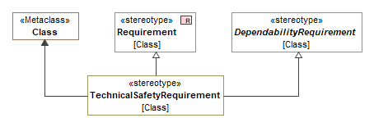
Figure 9.183 – TechnicalSafetyRequirement

SafetyGoal
Package: RequirementManagement
isAbstract: No
Generalization: DependabilityRequirement, Requirement
Extension: Class

Description
A safety goal extends the SysML <<Requirement>> stereotype. It represents a top-level safety requirement, defined as a result of the Hazard Analysis and Risk Assessment process.
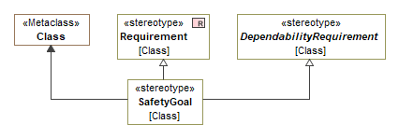
Figure 9.184 – SafetyGoal

DependabilityRequirement
Package: RequirementManagement
isAbstract: Yes
Generalization: AbstractRequirement, Block
Extension: Class

Description
Parent type of all subtypes of safety requirements
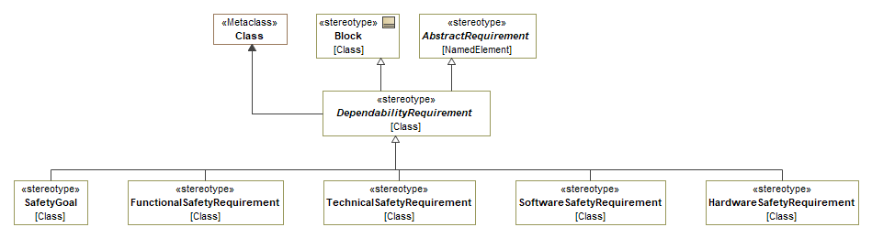
Figure 9.185 – DependabilityRequirement

Verified
Package: ISO 26262 Profile
isAbstract: No
Extension: Class

Description
Marker, indicating that hazardous event has been verified.
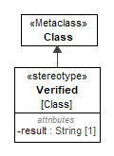
Figure 9.186 – Verified

Attributes
result : String[1] | Verification result

Confirmed
Package: ISO 26262 Profile
isAbstract: No
Extension: Class

Description
Marker, indicating that hazardous event has been confirmed.
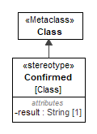
Figure 9.187 – Confirmed

Attributes
result : String[1] | Confirmation result

HazardAndRiskAssessment
Package: ISO 26262 Profile
isAbstract: No
Extension: Package

Description
Grouping package for storing hazardous events.
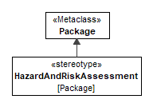
Figure 9.188 – HazardAndRiskAssessment

LessonLearned
Package: ISO 26262 Profile
isAbstract: No
Extension: Comment

Description
Comments about lessons learned from hazard and risk assessment.
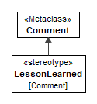
Figure 9.189 – LessonLearned

ASILAssignment
Package: ISO 26262 Profile
isAbstract: No
Extension: Element

Description
Stereotype for assigning ASIL values on system design elements.
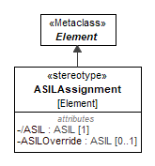
Figure 9.190 – ASILAssignment

Attributes
ASIL : ASIL[1] | The associated ASIL value of the system design element.
ASILOverride : ASIL[0..1] | An ASIL value which does not follow from the normal ASIL derivation rules but is exceptional. This exceptional value needs to have an associated rationale.

ASILOverrideRationale
Package: ISO 26262 Profile
isAbstract: No
Generalization: Rationale
Extension: Comment

Description
A rationale specifically justifying ASIL Override value.
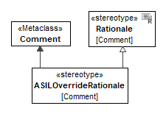
Figure 9.191 – ASILOverrideRationale

  - Methods::FHA
The Functional Hazard Assessment (FHA), as described in the ARP 4761A, is a systematic, comprehensive evaluation of the functional decomposition of a system or platform, performed at early stages of the V development process. This assessment identifies and classifies the failure conditions associated with each function. The goal in conducting an FHA is to clearly identify each failure condition along with the rationale for its severity classification. The classification of these failure conditions establishes the safety objectives to be met.

An FHA should also identify assumptions associated with the system/platform of interest and crew mitigations to limit the severity classification, e.g., operating limits, crew information presentation, operating procedures. The FHAs are then the starting point for the subsequent safety assessments and analyses.

The RAAML FHA package contains all required elements to implement this assessment at different levels (e.g., platform, system). Support for Functional Hazard Assessment (FHA) modeling is based on the ARP 4761A standard. The FHA package redefines or extends concepts from the Core and General packages. It is also tightly related to ISO 26262 and FMEA library methods within the RAAML standard.
- Methods::FHA::FHA Library

ExternalEvent
Package: FHA Library
isAbstract: Yes
Generalization: AbstractEvent
Applied Stereotype: «Situation»
Description
An occurrence which has its origin distinct from the aircraft or the system being examined, such as atmospheric conditions (e.g., wind gusts/shear, temperature variations, icing, lightning strikes), operating environment (e.g., runway conditions, conditions of communication, navigation, and surveillance services), cabin and baggage fires, and bird-strike. The term is not intended to cover sabotage. [Source: ARP 4761A]
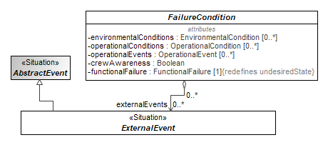
Figure 9.192 - ExternalEvent
Constraints
[1] FHA

DevelopmentAssuranceLevel
Package: FHA Library
isAbstract: No
Applied Stereotype: «ValueType»
Description
All those planned and systematic actions used to substantiate, at an adequate level of confidence, that development errors have been identified and corrected such that the system satisfies the applicable certification basis (derived from AC 25.1309 Draft ARSENAL revised and AMC 25.1309). [Source ARP 4761A]
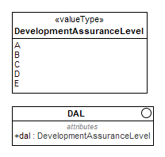
Figure 9.193 - DevelopmentAssuranceLevel
Constraints
[1] FHA

OperationalCondition
Package: FHA Library
isAbstract: Yes
Generalization: AbstractEvent
Applied Stereotype: «Situation»
Description
Specific state or circumstances under which the aircraft is operated within the approved aircraft operating envelope, relevant when evaluating the effects of a failure condition. Example of operational conditions include aircraft weight, center of gravity, speed...
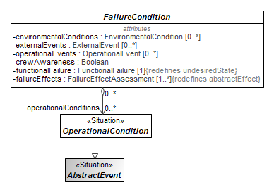
Figure 9.194 - OperationalCondition
Constraints
[1] FHA

DAL
Package: FHA Library
isAbstract: No
Description
All those planned and systematic actions used to substantiate, at an adequate level of confidence, that development errors have been identified and corrected such that the system satisfies the applicable certification basis (derived from AC 25.1309 Draft ARSENAL revised and AMC 25.1309). [Source: ARP 4761A]
Attributes
dal : DevelopmentAssuranceLevel | The level of rigor of development assurance tasks.
Constraints
[1] FHA

FunctionalFailure
Package: FHA Library
isAbstract: Yes
Generalization: UndesiredState
Applied Stereotype: «FunctionalFailure»
Description
An occurrence which affects the operation of an aircraft, system, equipment, item, or piece-part such that it can no longer function as intended (this includes both loss of function and malfunction). Failure conditions can be broadly categorized as the loss of a function or as a malfunction. Note: Errors may cause Failures but are not considered to be Failures. [Source: ARP 4761A]

Function: Intended behavior of an aircraft, system, equipment, or item regardless of implementation. [Source: ARP 4761A]
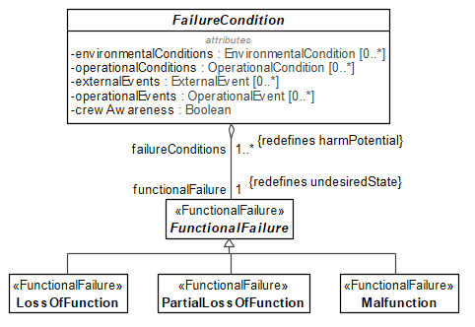
Figure 9.195 - FunctionalFailure
Attributes
failureConditions : FailureCondition[1..*] (member end of association, redefines harmPotential) | A condition having an effect on the aircraft and/or its occupants, either direct or consequential, which is caused or contributed to by one or more failures or errors, considering flight phase and relevant adverse operational or environmental conditions, or external events (AMC 25.1309). [Source: ARP 4761A]
Constraints
[1] FHA

EnvironmentalCondition
Package: FHA Library
isAbstract: Yes
Generalization: AbstractEvent
Applied Stereotype: «Situation»
Description
Atmospheric/physical factors within the approved aircraft operating envelope, relevant when evaluating the effects of a failure condition. Example of environmental conditions include weather, HIRF, volcanic ash...
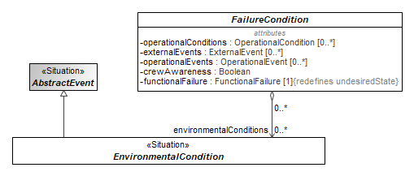
Figure 9.197 - EnvironmentalCondition
Constraints
[1] FHA

FDAL
Package: FHA Library
isAbstract: No
Generalization: DAL
Description
The level of rigor of development assurance tasks performed to Functions. Note: The FDAL is used to identify the ARP4754B/ED-79B objectives that need to be satisfied for the aircraft/system functions. [Source: ARP 4761A]
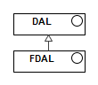
Figure 9.198 - FDAL
Constraints
[1] FHA

FailureEffectAssessment
Package: FHA Library
isAbstract: No
Generalization: AbstractEffect
Description
The effects of a failure condition for any particular flight phase are all the expected effects during the flight when the failure condition occurs in that flight phase. This includes immediate effects and effects that would occur during subsequent flight phases due to the same failure condition. The effects are described by a narrative and characterized with brief statements regarding the effect in aircraft, crew and occupant categories. [Source: ARP 4761A]
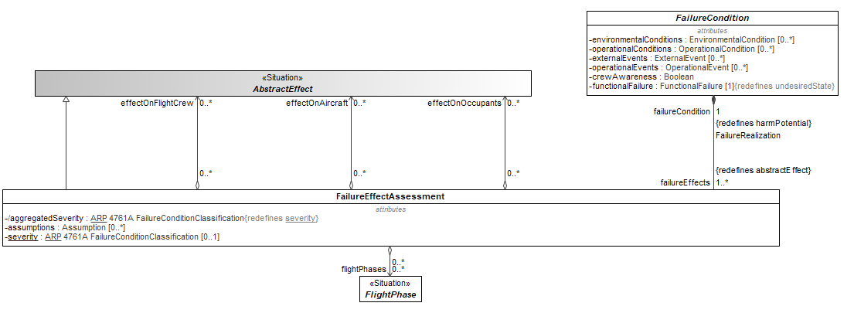
Figure 9.199 - FailureEffectAssessment
Attributes
effectOnAircraft : AbstractEffect[0..*] (member end of association) | Ability of the aircraft to perform its functions and to the aircraft’s structural integrity. Aircraft effects are characterized by a statement evaluating the reduction in aircraft capability and safety margin caused by the failure condition. [Source: ARP 4761A]
effectOnFlightCrew : AbstractEffect[0..*] (member end of association) | Any direct physiological effect on flight deck crew members or any increase in physical or mental activity required beyond the normal flight crew activity levels to counteract the effects of the failure and complete the flight safely. Typically, this includes the crew’s means of detecting the failure condition (if any) and their expected actions. Effects on crew are characterized by a statement evaluating the adverse physiological effects on the crew (if any) and the increase in crew workload caused by the failure condition (if any). [Source: ARP461A]
effectOnOccupants : AbstractEffect[0..*] (member end of association) | Cabin crew or passenger discomfort, injury or fatalities. These effects may be the direct result of the failure condition, such as high G maneuvering or abnormal environmental conditions, or an indirect effect, such as loss of life due to loss of aircraft control resulting in an uncontrolled crash. Occupant effects are characterized by a statement evaluating the adverse physiological effects on the cabin crew or passengers caused by the failure condition. [Source: ARP461A]
aggregatedSeverity : ARP 4761A FailureConditionClassification, redefines severity | A discrete scale allowing categorization of the severity of the effects of a failure condition. Classification levels are defined in the applicable regulation and advisory material. For example, AC 25.1309 Draft ARSENAL revised and AMC 25.1309 define the following classifications; Catastrophic, Hazardous, Major, Minor, and No Safety Effect. [Source: ARP 4761A]
flightPhases : FlightPhase[0..*] (member end of association) | Distinct time period within an average flight duration [Source: ARP4761A]
assumptions : Assumption[0..*] (member end of association) | Statements, principles and/or premises offered without proof. An evaluation process which may include one or more types of analysis and experience. [Source: ARP 4761A]
severity : ARP 4761A FailureConditionClassification[0..1] | A discrete scale allowing categorization of the severity of the effects of a failure condition. Classification levels are defined in the applicable regulation and advisory material. For example, AC 25.1309 Draft ARSENAL revised and AMC 25.1309 define the following classifications; Catastrophic, Hazardous, Major, Minor, and No Safety Effect. [Source: ARP 4761A]
Constraints
[1] FHA

FlightPhase
Package: FHA Library
isAbstract: Yes
Generalization: AbstractEvent
Applied Stereotype: «Situation»
Description
Distinct time period within an average flight duration [Source: ARP4761A]
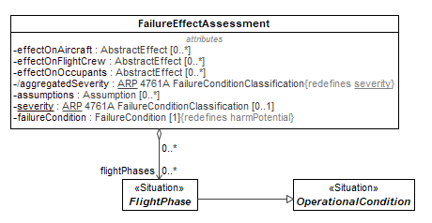
Figure 9.200 - FlightPhase
Constraints
[1] FHA

FailureCondition
Package: FHA Library
isAbstract: Yes
Generalization: AbstractRisk, Hazard
Description
A condition having an effect on the aircraft and/or its occupants, either direct or consequential, which is caused or contributed to by one or more failures or errors, considering flight phase and relevant adverse operational or environmental conditions, or external events (AMC 25.1309). [Source: ARP 4761A]

Hazard: A condition resulting from failures, external events, errors, or a combination thereof where safety is potentially affected. [Source: ARP 4761A]
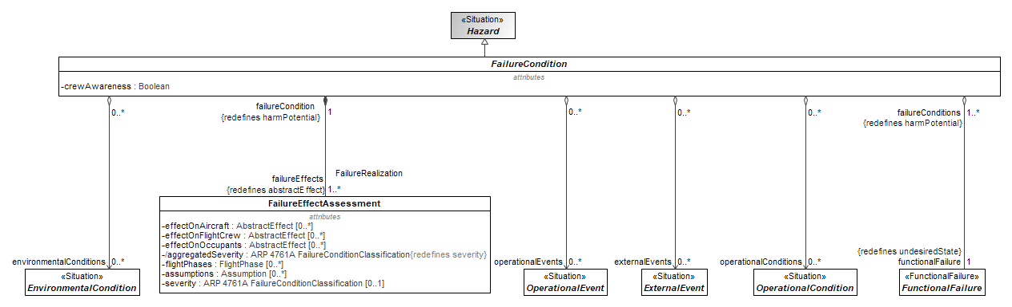
Figure 9.201 - FailureCondition
Attributes
environmentalConditions : EnvironmentalCondition[0..*] (member end of association) | Atmospheric/physical factors within the approved aircraft operating envelope, relevant when evaluating the effects of a failure condition. Example of environmental conditions include weather, HIRF, volcanic ash...
operationalConditions : OperationalCondition[0..*] (member end of association) | Specific state or circumstances under which the aircraft is operated within the approved aircraft operating envelope, relevant when evaluating the effects of a failure condition. Example of operational conditions include aircraft weight, center of gravity, speed...
externalEvents : ExternalEvent[0..*] (member end of association) | An occurrence which has its origin distinct from the aircraft or the system being examined, such as atmospheric conditions (e.g., wind gusts/shear, temperature variations, icing, lightning strikes), operating environment (e.g., runway conditions, conditions of communication, navigation, and surveillance services), cabin and baggage fires, and bird-strike. The term is not intended to cover sabotage. [Source: ARP 4761A]
operationalEvents : OperationalEvent[0..*] (member end of association) | Distinct occurrences and flight operations performed in response to specific occurrences or failures. These events may be considered operational events if they meet certain criteria, such as occurring at a distinct time, having a known statistical probability or rate of occurrence, and being infrequent or unlikely for a particular aircraft during its service life. Examples of operational events are: rejected take-off, or in-flight diversion. [Source: ARP4761A].
crewAwareness : Boolean | Understanding and perception that flight crew members have regarding a failure condition.
functionalFailure : FunctionalFailure[1] (member end of association, redefines undesiredState) | An occurrence which affects the operation of an aircraft, system, equipment, item, or piece-part such that it can no longer function as intended (this includes both loss of function and malfunction). Failure conditions can be broadly categorized as the loss of a function or as a malfunction. Note: Errors may cause Failures but are not considered to be Failures. [Source: ARP 4761A]  Function: Intended behavior of an aircraft, system, equipment, or item regardless of implementation. [Source: ARP 4761A
Constraints
[1] FHA

IDAL
Package: FHA Library
isAbstract: No
Generalization: DAL
Description
The level of rigor of development assurance tasks performed on Item(s); e.g., IDAL is the appropriate software level in DO-178C/ED-12C, and design assurance level in DO-254/ED-80 objectives that need to be satisfied for an item. [Source: ARP 4761A]
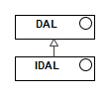
Figure 9.202 - IDAL
Constraints
[1] FHA

OperationalEvent
Package: FHA Library
isAbstract: Yes
Generalization: AbstractEvent
Applied Stereotype: «Situation»
Description
Distinct occurrences and flight operations performed in response to specific occurrences or failures. These events may be considered operational events if they meet certain criteria, such as occurring at a distinct time, having a known statistical probability or rate of occurrence, and being infrequent or unlikely for a particular aircraft during its service life. Examples of operational events are: rejected take-off, or in-flight diversion. [Source: ARP4761A].
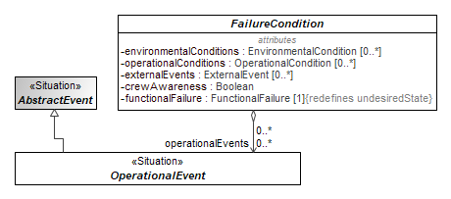
Figure 9.203 - OperationalEvent
Constraints
[1] FHA

PartialLossOfFunction
Package: FHA Library
isAbstract: No
Generalization: FunctionalFailure
Applied Stereotype: «FunctionalFailure»
Description
Partial losses of function are conditions where the function can still be performed but only at reduced capability (e.g., reduced effectiveness or with increased difficulty). [Source: ARP 4761A]

Malfunction
Package: FHA Library
isAbstract: No
Generalization: FunctionalFailure
Applied Stereotype: «FunctionalFailure»
Description
A condition where the operation of a function is different than intended, excluding the loss of function [Source: ARP 4761A]

LossOfFunction
Package: FHA Library
isAbstract: No
Generalization: FunctionalFailure
Applied Stereotype: «FunctionalFailure»
Description
Loss of function may be total or partial. Total loss of function is a condition where the function cannot be performed by any means. [Source: ARP 4761A]

ARP 4761A FailureConditionClassification
Package: FHA Library
isAbstract: No
Applied Stereotype: «ValueType»
Description
All those planned and systematic actions used to substantiate, at an adequate level of confidence, that development errors have been identified and corrected such that the system satisfies the applicable certification basis (derived from AC 25.1309 Draft ARSENAL revised and AMC 25.1309). [Source ARP 4761A]
Constraints
[1] FHA
- Methods::FHA::FHA Profile

FunctionalFailure
Package: FHA Profile
isAbstract: No
Generalization: «Situation»
Extension: Class
Description
An occurrence which affects the operation of an aircraft, system, equipment, item, or piece-part such that it can no longer function as intended (this includes both loss of function and malfunction). Failure conditions can be broadly categorized as the loss of a function or as a malfunction. Note: Errors may cause Failures but are not considered to be Failures. [Source: ARP 4761A]

Function: Intended behavior of an aircraft, system, equipment, or item regardless of implementation. [Source: ARP 4761A]
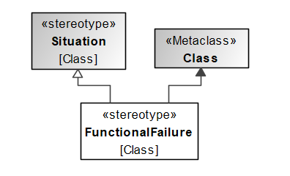
Figure 9.204 - FunctionalFailure

FunctionalFailure Customization
Package: FHA Profile
isAbstract: No
Applied Stereotype: «Customization»
Description
Attributes
Traceability :
Behavior : Element[0..*]

  - Methods::RBD
A Reliability Block Diagram (RBD) is a graphical representation used in reliability engineering to analyze the reliability and availability of complex systems. It is a method for assessing the performance of systems composed of multiple components, sub-systems, or processes. In an RBD, system elements (components or groups of components defined as an assemblies, subsystems, or other system architectural elements) are depicted as blocks, and these blocks are connected by lines to represent how they are interconnected or dependent on each other. The goal is to evaluate the overall reliability and availability of the entire system by considering the reliability characteristics of each component and their interconnections.
The method is based on IEC 61078:2016 (“Reliability block diagrams”) includes the following concepts:
- Probability distributions, cumulative distribution functions (CDFs), probability density functions (PDFs), and hazard functions (the exponential, Weibull, and lognormal distributions are included in the library but the framework allows for additional distributions)
- Component reliability, failure probability, restoration completion probability, failure rate, restoration rate, mean time to failure, and mean time to restore
- Restorable and non-restorable systems
- System reliability and availability calculations for series, parallel, homogeneous k-out-n, and heterogeneous k-out-of-n systems

Mathematical methods for calculation of cumulative distributions functions (CDFs), probability density functions (PDFs), hazard functions, and mean values of distributions are based on U.S. National Institute of Standards Handbook of Engineering Statistics (see references).
    - Methods::RBD::RBD Library

AbstractReliabilitySituation
Package: RBD Library
isAbstract: Yes
Generalization: AnySituation
Applied Stereotype: «Situation»
Description
The parent situation of the RBD library. Specialization of AnySituation from Core Library.
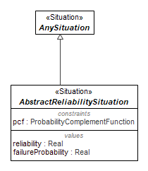
Figure 9.205 - AbstractReliabilitySituation
Attributes
reliability : Real | Value property for reliability in AbstractReliabilityituation (used to hold result of system or component reliability in non-restorable and restorable systems)
failureProbability : Real | Value property that is the complement of reliability
pcf : ProbabilityComplementFunction | Constraint property for calculating the complement of a value between 0 and 1

Restorable
Package: RBD Library
isAbstract: Yes
Generalization: AbstractReliabilitySituation
Applied Stereotype: «Situation»
Description
Specialization of AbstractReliabilitySituation for restorable systems. Parent of ResteorabailitySystemReliabiltiySituation and RestorableComponentReliabilitySituationSituation. Also has composition relationship (owns) RestorableSystemReliabilitySituation to enable recursion
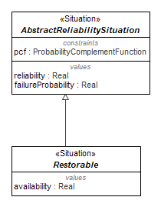
Figure 9.206 - Restorable
Attributes
availability : Real | Availability value property of Restorable

ComponentReliabilitySituation
Package: RBD Library
isAbstract: Yes
Generalization: AbstractReliabilitySituation
Applied Stereotype: «Situation»
Description
Situation for Components in RBDs. Specialization of AbstractReliabiltiySituation and parent of RestorableComponentReliabilitiySituation, NonrestorableComponentReliabilitiySituations. Owns Reliability ParameterGroup constraint and failurerate, shape, scale, and location distribution parameters that it provides its children
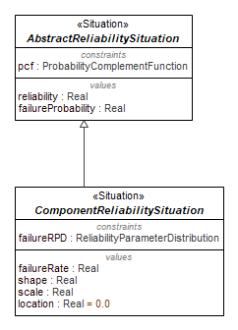
Figure 9.207 - ComponentReliabilitySituation
Attributes
failureRPD : ReliabilityParameterDistribution | Constraint property for expression of the reliability probability distirbution
failureRate : Real | Value property for the failure rate
shape : Real | Value property for the shape parameter of the reliability propbability distribution
scale : Real | Value property for the scale parameter of the reliability propbability distribution
location : Real | Value property for the location parameter of the reliability propbability distribution

RestorableComponentReliabilitySituation
Package: RBD Library
isAbstract: Yes
Generalization: ComponentReliabilitySituation, Restorable
Applied Stereotype: «Situation»
Description
Situation for restorable (repairable) component RBDs. Specialization of ComponentReliabilitySituation. Owns restorationRPG (Reliability Parameter Group) and RatioOfPartTotal (for determining availability). Value properties include MTBF, MTTR, restoration distribution parameters (shape, scale, and location), restorationCompletionProbability (calculated from restoration CDF) and restorationrate (calculated from restoration hazard function, i.e., ratio of PDF to CDF)
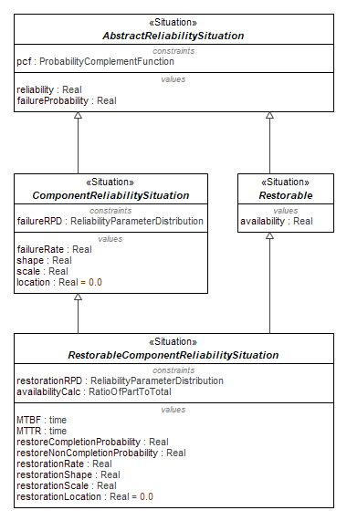
Figure 9.208 - RestorableComponentReliabilitySituation
Attributes
MTBF : time | Value property for Mean Time Between Failures (MTBF is used for restorable systems)
MTTR : time | Value property for Mean Time to Restoration
restorationRPD : ReliabilityParameterDistribution | Constraint property for restoration probabiltiy distribution
restoreCompletionProbability : Real | Value property for completion probability of restoration action (the value of the CDF for resteoration at a specified time)
restoreNonCompletionProbability : Real | Value property for the complement of the restoration completion probability
restorationRate : Real | Value property for the ratio of the restoration pdf to the restoration CDF at a specified time
restorationShape : Real | Value property shapre parameter of the restoration probability distribution
restorationScale : Real | Value property for the scale parameter of the restoration distribution
restorationLocation : Real | Value property for the location parameter of the restoration distribution (value of the location parameter must be less than the specified time)
availabilityCalc : RatioOfPartToTotal | Constraint property for the calculation of availability

NonRestorableComponentReliabilitySituation
Package: RBD Library
isAbstract: Yes
Generalization: ComponentReliabilitySituation
Applied Stereotype: «Situation»
Description
Situation for norestorable component RBDs. Specialization of ComponentReliabilitySituation. Owns MTTF value property
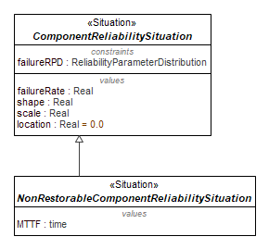
Figure 9.209 - NonRestorableComponentReliabilitySituation
Attributes
MTTF : time | Value property for the Mean Time to Failure (MTTF is used for non-restorable components or systems)

SystemReliabilitySituation
Package: RBD Library
isAbstract: Yes
Generalization: AbstractReliabilitySituation, Scenario
Applied Stereotype: «Situation»
Description
The parent situation for calculating a system reliability or availablity. Speciaalization of AbstractReliabilitySituation.
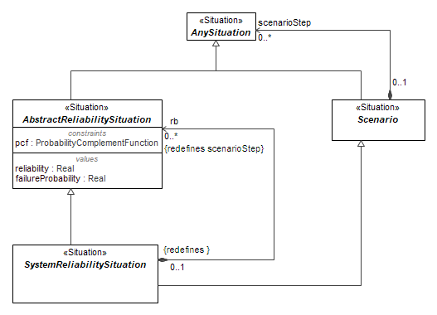
Figure 9.210 - SystemReliabilitySituation
Attributes
rb : AbstractReliabilitySituation[0..*] (member end of association, redefines scenarioStep) | Part property of SystemReliabiltiySituation of type Restorable (see Restorable situation)

RestorableSystemReliabilitySituation
Package: RBD Library
isAbstract: Yes
Generalization: Restorable, SystemReliabilitySituation
Applied Stereotype: «Situation»
Description
Situation for Resetorable Systems. Specialization of SystemReliabiltiySituation and part of Restorable Situation
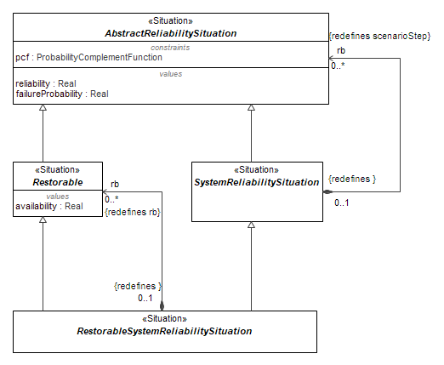
Figure 9.211 - RestorableSystemReliabilitySituation
Attributes
rb : Restorable[0..*] (member end of association, redefines rb) | Part property of RestorableSystemReliabiltiySituation of type Restorable (see Restorable situation)

InSeries
Package: RBD Library
isAbstract: Yes
Generalization: SystemReliabilitySituation
Applied Stereotype: «Situation»
Description
Situation for calculation of reliability oir avaliability for series systems. Specialization of SystemReliabilitySituation. Owns InSeries constraint block.
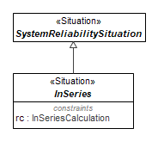
Figure 9.212 - InSeries
Attributes
rc : InSeriesCalculation | Constraint property for series reliability calculation

RestorableInSeries
Package: RBD Library
isAbstract: Yes
Generalization: InSeries, RestorableSystemReliabilitySituation
Applied Stereotype: «Situation»
Description
Situation for calculation of avaliability for restorable series systems. Specialization of SystemReliabilitySituation and the InSeries situation. Owns InSeries constraint block.
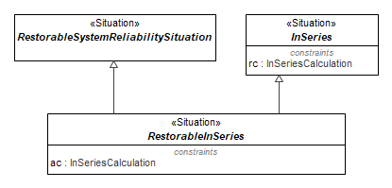
Figure 9.213 - RestorableInSeries
Attributes
ac : InSeriesCalculation | Constraint property for availability

InParallel
Package: RBD Library
isAbstract: Yes
Generalization: SystemReliabilitySituation
Applied Stereotype: «Situation»
Description
Situation for calculation of reliability oir avaliability for parallel systems. Specialization of SystemReliabilitySituation. Owns InParallel constraint block.
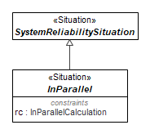
Figure 9.214 - InParallel
Attributes
rc : InParallelCalculation | Constraint property for availability

RestorableInParallel
Package: RBD Library
isAbstract: Yes
Generalization: InParallel, RestorableSystemReliabilitySituation
Applied Stereotype: «Situation»
Description
Situation for calculation of avaliability for restorable parallel systems. Specialization of RestorableSystemReliabilitySituation and InParallel situation. Owns InParallel constraint block.
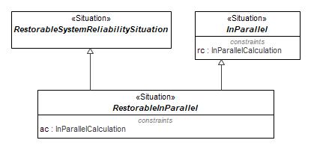
Figure 9.215 - RestorableInParallel
Attributes
ac : InParallelCalculation | Constraint property for availability

HomogeneousKofN
Package: RBD Library
isAbstract: Yes
Generalization: SystemReliabilitySituation
Applied Stereotype: «Situation»
Description
Situation for calculation of reliability or availablity for Homogenerous K out of N systems. Specialization of SystemReliabilitySituation. Owns HomogenousKofN constraint block.
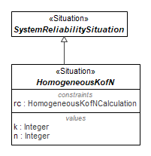
Figure 9.216 - HomogeneousKofN
Attributes
rc : HomogeneousKofNCalculation | Constraint propertyfor series reliability calculation
k : Integer | Value property for number of items needed for operation
n : Integer | Value property for Number of items installed or ready at start of operation

RestorableHomogeneousKofN
Package: RBD Library
isAbstract: Yes
Generalization: HomogeneousKofN, RestorableSystemReliabilitySituation
Applied Stereotype: «Situation»
Description
Situation for calculation of avaliability for Homogeneous K out of N systems. Specialization of RestorablSystemReliabiltiySituation and the InSeries situation. Owns KofN constraint block.
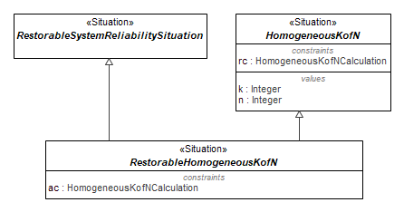
Figure 9.217 - RestorableHomogeneousKofN
Attributes
ac : HomogeneousKofNCalculation | Constraint property for availability

HeterogenerousKofN
Package: RBD Library
isAbstract: Yes
Generalization: SystemReliabilitySituation
Applied Stereotype: «Situation»
Description
Situation for calculation of reliability or availablity for Heterogenerous K out of N systems. Specialization of SystemReliabilitySituation. Owns HeterogenousKofN constraint block.
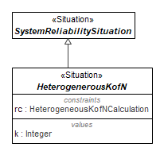
Figure 9.218 - HeterogenerousKofN
Attributes
rc : HeterogeneousKofNCalculation | Constraint property for series reliability calculation
k : Integer | Number of items needed for operation

RestorableHeterogeneousKofN
Package: RBD Library
isAbstract: Yes
Generalization: HeterogenerousKofN, RestorableSystemReliabilitySituation
Applied Stereotype: «Situation»
Description
Situation for calculation of avaliability for Heterogeneous K out of N systems. Specialization of RestorablSystemReliabiltiySituation and the InSeries situation. Owns HeterogenousKofN constraint block.
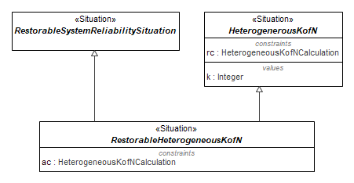
Figure 9.219 - RestorableHeterogeneousKofN
Attributes
ac : HeterogeneousKofNCalculation | Constraint property for availability
    - Methods::RBD::RBD Library::ConstraintBlocks

Methods::RBD::RBD Library::ConstraintBlocks::Probability

OneVariableFunction
Package: Probability
isAbstract: Yes
Applied Stereotype: «ConstraintBlock»
Description
This is an abstract constraint block which defines an input and an output for a constraint expression which has a single input and output
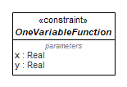
Figure 9.220 – OneVariableFunction
Attributes
x : Real | The input parameter
y : Real | The output parameter

ProbabilityComplementFunction
Package: Probability
isAbstract: No
Generalization: OneVariableFunction
Applied Stereotype: «ConstraintBlock»
Description
This constraint block calculates the complemenet (i.e., 1 - ) the input and is used for converting behind reliability and failure probability or between restoration completion success probability and restoration completion failure probabiltiy
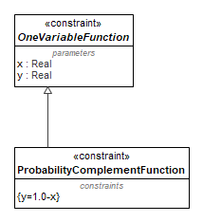
Figure 9.221 – ProbabilityComplementFunction

Constraints
[1] | y=1.0-x

ReciprocalFunction
Package: Probability
isAbstract: No
Generalization: OneVariableFunction
Applied Stereotype: «ConstraintBlock»
Description
Provides the reciprocal of the input
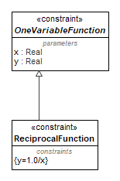
Figure 9.222 – ReciprocalFunction
Constraints
[1] | y=1.0/x

RatioOfPartToTotal
Package: Probability
isAbstract: No
Applied Stereotype: «ConstraintBlock»
Description
A constraint expression to calculate the proportion of one value to its sum (e.g., availability = MTBF/(MTBF+MTTR))
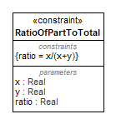
Figure 9.223 – RationOfPartToTotal
Attributes
x : Real | The numerator
y : Real | The other value
ratio : Real | =x/(x+y)
Constraints
[1] | ratio = x/(x+y)

ProbabilityDensityFunction
Package: Probability
isAbstract: Yes
Applied Stereotype: «ConstraintBlock»
Description
This is an abstract constraint block which defines 3 inputs (shape, scale, and locatrion) and one output for a probability density function
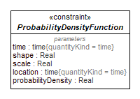
Figure 9.224 – ProbabilityDensityFunction
Attributes
time : time | The specified operating (exposure) time
shape : Real | the shape parameter of a probability distribution (see NIST/Sematech Engineering Statistics Handbook, section 8.1.6) https://www.itl.nist.gov/div898/handbook/apr/section1/apr16.htm
scale : Real | the scale parameter of a probability distribution (see NIST/Sematech Engineering Statistics Handbook, section 8.1.6) https://www.itl.nist.gov/div898/handbook/apr/section1/apr16.htm
location : time | the location parameter of a probability distribution (see NIST/Sematech Engineering Statistics Handbook, section 8.1.6) https://www.itl.nist.gov/div898/handbook/apr/section1/apr16.htm
probabilityDensity : Real | The output parameter providing the value of the probability density function at the specified operating time

ExponentialProbabilityDensityFunction
Package: Probability
isAbstract: No
Generalization: ProbabilityDensityFunction
Applied Stereotype: «ConstraintBlock»
Description
This constraint block calculates the cumulative distribution (CDF) for function for the exponential distribution.
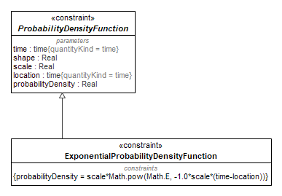
Figure 9.225 – ExponentialProbabilityDensityFunction
Constraints
[1] | probabilityDensity = scale*Math.pow(Math.E, -1.0*scale*(time-location))

WeibullProbabilityDensityFunction
Package: Probability
isAbstract: No
Generalization: ProbabilityDensityFunction
Applied Stereotype: «ConstraintBlock»
Description
This constraint block calculates the probablity desnity function (PDF) for function for the Weibull distribution.
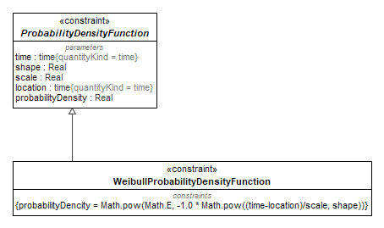
Figure 9.226 – WeibullProbabilityDensityFunction
Constraints
[1] | probabilityDencity = Math.pow(Math.E, -1.0 * Math.pow((time-location)/scale, shape))

LognormalProbabilityDensityFunction
Package: Probability
isAbstract: No
Generalization: ProbabilityDensityFunction
Applied Stereotype: «ConstraintBlock»
Description
This constraint block calculates the probablity desnity function (PDF) for function for the lognormal distribution.
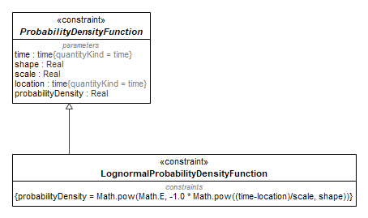
Figure 9.227 – LognormalProbabilityDensityFunction
Constraints
[1] | probabilityDensity = Math.pow(Math.E, -1.0 * Math.pow((time-location)/scale, shape))

CumulativeDistributionFunction
Package: Probability
isAbstract: Yes
Applied Stereotype: «ConstraintBlock»
Description
This abstract constraint block defines the parameters and is the parent of specific cumulative distribution constraint blocks (exponential, Weibull, lognormal, etc.). The parameters include the shape, scale, and location paraemters of the distribtuion, the time at which the value is to be evaluated, and the resultant probability (an output result). This probability is defined for the reliabiltiy distribution. Note that the cumulative is for the reliabiltiy distribution, which is often the complement of the distribution used by other software tools (e.g., Excel or R)
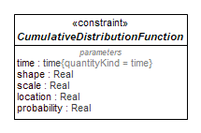
Figure 9.228 – CumulativeDistributionFunction
Attributes
time : time | The time at which the CDF is evaluated. If a location parameter is used, then the value of time must be greater than the value of the location paraemter
shape : Real | The shape parameter for the CDF
scale : Real | The scale parameter for the CDF
location : Real | The location parameter (in units of time) for the CDF
probability : Real | The output probability calculated by the CDF

ExponentialCumulativeDistributionFunction
Package: Probability
isAbstract: No
Generalization: CumulativeDistributionFunction
Applied Stereotype: «ConstraintBlock»
Description
This constraint block calculates the cumulative distribution (CDF) for function for the exponential distribution. See Cumulative Distribution Function constraint block note explaining how the CDF is defined.
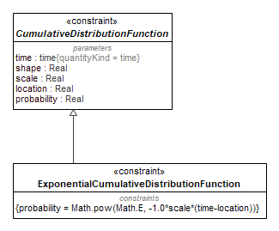
Figure 9.229 – ExponentialCumulativeDistributionFunction
Constraints
[1] | probability = Math.pow(Math.E, -1.0*scale*(time-location))

WeibullCumulativeDistributionFunction
Package: Probability
isAbstract: No
Generalization: CumulativeDistributionFunction
Applied Stereotype: «ConstraintBlock»
Description
This constraint block calculates the cumulative distribution (CDF) for function for the Weibull distribution. See Cumulative Distribution Function constraint block note explaining how the CDF is defined.
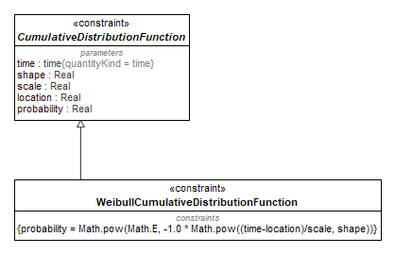
Figure 9.230 – WeibullCumulativeDistributionFunction

Constraints
[1] | probability = Math.pow(Math.E, -1.0 * Math.pow((time-location)/scale, shape))

LognormalCumulativeDistributionFunction
Package: Probability
isAbstract: No
Generalization: CumulativeDistributionFunction
Applied Stereotype: «ConstraintBlock»
Description
This constraint block calculates the cumulative distribution (CDF) for function for the lognormal distribution. See Cumulative Distribution Function constraint block note explaining how the CDF is defined.
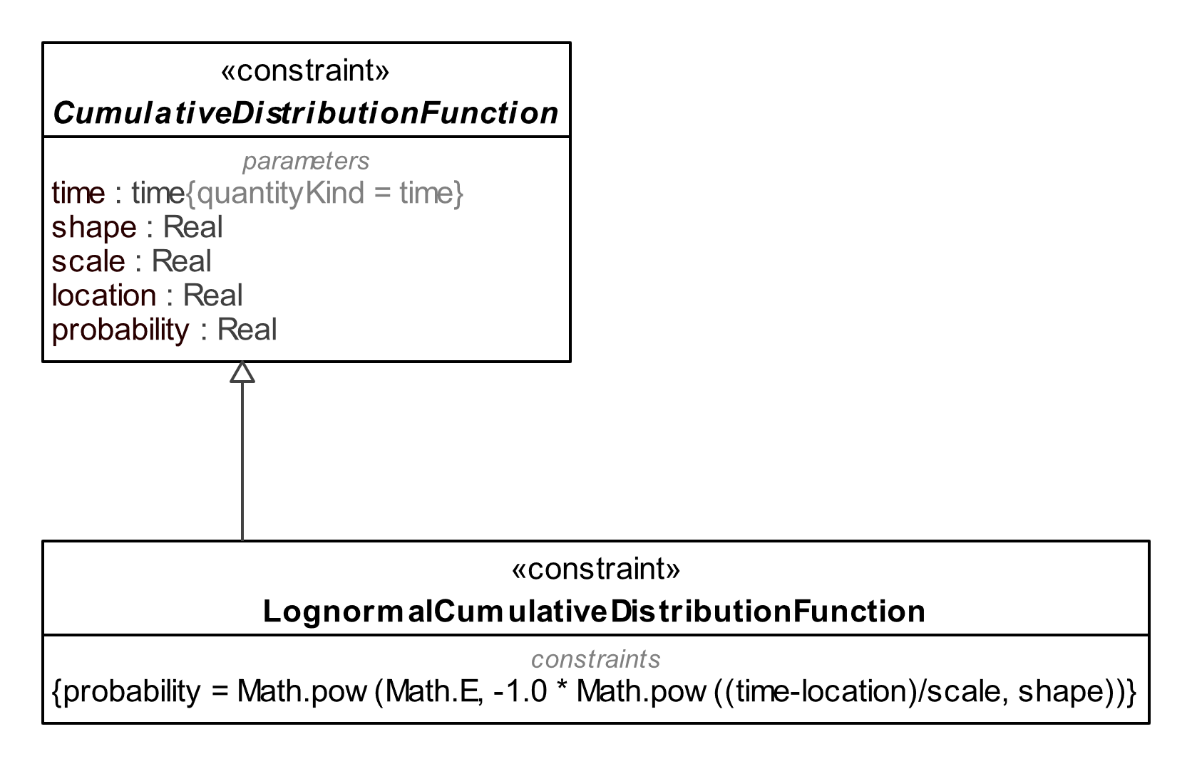
Figure 9.231 – LognormalCumulativeDistributionFunction
Constraints
[1] | probability = Math.pow(Math.E, -1.0 * Math.pow((time-location)/scale, shape))

MeanFunction
Package: Probability
isAbstract: Yes
Applied Stereotype: «ConstraintBlock»
Description
This abstract constraint blocks defines the input and output paraemters for calculating the mean and is the parent of specific cumulative distribution constraint blocks (exponential, Weibull, lognormal, etc.). The parameters include the shape, scale, and location paraemters of the distribtuion, the time at which the value is to be evaluated, and the resultant probability (an output result). The mean is defined for the reliabiltiy distribution.
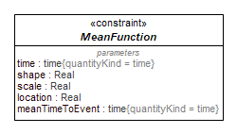
Figure 9.232 – MeanFunction
Attributes
time : time | The time at which the mean function is evaluated. If a location parameter is used, then the value of time must be greater than the value of the location paraemter
shape : Real | The shape parameter for the probabiltiy distribution for which the mean is being calculated
scale : Real | The scale parameter of the probabiltiy distribution function for which the mean is being calculated
location : Real | The location parameer of the probabiltiy distribution function for which the mean is being calculated
meanTimeToEvent : time | The output of the mean function

ExponentialMeanFunction
Package: Probability
isAbstract: No
Generalization: MeanFunction
Applied Stereotype: «ConstraintBlock»
Description
This constraint block calculates the mean of the exponential function (i.e., MTBF or MTTR). Note that for the exponential function, the mean is equiavlent to the reciprocal of the hazard function.
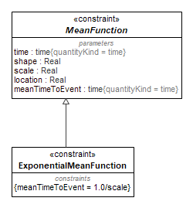
Figure 9.233 – ExponentialMeanFunction
Constraints
[1] | meanTimeToEvent = 1.0/scale

WeibullMeanFunction
Package: Probability
isAbstract: No
Generalization: MeanFunction
Applied Stereotype: «ConstraintBlock»
Description
This constraint block calculates the mean of the Webiull distribution (i.e., MTBF or MTTR). Note that for the exponential function, the mean is equiavlent to the reciprocal of the hazard function.
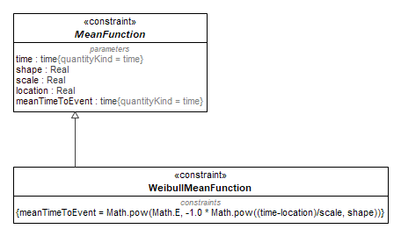
Figure 9.234 – WeibullMeanFunction
Constraints
[1] | meanTimeToEvent = Math.pow(Math.E, -1.0 * Math.pow((time-location)/scale, shape))

LognormalMeanFunction
Package: Probability
isAbstract: No
Generalization: MeanFunction
Applied Stereotype: «ConstraintBlock»
Description
This constraint block calculates the mean of the lognormal function (i.e., MTBF or MTTR). Note that for the exponential function, the mean is equiavlent to the reciprocal of the hazard function.
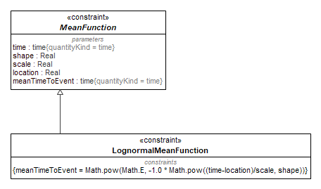
Figure 9.235 – LognormalMeanFunction
Constraints
[1] | meanTimeToEvent = Math.pow(Math.E, -1.0 * Math.pow((time-location)/scale, shape))

HazardFunction
Package: Probability
isAbstract: Yes
Applied Stereotype: «ConstraintBlock»
Description
This abstract constraint block defines the parameters used in the hazard function. The hazard function is the ratio of the probability density function and the cumulative distribtuion function
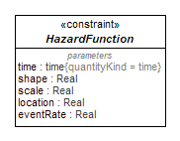
Figure 9.236 – HazardFunction
Attributes
time : time | The time at which the hazard function is being evaluated
shape : Real | The shape parameter for the hazard for which the hazard is being calculated
scale : Real | The scale parameter for the hazard function for which the sis being calculated
location : Real | The location parameter for the hazard function for which the sis being calculated
eventRate : Real | The output of the hazard distribution function

ExponentialHazardFunction
Package: Probability
isAbstract: No
Generalization: HazardFunction, MeanFunction
Applied Stereotype: «ConstraintBlock»
Description
This is the constraint block is a specialization of the hazard function constraint block and calculates the hazard function (failure rate) for the exponential distribution. Note that for the exponential distribution, the hazard function is a constant over time.
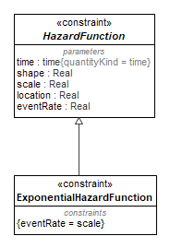
Figure 9.237 – ExponentialHazardFunction
Constraints
[1] | eventRate = scale

WeibullHazardFunction
Package: Probability
isAbstract: No
Generalization: HazardFunction, MeanFunction
Applied Stereotype: «ConstraintBlock»
Description
This is the constraint block is a specialization of the hazard function constraint block and calculates the hazard function (failure rate) for the Weibull distribution. .
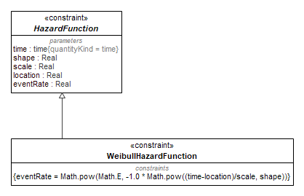
Figure 9.238 – WeibullHazardFunction
Constraints
[1] | eventRate = Math.pow(Math.E, -1.0 * Math.pow((time-location)/scale, shape))

LognormalHazardFunction
Package: Probability
isAbstract: No
Generalization: HazardFunction, MeanFunction
Applied Stereotype: «ConstraintBlock»
Description
This is the constraint block is a specialization of the hazard function constraint block and calculates the hazard function (failure rate) for the lognormal distribution. .
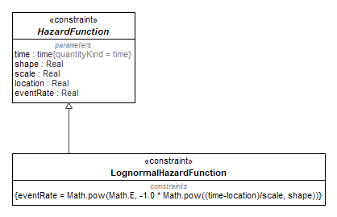
Figure 9.239 – LognormalHazardFunction
Constraints
[1] | eventRate = Math.pow(Math.E, -1.0 * Math.pow((time-location)/scale, shape))

ReliabilityParameterDistribution
Package: Probability
isAbstract: Yes
Applied Stereotype: «ConstraintBlock»
Description
This constraint block is the parent of probability distributions and parameters. It owns the pdf, cdf, mean, hazard function, and compelement constraint blocks. The parameters inherited by the children disributions include shape, scale, location, the instantaneous probability density value, probability value, complement value (e.g., failure probability from reliability), mean time to event (e.g., mean time between failures or mean time to failure), and event rate (e.g., failure rate). It also includes a time parameter which is the argument for the other paraemters
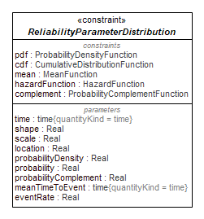
Figure 9.240 – ReliabilityParameterDistribution

Attributes
time : time | The time at which the probability function is to be evaluated. Time must be greater than the location value
shape : Real | The shape parameter of the distribution
scale : Real | The scale parameter of the distribution
location : Real | The location parameter of the distribution
probabilityDensity : Real | The value of the probability density function at a specified time
probability : Real | The probability (i.e., value of the CDF) at a specified time
pdf : ProbabilityDensityFunction | The constraint expression of the probability density function
cdf : CumulativeDistributionFunction | The constraint expression for the cumulative density function
mean : MeanFunction | The constraint expression for the mean of the CDF
hazardFunction : HazardFunction | The constraint expression for the hazard function (ratio of PDF to CDF)
complement : ProbabilityComplementFunction | A general expression to take the complement (i.e., 1-value).
probabilityComplement : Real | A general expression to take the complement of the probability (i.e., 1-value). The value for which the complement is calculated must be less than 1
meanTimeToEvent : time | The constraint expression to calculate the mean of the probability distribution
eventRate : Real | The constraint expression for determining the event rate (e.g., failure rate or repair rate) of the probability distribution

ExponentialDistribution
Package: Probability
isAbstract: No
Generalization: ReliabilityParameterDistribution
Applied Stereotype: «ConstraintBlock»
Description
This constraint block calculates owns 4 lower level constraint blocks for calculating the values of the cumulative, density, and hazard functions, as well as the mean for the exponential distribution. Note that for the exponential distribuhtion function, only scale and location parameters are defined
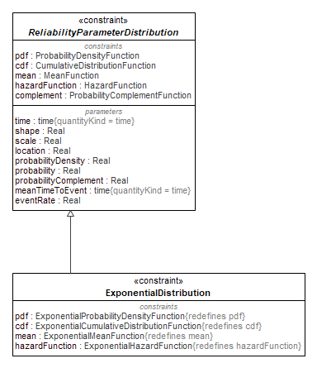
Figure 9.241 – ExponentialDistribution
Attributes
pdf : ExponentialProbabilityDensityFunction, redefines pdf | The PDF for the exponential distribution defined in the NIST/Sematech Engineering Statistics Handbook, section 8.1.6, https://www.itl.nist.gov/div898/handbook/apr/section1/apr16.htm
cdf : ExponentialCumulativeDistributionFunction, redefines cdf | The CDF for the exponential distribution defined in the NIST/Sematech Engineering Statistics Handbook, section 8.1.6, https://www.itl.nist.gov/div898/handbook/apr/section1/apr16.htm
mean : ExponentialMeanFunction, redefines mean | The mean for the exponential distribution defined in the NIST/Sematech Engineering Statistics Handbook, section 8.1.6, https://www.itl.nist.gov/div898/handbook/apr/section1/apr16.htm
hazardFunction : ExponentialHazardFunction, redefines hazardFunction | The hazard function for the exponential distribution defined in the NIST/Sematech Engineering Statistics Handbook, section 8.1.6, https://www.itl.nist.gov/div898/handbook/apr/section1/apr16.htm

WeibullDistribution
Package: Probability
isAbstract: No
Generalization: ReliabilityParameterDistribution
Applied Stereotype: «ConstraintBlock»
Description
This constraint block calculates owns 4 lower level constraint blocks for calculating the values of the cumulative, density, and hazard functions, as well as the mean for the Weibull distribution.
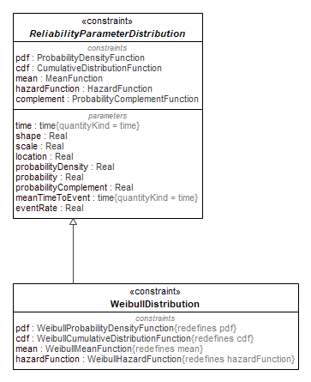
Figure 9.242 – WeibullDistribution

Attributes
pdf : WeibullProbabilityDensityFunction, redefines pdf | The PDF for the Weibull distribution defined in the NIST/Sematech Engineering Statistics Handbook, section 8.1.6, https://www.itl.nist.gov/div898/handbook/apr/section1/apr16.htm
cdf : WeibullCumulativeDistributionFunction, redefines cdf | The PDF for the Weibull distribution defined in the NIST/Sematech Engineering Statistics Handbook, section 8.1.6, https://www.itl.nist.gov/div898/handbook/apr/section1/apr16.htm
mean : WeibullMeanFunction, redefines mean | The mean for the Weibull distribution defined in the NIST/Sematech Engineering Statistics Handbook, section 8.1.6, https://www.itl.nist.gov/div898/handbook/apr/section1/apr16.htm
hazardFunction : WeibullHazardFunction, redefines hazardFunction | The hazard function for the Weibull distribution defined in the NIST/Sematech Engineering Statistics Handbook, section 8.1.6, https://www.itl.nist.gov/div898/handbook/apr/section1/apr16.htm

LognormalDistribution
Package: Probability
isAbstract: No
Generalization: ReliabilityParameterDistribution
Applied Stereotype: «ConstraintBlock»
Description
This constraint block calculates owns 4 lower level constraint blocks for calculating the values of the cumulative, density, and hazard functions, as well as the mean for the lognormal distribution.
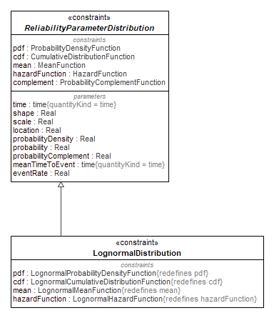
Figure 9.243 – LognormalDistribution
Attributes
pdf : LognormalProbabilityDensityFunction, redefines pdf | The PDF for the lognroml distribution defined in the NIST/Sematech Engineering Statistics Handbook, section 8.1.6, https://www.itl.nist.gov/div898/handbook/apr/section1/apr16.htm
cdf : LognormalCumulativeDistributionFunction, redefines cdf | The CDF for the lognormal distribution defined in the NIST/Sematech Engineering Statistics Handbook, section 8.1.6, https://www.itl.nist.gov/div898/handbook/apr/section1/apr16.htm
mean : LognormalMeanFunction, redefines mean | The mean for the lognormal distribution defined in the NIST/Sematech Engineering Statistics Handbook, section 8.1.6, https://www.itl.nist.gov/div898/handbook/apr/section1/apr16.htm
hazardFunction : LognormalHazardFunction, redefines hazardFunction | The hazard function for the lognormal distribution defined in the NIST/Sematech Engineering Statistics Handbook, section 8.1.6, https://www.itl.nist.gov/div898/handbook/apr/section1/apr16.htm

Methods::RBD::RBD Library::ConstraintBlocks::SystemBlocks

InSeriesCalculation
Package: SystemBlocks
isAbstract: No
Applied Stereotype: «ConstraintBlock»
Description
Constraint block for calculation of series system reliability or availability
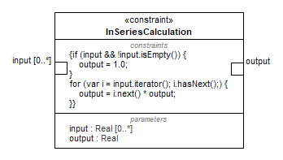
Figure 9.244 – InseriesCalculation
Attributes
input : Real[0..*] | Probabilities (reliablity or availability) of input components
output : Real | Series system reliability or availability
Constraints
[1] | if (input && !input.isEmpty()) {  output = 1.0;  }  for (var i = input.iterator(); i.hasNext();) {  output = i.next() * output;  }

InParallelCalculation
Package: SystemBlocks
isAbstract: No
Applied Stereotype: «ConstraintBlock»
Description
Constraint block for calculation of parallel system reliability or availability
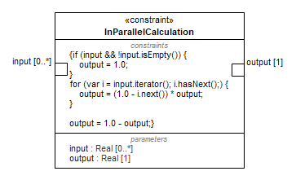
Figure 9.245 – InparalllelCalculation
Attributes
input : Real[0..*] | Reliability or availability of components
output : Real[1] | Reliability or availability of system
Constraints
[1] | if (input && !input.isEmpty()) {  output = 1.0;  }  for (var i = input.iterator(); i.hasNext();) {  output = (1.0 - i.next()) * output;  }  output = 1.0 - output;

HomogeneousKofNCalculation
Package: SystemBlocks
isAbstract: No
Applied Stereotype: «ConstraintBlock»
Description
Constraint block for calculation of k out of n system reliability or availability
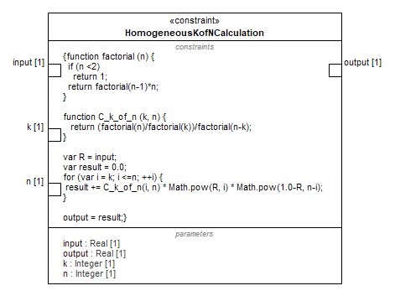
Figure 9.246 – HomogeneousKofNCalculation
Attributes
input : Real[1] | Reliability or availability of components (all components must have equal reliability or availability)
output : Real[1] | k ou tof n system reliability or availability
k : Integer[1] | Number of components or channels needed for system ro operate
n : Integer[1] | Number of components installed in system
Constraints
[1] | function factorial (n) {  if (n <2)  return 1;  return factorial(n-1)*n;  }  function C_k_of_n (k, n) {  return (factorial(n)/factorial(k))/factorial(n-k);  }  var R = input;  var result = 0.0;  for (var i = k; i <=n; ++i) {  result += C_k_of_n(i, n) * Math.pow(R, i) * Math.pow(1.0-R, n-i);  }  output = result;

HeterogeneousKofNCalculation
Package: SystemBlocks
isAbstract: No
Applied Stereotype: «ConstraintBlock»
Description
Constraint block for calculation of k out of n system reliability or availability where components have different reliabilities or availabilities
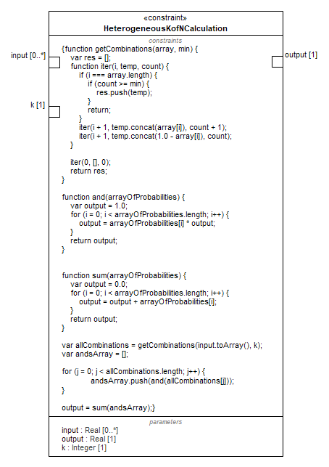
Figure 9.247 – HeterogeneousKofNCalculation

Attributes
input : Real[0..*] | Reliability or availability of components (components do not necessarily have equal reliability or availability)
output : Real[1] | Reliability or availability of system
k : Integer[1] | Number of components or channels needed for system ro operate
Constraints
[1] | function getCombinations(array, min) {  var res = [];  function iter(i, temp, count) {  if (i === array.length) {  if (count >= min) {  res.push(temp);  }  return;  }  iter(i + 1, temp.concat(array[i]), count + 1);  iter(i + 1, temp.concat(1.0 - array[i]), count);  }  iter(0, [], 0);  return res;  }  function and(arrayOfProbabilities) {  var output = 1.0;  for (i = 0; i < arrayOfProbabilities.length; i++) {  output = arrayOfProbabilities[i] * output;  }  return output;  }  function sum(arrayOfProbabilities) {  var output = 0.0;  for (i = 0; i < arrayOfProbabilities.length; i++) {  output = output + arrayOfProbabilities[i];  }  return output;  }  var allCombinations = getCombinations(input.toArray(), k);  var andsArray = [];  for (j = 0; j < allCombinations.length; j++) {  andsArray.push(and(allCombinations[j]));  }  output = sum(andsArray);
    - Methods::RBD::RBD Profile

ReliabilitySituation
Package: RBD Profile
isAbstract: Yes
Generalization: Situation
Extension: Class
Description
A marker stereotype for all reliability situations. See AbstractReliabilitySituation library class for definition.
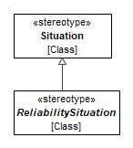
Figure 9.248 – ReliabilitySituation

Restorable
Package: RBD Profile
isAbstract: No
Extension: Class
Description
A mixin stereotype for all restorable reliability situations - both component and system. See Restorable library class for definition.
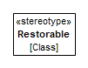
Figure 9.249 – Restorable
Constraints
[1] RestorableIsRestorable | self.base_Class->asSet()->closure(general).name->includes('Restorable')

ComponentReliability
Package: RBD Profile
isAbstract: No
Generalization: ReliabilitySituation
Extension: Class
Description
A marker stereotype for non-composite reliability situations. See ComponentReliabilitySituation library class for definition.
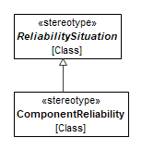
Figure 9.250 –ReliabilitySituation
Constraints
[1] ComponentReliabilityIsComponentReliabilitySituation | self.base_Class->asSet()->closure(general).name->includes('ComponentReliabilitySituation')

SystemReliability
Package: RBD Profile
isAbstract: Yes
Generalization: ReliabilitySituation
Extension: Class
Description
A marker stereotype for composite reliability situations. See SystemReliabilitySituation library class for definition.
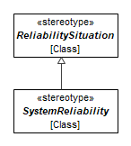
Figure 9.251 –SystemReliability

InSeries
Package: RBD Profile
isAbstract: No
Generalization: SystemReliability
Extension: Class
Description
A marker stereotype for in-series composite reliability situations. See InSeries library class for definition.
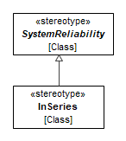
Figure 9.252 – InSeries
Constraints
[1] InSeriesIsInSeries | self.base_Class->asSet()->closure(general).name->includes('InSeries')

InParallel
Package: RBD Profile
isAbstract: No
Generalization: SystemReliability
Extension: Class
Description
A marker stereotype for in-parallel composite reliability situations. See InParallel library class for definition.
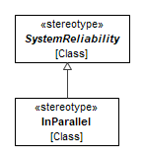
Figure 9.253 – InParallel
Constraints
[1] InParallelIsInParallel | self.base_Class->asSet()->closure(general).name->includes('InParallel')

HomogeneousKofN
Package: RBD Profile
isAbstract: No
Generalization: SystemReliability
Extension: Class
Description
A marker stereotype for homogeneous k-of-n composite reliability situations. See HomogeneousKofN library class for definition.
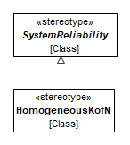
Figure 9.254 – HomogeneousKofN
Constraints
[1] HomogeneousKofNIsHomogeneousKofN | self.base_Class->asSet()->closure(general).name->includes('HomogeneousKofN')

HeterogeneousKofN
Package: RBD Profile
isAbstract: No
Generalization: SystemReliability
Extension: Class
Description
A marker stereotype for heterogeneous k-of-n composite reliability situations. See HeterogenerousKofN library class for definition.
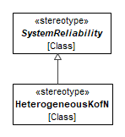
Figure 9.255 – HeterogeneousKofN
Constraints
[1] HeterogeneousKofNIsHeterogeneousKofN | self.base_Class->asSet()->closure(general).name->includes('HeterogeneousKofN')

- Views
- Core
- Core::Core Library
View Core::Core Library::Core Library
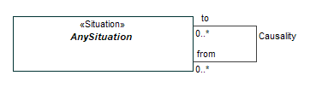
Figure 10.1 – Core Library

Elements
- AnySituation
- Causality
- Core::Core Profile
View Core::Core Profile::CoreProfile

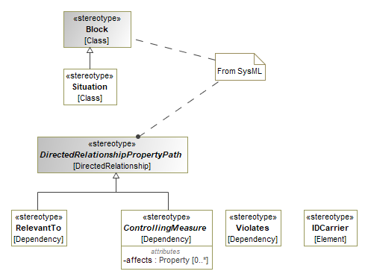
Figure 10.2 – CoreProfile

Elements
- ControllingMeasure
- RelevantTo
- Situation
- Violates
- General
- General::General Concepts Library
View General::General Concepts Library::General Concepts Library

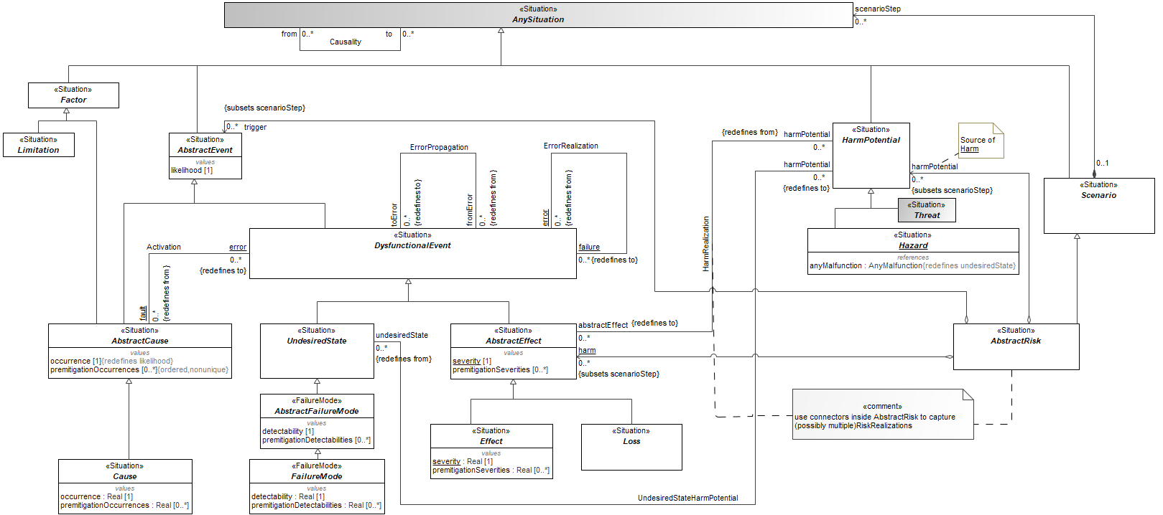
Figure 10.3 - General Concepts Library

Elements
- AbstractCause
- AbstractEffect
- AbstractEvent
- AbstractFailureMode
- AbstractRisk
- Activation
- AnySituation
- Causality
- Cause
- DysfunctionalEvent
- Effect
- ErrorPropagation
- ErrorRealization
- FailureMode
- HarmPotential
- Hazard
- Scenario
- UndesiredState
- General::General Concepts Profile
View General::General Concepts Profile::General Concepts Profile

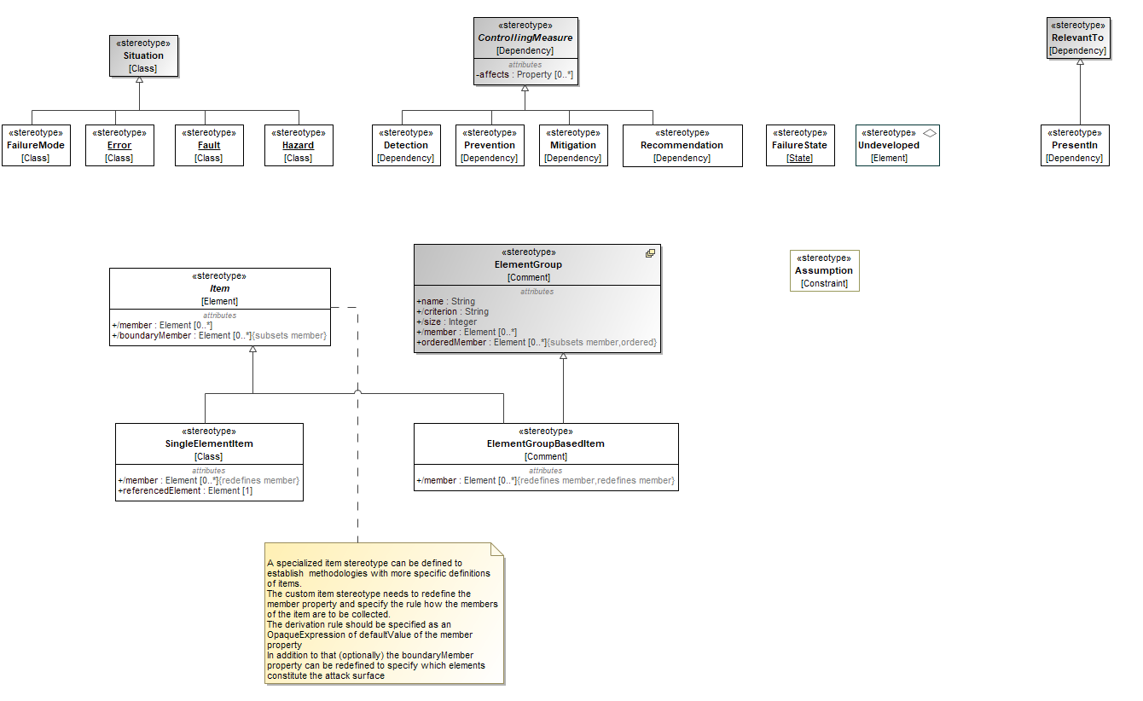
Figure 10.4 – General Concepts Profile

Elements
- ControllingMeasure
- Detection
- Error
- FailureMode
- FailureState
- Fault
- Mitigation
- Prevention
- Recommendation
- Situation
- Undeveloped
- Hazard
- Item
- PresentIn
- SingleElementItem
- ElementGroupBasedItem
- Assumption
- General Security
- General Security::General Security Concepts Library

View General Security::General Security Concepts Library::General Security Concepts Library
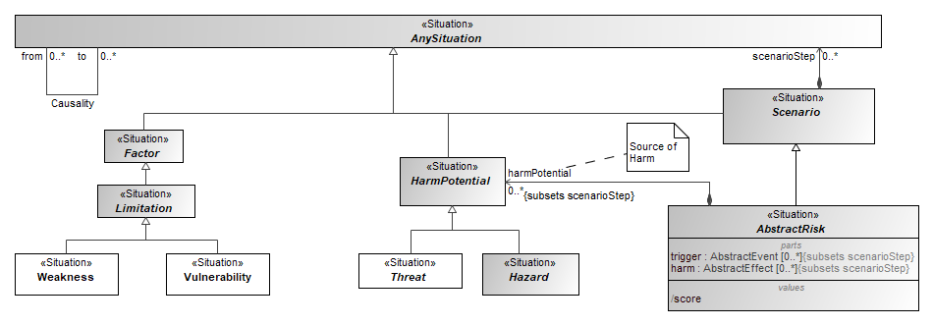
Figure 10.5 - General Security Concepts Library
Elements
- AbstractRisk
- AnySituation
- Causality
- Factor
- HarmPotential
- Hazard
- Limitation
- Scenario
- Threat
- Vulnerability
- Weakness
- General Security::General Security Concepts Profile

View General Security::General Security Concepts Profile::General Security Concepts Profile
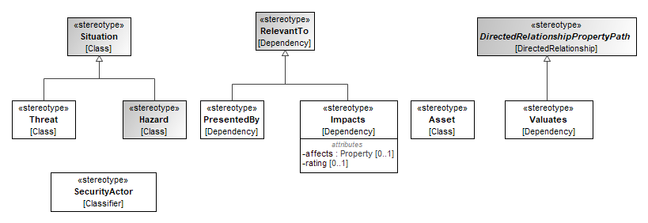
Figure 10.6 - General Security Concepts Profile
Elements
- Asset
- Hazard
- Impacts
- PresentedBy
- RelevantTo
- SecurityActor
- Situation
- Threat
- Valuates

- Methods::FMEA
- Methods::FMEA::FMEA Library
View Methods::FMEA::FMEA Library::FMEA Library
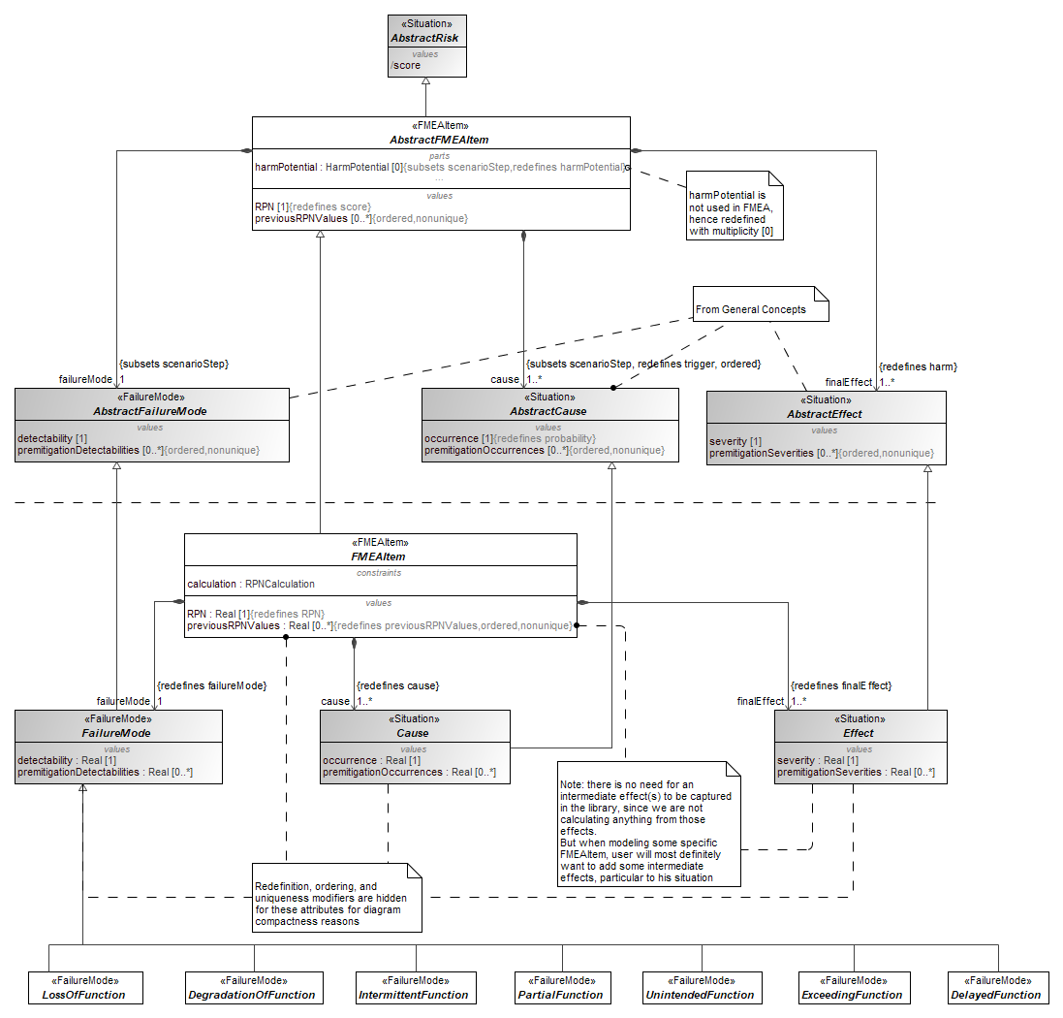
Figure 10.7 – FMEA Library

Elements
- AbstractCause
- AbstractEffect
- AbstractFailureMode
- AbstractFMEAItem
- AbstractRisk
- Cause
- DegradationOfFunction
- DelayedFunction
- Effect
- ExceedingFunction
- FailureMode
- FMEAItem
- IntermittentFunction
- LossOfFunction
- PartialFunction
- UnintendedFunction
- Methods::FMEA::FMEA Profile
View Methods::FMEA::FMEA Profile::FMEA Profile
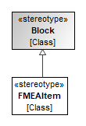
Figure 10.8 – FMEA Profile

Elements
- FMEAItem
- Methods::FTA
- Methods::FTA::FTALibrary

Methods::FTA::FTALibrary::Events
View Methods::FTA::FTALibrary::Events::Events
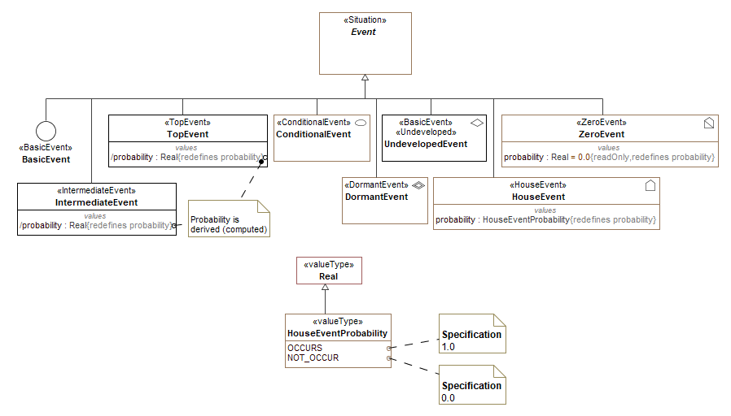
Figure 10.9 – Events

Elements
- BasicEvent
- ConditionalEvent
- DormantEvent
- Event
- HouseEvent
- IntermediateEvent
- TopEvent
- UndevelopedEvent
- ZeroEvent

View Methods::FTA::FTALibrary::FTA Library

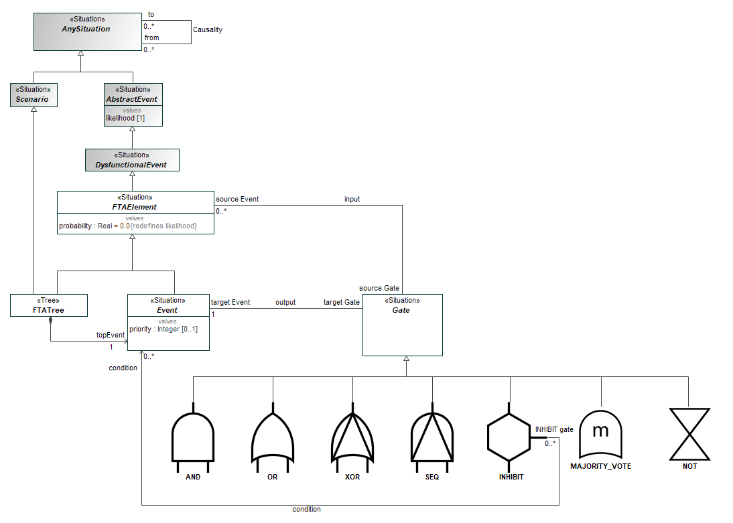
Figure 10.10 – FTA Library

Elements
- AbstractEvent
- AND
- AnySituation
- Causality
- DysfunctionalEvent
- Event
- FTAElement
- FTATree
- Gate
- INHIBIT
- MAJORITY_VOTE
- NOT
- OR
- Scenario
- SEQ
- XOR
- Methods::FTA::FTAProfile

Methods::FTA::FTAProfile::Diagrams by elements
View Methods::FTA::FTAProfile::FTA Profile

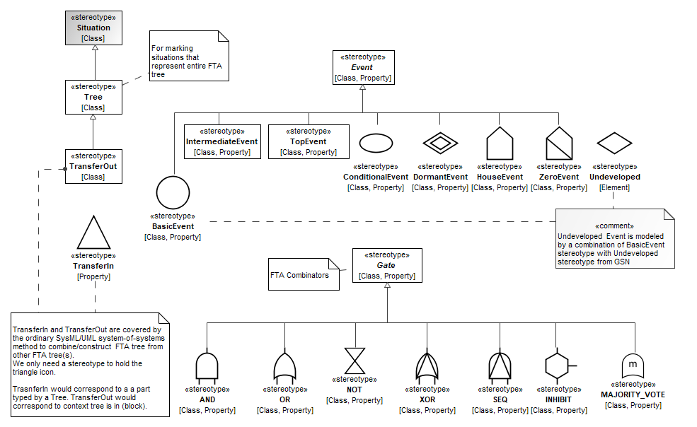
Figure 10.11 – FTA Profile

Elements
- AND
- BasicEvent
- ConditionalEvent
- DormantEvent
- Event
- Gate
- HouseEvent
- INHIBIT
- IntermediateEvent
- MAJORITY_VOTE
- NOT
- OR
- SEQ
- Situation
- TopEvent
- TransferIn
- TransferOut
- Tree
- Undeveloped
- XOR
- ZeroEvent
- Methods::STPA
- Methods::STPA::STPA Library
View Methods::STPA::STPA Library::STPA Library

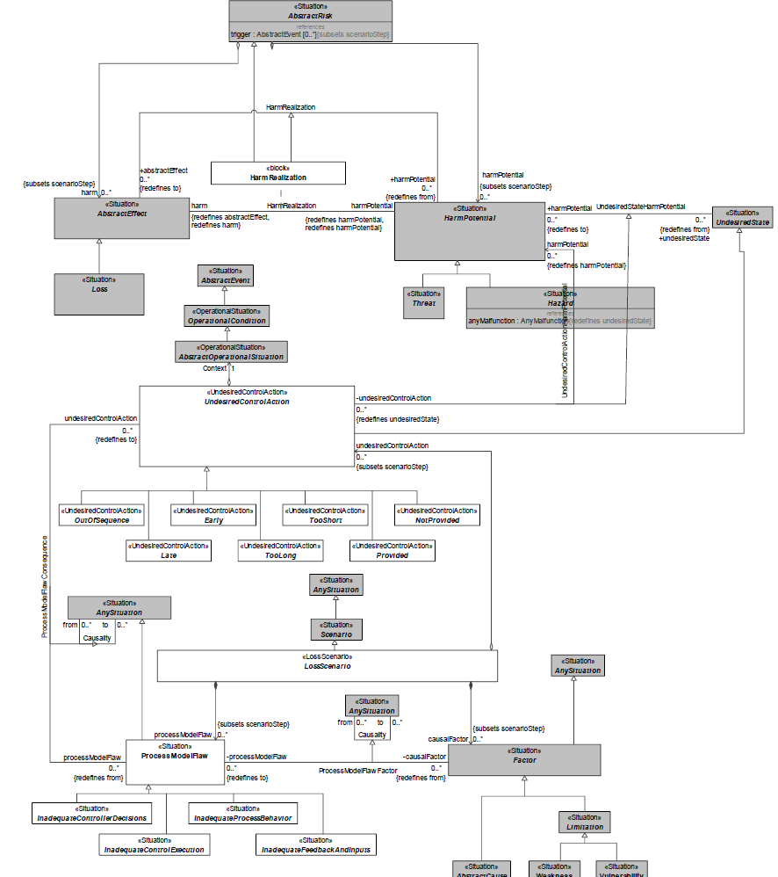
Figure 10.12 – STPA Library

Elements
- AbstractCause
- AbstractEffect
- AbstractEvent
- AbstractOperationalSituation
- AbstractRisk
- AnySituation
- Causality
- Early
- Factor
- HarmPotential
- Hazard
- Inadequate Control Execution
- Inadequate Controller Decisions
- Inadequate Feedback and Inputs
- Inadequate Process Behavior
- Late
- Limitation
- Loss
- LossScenario
- NotProvided
- OperationalCondition
- OutOfSequence
- ProcessModelFlaw
- ProcessModelFlawConsequence
- ProcessModelFlawFactor
- Provided
- RiskRealization
- Scenario
- Threat
- TooLong
- TooShort
- UndesiredState
- UndesiredControlAction
- UndesiredControlActionHarmPotential
- Vulnerability
- Weakness

- Methods::STPA::STPA Profile
View Methods::STPA::STPA Profile::STPA Profile

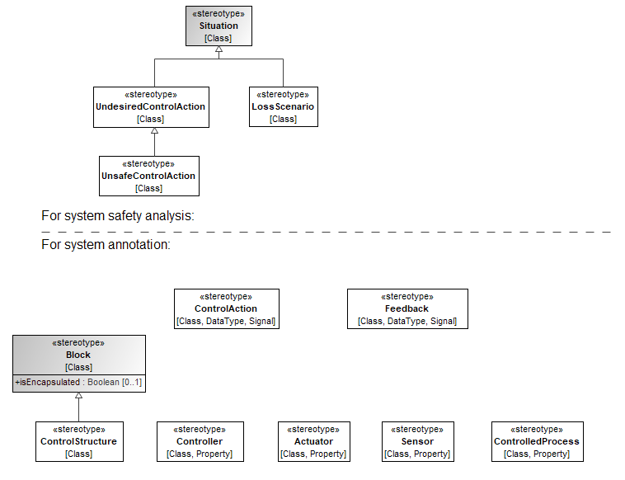
Figure 10.13 – STPA Profile

Elements
- Actuator
- ControlAction
- ControlledProcess
- Controller
- ControlStructure
- FailureMode
- Feedback
- Sensor
- UndesiredControlAction
- UnsafeControlAction

- GSN
- GSN::GSN Profile
View GSN::GSN Profile::GSN Profile

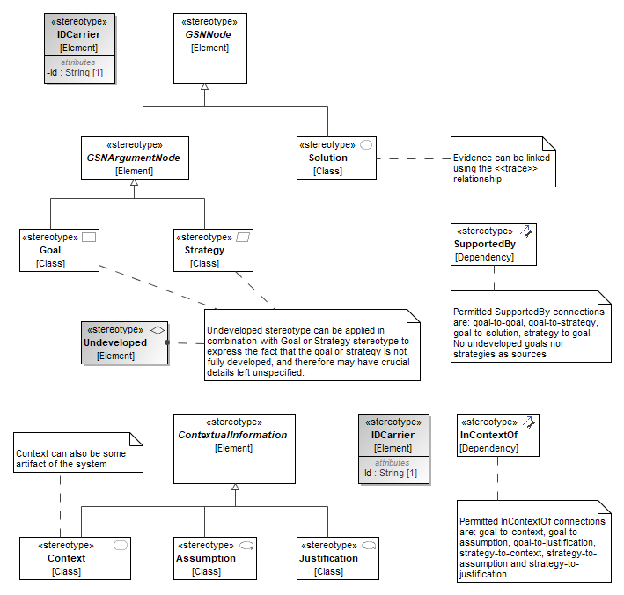
Figure 10.14 – GSN Profile

Elements
- Assumption
- Context
- Goal
- GSNArgumentNode
- GSNNode
- InContextOf
- Justification
- Solution
- Strategy
- SupportedBy
- ContextualInformation
- Undeveloped
- Methods::ISO 26262
- Methods::ISO 26262::ISO 26262 Library
View Methods::ISO 26262::ISO 26262 Library::ISO26262 Library

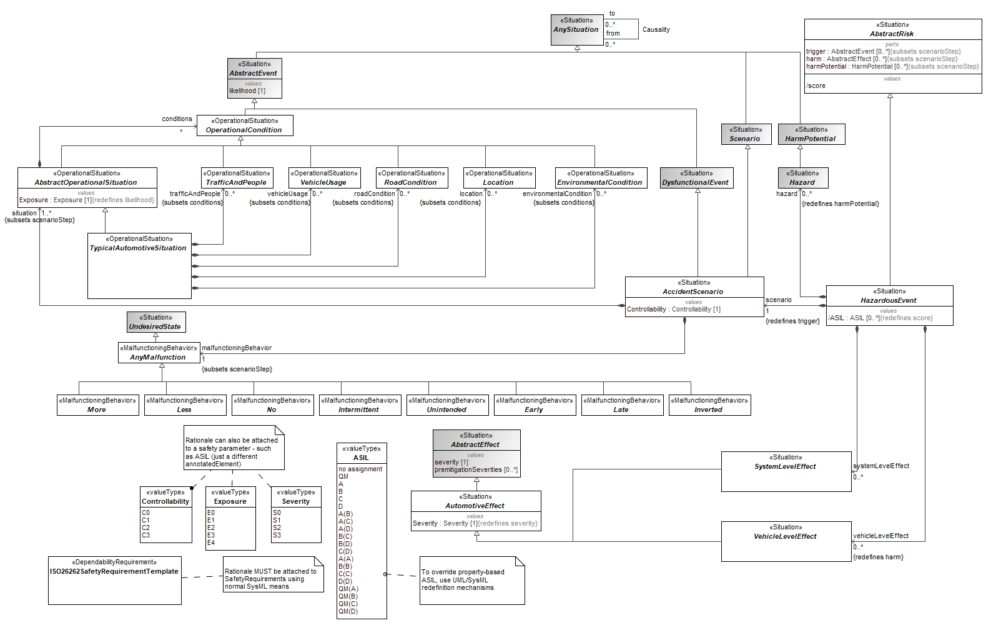
Figure 10.15 – ISO 26262 Library

Elements
- AbstractEffect
- AbstractEvent
- AbstractOperationalSituation
- AbstractRisk
- AccidentScenario
- AnyMalfunction
- AnySituation
- ASIL
- AutomotiveEffect
- Causality
- Controllability
- DysfunctionalEvent
- Early
- EnvironmentalCondition
- Exposure
- HarmPotential
- Hazard
- HazardousEvent
- Intermittent
- Inverted
- ISO26262SafetyRequirementTemplate
- Late
- Less
- Location
- More
- No
- OperationalCondition
- RoadCondition
- Scenario
- Severity
- SystemLevelEffect
- TrafficAndPeople
- TypicalAutomotiveSituation
- UndesiredState
- Unintended
- VehicleLevelEffect
- VehicleUsage

View Methods::ISO 26262::ISO 26262 Library::All-Encompassing Operational Situations
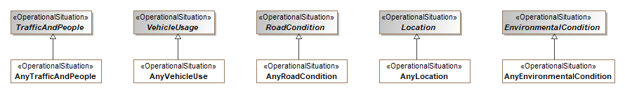
Figure 10.16 – All-Encompassing Operational Situations

Elements
- AnyEnvironmentalCondition
- AnyLocation
- AnyRoadCondition
- AnyTrafficAndPeople
- AnyVehicleUse
- EnvironmentalCondition
- Location
- RoadCondition
- TrafficAndPeople
- VehicleUsage
- Methods::ISO 26262::ISO 26262 Profile

Methods::ISO 26262::ISO 26262 Profile::RequirementManagement
View Methods::ISO 26262::ISO 26262 Profile::RequirementManagement::RequirementManagement
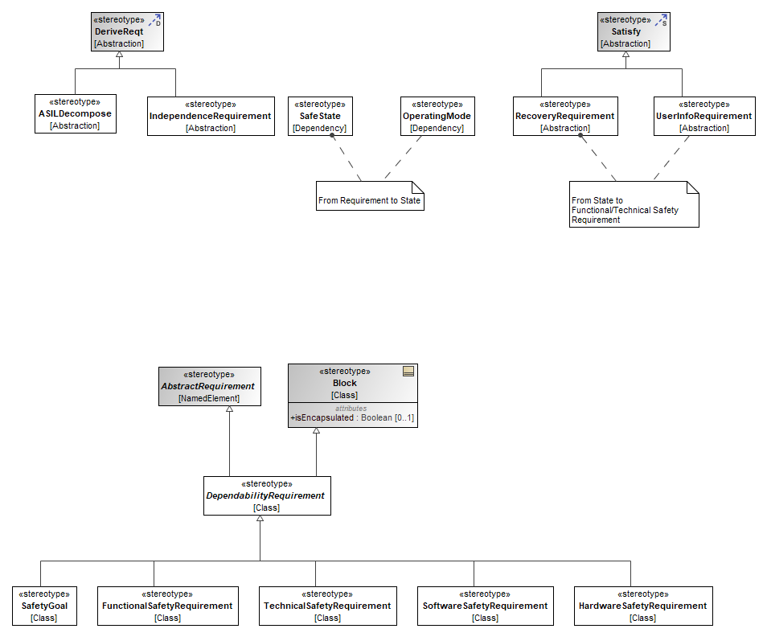
Figure 10.17 – RequirementManagement

Elements
- ASILDecompose
- DependabilityRequirement
- FunctionalSafetyRequirement
- HardwareSafetyRequirement
- IndependenceRequirement
- OperatingMode
- RecoveryRequirement
- SafeState
- SafetyGoal
- SoftwareSafetyRequirement
- TechnicalSafetyRequirement
- UserInfoRequirement

View Methods::ISO 26262::ISO 26262 Profile::ISO26262 Profile

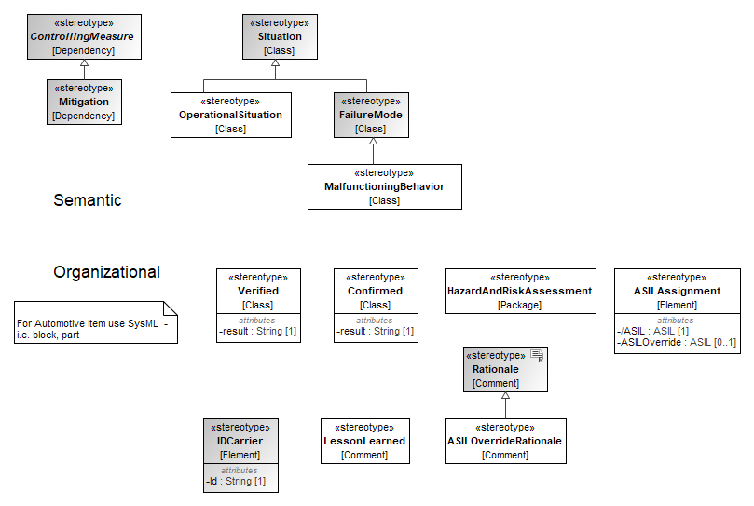
Figure 10.18 – ISO 26262 Profile

Elements
- ASILAssignment
- ASILOverrideRationale
- Confirmed
- ControllingMeasure
- FailureMode
- HazardAndRiskAssessment
- IDCarrier
- LessonLearned
- MalfunctioningBehavior
- Mitigation
- OperationalSituation
- Situation
- Verified

  - Methods::FHA
- Methods::FHA::FHA Library
View Methods::FHA::FHA Library::FHA Library
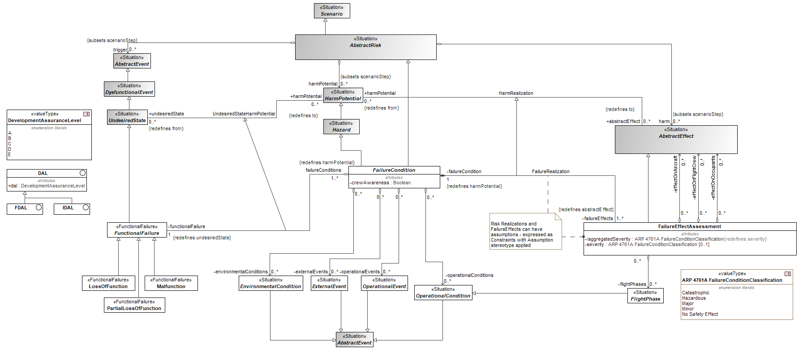
Figure 10.19 - FHA Library
Elements
- ARP 4761A FailureConditionClassification
- DAL
- DevelopmentAssuranceLevel
- EnvironmentalCondition
- ExternalEvent
- FailureCondition
- FailureEffect
- FDAL
- FlightPhase
- FunctionalFailure
- IDAL
- LossOfFunction
- Malfunction
- OperationalCondition
- OperationalEvent
- PartialLossOfFunction
- Methods::FHA::FHA Profile
View Methods::FHA::FHA Profile::FHA Profile
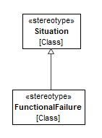
Figure 10.20 - FHA Profile
Elements
- FunctionalFailure

  - Methods::RBD

    - Methods::RBD::RBD Library

View Methods::RBD::RBD Library::RBD Library
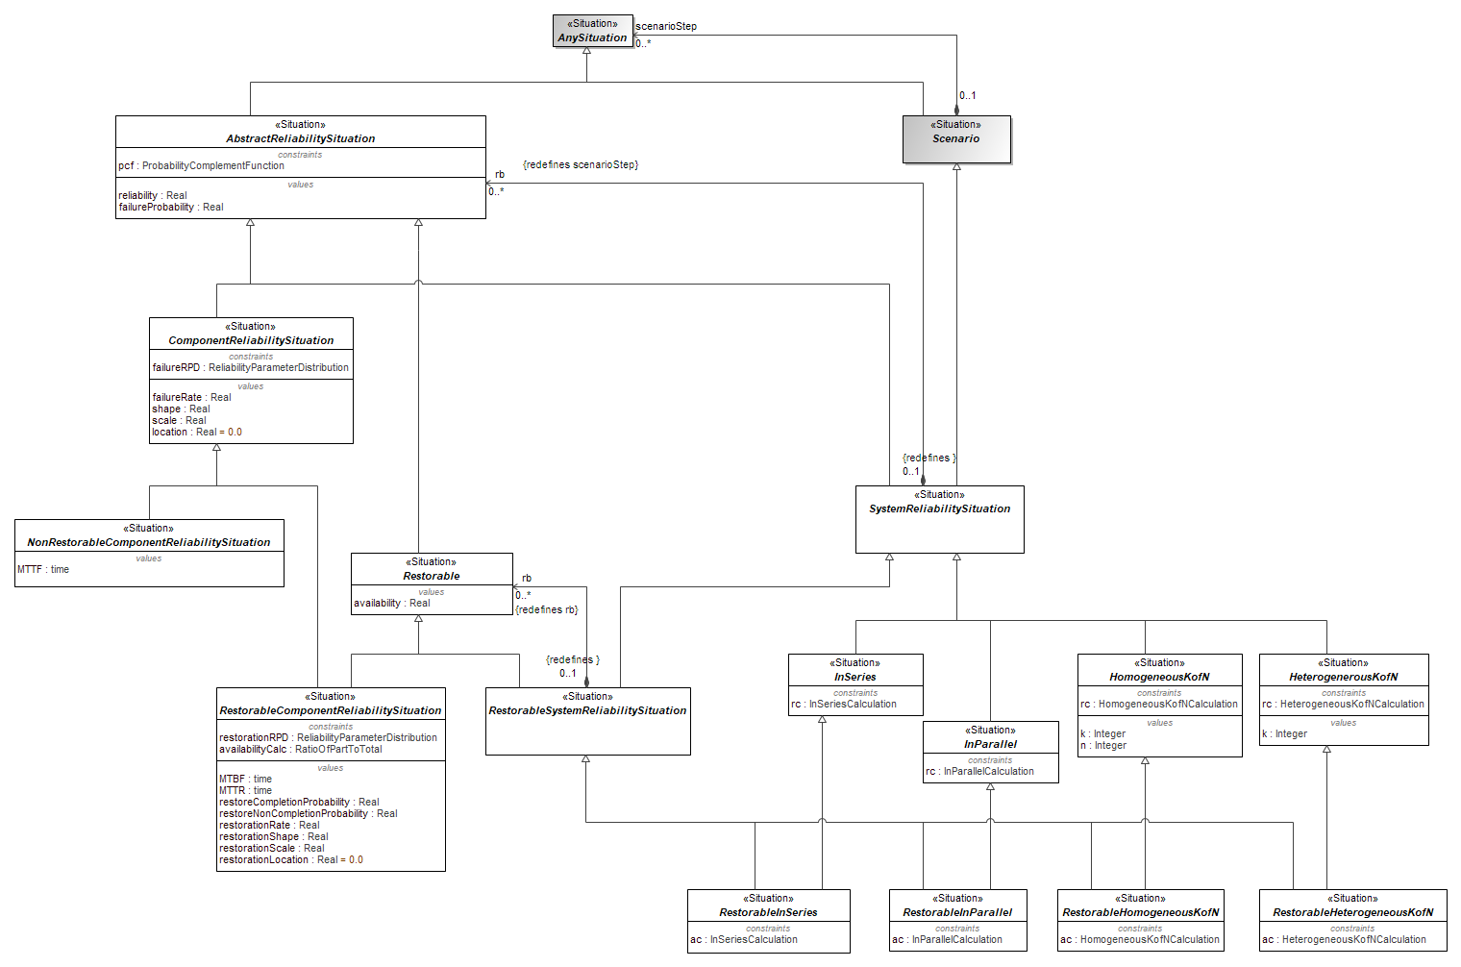
Figure 10.21 - RBD Library
Elements
- AbstractReliabilitySituation
- AnySituation
- ComponentReliabilitySituation
- HeterogenerousKofN
- HomogeneousKofN
- InParallel
- InSeries
- NonRestorableComponentReliabilitySituation
- Restorable
- RestorableComponentReliabilitySituation
- RestorableHeterogeneousKofN
- RestorableHomogeneousKofN
- RestorableInParallel
- RestorableInSeries
- RestorableSystemReliabilitySituation
- Scenario
- SystemReliabilitySituation

View Methods::RBD::RBD Library::AbstractReliabilitySituation::AbstractReliabilitySituation
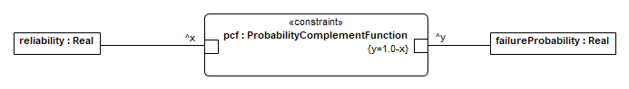
Figure 10.22 - AbstractReliabilitySituation

View Methods::RBD::RBD Library::ComponentReliabilitySituation::ComponentReliabilitySituation
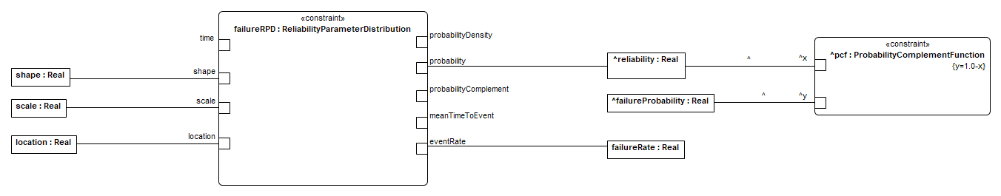
Figure 10.23 - ComponentReliabilitySituation
View Methods::RBD::RBD Library::NonRestorableComponentReliabilitySituation::NonRestorableComponentReliabilitySituation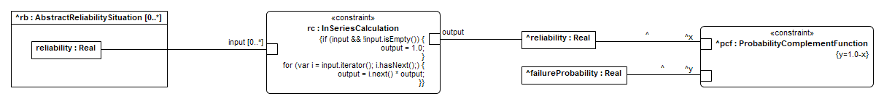
Figure 10.24 - InSeries

View Methods::RBD::RBD Library::RestorableInSeries::RestorableInSeries
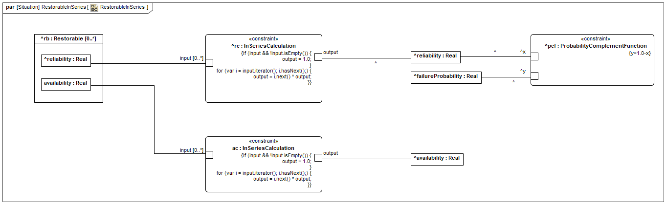
Figure 10.25 - RestorableInSeries

View Methods::RBD::RBD Library::InParallel::InParallel
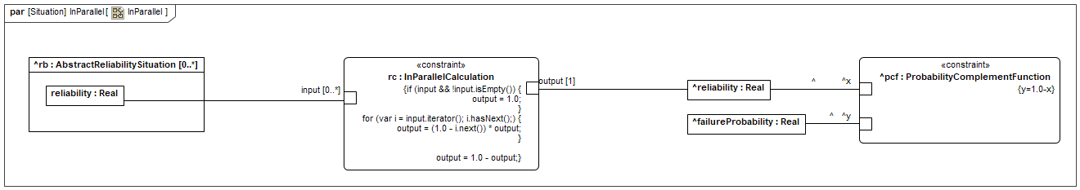
Figure 10.26 - InParallel

View Methods::RBD::RBD Library::RestorableInParallel::RestorableInParallel
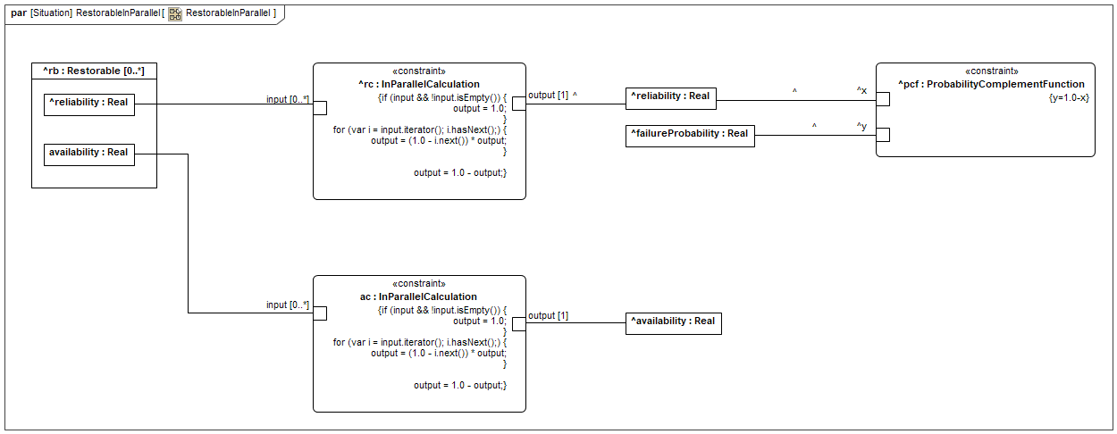
Figure 10.27 - RestorableInParallel

View Methods::RBD::RBD Library::HomogeneousKofN::HomogeneousKofN
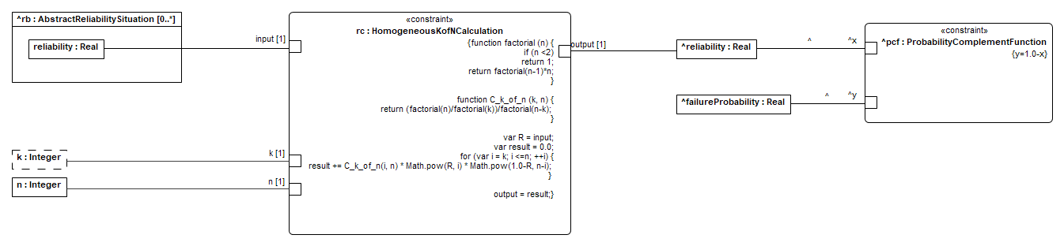
Figure10.28 - HomogeneousKofN

View Methods::RBD::RBD Library::RestorableHomogeneousKofN::RestorableHomogeneousKofN
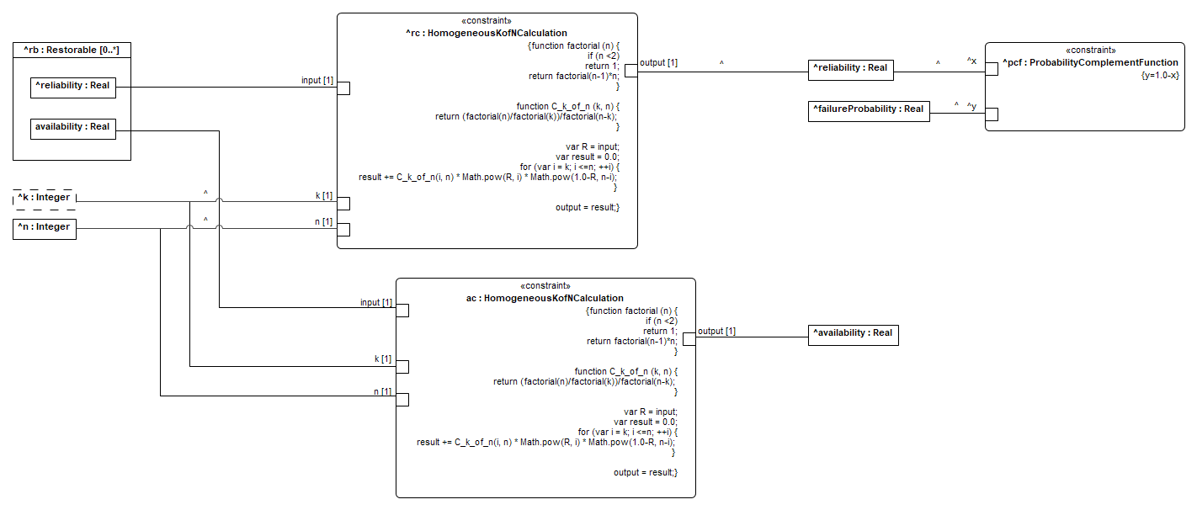
Figure 10.29 - RestorableHomogeneousKofN

View Methods::RBD::RBD Library::HeterogenerousKofN::HeterogeneousKofN
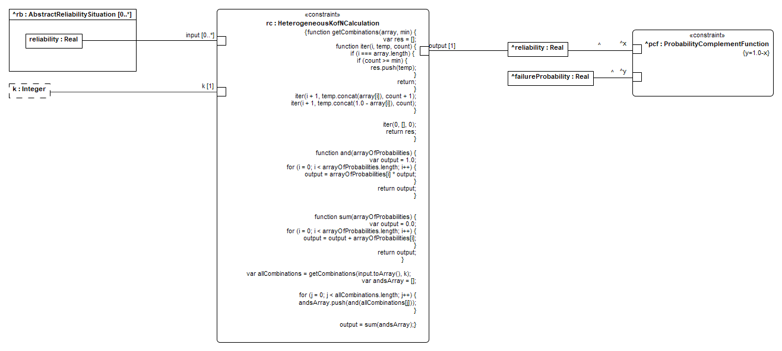
Figure 10.30 - HeterogeneousKofN

View Methods::RBD::RBD Library::RestorableHeterogeneousKofN::RestorableHeterogeneousKofN
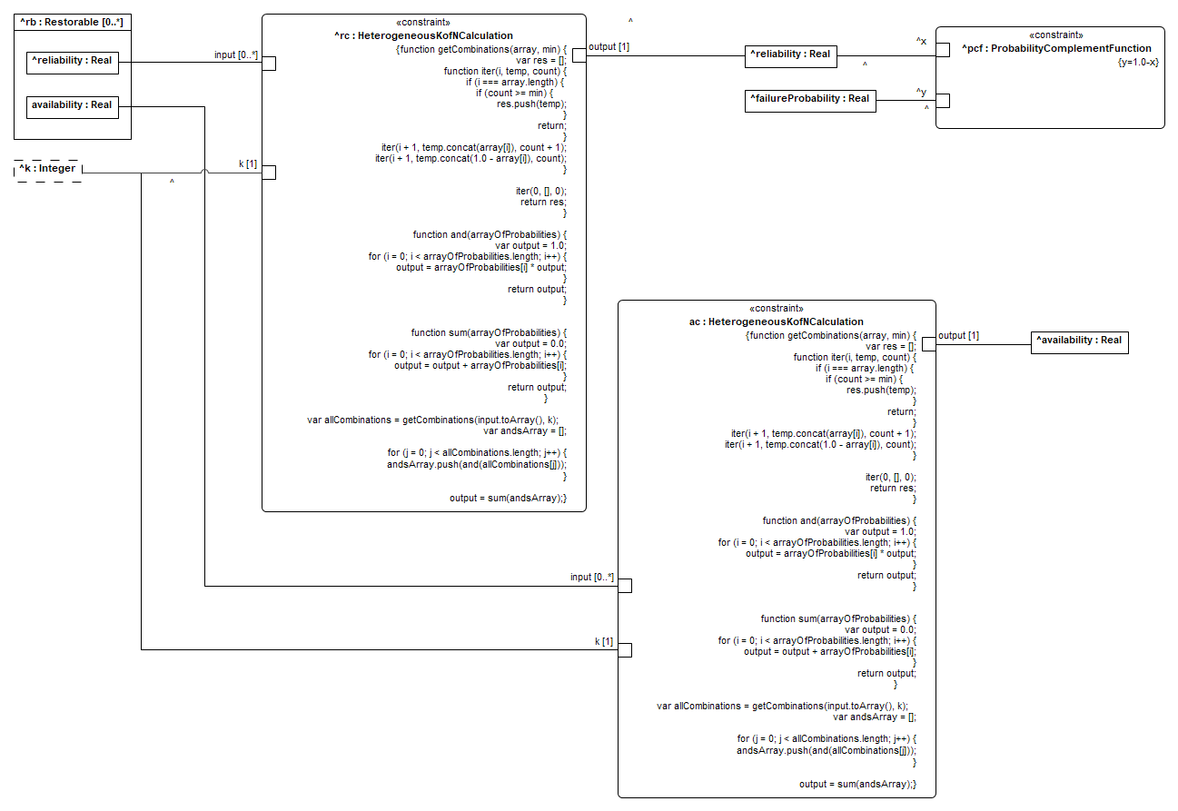
Figure 10.31 - RestorableHeterogeneousKofN
    - Methods::RBD::RBD Library::ConstraintBlocks

Methods::RBD::RBD Library::ConstraintBlocks::Probability

View Methods::RBD::RBD Library::ConstraintBlocks::Probability::Distributions
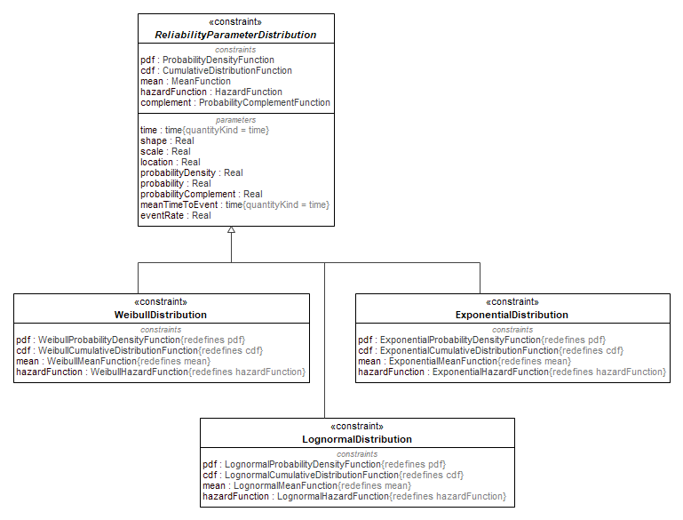
Figure 10.32 - Distributions
Elements
- ExponentialDistribution
- LognormalDistribution
- ReliabilityParameterDistribution
- WeibullDistribution

View Methods::RBD::RBD Library::ConstraintBlocks::Probability::ReliabilityParameterDistribution::ReliabilityParameterDistribution
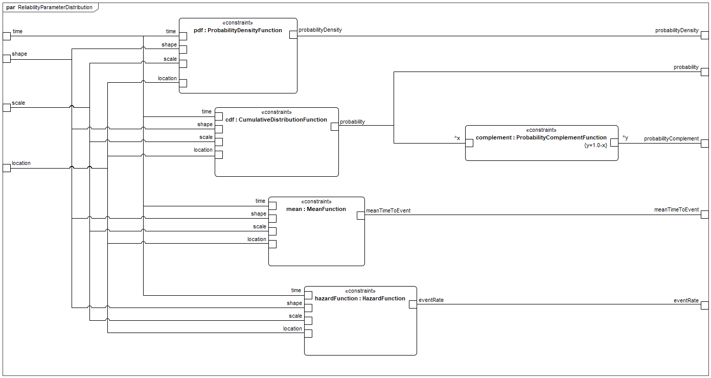
Figure 10.33 - ReliabilityParameterDistribution
    - Methods::RBD::RBD Profile

View Methods::RBD::RBD Profile::RBD Profile
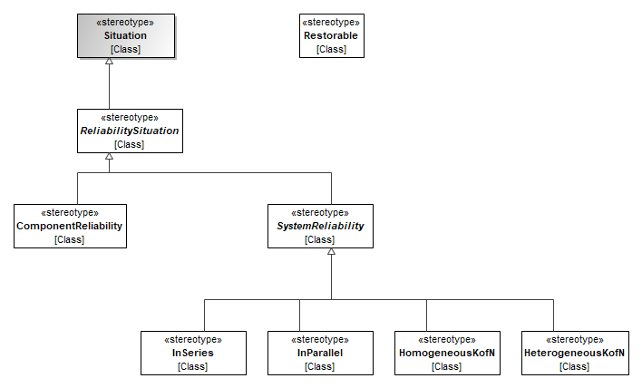
Figure 10.34 - RBD Profile
Elements
- ComponentReliability
- HeterogeneousKofN
- HomogeneousKofN
- InParallel
- InSeries
- ReliabilitySituation
- Restorable
- Situation
- SystemReliability

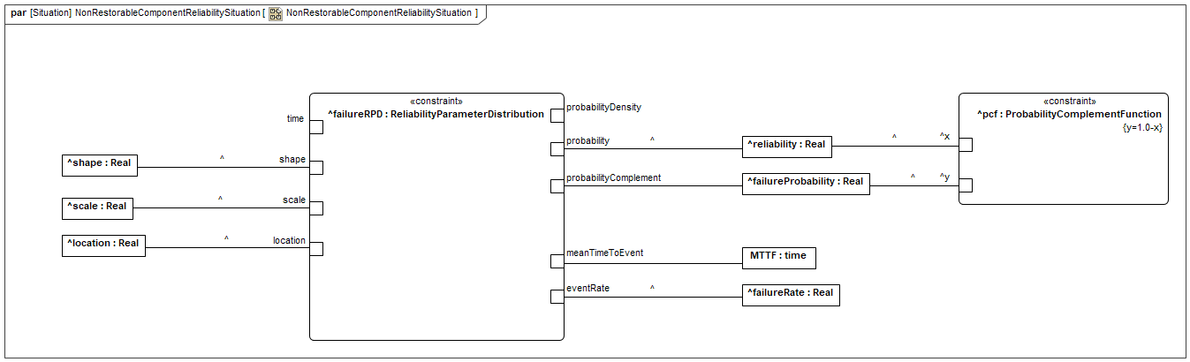
Figure 10.35 - NonRestorableComponentReliabilitySituation

View Methods::RBD::RBD Library::RestorableComponentReliabilitySituation::RestorableComponentReliabilitySituation
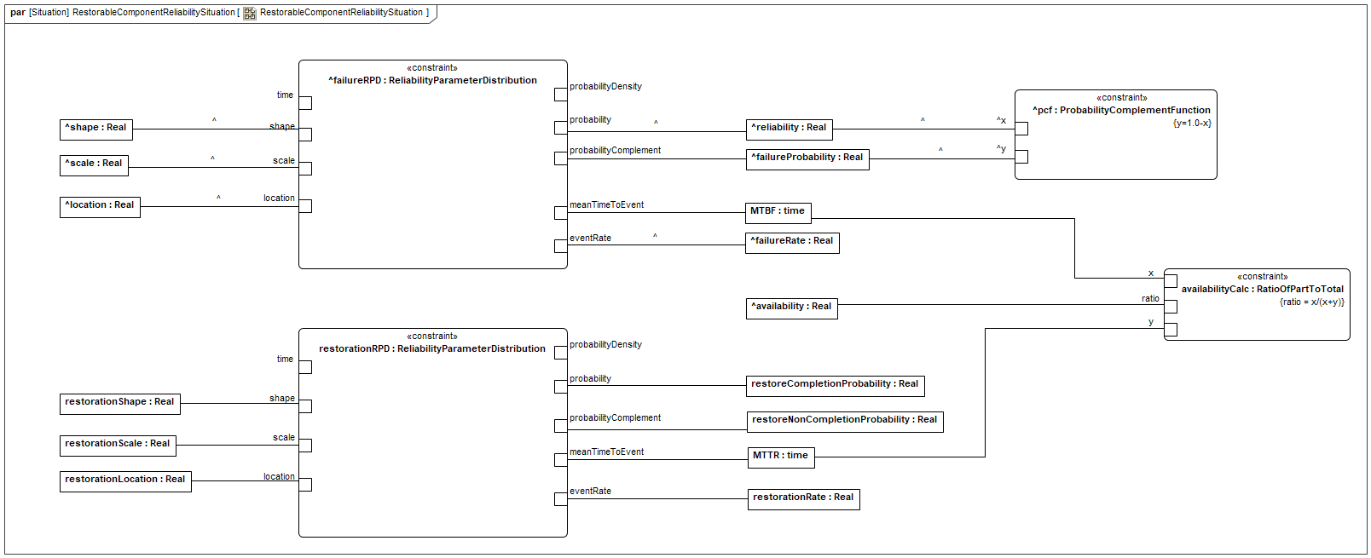
Figure 10.36 - RestorableComponentReliabilitySituation

https://psas.scripts.mit.edu/home/get_file.php?name=STPA_handbook.pdf

