Date: April 2025


Financial Instrument Global Identifier^{R} (FIGITM)
v1.3

OMG Document Number: formal/xx-xx-xx [smsc/xx-xx-xx]
Standard Document URL: https://www.omg.org/spec/FIGI/

Copyright © 2013-2026, Bloomberg LP
Copyright © 2015-2026, Object Management Group

USE OF SPECIFICATION – TERMS, CONDITIONS & NOTICES
The material in this document details an Object Management Group specification in accordance with the terms, conditions and notices set forth below. This document does not represent a commitment to implement any portion of this specification in any company's products. The information contained in this document is subject to change without notice.
LICENSES
The companies listed above have granted to the Object Management Group, Inc. (OMG) a nonexclusive, royalty-free, paid up, worldwide license to copy and distribute this document and to modify this document and distribute copies of the modified version. Each of the copyright holders listed above has agreed that no person shall be deemed to have infringed the copyright in the included material of any such copyright holder by reason of having used the specification set forth herein or having conformed any computer software to the specification.
Subject to all of the terms and conditions below, the owners of the copyright in this specification hereby grant you a fully-paid up, non-exclusive, nontransferable, perpetual, worldwide license (without the right to sublicense), to use this specification to create and distribute software and special purpose specifications that are based upon this specification, and to use, copy, and distribute this specification as provided under the Copyright Act; provided that: (1) both the copyright notice identified above and this permission notice appear on any copies of this specification; (2) the use of the specifications is for informational purposes and will not be copied or posted on any network computer or broadcast in any media and will not be otherwise resold or transferred for commercial purposes; and (3) no modifications are made to this specification. This limited permission automatically terminates without notice if you breach any of these terms or conditions. Upon termination, you will destroy immediately any copies of the specifications in your possession or control.
PATENTS
The attention of adopters is directed to the possibility that compliance with or adoption of OMG specifications may require use of an invention covered by patent rights. OMG shall not be responsible for identifying patents for which a license may be required by any OMG specification, or for conducting legal inquiries into the legal validity or scope of those patents that are brought to its attention. OMG specifications are prospective and advisory only. Prospective users are responsible for protecting themselves against liability for infringement of patents.
GENERAL USE RESTRICTIONS
Any unauthorized use of this specification may violate copyright laws, trademark laws, and communications regulations and statutes. This document contains information which is protected by copyright. All Rights Reserved. No part of this work covered by copyright herein may be reproduced or used in any form or by any means--graphic, electronic, or mechanical, including photocopying, recording, taping, or information storage and retrieval systems--without permission of the copyright owner.

DISCLAIMER OF WARRANTY
WHILE THIS PUBLICATION IS BELIEVED TO BE ACCURATE, IT IS PROVIDED "AS IS" AND MAY CONTAIN
ERRORS OR MISPRINTS. THE OBJECT MANAGEMENT GROUP AND THE COMPANIES LISTED ABOVE
MAKE NO WARRANTY OF ANY KIND, EXPRESS OR IMPLIED, WITH REGARD TO THIS PUBLICATION,
INCLUDING BUT NOT LIMITED TO ANY WARRANTY OF TITLE OR OWNERSHIP, IMPLIED WARRANTY
OF MERCHANTABILITY OR WARRANTY OF FITNESS FOR A PARTICULAR PURPOSE OR USE. IN NO
EVENT SHALL THE OBJECT MANAGEMENT GROUP OR ANY OF THE COMPANIES LISTED ABOVE BE
LIABLE FOR ERRORS CONTAINED HEREIN OR FOR DIRECT, INDIRECT, INCIDENTAL, SPECIAL,
CONSEQUENTIAL, RELIANCE OR COVER DAMAGES, INCLUDING LOSS OF PROFITS, REVENUE, DATA
OR USE, INCURRED BY ANY USER OR ANY THIRD PARTY IN CONNECTION WITH THE FURNISHING, PERFORMANCE, OR USE OF THIS MATERIAL, EVEN IF ADVISED OF THE POSSIBILITY OF SUCH DAMAGES.
The entire risk as to the quality and performance of software developed using this specification is borne by you. This disclaimer of warranty constitutes an essential part of the license granted to you to use this specification.
RESTRICTED RIGHTS LEGEND
Use, duplication or disclosure by the U.S. Government is subject to the restrictions set forth in subparagraph (c) (1) (ii) of The Rights in Technical Data and Computer Software Clause at DFARS 252.227-7013 or in subparagraph (c)(1) and (2) of the Commercial Computer Software - Restricted Rights clauses at 48 C.F.R. 52.227-19 or as specified in 48 C.F.R.
227-7202-2 of the DoD F.A.R. Supplement and its successors, or as specified in 48 C.F.R. 12.212 of the Federal
Acquisition Regulations and its successors, as applicable. The specification copyright owners are as indicated above and may be contacted through the Object Management Group, 9C Medway Rd, PMB 274, Milford, MA 01757, U.S.A.
TRADEMARKS
CORBA®, CORBA logos®, FIBO®, Financial Industry Business Ontology®, FINANCIAL INSTRUMENT GLOBAL
IDENTIFIER®, IIOP®, IMM®, Model Driven Architecture®, MDA®, Object Management Group®, OMG®, OMG Logo®, SoaML®, SOAML®, SysML®, UAF®, Unified Modeling Language®, UML®, UML Cube Logo®, VSIPL®, and XMI® are registered trademarks of the Object Management Group, Inc.
For a complete list of trademarks, see: https://www.omg.org/legal/tm_list.htm. All other products or company names mentioned are used for identification purposes only and may be trademarks of their respective owners.
COMPLIANCE
The copyright holders listed above acknowledge that the Object Management Group (acting itself or through its designees) is and shall at all times be the sole entity that may authorize developers, suppliers and sellers of computer software to use certification marks, trademarks or other special designations to indicate compliance with these materials.
Software developed under the terms of this license may claim compliance or conformance with this specification if and only if the software compliance is of a nature fully matching the applicable compliance points as stated in the specification. Software developed only partially matching the applicable compliance points may claim only that the software was based on this specification, but may not claim compliance or conformance with this specification. In the event that testing suites are implemented or approved by Object Management Group, Inc., software developed using this specification may claim compliance or conformance with the specification only if the software satisfactorily completes the testing suites.

OMG's Issue Reporting Procedure
All OMG specifications are subject to continuous review and improvement. As part of this process, we encourage readers to report any ambiguities, inconsistencies, or inaccuracies they may find by completing the Issue Reporting Form listed on the main web page https://www.omg.org, under Specifications, Report a Bug/Issue.

Table of Contents
Preface viii
1 Scope 1
1.1 Overview 1
2 Conformance 1
2.1 Introduction 1
2.2 Conformance as a Provider of Identifiers 3
2.2.1 Background & Approach 3
2.2.2 Conformance 3
2.3 Conformance as a Consuming Application 4
3 References 4
3.1 Normative References 4
4 Terms and definitions 5
4.1 Specific Terminology 5
4.2 Financial Terms 6
4.3 Identifier 6
5 Symbols and Abbreviations 7
5.1 Symbols 7
5.2 Abbreviations 7
6 Architecture 9
6.1 Global Identifier Structure 9
6.1.1 Introduction 9
6.1.2 Syntax 9
6.2 Global Identifier Associated Content 11
6.2.1 Introduction 11
6.2.2 Exchange Code 11
6.2.3 Financial Instrument Name 12
6.2.4 Pricing Source 12
6.2.5 Security Type 12
6.2.6 Ticker 12
6.3 Relationships Among Elements 12
6.3.1 Global Identifier 12
6.3.2 Composite Global Identifier 13
6.3.3 Share Class Global Identifier 13
6.3.4 Exchange Code 14
6.3.5 Financial Instrument Name 14
6.3.6 Pricing Source 14
6.3.7 Security Type 14
6.3.8 Ticker 14
7 Controlled Vocabularies 15
7.1 Introduction 15
7.2 Security Types 15
7.3 Pricing Sources 15
8 FIGI Ontology 17
8.1 Ontology Architecture and Namespaces 17
8.2 Global Instrument Identifiers Ontology 18
8.2.1 Ontology Metadata 18
8.2.2 Top-Level Class Hierarchy 20
8.2.3 Financial Instruments 22
8.2.4 Identifiers 24
8.2.5 Security Types 28
Annex A : Shared Semantics Treatments (Informative) 29
Annex B : Creation of New Identifiers 31
B.1 General 31
B.2 Request Service 31
B.3 Certified Provider (CP) 32
B.3.1 Registration Authority (RA) Role 33
B.3.2 Certified Provider (CP) Role 33
B.4 New Security Types and New Pricing Sources 33
Annex C : Allocation of Identifier Prefixes 35
Annex D : Other Standards in the Financial Space 37
D.1 Introduction 37
D.2 ISO 6166 (ISIN) 37
D.3 ISO 10962 (CFI) 38
D.4 ISO 20022 (UNIFI) 38
D.5 ISO 10383 (MIC) 38
D.6 Use with other identifiers and standards 38

Preface
About the Object Management Group
Founded in 1989, the Object Management Group, Inc. (OMG) is an open membership, not-for-profit computer industry standards consortium that produces and maintains computer industry specifications for interoperable, portable and reusable enterprise applications in distributed, heterogeneous environments. Membership includes Information Technology vendors, end users, government agencies and academia.
OMG member companies write, adopt, and maintain its specifications following a mature, open process. OMG's specifications implement the Model Driven Architecture® (MDA®), maximizing ROI through a full-lifecycle approach to enterprise integration that covers multiple operating systems, programming languages, middleware and networking infrastructures, and software development environments. OMG’s specifications include: UML® (Unified Modeling Language™); CORBA® (Common Object Request Broker Architecture); CWM™ (Common Warehouse Meta-model); and industry-specific standards for dozens of vertical markets.
More information on the OMG is available at https://www.omg.org/.
OMG Specifications
As noted, OMG specifications address middleware, modeling and vertical domain frameworks. All OMG Formal Specifications are available from this URL: https://www.omg.org/spec
All of OMG‟s formal specifications may be downloaded without charge from our website. (Products implementing OMG specifications are available from individual suppliers.) Copies of specifications, available in PostScript and PDF format, may be obtained from the Specifications Catalog cited above or by contacting the Object Management Group, Inc. at:
OMG Headquarters
9C Medway Road, PMB 274
Milford, MA 01757
USA
Tel: +1-781-444-0404
Fax: +1-781-444-0320 Email: pubs@omg.org
Certain OMG specifications are also available as ISO/IEC standards. Please consult: http://www.iso.org

Issues
The reader is encouraged to report and technical or editing issues/problems with this specification to:
https://www.omg.org/report_issue.htm

1 Scope
The Financial Instrument Global Identifier specification details an open data based approach for identifying financial instruments through use of a permanent, semantically meaningless code key with associated identifying metadata.
The Financial Instrument Global Identifier provides a data model approach to identifying financial instruments in various contexts. These contexts relate to different processes across asset classes and operational needs where associated metadata needs may differ for the same financial instrument or collection of financial instruments (such as baskets).
Through use of a persistent, semantically meaningless code (e.g. the FIGI), the methodology allows for creation of a self referential data model and creation of object entities that can satisfy different needs requiring different levels of granularity through associated metadata based on contextual usage.

1.1 Overview
The development of the Financial Instrument Global Identifier originated from a need for a standard methodology to bridge across multiple identification systems for financial instruments. Without prejudice against any existing symbol-based solutions, or any question of the validity of one system over the other, the FIGI standard utilizes a metadata driven approach to enable the unique and persistent identification of financial instruments. In so doing, while employing the principles of open data, it provides a mechanism for interoperability between existing identification systems.
This specification lays out the details of the Financial Instrument Global Identifier across two dimensions:
- The standard of the structure of the Global Identifier itself—what is/is not valid as a Global Identifier and how a Global Identifier is constructed and validated.
- An ontological model specifying the relationship between the Global Identifier and other closely related information.
This specification has been created with the clear understanding that a published interface for creating identifiers and linking together relevant parties, e.g., Certified Providers or the Registration Authority, through the use of technology is a critical part of the implementation of this standard. While high level descriptions of the various types of organizations that need to be involved as well as high level descriptions of the interactions between such organizations has been included in this document, they are included on the understanding that there will need to be a subsequent specification produced that details the necessary technical infrastructures and service level agreements for all participating organizations. To be clear, the technical specification of those services and service level agreements is out of scope for this document.
Global Identifier concepts are documented using two forms of definition:

- A structured ontology specification of the concept, and its relationships to others, represented using the Web Ontology Language (OWL), in the form of (a) RDF/XML serialized OWL, (b) ODM (Ontology Definition Metamodel)-compliant ODM XMI, and (c) ODM-compliant UML XMI.

- Natural language definitions which represent the concepts in natural language using the vocabulary of the finance industry.

This specification covers both the content of the models, and the underlying architecture employed for producing and presenting the model.
This model is developed from a previously existing infrastructure that had issued in excess of 150 million FIGI compliant identifiers as of the 2014 OMG publication of the original standard. The purpose of this specification is to specify the structure of the Identifier itself and its relationship to key information elements rather than to specify the technology and related interfaces used to generate, access, and manage the identifiers.

2 Conformance

2.1 Introduction
An identifier is in conformance with this standard if, and only if, all of the following conditions are met:

Requirement | Description | Reference
Syntax of identifier. | The identifier shall be a twelve (12) character string as follows:  Position 1: any upper case alphabetical character excluding vowels (but including “Y”).  Position 2: any upper case alphabetical character excluding vowels (but including “Y”)..  Position 3: the letter “G”.  Positions 4-11: any alpha numeric character excluding vowels (but including “Y”) that, in combination with positions 1 and 2 does not constitute a duplicate of an existing string.  Position 12: check digit (see section 6.1.2 for algorithm).  Qualification: positions 1 and 2 cannot be the following sequences: BS, BM, GG, GB, VG. | Sub clause 6.2.1 Introduction
Uniqueness of identifier. | The identifier shall be a twelve character string, as specified above, that has never been assigned as a  Financial Instrument Global Identifier. | Sub clause 6.2.1 Introduction
Composite Global Identifier | If a global identifier is to be designated as a Composite Global Identifier, it shall have at least one  Global identifier associated with it. | Sub clause 6.2.1 Introduction
Share Class Global Identifier | If a global identifier is to be designated as a Share Class Global  Identifier, it shall have at least one Composite Global identifier associated with it. | Sub clause 6.2.1 Introduction
Exchange Code | A global identifier shall have either zero (0) or one (1) exchange code associated with it. | Sub clause 6.2.2 Exchange Code
Financial Instrument Name | Each global identifier shall have at least one name, which need not be unique to the identifier. | Sub clause 6.2.3 Financial Instrument Name
Legal Entity Identifier | A global identifier shall have either zero (0) or one (1) Legal Entity Identifier (LEI) associated with it. | Sub clause 6.2.x Legal Entity Identifier
Security Type | A global identifier shall be associated with at least one (1) Security Type. | Sub clause 6.2.5 Security Type
Ticker | A global identifier shall have at least one ticker associated with it. That ticker need not be unique to the identifier. | Sub clause 6.2.6 Ticker
There are no degrees of conformance.

2.2 Conformance as a Provider of Identifiers

2.2.1 Background & Approach
In order to support the accurate assignment of identifiers it is vital that a single financial instrument, appropriately understood, be identified by exactly one identifier. Further, it shall be the case that a particular identifier, unless it is a composite or share class Identifier (see Clause 6 below), identifies exactly one financial instrument. In order to support this, then, when an Identifier is created two conditions shall be met:
- Uniqueness of Identifier: the twelve character string (see Clause 6 for details) is unique and has never been used at any time for a FIGI.
- Uniqueness of the Financial Instrument: the financial instrument being identified does not already have a FIGI associated with it.
In order to ensure these two conditions there are multiple approaches that could be taken. In the case of the FIGI the approach that is taken is to have a single Registration Authority and therefor, a single system of record globally. By having a single system of record the possibility that one instrument is assigned multiple FIGIs or a single FIGI is assigned to multiple instruments (qualifications for groupings notwithstanding) is greatly minimized. To that end, the following distinction needs to be made:
- Registration Authority (RA): the Registration authority serves as both an issuer of Identifiers and as a comprehensive system of record of the registered Identifiers.
  - The organization that will serve as the Registration Authority shall be specified by the Financial Services Domain Task Force (FSDTF) of the OMG.
- Certified Provider (CP): a Certified Provider (there can potentially be many) serves as an issuer of Identifiers and can elect to maintain a comprehensive inventory of Identifiers for their own purposes.
  - Each CP shall elect an unused two consonant prefix to be used as the first two characters of the identifiers that they create.
The details on restrictions that pertain to assignment of two letter prefixes are documented in Section 8.2.4.
See Informative Annex C for background information regarding two letter prefixes.. Examples of how new Identifiers can be created, either by a CP or through a request service, is documented in Informative Annex B. More information on ways the RA and CP can interact is also provided in Informative Annex B.

2.2.2 Conformance
In order to conform to this specification a Certified Provider shall be required to:
- Specify only identifiers that are compliant with the technical specifications of the identifier as specified in Clause 6.
- Specify only identifiers that begin with the two-letter prefix that is assigned to their organization as per the restrictions documented in Section 8.2.4. More background information on the process is outlined in Informative Annex C.
- Take reasonable steps to ensure that each identifier they issue is unique within their assigned domain of possible identifiers.
- Provide an appropriate description of the financial instrument, which may vary according to the type of financial instrument, so as to provide the Registration Authority with the ability to confirm the uniqueness of the instrument.

2.3 Conformance as a Consuming Application
A consuming application is in conformance with this standard provided that it is configured to ingest and store a syntactically correct Financial Instrument Global Identifier, a Composite Global Identifier, and a Share Class Global Identifier. Optionally, a consuming application may, but is not required to, ingest and store any or all of the remaining data points associated with an Identifier, e.g., the associated definition.

3 References

3.1 Normative References
The following normative documents contain provisions which, through reference in this text, constitute provisions of this specification. For dated references, subsequent amendments to, or revisions of, any of these publications do not apply.

Reference | Description
[OWL 2] | OWL 2 Web Ontology Language Quick Reference Guide (Second Edition), W3C Recommendation 11 December 2012. Available at http://www.w3.org/TR/2012/REC-owl2-quick-reference-20121211/.
[RDF 1.1] | RDF 1.1 Concepts and Abstract Syntax, W3C Recommendation, 25 February 2014. Available at http://www.w3.org/TR/2014/REC-rdf11concepts-20140225/
[RDF 1.1 Schema] | RDF Schema 1.1. W3C Recommendation, 25 February 2014. Available at http://www.w3.org/TR/2014/REC-rdf-schema-20140225/.
[SKOS] | SKOS Simple Knowledge Organization System Reference, W3C Recommendation 18 August 2009. Available at http://www.w3.org/TR/2009/REC-skos-reference-20090818/.
[W3C Datatypes in RDF and OWL] | XML Schema Datatypes in RDF and OWL, W3C Working Group Note 14 March 2006, Available at http://www.w3.org/TR/2006/NOTE-swbp-xschdatatypes-20060314/.
[XML Schema Datatypes] | W3C XML Schema Definition Language (XSD) 1.1 Part 2: Datatypes. W3C Recommendation, 5 April 2012. Available at http://www.w3.org/TR/xmlschema11-2/.
[Dublin Core] | DCMI Metadata Terms, Issued 2013-06-14 by the Dublin Core Metadata  Initiative. Available at http://www.dublincore.org/documents/dcmi-terms/.
[MOF] | Meta Object Facility (MOF™) Core, v2.4.1. OMG Available Specification, for-mal/2011-08-07. Available at https://www.omg.org/spec/MOF/2.4.1/.
[MOF XMI] | MOF 2/XMI (XML Metadata Interchange) Mapping Specification, v2.4.1. OMG Available Specification, formal/2011-08-09. Available at https://www.omg.org/spec/XMI/2.4.1/.
[ODM 1.1] | Ontology Definition Metamodel (ODM), Version 1.1, Available at https://www.omg.org/spec/ODM/1.1/.
[UML2] | Unified Modeling Language™ (UML®), version 2.4.1. OMG Specification, formal/2011-08-06. Available at http://www.omg.org/spec/UML/2.4.1/.
[COMMONS] | Commons Ontology Library, available at https://www.omg.org/spec/Commons

4 Terms and definitions

4.1 Specific Terminology
The human readable definitions have been constructed by and with the input of business subject matter experts. In cases where there are Financial Industry Business Ontology (FIBO) definitions available either the FIBO definitions were used, or they were incorporated into the formal definitions.
For the purposes of this specification, the following terms and definitions apply.

Ontology  Definition: | A formalization of a conceptualization. For the purposes of this specification the formalization is in OWL and the conceptualization is that of business subject matter specific to the identification of financial instruments.
Taxonomy  Definition: | A set of terms which stand in some classification relation to one another.
Vocabulary  Definition: | A set of words, each giving one or more formal definitions which apply to a meaningful concept that is referred to by that word.

4.2 Financial Terms

Financial Instrument Definition: | cash, evidence of an ownership interest in an entity, or a contractual right to receive, or deliver, cash or another financial instrument or baskets thereof.
Cash Instrument  Definition: | financial instruments whose value is determined directly by markets. They can be divided into securities, which are readily transferable, and other cash instruments such as loans and deposits, where both borrower and lender have to agree on a transfer.
Derivative Instrument  Definition: | financial instruments which derive their value from the value and characteristics of one or more underlying assets. They can be divided into exchange-traded derivatives and over the counter (OTC) derivatives.

4.3 Identifier
In general terms, an Identifier can be understood as follows:
An identifier is a name that identifies (that is, labels the identity of) either a unique object or a unique class of objects, where the "object" or class may be an idea, physical [countable] object (or class thereof), or physical [noncountable] substance (or class thereof). The abbreviation ID often refers to identity, identification (the process of identifying), or an identifier (that is, an instance of identification). An identifier may be a word, number, letter, symbol, or any combination of those.
The words, numbers, letters, or symbols may follow an encoding system (wherein letters, digits, words, or symbols stand for (represent) ideas or longer names) or they may simply be arbitrary. When an identifier follows an encoding system, it is often referred to as a code or ID code. Identifiers that do not follow any encoding scheme are often said to be arbitrary IDs; they are arbitrarily assigned and have no greater meaning. (Sometimes identifiers are called "codes" even when they are actually arbitrary, whether because the speaker believes that they have deeper meaning or simply because they are speaking casually and imprecisely.)
The above definition is general and applies to a range of items in this specification including Financial Instrument Names and Financial Instrument Identifiers. A more precise definition is, however, called for with respect to Financial Instrument Global Identifiers.

For the purposes of this specification an identifier when applied to the FIGI is understood as:

^{Definition:} a unique string of characters which is semantically meaningless but
adheres to specific syntax restrictions.

An important term used above is defined below.

Unique:

^{Definition:} ^{an item that} does not duplicate any other item either currently or historically specified as an identifier within the domain where “duplicate” means consisting of exactly the same twelve characters in exactly the same order.

Uniqueness does not apply across domains. That is to say, that there is no guarantee that a given string may not be used as an Identifier outside of FIGI. That said, considerable effort was employed to reduce the chances that a given Identifier would not be a duplicate of another Identifier within the financial domain.
To say that the identifier is semantically meaningless is to say that, beyond syntax restrictions, the assignment of characters to given positions within the twelve-character string is entirely without semantic content. The only exceptions to this clause are slight restrictions to which two letters can occupy the first two positions, the letter that shall occupy the third position, and the value of the last character, which is a calculated, though still meaningless, check digit.

5 Symbols and Abbreviations

5.1 Symbols
There are no symbols introduced by this specification.

5.2 Abbreviations
The following abbreviations are used throughout this specification:
- FIBO – Financial Industry Business Ontology
- FIGI – Financial Instrument Global Identifier
- ISIN – International Securities Identification Number
- ODM – Ontology Definition Metamodel
- OWL – Web Ontology Language
- RDF – Resource Definition Framework
- SME – Subject Matter Expert
- UML – Unified Modeling Language
- URL – Uniform Resource Locator
- XMI – XML Metadata Interchange
- XML – eXtensible Markup Language

Additional symbols and abbreviations that are used only in annexes to this specification are given in those annexes.

6 Architecture

6.1 Global Identifier Structure

6.1.1 Introduction
A Financial Instrument Global Identifier is structured as a twelve (12) character string which is semantically meaningless. As the string is intended to remain attached to a given financial instrument throughout the life of that instrument in addition to serving as a historical reference for retired/obsolete financial instruments, the string shall be structured in such a way as to be semantically neutral.
Owing to the granularity of the Financial Instrument Identifier, there is a need for multiple types of identifiers so as to provide groupings of Financial Instruments. The three types of Financial Instrument Global Identifiers are as follows:
- Global Identifier: this is the most basic type of identifier that applies to exactly and only one Financial Instrument at the most granular level, to the extent possible. For example, AAPL common stock as traded on NASDAQ Global Select. The granularity of this identifier is found in that which it identifies. In particular, the most basic FIGI identifies a financial instrument, where applicable, at the trading venue level. That is, where applicable, the Global Identifier identifies a Financial Instrument within the context of a venue.
- Composite Global Identifier: The Composite Global Identifier is itself a Global Identifier which is differentiated from a “normal” Global Identifier in that it serves as a parent in a hierarchy of individual Global Identifiers. For example, AAPL common stock, US Composite. The purpose of this “version” of the identifier is to group individual identifiers, as per above, into groupings such as at the country level. This is not, however, merely a grouping of financial instruments. Rather, a Composite Global Identifier can identify a unique financial instrument within the context of a country, or the aggregate of a financial instrument not bound by jurisdiction and can be traded on multiple venues.

- Share Class Global Identifier: The Share Class Global Identifier is itself a Global Identifier which is differentiated from a “normal” Global Identifier and a Composite Global Identifier in that it serves as a parent in a hierarchy of individual Composite Global Identifiers. For example, AAPL common stock as traded across the planet presented as a list of Composite Global Identifiers. Similar to a Composite Global Identifier, the Share Class Global Identifier identifies a financial instrument within the context of the global perspective, e.g., AAPL common stock.
All three types of Financial Instrument Identifiers have exactly the same structure and syntax restrictions as specified below.

6.1.2 Syntax
The permissible characters for use within a FIGI are a subset of ISO 8859-1 as follows:
- All upper case ISO 8859-1 consonants (including Y).
  - The exact list of permissible letters is B,C, D, F, G, H, J, K, L, M, N, P, Q, R, S, T, V, W, X, Y, Z
- The single digit integers 0 – 9.

While the string itself is semantically meaningless, there is a specific structure that is used. The syntax rules for the twelve characters are as follows:
- Characters 1 and 2:
  - Any combination of upper case consonants with the following exceptions:
BS, BM, GG, GB, GH, KY, VG The purpose of the restriction is to reduce the chances that the resulting identifier may be identical to an ISIN string. (Strictly speaking, a duplicate is not a problem as the strings designate different things, but care has been taken to reduce ambiguity.) The way that ISIN is constructed is that the first two characters correspond to the country of issuance. The third character, depending on the issuing organization is typically a numeral. However, in the case of the United Kingdom, the letter “G” is assigned. As we are using the letter “G” as our third character (see below), the only combinations that may come up within ISIN that only incorporates consonants are BSG (Bahamas), BMG (Bermuda), GGG (Guernsey), GBG (United Kingdom) and VGG (British Virgin Islands). The reason for this is that the United Kingdom issues ISIN numbers for entities within its broader jurisdiction.
The allocation of the prefixes for different Certified Providers (CPs) is specified in Annex C.
- Character 3:
  - The upper case letter G (for “global”)
- Characters 4 – 11:
  - Any combination of upper case consonants and the numerals 0 – 9
- Character 12:
  - A check digit (0 – 9) which is calculated as follows:
▪ Letters are converted to integers as illustrated below. Using the first 11 characters and beginning at the last character in integer format and working right to left, every second integer is multiplied by two. The resulting string of integers (numbers greater than 10 become two separate digits) are added up. Subtract the total from the next higher integer ending in zero. If the total obtained when summing up the digits is a integer ending in zero, then the check digit is zero.

Alphabetical characters are assigned a numeric value according to the following table:
B = 11 | F = 15 | J = 19 | M = 22 | Q = 26 | T = 29 | X = 33
C = 12 | G = 16 | K = 20 | N = 23 | R = 27 | V = 31 | Y = 34
D = 13 | H = 17 | L = 21 | P = 25 | S = 28 | W = 32 | Z = 35

For example, for the string BBG000BLNQ1 the calculation of the check digit would be as follows:
B B G 0 0 0 B L N Q 1
11 11 16 0 0 0 11 21 23 26 1 convert letters to numeric value here
1 2 1 2 1 2 1 2 1 2 1 multiply every other value by 2
11 22 16 0 0 0 11 42 23 52 1 the resulting values after multiplying in above step Add up the resulting values above :
1+1+2+2+1+6+0+0+0+1+1+4+2+2+3+5+2+1 = 34
Subtracting that sum from the next highest integer ending in zero:
40 – 34 = 6, thus, Check digit = 6
The string with check digit would be BBG000BLNQ16

Similarly:
N R G 9 2 C 8 4 S B 3
23 27 16 9 2 12 8 4 28 11 3 convert letters to numeric value here
1 2 1 2 1 2 1 2 1 2 1 multiply every other value by 2
23 54 16 18 2 24 8 8 28 22 3 the resulting values after multiplying in above step Add up the resulting values above :
2+3+5+4+1+6+1+8+2+2+4+8+8+2+8+2+2+3 = 71
Check digit 9
80
The string with check digit would be NRG92C84SB39.

The provenance of the check digit is the familiar Modulus 10 algorithm developed initially by Hans Peter Luhn and described in U.S. Patent No. 2,950,048 and part of the public domain. A familiar instantiation of this algorithm is specified in ISO 6166 and is used in generating the check digit for ISIN identifiers. In this instance, a few elements of the “standard” Modulus 10 algorithm have been adjusted so as to result in a different check digit than would be present in other similarly structured identifiers, e.g., ISIN. In particular, rather than multiplying the integer value corresponding to every second character starting with the second character in the identifier by two, as is the case with this specification, the ISIN standard begins with the first character. The result is that the check digit is different in over 90% of the logically possible strings.

6.2 Global Identifier Associated Content

6.2.1 Introduction
While the Global Identifier is at the heart of this specification, it does not exist in a vacuum. Rather, a set of complementary fields are associated with the Identifier, two of which are special instances of the identifier itself. The need for the additional data points is largely a function of the granularity of the Global Identifier. Since the Global Identifier serves to identify financial instruments at the most granular possible level, it is very helpful to clearly specify the differentiators that constitute the granularly. To that end, a number of key data elements are associated with each Global Identifier that serve to highlight the differentiating features as well as provide additional information about the financial instrument, e.g., its name.
The following sub clauses outline the various data elements associated with the Global Identifier. The relationships between the various types are explicated in later sub clauses.

6.2.2 Exchange Code
Financial instruments are, in many instances,, things which can be bought or sold. The financial instruments to which the concept of Exchange Code applies are instruments bought or sold on an individual exchange. Since the Global Identifier assigns unique identifiers to financial instruments at the most granular level possible, specifying the exchange on which the individual financial instrument is traded is valuable. It is an associated Code. Exchange codes are associated with Financial Instruments through the “has” object property. (“has” is used rather than a more descriptive object property such as “hasAssociatedCode” in order to leverage reasoning facilities and be “mappable” to FIBO relations.)

6.2.3 Financial Instrument Name
Financial Instrument Name is the name of the company, and sometimes including a brief description of the security. The name of an instrument may change in conjunction with corporate actions. As noted above, the Identifier associated with the instrument will not change in response to such an event. In many cases, e.g., common stock, the Financial Instrument Name also happens to be the name of the issuing body.
This is not sufficient to individuate the financial instrument, however, as organizations issue financial instruments with exactly the same name but that trade on different exchanges. This is a distinction that is absent in other identifiers but serves as an individuating characteristic for FIGI.
As it is the identifier that serves as the source of persistence through change, any changes in names are simply that, changes in names. The FIGI itself, which does not change, simply has the value of the Financial Instrument Name class change for a particular individual. Historical names are not part of the FIGI standard, though there is nothing precluding any organization from capturing and storing historical FIGI data for their own needs including, but not limited to, the Financial Instrument Name.

6.2.4 Legal Entity Identifier
The Legal Entity Identifier is an optional data element that conforms to the ISO 17442 standard. Like Financial Instrument Name, the LEI is not sufficient to individuate the financial instrument. Unlike Financial Instrument Name, an organization may not have an LEI assigned. As such, LEI can be informative but is not required.

6.2.5 Security Type
A security type is a specific category of a financial instrument that further clarifies the nature of the instrument. For example, an Equity might be an American Depository Receipt as opposed to a Common Stock. The list of Security types is dynamic and should be expected to change over time. A set of individuals that are members of the class “SecurityType” are specified in an associated ontology to be maintained and provided by the Registration Authority in a machine readable format and updated as changes occur.

6.2.6 Ticker
A ticker is a specific identifier for a financial instrument that reflects common usage. Tickers are not, however, unique to specific exchanges. Rather, a given ticker might be associated with multiple Global Identifiers, e.g., an October 13 Put on AAPL US (Name) might have a ticker value of AAPL10/19/13 P210 yet be associated with multiple Global Identifiers owing to the diversity of exchanges on which the asset can be traded.

6.2.6 Market Sector
A market sector is a category of a financial instrument that provides a general categorization based on prevailing industry conventions, such as Equity based versus currency based instruments. A set of individuals that are members of the class “MarketSector” are maintained by the Registration Authority and have an association with the “SecurityType” class.

6.3 Relationships Among Elements
As outlined above, there are multiple information elements that are associated with a given Global Identifier. These serve to provide either context for the financial instrument or a user-friendly reference. In order to serve in these functions, however, the various classes need to stand in specific relationships with the Global Identifier. The exact natures of the relationships are specified in the associated OWL file; below is the description of those relationships. Detailed UML diagrams specifying these relationships are presented below in Clause 8. The current descriptions are intended for a business audience that may be more comfortable with explanations rather than technical diagrams.

6.3.1 Global Identifier
At the heart of this model are two things: a financial instrument and a global identifier. The Global Identifier itself is part of a group of three different types of financial instrument identifiers, based on context. As such, the Global Identifier stands in relationships to both Financial Instruments and to the other identifiers.
- Relationship to Financial Instruments:
  - A Global Identifier identifies exactly one Financial Instrument.
  - A Financial Instrument is identified by exactly one Financial Instrument Identifier (the parent class of the Global Identifier).
- Relationship to other Financial Instrument Identifiers:
  - A Global Identifier may have up to, but not exceeding, one Composite Global Identifier as a parent.

6.3.2 Composite Global Identifier
As noted above, a Composite Global Identifier is, essentially, a grouping of more granular Global Identifiers. The key differentiator is that a Composite Global Identifier has at least one “child” global identifier. As such the relationship between a Global Identifier and a Composite Global identifier is:
• Relationship to other Financial Instrument Identifiers
- A Composite Global Identifier shall have at least one Global identifier as a child.
- A Composite Global Identifier may have up to, but not exceeding, one Share Class Global Identifier as a parent.

6.3.3 Share Class Global Identifier
The relationship between a Composite Global Identifier and a Share Class Global Identifier is as follows:
• Relationship to other Financial Instrument Identifiers
o A Share Class Global Identifier shall have at least one Composite Global Identifier as a child.
A visual summary of sub clauses 6.3.1 – 6.3.3 is presented below in Figure 6.1.

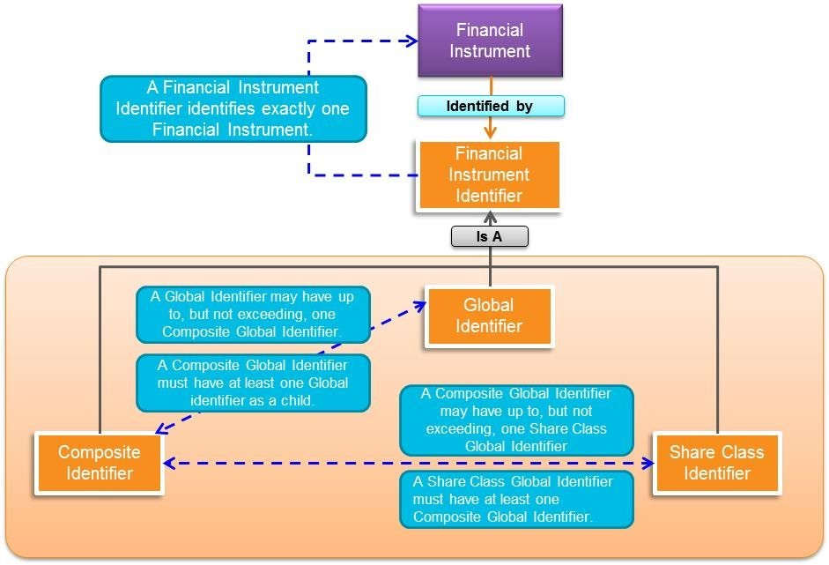

Figure 6- 1: Identifier Types

6.3.4 Exchange Code
The relationship between a Financial Instrument and an Exchange Code is as follows:
• A Financial Instrument may have up to, but not exceeding, one Exchange Code.
o Note: the vast majority of Financial Instruments have, as a matter of practice, one Exchange Code.

6.3.5 Financial Instrument Name
The relationship between a Financial Instrument and a Financial Instrument Name is as follows:
• A Financial Instrument is identified by at least one Financial Instrument Name.
Multiple Financial Instruments can be associated with a single name as there is no requirement that the name of a Financial Instrument specify all of the individuating characteristics of a Financial Instrument, e.g., the exchange code. There is, however, nothing precluding such specificity either.

6.3.6 Security Type
The relationship between a Financial Instrument and a Security Type is as follows:
• A Financial Instrument is classified by at least one Security Type.

6.3.7 Ticker
The relationship between a Financial Instrument and a Ticker is as follows:
• A Financial Instrument is identified by at least one Ticker.

6.3.8 Market Sector
The relationship between a Financial Instrument and a Market Sector is as follows:
• A Financial Instrument may have up to, but not exceeding, one Market Sector.

6.3.9 Legal Entity Identifier (LEI)
The relationship between a Financial Instrument and a LEI is as follows:
• A Financial Instrument may have up to, but not exceeding, one LEI.

7 Controlled Vocabularies

7.1 Introduction
In addition to the basic classes outlined above, there are two sets of named individuals1that serve as controlled vocabularies for the classes. While the vocabularies described below and included as a part of the specification are current as of this writing, they are subject to change, through growth, over time.
The process by which the controlled vocabularies changes is directly related to the activities of both the Registration Authority and the Certified Providers (see Annex B).

7.2 Security Types
As specified above, each Global Identifier has at least one Security Type associated with it. The Security Types are to be maintained and provided by the Registration Authority in a machine readable format or reference to such..
Over time, the set of available security types is subject to change. Two events can trigger such a change:
- New security types are invented.
The financial sector is dynamic and new financial instruments are constantly being created. Some are simply variations on existing instruments, e.g., a new mutual fund, but some are genuinely novel. Given the granularity of the security types currently inventoried, it is likely that new financial instruments will emerge that require a new identifier and description.
- The coverage of FIGI expands.
As of the 2025 OMG publication of this standard, FIGI covers over 1.4 billion financial instruments, across particular contexts that necessarily differ across security types. Over time, additional financial instruments that are not covered at present will be incorporated into FIGI at which point the security type list will need to be expanded.

¹ "Named Individual" is a standard part of both OWL and SKOS and is thus defined within those publicly available specifications.

8 FIGI Ontology

8.1 Ontology Architecture and Namespaces
The ontology architecture for FIGI is designed to facilitate ontology extension, evolution, mapping, and reuse to the degree possible. It depends on (1) basic terminology and ontology metadata, such as the OMG Architecture Board’s Specification Metadata recommendation, and (2) may ultimately be mapped to other ontologies such as parts of the Financial Industry Business Ontology (FIBO).
The namespaces and their well-known prefixes corresponding to external elements required for use of the FIGI Global Instrument Identifier ontology consist of those listed in Table 8.1, below.

Table 8-1: Prefix and Namespaces for referenced/external vocabularies
Namespace  Prefix | Namespace
cmns-av | https://www.omg.org/spec/Commons/AnnotationVocabulary/
cmns-cds | https://www.omg.org/spec/Commons/CodesAndCodeSets/
cmns-cls | https://www.omg.org/spec/Commons/Classifiers/
cmns-col | https://www.omg.org/spec/Commons/Collections/
cmns-dsg | https://www.omg.org/spec/Commons/Designators/
cmns-id | https://www.omg.org/spec/Commons/Identifiers/
cmns-txt | https://www.omg.org/spec/Commons/TextDatatype/
rdf | http://www.w3.org/1999/02/22-rdf-syntax-ns#
rdfs | http://www.w3.org/2000/01/rdf-schema#
owl | http://www.w3.org/2002/07/owl#
xsd | http://www.w3.org/2001/XMLSchema#
dct | http://purl.org/dc/terms/
skos | http://www.w3.org/2004/02/skos/core#

The namespace approach taken for FIGI is based on OMG guidelines and is constructed as follows:
- A standard OMG prefix, http://www.omg.org/spec/
- The abbreviation for the specification: FIGI
- The ontology or vocabulary name: GlobalInstrumentIdentifiers
Note that the URI/IRI strategy for the ontology and two related vocabularies takes a “slash” rather than “hash” approach, in order to accommodate server-side applications. Though not technically necessary, this specification does mandate namespace prefixes to be used. These are constructed as follows with the components separate by “-“:
- The specification abbreviation: figi
- The ontology or vocabulary abbreviation: gii, st, and ps, respectively.

The namespace itself for this specification is: http://www.omg.org/spec/FIGI/GlobalInstrumentIdentifiers/, and corresponding namespace prefix is figi-gii. The version IRI for the specification is https://www.omg.org/spec/FIGI/20260201/GlobalInstrumentIdentifiers/.

8.2 Global Instrument Identifiers Ontology

8.2.1 Ontology Metadata
The FIGI ontologies include metadata that conforms with the Specification Metadata recommendation from the OMG architecture board. The tables that follow provide the annotation property names and their values for metadata specified at the ontology level.

8.2.1.1 Specification-Level Metadata
The annotations provided in Table 8.2 include metadata common to the GlobalInstrumentIdentifiers ontology.. In every instance, the metadata is specified in the informative about files rather than in each ontology file.

Table 8-2: Specification Level and Version Metadata
Metadata Term | Value
dct:Title | Financial Instrument Global Identifier (FIGI) Specification
cmns-av:abbreviation | FIGI
dct:abstract | A Financial Instrument Global Identifier (FIGI) is a unique, persistent twelve-character string that serves to identify financial instruments. Along with the identifier, a number of related data points are identified and defined so as to provide clear context and differentiation of the financial instruments specified by the identifiers.
 | The machine consumable OWL file associated with FIGI defines all of the classes that constitute an identifier as well as the relationships between those classes so as to provide a comprehensive semantic model for Financial Instrument Global Identifiers.
owl:versionInfo | 1.3
dct:issued | 2014-02-24T18:00:00
dct:modified | 2026-02-18T18:00:00
skos:historyNote | Revisions to the FIGI specification are managed per the process outlined in the Policies and Procedures for OMG standards, with the intent to maintain backwards compatibility in the ontologies to the degree possible. The RDF/XML serialized OWL ontologies have been checked for syntactic errors and logical consistency with the HermiT reasoner (http://www.hermitreasoner.com/).
cmns-av:copyright | Copyright (c) 2013-2026 Bloomberg LP
cmns-av:copyright | Copyright (c) 2015-2026 Object Management Group
dct:creator | Bloomberg LP
dct:contributor | Adaptive Analytics, Inc., intuitive.ai, Thematix Partners LLC
dct:license | Copyright (c) 2013-2026 Bloomberg LP  Copyright (c) 2015-2026 Object Management Group  Permission is hereby granted, free of charge, to any person obtaining a copy of this software and associated documentation files (the 'Software'), to deal in the Software without restriction, including without limitation the rights to use, copy, modify, merge, publish, distribute, sublicense, and/or sell copies of the Software, and to permit persons to whom the Software is furnished to do so, subject to the following conditions:  The above copyright notice and this permission notice shall be included in all copies or substantial portions of the Software.  THE SOFTWARE IS PROVIDED 'AS IS', WITHOUT WARRANTY OF  ANY KIND, EXPRESS OR IMPLIED, INCLUDING BUT NOT LIMITED  TO THE WARRANTIES OF MERCHANTABILITY, FITNESS FOR A  PARTICULAR PURPOSE AND NONINFRINGEMENT. IN NO EVENT  SHALL THE AUTHORS OR COPYRIGHT HOLDERS BE LIABLE FOR  ANY CLAIM, DAMAGES OR OTHER LIABILITY, WHETHER IN AN ACTION OF CONTRACT, TORT OR OTHERWISE, ARISING FROM, OUT OF OR IN CONNECTION WITH THE SOFTWARE OR THE USE OR OTHER DEALINGS IN THE SOFTWARE.  See https://opensource.org/licenses/MIT.

8.2.1.2 Ontology-Level Metadata
The annotations provided in Table 8.3 include metadata specific to the GlobalInstrumentIdentifiers ontology.

Table 8-3: Ontology-level Annotations for FIGI
Metadata Term | Value
rdfs:label | Global Instrument Identifiers (FIGI) Ontology
OntologyIRI | https://www.omg.org/spec/FIGI/GlobalInstrumentIdentifiers/
owl:versionIRI | https://www.omg.org/spec/FIGI/20260201/GlobalInstrumentIdentifiers/

8.2.2 Top-Level Class Hierarchy
In addition to this specification, FIGI is provided as an ODM/OWL 2 compliant ontology.. The ontology is defined using the ODM 1.1 stereotypes for RDF and OWL and is explained via UML diagrams and corresponding tables describing the relevant model elements (the source for which is included as part of this specification in separate machine-readable files).
Each of the classes specified here are direct reflections of the concepts defined in Section 4, 6.1 and 6.2 with the single exception of Financial Instrument which is defined as follows:
Financial instruments are cash, evidence of an ownership interest in an entity, or a contractual right to receive, or deliver, cash or another financial instrument.
A clarification of this (which is represented as a “note” in the associated model files) is as follows:
Financial instruments can be categorized by form depending on whether they are cash instruments, derivative instruments or currency instruments:
Cash instruments are financial instruments whose value is determined directly by markets. They can be divided into securities, which are readily transferable, and other cash instruments such as loans and deposits, where both borrower and lender have to agree on a transfer.
Derivative instruments are financial instruments which derive their value from the value and characteristics of one or more underlying assets. They can be divided into exchange-traded derivatives and over-the-counter (OTC) derivatives.
Alternatively, financial instruments can be categorized by "asset class" depending on whether they are equity based (reflecting ownership of the issuing entity) or debt based (reflecting a loan the investor has made to the issuing entity). If it is debt, it can be further categorized into short term (less than one year) or long term.
Currency (fiat, Central Bank Digital Currency or otherwise), cryptocurrency, and Foreign Exchange instruments are neither debt nor equity based and belong in their own category.
Digital Assets, aside from currency and cryptocurrency digital representations, may come in two broad categories.
In the first case, new technologies may be utilized as a mechanism to issue and distribute a cash or derivative instrument, but the resulting financial instrument essentially retains all the same properties as if it were issued through more traditional methods. These may be classified in the same way as any other financial instrument.
In the second case, an existing financial instrument may exist, and a digital representation (such as a token) is created as an independent financial instrument unto itself, such that it is derived from the original financial instrument. In this later case, this may be considered a different financial instrument.
.
The grouping of Financial Instrument Identifier along with Financial Instrument Name and Ticker into a broader class named Identifier is a reflection of the fact that all three classes contain as individuals things which serve to identify, perhaps not uniquely in some cases, other things, in this case, financial instruments. Figure 8.1 provides the top-level class hierarchy for the model.

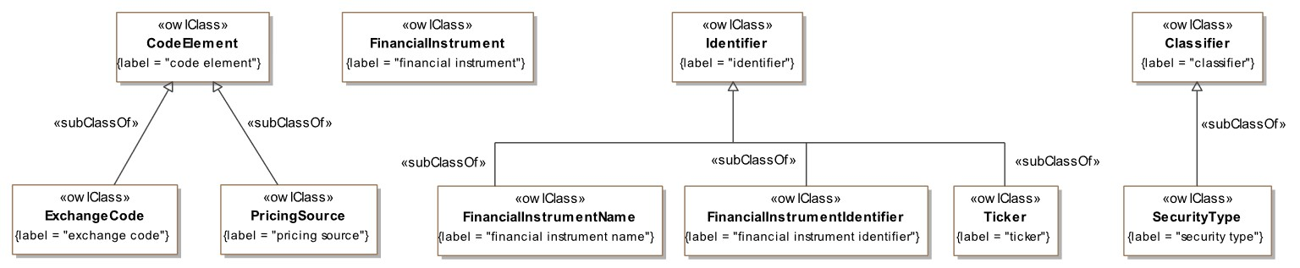

Figure 8- 1: Top-Level Class Hierarchy

Property definitions for all properties in the FIGI ontology are given in Table 8-4.

Table 8-4: Property Definitions for the FIGI Ontology
Property Name | Type | Label | Definition | Definition Source | Domain | Range
has | object property | has | indicates that someone (or something) possesses something, as a characteristic, attribute, feature, capability, and so forth |  | owl:Thing | owl:Thing
hasUnique  TextIdentifier | data property | has unique text identifier | links an entity to a unique identifier for that entity; may be associated with anything. With reference to a given (possibly implicit) set of objects, a unique identifier (UID) is any identifier which is guaranteed to be unique among all identifiers used for those objects and for a specific purpose. | https://en.wikiped ia.org/wiki/  Unique_identifier | owl:Thing | xsd:string

8.2.3 Financial Instruments
As noted in sub clause 6.3, Financial Instruments, which are at the heart of this specification, stand in a number of relationships to the other classes and subclasses defined in the model. Figure 8- 2 depicts these relationships in detail.

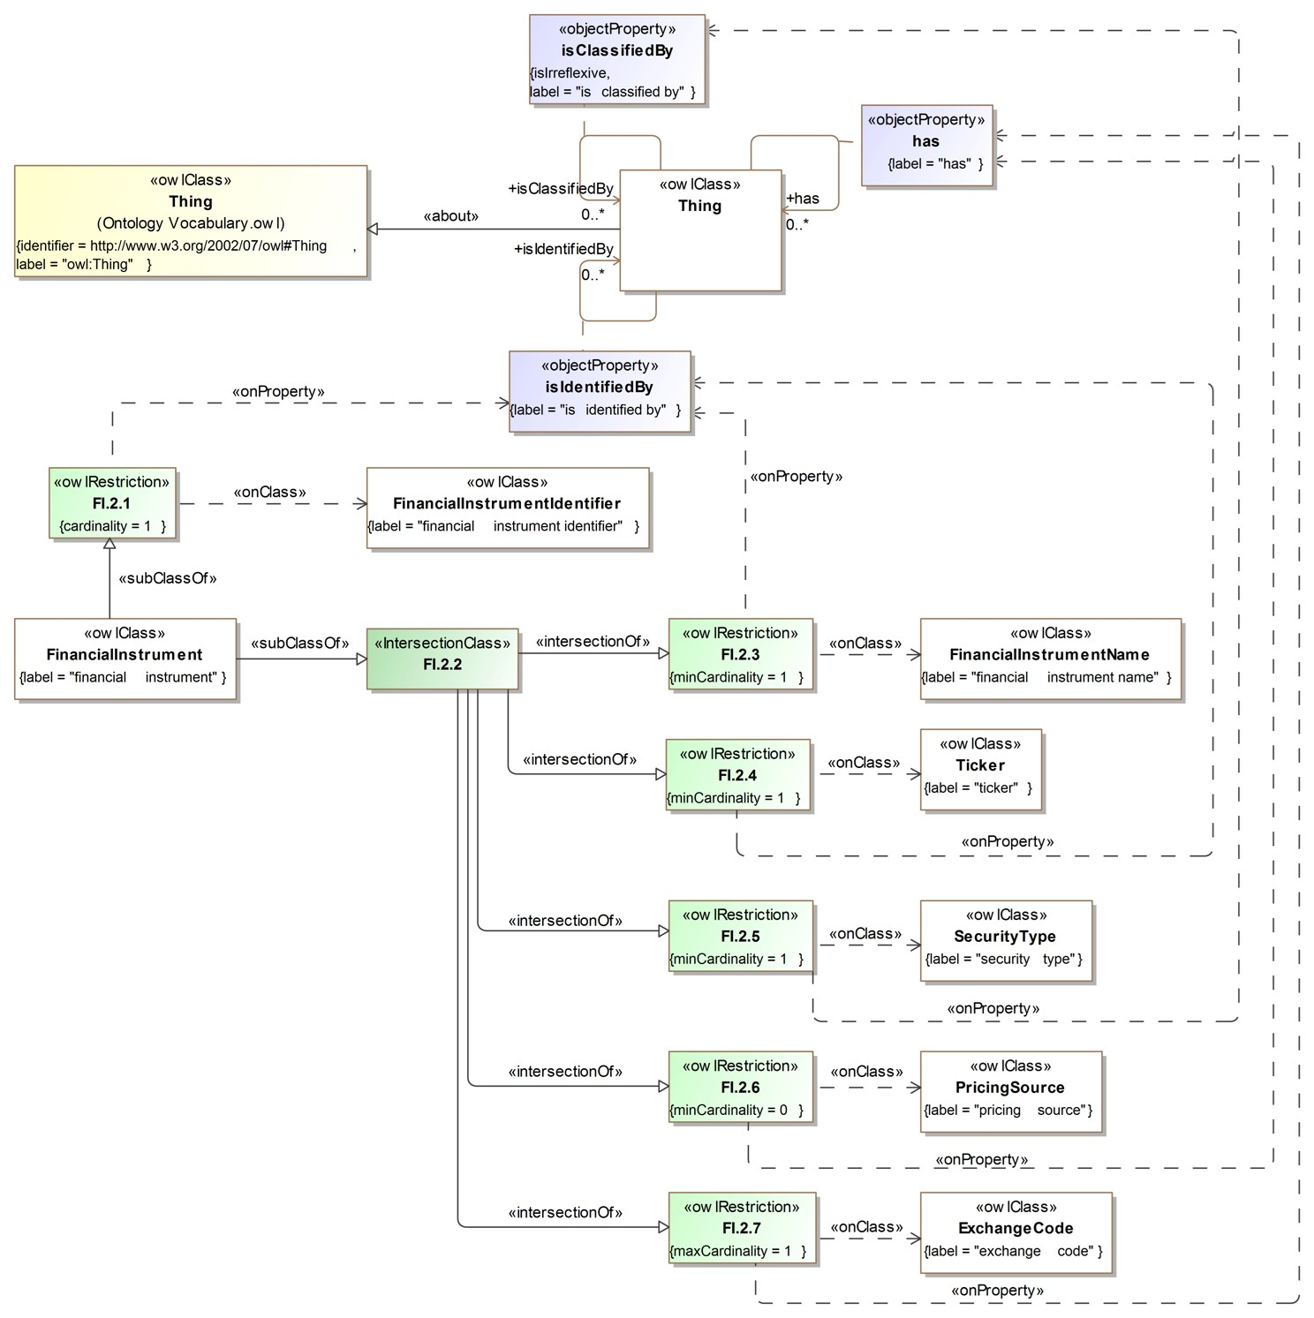
Figure 8- 2: Financial Instruments
Of note in the above diagram, we can see that Financial Instruments participate in three types of relationships:
- ‘has’: indicates that someone (or something) possesses a property such as a characteristic, attribute, feature, capability, and so forth.
- ‘is classified by’: indicates the category is used to classify an entity, in this case, a financial instrument.
- ‘is identified by’: relates an entity, in this case a financial instrument, to a label of some sort that serves as a reference to it (perhaps not uniquely).
The diagram illustrates the following, again as outlined in.6.3.3:
- ‘has’ applies to:
  - financial instrument → exchange code (FI.2.7) o financial instrument → pricing source (FI.2.6)
- ‘is classified by’ applies to:
  - financial instrument → security type (FI.2.5)
- ‘is identified by’ applies to:
  - financial instrument → financial instrument name (FI.2.3) o financial instrument → ticker (FI.2.4) o financial instrument → financial instrument identifier (FI.2.1)
Class expression definitions for all expressions depicted in Figures 8- 2, 8-3 and 8-4, above, are given in Table 8.5.

Table 8-5: Class Expression Definitions for Financial Instruments

Name and label | Annotations | Class Expressions
Name: cmns-id;Identifier | Explanatory note: An identifier is a name that identifies (that is, labels the identity of) either a unique object or a unique class of objects, where the object or class may be an idea, physical (countable) object  (or class thereof), or physical  Identifiers can be human readable or a series of alpha, numeric, or alphanumeric characters. In many cases, an identifier can be used as a pointer to an instance record. IRIs, tickers and database keys are different types of identifiers. | Property Restriction:  = 1 hasUniqueTextIdentifier.xsd:string
Name: Ticker  Label: ticker | Description: human-readable label that identifies some financial instrument  Note: The assigned ticker. The rules for forming the ticker vary according to security type. Tickers may not be unique, and multiple tickers could exist for the same financial instrument  Example: BMW common stock is typically identified through the ticker BMW on multiple different exchanges, while a corporate bond may have addition attributes for maturity and coupon such as ‘BMW 3.25 05/20/31’. Similarly, currencies typically use tickers such as USD for US Dollar, or USDGBP to represent the US Dollar over British Pound cross, but also may be represented as USD/GBP. | Parent Class: cmns-id:Identifier
Name: SecurityType  Label: security type | Definition: code representing a granular classification of the type of financial instrument  Note: The type of financial instrument, for example, common stock | Parent Class: cmns-cds:CodeElement, cmns-cls:Classifier  Property Restriction: ≥ 0 cmns-cls:classifies.FinancialInstrument
Name: MarketSector  Label: market sector | Definition: code representing the generic classification of the type of financial instrument  Examplecommon stock | Parent Class: cmns-cls:Classifier, cmns-cds:CodeElement  Property Restriction: ≥ 0 cmns-cls:classifies.FinancialInstrument
Name: ExchangeCode  Label: exchange code | Definition: label that identifies a venue where financial instruments are traded  Note: An identifier that labels the exchange on which the security trades. For example, common stock may trade on the New York Stock Exchange, identified by a code ‘UN’. Not all financial instruments trade via a formal exchange. | Parent Class: cmns-cds;CodeElement
Name: CompositeGlobalIdentifier  Label: composite global identifier | Definition: financial instrument identifier that labels an aggregation point of equatable financial instruments within an appropriate context  Note: This represents the identifier that aggregates financial instruments within an appropriate context. For example, this would aggregate a set of equity global identifiers within a country, or act as the aggregate level for currency and cryptocurrency pairs.  Example:  For IBM common stock, for example, FIGI BBG000BLNNH6 represents the ‘parent’ of all Global Identifiers traded within the United States which are identified with their own unique FIGI. The contextual usage is such that there is a single depository within jurisdictions so that for various operational functions requiring a unified view, the Composite Global Identifier can be used to aggregate all Global Identifiers.  Similarly, within the Municipal Bond market, multiple maturities may be issued that relate to the same ‘series’, such that a Composite Global Identifier can be used to identify the series, with each underlying maturity being assigned an individual Global Identifier and related back to maintain association. | Parent Class: cmns-id:Identifier  Property Restriction:  ∃ has.GlobalIdentifier  Subclass of: ∩ {  FinancialInstrumentIdentifier. <= has.ShareClassGlobalIdentifier}
Name: FinancialInstrument  Label: financial instrument | Definition: cash, evidence of an ownership interest in an entity, or a contractual right to receive, or deliver, cash or another financial instrument within a specific context  Example: Ownership interest can take the form of equity, debt or similar vehicles that provide the owner some potential or real financial value. Equity typically imparts some rights to the owner, while debt may provide the owner with a stream of payments in exchange for essentially loaning some entity cash. Cash can take the form of fiat currency or cryptocurrency. Meanwhile, derivative type instruments derive their value based on one or more other financial instruments, their interaction and the overall market. | Property Restrictions:  =1  isIdentifiedBy.  FinancialInstrumentIdentifier  Subclass of: ∩ { ( ∃ has.FinancialInstrumentName),  ( ∃  isIdentifiedBy.Ticker),  ( ∃  isClassifiedBy.SecurityType),  ( <=  isClassifiedBy.Market Sector),  ( <= has.ExchangeCode) }
Name: FinancialInstrumentIdentifier  Label: financial instrument identifier | Definition: unique, persistent, semantically meaningless identifier that acts as a label for a financial instrument  Note: A financial instrument identifier is an identifier that identifies (that is, labels the identity of) a financial instrument with a unique, persistent, semantically meaningless ID. The abbreviation ID often refers to identity, identification (the process of identifying), or an identifier (that is, an instance of identification).  Example: The FIGI BBG000BGPHV2 is the identifier for Mitsubishi Heavy Industries, specifically the common stock traded on the Tokyo Stock Exchange. Meanwhile FIGI BBG000BXKWZ3 identifies the specific listing for the same company on the Frankfurt Stock Exchange. | Parent Class: cmns-id:Identifier  Property Restriction:  = 1 identifies.FinancialInstrument  Equivalent Class: { ∀ hasUniqueTextIdentifier.xsd:string,  pattern=">^(((?!BS|BM|GG|GB|VG)[  BCDFGHJKLMNPQRSTVWXYZ]{2  })G[BCDFGHJKLMNPQRSTVWXY  Z\d]{8}\d)$ }
Name: FinancialInstrumentName  Label: financial instrument name | Definition: human-readable label that provides a description of the company or features of the financial instrument  Note: The English language name of the company or the financial instrument, e.g., a particular fund name, and sometimes include a brief description of the security or a differentiating feature, e.g., the issuance date. The name of an instrument may change in conjunction with corporate actions.  Example: American Airlines can be used to indicate the common stock, when used in context. Similarly, American Airlines Loan USD TL B 04/20/2028 is the name for a loan instrument by American Airlines with a particular maturity of 20April2028 | Parent Class: cmns-id:Identifier
Name: GlobalIdentifier  Label: global identifier | Definition: financial instrument identifier that labels a financial instrument within an appropriate context such that it is deemed functionally unique, regardless of fungibility  Note: Global Identifiers typically will correspond to a specific traded financial instrument where pricing, among other functions, may differ from other instances that could be considered otherwise ‘fungible.’  For example, BMW common stock may be traded on multiple exchanges, in the same currency and also in different currencies. However, even when traded in the same currency on two different exchanges, there could be price differences. In addition, different exchanges may have different downstream processes, which necessitate tracking the financial instrument differently.  Many cryptocurrency pairs, similarly, may be traded on different platforms. There may be pricing differences for the same traded pairs, and the underlying currencies also may be restricted to trading within a specific platform unless withdrawn and redeposited in a different platform or venue.  Note: A global identifier is a 12 character alphanumeric, randomly generated ID covering active and inactive securities. In total there will be more than 852 billion potential combinations available. The first 3 characters begin with ‘BBG’; positions 4-11 are alphanumeric (less vowels) and the last digit is a check digit, which is calculated based on the Modulus 10 Double Add Double Formula. | Parent Class: cmns-id:Identifier  Subclass of:  { ∩ FinancialInstrumentIdentifier, ( <= 1 CompositeGlobalIdentifier) }
Name: ShareClassGlobalIdentifier  Label: share class global identifier | Definition: financial instrument identifier that labels a unique aggregate of composite global identifiers  Note: A Share Class Global Identifier is assigned so as to represent an aggregate of Composite Global Identifiers. This class may be only applicable to some securities.  For example, for currency and cryptocurrency, Share Class may refer to a currency within its own context – that is without relative value or relationship to another currency or financial instrument.  Similarly, IBM common stock can be traded in multiple jurisdictions, such as the USA, UK, Germany and elsewhere, and in each of these jurisdictions, a unique Composite Global Identifier would be assigned. A single Share Class identifier (BBG001S5S399) is assigned to aggregate these composite identifiers, in addition to all Global Identifiers aggregated under each composite Identifier. | Parent Class: FinancialInstrumentIdentifier,  Property Restriction:  ∃  has.CompositeGlobalIdentifier

8.2.4 Identifiers
Figure 8- 3 specifies the ontological relationships between the three varieties of Financial Instrument Identifiers as well as their relationship to Financial Instruments. In every case, the relationships are as specified in 6.3.1 – 6.3.3.

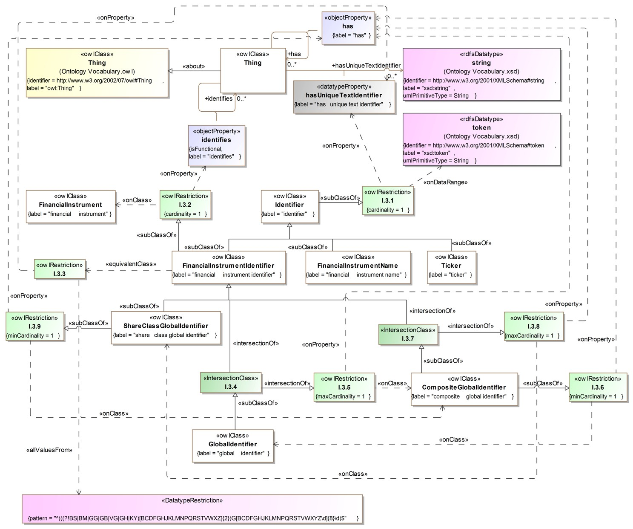
Figure 8- 3: Identifiers
Of note in this diagram is the additional DataTypeRestriction (I.3.3) placed on the Financial Instrument Identifier, in particular:
"^(((?!BS|BM|GG|GB|VG|GH|KY)[BCDFGHJKLMNPQRSTVWXYZ]{2})G[BCDFGHJKLMNPQRSTVWX
YZ\\d]{8}\\d)$"^^string]
This regex expression is in place to specify the syntactic restrictions on FIGI as specified in section 6.1. The breakdown is as follows:
- (?!BS|BM|GG|GB|VG|GH|KY): the first two characters cannot be any of the following strings:
o ‘BS’ o ‘BM’ o ‘GG’ o ‘GB’ o ‘VG’ o ‘GH’ o ‘KY’
- [BCDFGHJKLMNPQRSTVWXYZ]{2}: the above condition not-with-standing, the first two characters can be any combination of upper case consonants (including “Y”).
- G: the third character shall be an upper case ‘G’.

- [BCDFGHJKLMNPQRSTVWXYZ\\d]{8}: the next eight characters (positions 4 – 11) can be any upper case consonant or any single digit (trivially 0 – 9) numeral.
- \\d: the last character shall be a single digit (trivially 0 – 9) numeral.

What is absent from this DataTypeRestriction is the logic which dictates the calculation of the last character. This is specified in 6.2.2 but is not included in the OWL file as the calculation of the check digit would require an algorithm which is beyond the scope of regular expressions, e.g., javascript. At this point OWL 2.0 cannot support such code.
Class expression definitions for all expressions depicted in Figure 8- 3, above, are given in Table 8.5

8.2.5 Security Types and Market Sector
As discussed in 6.2.6, 6.3.8, and 7.2 Financial Instruments are further classified by Security type and Market Sector. Security Types and Market Sectors and their relationships are specified below in Figure 8.4.

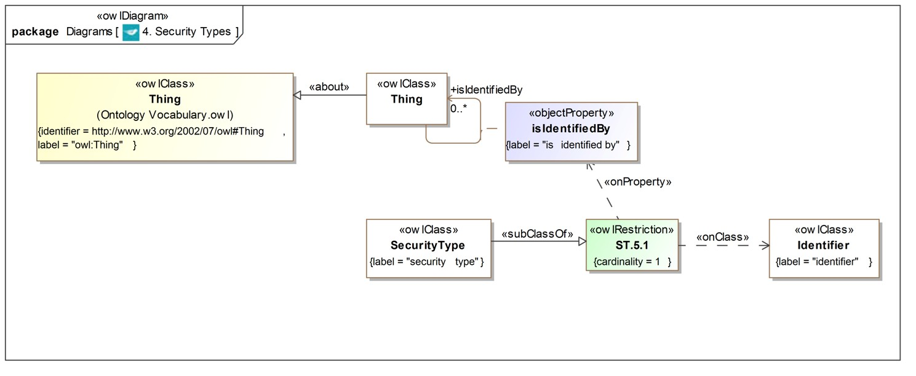
Figure 8- 4: Security Types and Market Sectors
Class expression definitions for all expressions depicted in Figure 8.4 are given in Table 8-5.

Annex A: Shared Semantics Treatments

(Informative)
The following Annex is intended to provide additional information that practitioners may find useful in understanding the standard. While there may be references to normative sections of the standard, no new requirements are specified below. Rather, background information is provided that will aid in understanding the requirements specified elsewhere.
The Financial Instrument Global Identifier can be complimentary to other ontologies and standards as previously stated. The FIGI model does not specify a conceptual model of the financial instruments themselves. Rather, it provides a concrete model for references, both descriptive and technical, for those instruments based on context of use within specific domains. FIGI is also designed to be mapped to the relevant aspects of complementary ontologies, standards and taxonomies that describe financial instruments.
The scope of the Financial Instrument Global Identifier is exclusively focused on Financial Instruments. As semantic meaning for terms within other standards and ontologies may be dependent upon context, care should be taken to ensure that the context, as defined by the domain of the use case, is properly aligned with the context of the FIGI model.

Annex B: Creation of New Identifiers
(Informative)

The following Annex is intended to provide additional information that practitioners may find useful in understanding the standard. While there may be references to normative sections of the standard, no new requirements are specified below. Rather, background information is provided that will aid in understanding the requirements specified elsewhere.

B.1 General
There can be two mechanisms by which an organization other than the designated Registration Authority (RA) can initiate the creation of new identifiers. It is recognized that a single RA individual cannot anticipate all possible market needs for identifiers. And while an RA can certainly provide a broad coverage of the market, there are inevitable market needs that will emerge over time. To this end, in addition to establishing additional RAs, two mechanisms for creation of new identifiers are proposed: 1. Request Service. 2. Certified Provider (CP) status. Each is explicated below.

B.2 Request Service
The simplest manner in which a new identifier or a set of new identifiers can be created is through the use of a request service whereby an organization interested in having an identifier or set of identifiers established simply issues a request to the RA which results in the RA creating a new identifier(s).
As has been noted throughout this document, the uniqueness of identifiers is vitally important. This applies not only to the actual twelve-character string used as an identifier, but also to the instrument(s) identified. Simply put, a single financial instrument, appropriately defined, can only have one identifier, as per the rules set out in section 2.1 of the standard.. So, in order to issue a new identifier, per section 2.2.1 above:
“In order to support the accurate assignment of identifiers it is vital that a single financial instrument, appropriately understood, be identified by exactly one identifier. Further, it shall be the case that a particular identifier, unless it is a composite or share class Identifier (see Clause 6 below), identifies exactly one financial instrument. In order to support this, then, when an Identifier is created two conditions shall be met:
- Uniqueness of Identifier: the twelve character string (see Clause 6 for details) is unique and has never been used at any time for a FIGI.
- Uniqueness of the Financial Instrument: the financial instrument being identified does not already have a FIGI associated with it.”
Meeting the first condition is trivial: since the RA serves as the system of record for all FIGIs, assigning a novel FIGI is merely a matter of creating a new identifier and checking against the existing inventory to ensure that the identifier is new. Exactly how the RA (or a CP, see below) might elect to do this is left open to the organization in question, provided that uniqueness is obtained.
Meeting the second condition is much more elaborate than was meeting the first condition. The conceptual model of a financial instrument that has been employed in this standard, however, is key to addressing this issue. As explicated in Section 6 of this standard, a financial instrument is identified by multiple things, is classified by multiple things, and is associated with multiple things. It is this collection of relationships that needs to be understood so as to ensure that a given financial instrument has not already been assigned an identifier.
So, the following data points, as previously defined in Section 6 need to be reviewed in order to confirm that the Financial Instrument in question has not yet been assigned an Identifier:

- Name
- Ticker (if applicable)
- Exchange Code

- Security Type
Owing to the diverse nature of financial instruments, it is expected that additional data points will be required, particularly as the coverage provided by FIGI expands, to provide decisive identification of financial instruments. (If such is viewed as necessary by either the Registration Authority or by a Certified Provider (see B.3), a revision of this specification can be initiated, or updated during a standard review so as to fully document the additional classes or vocabularies.) In any event, once the uniqueness of the financial instrument is established, then condition 1 can be met by issuing a new identifier.
In order to request a new identifier, therefore, it is necessary that the requester provide the data points corresponding to the above data points (where applicable/available) so as to identify the financial instrument as well as any additional data points that might be required moving forward. Further, it is incumbent upon the RA to provide a request mechanism that easily accommodates the multi-faceted requests, both in one-off format and in bulk (perhaps with restrictions on the number per request), in a simple and easy to use manner, e.g., a web site, web service or an ftp drop box.

B.3 Certified Provider (CP)
It is recognized that some organizations may have an interest in the creation of such a volume of identifiers that utilizing a request service as outlined in Annex C. is simply insufficient for their needs. This, coupled with the fact that the FIGI standard is an open standard, requires that a set of mechanisms and processes be defined so as to accommodate alternative issuers of identifiers.
Certified Providers are self-identified and nominated (self-nomination included) as potential Certified Providers to both the OMG Financial Services Domain Task Force and the RA. A Finance Services Domain Task Force sub-committee, which meets FSDTF quorum requirements, consisting of at least one representative from the RA and at least one OMG member organization that is not the RA (CP evaluation committee) will evaluate the nomination of the CP according to the following criteria that simply apply the normative aspects of the standard to the circumstances of a potential CP:
- The potential CP should have the necessary infrastructure in place or in a funded, scheduled infrastructure project that is sufficient to:
  - Scalably store and maintain the repository necessary to provide FIGIs?
  - Scalably, and with sufficient redundancy, provide only access to the FIGIs it creates?
  - Provide a sufficiently robust API interface to support the registration of new FIGIs and related items?
- The potential CP should be committed to providing the above services in perpetuity with no restrictions on redistribution and absolutely no charge to any potential user or organization?
The CP evaluation committee would issue their response to the application within six (6) months/two OMG meetings of the completed application being presented to the Finance Domain Task Force at an OMG meeting. The response will provide appropriate documentation explaining why the decision was made as it was if the outcome is not positive. In the event of a negative outcome, the potential CP is free to reapply for CP status anytime in the future through the above process.
The two conditions outlined above, 1. Uniqueness of the identifier and 2. Novelty of the financial instrument are both highly relevant and, as it happens, a bit more complex in the case of a CP. The complexity stems from the fact that there would only be one comprehensive system of record that can serve to ensure that conditions 1 and 2 are met: the inventory maintained by the RA. To address this complexity, the mechanism and processes by which CPs can create identifiers needs to be considered from both the perspective of the potential CP as well as from the perspective of the RA. We begin with the RA.

B.3.1 Registration Authority (RA) Role
The RA, as the keeper of the comprehensive inventory of identifiers needs to ensure that both conditions 1 and 2 (As per Section 2.1) are met prior to an identifier being issued. When the RA itself is issuing an identifier, this is relatively simple as outlined in C.1. When an identifier is requested by a CP, however, the situation is different. Regarding the first condition: the uniqueness of the identifier, an allocation system for two letter prefixes as outlined below in Annex C addresses that easily enough. Regarding condition 2: the uniqueness of the financial instrument requires a bit more effort.
Given the data points associated with a given financial instrument as discussed in C.1, determining if an instrument has already been assigned an identifier within the confines of the RA environment is not overly complex. In the case of an order to ensure that the second condition is met, the RA would need to provide an API in order to permit each CP to check their proposed financial instrument against the existing inventory as part of the registration process. As it is possible that two CPs might elect to assign identifiers (trivially different twelve-character strings, see Annex C) within a small window of time, it is necessary that this check occur at the time of registration, which would be after the time when the CP has assigned an identifier string, as opposed to a preliminary step prior to the assignment of the string. This way, at any given time there would be either zero (0) or one (1) twelve-character string assigned to any given financial instrument with no need to “hold” a spot.

B.3.2 Certified Provider (CP) Role
Like the RA, the CP is responsible for ensuring that conditions 1 and 2 of Section 2.1 are met. In this case, however, the CP is not expected to check for conditions 1 and 2 against the entire inventory of financial instruments. Rather, they are only responsible for checking that conditions 1 and 2 are met against their own inventory. Once it is determined that a candidate financial instrument is not already present in the CPs inventory and that the identifier assigned to the instrument is unique within the CPs inventory (again, the uniqueness of identifiers across inventories is assured given the allocation rules specified in Annex C), the CP issues a call to the API provided by the RA to register the financial instrument and the identifier assigned to it. There are three possible outcomes, all of which would be communicated back to the CP:
- The registration is accepted, and the financial instrument and identifier are inserted into the RAs comprehensive inventory thereby making it/them available for use.
- The registration is rejected because:
  - The instrument is already present in the comprehensive inventory, in which case the identifier would be communicated back.
  - The data points provided to describe the instrument was incomplete or otherwise non-computable, in which case the offending data elements would be specified in the communication back.
- Manual review of the request is required owing to some ambiguity or other issue; in which case an estimated time of resolution will be communicated back (within the constraints of an established SLA). This is expected to be a very rare occurrence and is included here for the sake of logical completeness.
In the event that a registration is rejected because the instrument is already present in the comprehensive inventory, it is up to the CP whether they put the identifier string back into their unused inventory or not. Given that each CP would have an initial allotment of roughly 852 Billion identifiers, inventory control is not a high priority.

B.4 New Security Types
In addition to new identifiers, new Security Types can be created from time to time. The mechanism by which these can be created are entirely parallel to the mechanisms by which new identifiers are created. In particular, as the two conditions necessary for a new identifier: 1. Uniqueness, and 2. Novelty, apply also the Security Types, the exact same process is followed:
- The Registration Authority, as the holder of the definitive repository, is responsible for confirming the uniqueness and novelty of each new Security Type it creates.
- The Certified Provider(s) are responsible for:
  - Confirming the uniqueness and novelty of each new Security Type it creates against their own inventory.
  - Making a call to the RA’s API to confirm the global uniqueness and novelty of the new vocabulary item.
  - It is expected that this process can either stand alone as the registration of a vocabulary item or can be packaged as part of the request process for a new identifier which is such that a new vocabulary item is required to support it.

Annex C: Allocation of Identifier Prefixes
(Informative)

The following Annex is intended to provide additional information that practitioners may find useful in understanding the standard. While there may be references to normative sections of the standard, no new requirements are specified below. Rather, background information is provided that will aid in understanding the requirements specified elsewhere.
The total possible inventory of identifiers is in excess of 600 Trillion. Each two letter prefix can be associated with over 852 Billion identifiers given the logic by which the identifiers are governed. While these numbers are sufficient to give us comfort from a statistical perspective that duplicate identifiers will not be generated, a mechanism by which specific two character prefixes are allocated and managed is necessary to ensure that duplication does not occur across different providers. To this end, the following logic can be employed:
Given that all grandfathered identifiers (those specified prior to the adoption of this standard and numbering over 150 Million) have been generated by a single organization and all begin with the “BB” as the first two letters:
- The organization currently issuing identifiers can continue to issue identifiers using the “BB” prefix until such time as the possible combinations are exhausted or are nearing exhaustion (threshold: 500 Million remaining identifiers) at which point they would select another two letter prefix following the same process as other organizations.

- Other organizations that wish to create identifiers have the opportunity to select a two letter prefix from the unused inventory of two letter prefixes. In order to secure a particular two letter prefix, the following conditions are to be met:
  - The organization demonstrates that they either currently have the capacity to deliver identifiers in accordance with the requirements specified concerning issuing authorities or have in place a funded project by which they demonstrate the capacity to deliver identifiers in accordance with the requirements specified concerning issuing authorities within 18 months of approval.

  - The application for a new two letter prefix is presented in writing to both the relevant part of the OMG as well as the RA at least six (6) months prior to the anticipated approval date.

- If an issuing organization that has secured an identifier does not issue at least one identifier within six months of establishing the operational ability to create identifiers, the two letter prefix would be returned to the open inventory not withstanding any other written agreements between the issuing organization, OMG, and the RA to the contrary.
Once a two letter prefix is established and in use by a particular issuer, the issuer is restricted to issuing identifiers using only that prefix until such as time as all of the possible combinations are exhausted or are nearing exhaustion (threshold: 500 Million remaining identifiers) at which point they would be allocated another two letter prefix following the same process as outlined above. There can be cases that result in exceptions to this that should be reviewed when they occur.

The process flow by which CPs are established is as illustrated below:

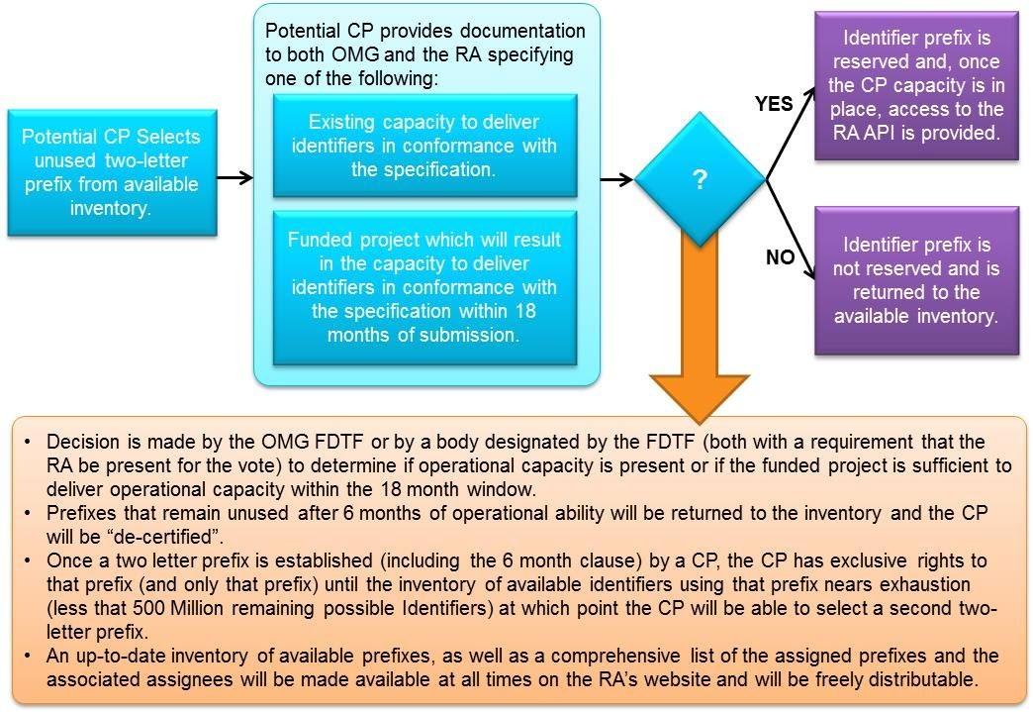

Figure C. 1: Allocation of Certified Providers and Prefixes

Annex D: Other Standards in the Financial Space
(Informative)
The following Annex is intended to provide additional information that practitioners may find useful in understanding the standard. While there may be references to normative sections of the standard, no new requirements are specified below. Rather, background information is provided that will aid in understanding the requirements specified elsewhere.

D.1 Introduction
While the Financial Instrument Global Identifier specification is intended as a stand-alone specification which is focused on the integrity of unique, persistent identification of Financial Instruments, the fact remains that there are standards in place at any given time that speak to Financial Instruments and may, therefore, intersect with or overlap with the FIGI specification. The purpose of this annex is to provide some acknowledgement of those facts and to proactively counter any confusion that might arise. To that end, this appendix consists of a listing of the relevant standards and a brief treatment of the relationship between those standards and FIGI. These should aid in understanding the FIGI. Again, as there are constantly emerging and evolving standards, it is expected that this appendix will change over time as part of the revision process.

D.2 ISO 6166 (ISIN)
The ISIN standard overlaps with the FIGI standard in that it, too, seeks to assign unique identifiers to Financial Instruments. It differs, however, from the FIGI in a number of critical ways which will be explicated below. Because of the overlap and the differentiation, FIGI and ISIN can be viewed as complementary, rather than competing, standards.

The ISIN and the FIGI differ in three broad ways:
- Scope: The FIGI provides, both in practice and in future implementation, a much broader scope than does ISIN. In particular, FIGI identifies not only securities, but, potentially, all financial instruments and inherent self relationships. The reason that the scope is so much broader is a function of purpose: the ISIN is focused on serving as a reference for a fungible instrument at the initial issuance level, which serves a proper and needed function in and of itself. FIGI, in contrast, while capable of serving in that capacity, is focused on providing a consistent and unique data model that serves to identify financial instruments and the different contexts they exist in throughout their lifecycle, so as to enable robust and comprehensive data management and, from that, compliance.
- Granularity: The ISIN provides a single identifier at the single issued level for a fungible instrument. FIGI, in contrast, provides not only that in the form of the Share Class Global Identifier (hence the overlap), but also at the country level through the Composite Global Identifier, and, where applicable, at the trading venue level as well.
- Persistence: Corporate actions, such as name changes, acquisitions, corporate relocations, and so on, can result in the need for an ISIN to change. This is not intended as part of the ISO 6166 specification but is a function of the distributed delivery system for ISINs. Such is not the case with FIGIs in that the characters present in the FIGI string are, with the exception of the check digit, entirely meaningless. As such, there are no inferred references to the currency, market or country location, or company name present in the identifier—a condition which can be present in ISINs, depending on the structure of the embedded national number and the country prefix used.
Organizations that are licensed to use ISIN are free to map between FIGI and ISIN at the Global share class level. Indeed, this is a common practice. Owing, however, to licensing restrictions on ISIN (though not on FIGI), such mappings cannot be freely redistributed.

D.3 ISO 10962 (CFI)
The Classification of Financial Instruments (CFI) code is a six character string that serves to classify financial instruments both at a high-level, e.g., debt instruments vs equities, and through their attributes, e.g., fully paid vs partly paid. In a sense, this can be viewed as related to the Security Type vocabulary that is part of the FIGI specification. The mechanism by which the distinctions are made, beyond the top levels, however, are very different and so these should be viewed as complementary classification systems.

The mechanism by which CFI distinguishes between Financial Instruments at the granular level is largely a function of the legal distinctions that govern the acquisition and disposition of such instruments. For example, Future Contracts are differentiated by whether the terms are standardized or non-standardized. In contrast, the different security types that inform FIGI reflect the manner(s) in which a financial institution would classify their positions for multiple operational and regulatory reporting purposes and may be influenced by jurisdiction.
As with other standards, it is possible for organizations to map their holdings to both the FIGI listing of Security Types and to CFI. Distribution of the CFI mapping is not, however, part of the FIGI specification, nor it is required as part of FIGI compliance within the standard (though it is not precluded).
It should be noted that multiple different classification systems, taxonomies, and ontologies exist, will persist, and it is unlikely a single definitive system will emerge. This is due to multiple factors, notwithstanding legal, regional, jurisdictional, operational and other differences. As such, the primary function of the FIGI Security Type classification is to enable interoperability across approaches.

D.4 ISO 20022 (UNIFI)
ISO 20022 is a business modelling standard that specifies the structure of a metadata repository containing descriptions of business processes such that physical messages can be generated for business communication. The relationship between ISO 20022 and FIGI is an intersecting, rather than overlapping, relationship. In fact, the FIGI standard is formally recognized as having a place within ISO 20022 within the accepted external codesets. Strictly speaking, however, ISO 20022 and FIGI are entirely independent of one another as they seek to do very different things.

D.5 ISO 10383 (MIC)
The Market Identifier Code (MIC) provides a universal method of identifying exchanges, trading platforms, and regulated or non-regulated markets as sources of prices and related information for Financial Instruments. This function overlaps with parts of FIGI, in particular, the Pricing Source. As with ISIN, there are key differences.
- Scope: The MIC provides identification of places where securities can be, broadly speaking, bought and sold. As such, it only applies to tradable securities that are exchanged at a venue (broadly understood). The list of exchange codes present in FIGI includes codes to support Financial Instruments that are not exchanged at a venue that is not eligible for a MIC. In fact, FIGI can support Financial Instruments that are not technically tradable at all, e.g., an individual person’s home mortgage contract.
- Embeddedness: The MIC code is a stand-alone code that identifies a Market. As such, it serves a different purpose than does the Exchange Code attribute of FIGI and is definitionally different, although there may be similarities The Exchange Code attribute of FIGI serves as a differentiator of otherwise identical financial instruments and that differentiation is embedded into the Financial Instrument Global Identifier as part of the defining metadata. In the case of the MIC, it can be used in concert with the ISIN for informational purposes, as when used together, the combination can provide a certain context that is usable in certain functions. However, in general, it is not part of the core metadata of the ISIN in the same functional context as Exchange Code attribute exists within FIGI metadata.

D.7 Legal Entity Identifier

ISO 17442 is an International Organization for Standardization (ISO) standard that defines the Legal Entity Identifier (LEI). The LEI is a 20-character, alphanumeric code that uniquely identifies legal entities participating in financial transactions. This standard ensures a consistent and unambiguous way to identify these entities globally.

D.6 Use with other identifiers and standards
FIGI, as noted in Table 8-2, is based on the open source concepts of the MIT Open Source license. As such, they are freely redistributable, can be used, transmitted, databased, stored, enriched or otherwise utilized without restrictions aside from ensuring that the MIT Open Source permissions are included and disclosed. As such, there are no restrictions on associating or ‘mapping’ FIGI or the associated metadata to other standards, using the FIGI in or as part of other standards, or adding these other standards or identifiers as associated metadata within an extended FIGI object.
It should be noted that other standards or identifiers in the marketplace may carry some level of licensing or restrictions under different conditions. These licenses may be incompatible with the MIT Open Source license in some conditions such that users should be aware that the MIT Open Source license would not override or invalidate those licenses or restrictions.
Regardless, use of the FIGI in concert with any of these other licenses does not restrict or otherwise change the MIT Open Source license conditions of FIGI and the associated data covered. Under no conditions would the MIT license be invalidated or otherwise revoked.

