OMG BACM 1.2 RTF Issue Resolution

Issues to be resolved

BACM12-4 – Binding Object
The BIZBOK introduces the notion that value streams include the concept of a binding business object(s) whose state, together with entry and exit criteria controls the sequencing of value stream stages. How should BACM represent this concept? Is it explicit in the metamodel, or is it the result of analysis or some combination of these?

BACM12-6 – Outcome logical relations
The BACM 1.1b1 specification provides OutcomeRelation as a template for the model level definition of relations between outcomes. Recent work on entry and exit criteria for value streams as well as capability and process flows has informally used logical relationships that instance/specialize OutcomeRelation and effectively define an Outcome that is the logical union or other Outcomes. The issue is whether the metamodel should define a set of specifically logical relations. For example, include, exclude, include complement could be used to create an Outcome by conjunctive composition where the semantics of the Outcome is the union of all facts from included Outcomes, no facts from excluded Outcomes (i.e. not known whether these are true or false), complement facts from included complement Outcomes.

BACM12-16 – Outcomes for Stages and Capabilities
In prototyping the Guild transportation reference model, it became apparent that the BACM 1.1b1 metamodel does not support the notion of outcomes associated with the execution of value stream stages or abstract capabilities. For example, safety and comfort of the traveler are outcomes that have high value in the value proposition, They are continuously associated with the enroute stage of the value stream and are not appropriately characterized as exit-criteria, which are outcomes associated with the ending of the stage.
Such outcomes should be associated with capabilities such as conveyor operations to indicate that the outcome is in force throughout the execution of the capability.

Relevant facilities in BACM 1.1b1

Entry and Exit Criteria
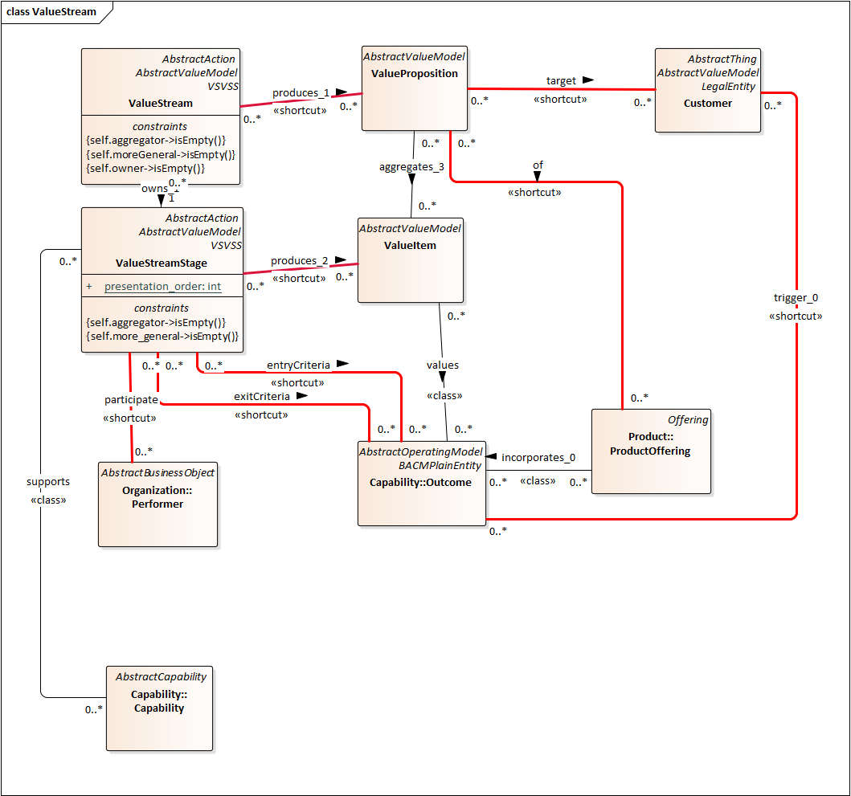
Figure 1 - BACM 1.1b1 Value Stream metamodel
EntryCriteria and exitCriteria are <<shortcut>> associations between value stream stages and outcomes. The intended meaning of the entry criteria association is that the outcome should be present and valid for the value stream stage to be entered. The intended meaning of the exit criteria association is that the outcome should be present and valid by the exit from the value stream stage.

Outcomes as Statecharts: An intuitive model for action/consequence analysis
The metamodel does not provide an execution or analysis semantic that would resolve the question: what does it mean for an outcome to be present and valid? A commonsense interpretation would say that the activities of a value stream stage take time so the value stream stage itself will take time. For an outcome to be present and valid, the business objects whose state is described by the entry criteria outcome must be in this state prior to and during the entry to the value stream stage. At some time later, the business objects whose state is described by the exit criteria must become valid. In lieu of an execution semantic, BACM-based models should support a type of analysis that examines sequences of “Outcome needed by ValueStreamStage produces Outcome”, where part or all of a produced Outcome matches a needed Outcome of another ValueStreamStage. The analysis is generalized to include AbstractCapabilities and AbstractProcesses in addition to ValueSTreamStages. Taken together, ValueStreamStages, AbstractCapabilities and AbstractProcesses will be referred to as “action elements”.
The result of such an analysis will be tree-like structures with loops, rooted in a selected outcome at which the analysis begins. Because of possible decompositions of outcomes and action elements, the actual structure will be more complicated. The analysis may be terminated by the architect when the desired results have been found or when the analysis becomes complex without revealing a result. The latter case may indicate errors or incompleteness in the model.
The semantic relation between the root Outcome and all final Outcomes is that it is possible for any of the final Outcomes to result from the root Outcome. This result is important because it allows the architect to see and examine the possible outcomes, e.g. of a value stream and to observe the path leading to those outcomes. This result cannot be as precise as a result derived from executing the model with test outcomes, but such an execution model would require much more detail and precision from the architect. An execution effort would be more appropriate when the modeler is working with process and data descriptions.
In the BACM metamodel, business objects do not have internal state; instead, their state is described by outcomes that reference them. A modeler should imagine a clock that is referenced by each outcome such that the clock reference defines the clock periods when the outcome is valid and the clock periods when the outcome is invalid. It is possible that there are clock periods when an outcome is neither valid nor invalid. The clock periods can be ordered. Contradictory outcomes are not allowed when any of their clock periods overlap. The BACM 1.1b1 metamodel does not define a clock concept.
The entry criteria and exit criteria outcomes may have overlaps during their periods of validity but may not contradict each other during an overlap. When outcomes are contradictory and one is an entry criterion and one is an exit criterion, the validity or invalidity period of the exit criteria must follow the validity period of the entry criteria without overlap. For example, a physical business object may not be in different locations at the same time. A value stream stage that results in a change in location of such a business object will have a prior location described by an entry criteria outcome and a post location described by an exit criteria outcome. The validity period of the entry criteria location describing outcome will precede and not overlap with the exit criteria location describing outcome.
A value stream stage may not have contradictory entry criteria unless these are exclusive, i.e. one criteria or the other may be valid on entry, but not both. The same rule is true for exit criteria. If such contradictions would not be obvious to a user of the model, the modeler should include them in the descriptions of the outcomes. Because the establishment of a contradiction between outcomes is technically challenging, the modeler should treat the group of outcomes that are entry criteria to a value stream stage as being mutually exclusive and multiple exit criteria outcomes from the value stream stage as being mutually exclusive. This same interpretation should apply to outcomes related to capabilities and processes. This interpretation encourages the modeler to think of such a group of outcomes as alternative states, each of which may be composed of a conjunction of positive and negative assertions about business objects. For example, some flight segment outcomes could be “ready to depart”, “cancelled”, or “subject to a hold”; in order for the “ready to depart” outcome to be positive, it must be the case that the “travelers have boarded” and that the “crew is on duty” and that the “aircraft is provisioned” and that there does not exist a “subject to a hold” outcome.
It is possible that an outcome will be an entry criterion for a value stream stage and remain valid after the value stream stage is exited. In a manufacturing scenario, an entry criterion for the (non-destructive) product testing stage may require the test item to be completely built (an entry criteria outcome) and this outcome remains valid on completion of testing.
The model assumes that a produced outcome becomes valid later than the needed outcome. The elements in successive levels of the tree-like structure become valid later than their predecessors. The model assumes a synchronization of action elements that is the result of the exchange of outcomes. If an action element A is decomposed into action element A1 followed by action element A2, the intermediate outcome between A1 and A2 must occur sometime after the start of A and its end.
Temporal comparisons between elements of the same level are not possible without assigning time distributions for the behavior of each element and potentially time distributions for the transmission of outcomes. Despite the obvious appeal of producing time-ordered results across branches of the tree-like structure, it is discouraged because of complexity and the difficulty of obtaining representative time distributions.
In practice, a modeler should include in the description of each entry or exit criteria outcome, statements about the validity of this outcome with respect to other outcomes that are entry and exit criteria of the stage when such validity descriptions might not be obvious to a user of the model.
This intuitive model of execution is chosen to allow the modeler to describe potentially complex value stream scenarios such as those found in knowledge work but does not require the modeler to formally describe clocks and validity periods, as might be the case in an engineering-oriented specification such as SysML V2. The intuitive execution model is thought to be sufficient to allow examination of root causes of failure and downstream impacts of failure and other analyses that would be of interest to the clients of a business architect.

Relevance to open issues BACM12-16 and BACM12-4
The entry criteria and exit criteria provide information about the prior state and post state of business objects that participate in a value stream stage. They do not provide information about the state of these business objects while a stage is ongoing. For example, it may be useful to confine the locations of a business object to follow one of a collection of paths that begin with the prior location and end with the post location. Such a facility is useful in travel and shipping businesses to associate a trip or a shipment with a flight segment or route. While the entry and exit criteria provide some information relevant to BACM12-16, there is no association that represents outcomes that result during the stage.
The BIZBOK describes a “binding object” as a business object that is the focus of a value stream and whose states help to order the stages. The binding object also links to other business objects that are involved in the value stream. For example, a shipment business object may bind together a customer, a shipper, a collection of physical objects being shipped, a conveyor and a route.
In a BACM model, the binding object should be a business object whose outcomes are in the entry and exit criteria of every stage in the value stream. This must be the case if the business object states (represented as outcomes that are entry and exit criteria) can be used to order the stages via the intuitive execution model. The entry and exit criteria are relevant to issue BACM12-4. While this rule is a necessary condition for a business object to be a binding object, it is not a sufficient condition. Where the rule allows multiple candidates, the modeling practice should indicate in one or more outcomes of the selected binding object that this business object is intended as the binding object. In the shipment value stream, the shipment, the customer and the shipper may be referenced in entry and exit criteria for every stage, but the shipment would be described as the binding object for this value stream.

Capabilities and Outcomes
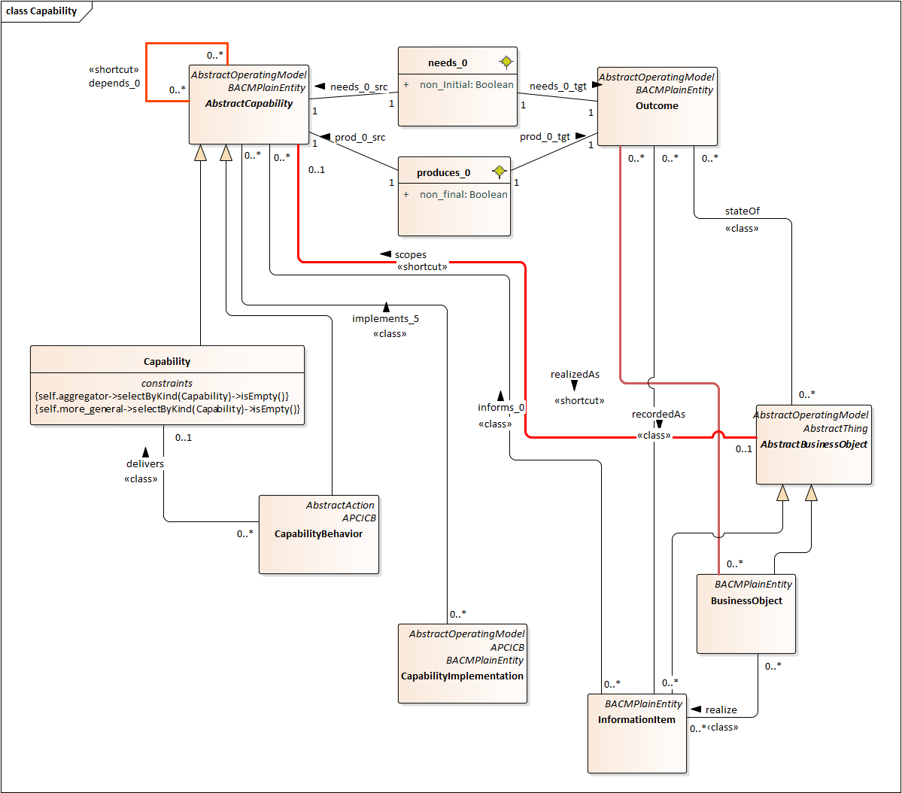
Figure 2 - BACM 1.1b1 Capability metamodel
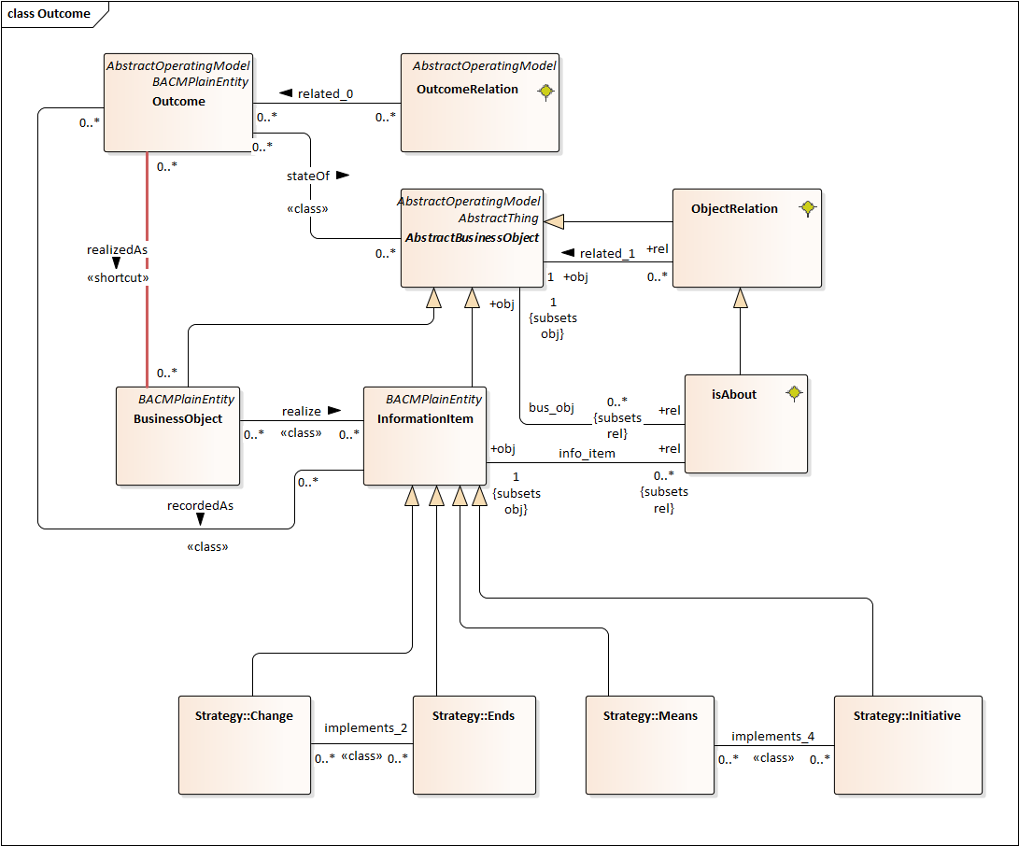
Figure 3 - BACM 1.1b1 Outcome metamodel

Relevance to Issues BACM12-6 and BACM12-16
The BACM 1.1b1 metamodel provides a general relationship, OutcomeRelation, between Outcomes that is intended to be specialized. BACM12-6 suggests OutcomeRelation should be specialized to provide concrete relationships for common cases such as conjunction, disjunction, and negation.
The BACM 1.1b1 metamodel also provides features on the needs_0 and produces_0 relationships indicating that an Outcome can satisfy a non-initial needs_0 relationship during the execution of the Capability. The normal interpretation of needs_0 is that the Capability needs the Outcome to trigger its execution. Likewise, the non-final produces_0 relationship allows a Capability to produces_0 an Outcome that may be needs_0 by another Capability without terminating execution. This feature of the BACM 1.1b1 metamodel allows Capabilities to delegate work to other Capabilities, eliminating the tendency for modelers to duplicate low level capabilities across branches of the capability hierarchy. For example, TripManagement may use sub-capabilities of IncidentManagement to deal with incidents occurring during a trip. The Incident/TripMatching Capability manages the relationship between a Trip and an Incident but does not appear to manage the Incident in the context of the Trip. A health crisis onboard a conveyor would be dealt with medically as if it occurred in a health facility to the extent made possible by training and relevant medical equipment.
Using the 1.1b1 metamodel, a TripManagement Capability could non-final produces_0 a ResolveHealthCrisis Outcome that is needs_0 by an IncidentManagement Capability which resolves the incident and produces_0 a HealthCrisisResolved Outcome that is non-initial needs_0 by the TripManagement Capability.
The 1.1b1 metamodel does not specify how such delegations are related to other delegations from the same capability, limiting the dependency analyses that may be carried out. This metamodel does not specify sequencing or context that would pair the non-final produces_0 to a non-initial needs_0 as would be the case for a subroutine or co-routine execution model. BACM12-16 realizes the shortcomings of the BACM 1.1b1 metamodel and suggests solutions that would support additional analyses at the cost of adding additional detail to the model.

How to resolve BACM12-4, BACM12-6 and BACM12-16

Background Discussion

Outcomes as a statecharts model
Statecharts are a hierarchical state modeling language invented by David Harel and incorporated into UML. A composite state can be decomposed into a network of states that occur sequentially as determined by transitions between the states in the network. Alternatively, a composite state can be decomposed into a set of regions that each contain a sequential network of substates that can be either atomic or composite. The different regions of a composite state execute independently of each other.
This proposal adopts a statechart-like representation for outcomes. An Outcome that describes an atomic state of an AbstractBusinessObject, a group of AbstractBusinessObjects, a relationship between AbstractBusinessObjects or a group of relationships between AbstractBusinessObjects is like an atomic state in a statechart model.
Transitions between outcomes that are like atomic states are associated with Capabilities, AbstractProcesses or ValueStreamStages. These transitions partially represent the work done by the capability, etc. These outcomes are indicated by the entryCriteria and exitCriteria criteria of ValueStreamStages, the needs_0 and produces_0 associations of Capabilities and the input and output associations of AbstractProcess. A consequence of the intuitive execution model applied to this model structure is that the validity periods of each outcome are updated by the work done during the execution of the AbstractCapabilitY, AbstractProcess or ValueStreamStage.
BACM 1.1b1 does not provide metamodeling syntax that allows this association of a Capability, AbstractProcess or ValueStreamStage with an Outcome that represents this work and it does not have syntax that allows such an outcome to be decomposed in the ways defined by statecharts.

Outcomes can be logically combined
To reduce the number of associations between Outcomes and Capabilities, AbstractProcesses or ValueStreamStages, a general principle of intertia is applied. This principle says that a prior Outcome that is valid on entry to a Capability, AbstractProcess or ValueStreamStage, will remain valid during and post unless it is made invalid by the work.
However, this principle does not completely resolve the need to define complex prior states. In a travel scenario, the departure stage needs outcomes about the traveler, the conveyor, the departure facility, the pilot and the crew to be current and valid at the same time. This requirement can be described as a conjunction of outcomes:
- The traveler is at the departure facility and ready to depart.
- The conveyor is at the departure facility and ready to depart
- The pilot and crew are at the departure facility and ready to depart.
- The departure facility is ready to orchestrate the departure.
- There is not a ground hold current and valid.
This example shows that requirements may be negative, i.e. that there are no current and valid outcomes of a specific kind.

Modeling Outcomes for Business Architects
In the belief that BACM must be usable by businesspeople but be clear and concise enough to the useful to technical people, it has avoided requiring technical details that would allow automated execution/simulation or consistency checking. It aims to allow the expression of information that a business architect or analyst could use to investigate whether a model correctly represents the business and does not contain obvious contradictions. It has also aimed to allow useful analyses such as root cause and change impact to be performed by business architects and analysts.
This has meant that entities in a business architecture model have semantics described in prose instead of a technical language, e.g. a programming or simulation language. This is also the case for outcomes whose descriptions should express the state of the associated business objects in prose. To avoid ambiguity, it is recommended that the nominals in the prose that refer to business objects should be the labels of the associated business objects, e.g. “traveler”, “conveyor”. Other phrases, e.g. “ready to depart”, that refer to states should be the labels of referenced outcomes, i.e. an outcome labelled “The traveler is ready to depart” describing the state of the “traveler” business object.
Perhaps in the future, technology such as large language models (LLMs) will assist the business architect to interpret these prose statements and requirements, reducing the level of skill and experience required to perform an analysis.

Proposal rationale and Examples

Adoption of state charts
The proposed adoption of a state chart-like model to create composite Outcomes was deemed the best solution because state charts are well designed and have been in the UML specification for many years. Other behavior-specifying languages such as interaction diagrams, activity diagrams, Petri nets are thought to be less familiar to business architects and analysts and more associated with technologists. Interaction diagrams and activity diagrams depend on model classes having methods, a concept that is not in the BACM metamodel.
Petri nets assume that places are associated with activities and token-passing is the mechanism that invokes activities. While a Petri net semantic could be applied to the activity entity/Outcome model, it would require additional machinery in the BACM metamodel to specify the token activity rules.
The BIZBOK advocates a net-like behavior model it terms “rules-based routing” that uses rules based on object state to control transitions and enable activities. The nodes are work queues or places where work is done and are associated with stakeholders. The BIZBOK does not offer guidance about relating “rules-based routing maps” to capabilities and outcomes. It does provide an example diagram and Excel worksheet illustrating alignment of a routing map to a value stream. However, the stage entry and exit criteria are not indicated and are difficult to determine from the Excel spreadsheet example. The alignment principles are general and work will be required to refine them to a level of detail where they can be harmonized with the BACM metamodel. Adopting this model into the BACM would seem to require the addition of work queues and associations from them to AbstractCapabilities, AbstractProcesses and Performers. A modeler may use a routing map implemented as a spreadsheet and align it with a BACM model using the external reference facility. Supporting routing maps in the BACM metamodel is an issue for a future Revision Task Force.
Behavior models like BPMN, DMN and CMMN do not explicitly specify state and are difficult to reconcile with ValueStreams and Capability/Outcome networks that are core to business architecture and to the BACM metamodel.

Composite Outcome Example
The following example is derived from the Guild’s Transportation Reference Model V4.0.1 and shows the statechart-like decomposition of PlanATrip_state, the outcome associated with the PlanATrip value stream stage.
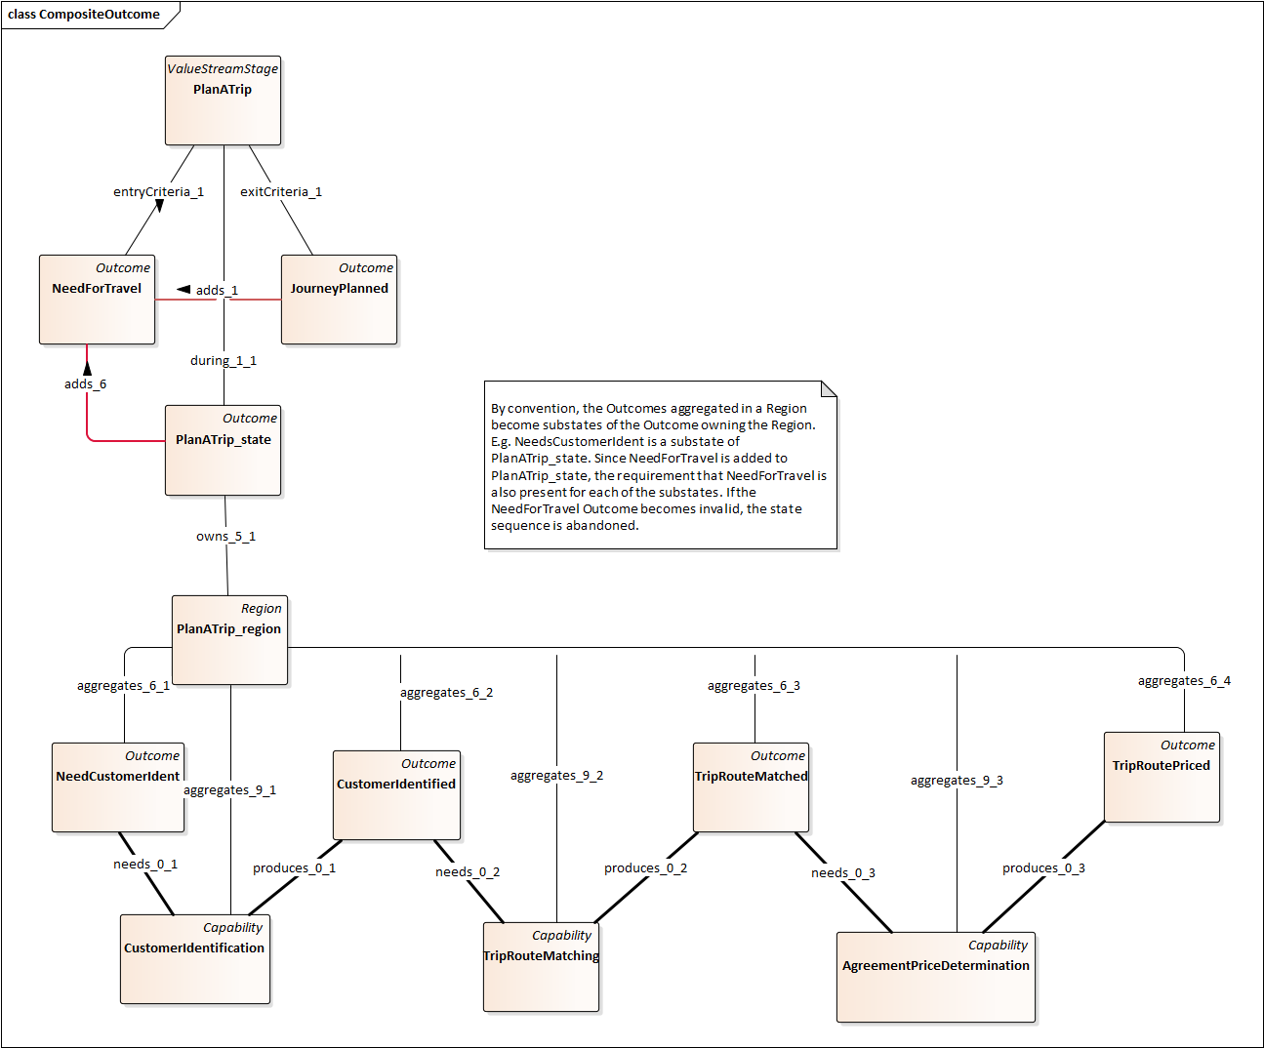
Figure 9 - Decomposition of a composite state
The PlanATrip_state outcome represents the activities that occur during the PlanATrip value stream stage. This outcome has been decomposed into 4 outcomes (NeedCustomerIdent, …) that are substates of PlanATrip_state. A substate provides additional information about the parent state and may not conflict with the parent state. In this example, the outcomes are connected by capabilities (CustomerIdentification, …) that need and produce the outcomes. If the activities of a capability take time, it follows that the outcomes will occur in sequence [NeedCustomerIdent, CustomerIdentified, TripRouteMatched, TripRoutePriced].
A statechart model will allow states to be connected by transitions that indicate which states may follow a given state. These transitions are associated with activities that cause the change of state. The additions to the BACM metamodel allow capabilities and processes to represent these transitions. The modeler must choose capabilities and processes to serve as transitions and add them to the proper Region with the aggregates_9 relationship. Likewise, the modeler must choose the outcomes that are to be in the Region using the aggregates_6 relationship. This gives the modeler the ability to choose the contents of the Region to support a needed analysis or to communicate information.
Statecharts allow a composite state to have multiple state sequences that can occur in parallel by dividing the composite state into one or more Regions. The changes to the BACM metamodel allow a composite outcome to own one or more regions. The sequencing of outcomes in a Region is independent of the sequencing of outcomes in sibling Regions except where an outcome appears in two or more regions, indicating a synchronization.
Note that the outcome NeedForTravel is incorporated into the PlanATrip_state outcome. This means that NeedForTravel is current throughout the duration of PlanATrip_state. It represents that the traveler’s continuing desire to travel is required to complete the value stream stage. If the traveler should cease to have this desire, the PlanATrip_state will also cease, along with its child Regions.

Complex Outcomes
Outcomes that are entryCriteria and exitCriteria are effectively pre-condition rules and post-condition rules because they stipulate facts about the state of the world on entry to and exit from a ValueStreamStage. This is also the case for needs_0 and produces_0 and input and output. Such rules require a language that denotes logical conjunction, disjunction and negation. The BACM metamodel avoids technical languages with these denotations in favor of prose descriptions of the rules, augmented with Outcome relations adds and denies that facilitate automated analyses of the models.
The proposal offers two referring associations: adds incorporates the referenced Outcome semantically, denies incorporates the negation of that Outcome. An Outcome that is not referenced is neither added nor denied. When interpreted as an entryCriteria (needs_0, input), the state of the hypothetical model world must be consistent with the entryCriteria-related Outcome. When interpreted as an exitCriteria (produces_0, output) the hypothetical state of the world after the work is done must be consistent with the exitCriteria-related Outcome.

Complex Outcome Example
The following example is also taken from the Guild’s Transportation Reference Model V4.0.1. It shows how the principle of inertia (the tendency of the state of the world to remain the same, absent a force or energy to change it) can be represented by the use of the adds relationship.
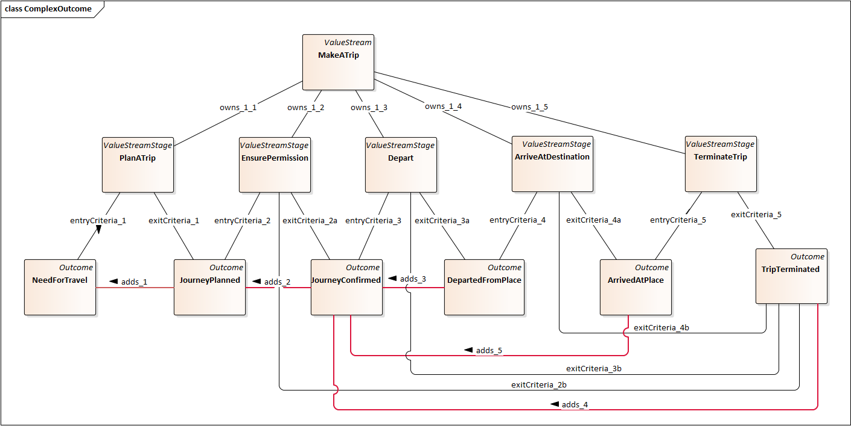
Figure 10 - Modeling Inertia with complex outcomes
The NeedForTravel outcome is an entryCriteria for the PlanATrip value stream stage and the JourneyPlanned outcome is an exitCriteria of this stage. The adds_1 relationship shows that NeedForTravel is also current in JourneyPlanned. Should the NeedForTravel cease to exist (e.g. the traveler decided not to travel), JourneyPlanned could not become current, effectively aborting the entire value stream.
Note that NeedForTravel is incorporated into every direct outcome that is an entryCriteria or an exitCriteria of the stages of the value stream except the final stage (presumably, the NeedForTravel has been satisfied and ceases to be current). This is evidence of the importance of this outcome to the success of the value stream.
Note also that the EnsurePermission and Depart value stream stages have two exitCriteria. The outcome of one of these exitCriteria is TripTerminated, representing that the travel will not happen and that the TerminateTrip value stream stage must deal with the consequences (e.g. that a weather event prevented the Depart stage or a flight cancellation prevented the EnsurePermission stage). A modeler may decide to add an alternative exitCondition to the PlanATrip stage; that was not done in this example to reduce visual complexity.

Criteria Specification with Complex Outcomes
The following example shows how to use adds and denies relationships to provide detail for the JourneyConfirmed outcome that is an entryCriteria for the Depart value stream stage.
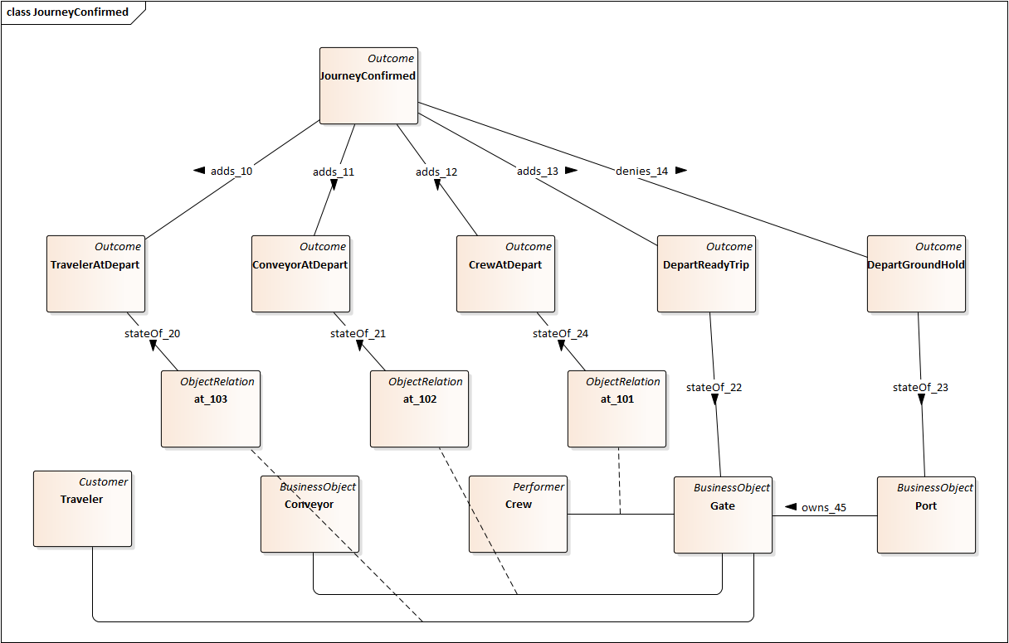
Figure 11 - Outcomes Specify Complex Criteria
The JourneyConfirmed outcome is modeled as the conjunction of 4 added outcomes and 1 denied outcome as shown in prose in the section titled Outcomes can be logically combined.
Three of these outcomes are modeled as statesOf association classes (at_101, …). This means that the outcome controls the currency and validity of a relationship (i.e. at_101 is a potential relationship between a crew and a gate). When an outcome specifies the state of a relationship, the objects participating in the relationship must have existence that is current and valid for the relationship to be current and valid.
A modeler may want to use this pattern to have DepartReadyTrip specify the state of a relationship between Gate and Trip; this was not done in order to simplify the diagram and to show that detail can be omitted from a model when it is not needed. Likewise, this example has omitted detail about how a ground hold affects Gates owned by a Port.

Understanding Object State by Viewing Outcomes
The following diagram shows a view of the Traveler, the Trip and the TravelAgreement as concepts, along with the primary relationships (Traveler-trip, Agreement-trip and Agreement-traveler). This part of the diagram can be used as a conceptual model of the information the travel provider has about these concepts. The BACM models object state by means of outcomes, with the consequence that these concepts do not have features, attributes or properties, as would be the case for an object-oriented concept model.
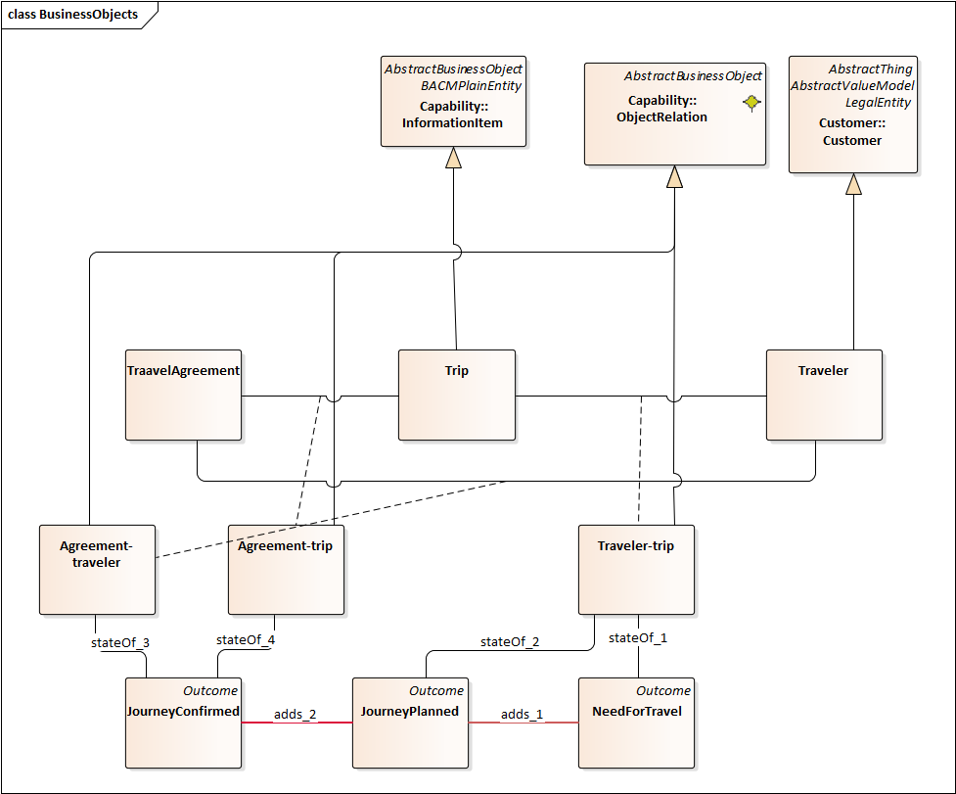
Figure 12 - Entity State defined by Outcomes
The JourneyConfirmed outcome specifies that the Agreement-traveler and the Agreement-trip relationships are current and valid if the JourneyConfirmed outcome is current and valid. In a relational schema, TravelAgreement might be modeled as a multi-column table with foreign keys to Trip and Traveler and a key that identifies the agreement. A foreign key relationship cannot be created unless the foreign key exists in the other table; this is consistent with the interpretation of currency and validity described previously.
The JourneyConfirmed outcome incorporates JourneyPlanned – implying that the Traveler-trip relationship is current and valid in JourneyConfirmed as it was in JourneyPlanned. This would be interpreted as meaning that the Trip in the Agreement-trip relationship is the same trip that is in the Traveler-trip relationship. This could be made explicit by an annotation of the adds_2 relationship. Alternatively, the model could be redefined so that the agreement is about the Traveler-trip relationship.

Resolution of BACM12-4
BACM12-4 is about the concept of a “binding object” and whether such a concept should be added to the BACM. This resolution does not add the concept to the BACM metamodel and offers a methodological alternative in which the modeler would add an annotation to an AbstractBusinessObject typed model element to indicate that it has been chosen as the “binding object”.
The proposal provides support for analyses of ValueStreams and their entryCrteria and exitCriteria related Outcomes and stateOf related AbstractBusinessObjects to identify candidates for “binding object”. These types of analysis, based on entryCriteria and exitCriteria and related AbstractBusinessObjects are consistent with the analysis principles described in BIZBOK V14.
A resolution was considered where “binding object” would be added as a <<shortcut>> association between a ValueStream and an AbstractBusinessObject. However, a careful reading of the BIZBOK V14 did not reveal a potential statement of the shortcut constraint that would produce results consistent with the examples provided in the BIZBOK. It is likely that this issue will resurface if changes in the BIZBOK lead to a constraint that produces examples consistent with the BIZBOK examples.

Resolution of BACM 12-6
This issue is about allowing the construction of complex Outcomes by logically combining other Outcomes. Consider the example in the section Outcomes can be logically combined above, in which multiple states must be simultaneously valid for the Depart stage to be entered. While this could be entirely specified in the prose description of the entryCriteria related Outcome, it is very helpful for automated analysis to be able to access the incorporated Outcomes by means of an explicit association, as opposed to searching the modeled Outcomes for one whose label matches a noun phrase in the complex Outcome description.
The specialization of OutcomeRelation by adds and denies, and the specialization of the related_0 association to adds_src, adds_tgt, denies_src and denies_tgt provides the modeler the ability to reference Outcomes that must be valid and Outcomes that must not be valid from a complex Outcome used as an entryCriteria. When used in an exitCriteria Outcome, these Outcome references are asserted to be valid or their negation is valid.

Resolution of BACM 12-16
This issue observes that while activity concepts such as ValueStreamStages, AbstractProcesses and AbstractCapabilities (i.e. activity entities) can model prior and post states, there is no facility in BACM that allows the modeling of state during the activities associated with these concepts.
The proposal provides such a facility by adding a group of during typed associations that relate ValueStreamStages to Outcomes, AbstractCapabilities to Outcomes and AbstractProcesses to Outcomes. The proposal also adds the concept of multiple independent Regions to an Outcome, where a Region aggregates a collection of activity entities and Outcomes (that are sub-states of the during-related Outcome’s Region). For the purposes of this document and to align with state chart terminology, an Outcome with owned Regions will be termed a composite Outcome. This aggregation of activity entities and Outcomes in a Region should be interpretable as a sequential state machine whose transitions are represented by the activity entities that occur between the aggregated Outcomes.
The metamodel does not enforce strict sequential state machine syntax. Where the modeler needs actual state charts to describe behavior, a state chart diagram/model may be associated with the during-related Outcome using the external reference facility already in the prior BACM specifications. In such a case, it may be useful to define proxy Outcomes corresponding to some state chart sub-states and link them to the sub-states via external reference. This will facilitate moving between the BACM model and the state chart model for understanding and analysis.
The metamodel also does not presently constrain the use of composite Outcomes to those that are during-related to an activity entity. This could be done with an OCL constraint in the UML and MOF but is not seen as needed for this proposal even though the semantic interpretation of a non-during-related composite Outcome is unknown at this time. Methodological advice to the modeler to avoid such constructions is thought to be sufficient.

Additional examples

Using action element decomposition to restrict possible paths
The following figure shows that the “precedes” relation, derived from the prior explanation of the analysis methods, generally results in the cross-product of the needed outcomes and the produced outcomes.
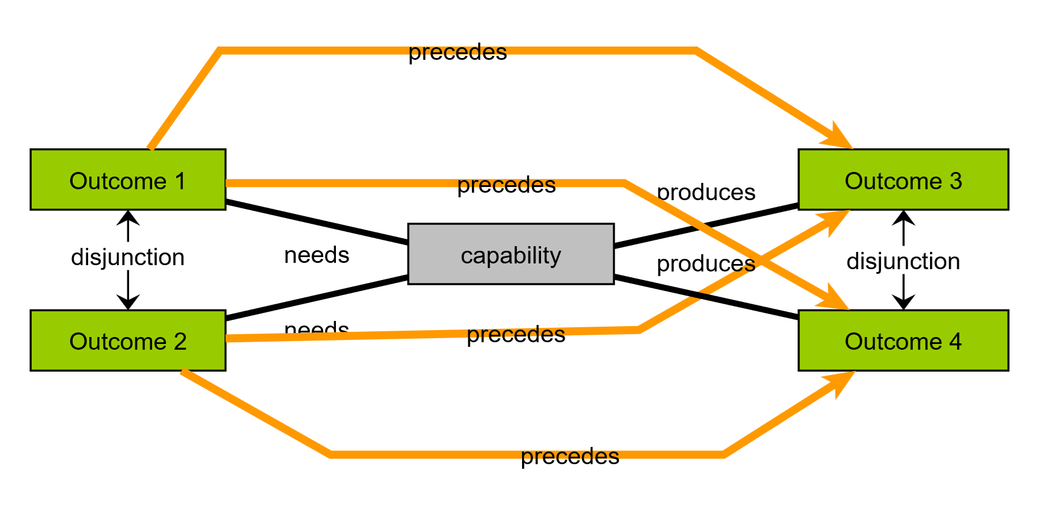

In the following figure, the needed and produced outcomes have been decomposed into exclusive outcomes, e.g. Outcome1 is Outcome5 and Outcome6, while Outcome 2 is Outcome5 and not Outcome6.
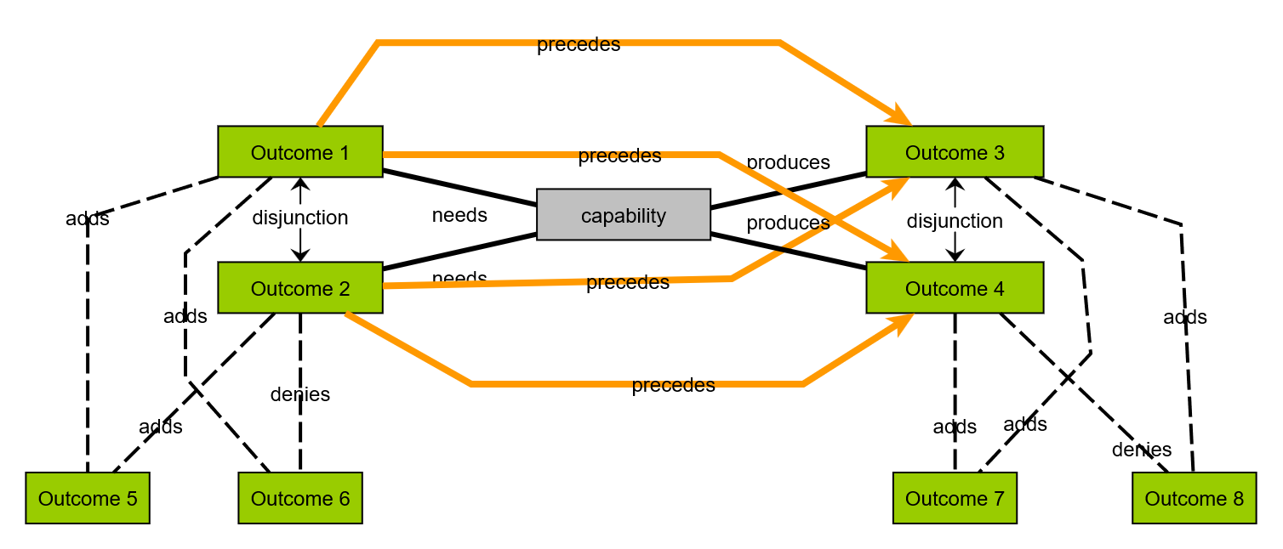
Suppose we wish to restrict the top level precedence relations to Outcome1 precedes Outcome3 and Outcome2 precedes Outcome 4. If precedence relations between outcomes 5, 6, 7 and 8 as shown in the following figure can be established, these rule out the possibility that Outcome1 precedes Outcome4 and Outcome2 precedes Outcome3.
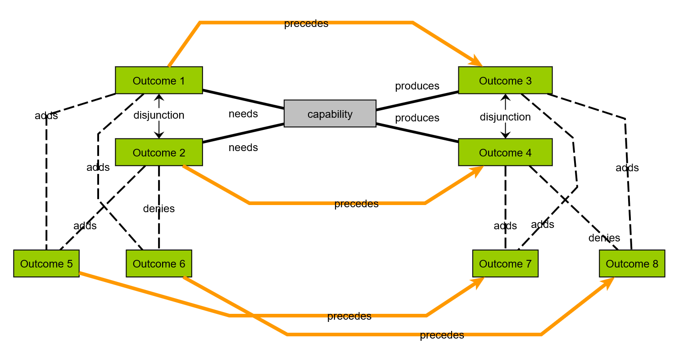
This can be justified by creating parallel regions that represent the composite state of the capability. The dotted arrows in the following figure represent that region_1a defines a sequence in which the capability needs Outcome2 and produces Outcome4, while region_1b defines a sequence in which Outcome1 is needed by the capability and produces Outcome3.
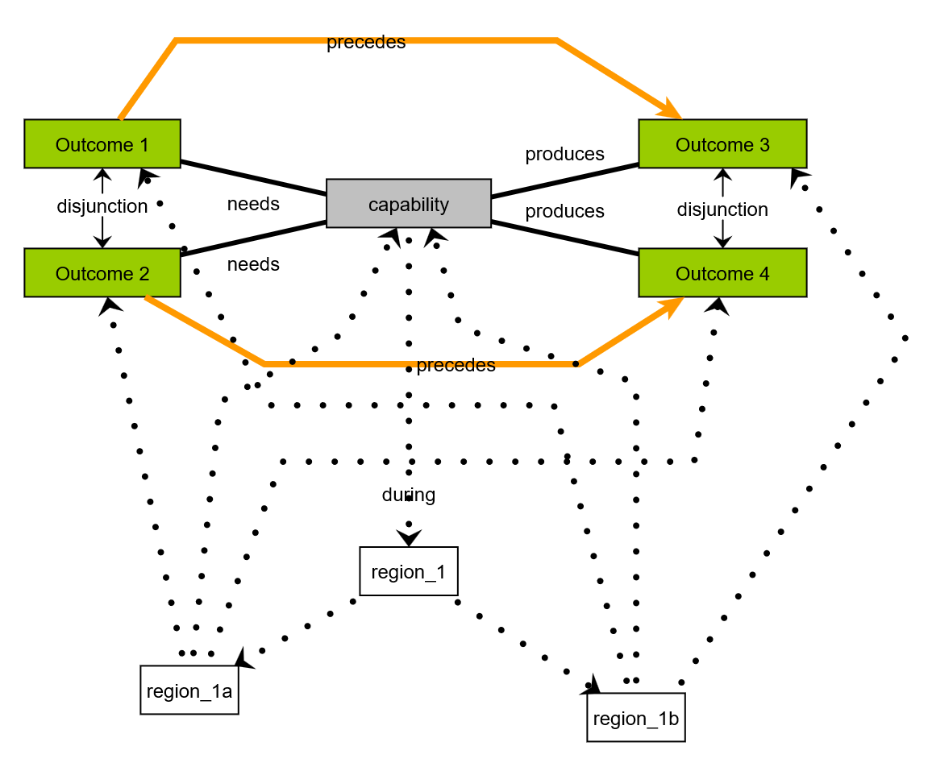
If the architect wished, the capability could be decomposed into two sub-capabilities, one in each of the regions making it clear that the composite behavior is the result of two independent capabilities. All that can be concluded from the previous figure is that there is some logic within the capability that produces Outcome3 when presented with Outcome1, and produces Outcome4 when presented with Outcome2.

Looping and alternative behaviors
The following figure illustrates the modeling of alternative outcomes. The “operation activation” capability can produce two alternative outcomes: “ready depart” means that the conveyor segment is ready to proceed, and “conveyor segment cancelled” meaning that the conveyor segment will not proceed.
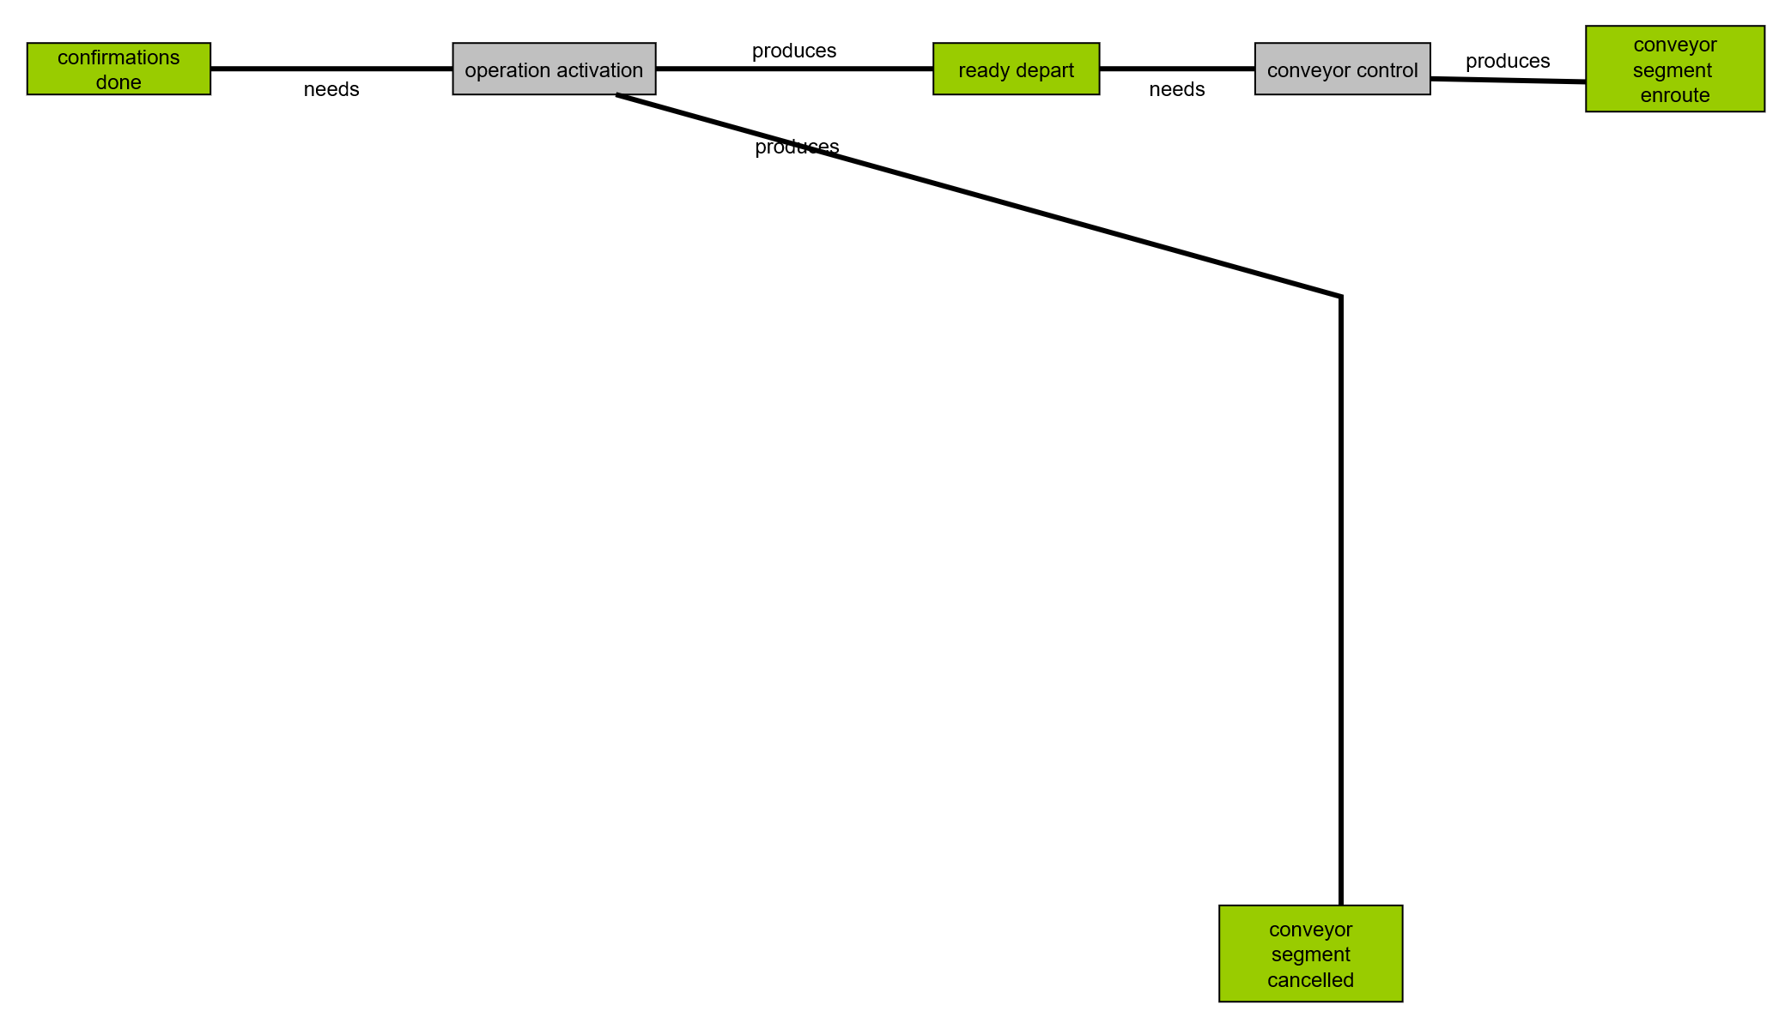
The precedence relations implied by the model in the preceding figure are shown below.
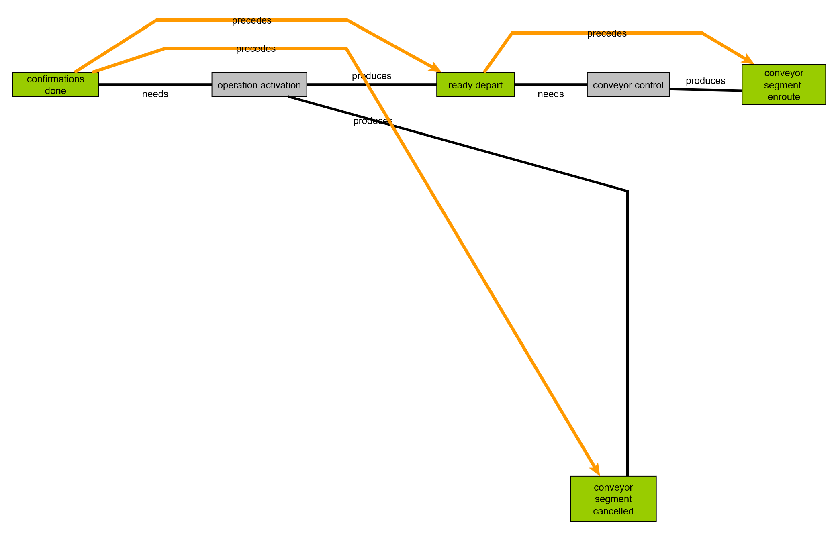
To model why the conveyor segment is cancelled, the outcomes and capabilities are decomposed as shown below.
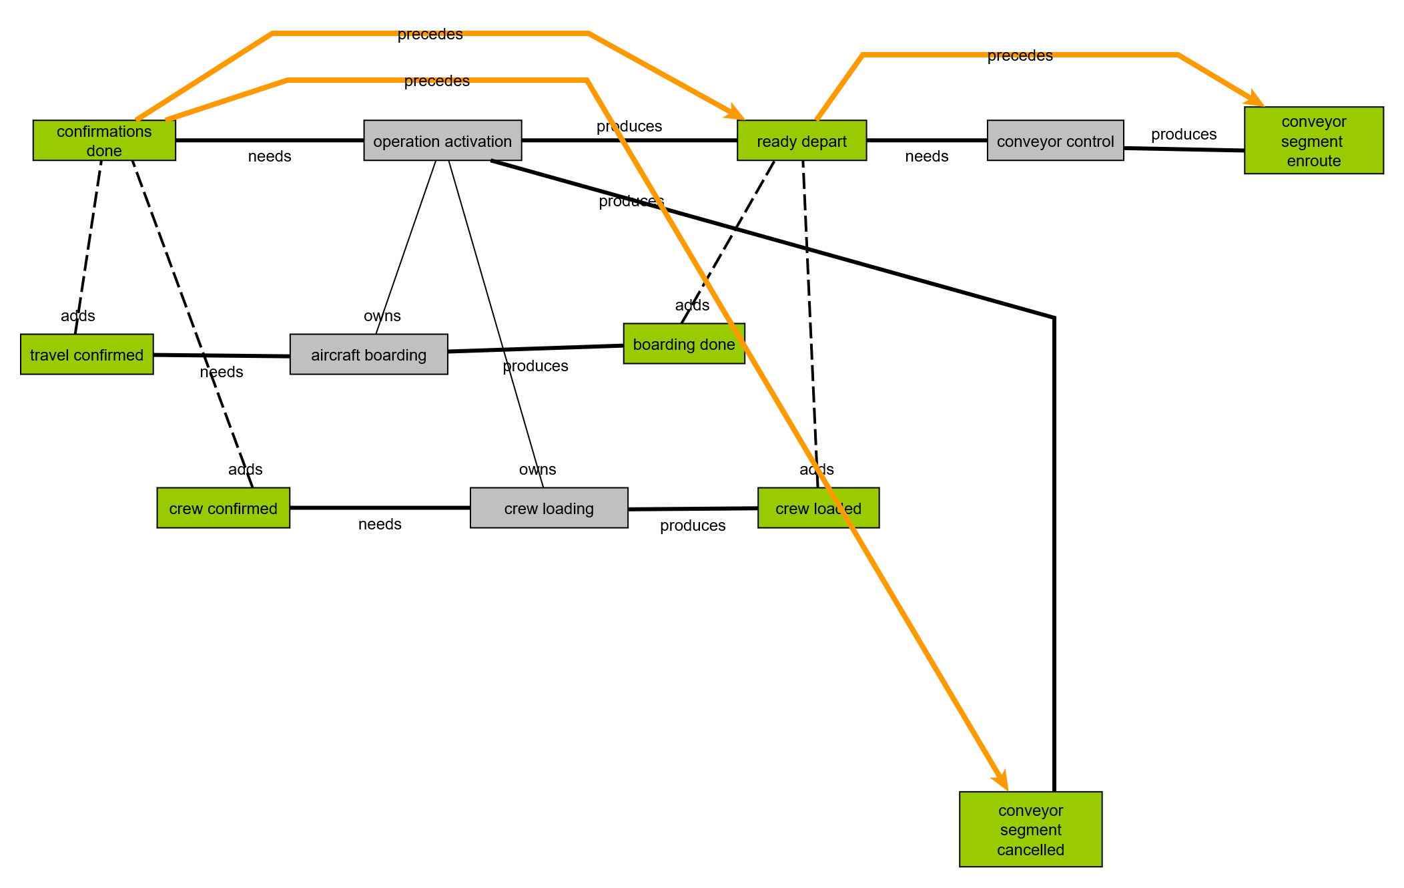
The model is extended to show that a failure to load the crew was the reason for the cancellation. The “crew not loaded” outcome is needed by a “crew assignment” capability that produces a “crew confirmed” outcome, creating a cycle in the possible sequences.
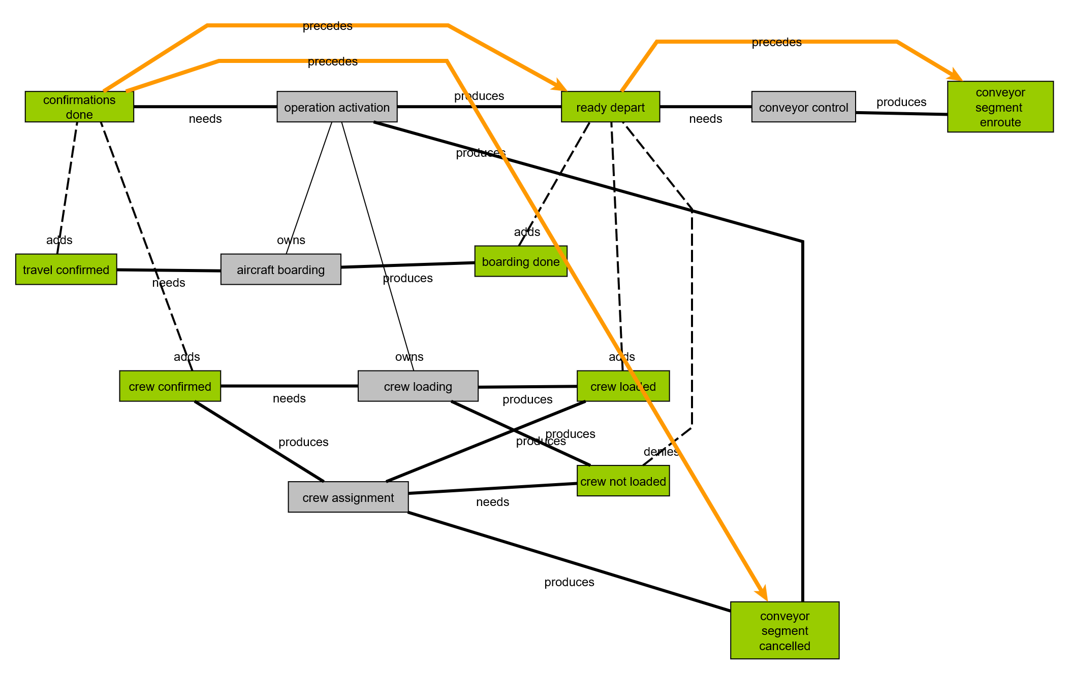
The existence of a cycle in the sequence cannot be allowed to explode the precedence diagram. This is handled by marking elements in the precedence structure to detect loops and annotating the precedence element to indicate the business objects (the “crew”) that are changing as a result of the loop. The resulting precedence structure is shown in the following figure.
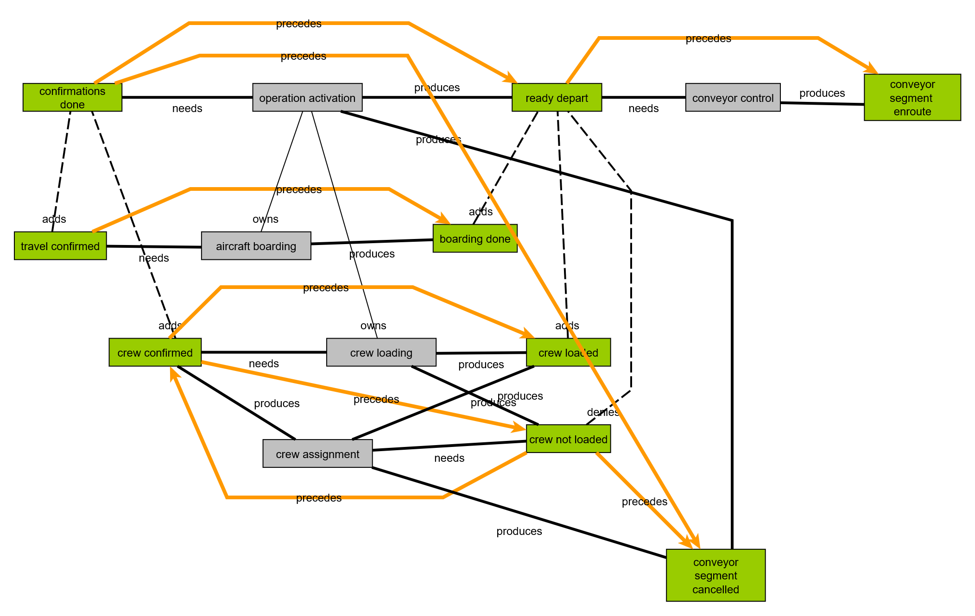
As in the prior example, we can define two independent regions to describe the composite behavior of the “operation activation” capability, one for “aircraft boarding” and the other for “crew loading”.
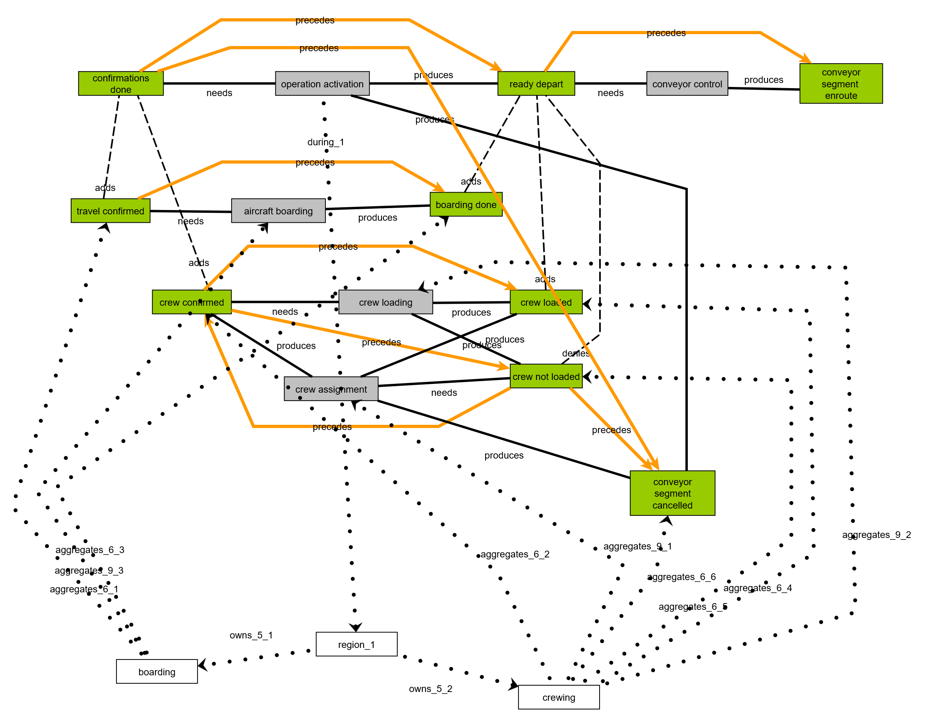
The precedence structure arising from this example is shown below:
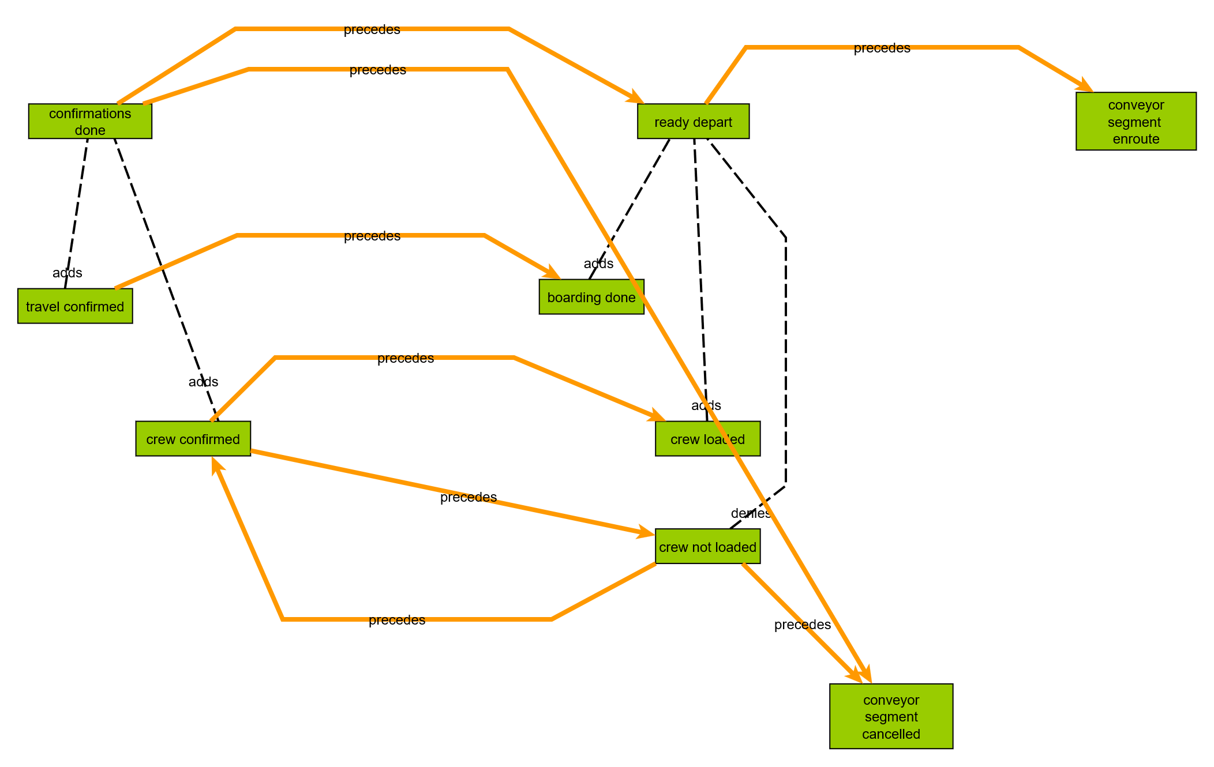
The following diagram shown the impact of the outcomes on the business objects representing the assignment of a crew to a conveyor segment. This figure is incomplete; “conveyor segment enroute” should be a “stateOf” “conveyor segment” and has been omitted to simplify the figure. Note that in BACM, relations are also business objects and can have state described by outcomes. In this example, the “assign” relation between “crew” and “conveyor segment” is shown to have three states: “confirmed”, “crew loaded” and “crew not loaded”. In a data schema, “crew not loaded” and “crew not confirmed” (not shown) might both be represented by the absence of a tuple in a crew assignment table. In BACM however, the absence of an Outcome negating a positive Outcome, only means that the state of the business object is unknown. This modeling principle forces the architect to think explicitly about negative situations that may require additional modeling.
