Date: December 8 2020

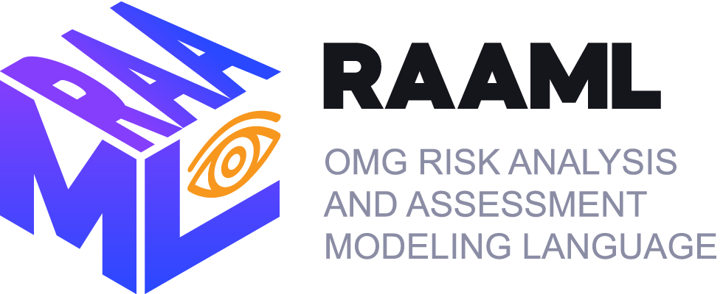

Risk Analysis and Assessment Modeling Language (RAAML)
Examples (Informative)
Version 1.1
__________________________________________________
OMG Document Number: ad/2020-12-03
Standard document URL: http://www.omg.org/spec/RAAML/
Normative Machine Consumable File(s):
https://www.omg.org/spec/RAAML/20201101/CoreRAAML.xmi
https://www.omg.org/spec/RAAML/20201101/CoreRAAMLLib.xmi
https://www.omg.org/spec/RAAML/20201101/GeneralRAAML.xmi
https://www.omg.org/spec/RAAML/20201101/GeneralRAAMLLib.xmi
https://www.omg.org/spec/RAAML/20201101/GSN.xmi https://www.omg.org/spec/RAAML/20201101/FMEA.xmi
https://www.omg.org/spec/RAAML/20201101/FMEALib.xmi
https://www.omg.org/spec/RAAML/20201101/FTA.xmi https://www.omg.org/spec/RAAML/20201101/FTALib.xmi
https://www.omg.org/spec/RAAML/20201101/ISO26262.xmi https://www.omg.org/spec/RAAML/20201101/ISO26262Lib.xmi
https://www.omg.org/spec/RAAML/20201101/STPA.xmi https://www.omg.org/spec/RAAML/20201101/STPALib.xmi
__________________________________________________

This OMG document is the revised submission replacing the initial submission (ad/2017-08-01). Comments on the content of this document are welcome, and should be entered by December 11, 2020 using the Issue Reporting Form on the main web page http://www.omg.org, under Documents, Report a Bug/Issue (http://issues.omg.org/issues/create-new-issue).

Copyright © 2020, Dassault Systemes
Copyright © 2020, Ford Motor Company
Copyright © 2020, Gesellschaft für Systems Engineering
Copyright © 2020, Object Management Group, Inc.

USE OF SPECIFICATION - TERMS, CONDITIONS & NOTICES
The material in this document details an Object Management Group specification in accordance with the terms, conditions and notices set forth below. This document does not represent a commitment to implement any portion of this specification in any company's products. The information contained in this document is subject to change without notice.

LICENSES
The companies listed above have granted to the Object Management Group, Inc. (OMG) a nonexclusive, royalty-free, paid up, worldwide license to copy and distribute this document and to modify this document and distribute copies of the modified version. Each of the copyright holders listed above has agreed that no person shall be deemed to have infringed the copyright in the included material of any such copyright holder by reason of having used the specification set forth herein or having conformed any computer software to the specification.
Subject to all of the terms and conditions below, the owners of the copyright in this specification hereby grant you a fully-paid up, non-exclusive, nontransferable, perpetual, worldwide license (without the right to sublicense), to use this specification to create and distribute software and special purpose specifications that are based upon this specification, and to use, copy, and distribute this specification as provided under the Copyright Act; provided that: (1) both the copyright notice identified above and this permission notice appear on any copies of this specification; (2) the use of the specifications is for informational purposes and will not be copied or posted on any network computer or broadcast in any media and will not be otherwise resold or transferred for commercial purposes; and (3) no modifications are made to this specification. This limited permission automatically terminates without notice if you breach any of these terms or conditions. Upon termination, you will destroy immediately any copies of the specifications in your possession or control.

PATENTS
The attention of adopters is directed to the possibility that compliance with or adoption of OMG specifications may require use of an invention covered by patent rights. OMG shall not be responsible for identifying patents for which a license may be required by any OMG specification, or for conducting legal inquiries into the legal validity or scope of those patents that are brought to its attention. OMG specifications are prospective and advisory only. Prospective users are responsible for protecting themselves against liability for infringement of patents.

GENERAL USE RESTRICTIONS
Any unauthorized use of this specification may violate copyright laws, trademark laws, and communications regulations and statutes. This document contains information which is protected by copyright. All Rights Reserved. No part of this work covered by copyright herein may be reproduced or used in any form or by any means--graphic, electronic, or mechanical, including photocopying, recording, taping, or information storage and retrieval systems--without permission of the copyright owner.
DISCLAIMER OF WARRANTY

WHILE THIS PUBLICATION IS BELIEVED TO BE ACCURATE, IT IS PROVIDED "AS IS" AND MAY CONTAIN ERRORS OR MISPRINTS. THE OBJECT MANAGEMENT GROUP AND THE COMPANIES LISTED ABOVE MAKE NO WARRANTY OF ANY KIND, EXPRESS OR IMPLIED, WITH REGARD TO THIS PUBLICATION, INCLUDING BUT NOT LIMITED TO ANY WARRANTY OF TITLE OR OWNERSHIP, IMPLIED WARRANTY OF MERCHANTABILITY OR WARRANTY OF FITNESS FOR A PARTICULAR PURPOSE OR USE. IN NO EVENT SHALL THE OBJECT MANAGEMENT GROUP OR ANY OF THE COMPANIES LISTED ABOVE BE LIABLE FOR ERRORS CONTAINED HEREIN OR FOR DIRECT, INDIRECT, INCIDENTAL, SPECIAL, CONSEQUENTIAL, RELIANCE OR COVER DAMAGES, INCLUDING LOSS OF PROFITS, REVENUE, DATA OR USE, INCURRED BY ANY USER OR ANY THIRD PARTY IN CONNECTION WITH THE FURNISHING, PERFORMANCE, OR USE OF THIS MATERIAL, EVEN IF ADVISED OF THE POSSIBILITY OF SUCH DAMAGES.
The entire risk as to the quality and performance of software developed using this specification is borne by you. This disclaimer of warranty constitutes an essential part of the license granted to you to use this specification.

RESTRICTED RIGHTS LEGEND
Use, duplication or disclosure by the U.S. Government is subject to the restrictions set forth in subparagraph (c) (1) (ii) of The Rights in Technical Data and Computer Software Clause at DFARS 252.227-7013 or in subparagraph (c)(1) and (2) of the Commercial Computer Software - Restricted Rights clauses at 48 C.F.R. 52.227-19 or as specified in 48 C.F.R. 227-7202-2 of the DoD F.A.R. Supplement and its successors, or as specified in 48 C.F.R. 12.212 of the Federal Acquisition Regulations and its successors, as applicable. The specification copyright owners are as indicated above and may be contacted through the Object Management Group, 9C Medway Road, Milford, MA 01757, U.S.A.

TRADEMARKS
CORBA®, CORBA logos®, FIBO®, Financial Industry Business Ontology®, FINANCIAL INSTRUMENT GLOBAL IDENTIFIER®, IIOP®, IMM®, Model Driven Architecture®, MDA®, Object Management Group®, OMG®, OMG Logo®, SoaML®, SOAML®, SysML®, UAF®, Unified Modeling Language®, UML®, UML Cube Logo®, VSIPL®, and XMI® are registered trademarks of the Object Management Group, Inc.
For a complete list of trademarks, see: http://www.omg.org/legal/tm_list.htm. All other products or company names mentioned are used for identification purposes only, and may be trademarks of their respective owners.

COMPLIANCE
The copyright holders listed above acknowledge that the Object Management Group (acting itself or through its designees) is and shall at all times be the sole entity that may authorize developers, suppliers and sellers of computer software to use certification marks, trademarks or other special designations to indicate compliance with these materials.
Software developed under the terms of this license may claim compliance or conformance with this specification if and only if the software compliance is of a nature fully matching the applicable compliance points as stated in the specification. Software developed only partially matching the applicable compliance points may claim only that the software was based on this specification, but may not claim compliance or conformance with this specification. In the event that testing suites are implemented or approved by Object Management Group, Inc., software developed using this specification may claim compliance or conformance with the specification only if the software satisfactorily completes the testing suites.

Table of Contents
Preface 1
1. Purpose 3
1.1 Assumptions 3
1.2 End user (or customer) 3
1.3 Summary 3
1.4 Acknowledgements 3
1.5 Acronyms and Abbreviations 4
2. Examples 6
2.1 FMEA 6
2.2 Fault Tree Analysis (FTA) 8
2.3 STPA 10
2.4 GSN 15
2.5 ISO 26262 Road Vehicles - Functional Safety 16
3. References 26

Table of Figures

Figure 2.1 – System model and simulation context 6
Figure 2.2 – FMEA example (Block Definition Diagram) 6
Figure 2.3 – FMEA example (Internal Block Diagram) 7
Figure 2.4 – RPN calculation using simulation capabilities of a system modeling tool 7
Figure 2.5 – FMEA in a tabular view 8
Figure 2.6 – Wheel brake system example (Block Definition Diagram) 8
Figure 2.7 – Top-Level event Loss of aircraft (Fault Tree Diagram) 9
Figure 2.8 – Top-Level event Loss of aircraft (Fault Tree Diagram) 9
Figure 2.9 – Hierarchy of losses and hazards 10
Figure 2.10 – Mapping of losses and hazards 11
Figure 2.11 – System control flows of BSCU 11
Figure 2.12 – Operational situations of the system 12
Figure 2.13 – List of unsafe control action 12
Figure 2.14 – Context of unsafe control actions of the BSCU 13
Figure 2.15 – Relations among unsafe control actions and hazards 14
Figure 2.16 – Situational context of BSCU 14
Figure 2.17 – Expending out a loss scenario 15
Figure 2.18 – Situation hierarchy 15
Figure 2.19 – GSN example 16
Figure 2.20 – Vehicel SysML BDD diagram 16
Figure 2.21 – HazOp as SysML BDD diagram 17
Figure 2.22 – HazOp in a tabular view 17
Figure 2.23 – Operational conditions library in a SysML BDD diagram 18
Figure 2.24 – Operational conditions library in a tabular view 19
Figure 2.25 – Operational situations in a SysML BDD diagram 20
Figure 2.26 – Operational situations in a tabular view 20
Figure 2.27 – Accident scenario in a SysML BDD diagram 21
Figure 2.28 – Accident scenario in a tabular view 21
Figure 2.29 – Effects in a SysML BDD diagram 22
Figure 2.30 – Effects in a tabular view 22
Figure 2.31 – Hazards in a tabular view 22
Figure 2.32 – HARA in a SysML BDD diagram 23
Figure 2.33 – HARA in a tabular view 24
Figure 2.34 – Safety goal decomposition 25

Table of Tables

Table 1.1 - Description of acronyms used in this specification 4
Table 2.1 – Example of unsafe control action presented as a table 13

Preface
OMG
Founded in 1989, the Object Management Group, Inc. (OMG) is an open membership, not-for-profit computer industry standards consortium that produces and maintains computer industry specifications for interoperable, portable and reusable enterprise applications in distributed, heterogeneous environments. Membership includes Information Technology vendors, end users, government agencies and academia. OMG member companies write, adopt, and maintain its specifications following a mature, open process. OMG's specifications implement the Model Driven Architecture® (MDA®), maximizing ROI through a full-lifecycle approach to enterprise integration that covers multiple operating systems, programming languages, middleware and networking infrastructures, and software development environments. OMG's specifications include: UML® (Unified Modeling Language™); CORBA® (Common Object Request Broker Architecture); CWM™ (Common Warehouse Metamodel); and industry-specific standards for dozens of vertical markets. More information on the OMG is available at http://www.omg.org/.
OMG Specifications
As noted, OMG specifications address middleware, modeling and vertical domain frameworks. All OMG Specifications are available from this URL: http://www.omg.org/spec
Specifications are organized by the following categories:
Business Modeling Specifications
Middleware Specifications
- CORBA/IIOP
- Data Distribution Services
- Specialized CORBA IDL/Language Mapping Specifications
Modeling and Metadata Specifications
- UML, MOF, CWM, XMI
- UML Profile Specifications
Platform Independent Model (PIM) - Platform Specific Model (PSM) - Interface Specifications
- CORBAServices
- CORBAFacilities
- OMG Domain Specifications
- CORBA Embedded Intelligence Specifications
- CORBA Security Specifications
All of OMG’s formal specifications may be downloaded without charge from our website. (Products implementing OMG specifications are available from individual suppliers.) Copies of specifications, available in PostScript and PDF format, may be obtained from the Specifications Catalog cited above or by contacting the Object Management Group, Inc. at: OMG Headquarters, 9C Medway Road - PMB 274, Milford, MA 01757, USA Tel: +1- 781-444-0404 Fax: +1-781-444-0320 Email: pubs@omg.org
Certain OMG specifications are also available as ISO standards. Please consult http://www.iso.org

Typographical Conventions
The type styles shown below are used in this document to distinguish programming statements from ordinary English. However, these conventions are not used in tables or section headings where no distinction is necessary.
Times/Times New Roman - 10 pt.: Standard body text
Helvetica/Arial - 10 pt. Bold: OMG Interface Definition Language (OMG IDL) and syntax elements.
Courier - 10 pt. Bold: Programming language elements.
Helvetica/Arial - 10 pt: Exceptions
Note – Terms that appear in italics are defined in the glossary. Italic text also represents the name of a document, specification, or other publication.
Issues
All OMG specifications are subject to continuous review and improvement. As part of this process we encourage readers to report any ambiguities, inconsistencies, or inaccuracies they may find by completing the Issue Reporting Form listed on the main web page http://www.omg.org, under Documents, Report a Bug/Issue (http://issues.omg.org/issues/create-new-issue).

Purpose
This Annex [Risk Analysis and Assessment Modeling Language Examples (Non-Normative)] is meant to illustrate the practical utility of using RAAML. While the Examples annex is not normative, the examples show the intent of the developers/submitters of the RAAML specification relevant to its use and implementation. While the Annex is not by itself an introductory text of the safety and reliability field, it does have two purposes that form the basis of a future textbook:
- First, to address Senior Architects implementing this specification on a specific project.
- Second, to guide potential Tool Vendors toward conformance with this specification.
The specification provides out of the box support for several safety and reliability analysis methods: FMEA, FTA, STPA, GSN, ISO 26262 Functional Safety standard and RBD. Each of the aforementioned methods is illustrated by this document.
- Assumptions
While the reader does not require a tool to read and understand this Examples specification, we presume access to a RAAML 1.1 conformant tool that will organize and allow the user to view the model data in a user-friendly way. RAAML also assumes the reader is familiar with the basic notations of SysML 1.6, particularly
- Four structural diagrams: block definition diagram, internal block diagram, parametric diagram, and requirement diagram
- End user (or customer)
The End user (or customer) of this specification is a tool vendor or a senior safety or reliability specialist at the adopting organization. The specification mostly focuses on how to correctly capture safety and reliability aspects of systems and how to integrate those aspects into model-based systems engineering, however user-friendly views should be provided by tool vendors so that this specification could be used effectively in practice. Senior safety and reliability specialists at the adopting organization should get familiarized themselves with the core of the RAAML language so that they could extend it and adopt it in a specification organization.
Each view in this document contains the suggested implementation and shows an example. Alternative expressions of the views are also possible depending on the audience of the intended RAAML implementation.
- Summary
We have included as many of the RAAML diagrams as is possible given time and effort constraints. Just like with OMG SysML, the same information can be presented in many different ways and this specification only demonstrates the most likely representations of typical RAAML models.
- Acknowledgements
The following companies and organizations submitted or supported parts of the original version of this International Standard:

Industry
- Dassault Systemes
- Ford Motor Company
- The Aerospace Corporation

Government
- NASA/Jet Propulsion Laboratory
- Commissariat à l’énergie atomique
- German Aerospace Center
- National Institute of Advanced Industrial Science and Technology (AIST)

Vendors
- No Magic owned by Dassault Systemes

Academia
- Massachusetts Institute of Technology

Liaisons
- Gesellschaft für Systems Engineering
- MACE
- Assystem

The following persons were members of the team that designed and wrote this International Standard: Achim Weiss, Andreas Knapp, Andrius Armonas, Annelisa Sturgeon, Axel Berres, Christian Lalitsch-Schneider, Christoph Barchanski, Christopher Davey, Damun Mollahassani, Dave Banham, Edith Holland, Geoffrey Biggs, George Walley, Ilse Adamek, Jean-Francois Castet, Jianlin Shi, John Thomas, Kyle Post, Laura Hart, Manfred Koethe, Mark Sampson, Matthias Nagorni, Myron Hecht, Nataliya Yakymets, Rajiv Murali, Regis Casteran, Sarra Yako, Stephan Boutenko, Thomas Krynicki, Tim Weilkiens, Tomas Juknevicius, Vanessa Sehon, Victor Arcos Barraquero, Yan Liu.

For the final edition of the standard, the following people contributed: Andrius Armonas, Axel Berres, Dave Banham, Kyle Post, George Walley, Tomas Juknevicius.

- Acronyms and Abbreviations
For the purposes of this specification, the following List of acronyms and abbreviations apply.

Table 1.1 - Description of acronyms used in this specification
ASIL | Automotive Safety Integrity Level
BDD | Block Definition Diagram
DET | Detectability
FMEA | Failure Mode and Effect Analysis
FTA | Fault Tree Analysis
GSN | Goal Structuring Notation
HARA | Hazard Analysis and Risk Assessment
HAZOP | A hazard and operability study
MBSE | Model-Based Systems Engineering
IBD | Internal Block Diagramm
ISO | International Standardization Organization
OCC | Occurrence
OMG | Object Management Group
RAAML | Risk Analysis and Assessment Modeling Language
RPN | Risk priority number
SEV | Severity
STPA | Systems Theoretic Process Analysis
SysML | Systems Modeling Language
UAF | Universal Architecture Framework
UML | Unified Modeling Language

Examples

- FMEA
The system model (a glucose meter) is shown in Figure 2.1. As a methodological approach, we recommend introducing a simulation context (GlucoseMeterSimulation in this particular case), which is composed of all systems that are being analyzed from the risk perspective. 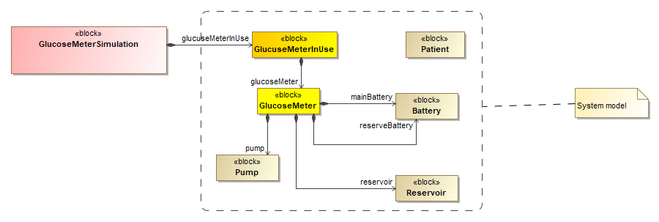
Figure 2-1 – System model and simulation context
The simulation context includes an FMEA analysis (see Figure 2.2). This analysis is represented by a single GlucoseMeterFMEAItem in this example, but there could be as many FMEAAnalysisItems as necessary. This specific item violates a stakeholder requirement and as a result of the analysis a new safety requirement called “Alarm when battery has sunk” is introduced. A specific cause, failure mode, intermediate effect, and final effect are introduced by specializing Cause, FailureMode, and Effect elements from the FMEA library. Calculations from the FMEAItem parametrics are reused by inheriting and redefining cause, failure mode, finalEffect, and RPN value properties.
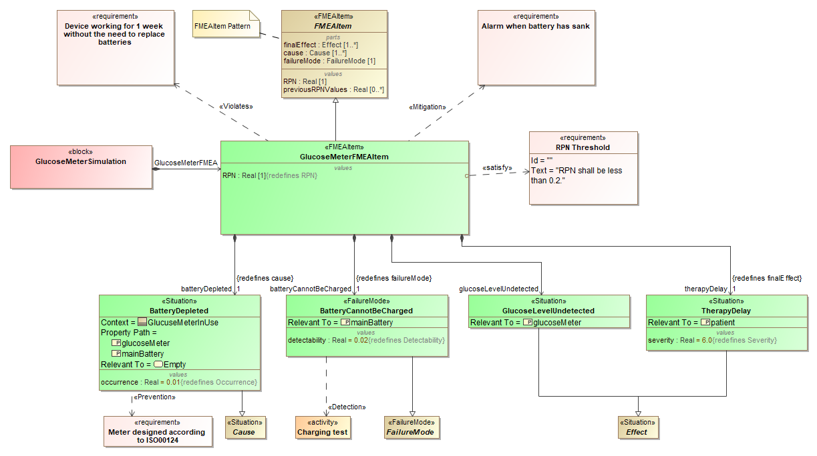
Figure 2-2 – FMEA example (Block Definition Diagram)
Figure 2.3 shows that causes, failure modes, intermediate effects and effects can be chained for fault propagation. This allows modeling an effect in the lower levels of a system as a cause of a failure in the upper levels of a system.

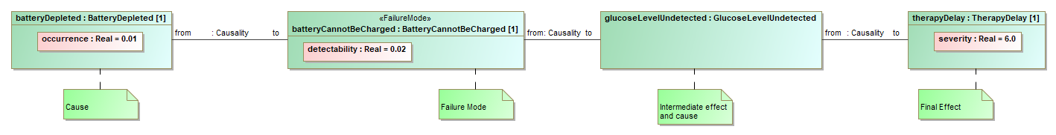
Figure 2-3 – FMEA example (Internal Block Diagram)

Figure 2.4 demonstrates a commercial tool (No Magic/Dassault Systemes MagicDraw/Cameo Systems Modeler) simulating the example model out of the box (no modifications to the tool) to calculate the RPN value. It is important to note that the model may look complicated, but tool vendors are expected to implement tabular representations of this model similar to classical FMEA tables to hide most of the complexity while keeping the benefits of employing a model-based approach and integrating with SysML.

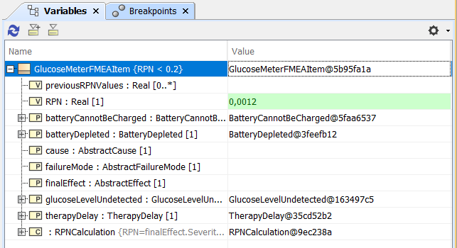
Figure 2-4 – RPN calculation using simulation capabilities of a system modeling tool

Figure 2.5 depicts an FMEA in a tabular format. Every row in the table represents FMEAItems. The Item column represents the element retrieved via the RevelantTo relationship. Failure mode, cause, local and final effects are represented in columns “Failure Mode”, “Cause”, “Local Effect of Failure”, “Final Effect of Failure” respectively. Severity of the final effect of failure, detectability of the failure mode, occurrence of the cause, and risk priority numbers are represented in the SEV, DET, OCC, and RPN columns. A tool vendor can choose to color-code RPN values based on priority.

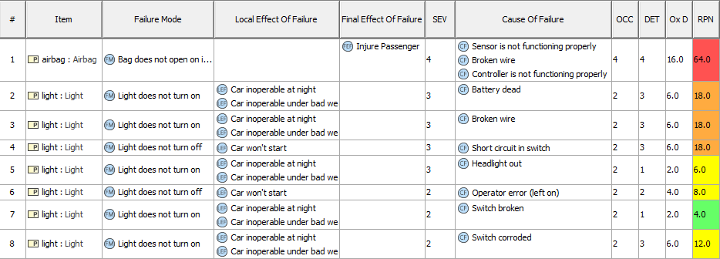
Figure 2-5 – FMEA in a tabular view
- Fault Tree Analysis (FTA)
For the fault tree analysis, the Wheel Braking System (WBS) from the ARP 4751A shown Figure 2.6 is used. To perform the fault tree analysis, a system description is required which simplifies and enables the identification of the system failure. The description of the system comprises different systems and is done with the help of IDB and BDD.
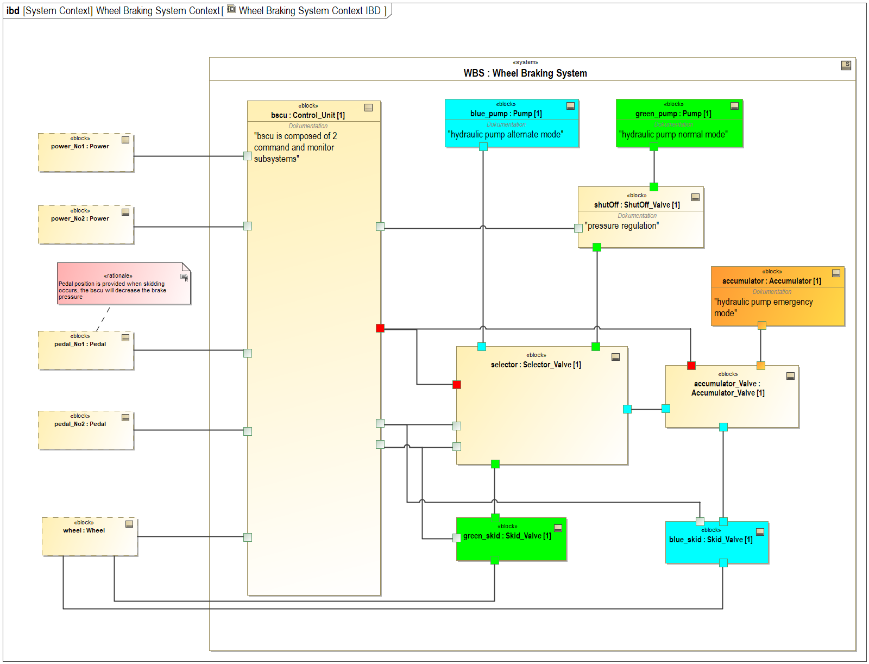
Figure 2-6 – Wheel brake system example (Block Definition Diagram)
The fault tree analysis shows which causes for the failure of a system have been considered. The dependencies between these causes are also shown. The analysis is a top-down method and starts with the identification of the top-level events. Figure 2.7 shows how the loss of the WBS contributes to the loss of the aircraft as the top-level event. The top-level event can be triggered independently from two intermediate events. These are the loss or improper deceleration. The event inadvertent deceleration can be triggered independently of three base events.
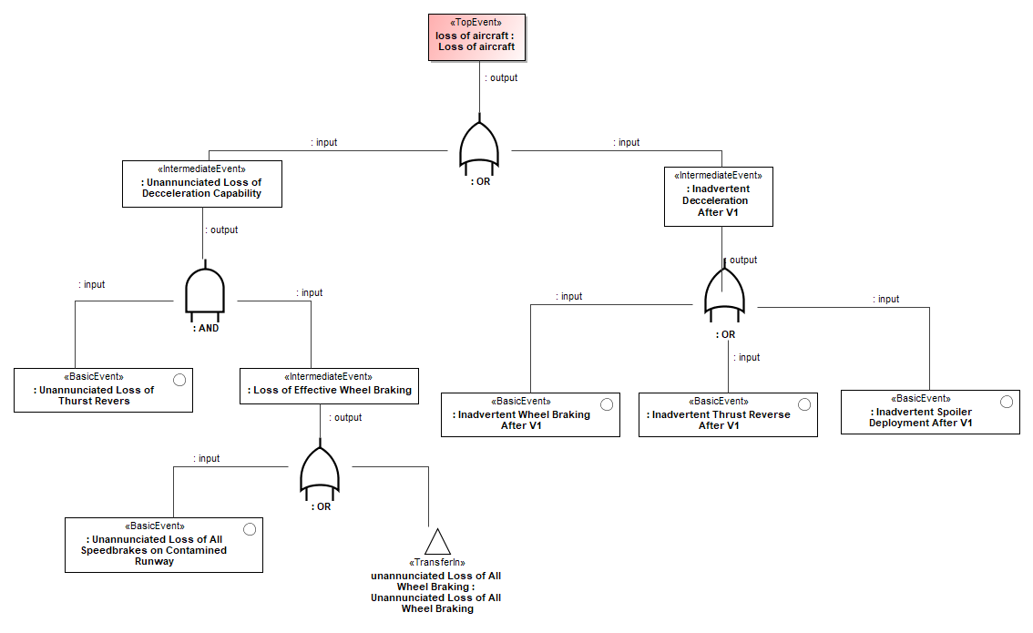
Figure 2-7 – Top-Level event Loss of aircraft (Fault Tree Diagram)
To understand the Loss of braking capabilities in case of losing WBS Figure 2.8 shows the related fault tree. As shown Fault Trees can be partitioned and referenced by using <<Transferin>> gates.
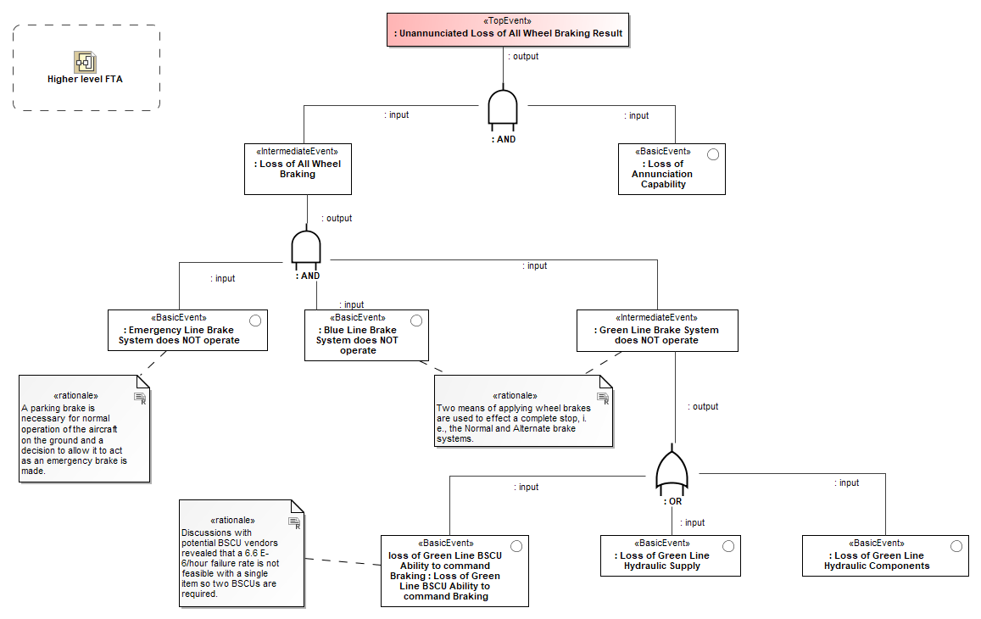
Figure 2-8 – Top-Level event Loss of aircraft (Fault Tree Diagram)
Not shown in the example is the capability to calculate the failure rate of an events. Therefore, the failure rate of each event needs to be provided during the development of the system.
- STPA
For the STPA method, the Wheel Braking System (WBS) from the ARP 4751A will also be used. The example used is exactly the same as the example from the STPA handbook [5]. However, in the example, only views of the Brake System Computer Unit (BSCU) are presented using RAAML. To understand the system investigated, in the figure below the control flows are shown for the BSCU. Therefore, the description of the system can be done with the help of IDB and BDD. This example does not provide guidance on how to conduct an STPA analysis, but describes how to represent it in a model form. The content below follows the process outline of the example in the STPA handbook [5]. The following Figure 2.9 shows the capability to represent a hierarchy of Losses and Hazards as applied from the specification using the STPA Handbook WBS example.

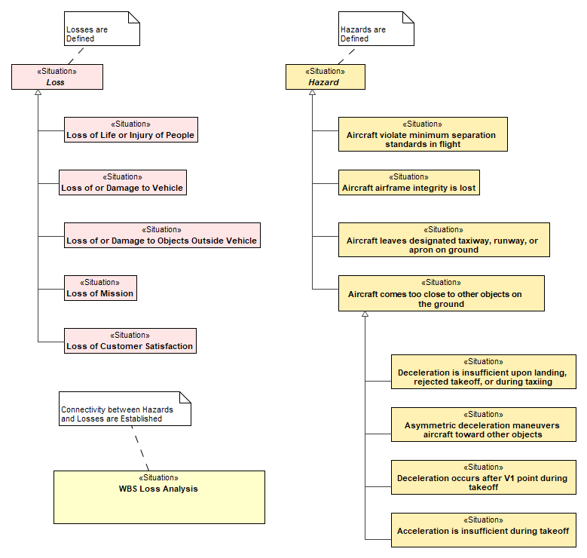
Figure 2-9 – Hierarchy of losses and hazards
Mapping of Losses to Hazards is performed using connectors between the usage of the previously defined elements as parts of the WBS Loss Analysis as shown in in the following Figure 2.10.
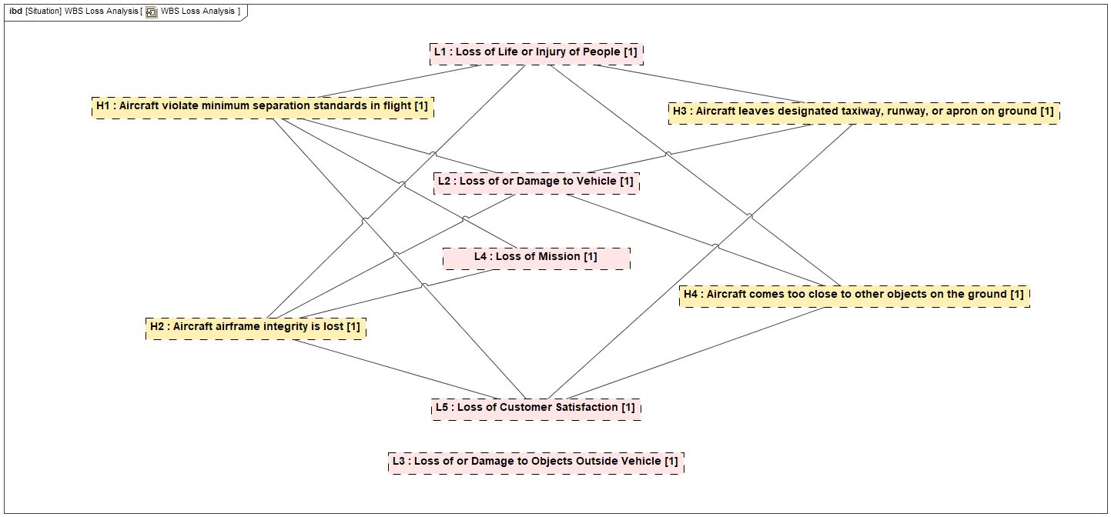
Figure 2-10 – Mapping of losses and hazards
The STPA Control Structure can be constructed as a standalone diagram or integrated into the system model by applying the relevant Control Structure stereotypes. The internal block diagram below (Figure 2.11) outlines represents the WBS Control Structure, including the Control Actions and Feedback. The diagram shows examples of the ControlAction and Feedback explicitly called out or hidden which can be based on the user’s preference.
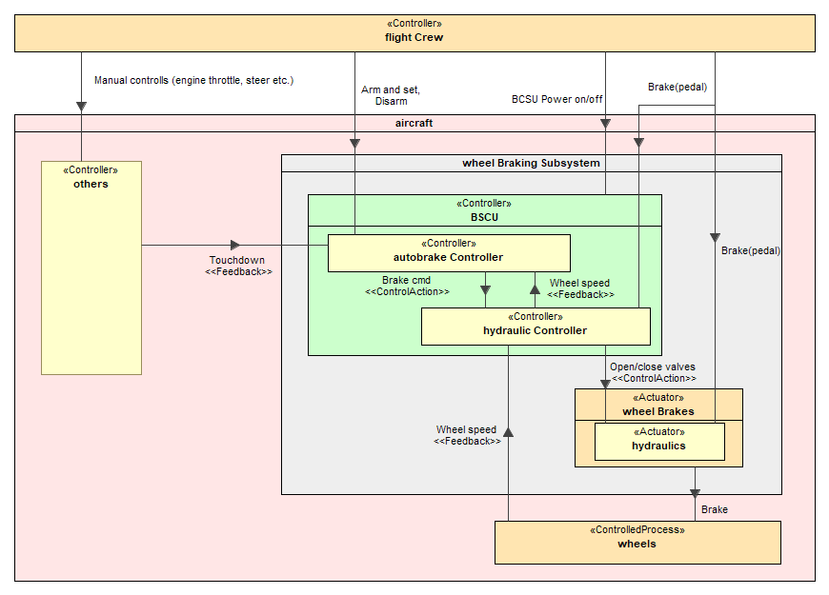
Figure 2-11 – System control flows of BSCU
The context of the controller analysis is constructed as a library from the Operational Situation. The context can be constructed as a flat library or a hierarchy of operational situations to specify more complex contexts. The figure below (Figure 2.12) shows the WBS using both representations.
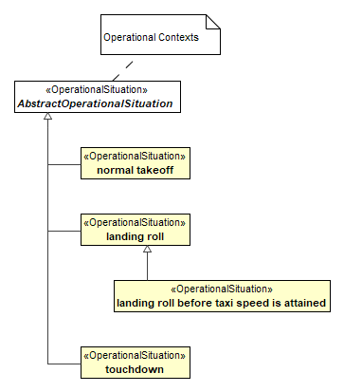
Figure 2-12 – Operational situations of the system
The Unsafe Control Actions (UCA), outlined in Figure 2.13, can be constructed in a number of different views depending on the user’s preference.
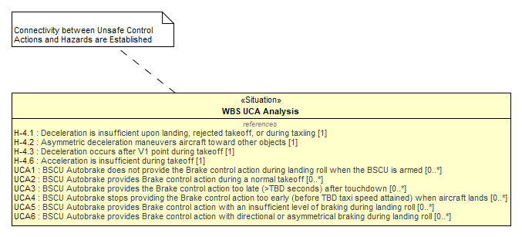
Figure 2-13 – List of unsafe control action

The following examples show possible representations which are diagram or table based. The following figure shows an overview of the UCA Analysis for the WBS, which contains the elements to define UCAs. The UCAs can be modified in any of the table (Table 2.1) or graphical (Figure 2.14) views depending on the preference of the user.

Table 2.1 – Example of unsafe control action presented as a table
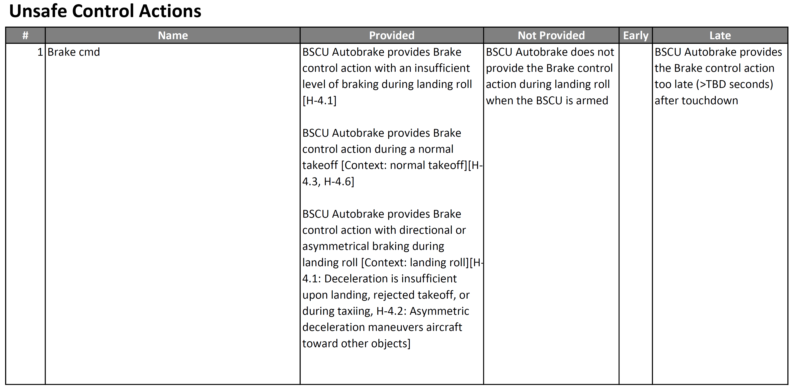
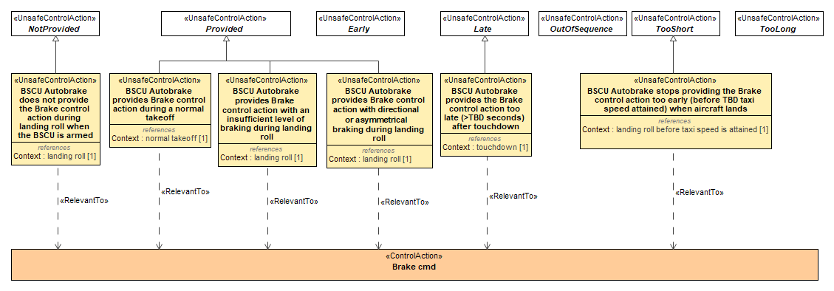
Figure 2-14 – Context of unsafe control actions of the BSCU
The Unsafe Control Actions can be developed using a table as shown in Table 2.1. The following table consists a list of the ControlActions which are identified in the “Name” column. The following columns represent the UCA guidewords which can be tailored in the library as desired by the user. Note that this example does not show all the guideword columns to fit the page. The content of the guideword columns can be tailored to either show the UCA text which is described in the name of the element or it can also include the references to the Context elements and/or Hazard elements indicated the square brackets. The table view of the UCA’s can also be represented in graphical views. Figure 2.14 shows the guide words used for constructing the UCA’s and the Control Action under analysis.

The following representation (Figure 2.15) shows an overview of the UCAs, the referenced Context, and the associated Hazards. These are defined in the UCA Analysis element and use connectors for the relations.

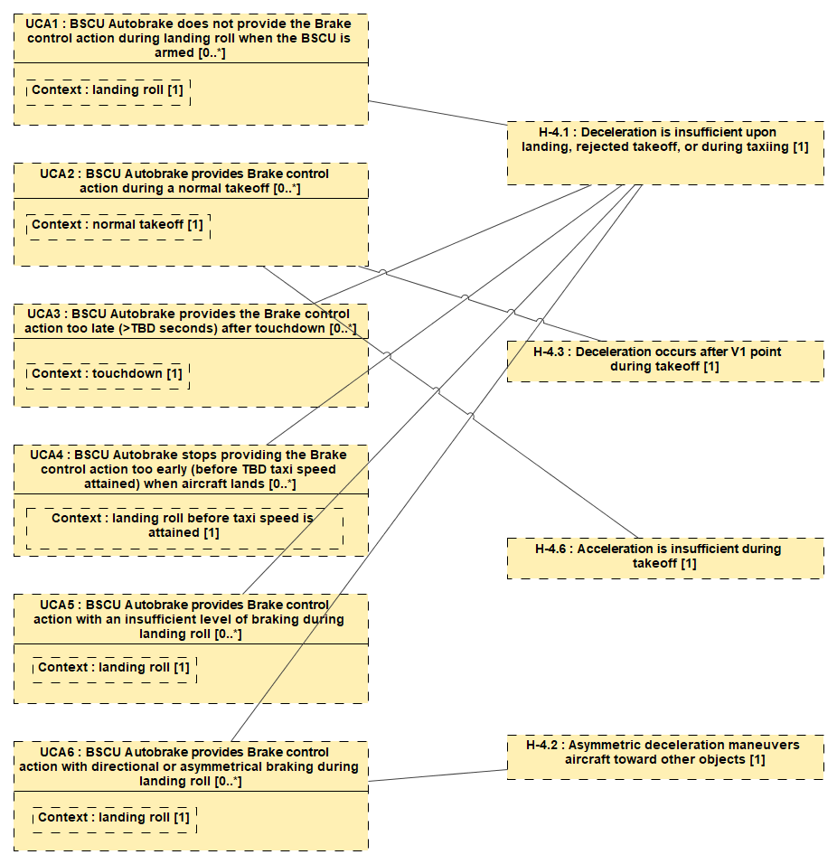
Figure 2-15 – Relations among unsafe control actions and hazards

The STPA causal analysis is defined by the loss scenario’s which can reference the relevant UCAs. The level of detail to model the causal analysis is left to the user and their specific needs. The following example (Figure 2.16) shows a typical high-level representation of a loss scenarios where the name outlines the description of the scenario and the related UCAs are identified. The tool implementation can simplify the view for ease of use.
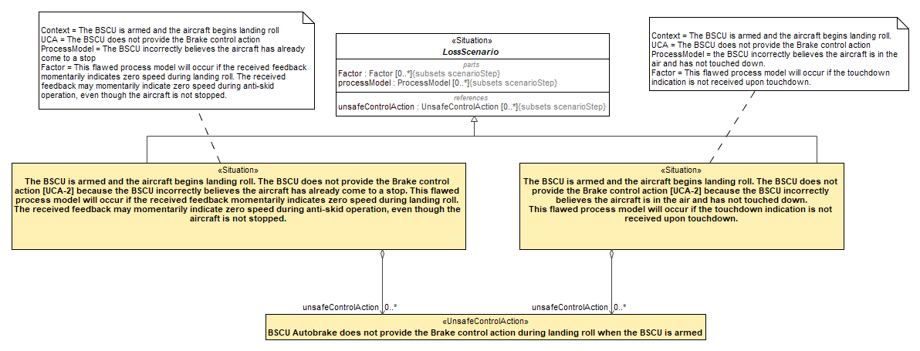
Figure 2-16 – Situational context of BSCU
The following figure represents a lower level of granularity of the loss scenario which provides the ability to specify elements of the scenario’s UCA, Process Models of interest, and any associated Factors relevant to the analysis. This information can also be represented in a table form. The following Figure 2.17 shows an alternative representation of the previous figure, but breaks the information into separate elements. The Factors can be further refined, as shown in the figure, using intermediate Factors.
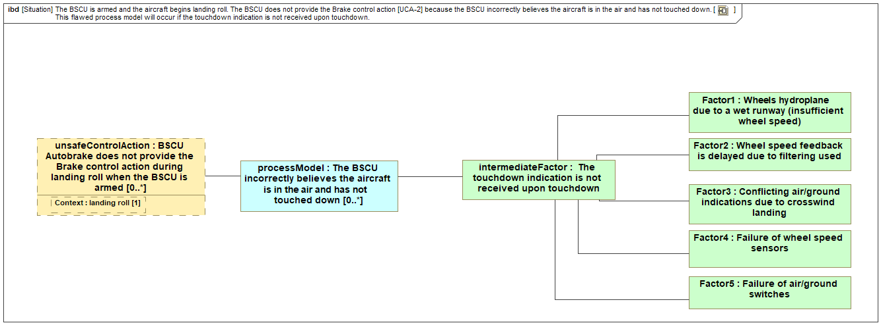
Figure 2-17 – Expending out a loss scenario
Depending on the user’s specific usage of STPA they can classify the Process Models which are modeled in diagram Figure 2.18. These categories can be tailored by the end user.
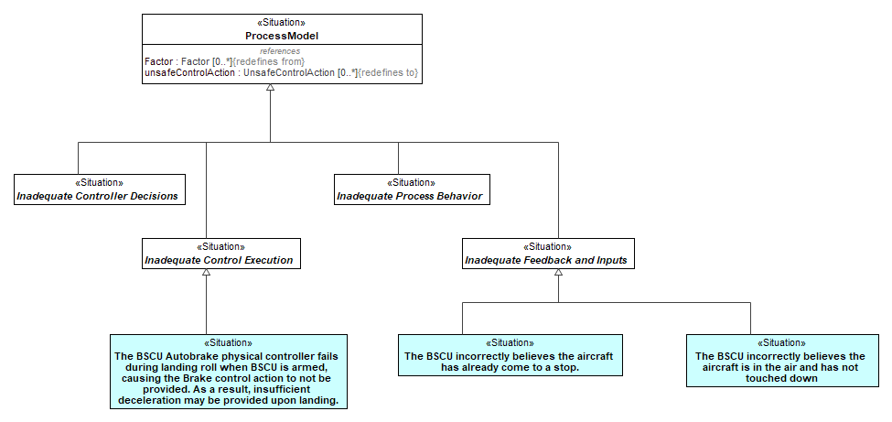
Figure 2-18 – Situation hierarchy
- GSN
The following diagram (Figure 2.19) illustrates the use of the GSN profile. Here, the top-level goal is “Control System is acceptably safe to operate”, which is contextualized against a GSN context “Operating Role and Context” and a SysML block “Control System”. The top-level goal is decomposed into two child goals without the use of a strategy. However, GSN strategy elements are used to decompose these goals into their child goals. At the bottom of the diagram, the GSN solution elements terminate each line of argument in the assurance case.
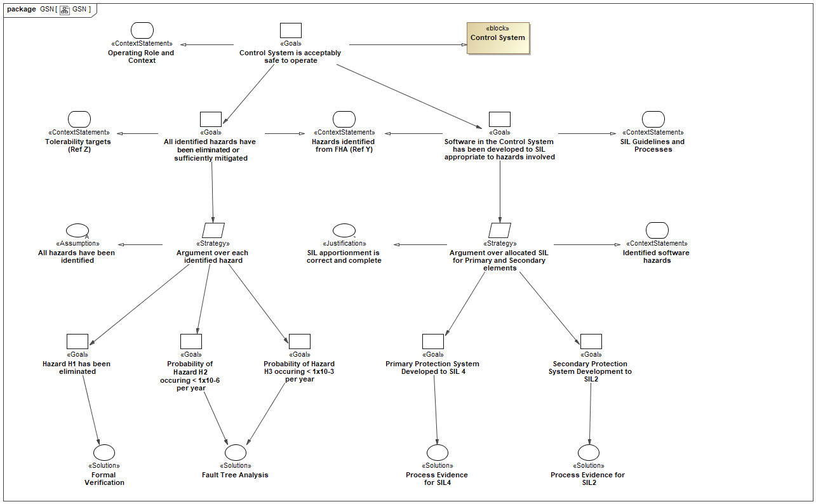
Figure 2-19 – GSN example
- ISO 26262 Road Vehicles - Functional Safety
The ISO 26262 package enables modeling a HAZOP, which is typically used to identify malfunctioning behaviors. The failure modes concept is used from the general concepts and specialized as a malfunctioning behavior. This allows the malfunctioning behavior to be related to the system behaviors through the HAZOP guide words for construction of the HAZOP table. Specifically, in this example, in Figure 2.20 a SysML model has the Steering Assist activity performed by the Power Steering System.

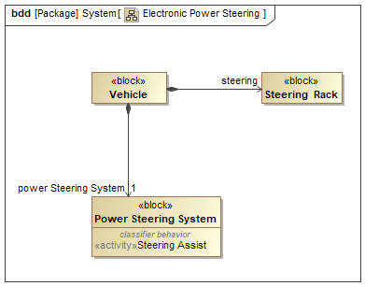
Figure 2-20 – Vehicel SysML BDD diagram
The Steering Assist activity relates to malfunctioning behaviors using the RelevantTo relationship (see Figure 2.21).
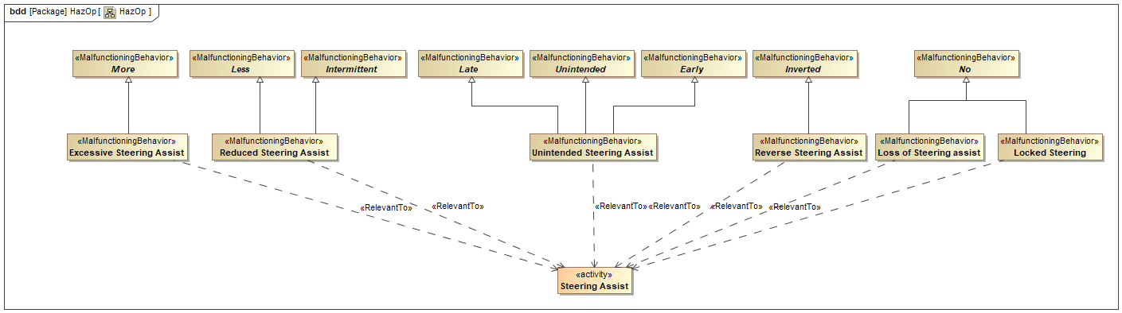
Figure 2-21 – HazOp as SysML BDD diagram
The model represented in Figure 2.21 can be shown in a tabular view (see Figure 2.22 below). The activity is represented as a row in such a table, and columns represent guidewords. The cells represent the malfunctioning behaviors.

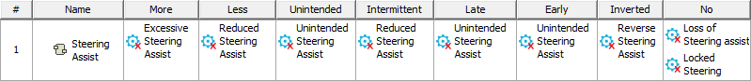
Figure 2-22 – HazOp in a tabular view

The conditions library can either be specified using a SysML IBD diagram (Figure 2.23) or a table (see Figure 2.24). If operational conditions are represented in a tabular view, their names are represented in cells and a generalization between different operational conditions is represented using a hierarchy between them.
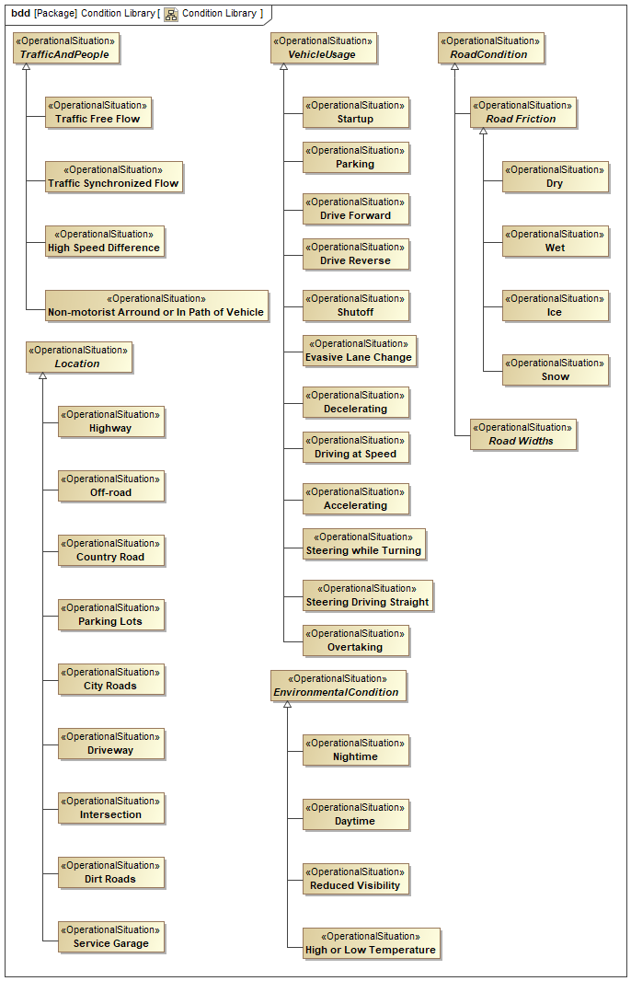
Figure 2-23 – Operational conditions library in a SysML BDD diagram
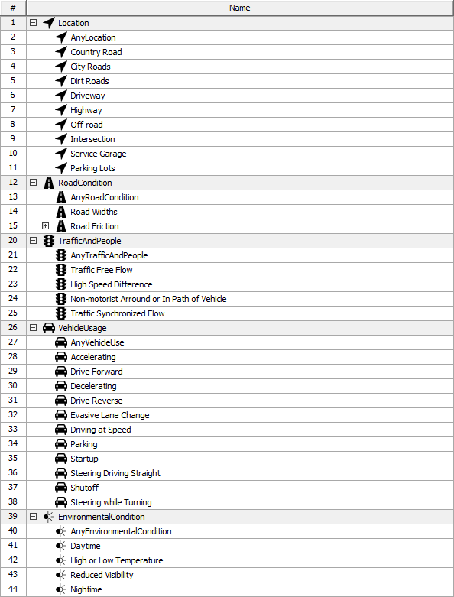
Figure 2-24 – Operational conditions library in a tabular view
Operational situations are combinations of operational conditions. They can be represented using SysML IBD diagrams (see Figure 2.25) or tables (see Figure 2.26). When shown in tables, each row represents an operational situation. Generalizations between operational situations are represented using hierarchies. All properties (Exposure and other part properties) are represented as columns. Cells represent values of the Exposure property or types of part properties.
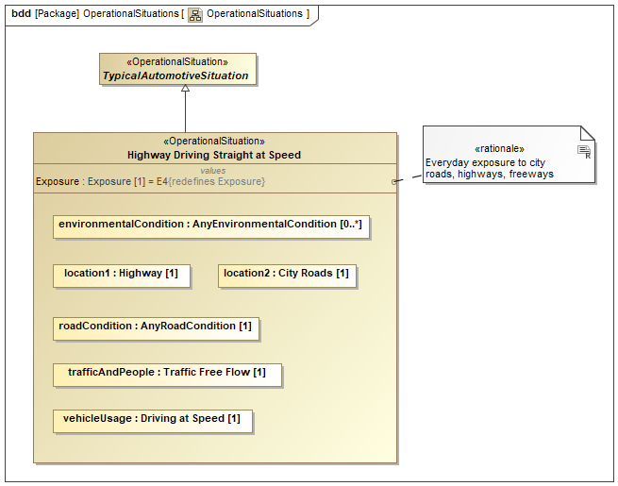
Figure 2-25 – Operational situations in a SysML BDD diagram

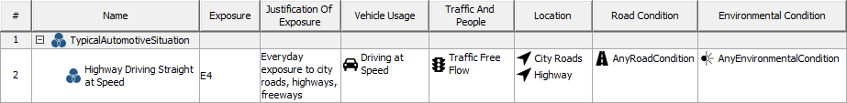
Figure 2-26 – Operational situations in a tabular view
Accident scenarios are combinations of operational situations and a malfunctioning behavior. They can be represented using SysML IBD diagrams (see Figure 2.27 – Accident scenario in a SysML BDD diagram) or tables (see Figure 2.28). When shown in tables, each row represents an accident scenario. Generalizations between accident scenarios are represented using hierarchies. All properties (Controllability and other part properties) are represented as columns. Cells represent values of the Controllability property or types of part properties.
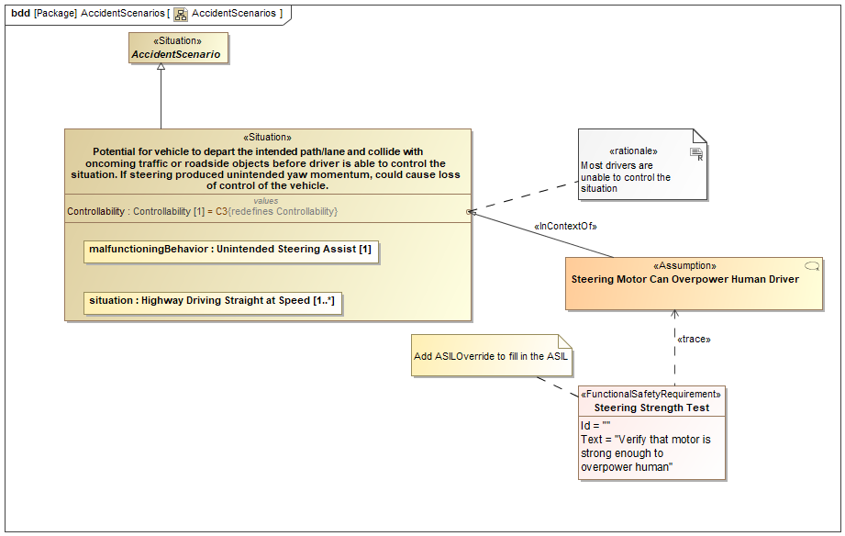
Figure 2-27 – Accident scenario in a SysML BDD diagram

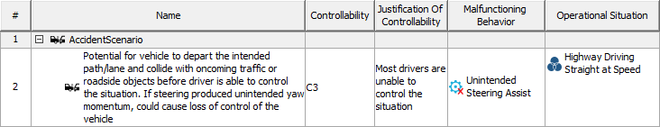
Figure 2-28 – Accident scenario in a tabular view
Effects and hazards are either represented using SysML IBD diagrams (see Figure 2.29) or tables (see Figure 2.30 and Figure 2.31). If shown in tables, hierarchies between effects or between hazards represent generalizations between them. The vehicle level effect has a severity and a justification which can be specified in cells of the row representing that effect in a table (Figure 2.30Figure 2.28).
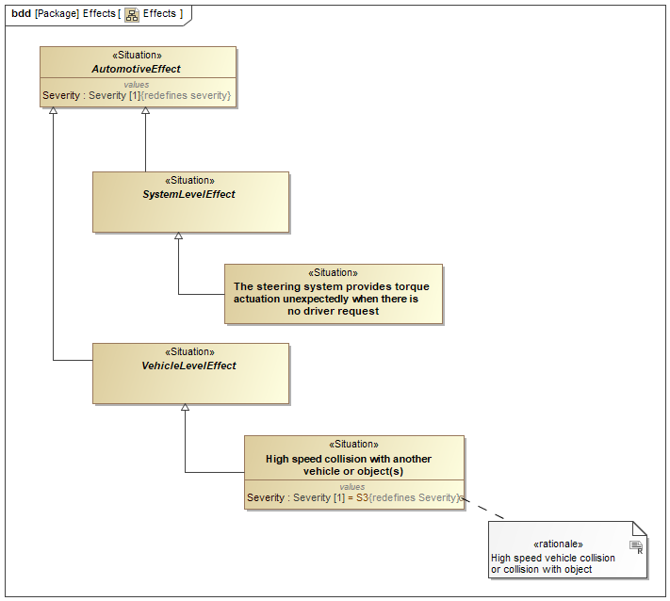
Figure 2-29 – Effects in a SysML BDD diagram

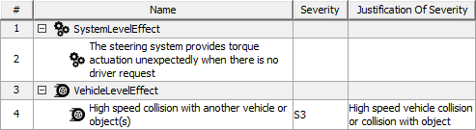
Figure 2-30 – Effects in a tabular view

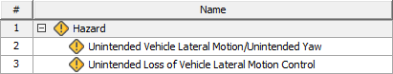
Figure 2-31 – Hazards in a tabular view
The risk analysis is performed by identifying Hazards that could result from the MalfunctioningBehavior, which in combination with a particular OperationalSituation could result in an AccidentScenario. This information is contained in the HazardousEvent which provides the risk level assessment for the event.
ISO 26262 represents risk levels using Automotive Safety Integrity Level (ASIL) concept. The specification models this as redefining the Score value of the AbstractRisk general concept. Values that the ASIL may take are defined in an enumeration contained in the ISO 26262 package.
HazardousEvents are specified either in SysML IBD diagrams (see Figure 2.32) or tables (see Figure 2.33). Just like in previous views, hierarchies between hazardous events represent genearlizations between them. Cells represent types of part properties and value property default values.
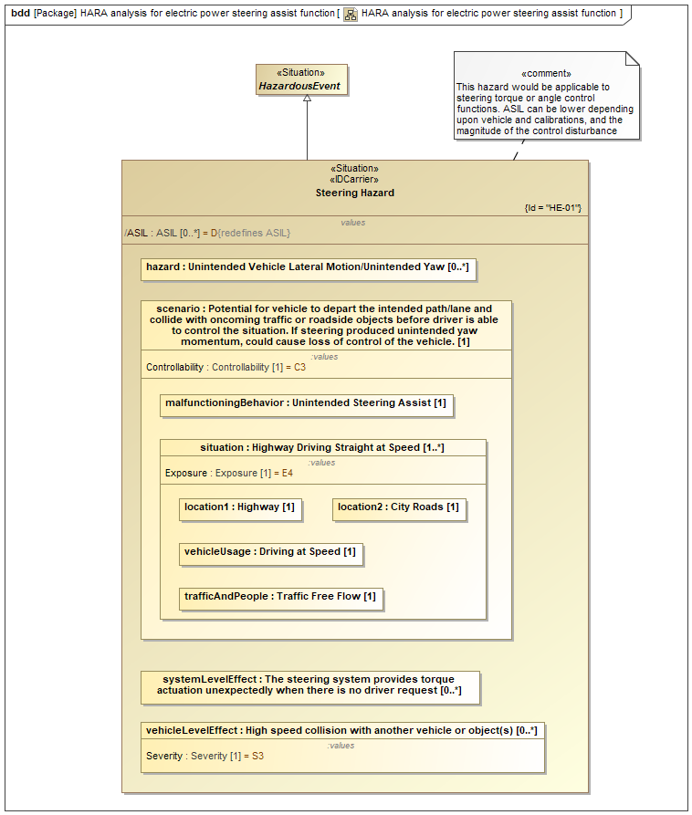
Figure 2-32 – HARA in a SysML BDD diagram

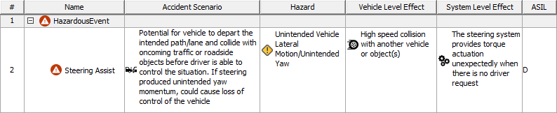
Figure 2-33 – HARA in a tabular view
Safety goals are derived from hazardous events and can be represented using SysML BDD or SysML Requirements diagrams (Figure 2.34). Functional safety requirements can be derived from safety goals, and functional safety requirements can be decomposed into other functional safety requirements from which technical safety requirements are derived. Hardware and software safety requirements are decomposed from technical safety requirements.
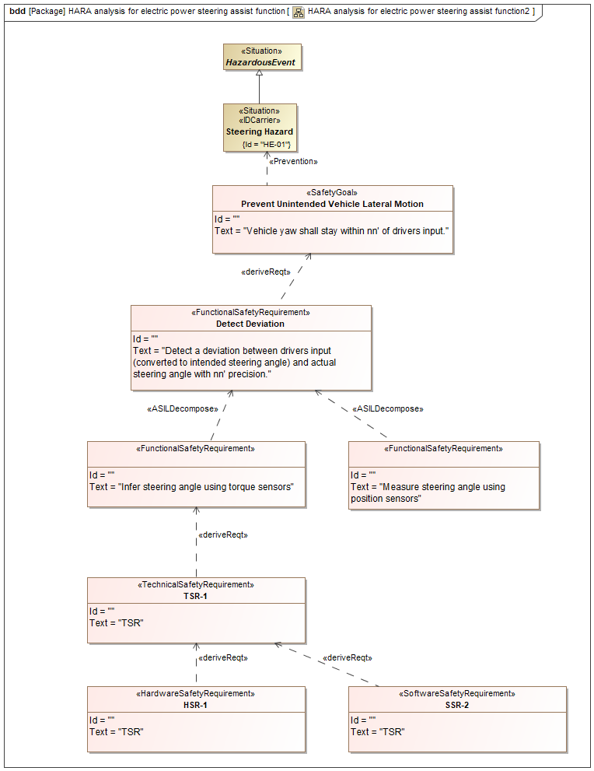
Figure 2-34 – Safety goal decomposition
- Reliability Block Diagrams

This subsection illustrates the use of the RAAML 1.1 Reliability Block Diagram (RBD) method for the hardware of a hypothetical computer server consisting of dual redundant network ports and power supplies; a non-redundant motherboard consisting of a processor (block name CPU), memory (block name RAM, for random access memory), input/output (I/O) subsystem consisting of 3 USB ports and a video port (block name I/O); and a Redundant Array of Independent Disks (RAID) Level 6 (5 out of 6 disk redundancy; block name Disk Array). For the I/O subsystem, 2 ouf of 3 USB ports are required. Figure 0-35 shows the SysML Block Definition Diagram (BDD) for this system.

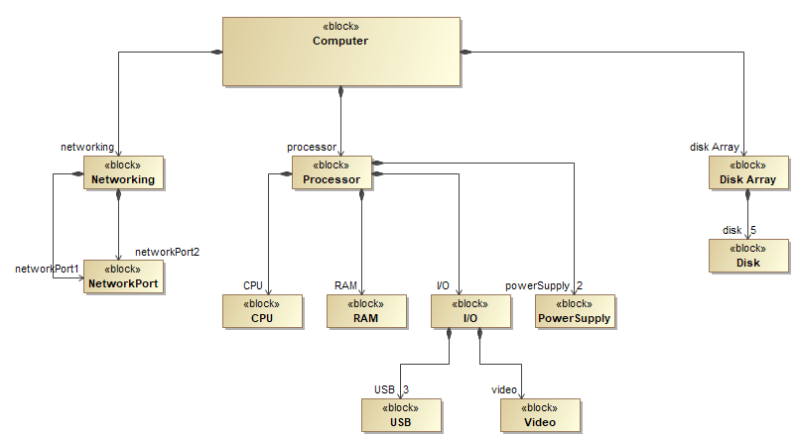
Figure 2-35. Block Definition Diagram for the Computer Server
Of note in this diagram are two different ways of depicting component redundancy. For the network port, there are two associations to represent the two different part properties. For the USB and disk array, multiplicities are used.
The first step in the use of the profile and library is to use the classes in the library to add the properties and associations that will enable the calculation of reliability and availability values for this system as shown in Figure 0-36. The applied base classes are listed in the table shown in Figure 0-37 (in the BDD, not all the base classes are shown due to the characteristics of the tool that was used to create them). The base class for all the blocks is the RAAML situation, which is then specialized as an AbstractReliabilitySituation. The specific base classes are then further specialized from the AbstractReliabilitySituation. The base class of the top level block is a RestorableInSeriesSituation, meaning that the result that will be calculated will be availability, and that the result will be the series availability of the three major subsystems (i.e., SysML parts): network, processor, and disk array. The RBD profile allows for recursion as the model is defined for lower levels of the system architectural hierarchy. A third level of recursion is used to represent the dual redundant power supply with a parallel system block and the actual power supplies at the lowest level of the model. These and the lower level blocks inherit from the base classes shown in Figure 0-37.
The third colum in Figure 0-37 shows the constraint blocks for the blocks whose availability is calculated based on lower level component blocks in series, parallel, or k out of n configurations. The lowest level blocks, the component blocks, show the constraints to calculate the Mean Tibem Between Failure (MTBF) and Mean Time to Restore (MTTR). The calculation of these values depends on the distribution, and in this case only the exponential distribution is used. However, the RBD methods allows the inclusion of any of the distributions included in the library (as of this writing, exponential, Weibull, and lognormal) to be used for any of the components. The fourth (right hand) column shows the values used for the MTBF and MTTR. For the purposes of this example, they are all set to 100,000 and 1 hour respectively.

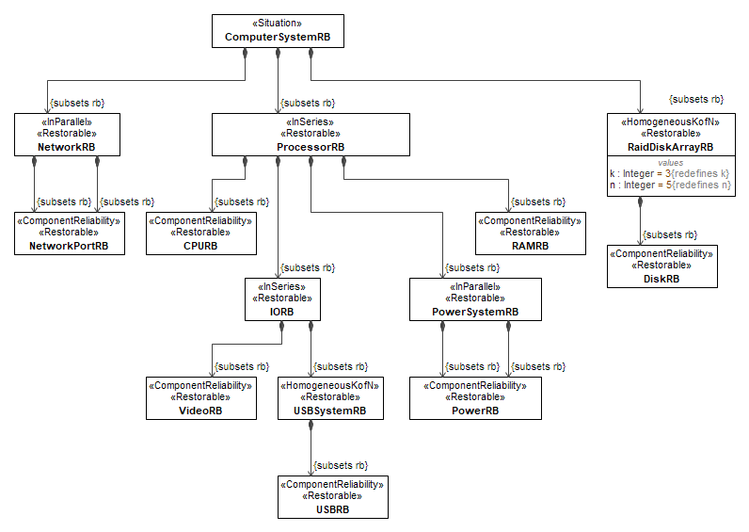
Figure 2-36. Computer Hardware Server System with RBD library classes applied

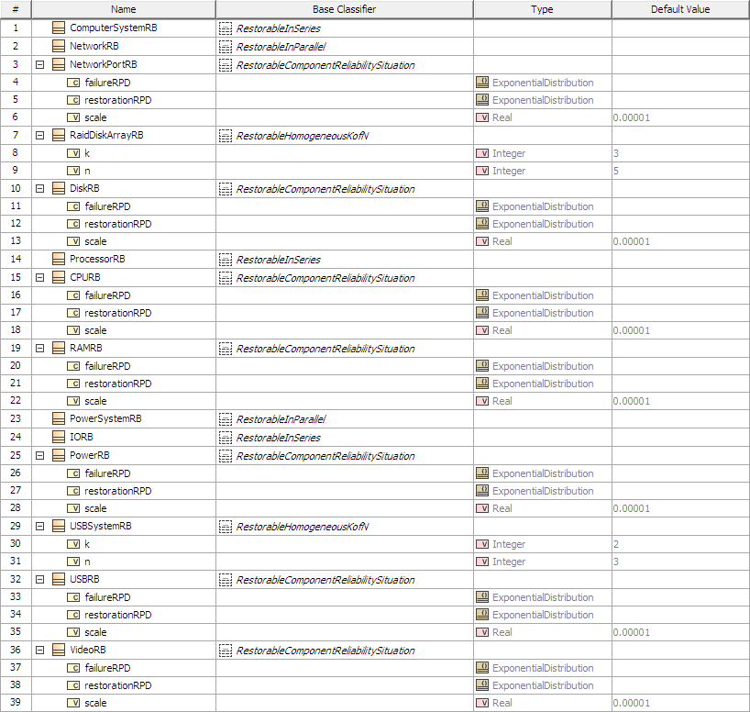
Figure 2-37. Table showing the blocks, base classifiers, internal elements, and values for the computer server model

Figure 0-38 shows the Internal Block Diagram (IBD) generated from the BDD shown in as shown in Figure 0-36. For the purposes of clarity, connectors (SysML IBD connectors) were manually added, as were the value properties for k and n for the USB ports in the I/O susbsystem and the RAID subsystems (value properties). These manual diagram additions could be automated by the use of SysML tool-specific features. Figure 0-38 shows a table of the model elements for the IBD.

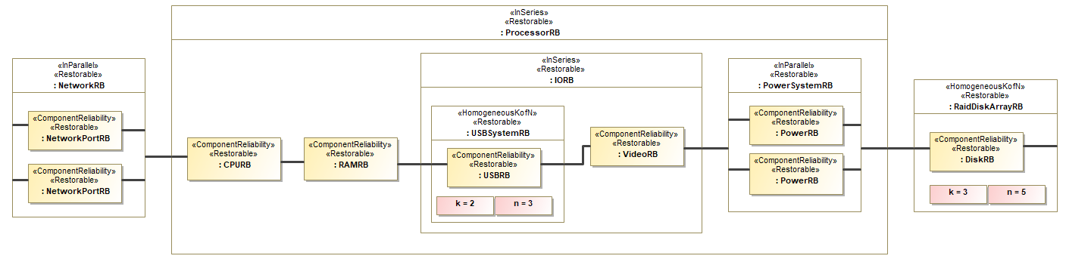
Figure 2-38. IBD of the Computer Server BDD

The final setp in the RBD method usage is the actual calculation of the model. Performing this step varies based on the SysML tool used. However, the end result of the calculation for this model, where the failure rate is set to 10⁻⁵ per hour and the restoration time is set 1 hour for all of the hardware components, the result is 0.99997.

- SysML4Sec
To meet the objectives of SAE ARP-4754 for certifying highly integrated and complex aircraft systems, the development process employs uses the V-model, which to structures the system development lifecycle toand ensure systematic progress. Complementing this, theThe safety assessment process specified in SAE ARP-4761-A , which is also based on the V-model, ensures the reliability of system functions and complements the development process. Recognizing the growing need for information security in aircraft system development, the FAA introduced the special conditions 25-07-01-SC and 25-07-02-SC for the certification of the Boeing 787 in 2007. Over the past decade , with reference to CS-25.1319, EASA has established ED-202A, ED-203A, and ED-204A, referenced in CS-25.1319, which are as part of the DO-326/ED-202 set. This document framework integrates security engineering into systems engineering and introduces a security engineering process as a critical element also, which is also based on the V-model of aircraft system developmentto. The resulting Three-V-Model (see Figure 2 39) serves as the baseline for the development of future aircraft cabin systems. It aligns the system engineering process (SEP) with the safety engineering process (SafEP) and the security engineering process (SecEP), ensuring a comprehensive and unified approach.

Figure 2-39 - Three-V-Model derived from EUROCAE, SAE and RTCA guidelines
Building on the Three-V-Model, SysML4Sec is introduced, a model-based security engineering method designed for the development of complex aircraft systems. It details how the specific SecEP activities outlined in the Three-V-Model can be implemented with respect to the RAAML profile within a model-based framework during the design phase . Furthermore, SysML4Sec is integrated into a unified SysML aircraft system model, leveraging the CATIA Magic Systems of Systems Architect tool.
- Security Concepts for Airworthiness Security Analysis
The objective of the certification specification CS-25.1319 is to protect aircraft and aircraft systems from Intentional Unauthorized Electronic Interaction (IUEI). This regulation mandates identification, assessment, and, where necessary, mitigation of security risks. To fulfill the certification requirements for (initial) airworthiness security, the ED-202 set, recognized by EASA as an acceptable means of compliance, provides guidelines on processes, methods, and underlying security concepts. The ED-202A standard defines the airworthiness security process, which encompasses several key activities:
- Certification-related activities: These involve interactions with airworthiness authorities to ensure compliance.
- Security development-related activities: These include designing a security architecture and integrating security measures to mitigate identified risks.
- Security risk assessment-related activities: These are focused on evaluating risks associated with potential threat scenarios.
Threat scenarios, as illustrated in Figure 2-40, consist of two main elements: a threat condition and a scenario description. The threat condition identification and evaluation activity involve identifying conditions caused by IUEI within the system under development and determining their safety effects on the aircraft, passengers, flight crew, and cabin crew or other indirect assets. These effects are classified according to their severity. The overall severity of the threat conditions is determined by the maximum of the severity for their associated safety effects, forming the basis for prioritizing mitigation efforts. The components of threat scenarios will be discussed in detail in the SysML4Sec section.
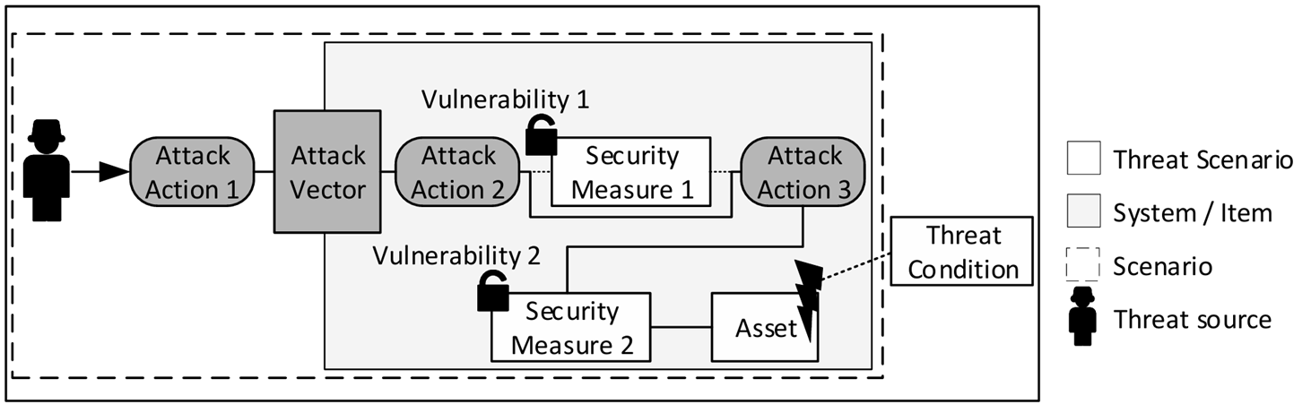
Figure 2-40 - Concept of threat scenario and attack path according to European Organization for Civil Aviation Equipment (EUROCAE)
- SysML-based Security Analyses
Aviation regulations mandate that systems installed on an aircraft must be not only safe but also secure, as outlined in CS-25.1319. Consequently, as discussed earlier, security processes executed by security engineers in collaboration with system, software, and hardware engineers are tightly integrated into overall system design processes. The Risk Analysis and Assessment Modeling Language (RAAML) is designed to capture safety, reliability, and security information within SysML models. Its primary goal is to ensure that safety and security information can be consistently shared across various engineering domains and organizations. Additionally, RAAML provides mechanisms to link this information to the system model itself. This link refers to the concept that the modeled safety and security information exists as a self-contained, consistent part of the model, rather than being tightly coupled with the system model.
- SysML4Sec Library and Profile
SysML4Sec is designed to facilitate model-based security engineering for large-scale product development, such as in the context of aircraft systems. It enables the application of system engineering principles across multiple design levels, including the system of interest, multisystem, and system development levels. This section explains how SysML4Sec integrates with and extends the RAAML profile, illustrating its application through an example of aircraft passenger seat connectivity. In the most recent version of the RAAML specification, version 1.1, general security concepts have been introduced through the addition of a comprehensive security concepts library and profile. These concepts encompass key elements such as assets, threats, weaknesses, and vulnerabilities. To facilitate the application of the SysML4Sec approach and address aviation-specific interpretations of security concepts, the general security concepts library and profile are extended based on the RAAML framework. The SysML4Sec library, aligned with the methodological steps of the SysML4Sec approach, defines the element ThreatCondition as a specialization of AbstractEvent (see Figure 2-41). Furthermore, the ThreatCondition element aggregates components that facilitate modeling changes in the condition of the system under analysis due to Intentional Unauthorized Electronic Interaction (IUEI) and its associated effect assessment. The aggregated elements include Consequence, DirectAsset, and IndirectAsset.
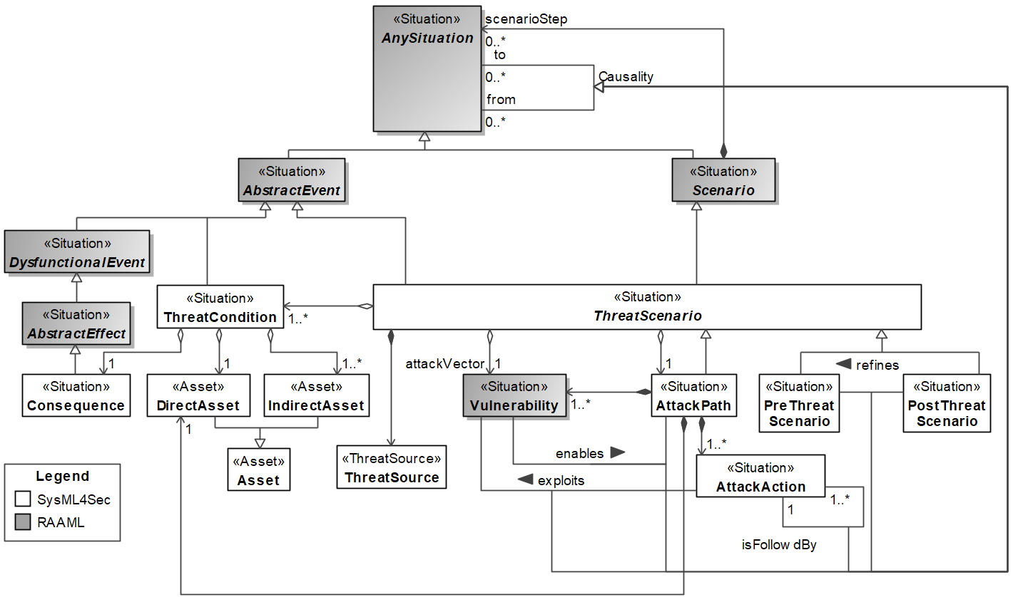
Figure 2-41 - SysML4Sec Security concept Library
A ThreatCondition is described in Figure 6 as relating to a single (direct) asset, such as a function, which is indicated by the assigned multiplicity of one. Each ThreatCondition addresses one Consequence associated with a specific security property, such as a loss of confidentiality or integrity. The impact of the Consequence on indirect assets and the effect on the direct asset can be modeled using specific dependency relationships introduced in the SysML4Sec profile, as illustrated in Figure 2-42.
In addition to threat conditions, the SysML4Sec library introduces threat scenarios which are defined to identify security risks. A corresponding abstract element labeled ThreatScenario is part of the library. Its purpose is to implement the concept of threat scenarios in a manner that is compliant with the standards. In accordance with the relevant standards, a ThreatScenario consists of one or more ThreatConditions, a ThreatSource, an AttackVector representing the Vulnerability, and an AttackPath. Additionally, the ThreatScenario element includes two key properties: riskValue and riskEvaluation. The riskValue property documents the risk level, determined by evaluating the impact of threat conditions and likelihood of potential attack paths. The riskEvaluation property, on the other hand, is used to classify the risk as either acceptable or unacceptable. An AttackPath comprises a DirectAsset, one or more Vulnerabilities, and AttackAction elements. AttackActions can be associated with architectural components such as functions, interfaces, and communication links, effectively linking the attack path to the system architecture. The AttackPath library element also includes attributes for assessing the likelihood of a successful attack, as outlined in ISO/IEC 18045:2022. Two additional elements, which specialize the ThreatScenario, enhance the library:
- A PreThreatScenario is identified and modeled at the multi-system level.
- A PostThreatScenario refines the multi-system-level threat scenario at the system level, incorporating the consideration of security measures.
In the specified SysML4Sec profile (see Figure 2-42), the stereotype ThreatSource extends the RAAML stereotype SecurityActor. This extension facilitates the modeling of various threat sources (attackers). Three tags are defined to accomplish this:
- isDeliberate: Indicates whether the threat source acts with intentionality.
- isHuman: Specifies whether the threat source is a human actor.
- isMalicious: Denotes whether the threat source has malicious intent.
These tags provide a structured way to categorize and describe the characteristics of threat sources within the security model.
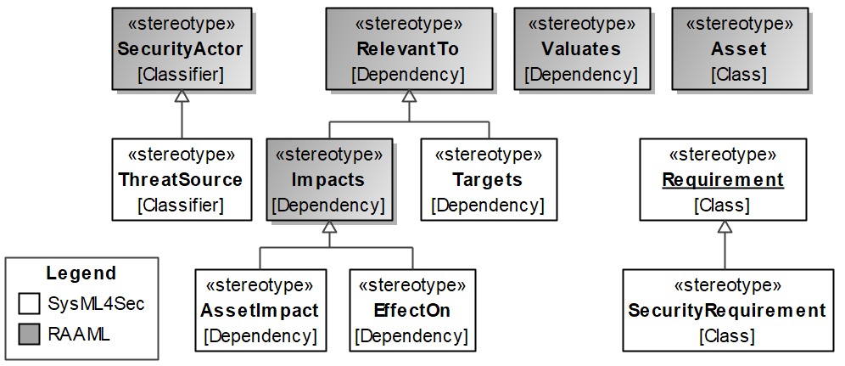
Figure 2-42 - SysML4Sec Security concept profile
The AssetImpact and EffectOn stereotypes provide mechanisms to model the relationships between Consequences and IndirectAssets (EffectOn), as well as between Consequences and the DirectAsset (AssetImpact). Both stereotypes extend the RelevantTo stereotype specified in RAAML. Additionally, the Targets stereotype, which also specializes RelevantTo, facilitates the linkage of AttackActions (within an AttackPath) to architectural elements, as described in. To complete the SysML4Sec profile, the SecurityRequirement stereotype is introduced. This enables the modeling of security requirements to address unacceptable security risks that must be mitigated.
- SysML4Sec Methodological Steps for Security Modeling
Efficient security engineering in aircraft development focuses on three primary objectives. The first objective is adopting a top-down approach, where security engineering begins at the earliest stages of development and aligns closely with the overall development process. The second objective is ensuring global applicability of security engineering practices to both current and future aircraft functions. The third objective is enhancing communication and collaboration between engineering departments by utilizing standardized methods for transferring security-related information across all development levels. The model-based execution of the Security Engineering Process (SEP) and the Security Extension Process (SecEP), as illustrated in Figure 2-43, emphasizes their parallel implementation during the functional development of the aircraft system. This phase corresponds to the system design stage represented by the left branch of the V-model in line with the former introduced Three-V-Model derived from EUROCAE, SAE and RTCA guidelines. It is important to note that the established Safety Engineering Process (SafEP), which forms part of the Three-V-Model, is not addressed in this context.
Figure 2-43 - Model-based execution of particularized SEP and SecEP activities within the design phase according to the Three-V-Model and their documentation in a single and unified SysML system model.
Due to the high complexity of an aircraft, the design phase is subdivided into four development levels: the aircraft level, the multi-system level, the system level and item level. Each development level refines the higher-level information to an appropriate granularity until the design process reaches the lowest development level, which is the item level. Since these design levels are well-suited for the use of the system modelling language (SysML), the item level, on the other hand, addresses a level of detail that is better served for example by the unified modelling language (UML). Compatibility at the transition between the system level and the item level is ensured. As shown in Figure 2-43, each design level incorporates contributions to a shared model within both the SEP and the SecEP, aligned with their respective specification objectives. The source for SecEP activities at any given design level is the corresponding SEP specification content. On the SecEP side, the information received from the SEP is analyzed and evaluated. The results are then fed back to the SEP for further consideration. The individual SysML4Sec steps, as described in Figure 2-43, are further explained in the following subsections using the example of a connectivity function for the adjustment of a passenger seat.

L1 / Aircraft Level
A first-class seat on a modern aircraft offers various functionalities to enhance the passenger experience. These typically include adjustable lighting, reclining and seat adjustment mechanisms, as well as entertainment and connectivity features. The development of these functionalities aligns with the top-level aircraft functional process, which begins with a decomposition of the aircraft top-level functions, as illustrated in Figure 2-44.
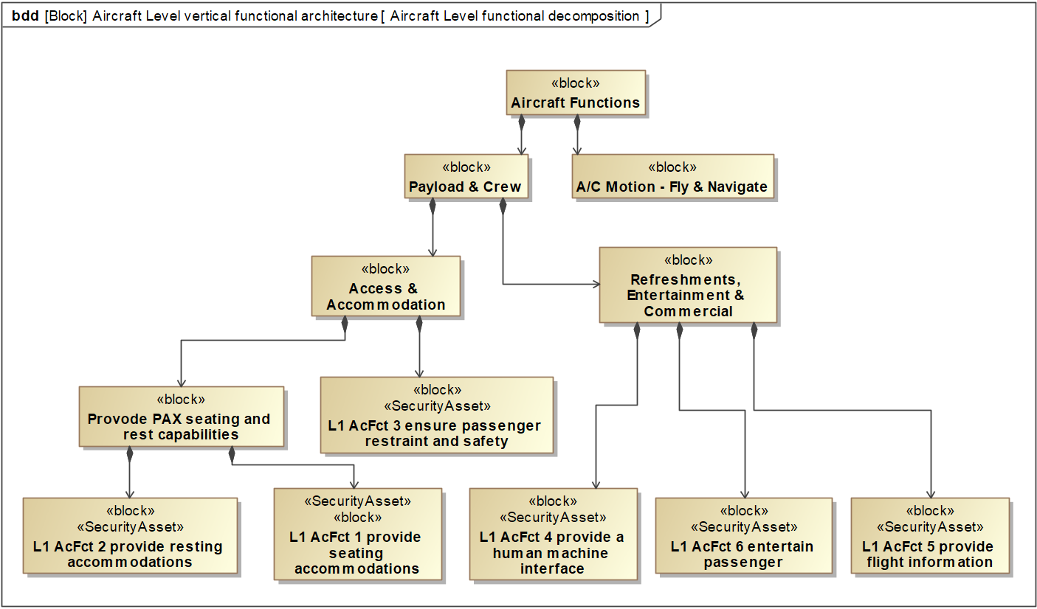
Figure 2-44 - Top-level decomposition of aircraft functions
Figure 2-45 provides an overview of the top-level aircraft functions and their interactions with external actors, such as passengers, cabin crew, and maintenance crew. This visual representation supports the systems security engineer, as depicted on the right side of Figure 2-45, in identifying the security context, security environment, and assets requiring protection throughout subsequent activities across the development levels.
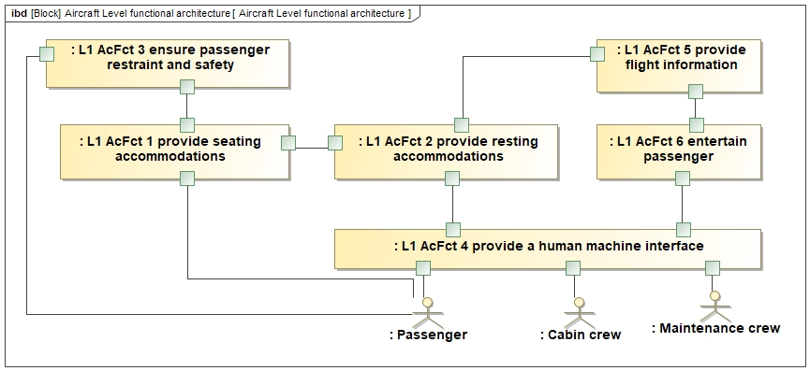
Figure 2-45 - Aircraft functional archtecture at its lowes decoposition level
With focus in this example on Aircraft Function 2, "Provide Resting Accommodations" (see Figure 2-45, L1 AcFct 2). From the Security Engineering Process (SecEP) perspective, the objective is to identify threat conditions (TC) that arise due to the presence of vulnerabilities. To accomplish this, it is utilizing the CIA+ framework to assess the loss of security attributes, which include confidentiality, integrity, availability, accountability, and privacy.
The table in Figure 2-46 presents the identified threat conditions, considering direct and indirect assets, consequences, and safety impacts. Loss of accountability and confidentiality are determined to have no significant effect. However, a minor effect on the flight crew is identified due to the loss of availability and integrity. In contrast, a major effect impacts passengers for these same security attributes. The Aggregate Impact Rating column highlights the most critical effects for each identified condition.
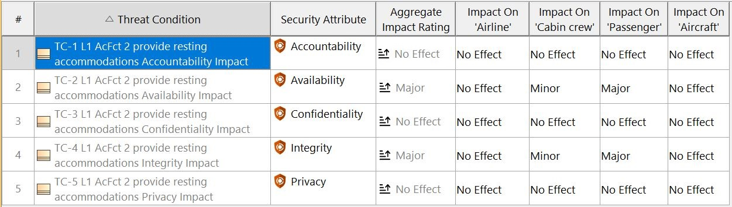
Figure 2-46 - Aircraft threat condition associated to resting accommodations function
This information can also be visualized in a diagram, as shown in Figure 2-47. The diagram offers the advantage of facilitating discussions with other stakeholders by allowing the extraction of blocks for deeper analysis. Conversely, the table view ensures scalability, making it suitable for larger studies involving numerous threat conditions.
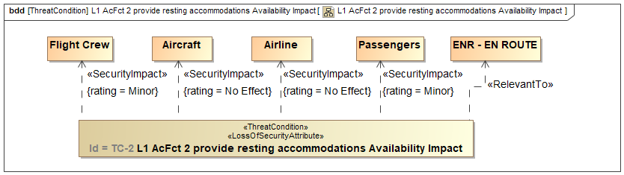
Figure 2-47 - Threat condition diagram and its related elements

L2 / Multi-Systems Level
At the multi-systems level, the systems engineer decomposes top-level aircraft functions to manage the complexity of interactions between multiple systems working together to achieve the desired objectives. During the Functional Refinement activity, valuable insights are gained regarding how external actors will interface with the aircraft passenger seat, enabling the creation of multi-system threat scenarios (TS).
Figure 2-48 illustrates how the Seat System interfaces with the Flight Management System and the In-Flight Entertainment System. This diagram also delineates the boundaries of the system of interest, specifically the Seat System. Based on the information in Figure 2-48, the security engineer will:
- Model multi-system threat scenarios.
- Assess these scenarios in terms of severity of impact and likelihood of occurrence, following the guidelines in ISO 18045:2022.
- Define appropriate security requirements to mitigate the risk of these threat scenarios occurring.
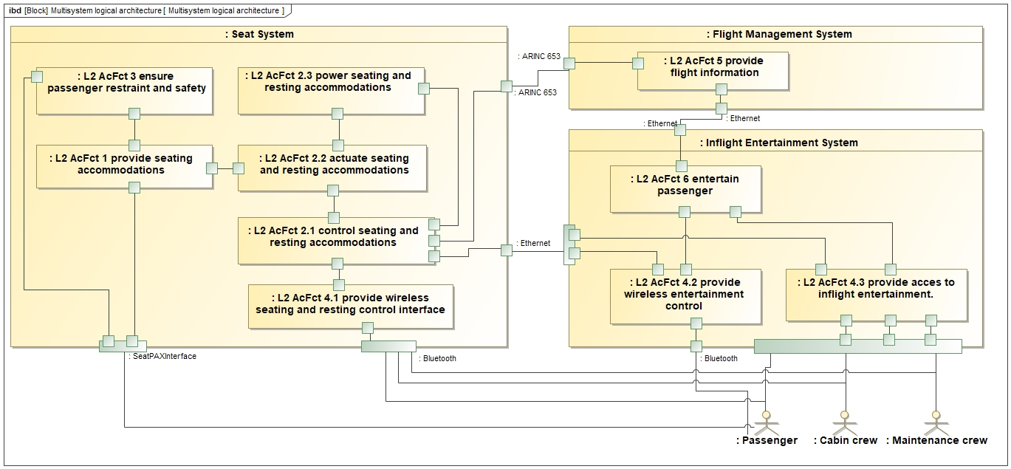
Figure 2-48 - Multi-System aircraft functions
Figure 2-49 illustrates the threat scenario (TS) along with its essential components. The identified adversary is characterized as a human with intention (Threat Source), exploiting a vulnerability in Bluetooth interface. This action impacts the two threat conditions (TCs) depicted in Figure 2-46. To provide additional context and ensure comprehensive coverage of the threat scenarios, the TS can be associated with a misuse case.
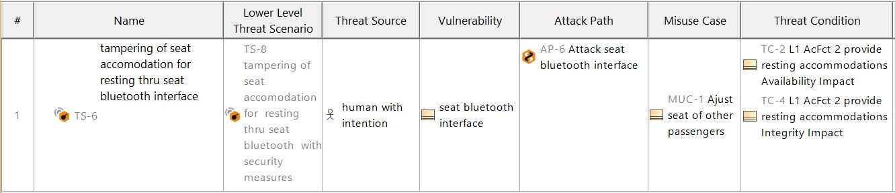
Figure 2-49 - Threat Scenario table gathering relevant element
Another perspective can be extracted from the threat scenario (TS) model, as shown in Figure 2-50, to facilitate discussions with other stakeholders. This view emphasizes specific elements, such as the likelihood value, to enhance understanding and analysis. The likelihood value is determined in this design level based on ISO 18045:2022, which outlines the attributes for evaluating the probability of a TS occurring.
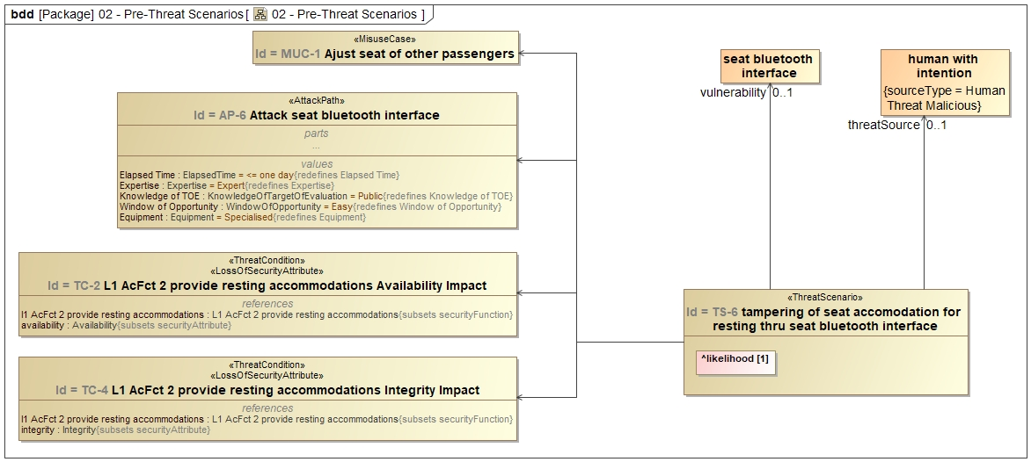
Figure 2-50 - Threat Scenario diagram and its related elements
The risk rating is determined using the acceptability matrix (see Figure 2-51). If the risk is deemed acceptable, no mitigation measures are required. However, for unacceptable risks, security requirements must be specified to reduce the risk to an acceptable level. In this example, TS-1 is classified as an unacceptable risk due to the combination of a major potential impact, as indicated by the Threat Condition rating, and a very high potential likelihood derived from the Attack Path rating.
Figure 2-51 - Risk Acceptability matrix
The description of Multi-Systems TS-1 is as follows: "An adversary can establish a nominal Bluetooth connection to the aircraft passenger seat system, bypassing the authentication mechanism in place via pairing. Subsequently, the adversary can directly send commands to the aircraft passenger seat system."
The attack path outlines the steps an adversary must take to successfully execute the attack. From
Figure 2-52, it is evident that the adversary must first compromise L2 AcFct 4.1, then gain access to L2 AcFct 2.1, ultimately achieving their objective of impacting the actuate function L2 AcFct 2.2. The L2 functional elements are highlighted in bold for emphasis.
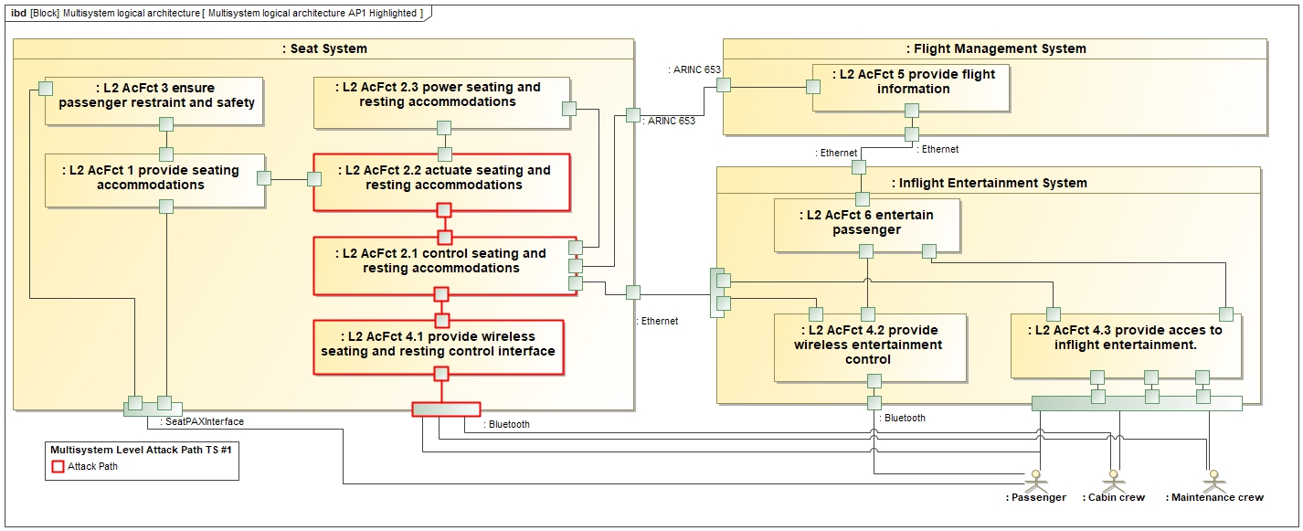
Figure 2-52 - Attack Path modeling directly within the system model
To mitigate the risk associated with TS-1, the security engineer identifies two security requirements, as shown in Figure 2-53. These requirements are designed to reduce the likelihood rating, thereby bringing the risk to an acceptable level.

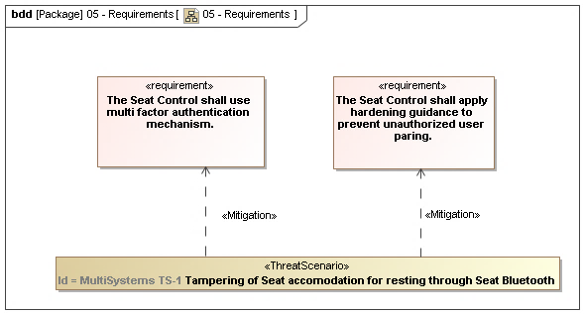
Figure 2-53 - Security requirements to be implemented to mitigate TS-1

L3 / Systems Level
At the L3 system level, the system engineer refines the logical architecture of the passenger seat to incorporate security functions that satisfy the security requirements defined at level 2. These security measures collectively contribute to risk reduction. Figure 2-54 presents a Level 3 system view, illustrating how the functional security measures are integrated into the refined attack path. The security measures are highlighted in bold for clarity.
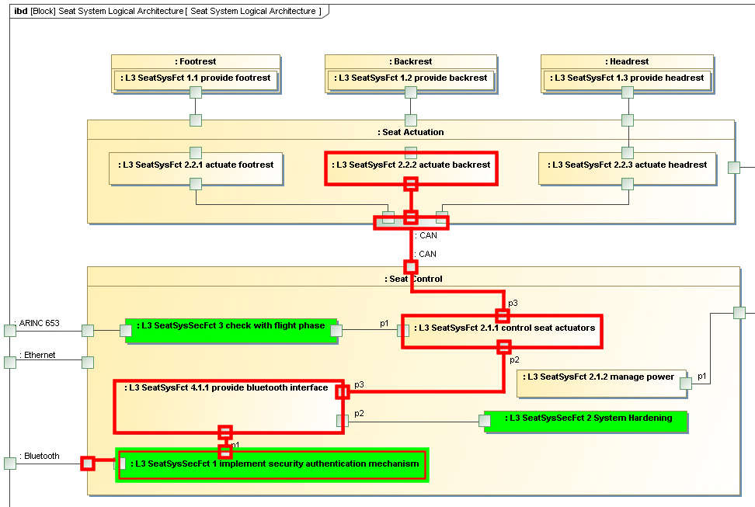
Figure 2-54 - System model including Level 3 security measures for TS-1
At the top of Figure 2-55, the row highlights a safety impact of major severity, starting at 30 points. The security engineer's task is to identify and characterize security measures that will reduce the risk to an acceptable level. It is assumed that implementing security measures will lower the likelihood of the risk but not its impact. Each security measure is weighted based on its effectiveness. The model calculates this effectiveness, factoring in effectiveness capping (see Figure 2-55, right-hand column). With the proposed security measures, the risk is successfully reduced to 15 points, which is within the acceptable range. Based on this refined architecture, the security engineer will:
- Model a System Threat Scenario that refines the Multi-Systems Threat Scenario, including functional security measures.
- Define additional non-functional security measures.
- Assess security measures in terms of their effectiveness based on ED-203A guidance (European Organization for Civil Aviation Equipment, 2018).
- Review the final Risk Acceptability Matrix.
The effectiveness of security measures is categorized into exposure reduction and protection. Exposure reduction refers to actions or measures that minimize the ways in which an asset or system is accessible or vulnerable to threats. These measures do not alter the system's design but instead aim to limit potential attack vectors. Protection, on the other hand, operates within the system’s security perimeter and directly influences the system’s design and security architecture. These are functional security measures implemented by the system engineer to safeguard the system’s critical components.
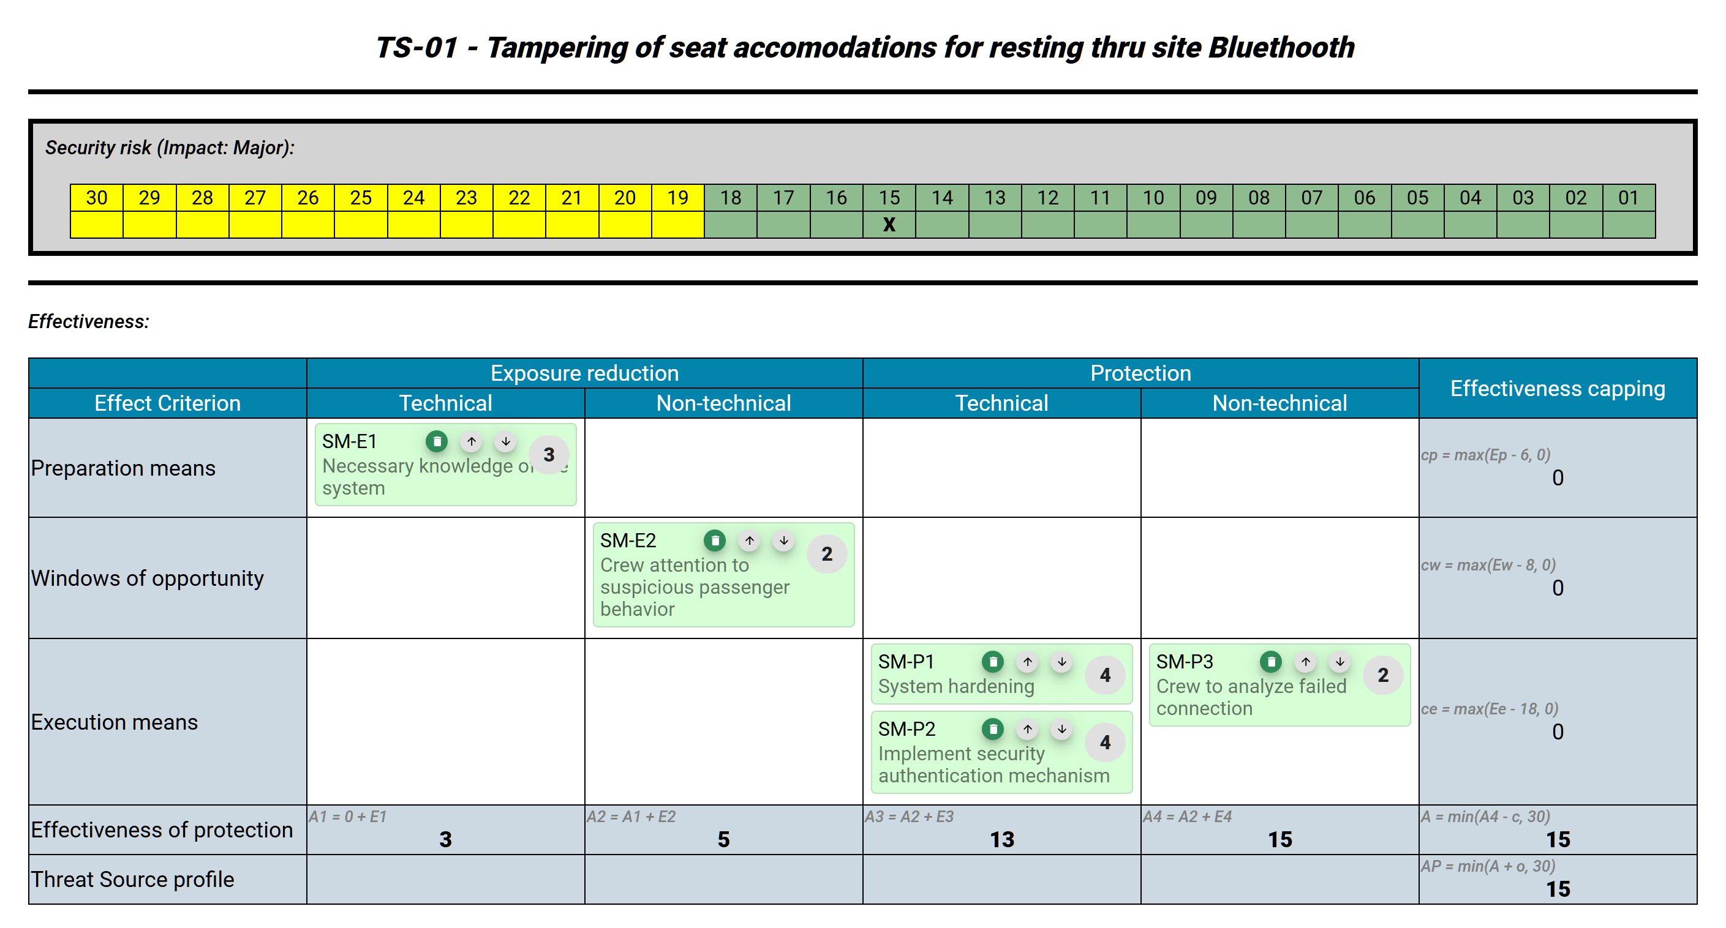
Figure 2-55 presents the identified security measures. Preparation means (PM) refer to efforts involved in understanding system specifics and determining the difficulty of acquiring the necessary information or preparation resources. Window of opportunity (WO) relates to the timing of when an attack can be executed. Execution means (EM), however, contribute more significantly to the overall effectiveness than preparation means, as the tasks within the preparation phase only need to be completed once and can be reused for subsequent attacks.
Figure 2-55 - Security Measures in Effectiveness Table as given by ED-203A
Finally, the acceptability matrix is reviewed and the TS-1 is now re-assessed to an acceptable level as illustrated within Figure 2-56.
Figure 2-56 - Risk Acceptability Matrix

References
- IEC 60812 for FMEA, https://webstore.iec.ch/publication/26359 [accessed on October 28, 2020]
- IEC 61025 for FTA, https://webstore.iec.ch/publication/4311 [accessed on October 28, 2020]
- International Standardization Organization. ISO PAS 21448:2019(en) Road vehicles – Safety of the intended functionality, https://www.iso.org/standard/70939.html [accessed on October 28, 2020]
- International Standardization Organization. ISO 26262-1:2011(en) Road vehicles Functional safety - Part 1, Part 3. https://www.iso.org/obp/ui/#iso:std:iso:26262:-1:ed-1:v1:en [accessed on October 28, 2020]
- N. Leveson and J. Thomas, STPA Handbook, Boston, MA: MIT, March 2018, https://psas.scripts.mit.edu/home/get_file.php?name=STPA_handbook.pdf [accessed on October 28, 2020]
- GSN specification, http://www.goalstructuringnotation.info [accessed on October 28, 2020]
- SAE, ARP 4754A Guidelines for Development of Civil Aircraft and Systems, https://www.sae.org/standards/content/arp4754a/ , [accessed on November 6, 2020]
- IEC 61078:2016, Reliability Block Diagrams, https://webstore.iec.ch/publication/25647 [accessed on October 21, 2023]
- National Institute of Standards and Technology, “NIST/Sematech Engineering Statistics Handbook”, https://www.itl.nist.gov/div898/handbook/ [accessed on October 21, 2023]
- European Organization for Civil Aviation Equipment. (2014). Airworthiness security
process specification: EUROCAE-ED-202A. EUROCAE.
- European Organization for Civil Aviation Equipment. (2018). Airworthiness security
methods and considerations: EUROCAE-ED-203A. EUROCAE.
- European Organization for Civil Aviation Equipment. (2020). Information security guidance for
continuing airworthiness: EUROCAE-ED-204A. EUROCAE.

