Ontology: Documents
The documents ontology defines a high-level concept of a document, and a similarly high-level notion of a reference, which may or may not be a document. Subordinate concepts include legal document, certificate, notice, reference document, and specification. A document in this ontology refines the FRBR (Functional Requirements for Bibliographic Records) notion of an Expression, and aligns well with and can be mapped to FRBR, more recent work by the International Federation of Library Associations and Institutions (IFLA), and other bibliographic ontologies. The conceptualization provided in the Documents ontology is designed primarily for mapping purposes, and to provide the hooks required for representation of references, such as those needed for defining quantities and units.
Metadata for the Documents ontology is given in Table 8.17.
Table 1: Documents Ontology Metadata
Metadata Term | Value
OntologyIRI | https://www.omg.org/spec/Commons/Documents/
rdfs:label | Commons Documents Ontology
dct:abstract | This ontology defines high-level concepts for representation of documents, including legal documents and records, such as a transaction record, purchase history, or payment history. It is deliberately lightweight in order to accommodate mappings to other document and bibliographic ontologies.
dct:contributor | Davide Sottara, Mayo Clinic
dct:contributor | Elisa Kendall, Thematix Partners LLC
dct:contributor | Evan Wallace, U.S. National Institute of Standards and Technology (NIST)
dct:contributor | Pete Rivett, Federated Knowledge LLC
cmns-av:copyright | Copyright (c) 2014-2023 EDM Council, Inc.
cmns-av:copyright | Copyright (c) 2022-2023 Federated Knowledge LLC
cmns-av:copyright | Copyright (c) 2022-2023 Mayo Clinic
cmns-av:copyright | Copyright (c) 2022-2023 Thematix Partners LLC
cmns-av:copyright | Copyright (c) 2023 Object Management Group, Inc.
dct:license | https://opensource.org/licenses/MIT
owl:versionIRI | https://www.omg.org/spec/Commons/20230801/Documents/
skos:note | This ontology was derived from the Financial Industry Business Ontology (FIBO), and generalized for use in other domain areas.

An overview diagram for the Documents ontology is given in Figure 10.
The detailed annotations and axioms that comprise the Documents ontology are provided in Table 8.18, below.
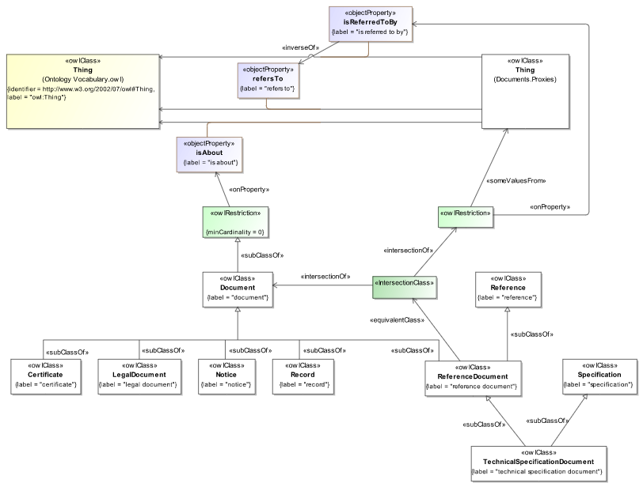Figure 1: Documents Ontology Overview
Table 2: Documents Ontology Details
Classes
Name | Annotations | Class Expressions
Certificate (certificate) | Definition: document attesting to the truth of some fact or set of facts  Explanatory note: A certificate may or may not also be a legal document, depending on the issuing authority and how it can be used.  Explanatory note: Certificates, such as electronic certificates, including public keys, may be issued by some certificate authority.  Adapted from: ISO 5127 - Information and documentation - Foundation and vocabulary, Second edition, 2017-05, clause 3.1.1.38 | Parent Class: Document
Document (document) | Definition: unitary expression of some realization of an intellectual or artistic work  Note: See also ISO 25964–1:2011, definition 2.15; ISO 11005:2010, definition 3.1; ISO 15489–1:2016, definition 3.10; IEC 82045–1:2001, definition 3.2.3; ISO 9000:2015, definition 3.7.2  Note: The definition of document provided herein roughly corresponds to the concept of an expression in FRBR. A document is a realization of something that typically takes the form of alpha-numeric, musical, or choreographic notation, sound, image, etc., or any combination of such forms. A manifestation of the document must be inscribed, encoded, engraved, recorded, or otherwise imprinted in some medium. The concept of a manifestation of an expression corresponds to the ISO 5127 notion of a document. Documents can differ extensively in form and characteristics.  Note: The manifestation of a document (FRBR expression) refers not only to written and printed materials in paper or microform versions (for example, conventional books, journals, diagrams, maps), but also to non-printed media such as machine-readable and digitized records, Internet and intranet resources, films, sound recordings, buildings, sites, monuments, three-dimensional objects or realia [when used to carry some sort of engraving]; and to collections of such items or parts of such items. (Note taken from ISO 25964–1:2011, definition 2.15.) Also, software, since recorded, can be considered a document.  Explanatory note: A document, especially a legal document, may serve to establish one or several facts, and can be relied upon as a proof thereof.  Usage note: This definition of document corresponds to a subclass of expression in FRBR. The notion of being a unitary expression is the differentiator between an FRBR expression and document in this sense.  Adapted from: ‘Functional Requirements for Bibliographic Records’, Final Report, IFLA (International Federation of Library Associations and Institutions) Study Group on the Functional Requirements for Bibliographic Records, September 1997 - see https://repository.ifla.org/bitstream/123456789/811/2/ifla-functional-requirements-for-bibliographic-records-frbr.pdf  Adapted from: ISO 5127 - Information and documentation - Foundation and vocabulary, Second edition, 2017-05, clause 3.1.1.38  See also: https://www.ifla.org/wp-content/uploads/2019/05/assets/cataloguing/frbr/frbroo_v2.2.pdf | Property Restriction: ≥ 0 isAbout
LegalDocument (legal document) | Definition: document specifying the terms of, or provides evidence for, an agreement, attestation, certification, conditions, permissions, and/or decisions of legal persons, government entities, or courts of law, drawn up in accordance with certain rules that apply in the relevant jurisdiction(s)  Example: Examples include some certificates, deeds, bonds, business documents (such as articles of incorporation, bylaws, partnership agreements), contracts, certain identity documents, wills, trusts, legislative acts, notarial acts, court writs or processes (such as related complaints and pleadings in the context of litigation as well as other documents relevant to some legal issue), and any law passed by a competent legislative body in municipal (domestic) or international law.  Note: A legal document bears the original, official, or legal form of something, that can be fully attributed to its author(s), that records and formally expresses a legally enforceable act, process, or contractual duty, obligation, or right and that can be used to furnish decisive evidence for that act, process, or agreement.  Note: Many legal documents only become ‘legal’ once they are signed and dated, and possibly notarized.  Adapted from: ISO 5127 - Information and documentation - Foundation and vocabulary, Second edition, 2017-05, clause 3.4.6.02 | Parent Class: Document
Notice (notice) | Definition: announcement, communication, intimation, or advance warning of something, usually, but not necessarily, to allow preparations to be made  Example: registered trademark notice, disclaimer, copyright notice, overdue notice, recall notice  Note: Although many notices are delivered electronically, certain legal notices must be given given in writing, often by regular mail or hand delivery, with the sender retaining sufficient proof of having given such notice (e.g., through a certificate of service).  Adapted from: ISO 5127 - Information and documentation - Foundation and vocabulary, Second edition, 2017-05 | Parent Class: Document
Record (record) | Definition: memorialization and objective evidence of activities performed, events occurred, results achieved, or statements made, regardless of its characteristics, media, physical form, or the manner in which it is recorded or stored  Note: Records are created or received by an organization in routine transaction of its business or in pursuance of its legal obligations. | Parent Class: Document
Reference (reference) | Definition: source that may be used to ascertain, interpret, or understand something  Explanatory note: In linguistics, a reference characterizes, provides context for, or specifies the relationship of one linguistic expression to another, i.e., provides the information necessary to interpret the dependent expression.  Explanatory note: References may be rendered in the form of a document, but may also take other forms, such as reference materials, scientific equations, and constants, including in some cases physical things, used as the basis for units of measure.
ReferenceDocument (reference document) | Definition: document that is used as a reference for something  Explanatory note: A reference document is typically one that provides pertinent details for consultation about a subject.  Adapted from: ISO/IEC 11179-3 Information technology - Metadata registries (MDR) - Part 3: Registry metamodel and basic attributes, Third edition, 2013-02-15 | Parent Class: Document, Reference  Class Axiom: ≡ (Document ∩ ( isReferredToBy))
Specification (specification) | Definition: explicit requirement or set of requirements to be satisfied by something, such as a product, material, model, process or system  Abbreviation: spec  Adapted from: ISO 6707-2:2017 Buildings and civil engineering works - Vocabulary - Part 2: Contract and communication terms, clause 3.2.22
TechnicalSpecificationDocument (technical specification document) | Definition: document that sets out detailed requirements to be satisfied by a product, material, process or system and the procedures for checking conformity to these requirements  Note: Technical specifications may evolve from a functional specification and define the technical requirements for the selected solution as part of a business agreement.  Explanatory note: A technical specification is a specification expressing technical requirements, such as one for designing and developing a solution to be implemented.  Adapted from: ISO 10795:2019 Space systems - Programme management and quality - Vocabulary, clause 3.238  Adapted from: ISO 6707-2:2017 Buildings and civil engineering works - Vocabulary - Part 2: Contract and communication terms, clause 3.2.22 | Parent Class: ReferenceDocument, Specification

Properties
Name | Annotations | Property Axioms
hasDataSource (has data source) | Definition: relates something, such as an agreement, contract, document, record, report, or process, to a source of data used to analyze, develop, explain, produce, or otherwise create it  Usage note: Although in many cases an annotation property, such as dct:source, is sufficient for this purpose, there are occasions when a more complete description of a source is required, such as to meet data lineage requirements, for which this property may be used. | Parent Property: refersTo
isAbout (is about) | Definition: indicates the subject or topic of something, such as a document
isReferredToBy (is referred to by) | Definition: indicates something that is referenced as a source for information or explanation | Inverse: refersTo
isSpecifiedIn (is specified in) | Definition: indicates the explicit source for some requirement, fact, or set of facts | Parent Property: refersTo  Inverse: specifies
records (records) | Definition: documents for later reference
refersTo (refers to) | Definition: makes reference to as a source for information or explanation
specifies (specifies) | Definition: mentions, names or states something clearly and definitively  Explanatory note: Specifies may be used to refer to a requirement, fact, or set of facts.

https://www.ifla.org/g/cataloguing/ifla-s-bibliographic-conceptual-models/
https://www.ifla.org/

