Example Role and Composition
The notion of a composition is widely used in UML modeling, but is not provided “out of the box” in the Web Ontology Language (OWL). Ontologists frequently need to reify relationships, for example to represent ternary relations, without having a single pattern built into the language for doing so, although several options are described in ‘Defining N-ary Relations on the Semantic Web’.
The model described herein provides a pattern for representing roles and compositions and incorporates three restrictions on composition that are optional: (1) inclusion of constituents – parts of something, (2) inclusion of roles, and (3) context.
One common kind of composition is that of a recipe. A recipe has ingredients, each of which may have some amount, and possibly other properties associated with them. In the case of pharmaceutical ingredients which are substances playing the role of ingredients, for example, each has an amount and a strength as well as certain jurisdiction-specific details.
Figure 1, below, provides a partial, high-level diagram from an explanatory wiki page for the Identification of Medicinal Products (IDMP-O) ontology project for a pharmaceutical product composition, showing the relationships between the composition and its ingredients.
In the diagram, the ‘has ingredient’ property is a subproperty of ‘has role’ in the Commons Roles and Compositions ontology.
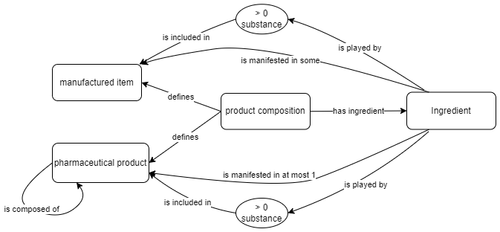
Figure 1. Example product composition
A turtle representation of the OWL definitions for product composition, has ingredient and the ingredient class are given below.

idmp-mprd:ProductComposition
a owl:Class ;
rdfs:subClassOf
cmns-rlcmp:Composition ,
[
a owl:Restriction ;
owl:onProperty idmp-mprd:hasReferenceStrength ;
owl:onClass idmp-mprd:ReferenceStrength ;
owl:minQualifiedCardinality "0"^^xsd:nonNegativeInteger ;
] ,
[
a owl:Restriction ;
owl:onProperty idmp-sub:hasIngredient ;
owl:someValuesFrom idmp-sub:Ingredient ;
] ,
[
a owl:Restriction ;
owl:onProperty cmns-dsg:defines ;
owl:someValuesFrom [
a owl:Class ;
owl:unionOf (
idmp-sub:ManufacturedItem
idmp-mprd:MedicinalProduct
idmp-mprd:PharmaceuticalProduct
) ;
] ;
]
;
rdfs:label "product composition" ;
skos:definition "composition that defines some product based on its relationship(s) to some other substance(s) (ingredient(s)), potentially with a given strength, in some context" ;
cmns-av:usageNote "From an implementation (mapping) perspective, this product composition class provides the basis for a (blank) node in the relationship 'product realizes ingredient role played by some substance', where the ingredient role may be that of an active ingredient which, in turn, may have some basis of strength in some context. The same product composition could be used to link inactive ingredients to a product in which they are realized. A given product may include multiple active ingredients, each of which may have a different basis of strength." ;
.
idmp-sub:hasIngredient
a owl:ObjectProperty ;
rdfs:subPropertyOf cmns-rlcmp:manifests ;
rdfs:label "has ingredient" ;
rdfs:range idmp-sub:Ingredient ;
skos:definition "relates a substance or product composition to an ingredient of that composition" ;
cmns-av:usageNote "This property should be used primarily in a manufacturing context where differentiation of substances or pharmaceutical products in a product from other elements that play roles in the manufacturing context is important." ;
.

idmp-sub:Ingredient
a owl:Class ;
rdfs:subClassOf
cmns-rlcmp:FunctionalRole ,
[
a owl:Restriction ;
owl:onProperty cmns-rlcmp:isPlayedBy ;
owl:onClass [
a owl:Restriction ;
owl:onProperty cmns-col:isIncludedIn ;
owl:onClass idmp-sub:ManufacturedItem ;
owl:minQualifiedCardinality "0"^^xsd:nonNegativeInteger ;
] ;
owl:minQualifiedCardinality "0"^^xsd:nonNegativeInteger ;
]
[
a owl:Restriction ;
owl:onProperty cmns-rlcmp:isManifestedIn ;
owl:onClass idmp-mprd:PharmaceuticalProduct ;
owl:maxQualifiedCardinality "1"^^xsd:nonNegativeInteger ;
] ,
[
a owl:Restriction ;
owl:onProperty cmns-rlcmp:isManifestedIn ;
owl:onClass idmp-sub:ManufacturedItem ;
owl:minQualifiedCardinality "0"^^xsd:nonNegativeInteger ;
] ,
[
a owl:Restriction ;
owl:onProperty idmp-mprd:hasStrength ;
owl:onClass idmp-mprd:Strength ;
owl:minQualifiedCardinality "0"^^xsd:nonNegativeInteger ;
] ,
[
a owl:Restriction ;
owl:onProperty cmns-rlcmp:isPlayedBy ;
owl:onClass [
a owl:Restriction ;
owl:onProperty cmns-col:isIncludedIn ;
owl:onClass idmp-mprd:PharmaceuticalProduct ;
owl:minQualifiedCardinality "0"^^xsd:nonNegativeInteger ;
] ;
owl:minQualifiedCardinality "0"^^xsd:nonNegativeInteger ;
]
;
rdfs:label "ingredient" ;
dct:source "ISO/TS 20443:2017(E) Health informatics - Identification of medicinal products (IDMP) - Implementation guidelines for ISO 11615 data elements and structures for the unique identification and exchange of regulated medicinal product information, table D.1, clause D.2.1" ;
dct:source "ISO 11615:2017 Health informatics - Identification of medicinal products (IDMP) - Data elements and structures for the unique identification and exchange of regulated information on substances, clauses 3.1.28 and 9.7, Figure 12" ;
skos:note "An ingredient is part of a medicinal product, either alone or in combination with other ingredients. The ingredient is also a component of a pharmaceutical product. Ingredient is equal to a substance with the indication of the specific role it is playing in the product." ;
skos:definition "role of a substance that is specifically part of or used in the preparation of some manufactured item, pharmaceutical product, medication, or drug" ;
idmp-cmpl:hasConformanceToISOLevel idmp-cmpl:ConformanceToISOLevel-NamingConformant ;
cmns-av:synonym "pharmacological role" ;
cmns-av:usageNote
"An ingredient is defined as a material in the ISO 11238 standard rather than as a role, which would make the model inconsistent. Thus this concept is consistent in terms of its name but not in terms of its definition." ,
"Note that any inactive ingredient that is described as 'ingredient not otherwise specified' in the ISO/TS 20443 implementation guide will simply be classified as an ingredient at this level in the hierarchy in the ontology, or as an inactive ingredient without other differentiation."
;
.

https://www.w3.org/TR/swbp-n-aryRelations/
https://wiki.edmcouncil.org/display/IDMP/Pattern%3A+Representing+Ingredients+-+APPROVED

