11 April 2022
13 - Elements, Properties, and Stereotypes
_________________________________________________________________________________
Purpose of this Memo
To make the case for updating CSRM stereotypes. Once agreement is reached, updates to the CSRM Specification will be developed.
This is a big deal and needs lots of discussion.
Figures 1 lists CSRM element stereotypes. Black font denotes current baseline as captured in the normative CSRM Profile. Blue font denotes recommended additions.
Figure 2 lists requirement elements related properties that are part of the SysML language.
Figure 3 illustrates one of many ways to establish relationships between the mission stakeholders, requirements, technical measures, and use cases stereotypes. These stereotypes are denoted by italicized font in Figure 1.
The relationships are captured in the element specifications and are displayed and maintained in diagrams and tables as shown in Figure 1.
Object Constraint Language
There has been discussion about codifying the allowable relationships using Object Constraint Language (OCL). OCL is a declarative language describing rules applying to Unified Modeling Language (UML) models. For example, a refine relationship can exist between a requirement. and any other model element, whereas a derive relationship can only exist between requirements.
That could be done founded on the examples in Figure 3. This would be of limited benefit. A mission team will be using the stereotypes and relationships best suited to their mission and the stereotypes in Figure 3 are very limited as compared to Figure 1.
A case could be made to established relationships for the stereotypes in Figure 1. But that is out-of-Scope for the SSWG CSRM effort.
An Issue that Needs Resolution.
The intent of defining addition stereotypes as shown in Figure 1 is to provide stereotypes for a variety of mission architectures. However, several of the stereotypes are identified as CubeSat stereotypes. But they are not unique to CubeSats. The only thing that makes a model a CubeSat model is the incorporation of a CubeSat form factor such as the Cal Poly CubeSat Design Specification.
My recommendation is to rename the stereotypes as show in Table 1 below.

xx
Stakeholder
StakeholderConcern
MissionNeed
MissionObjective
MissionConstraint
Mission Requirement
SegmentRequirement
SpaceSegmentRequirement
CubeSatRequirement
GroundSegmentRequirement
SubsystemRequirement
CubeSatSubsystemRequirement
GroundSubsystemRequirement
ComponentRequirement
CubeSatComponentRequirement
GroundComponentRequirement
SpacecraftRequirement
SatelliteRequirement
DeployerRequirement
moeSpecification
mopSpecification
tpmSpecification
kppSpecification
moeRequirement
mopRequirement
tpmRequirement
kppRequirement
EnterpriseUseCase
MissionUseCase
SegmentUseCase
SpaceSegmentUseCase
CubeSatUseCase
GroundSegmentUseCase
SubsystemUseCase
CubeSatSubsystemUseCase
GroundSubsystemUseCase
ValidationActivity
VerificationActivity

Mission
Domain
Enterprise
System
Spacecraft
Satellite
Segment
SpaceSegment
CubeSat
GroundSegment
Subsystem
CubeSatSubsystem
GroundSubsystem
Component
CubeSatComponent
GroundComponent
Facility
Equipment
Figure 1. CSRM Stereotypes
Refines
RefinedBy
TracedTo
TracedFrom
Derived
DerivedFrom
AllocatedTo
AllocatedFrom
ValidatedBy
VerifiedBy
SatisfiedBy
Figure 2. Requirements Related Properties

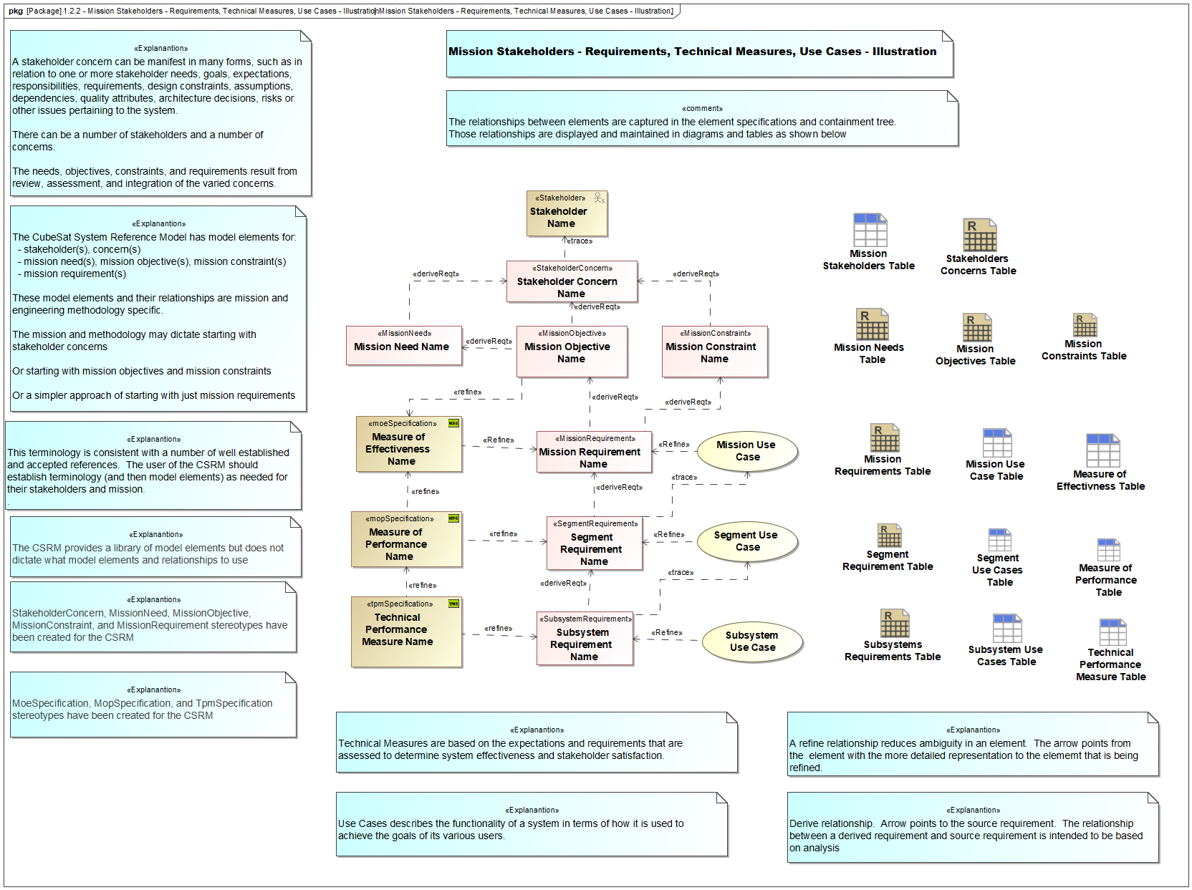
Figure 3. Mission Stakeholders – Requirement, Technical Measures, Use Cases - Illusion

Replace | With
CubeSatRequirement | SatelliteRequirement
CubeSatSubsystemRequirement | SatelliteSubsystemRequirement
CubeSatComponentRequirement | SatelliteComponentRequirement
CubeSatUseCase | SatelliteUseCase
CubeSatSubsystemUseCase | SatelliteSubsystemUseCase
Table 1. Renaming of Stereotypes
x

