**UnifiedPOS Retail Peripheral Architecture**

**Version 1.16 RCSD**

**International Standard**

**For Implementation of Point Of Service Peripherals**

**OMG Document Number: retail/2019-04-01**

**Original submission date: February 18th, 2019**

**Standard document URL: https://www.omg.org/spec/UPOS/**

**This proposal adds to and extends the UPOS 1.15 standard.**

Copyright © 2017, Object Management Group, Inc.

USE OF SPECIFICATION - TERMS, CONDITIONS & NOTICES

The material in this document details an Object Management Group specification in accordance with the terms, conditions and notices set forth below. This document does not represent a commitment to implement any portion of this specification in any company's products. The information contained in this document is subject to change without notice.

LICENSES

The companies listed above have granted to the Object Management Group, Inc. (OMG) a nonexclusive, royalty-free, paid up, worldwide license to copy and distribute this document and to modify this document and distribute copies of the modified version. Each of the copyright holders listed above has agreed that no person shall be deemed to have infringed the copyright in the included material of any such copyright holder by reason of having used the specification set forth herein or having conformed any computer software to the specification.

Subject to all of the terms and conditions below, the owners of the copyright in this specification hereby grant you a fully-paid up, non-exclusive, nontransferable, perpetual, worldwide license (without the right to sublicense), to use this specification to create and distribute software and special purpose specifications that are based upon this specification, and to use, copy, and distribute this specification as provided under the Copyright Act; provided that: (1) both the copyright notice identified above and this permission notice appear on any copies of this specification; (2) the use of the specifications is for informational purposes and will not be copied or posted on any network computer or broadcast in any media and will not be otherwise resold or transferred for commercial purposes; and (3) no modifications are made to this specification. This limited permission automatically terminates without notice if you breach any of these terms or conditions. Upon termination, you will destroy immediately any copies of the specifications in your possession or control.

PATENTS

The attention of adopters is directed to the possibility that compliance with or adoption of OMG specifications may require use of an invention covered by patent rights. OMG shall not be responsible for identifying patents for which a license may be required by any OMG specification, or for conducting legal inquiries into the legal validity or scope of those patents that are brought to its attention. OMG specifications are prospective and advisory only. Prospective users are responsible for protecting themselves against liability for infringement of patents.

IPR Mode

This specification is issued under the RAND Mode base on the OMG IPR Policy.

OMG IPR Policy https://www.omg.org/cgi-bin/doc.cgi?ipr

GENERAL USE RESTRICTIONS

Any unauthorized use of this specification may violate copyright laws, trademark laws, and communications regulations and statutes. This document contains information which is protected by copyright. All Rights Reserved. No part of this work covered by copyright herein may be reproduced or used in any form or by any means--graphic, electronic, or mechanical, including photocopying, recording, taping, or information storage and retrieval systems--without permission of the copyright owner.

DISCLAIMER OF WARRANTY

WHILE THIS PUBLICATION IS BELIEVED TO BE ACCURATE, IT IS PROVIDED "AS IS" AND MAY CONTAIN ERRORS OR MISPRINTS. THE OBJECT MANAGEMENT GROUP AND THE COMPANIES LISTED ABOVE MAKE NO WARRANTY OF ANY KIND, EXPRESS OR IMPLIED, WITH REGARD TO THIS PUBLICATION, INCLUDING BUT NOT LIMITED TO ANY WARRANTY OF TITLE OR OWNERSHIP, IMPLIED WARRANTY OF MERCHANTABILITY OR WARRANTY OF FITNESS FOR A PARTICULAR PURPOSE OR USE. IN NO EVENT SHALL THE OBJECT MANAGEMENT GROUP OR ANY OF THE COMPANIES LISTED ABOVE BE LIABLE FOR ERRORS CONTAINED HEREIN OR FOR DIRECT, INDIRECT, INCIDENTAL, SPECIAL, CONSEQUENTIAL, RELIANCE OR COVER DAMAGES, INCLUDING LOSS OF PROFITS, REVENUE, DATA OR USE, INCURRED BY ANY USER OR ANY THIRD PARTY IN CONNECTION WITH THE FURNISHING, PERFORMANCE, OR USE OF THIS MATERIAL, EVEN IF ADVISED OF THE POSSIBILITY OF SUCH DAMAGES.

The entire risk as to the quality and performance of software developed using this specification is borne by you. This disclaimer of warranty constitutes an essential part of the license granted to you to use this specification.

RESTRICTED RIGHTS LEGEND

Use, duplication or disclosure by the U.S. Government is subject to the restrictions set forth in subparagraph (c) (1) (ii) of The Rights in Technical Data and Computer Software Clause at DFARS 252.227-7013 or in subparagraph (c)(1) and (2) of the Commercial Computer Software - Restricted Rights clauses at 48 C.F.R. 52.227-19 or as specified in 48 C.F.R. 227-7202-2 of the DoD F.A.R. Supplement and its successors, or as specified in 48 C.F.R. 12.212 of the Federal Acquisition Regulations and its successors, as applicable. The specification copyright owners are as indicated above and may be contacted through the Object Management Group, 109 Highland Avenue, Needham, MA 02494, U.S.A.

TRADEMARKS

IMM®, MDA®, Model Driven Architecture®, UML®, UML Cube logo®, OMG Logo®, CORBA® and XMI® are registered trademarks of the Object Management Group, Inc., and Object Management Group™, OMG™ , Unified Modeling Language™, Model Driven Architecture Logo™, Model Driven Architecture Diagram™, CORBA logos™, XMI Logo™, CWM™, CWM Logo™, IIOP™ , MOF™ , OMG Interface Definition Language (IDL)™ , and OMG SysML™ are trademarks of the Object Management Group. All other products or company names mentioned are used for identification purposes only, and may be trademarks of their respective owners.

COMPLIANCE

The copyright holders listed above acknowledge that the Object Management Group (acting itself or through its designees) is and shall at all times be the sole entity that may authorize developers, suppliers and sellers of computer software to use certification marks, trademarks or other special designations to indicate compliance with these materials.

Software developed under the terms of this license may claim compliance or conformance with this specification if and only if the software compliance is of a nature fully matching the applicable compliance points as stated in the specification. Software developed only partially matching the applicable compliance points may claim only that the software was based on this specification, but may not claim compliance or conformance with this specification. In the event that testing suites are implemented or approved by Object Management Group, Inc., software developed using this specification may claim compliance or conformance with the specification only if the software satisfactorily completes the testing suites.

**OMG’s Issue Reporting Procedure**

All OMG specifications are subject to continuous review and improvement. As part of this process we encourage readers to report any ambiguities, inconsistencies, or inaccuracies they may find by completing the Issue Reporting Form listed on the main web page http://www.omg.org, under Documents, Report a Bug/Issue (http://www.omg.org/report_issue.)

Document Sumbitter

Vinx Corp.

Document Publishing Supportes

OPOS-J

Sorimachi Giken Co. Ltd.

Microsoft Japan Ltd.

SEIKO EPSON Corp.

Toshiba TEC Corp.

Star Micronics Corp.

Fujitsu Frontec Corp.

NCR Corporation

Sharp Corporation

Omron Social Solutions Corp.

NEC Platforms Corp.

Transaction Media Networks Inc.

**Table of Content**

Preface 7

UPOS 1.16 RCSD Specification Overivew 10

Updated Items in Release 1.16 10

Updated Items in ＣＨＡＰＴＥＲ 21 Lights 10

Properties 10

Methods 10

Updated Items in ＣＨＡＰＴＥＲ 29 POS Power 10

Properties 10

Added Chapters in Release 1.16 10

ＣＨＡＰＴＥＲ 21 11

Lights 11

Summary 11

**General Information** 15

Capabilities 15

Device Sharing 15

Lights Class Diagram 16

Lights Sequence Diagram 17

Properties (UML attributes) 19

**Methods (UML operations)** 22

**Events (UML interfaces)** 26

ＣＨＡＰＴＥＲ 29 28

POS Power 28

Summary 28

**General Information** 32

Capabilities 32

**Device Sharing** 32

**Model** 33

POSPower Class Diagram 34

POSPower Sequence Diagram 35

POSPower Standby Sequence Diagram 36

POSPower PowerState Diagram - Part 2 39

POSPower PowerState Diagram - Part 3 40

POSPower State Chart Diagram for Fan and Temperature 41

POSPower Battery State Diagram 42

POSPower Power Transitions State Diagram 43

Properties (UML attributes) 44

Methods (UML operations) 52

Events (UML Interfaces) 55

ＣＨＡＰＴＥＲ 39 59

Video Capture 59

Summary 59

General Information 64

Capabilities 64

Video Capture Class Diagram 65

Model 66

Capture only mode 66

Photo shooting mode 66

Movie shooting mode 66

Input Model 67

Bar Code Scan 67

Individual Recognition 68

**Device Sharing** 68

Properties (UML attributes) 69

**Methods (UML operations)** 88

**Events (UML interfaces)** 91

ＣＨＡＰＴＥＲ 40 95

Individual Recognition 95

Summary 95

**General Information** 98

Capabilities 98

Individual Recognition Class Diagram 98

Model 99

**Device Sharing** 99

**Properties (UML attributes)** 100

ＣＨＡＰＴＥＲ 41 102

Sound Recorder 102

Summary 102

**General Information** 106

**Capabilities** 106

**Sound Recorder Class Diagram** 106

**Model** 107

Device Sharing 107

**Properties(UML attributes)** 108

**Methods(UML operations)** 112

**Events(UML interfaces)** 113

ＣＨＡＰＴＥＲ 42 115

Voice Recognition 115

Summary 115

**General Information** 119

**Capabilities** 119

**Voice Recognition Class Diagram** 119

**Model** 120

Device Sharing 121

**Properties (UML attributes)** 122

**Methods (UML operations)** 126

ＣＨＡＰＴＥＲ 43 130

Sound Player 130

Summary 130

**General Information** 134

**Capabilities** 134

**Sound Player Class Diagram** 134

**Model** 135

Device Sharing 135

**Properties(UML attributes)** 136

**Methods (UML operations)** 138

ＣＨＡＰＴＥＲ 44 139

Speech Synthesis 139

Summary 139

**General Information** 143

**Capabilities** 143

**Speech Synthesis Class Diagram** 143

**Model** 144

Device Sharing 144

**Properties (UML attributes)** 145

**Methods (UML operations)** 150

ＣＨＡＰＴＥＲ 45 153

Gesture Control 153

Summary 153

General Information 157

Capabilities 157

**Gesture Control Class Diagram** 158

Model 159

Automatic control 159

Pose / Motion 160

Device Sharing 160

Properties (UML attributes) 161

Methods (UML operations) 165

ＣＨＡＰＴＥＲ 46 170

Device Monitor 170

Summary 170

General Information 173

Capabilities 173

Device Monitor Class Diagram 173

**Model** 174

Device Sharing 174

Properties (UML attributes) 175

Methods (UML operations) 178

ＣＨＡＰＴＥＲ 47 182

Graphic Display 182

Summary 182

General Information 186

**Capabilities** 186

Graphics Display Class Diagram 186

**Model** 187

Image Display Mode 187

**Movie Display Mode** 188

**Web Display Mode** 189

Device Sharing 189

**Properties (UML attributes)** 190

**Methods (UML operations)** 195

Ａｐｐｅｎｄｉｘ K 199

Relationship to other OMG specification and activities 199

**Robotics Domain Task Force** 199

Activities in Robotics Domain Task Force 199

**RoIS Specification** 199

Scope of RoIS specification 199

Robot Servcie Ontology [RoSO] RFP 200

**Interoperability between UPOS RCSD and RoIs** 201

**Rleationsihp between UPOS RCSD and RoIS** 201

Document History 203

Version History 203

Glossary 204

# Preface

**OMG**

Founded in 1989, the Object Management Group, Inc. (OMG) is an open membership, not-for-profit computer industry standards consortium that produces and maintains computer industry specifications for interoperable, portable, and reusable enterprise applications in distributed, heterogeneous environments. Membership includes Information Technology vendors, end users, government agencies, and academia.

OMG member companies write, adopt, and maintain its specifications following a mature, open process. OMG’s specifications implement the Model Driven Architecture® (MDA®), maximizing ROI through a full-lifecycle approach to enterprise integration that covers multiple operating systems, programming languages, middleware and networking infrastructures, and software development environments. OMG’s specifications include: UML® (Unified Modeling Language™); CORBA® (Common Object Request Broker Architecture); CWM™ (Common Warehouse Metamodel); and industry-specific standards for dozens of vertical markets.

More information on the OMG is available at http://www.omg.org/.

**OMG Specifications**

As noted, OMG specifications address middleware, modeling and vertical domain frameworks. All OMG Specifications are available from the OMG website at:

*http://www.omg.org/spec*

Specifications are organized by the following categories:

Business Modeling Specifications

Middleware Specifications

1. CORBA/IIOP
2. Data Distribution Services
3. Specialized CORBA

IDL/Language Mapping Specifications

Modeling and Metadata Specifications

1. UML, MOF, CWM, XMI
2. UML Profile

Modernization Specifications

Platform Independent Model (PIM), Platform Specific Model (PSM), Interface Specifications

1. CORBAServices
2. CORBAFacilities

OMG Domain Specifications

CORBA Embedded Intelligence Specifications

CORBA Security Specifications

All of OMG’s formal specifications may be downloaded without charge from our website. (Products implementing OMG specifications are available from individual suppliers.) Copies of specifications, available in PostScript and PDF format, may be obtained from the Specifications Catalog cited above or by contacting the Object Management Group, Inc. at:

OMG Headquarters  
109 Highland Avenue  
Needham, MA 02494  
USA  
Tel: +1-781-444-0404  
Fax: +1-781-444-0320  
Email: *pubs@omg.org*

Certain OMG specifications are also available as ISO standards. Please consult http://www.iso.org

**Typographical Conventions**

The type styles shown below are used in this document to distinguish programming statements from ordinary English. However, these conventions are not used in tables or section headings where no distinction is necessary.

Times/Times New Roman - 10 pt.: Standard body text

NOTE: Terms that appear in italics are defined in the glossary. Italic text also represents the name of a document, specification, or other publication.

**Issues**

The reader is encouraged to report any technical or editing issues/problems with this specification to <http://www.omg.org/report_issue.htm>.

# UPOS 1.16 RCSD Specification Overivew

## Updated Items in Release 1.16

Chapter sections 23 and 38 from UPOS1.15 are included with annotations denoting the changes necessary for supporting the addition of the Retail Communications Service Devices. Chapters 39-47 are new chapters for devices being added to UPOS v1. The following is a list of the proterties, methods and chapters.

## Updated Items in ＣＨＡＰＴＥＲ 21 Lights

## Properties

CapFullColor **Property**

CapPattern **Property**

FullColor **Property**

## Methods

switchOn **Method**

switchONMultipl**e Method**

switchOnPattern **Method**

switchOffPattern **Method**

## Updated Items in ＣＨＡＰＴＥＲ 29 POS Power

## Properties

CapChargeTime **Property**

CapTimeMode **Property**

ChargeTime **Property**

TimeMode **Property**

## Added Chapters in Release 1.16

ＣＨＡＰＴＥＲ 39 Video Capture

ＣＨＡＰＴＥＲ 40 Individual Recognition

ＣＨＡＰＴＥＲ 41 Sound Recorder

ＣＨＡＰＴＥＲ 42 Voice Recognition

ＣＨＡＰＴＥＲ 43 Sound Player

ＣＨＡＰＴＥＲ 44 Speech Synthesis

ＣＨＡＰＴＥＲ 45 Gesture Control

ＣＨＡＰＴＥＲ 46 Device Monitor

ＣＨＡＰＴＥＲ 47 Graphic Display

# ＣＨＡＰＴＥＲ 21

## Lights

This Chapter defines the Lights device category.

## Summary

|  |  |  |  |  |
| --- | --- | --- | --- | --- |
| **Properties (UML attributes)** |  |  |  |  |
| ***Common*** | ***Type*** | ***Mutability*** | ***Version*** | ***May Use After*** |
| **AutoDisable:** | *boolean* | {read-write} | 1.12 | Not Supported |
| **CapCompareFirmwareVersion:** | *boolean* | {read-only} | 1.12 | open |
| **CapPowerReporting:** | *int32* | {read-only} | 1.12 | open |
| **CapStatisticsReporting:** | *boolean* | {read-only} | 1.12 | open |
| **CapUpdateFirmware:** | *boolean* | {read-only} | 1.12 | open |
| **CapUpdateStatistics:** | *boolean* | {read-only} | 1.12 | open |
| **CheckHealthText:** | *string* | {read-only} | 1.12 | open |
| **Claimed:** | *boolean* | {read-only} | 1.12 | open |
| **DataCount:** | *int32* | {read-only} | 1.12 | Not Supported |
| **DataEventEnabled:** | *boolean* | {read-write} | 1.12 | Not Supported |
| **DeviceEnabled:** | *boolean* | {read-write} | 1.12 | open, claim |
| **FreezeEvents:** | *boolean* | {read-write} | 1.12 | open |
| **OutputID:** | *int32* | {read-only} | 1.12 | Not Supported |
| **PowerNotify:** | *int32* | {read-write} | 1.12 | open |
| **PowerState:** | *int32* | {read-only} | 1.12 | open |
| **State:** | *int32* | {read-only} | 1.12 | -- |
|  |  |  |  |  |
| **DeviceControlDescription:** | *string* | {read-only} | 1.12 | -- |
| **DeviceControlVersion:** | *int32* | {read-only} | 1.12 | -- |
| **DeviceServiceDescription:** | *string* | {read-only} | 1.12 | open |
| **DeviceServiceVersion:** | *int32* | {read-only} | 1.12 | open |
| **PhysicalDeviceDescription:** | *string* | {read-only} | 1.12 | open |
| **PhysicalDeviceName:** | *string* | {read-only} | 1.12 | open |

|  |  |  |  |  |
| --- | --- | --- | --- | --- |
| **Properties (Continued)** |  |  |  |  |
| ***Specific*** | ***Type*** | ***Mutability*** | ***Version*** | ***May Use After*** |
| **CapAlarm:** | *int32* | {read-only} | 1.12 | open |
| **CapBlink:** | *boolean* | {read-only} | 1.12 | open |
| **CapColor:** | *int32* | {read-only} | 1.12 | open |
| **CapFullColor:** | *boolean* | {read-only} | 1.16 | open |
| **CapPattern:** | *int32* | {read-only} | 1.16 | open |
|  |  |  |  |  |
| **FullColor:** | *boolean* | {read-write} | 1.16 | open |
| **MaxLights:** | *int32* | {read-only} | 1.12 | open |
|  |  |  |  |  |

|  |  |
| --- | --- |
| **Methods (UML operations)** |  |
| ***Common*** |  |
| ***Name*** | ***Version*** |
| **open (logicalDeviceName:** *string***): void {raises-exception}** | 1.12 |
| **close ( ): void {raises-exception, use after open}** | 1.12 |
| **claim (timeout:** *int32***): void {raises-exception, use after open}** | 1.12 |
| **release ( ): void {raises-exception, use after open, claim}** | 1.12 |
| **checkHealth (level:** *int32***): void {raises-exception, use after open, enable}** | 1.12 |
| **clearInput ( ): void { }** | ***Not supported*** |
| **clearInputProperties ( ): void { }** | ***Not supported*** |
| **clearOutput ( ): void { }** | ***Not supported*** |
| **directIO (command:** *int32****,* inout data:** *int32****,* inout obj:** *object***): void {raises-exception, use after open}** | 1.12 |
| **compareFirmwareVersion (firmwareFileName:** *string*, **out** **result:** *int32***): void {raises-exception, use after open, enable}** | 1.12 |
| **resetStatistics (statisticsBuffer:** *string***): void {raises-exception, use after open, enable}** | 1.12 |
| **retrieveStatistics (inout statisticsBuffer:** *string***): void {raises-exception, use after open, enable}** | 1.12 |
| **updateFirmware (firmwareFileName:** *string***): void {raises-exception, use after open, enable}** | 1.12 |
| **updateStatistics (statisticsBuffer:** *string***):** **void {raises-exception, use after open, enable}** | 1.12 |
|  |  |
| ***Specific*** |  |
| ***Name*** |  |
| **switchOff (lightNumber*:*** *int32***):  void {raises-exception, use after open, claim, enable}** | 1.12 |
| **switchOn (lightNumber:** *int32*,**blinkOnCycle:** *int32*, **blinkOffCycle:** *int32*,**color:** *int32*, **alarm:** *int32***):  void {raises-exception, use after open, claim, enable}** | 1.16 |
| **switchOnMultiple (lightNumbers: string, blinkOnCycle: int32,**  **blinkOffCycle: int32, color: int32, alarm: int32):**  **void {raises-exception, use after open, claim, enable}** | 1.16 |
| **switchOnPattern (pattern: int32, alarm: int32):**  **void {raises-exception, use after open, claim, enable}** | 1.16 |
| **switchOffPattern ( ):**  **void {raises-exception, use after open, claim, enable}** | 1.16 |

|  |  |  |  |
| --- | --- | --- | --- |
| **Events (UML interfaces)** |  |  |  |
| ***Name*** | ***Type*** | ***Mutability*** | ***Version*** |
|  |  |  |  |
| **upos::events::DataEvent** |  | ***Not Supported*** |  |
|  |  |  |  |
| **upos::events::DirectIOEvent** |  |  | 1.12 |
| **EventNumber:** | *int32* | {read-only} |  |
| **Data:** | *int32* | {read-write} |  |
| **Obj:** | *object* | {read-write} |  |
|  |  |  |  |
| **upos::events::ErrorEvent** |  | ***Not Supported*** |  |
|  |  |  |  |
| **upos::events::OutputCompleteEvent** |  | ***Not Supported*** |  |
|  |  |  |  |
| **upos::events::StatusUpdateEvent** |  |  | 1.12 |
| **Status:** | *int32* | {read-only} |  |

**General Information**

The Lights programmatic name is “Lights”.

This device category was added to Version 1.12 of the specification.

### Capabilities

* The Lights Control has the following capability:
* Supports commands to “switch on” and “switch off” a light.
* The Lights Control may have the following additional capabilities:
  + Supports device-level blinking at adjustable blink cycles.
  + Support multiple lights.
  + Supports different colors of a light.
  + Supports different alarms

### Device Sharing

Lights is an exclusive-use device. Its device sharing rules are:

* The application must claim the device before enabling it.
* The application must claim and enable the device before accessing some of the properties and methods, or receiving events.
* See the “Summary” table for precise usage prerequisites.

### Lights Class Diagram

***Updated in Release 1.16***

The following diagram shows the relationships between the Lights classes



Fig. Chap. 21-1 Lights Class Diagram

### Lights Sequence Diagram

The following sequence diagram show the typical usage of the Lights device illustrating the handling of the media entry indicator lights.



Fig. Chap. 21-2 Lights Sequence Diagram (handling of the media entry indicator lights)

The following sequence diagram show the typical usage of the Lights device illustrating the handling of the pole lights.

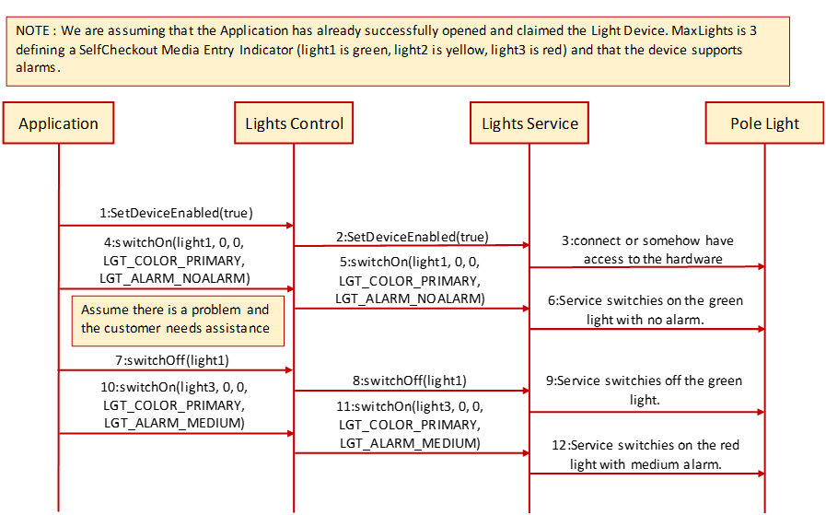

Fig. Chap. 21-3 Lights Sequence Diagram (handling of the pole lights)

## Properties (UML attributes)

**CapAlarm Property**

**Syntax** **CapAlarm: *int32*** **{read-only, access after open}**

**Remarks** This capability indicates if the device supports different alarms.

**CapAlarm** is a logical OR combination of any of the following values:

**Value Meaning**

LGT_ALARM_NOALARM Alarms are not supported.

LGT_ALARM_SLOW Supports a slow beep.

LGT_ALARM_MEDIUM Supports a medium beep.

LGT_ALARM_FAST Supports a fast beep.

LGT_ALARM_CUSTOM1 Supports 1st custom alarm.

LGT_ALARM_CUSTOM2 Supports 2nd custom alarm.

This property is initialized by the **open** method. If the device does not support alarms, it is initialized to LGT_ALARM_NOALARM.

**Errors** A UposException may be thrown when this property is accessed. For further information, see **“Errors"** on page Intro-20.

**CapBlink Property**

**Syntax** **CapBlink: *boolean*** **{read-only, access after open}**

**Remarks** If true, a blinking capability is supported. It may be either a physical capability of the device or emulated by the service.

This property is initialized by the **open** method.

**Errors** A UposException may be thrown when this property is accessed. For further information, see **“Errors"** on page Intro-20.

**CapColor Property**

**Syntax** **CapColor: *int32*** **{read-only, access after open}**

**Remarks** This capability indicates if the device supports different colors.

**CapColor** is a logical OR combination of any of the following values:

**Value Meaning**

LGT_COLOR_PRIMARY Supports Primary Color (Usually Green).

LGT_COLOR_CUSTOM1 Supports 1st Custom Color (Usually Red).

LGT_COLOR_CUSTOM2 Supports 2nd Custom Color (Usually Yellow).

LGT_COLOR_CUSTOM3 Supports 3rd Custom Color.

LGT_COLOR_CUSTOM4 Supports 4th Custom Color.

LGT_COLOR_CUSTOM5 Supports 5th Custom Color.

This property is initialized by the **open** method. If the device supports only one color, it is initialized to LGT_COLOR_PRIMARY.

**Errors** A UposException may be thrown when this property is accessed. For further information, see **“Errors"** on page Intro-20.

**CapFullColor Property　　  *Added in Release 1.16***

**Syntax** **CapColor: *boolean*** **{read-only, access after open}**

**Remarks** If true, the application can set **FullColor** property to true and specify full color.

If false, the application cannot specify full color.

This property is initialized by the **open** method.

**Errors** A UposException may be thrown when this property is accessed. For further information, see **“Errors"** on page Intro-20.

**See Also FullColor** Property, **switchOn** Method, **switchOnMultiple** Method.

**CapPattern Property *Added in Release 1.16***

**Syntax** **CapColor: *int32*** **{read-only, access after open}**

**Remarks** This capability indicates if the device supports different lighting patterns.

**CapPattern** is a logical OR combination of any of the following values:

**Value Meaning**

LGT_PATTERN_NOPATTERN Lighting patterns are not supported.

LGT_ PATTERN _CUSTOM 1~32 Supports 1st to 32th Lighting Pattern.

This property is initialized by the **open** method. If the device does not support lighting pattern, it is initialized to LGT_PATTERN_NOPATTERN.

**Errors** A UposException may be thrown when this property is accessed. For further information, see **“Errors"** on page Intro-20.

**See Also switchOnPattern** Method.

**FullColor Property *Added in Release 1.16***

**Syntax** **FullColor: *boolean*** **{read-write, access after open}**

**Remarks** Holds the format of the value to specify for the *Color* parameter of **SwitchOn** method and **SwitchOnMultiple** method.

If true, the *Color* parameter format is full color of 0xRRGGBB format.

If false, the *Color* parameter format is one of the colors defined by **CapColor**.

This property is initialized by the **open** method.

**Errors** A UposException may be thrown when this property is accessed. For further information, see **“Errors"** on page Intro-20.

**See Also CapFullColor** Property, **switchOn** Method, **switchOnMultiple** Method.

**MaxLights Property**

**Syntax** **MaxLights: *int32*** **{read-only, access after open}**

**Remarks** **MaxLights** specifies the maximum number of lights that the device can support.

This property is initialized by the **open** method.

**Errors** A UposException may be thrown when this property is accessed. For further information, see **“Errors"** on page Intro-20.

**Methods (UML operations)**

**switchOff Method**

**Syntax switchOff (lightNumber: *int32*):   
 void {raises-exception, use after open, claim, enable}**

**Parameter Description**

*lightNumber* Specifies the light number. Valid light numbers are 1 through **MaxLights**.

**Remarks** Switches off the light specified by *lightNumber*.

**Errors** A UposException may be thrown when this method is invoked. For further information, see **“Errors"** on page Intro-20**.**

A possible value of the exception’s *ErrorCode* property is:

**Value Meaning**

E_ILLEGAL The *lightNumber* parameter exceeds **MaxLights**.

**See Also MaxLights** Property**.**

**switchOffPattern Method**

**Syntax switchOff Pattern ():   
 void {raises-exception, use after open, claim, enable}**

**Remarks** Switches off the pattern lighting.

**Errors** A UposException may be thrown when this method is invoked. For further information, see **“Errors"** on page Intro-20**.**

A possible value of the exception’s *ErrorCode* property is:

**Value Meaning**

E_ILLEGAL Pattern lighting is not executed.

**See Also switchOnPattern** Method.

**switchOn Method *Updated in Release 1.16***

**Syntax switchOn (lightNumber: *int32,* blinkOnCycle: *int32,* blinkOffCycle: *int32,* color: *int32,* alarm: *int32*):   
 void {raises-exception, use after open, claim, enable}**

**Parameter Description**

*lightNumber* Specifies the light number. Valid light numbers are 1 through **MaxLights**.

*blinkOnCycle* A zero (0) value indicates no blink cycle. A positive value indicates the blink on cycle time in milliseconds. Negative values are not allowed.

*blinkOffCycle* A zero (0) value indicates no blink cycle. A positive value indicates the blink off cycle time in milliseconds. Negative values are not allowed.

*color* If **FullColor** is true, specifies the color of the light, must be full color of 0xRRGGBB format.

If **FullColor** is false, specifies the color of the light, must be one of the colors defined by **CapColor**.

*alarm* Specifies the used alarm type, must be one of the alarms defined by **CapAlarm**.

**Remarks** Switches on the light specified by *lightNumber* or let it blink.

If *blinkOnCycle* and *blinkOffCycle* are zero (0) or **CapBlink** is false, then the parameters *blinkOnCycle* and *blinkOffCycle* will be ignored and the light will only be switched on.

If **CapBlink** is true and *blinkOnCycle* and *blinkOffCycle* are positive then the light will blink.

If **CapColor** is LGT_COLOR_PRIMARY the light does not support different colors and *color* is ignored, otherwise **switchOn** will use the color specified by *color*.

If **CapAlarm** is LGT_ALARM_NOALARM the light does not support different alarms and *alarm* is ignored, otherwise **switchOn** will use the alarm specified by *alarm*.

Subsequent calls to **switchOn** will change the blink cycles, the color or the alarm type of the light.

**Errors** A UposException may be thrown when this method is invoked. For further information, see **“Errors"** on page Intro-20**.**

A possible value of the exception’s *ErrorCode* property is:

**Value Meaning**

E_ILLEGAL The *lightNumber* parameter exceeds **MaxLights**, an invalid *color* or *alarm* was specified.

**See Also** **CapAlarm** Property, **CapBlink** Property, **CapColor** Property, **FullColor** Property, **MaxLights** Property**.**

**switchOnMultiple Method** ***Added in Release 1.16***

**Syntax switchOnMultiple (lightNumbers: *string,* blinkOnCycle: *int32,* blinkOffCycle: *int32,* color: *int32,* alarm: *int32*):   
 void {raises-exception, use after open, claim, enable}**

**Parameter Description**

*lightNumbers* Specifies the comma-delimited list of light number. Valid light numbers are 1 through **MaxLights**.

*blinkOnCycle* A zero (0) value indicates no blink cycle. A positive value indicates the blink on cycle time in milliseconds. Negative values are not allowed.

*blinkOffCycle* A zero (0) value indicates no blink cycle. A positive value indicates the blink off cycle time in milliseconds. Negative values are not allowed.

*color* If **FullColor** is true, specifies the color of the light, must be full color of 0xRRGGBB format.

If **FullColor** is false, specifies the color of the light, must be one of the colors defined by **CapColor**.

*alarm* Specifies the used alarm type, must be one of the alarms defined by **CapAlarm**.

**Remarks** Switches on the multiple lights specified by *lightNumbers* or let it blink.

If *blinkOnCycle* and *blinkOffCycle* are zero (0) or **CapBlink** is false, then the parameters *blinkOnCycle* and *blinkOffCycle* will be ignored and the light will only be switched on.

If **CapBlink** is true and *blinkOnCycle* and *blinkOffCycle* are positive then the light will blink.

If **CapColor** is LGT_COLOR_PRIMARY the light does not support different colors and *color* is ignored, otherwise **switchOnMultiple** will use the color specified by *color*.

If **CapAlarm** is LGT_ALARM_NOALARM the light does not support different alarms and *alarm* is ignored, otherwise **switchOnMultiple** will use the alarm specified by *alarm*.

**Errors** A UposException may be thrown when this method is invoked. For further information, see **“Errors"** on page Intro-20**.**

A possible value of the exception’s *ErrorCode* property is:

**Value Meaning**

E_ILLEGAL The *lightNumbers* parameter exceeds **MaxLights**, an invalid value was specified.

**See Also CapAlarm** Property, **CapBlink** Property, **CapColor** Property, **FullColor** Property, **MaxLights** Property**.**

**switchOnPattern Method** ***Added in Release 1.16***

**Syntax switchOnPattern (pattern: *int32,* alarm: *int32*):   
 void {raises-exception, use after open, claim, enable}**

**Parameter Description**

*pattern* Specifies the lighting pattern, must be one of the pattern defined by **CapPattern**.

*alarm* Specifies the used alarm type, must be one of the alarms defined by **CapAlarm**.

**Remarks** Switches on the light specified by *pattern*.

If **CapAlarm** is LGT_ALARM_NOALARM the light does not support different alarms and *alarm* is ignored, otherwise **switchOn** and **swithOnPattern** will use the alarm specified by *alarm*.

**Errors** A UposException may be thrown when this method is invoked. For further information, see **“Errors"** on page Intro-20**.**

A possible value of the exception’s *ErrorCode* property is:

**Value Meaning**

E_ILLEGAL An invalid value was specified, or unsupported operation with the Device.

**See Also CapAlarm** Property, **CapPattern** Property**.**

**Events (UML interfaces)**

**DirectIOEvent**

**<< event >> upos::events::DirectIOEvent  
EventNumber: *int32* {read-only}  
Data: *int32* {read-write}  
Obj: *object*{read-write}**

**Description** Provides Service information directly to the application. This event provides a means for a vendor-specific Lights Service to provide events to the application that are not otherwise supported by the Control.

**Attributes** This event contains the following attributes:

**Attribute Type Description**

*EventNumber int32* Event number whose specific values are assigned by the Service.

*Data int32* Additional numeric data. Specific values vary by the *EventNumber* and the Service. This property is settable.

*Obj* *Object* Additional data whose usage varies by the *EventNumber* and Service. This property is settable.

**Remarks** This event is to be used only for those types of vendor specific functions that are not otherwise described. Use of this event may restrict the application program from being used with other vendor’s Lights devices which may not have any knowledge of the Service’s need for this event.

**See Also** **“Events"** on page Intro-19, **directIO** Method.

**StatusUpdateEvent**

**<< event >> upos::events::StatusUpdateEvent  
 Status: *int32* {read-only}**

**Description** Notifies the application that there is a change in the power status of a light.

**Attributes** This event contains the following attribute:

**Attribute Type Description**

*Status int32* Reports a change in the power status of a light.

***Note that Release 1.3*** added Power State Reporting with additional *Power reporting* **StatusUpdateEvent** *values.*

The Update Firmware capability, added in ***Release 1.9***, added additional *Status* values for communicating the status/progress of an asynchronous update firmware process.

See “**StatusUpdateEvent**” description on page 1-34.

**Remarks** Enqueued when the light detects a power state change.

**See Also** **“Events"** on page Intro-19.

# ＣＨＡＰＴＥＲ 29

## POS Power

This Chapter defines the POS Power device category.

## Summary

|  |  |  |  |  |
| --- | --- | --- | --- | --- |
| **Properties (UML attributes)** |  |  |  |  |
| ***Common*** | ***Type*** | ***Mutability*** | ***Version*** | ***May Use After*** |
| **AutoDisable:** | *boolean* | {read-write} | 1.5 | Not Supported |
| **CapCompareFirmwareVersion:** | *boolean* | {read-only} | 1.9 | open |
| **CapPowerReporting:** | *int32* | {read-only} | 1.3 | open |
| **CapStatisticsReporting:** | *boolean* | {read-only} | 1.8 | open |
| **CapUpdateFirmware:** | *boolean* | {read-only} | 1.9 | open |
| **CapUpdateStatistics:** | *boolean* | {read-only} | 1.8 | open |
| **CheckHealthText:** | *string* | {read-only} | 1.5 | open |
| **Claimed:** | *boolean* | {read-only | 1.5 | open |
| **DataCount:** | *int32* | {read-only} | 1.5 | Not Supported |
| **DataEventEnabled:** | *boolean* | {read-write} | 1.5 | Not Supported |
| **DeviceEnabled:** | *boolean* | {read-write} | 1.5 | open, claim |
| **FreezeEvents:** | *boolean* | {read-write} | 1.5 | open |
| **OutputID:** | *int32* | {read-only} | 1.5 | Not Supported |
| **PowerNotify:** | *int32* | {read-write} | 1.5 | open |
| **PowerState:** | *int32* | {read-only} | 1.5 | open |
| **State:** | *int32* | {read-only} | 1.5 | -- |
| **DeviceControlDescription:** | *string* | {read-only} | 1.5 | -- |
| **DeviceControlVersion:** | *int32* | {read-only} | 1.5 | -- |
| **DeviceServiceDescription:** | *string* | {read-only} | 1.5 | open |
| **DeviceServiceVersion:** | *int32* | {read-only} | 1.5 | open |
| **PhysicalDeviceDescription:** | *string* | {read-only} | 1.5 | open |
| **PhysicalDeviceName:** | *string* | {read-only} | 1.5 | open |

|  |  |  |  |  |
| --- | --- | --- | --- | --- |
| **Properties (Continued)** |  |  |  |  |
| ***Specific*** | ***Type*** | ***Mutability*** | ***Version*** | ***May Use After*** |
| **BatteryCapacityRemaining:** | *int32* | {read-only} | 1.9 | open |
| **BatteryCriticallyLowThreshold:** | *int32* | {read-write} | 1.9 | open |
| **BatteryLowThreshold:** | *int32* | {read-write} | 1.9 | open |
| **CapBatteryCapacityRemaining:** | *boolean* | {read-only} | 1.9 | open |
| **CapChargeTime:** | *boolean* | {read-only} | 1.16 | open |
| **CapFanAlarm:** | *boolean* | {read-only} | 1.5 | open |
| **CapHeatAlarm:** | *boolean* | {read-only} | 1.5 | open |
| **CapQuickCharge:** | *boolean* | {read-only} | 1.5 | open |
| **CapRestartPOS:** | *boolean* | {read-only} | 1.9 | open |
| **CapShutdownPOS**: | *boolean* | {read-only} | 1.5 | open |
| **CapStandbyPOS:** | *boolean* | {read-only} | 1.9 | open |
| **CapSuspendPOS:** | *boolean* | {read-only} | 1.9 | open |
| **CapTimeMode:** | *boolean* | {read-only} | 1.16 | open |
| **CapUPSChargeState:** | *int32* | {read-only} | 1.5 | open |
| **CapVariableBatteryCriticallyLowThreshold:** | *boolean* | {read-only} | 1.9 | open |
| **CapVariableBatteryLowThreshold:** | *boolean* | {read-only} | 1.9 | open |
| **ChargeTime:** | *int32* | {read-only} | 1.16 | open |
| **EnforcedShutdownDelayTime:** | *int32* | {read-write} | 1.5 | open |
| **PowerFailDelayTime:** | *int32* | {read-only} | 1.5 | open |
| **PowerSource:** | *int32* | {read-only} | 1.9 | open |
| **QuickChargeMode:** | *boolean* | {read-only} | 1.5 | open |
| **QuickChargeTime:** | *int32* | {read-only} | 1.5 | open |
| **TimeMode:** | *boolean* | {read-write} | 1.16 | open |
| **UPSChargeState:** | *int32* | {read-only} | 1.5 | open, claim & enable |

|  |  |
| --- | --- |
| **Methods (UML operations)** |  |
| ***Common*** |  |
| ***Name*** | ***Version*** |
| **open (logicalDeviceName:** *string***): void {raises-exception}** | 1.5 |
| **close ( ): void {raises-exception, use after open}** | 1.5 |
| **claim (timeout:** *int32* **): void {raises-exception, use after open}** | 1.5 |
| **release ( ): void {raises-exception, use after open, claim}** | 1.5 |
| **checkHealth (level:** *int32***): void {raises-exception, use after open, enable}** | 1.5 |
| **clearInput ( ): void { }** | ***Not supported*** |
| **clearInputProperties ( ): void { }** | ***Not supported*** |
| **clearOutput ( ): void { }** | ***Not supported*** |
| **directIO (command:** *int32****,* inout data:** *int32****,* inout obj:** *object***): void {raises-exception, use after open}** | 1.5 |
| **compareFirmwareVersion (firmwareFileName:** *string*, **out** **result:** *int32***): void {raises-exception, use after open, claim, enable}** | 1.9 |
| **resetStatistics (statisticsBuffer:** *string***): void {raises-exception, use after open, claim, enable}** | 1.8 |
| **retrieveStatistics (inout statisticsBuffer:** *string***): void {raises-exception, use after open, claim, enable}** | 1.8 |
| **updateFirmware (firmwareFileName:** *string***): void {raises-exception, use after open, claim, enable}** | 1.9 |
| **updateStatistics (statisticsBuffer:** *string***):** **void {raises-exception, use after open, claim, enable}** | 1.8 |
| ***Specific*** |  |
| ***Name*** |  |
| **restartPOS ( ):  void {raises-exception, use after open, enable}** | 1.9 |
| **shutdownPOS ( ):  void {raises-exception, use after open, enable}** | 1.5 |
| **standbyPOS (reason: int32 ):  void {raises-exception, use after open, enable}** | 1.9 |
| **suspendPOS (reason: int32 ):  void {raises-exception, use after open, enable}** | 1.9 |

|  |  |  |  |
| --- | --- | --- | --- |
| **Events (UML interfaces)** |  |  |  |
| ***Name*** | ***Type*** | ***Mutability*** | ***Version*** |
|  |  |  |  |
| **upos::events::DataEvent** |  | ***Not Supported*** |  |
|  |  |  |  |
| **upos::events::DirectIOEvent** |  |  | 1.5 |
| **EventNumber:** | ***int32*** | {read-only} |  |
| **Data:** | ***int32*** | {read-write} |  |
| **Obj:** | ***object*** | {read-write} |  |
|  |  |  |  |
| **upos::events::ErrorEvent** |  | ***Not Supported*** |  |
|  |  |  |  |
| **upos::events::OutputCompleteEvent** |  | ***Not Supported*** |  |
|  |  |  |  |
| **upos::events::StatusUpdateEvent** |  |  | 1.5 |
| **Status:** | ***int32*** | {read-only} |  |
|  |  |  |  |

**General Information**

The POS Power programmatic name is “POSPower”.

### Capabilities

The POSPower device class has the following capabilities:

* Supports a command to “shut down” the system.
* Supports a command to restart the system.
* Supports a command to “suspend” the system.
* Supports a command to have the system go to standby.
* Supports accessing a power handling mechanism of the underlying operating system and hardware.
* Informs the application if a power fail situation has occurred.
* Informs the application about battery level.
* Informs the application if the UPS charge state has changed.
* Informs the application about high CPU temperature.
* Informs the application about stopped CPU fan.
* Informs the application if an operating system dependent enforced shutdown mechanism is processed.
* Allows the application after saving application data locally or transferring application data to a server to shut down the POS terminal.
* Informs the application about an initiated shutdown.

**Device Sharing**

The POSPower is a sharable device. Its device sharing rules are:

* After opening and enabling the device, the application may access all properties and methods and will receive status update events.
* If more than one application has opened and enabled the device, all applications may access its properties and methods. Status update events are fired to all of the applications.
* If one application claims the POSPower, then only that application may call the **shutdownPOS, standbyPOS, or suspendPOS** methods. This feature provides a degree of security, such that these methods may effectively be restricted to the main POS application if that application claims the device at startup.
* See the “Summary” table for precise usage prerequisites.

**Model**

The general model of POSPower is based on the power model of each device in version 1.3 or later. The same common properties are used but all states relate to the POS terminal itself and not to a peripheral device.

There are three states of the POSPower:

* ONLINE. The POS terminal is powered on and ready for use. This is the “operational” state.
* OFF. The POS terminal is powered off or detached from the power supplying net. The POS terminal runs on battery power support. This is the powerfail situation.
* OFFLINE. The POS terminal is powered on but is running in a “lower-power-consumption” mode. It may need to be placed online by pressing a button or key or something else which may wake up the system.

Power reporting only occurs while the device is open, enabled and power notification is switched on.

In a powerfail situation - that means the POSPower is in the state OFF - the POS terminal will be shut down automatically after the last application has closed the POSPower device or the time specified by the **EnforcedShutdownDelayTime** property has been elapsed.

A call to the **shutdownPOS** method will always shut down the POS terminal independent of the system power state.

**Version 1.9 or later**

Support of battery powered devices is added. In addition to adding properties to report battery levels and power sources, properties are added to allow for the setting of low and critically low battery levels. The POSPower device also includes the ability to request or respond to request to enter the standby and suspend states. The model does not attempt to duplicate other power management models such as APM and ACPI, but leaves those implementation details to the provider. As a rule, the suspend state will consume less power than the standby state, which in turn will consume less power than the on state. A suggested mapping of these states to other power management models is:

|  |  |  |  |
| --- | --- | --- | --- |
| ***State*** | ***ACPI*** | ***APM*** | ***Description*** |
| On | S0 | ON | Active, Powered On |
| Standby | S1 | SUSPEND | Displays and drives off, CPU, RAM and fans powered on |
| Suspend | S3 | SUSPEND | Only RAM powered |
| Off | S5 | OFF | Completely powered off |

### POSPower Class Diagram

***Updated in Release 1.16***

The following diagram shows the relationships between the POSPower classes.

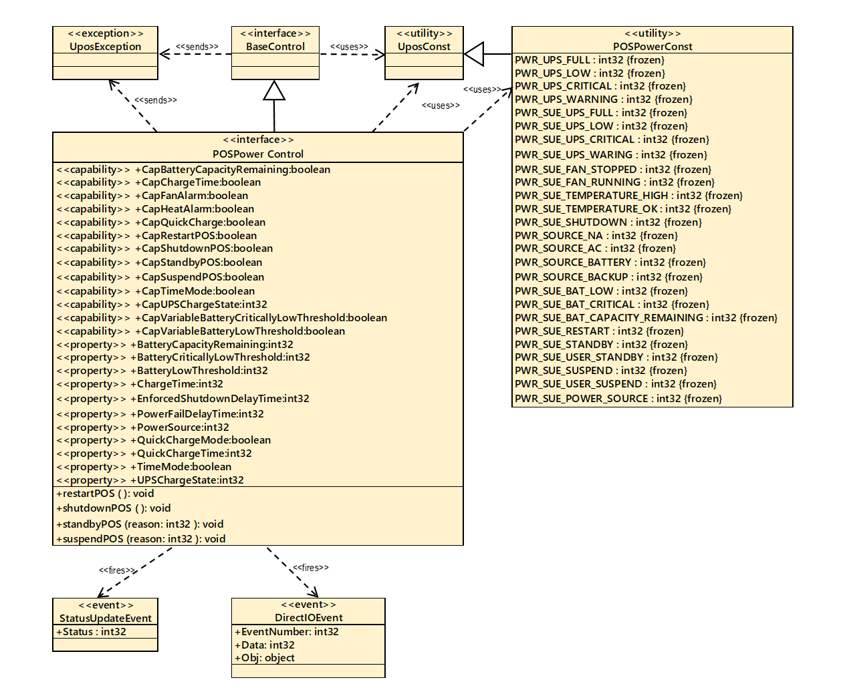

Fig. Chap.29-1 POSPower Class Diagram

### POSPower Sequence Diagram

The following sequence diagram shows the typical usage of the POSPower device for registering for **StatusUpdateEvent**s and an atypical case of initiating a **shutdownPOS** call.

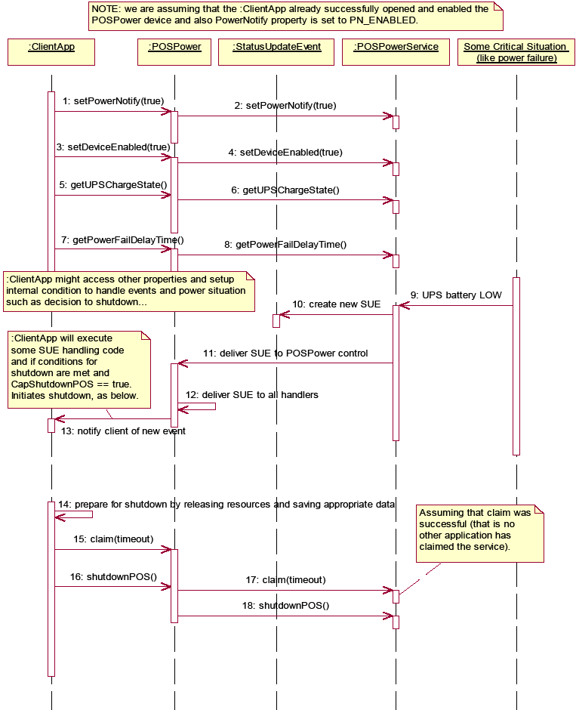

Fig. Chap. 29-2 POSPower Sequence Diagram

### POSPower Standby Sequence Diagram

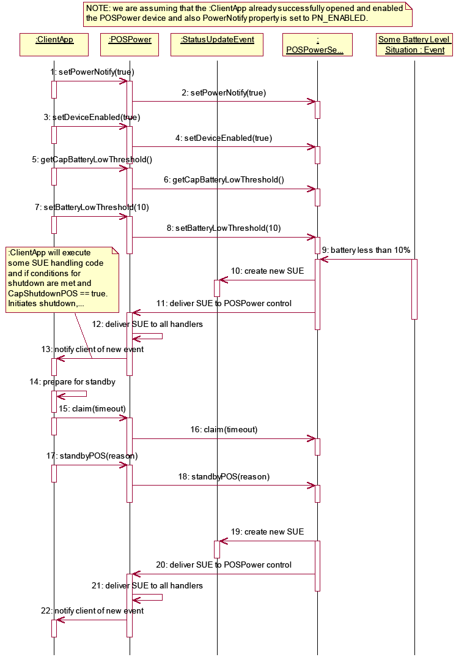

　　　　　　 Fig. Chap. 29-3 POSPower Standby Sequence Diagram

**POSPower State Diagram**

The following state diagram depicts the POSPower Control device model.

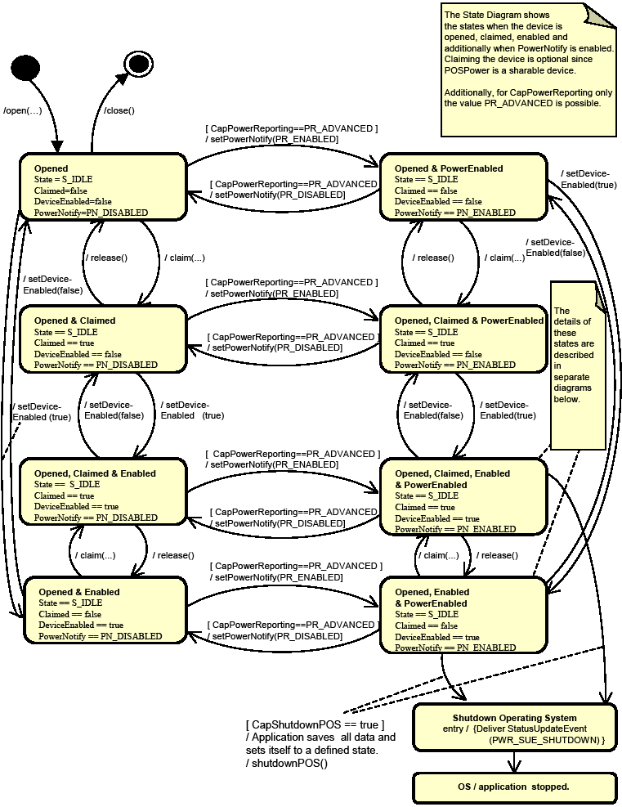

Fig. Chap. 29-4 Power State Diagram (POSPoer Control Device Model)

**POSPower PowerState Diagram - Part 1**

The following state diagram depicts the POSPower Power States.

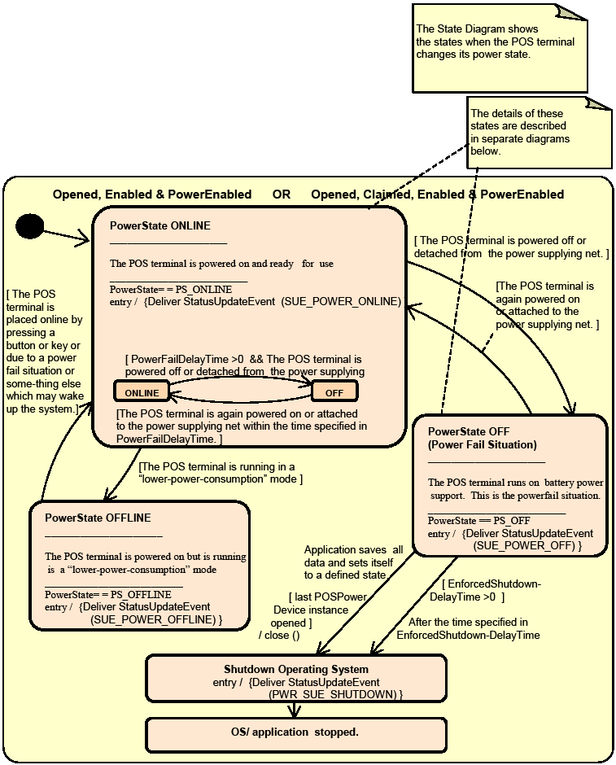

Fig. Chap. 29-5 POSPower PowerState Diagram (Part 1)

### POSPower PowerState Diagram - Part 2

The following state diagram depicts the POSPower PowerState ONLINE.

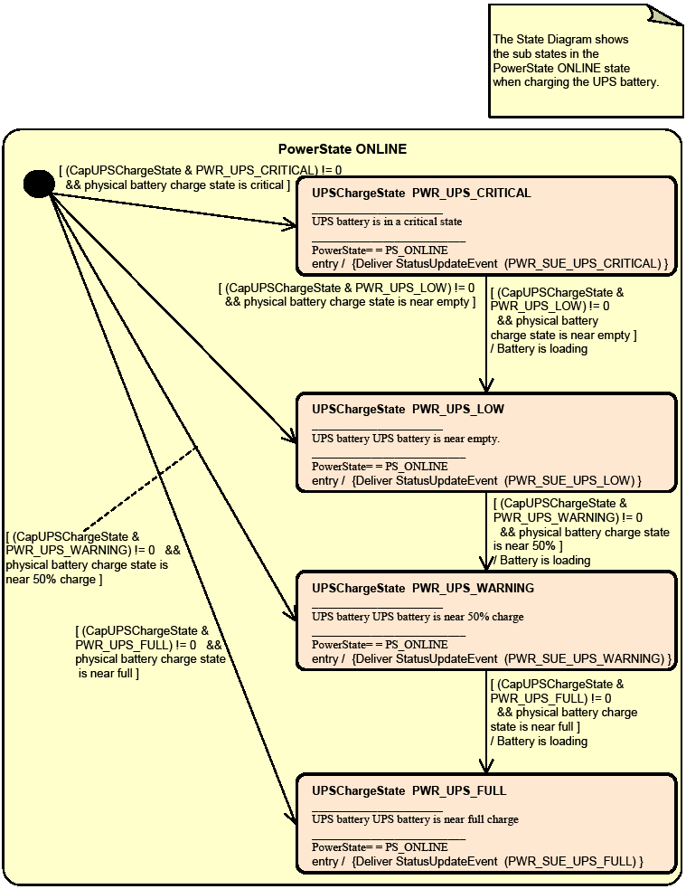

Fig. Chap. 29-6 POSPower PowerState Diagram (Part 2)

### POSPower PowerState Diagram - Part 3

The following state diagram depicts the POSPower PowerState OFF.

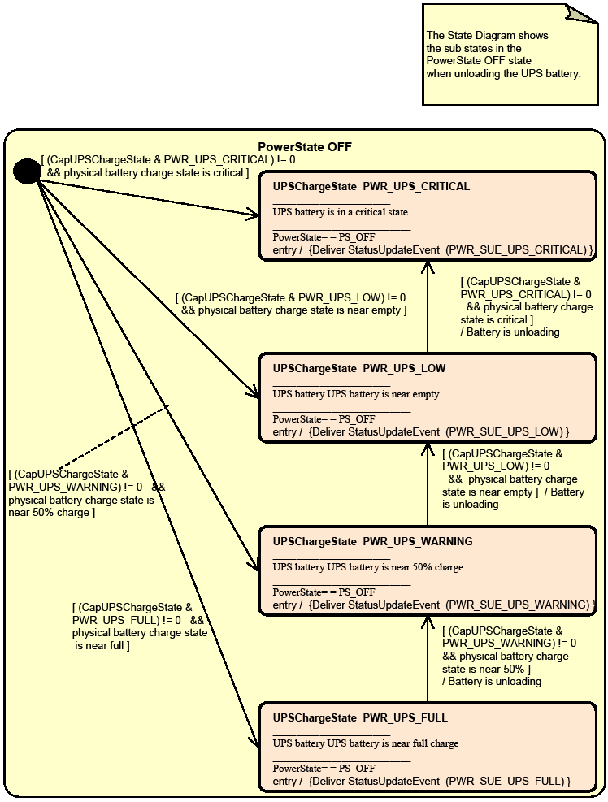

Fig. Chap. 29-7 POSPower PowerState Diagram (Part 3)

### POSPower State Chart Diagram for Fan and Temperature

The following state diagram depicts the handling of fan and temperature alarms.

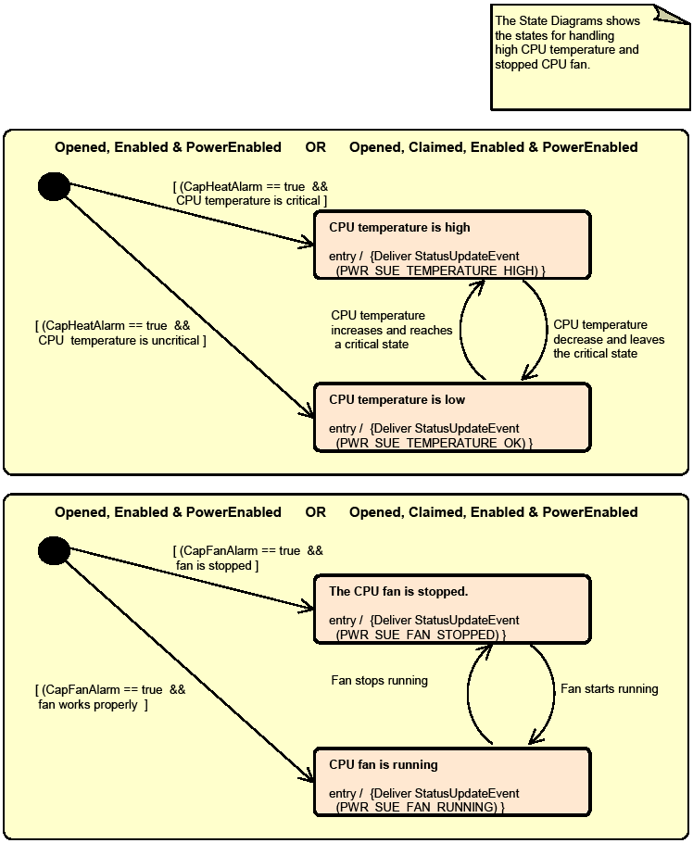

Fig. Chap. 29-8 POSPower State Chart Diagram (Fan and Temperature)

### POSPower Battery State Diagram

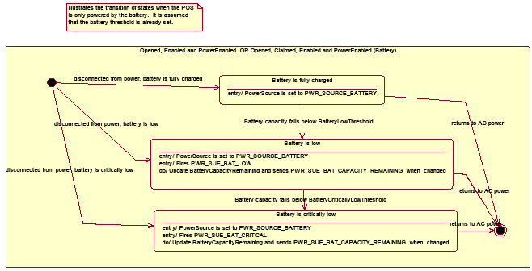

Fig. Chap. 29-9 POSPower Battery State Diagram

### POSPower Power Transitions State Diagram

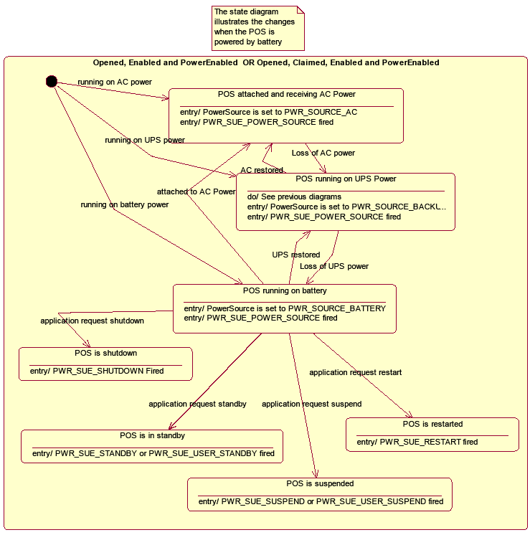

Fig. Chap. 29-10 POSPower Power Transitions State Diagram

## Properties (UML attributes)

**BatteryCapacityRemaining Property**

**Syntax BatteryCapacityRemaining: *int32* {read-only, access after open}**

**Remarks** A value of 0 to 100 represents percent of battery capacity remaining.

This property is initialized by the **open** method.

**Errors** A UposException may be thrown when this property is accessed. For further information, see **“Errors"** on page Intro-20.

**See Also** **CapBatteryCapacityRemaining** Property

**BatteryCriticallyLowThreshold Property**

**Syntax BatteryCriticallyLowThreshold: *int32* {read-write, access after open}**

**Remarks** If not zero, this property holds the threshold at which a **PWR_SUE_BAT_CRITICAL** Status Update Event is generated. The values 1 through 99 represent the percentage of the capacity remaining. The value 0 indicates that Battery Critically Low reporting is not supported or is disabled.

This property is initialized by the **open** method.

**Errors** A UposException may be thrown when this property is accessed. For further information, see **“Errors"** on page Intro-20.

**See Also** **CapVariableBatteryCriticallyLowThreshold** Property**, StatusUpdateEvent**

**BatteryLowThreshold Property**

**Syntax BatteryLowThreshold: *int32* {read-write, access after open}**

**Remarks** If not zero, this property holds the threshold at which a **PWR_SUE_BAT_LOW** Status Update Event is generated. The value 1 to 99 represents the percent capacity remaining. The value 0 indicates that battery low reporting is not supported or is disabled. If variable battery low threshold is supported, setting a value between 1 and 99 sets the threshold to that value. Setting a value of zero disables battery low reporting.

This property is initialized by the **open** method.

**Errors** A UposException may be thrown when this property is accessed. For further information, see **“Errors"** on page Intro-20.

**See Also** **CapVariableBatteryLowThreshold** Property**, StatusUpdateEvent**

**CapBatteryCapacityRemaining Property**

**Syntax CapBatteryCapacityRemaining: *boolean* {read-only, access after open}**

**Remarks** If true, the device is able to provide battery capacity information. Otherwise it is false.

This property is initialized by the **open** method.

**Errors** A UposException may be thrown when this property is accessed. For further information, see **“Errors"** on page Intro-20.

**See Also** **BatteryCapacityRemaining** Property

**CapChargeTime Property  *Added in Release 1.16***

**Syntax CapChargeTime: *boolean* {read-only, access after open}**

**Remarks** If true, the device is able to acquire the remaining time until full charging. Otherwise it is false.

This property is initialized by the **open** method.

**Errors** A UposException may be thrown when this property is accessed. For further information, see **“Errors"** on page Intro-20.

**See Also** **ChargeTime** Property.

**CapFanAlarm Property**

**Syntax CapFanAlarm: *boolean* {read-only, access after open}**

**Remarks** If true, the device is able to detect whether the CPU fan is stopped. Otherwise it is false.

This property is initialized by the **open** method.

**Errors** A UposException may be thrown when this property is accessed. For further information, see **“Errors"** on page Intro-20.

**CapHeatAlarm Property**

**Syntax CapHeatAlarm: *boolean* {read-only, access after open}**

**Remarks** If true the device is able to detect whether the CPU is running at too high of a temperature. Otherwise it is false.

This property is initialized by the **open** method.

**Errors** A UposException may be thrown when this property is accessed. For further information, see **“Errors"** on page Intro-20.

**CapQuickCharge Property**

**Syntax CapQuickCharge: *boolean* {read-only, access after open}**

**Remarks** If true, the power management allows the charging of the UPS battery in quick mode. The time for charging the battery is shorter than usual. Otherwise it is false.

This property is initialized by the **open** method.

**Errors** A UposException may be thrown when this property is accessed. For further information, see **“Errors"** on page Intro-20.

**See Also** **QuickChargeMode** Property, **QuickChargeTime** Property.

**CapRestartPOS Property**

**Syntax CapRestartPOS: *boolean* {read-only, access after open}**

**Remarks** If true the device is able to explicitly restart the POS. Otherwise it is false.

This property is initialized by the **open** method.

**Errors** A UposException may be thrown when this property is accessed. For further information, see **“Errors"** on page Intro-20.

**See Also** **restartPOS** Method.

**CapShutdownPOS Property**

**Syntax CapShutdownPOS: *boolean* {read-only, access after open}**

**Remarks** If true the device is able to explicitly shut down the POS. Otherwise it is false.

This property is initialized by the **open** method.

**Errors** A UposException may be thrown when this property is accessed. For further information, see **“Errors"** on page Intro-20.

**See Also** **shutdownPOS** Method.

**CapStandbyPOS Property**

**Syntax CapStandbyPOS: *boolean* {read-only, access after open}**

**Remarks** If true, the device is able to request that the POS System enter the Standby state. Otherwise it is false.

This property is initialized by the **open** method.

**Errors** A UposException may be thrown when this property is accessed. For further information, see **“Errors"** on page Intro-20.

**See Also** **standbyPOS** Method.

**CapSuspendPOS Property**

**Syntax CapSuspendPOS: *boolean* {read-only, access after open}**

**Remarks** If true, the device is able to request that the POS System enter the Suspend state. Otherwise it is false.

This property is initialized by the **open** method.

**Errors** A UposException may be thrown when this property is accessed. For further information, see **“Errors"** on page Intro-20.

**See Also** **suspendPOS** Method.

**CapTimeMode Property  *Added in Release 1.16***

**Syntax CapTimeMode: *boolean* {read-only, access after open}**

**Remarks** If true the device is able to switch the unit of battery remaining / threshold related property value to seconds. Otherwise it is false.　　　　　　　　　　This property is initialized by the **open** method.

**Errors** A UposException may be thrown when this property is accessed. For further information, see **“Errors"** on page Intro-20.

**See Also** **TimeMode** Property

**CapUPSChargeState Property**

**Syntax CapUPSChargeState: *int32* {read-only, access after open}**

**Remarks** If not equal to zero, the UPS can deliver one or more charge states. It can contain any of the following values logically ORed together.

**Value Meaning**

PWR_UPS_FULL UPS battery is near full charge.

PWR_UPS_WARNING UPS battery is near 50% charge.

PWR_UPS_LOW UPS battery is near empty. Application shutdown should be started to ensure that is can be completed before the battery charge is depleted. A minimum of 2 minutes of normal system operation can be assumed when this state is entered unless this is the　first state reported upon entering the “Off” power state.

PWR_UPS_CRITICAL UPS battery is in a critical state and could be disconnected at any time without further warning. This property is initialized by the **open** method.

**Errors** A UposException may be thrown when this property is accessed. For further information, see **“Errors"** on page Intro-20.

**See Also** **UPSChargeState** Property.

**CapVariableBatteryCriticallyLowThreshold Property**

**Syntax CapVariableBatteryCriticallyLowThreshold: *boolean* {read-only, access after open}**

**Remarks** If true, the device supports a variable threshold for critically low battery. Otherwise it is false.

This property is initialized by the **open** method.

**Errors** A UposException may be thrown when this property is accessed. For further information, see **“Errors"** on page Intro-20.

**See Also** **BatteryCriticallyLowThreshold** Property**, StatusUpdateEvent**

**CapVariableBatteryLowThreshold Property**

**Syntax CapVariableBatteryLowThreshold: *boolean* {read-only, access after open}**

**Remarks** If true, the device supports a variable threshold for battery low. Otherwise it is false.

This property is initialized by the **open** method.

**Errors** A UposException may be thrown when this property is accessed. For further information, see **“Errors"** on page Intro-20.

**See Also** **BatteryLowThreshold** Property**, StatusUpdateEvent**

**ChargeTime Property  *Added in Release 1.16***

**Syntax ChargeTime: *int32* {read-only, access after open}**

**Remarks** Indicates the time remaining until the battery is fully charged in seconds.

If equal to zero the battery is not charging or not supported.

This property is only set if **CapChargeTime** is true.

This property is initialized by the **open** method.

**Errors** A UposException may be thrown when this property is accessed. For further information, see **“Errors"** on page Intro-20.

**See Also** **CapChargeTime** Property.

**EnforcedShutdownDelayTime Property**

**Syntax EnforcedShutdownDelayTime: *int32* {read-write, access after open}**

**Remarks** If not equal to zero the system has a built-in mechanism to shut down the POS　terminal after a determined time in a power fail situation. This property contains the time in milliseconds when the system will shut down automatically after a power failure. A power failure is the situation when the POS terminal is powered off or detached from the power supplying net and runs on UPS.   
If zero no automatic shutdown is performed and the application has to call itself the **shutdownPOS** method. 　　　Applications will be informed about an initiated automatic shutdown**.**This property is initialized by the **open** method.

**Errors** A UposException may be thrown when this property is accessed. For further information, see **“Errors"** on page Intro-20.

**See Also** **shutdownPOS** Method.

**PowerFailDelayTime Property**

**Syntax PowerFailDelayTime: *int32* {read-only, access after open}**

**Remarks** This property contains the time in milliseconds for power fail intervals which will not create a power fail situation. In some countries the power has sometimes short intervals where the power supply is interrupted. Those short intervals are in the range of milliseconds up to a few seconds and are handled by batteries or other electric equipment and should not cause a power fail situation. The power fail interval starts when the POS terminal is powered off or detached from the power supplying net and runs on UPS. The power fail interval ends when the POS terminal is again powered on or attached to the power supplying net. However, if the power fail interval is longer than the time specified in the **PowerFailDelayTime** property a power fail situation is created.

Usually this parameter is a configuration parameter of the underlying power management. So, the application can only read this property.

This property is initialized by the **open** method.

**Errors** A UposException may be thrown when this property is accessed. For further information, see **“Errors"** on page Intro-20.

**PowerSource Property**

**Syntax PowerSource: *int32* {read-only, access after open}**

**Remarks** This property holds the current power source if power source reporting is available. A StatusUpdateEvent is generated each time this property is updated.

**Value Meaning**

PWR_SOURCE_NA Power source reporting is not available.

PWR_SOURCE_AC The current power source is the AC line.

PWR_SOURCE_BATTERY The current power source is a system battery. This value is only presented for systems that operate normally on battery.

PWR_SOURCE_BACKUP The current power source is a backup source such as an UPS or backup battery.

This property is initialized by the **open** method.

**Errors** A UposException may be thrown when this property is accessed. For further information, see **“Errors"** on page Intro-20.

**See Also** **StatusUpdateEvent**

**QuickChargeMode Property**

**Syntax QuickChargeMode: *boolean* {read-only, access after open}**

**Remarks** If true, the UPS battery is being recharged in a quick charge mode.  
If false, it is being charged in a normal mode.

This property is only set if **CapQuickCharge** is true.

**Errors** A UposException may be thrown when this property is accessed. For further information, see **“Errors"** on page Intro-20.

**See Also** **CapQuickCharge** Property, **QuickChargeTime** Property.

**QuickChargeTime Property**

**Syntax QuickChargeTime: *int32* {read-only, access after open}**

**Remarks** This time specifies the remaining time for charging the UPS battery in quick charge mode. After the time has elapsed, the UPS battery charging mechanism of power management usually switches into normal mode.

This time is specified in milliseconds.

This property is only set if **CapQuickCharge** is true.

**Errors** A UposException may be thrown when this property is accessed. For further information, see **“Errors"** on page Intro-20.

**See Also** **CapQuickCharge** Property, **QuickChargeTime** Property.

**TimeMode Property *Added in Release 1.16***

**Syntax UPSChargeState: *boolean* {read-write, access after open}**

**Remarks** If true, the value of the battery remaining / threshold related property is in seconds.

If false, the value of the battery remaining / threshold related property is in percent.

This property is initialized by the **open** method.

**Errors** A UposException may be thrown when this property is accessed. For further information, see **“Errors"** on page Intro-20

**See Also** **CapTimeMode** Property, **BatteryCapacityRemaining** Property, **BatteryCriticallyLowThreshold** Property, **BatteryLowThreshold** Property.

**UPSChargeState Property**

**Syntax UPSChargeState: *int32* {read-only, access after open, enable}**

**Remarks** This property holds the actual UPS charge state.

It has one of the following values:

**Value Meaning**

PWR_UPS_FULL UPS battery is near full charge.

PWR_UPS_WARNING UPS battery is near 50% charge.

PWR_UPS_LOW UPS battery is near empty. Application shutdown should be started to ensure that is can be completed before the battery charge is depleted. A minimum of 2 minutes of normal system operation can be assumed when this state is entered unless this is the first state reported upon entering the “Off” power state.

PWR_UPS_CRITICAL UPS battery is in a critical state and could be disconnected at any time without further warning.

This property is initialized and kept current while the device is enabled.

**Errors** A UposException may be thrown when this property is accessed. For further information, see **“Errors"** on page Intro-20

**See Also** **CapUPSChargeState** Property.

## Methods (UML operations)

**restartPOS Method**

**Syntax restartPOS ( ):   
void{raises-exception, use after open, enable}**

**Remarks** Call to restart the POS terminal. This method will always restart the system independent of the system power state.

If the POSPower is claimed, only the application which claimed the device is able to restart the POS terminal.

Applications will be informed about an initiated restart.

**Errors** A UposException may be thrown when this method is invoked. For further information, see **“Errors"** on page Intro-20

Some possible values of the exception’s *ErrorCode* property are:

**Value Meaning**

E_ILLEGAL This method is not supported (see the **CapRestartPOS** property**)**

**See Also** **CapRestartPOS** Property

**shutdownPOS Method**

**Syntax shutdownPOS ( ):   
void{raises-exception, use after open, enable}**

**Remarks** Call to shut down the POS terminal. This method will always shut down the system independent of the system power state.

If the POSPower is claimed, only the application which claimed the device is able to shut down the POS terminal.

Applications will be informed about an initiated shutdown.

It is recommended that in a power fail situation an application has to call this method after saving all data and setting the application to a defined state.  
If the **EnforcedShutdownDelayTime** property specifies a time greater than zero and the application did not call the **shutdownPOS** method within the time specified in **EnforcedShutdownDelayTime**, the system will be shut down automatically. This mechanism may be provided by an underlying operating system to prevent the battery from being emptied before the system is shut down.  
This method is only supported if **CapShutdownPOS** is true.

**Errors** A UposException may be thrown when this method is invoked. For further information, see **“Errors"** on page Intro-20

Some possible values of the exception’s *ErrorCode* property are:

**Value Meaning**

E_ILLEGAL This method is not supported. (See the **CapshutdownPOS** property**)**

**See Also** **CapShutdownPOS** Property, **EnforcedShutdownDelayTime** Property.

**standbyPOS Method**

**Syntax standbyPOS (reason: *int32*):   
void{raises-exception, use after open, enable}**

**Remarks** Call to request that the system be placed into the Standby state or to respond to a request from the system, OS or other application that the system be put into Standby state.

The *reason* parameter indicates the reason the POS terminal should enter a standby state:

**Value Description**

PWR_REASON_REQUEST Call is to request that the system enter the standby state.

PWR_REASON_ALLOW Call is a response to a standby Status Update Event and specifies that the request should be allowed.

PWR_REASON_DENY Call is a response to a standby Status Update Event and specifies that the request should be denied.

**Errors** A UposException may be thrown when this method is invoked. For further information, see **“Errors"** on page Intro-20

Some possible values of the exception’s ***ErrorCode***property are:

**Value Meaning**

E_ILLEGAL This method is not supported (see the **CapStandbyPOS** property**)**

**See Also** **CapStandbyPOS** Property.

**suspendPOS Method**

**Syntax suspendPOS (reason: *int32*):   
void{raises-exception, use after open, enable}**

**Remarks** Call to request that the system be placed into the Suspend state or to respond to a request from the system, OS or other application that the system be put into Suspend state.

The *reason* parameter indicates the reason the POS terminal should enter a standby state:

**Value Description**

PWR_REASON_REQUEST Call is to request that the system enter the suspend state.

PWR_REASON_ALLOW Call is a response to a suspend Status Update Event and specifies that the request should be allowed.

PWR_REASON_DENYCall is a response to a suspend Status Update Event and specifies that the request should be denied.

**Errors** A UposException may be thrown when this method is invoked. For further information, see **“Errors"** on page Intro-20

Some possible values of the exception’s *ErrorCode* property are:

**Value Meaning**

E_ILLEGAL This method is not supported (see the **CapSuspendPOS** property**)**

**See Also** **CapSuspendPOS** Property.

## Events (UML Interfaces)

**DirectIOEvent**

**<< event >> upos::events::DirectIOEvent  
 EventNumber : *int32* {read-only}  
 Data : *int32* {read-write}  
 Obj : *object*{read-write}**

**Description** Provides Service information directly to the application. This event provides a means for a vendor-specific POSPower Service to provide events to the application that are not otherwise supported by the Control.

**Attributes** This event contains the following attributes:

**Attributes Type Description**

*EventNumber* *int32* Event number whose specific values are assigned by the Service.

*Data int32* Additional numeric data. Specific values vary by the *EventNumber* and the Service. This property is settable.

*Obj object* Additional data whose usage varies by the E*ventNumber* and Service. This property is settable.

**Remarks** This event is to be used only for those types of vendor specific functions that are not otherwise described. Use of this event may restrict the application program from being used with other vendor’s POSPower devices which may not have any knowledge of the Service’s need for this event.

**See Also** **“Errors"** on page Intro-20, **directIO** Method.

**StatusUpdateEvent**

**<< event >> upos::events::StatusUpdateEvent  
 Status: *int32* {read-only}**

**Description** Delivered when **UPSChargeState** changes or an alarm situation occurs.

**Attributes** This event contains the following attribute:

**Attributes Type Description**

*Status int32* See below.

The *Status* property contains the updated power status or alarm status.

**Value Meaning**

PWR_SUE_UPS_FULL

UPS battery is near full charge. Can be returned if **CapUPSChargeState** contains PWR_UPS_FULL.

PWR_SUE_UPS_WARNING

UPS battery is near 50% charge. Can be returned if CapUPSChargeState contains PWR_UPS_WARNING.

PWR_SUE_UPS_LOW UPS battery is near empty. Application shutdown should be started to ensure that it can be completed before the battery charge is depleted. A minimum of 2 minutes of normal system operation can be assumed when this state is entered unless this is the first charge state reported upon entering the “Off” state. Can be returned if **CapUPSChargeState** contains PWR_UPS_LOW.

PWR_SUE_UPS_CRITICAL

UPS is in critical state, and will in short time be disconnected. Can be returned if **CapUPSChargeState** contains PWR_UPS_CRITICAL.

PWR_SUE_FAN_STOPPED

The CPU fan is stopped. Can be returned if **CapFanAlarm** is true.

PWR_SUE_FAN_RUNNING

The CPU fan is running. Can be returned if **CapFanAlarm** is true.

PWR_SUE_TEMPERATURE_HIGH

The CPU is running on high temperature. Can be returned if **CapHeatAlarm** is true.

PWR_SUE_TEMPERATURE_OK

The CPU is running on normal temperature. Can be returned if **CapHeatAlarm** is true.

PWR_SUE_SHUTDOWN The system will shut down immediately.

PWR_SUE_BAT_LOW

The system remaining battery capacity is at or below the low battery threshold and the system is operating from the battery.

PWR_SUE_BAT_CRITICAL

The system remaining battery capacity is at or below the critically low battery threshold and the system is operating from the battery.

PWR_SUE_BAT_CAPACITY_REMAINING.

The **BatteryCapacityRemaining** property has been updated

PWR_SUE_RESTART

The system will restart immediately.

PWR_SUE_STANDBY

The system is requesting a transition to the 　　　　**Standby** state

PWR_SUE_USER_STANDBY

The system is requesting a transition to the 　　　　　　**Standby** state as a result of user input.

PWR_SUE_SUSPEND The system is requesting a transition to the **Suspend** state.

PWR_SUE_USER_SUSPEND

The system is requesting a transition to the **Suspend** state as a result of user input.

PWR_SUE_PWR_SOURCE

The **PowerSource** property has been updated.

***Note*** *that* ***Release 1.3*** added Power State Reporting with additional *Power reporting***StatusUpdateEvent** *values.*

The Update Firmware capability, added in ***Release 1.9***, added additional *Status* values for communicating the status/progress of an asynchronous update firmware process. See “**StatusUpdateEvent**” description on page 1-34.

**See Also** **CapFanAlarm** Property, **CapHeatAlarm** Property, **CapUPSChargeState** Property**,** **UPSChargeState** Property.

# ＣＨＡＰＴＥＲ 39

## Video Capture

This Chapter defines the Video Capture device category.

## Summary

|  |  |  |  |  |
| --- | --- | --- | --- | --- |
| **Properties (UML attributes)** |  |  |  |  |
| ***Common*** | ***Type*** | ***Mutability*** | ***Version*** | ***May Use After*** |
| **AutoDisable:** | *boolean* | {read-write} | 1.16 | open |
| **CapCompareFirmwareVersion:** | *boolean* | {read-only} | 1.16 | open |
| **CapPowerReporting:** | *int32* | {read-only} | 1.16 | open |
| **CapStatisticsReporting:** | *boolean* | {read-only} | 1.16 | open |
| **CapUpdateFirmware:** | *boolean* | {read-only} | 1.16 | open |
| **CapUpdateStatistics:** | *boolean* | {read-only} | 1.16 | open |
| **CheckHealthText:** | *string* | {read-only} | 1.16 | open |
| **Claimed:** | *boolean* | {read-only} | 1.16 | open |
| **DataCount:** | *int32* | {read-only} | 1.16 | open |
| **DataEventEnabled:** | *boolean* | {read-write} | 1.16 | open |
| **DeviceEnabled:** | *boolean* | {read-write} | 1.16 | open, claim |
| **FreezeEvents:** | *boolean* | {read-write} | 1.16 | open |
| **OutputID:** | *int32* | {read-only} | 1.16 | Not Supported |
| **PowerNotify:** | *int32* | {read-write} | 1.16 | open |
| **PowerState:** | *int32* | {read-only} | 1.16 | open |
| **State:** | *int32* | {read-only} | 1.16 | -- |
| **DeviceControlDescription:** | *string* | {read-only} | 1.16 | -- |
| **DeviceControlVersion:** | *int32* | {read-only} | 1.16 | -- |
| **DeviceServiceDescription:** | *string* | {read-only} | 1.16 | open |
| **DeviceServiceVersion:** | *int32* | {read-only} | 1.16 | open |
| **PhysicalDeviceDescription:** | *string* | {read-only} | 1.16 | open |
| **PhysicalDeviceName:** | *string* | {read-only} | 1.16 | open |

|  |  |  |  |  |
| --- | --- | --- | --- | --- |
| **Properties (Continued)** |  |  |  |  |
| ***Specific*** | ***Type*** | ***Mutability*** | ***Version*** | ***May Use After*** |
| **CapCameraAutoExposition:** | *boolean* | {read-only} | 1.16 | open |
| **CapCameraAutoFocus:** | *boolean* | {read-only} | 1.16 | open |
| **CapCameraAutoGain:** | *boolean* | {read-only} | 1.16 | open |
| **CapCameraAutoWhiteBalance:** | *boolean* | {read-only} | 1.16 | open |
| **CapCameraBrightness:** | *boolean* | {read-only} | 1.16 | open |
| **CapCameraContrast:** | *boolean* | {read-only} | 1.16 | open |
| **CapCameraExposure:** | *boolean* | {read-only} | 1.16 | open |
| **CapCameraGain:** | *boolean* | {read-only} | 1.16 | open |
| **CapCameraHorizontalFlip:** | *boolean* | {read-only} | 1.16 | open |
| **CapCameraHue:** | *boolean* | {read-only} | 1.16 | open |
| **CapCameraSaturation:** | *boolean* | {read-only} | 1.16 | open |
| **CapCameraVerticalFlip:** | *boolean* | {read-only} | 1.16 | open |
| **CapCapture:** | *boolean* | {read-only} | 1.16 | open |
| **CapCaptureColorSpace:** | *boolean* | {read-only} | 1.16 | open |
| **CapCaptureColorSpaceList:** | *string* | {read-only} | 1.16 | open |
| **CapCaptureFrameRate:** | *boolean* | {read-only} | 1.16 | open |
| **CapCaptureMaxFrameRate:** | *int32* | {read-only} | 1.16 | open |
| **CapCaptureResolution:** | *boolean* | {read-only} | 1.16 | open |
| **CapCaptureResolutionList:** | *string* | {read-only} | 1.16 | open |
| **CapDecodeData:** | *boolean* | {read-only} | 1.16 | open |
| **CapIndividualRecognition:** | *boolean* | {read-only} | 1.16 | open |
| **CapPhotograph:** | *boolean* | {read-only} | 1.16 | open |
| **CapPhotographResolution:** | *boolean* | {read-only} | 1.16 | open |
| **CapPhotographResolutionList** | *string* | {read-only} | 1.16 | open |
| **CapPhotographType:** | *boolean* | {read-only} | 1.16 | open |
| **CapPhotographTypeList:** | *string* | {read-only} | 1.16 | open |
| **CapVideoRecording:** | *boolean* | {read-only} | 1.16 | open |
| **CapVideoRecordingFrameRate:** | *boolean* | {read-only} | 1.16 | open |
| **CapVideoRecordingMaxFrameRate:** | *int32* | {read-only} | 1.16 | open |
| **CapVideoRecordingResolution:** | *boolean* | {read-only} | 1.16 | open |
| **CapVideoRecordingResolutionList:** | *string* | {read-only} | 1.16 | open |
| **CapVideoRecordingType:** | *boolean* | {read-only} | 1.16 | open |
| **CapVideoRecordingTypeList:** | *string* | {read-only} | 1.16 | open |
| **BarCodeEnabled:** | *boolean* | {read-write} | 1.16 | open, claim & enable |
| **CameraAutoExposure:** | *boolean* | {read-write} | 1.16 | open, claim & enable |
| **CameraAutoFocus:** | *boolean* | {read-write} | 1.16 | open, claim & enable |
| **CameraAutoGain:** | *boolean* | {read-write} | 1.16 | open, claim & enable |
| **CameraAutoWhiteBalance:** | *boolean* | {read-write} | 1.16 | open, claim & enable |
| **CameraBrightness:** | *int32* | {read-write} | 1.16 | open, claim & enable |
| **CameraContrast:** | *int32* | {read-write} | 1.16 | open, claim & enable |
| **CameraExposure** | *int32* | {read-write} | 1.16 | open, claim & enable |
| **CameraGain:** | *int32* | {read-write} | 1.16 | open, claim & enable |
| **CameraHorizontalFlip:** | *boolean* | {read-write} | 1.16 | open, claim & enable |
| **CameraHue:** | *int32* | {read-write} | 1.16 | open, claim & enable |
| **CameraSaturation:** | *int32* | {read-write} | 1.16 | open, claim & enable |
| **CameraVerticalFlip:** | *boolean* | {read-write} | 1.16 | open, claim & enable |
| **CaptureColorSpace:** | *string* | {read-write} | 1.16 | open, claim & enable |
| **CaptureFrameRate:** | *int32* | {read-write} | 1.16 | open, claim & enable |
| **CaptureResolution:** | *string* | {read-write} | 1.16 | open, claim & enable |
| **IndividualRecognitionEnabled:** | *boolean* | {read-write} | 1.16 | open, claim & enable |
| **PhotographResolution:** | *string* | {read-write} | 1.16 | open, claim & enable |
| **PhotographType:** | *int32* | {read-write} | 1.16 | open, claim & enable |
| **VideoCaptureMode:** | *int32* | {read-write} | 1.16 | open, claim & enable |
| **VideoRecordingFrameRate:** | *int32* | {read-write} | 1.16 | open, claim & enable |
| **VideoRecordingResolution:** | *int32* | {read-write} | 1.16 | open, claim & enable |
| **VideoRecordingType:** | *string* | {read-write} | 1.16 | open, claim & enable |

|  |  |
| --- | --- |
| **Methods (UML operations)** |  |
| ***Common*** |  |
| ***Name*** | ***Version*** |
| **open (logicalDeviceName:** *string***): void {raises-exception}** | 1.16 |
| **close ( ): void {raises-exception, use after open}** | 1.16 |
| **claim (timeout:** *int32***): void {raises-exception, use after open}** | 1.16 |
| **release ( ): void {raises-exception, use after open, claim}** | 1.16 |
| **checkHealth (level:** *int32***): void {raises-exception, use after open, enable}** | 1.16 |
| **clearInput ( ): void { }** | Not supported |
| **clearInputProperties ( ): void { }** | Not supported |
| **clearOutput ( ): void { }** | Not supported |
| **directIO (command:** *int32****,* inout data:** *int32****,* inout obj:** *object***): void {raises-exception, use after open}** | 1.16 |
| **compareFirmwareVersion (firmwareFileName:** *string*, **out** **result:** *int32***): void {raises-exception, use after open, enable}** | 1.16 |
| **resetStatistics (statisticsBuffer:** *string***): void {raises-exception, use after open, enable}** | 1.16 |
| **retrieveStatistics (inout statisticsBuffer:** *string***): void {raises-exception, use after open, enable}** | 1.16 |
| **updateFirmware (firmwareFileName:** *string***): void {raises-exception, use after open, enable}** | 1.16 |
| **updateStatistics (statisticsBuffer:** *string***): void {raises-exception, use after open, enable}** | 1.16 |
| ***Specific*** |  |
| ***Name*** |  |
| **readFrame (frameData:** *string***):**  **void {raises-exception, use after open, claim, enable}** | 1.16 |
| **startVideoRecording (fileName:** *string***, overwrite:** *boolean***, recordingTime:** *int32***):**  **void {raises-exception, use after open, claim, enable}** | 1.16 |
| **stopVideoRecording ( ):**  **void {raises-exception, use after open, claim, enable}** | 1.16 |
| **takePhotograph (fileName:** *string***, overwrite:** *int32***):**  **void {raises-exception, use after open, claim, enable}** | 1.16 |

|  |  |  |  |
| --- | --- | --- | --- |
| **Events (UML interfaces)** |  |  |  |
| ***Name*** | ***Type*** | ***Mutability*** | ***Version*** |
|  |  |  |  |
| **upos::events::DataEvent** |  |  | 1.16 |
| **Status:** | *int32* | {read-only} |  |
|  |  |  |  |
| **upos::events::DirectIOEvent** |  |  | 1.16 |
| **EventNumber:** | *int32* | {read-only} |  |
| **Data:** | *int32* | {read-write} |  |
| **Obj:** | *object* | {read-write} |  |
|  |  |  |  |
| **upos::events::ErrorEvent** |  |  | 1.16 |
| **ErrorCode:** | *int32* | {read-only} |  |
| **ErrorCodeExtended:** | *int32* | {read-only} |  |
| **ErrorLocus:** | *int32* | {read-only} |  |
| **ErrorResponse** | *int32* | {read-write} |  |
|  |  |  |  |
| **upos::events::OutputCompleteEvent** |  | Not Supported |  |
|  |  |  |  |
| **upos::events::StatusUpdateEvent** |  |  | 1.16 |
| **Status:** | *int32* | {read-only} |  |

## General Information

The Video Capture Device name is “VideoCapture”.

### Capabilities

Video capture device class has the following capabilities:

* Get the captured frame data.
* Take a photograph and record it in a file.
* Take a movie and record it in a file.
* Read the encoded data from the bar code label.
* Detect the objects such as faces.

### Video Capture Class Diagram

The following diagram shows the relationships between the Video Capture classes.

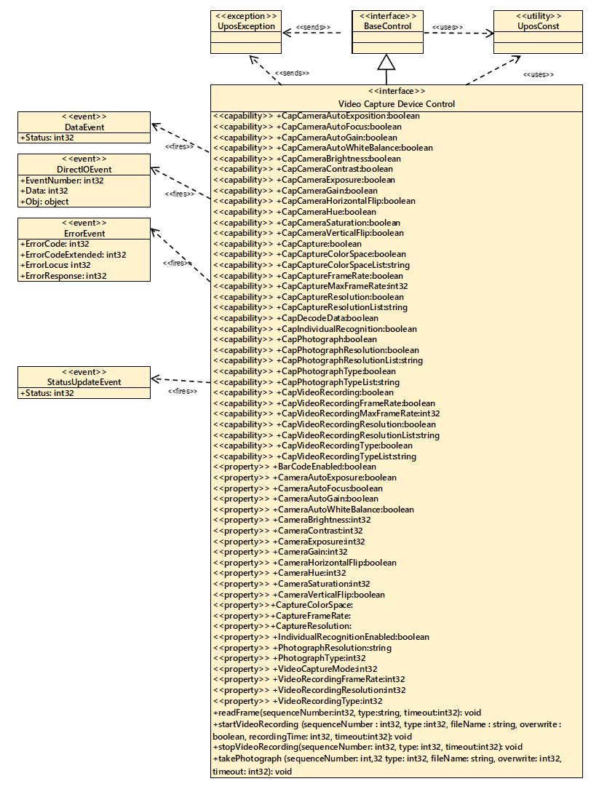

Fig. Chap. 39-1 Video Capture Class Diagram

### Model

When video capture is enabled, the capture begins and the frame data can be retrieved by calling the **readFrame** method.

The resolution and frame rate of the frame data to be acquired depend on the operation mode set in the **VideoCaptureMode** property.

The following shows the setting to refer to each operation mode and the property for confirming valid values.

### Capture only mode

**Color space**: **CaptureColorSpace** property => Valid value confirmation with **CapCaptureColorSpaceList** property

**Resolution**: **CaptureResolution** property => Valid value confirmation with **CapCaptureResolutionList** property

**Frame rate**: **CaptureFrameRat**e property

=> Valid value confirmation with **CapCaptureMaxFrameRate** property

### Photo shooting mode

**Color space**: **CaptureColorSpace** property

=> Valid value confirmation with **CapCaptureColorSpaceList** property

**Resolution**: **PhotographResolution** property

=> Valid value confirmation with **CapPhotographResolutionList** property

**Frame rate**: **CaptureFrameRate** property

=> Valid value confirmation with **CapCaptureMaxFrameRate** property

**Remarks**: You can take pictures with **takePhotograph** method only in this mode.

### Movie shooting mode

**Color space**: **CaptureColorSpace** property

=> Valid value confirmation with **CapCaptureColorSpaceLis**t property

**Resolution**: **VideoRecordingResolution** property

=> Valid value confirmation with the **CapVideoRecordingResolutionLis**t property

**Frame rate**: **VideoRecordingFrameRate** property

=> Valid value confirmation with **CapVideoRecordingMaxFrameRate** property

**Remarks**: It is possible to shoot movies with the **startVideoRecording** method only in this mode. Since the captured image / movie file is recorded in the area managed by the **"hard** **total**" service, the application must also support "**hard total**" service.

### Input Model

Video capture control follows a common input model of event driven input, although there are some differences.

"**Control**” raises a **DataEvent** event when the recording started by the **startVideoRecording** method. And it ends when the specified time elapses and the recording to the specified file is completed.

When an application calls the **stopVideoRecording** method to end recording, **DataEvent** event will not occur. "

Also, by activating the **FaceCatchEnabled** property, face recognition is started, and even when a face is recognized, a **DataEvent** event is generated.

To distinguish between Recording Completed to File by Recording and **DataEvent** event of Face Recognition, refer to the **DataEventType** property.

The control sets VCP_ET_VIDEO when recording to the file by recording is completed, and sets VCP_ET_FACECATCH to the **DataEventType** property when recognizing the face. "

If the **AutoDisable** property is true, control will be disabled automatically when queuing **DataEvent** event.

If the **DataEventEnabled** property is true, the queued **DataEvent** is notified to the application. Just before triggering this event, the control copies the data to the property and sets the **DataEventEnabled** property to false to prevent further data events firing. This allows the control to queue subsequent input data while the application is processing the current input and processing the related properties. When the application finishes processing the current input data and is ready for the next data processing, setting the **DataEventEnabled** property to true will notify the **Data Event** again.

If an error occurs in the control while reading or processing the input data, an **ErrorEvent** is issued, and if the **DataEventEnabled** property is true, the application is notified.

By reading the **DataCount** property you get the number of **Data Events** queued by the control.

All input data queued in the control can be deleted by calling the **clearInput** method.

All data properties entered by **DataEvent** or **ErrorEvent** occurrence can be restored to the default value by calling the **clearInputProperties** method.

### Bar Code Scan

By setting the **BarcodeEnabled** property to true for video capture, it is possible to scan the bar code by the camera.

When reading data from the bar code, the **DataEvent** event is queued in the scanner service object.

Scanned data is stored in the **ScanData** property. If the application sets the **DecodeData** property to true, the data is decoded to ScanDataLabel and ScanDataType.

### Individual Recognition

By setting the **IndividualRecognitionEnabled** property to true for video capture, it is possible for objects to be recognized by the camera.

When an object is detected, a **DataEvent** is queued in the object recognition service object.

The detected data is stored in the **IndividualRecognitionInformation** and **IdividualIDs** of Individual Recognition Device properties.

**Device Sharing**

Video capture is an exclusive-use device, as follows:

* The application must claim the device before enabling it.
* The application must claim and enable the device before accessing many video capture-specific properties.
* The application must claim and enable the device before calling methods that manipulate the device.
* See the “Summary” table for precise usage prerequisites.

## Properties (UML attributes)

**BarCodeEnabled Property**

**Syntax** **BarCodeEnabled: *boolean* {read-write, access after open}**

**Remarks** If true, bar code scan is enabled. If false, bar code scan is disabled. This property is initialized to false by the **open** method.

**Errors** A UposException may be thrown when this property is accessed. For further information, see “**Errors**" on page Intro-20. Some possible values of the exception’s *ErrorCode* property are:

**Value Meaning**  E_ILLEGAL Bar code scanning function is not supported (If it is set true)

**See also CapDecodeData** Property

**CameraAutoExposure Property**

**Syntax CameraAutoExposure:*****boolean* {read-write, access after open}**

**Remarks** If true, auto exposure of camera is enabled. If false, auto exposure of camera is disabled. This property is initialized by the **open** method.

**Errors** A UposException may be thrown when this property is accessed. For further information, see “**Errors**" on page Intro-20.Some possible values of the exception’s*ErrorCode* propertyare:

**Value Meaning**

E_ILLEGAL An invalid value was specified. Or it does not support this function.

**See also** **CapCameraAutoExposition** Property

**CameraAutoFocus Property**

**Syntax CameraAutoFocus: *boolean* {read-write, access after open}**

**Remarks** If true, auto focus of camera is enabled. If false, auto focus of camera is disabled. This property is initialized by the **open** method.

**Errors** A UposException may be thrown when this property is accessed. For further information, see “**Errors**" on page Intro-20.Some possible values of the exception’s*ErrorCode* propertyare:

**Value Meaning**

E_ILLEGAL An invalid value was specified. Or it does not support this function.

**See also CapCameraAutoFocus** Property

**CameraAutoGain Property**

**Syntax CameraAutoGain: *boolean* {read-write, access after open}**

**Remarks** If true, auto gain of camera is enabled. If false, auto gain of camera is disabled. This property is initialized by the **open** method.

**Errors** A UposException may be thrown when this property is accessed. For further information, see “**Errors**" on page Intro-20. Some possible values of the exception’s *ErrorCode* property are:

**Value Meaning**

E_ILLEGAL An invalid value was specified. Or it does not support this function.

**See also** **CapCameraAutoGain** Property

**CameraAutoWhiteBalance Property**

**Syntax** **CameraAutoWhiteBalance: *boolean* {read-write, access after open}**

**Remarks** If true, auto white balance of camera is enabled.  
 If false, auto white balance of camera is disabled. This property is initialized by the **open** method.

**Errors** A UposException may be thrown when this property is accessed. For further information, see “**Errors**" on page Intro-20.Some possible values of the exception’s*ErrorCode* propertyare:

**Value Meaning**

E_ILLEGAL An invalid value was specified. Or it does not support this function.

**See also** **CapCameraAutoWhiteBalance** Property

**CameraBrightness property**

**Syntax CameraBrightness:*****int32* {read-write, access after open}**

**Remarks** Indicate the brightness of camera. Valid values range from 0 to 100. This property is initialized by the **open** method.

**Errors** A UposException may be thrown when this property is accessed. For further information, see “**Errors**" on page Intro-20.Some possible values of the exception’s*ErrorCode* propertyare:

**Value Meaning** E_ILLEGAL An invalid value was specified. Or it does not support this function.

**See Also CapCameraBrightness** Property

**CameraContrast Property**

**Syntax CameraContrast: *int32* {read-write, access after open}**

**Remarks** Indicate the contrast of the camera. Valid values range from 0 to 100. This property is initialized by the **open** method.

**Errors** A UposException may be thrown when this property is accessed. For further information, see “**Errors**" on page Intro-20.Some possible values of the exception’s*ErrorCode* propertyare:

**Value Meaning** E_ILLEGAL An invalid value was specified. Or it does not support this function.

**See Also CapCameraContrast** Property

## CameraExposure Property

**Syntax** **CameraExposure: *int32* {read-write, access after open}**

**Remarks** Indicate the exposure of camera. Valid values range from 0 to 100.　 This property is initialized by the **open** method.

**Errors** A UposException may be thrown when this property is accessed. For further information, see “**Errors**" on page Intro-20.Some possible values of the exception’s*ErrorCode* propertyare:

**Value Meaning**

E_ILLEGAL An invalid value was specified. Or it does not support this function.

**See also** **CapCameraExposure** Property

**CameraGain Property**

**Syntax** **CameraGain: *int32* {read-write, access after open}**

**Remarks** Indicate the gain of camera. Valid values range from 0 to 100. This property is initialized by the **open** method.

**Errors** A UposException may be thrown when this property is accessed. For further information, see “**Errors**" on page Intro-20.Some possible values of the exception’s*ErrorCode* propertyare:

**Value Meaning**

E_ILLEGAL An invalid value was specified. Or it does not support this function.

**See also CapCameraGain** Property

**CameraHorizontalFlip Property**

**Syntax** **CameraHorizontalFlip:*****boolean* {read-write, access after open}**

**Remarks** If true, horizontal flip of camera is enabled. If false, horizontal flip of camera is disabled. This property is initialized by the **open** method.

**Errors** A UposException may be thrown when this property is accessed. For further information, see “**Errors**" on page Intro-20.Some possible values of the exception’s*ErrorCode* propertyare:

**Value Meaning**

E_ILLEGAL An invalid value was specified. Or it does not support this function.

**See Also** **CapCameraHorizontalFlip** property

**CameraHue Property**

**Syntax**  **CameraHue: *int32* {read-write, access after open}**

**Remarks** Indicate the hue of camera. Valid values range from 0 to 100. This property is initialized by the **open** method.

**Errors** A UposException may be thrown when this property is accessed. For further information, see “**Errors**" on page Intro-20.Some possible values of the exception’s*ErrorCode* propertyare:

**Value Meaning**

E_ILLEGAL An invalid value was specified. Or it does not support this function.

**See also** **CapCameraHue** Property

**CameraSaturation Property**

**Syntax** **CameraSaturation: *int32* {read-write, access after open}**

**Remarks** Indicate the saturation of camera. Valid values range from 0 to 100. This property is initialized by the **open** method.

**Errors** A UposException may be thrown when this property is accessed. For further information, see “**Errors**" on page Intro-20.Some possible values of the exception’s*ErrorCode* propertyare:

**Value Meaning**

E_ILLEGAL An invalid value was specified. Or it does not support this function.

**See also** **CapCameraSaturation** Property

### CameraVerticalFlip Property

**Syntax** **CameraVerticalFlip: *boolean* {read-write, access after open}**

**Remarks** If true, vertical flipping of the camera is enabled. If false, vertical flipping of camera is disabled. This property is initialized by the open method.

**Errors** A UposException may be thrown when this property is accessed. For further information, see “**Errors**" on page Intro-20. Some possible values of the exception’s *ErrorCode* property are:

**Value Meaning**

E_ILLEGAL An invalid value was specified. Or it does not support this function.

**See also** **CapCameraVerticalFlip** Property

## CapCameraAutoExposition Property

**Syntax** **CapCameraAutoExposition: *boolean* {read-only, access after open}**

**Remarks** If true, can change the auto exposition of camera. If false, cannot change the auto exposition of camera. This property is initialized by the **open** method.

**Errors** A UposException may be thrown when this property is accessed. For further information, see “**Errors**" on page Intro-20.

**See also** **CameraAutoExposition** Property

## CapCameraAutoFocus Property

**Syntax** **CapCameraAutoFocus: *boolean* {read-only, access after open}**

**Remarks** If true, can change the auto focus of camera. If false, cannot change the auto focus of camera. This property is initialized by the **open** method.

**Errors** A UposException may be thrown when this property is accessed. For further information, see “**Errors**" on page Intro-20.

**See also CameraAutoFocus** Property

## CapCameraAutoGain Property

**Syntax** **CapCameraAutoGain: *boolean* {read-only, access after open}**

**Remarks** If true, automatic gain change of the camera is possible. If false, automatic gain change of camera is not possible. This property is initialized by the **open** method.

**Errors** A UposException may be thrown when this property is accessed. For further information, see “**Errors**" on page Intro-20.

**See also CameraAutoGain** Property

## CapCameraAutoWhiteBalance Property

**Syntax** **CapCameraAutoWhiteBalance: *boolean* {read-only, access after open}**

**Remarks** If true, auto white balance of camera is possible. If false, auto white balance of camera is not possible. This property is initialized by the **open** method.

**Errors** A UposException may be thrown when this property is accessed. For further information, see “**Errors**" on page Intro-20.

**See also** **CameraAutoWhiteBalance** Property

## CapCameraBrightness Property

**Syntax** **CapCameraBrightness: *boolean* {read-only, access after open}**

**Remarks** If true, the brightness of camera can be changed. If false, the brightness of the camera cannot be changed. This property is initialized by the **open** method.

**Errors** A UposException may be thrown when this property is accessed. For further information, see “**Errors**" on page Intro-20.

**See also** **CameraBrightness** Property

**CapCameraContrast Property**

**Syntax** **CapCameraContrast: *boolean* {read-only, access after open}**

**Remarks** If true, can change the contrast of camera. If false, cannot change the contrast of camera. This property is initialized by the **open** method.

**Errors** A UposException may be thrown when this property is accessed. For further information, see “**Errors**" on page Intro-20.

**See also** **CameraContrast** Property

**CapCameraExposure Property**

**Syntax CapCameraExposure: *boolean* {read-only, access after open}**

**Remarks** If true, can change the exposure of camera. If false, cannot change the exposure of camera. This property is initialized by the **open** method.

**Errors** A UposException may be thrown when this property is accessed. For further information, see “**Errors**" on page Intro-20.

**See also CameraExposure** Property

**CapCameraGain Property**

**Syntax CapCameraGain: *boolean* {read-only, access after open}**

**Remarks** If true, can change the gain of camera. If false, cannot change the gain of camera. This property is initialized by the open method.

**Errors** A UposException may be thrown when this property is accessed. For further information, see “**Errors**" on page Intro-20.

**See also CameraGain** Property

**CapCameraHorizontalFlip Property**

**Syntax**  **CapCameraHorizontalFlip: *boolean* {read-only, access after open}**

**Remarks** If true, can change the horizontal flip of camera. If false, cannot change the horizontal flip of camera. This property is initialized by the **open** method.

**Errors** A UposException may be thrown when this property is accessed. For further information, see “**Errors**" on page Intro-20.

**See also** **CameraHorizontalFlip** Property

**CapCameraHue Property**

**Syntax** **CapCameraHue: *boolean* {read-only, access after open}**

**Remarks** If true, the hue of the camera can be changed. If false, hue of the camera cannot be changed. This property is initialized by the **open** method.

**Errors** A UposException may be thrown when this property is accessed. For further information, see “**Errors**" on page Intro-20.

**See also** **CameraHue** Property

**CapCameraSaturation Property**

**Syntax CapCameraSaturation: *boolean* {read-only, access after open}**

**Remarks** If true, can change the saturation of camera. If false, cannot change the saturation of camera. This property is initialized by the **open** method.

**Errors** A UposException may be thrown when this property is accessed. For further information, see “**Errors**" on page Intro-20.

**See also** **CameraSaturation** Property

**CapCameraVerticalFlip Property**

**Syntax**  **CapCameraVerticalFlip: *boolean* {read-only, access after open}**

**Remarks** If true, can change the vertical flip of camera. If false, cannot change the vertical flip of camera. This property is initialized by the **open** method.

**Errors** A UposException may be thrown when this property is accessed. For further information, see “**Errors**" on page Intro-20.

**See also** **CameraVerticalFlip** Property

**CapCapture Property**

**Syntax CapCapture:** ***boolean* {read-only, access after open}**

**Remarks** If true, it supports the capture function and can call the **readFrame** method and retrieve the frame data.  
 If false, it does not support the capture function and cannot retrieve the frame data. This property is initialized by the **open** method.

**Errors** A UposException may be thrown when this property is accessed. For further information, see “**Errors**" on page Intro-20.

**See also** **readFrame** Method

**CapCaptureColorSpace Property**

**Syntax** **CapCaptureColorSpace: *boolean* {read-only, access after open}**

**Remarks** If true, can change the capture color space.  
 If false, cannot change the capture color space. This property is initialized by the **open** method.

**Errors** A UposException may be thrown when this property is accessed. For further information, see “**Errors**" on page Intro-20.

**CapCaptureColorSpaceList Property**

**Syntax** **CapCaptureColorSpaceList: *string* {read-only, access after open}**

**Remarks** Color space information supported by the device is indicated in a comma-separated list. Each color space information is composed of the following information and is shown in the following order separated by a colon (":"). This property is initialized by the **open** method.

**Parameter Description**

*Color space ID* ID for identifying the color space of RGB, YUV 422, etc.

*Depth* Number of bits per 1 pixel

**Errors** A UposException may be thrown when this property is accessed. For further information, see **“Errors"** on page Intro-20.

***See also*** **CaptureColorSpace** Property

**CapCaptureFrameRate Property**

**Syntax CapCaptureFrameRate: *boolean* {read-only, access after open}**

**Remarks** If true, can change the capture frame rate.  
 If false, cannot change the capture frame rate. This property is initialized by the **open** method.

**Errors** A UposException may be thrown when this property is accessed. For further information, see “**Errors**" on page Intro-20.

**CapCaptureMaxFrameRate Property**

**Syntax CapCaptureMaxFrameRate: *int32* {read-only, access after open}**

**Remarks** Indicates the maximum frame rate that can be set for the **CaptureFrameRate** property. This property is initialized by the **open** method.

**Errors** A UposException may be thrown when this property is accessed. For further Information, see “**Errors**" on page Intro-20.

**See also CaptureFrameRate** Property

**CapCaptureResolution Property**

**Syntax CapCaptureResolution: *boolean* {read-only, access after open}**

**Remarks** If true, capture resolution is enabled. If false, capture resolution is disabled. This property is initialized by the open method.

**Errors** A UposException may be thrown when this property is accessed. For further information, see “**Errors**" on page Intro-20.

**See also CaptureResolution** Propert**y**

**CapCaptureResolutionList Property**

**Syntax CapCaptureResolutionList: *string* {read-only, access after open}**

**Remarks** Indicating the comma-separated list of possible resolutions for the **CaptureResolution** property. Resolution is indicated in "horizontal x height" format. For example, when you support 320x240, 640x480, 640x360, it is the following. "320 x 240, 640 x 480, 640 x 360".  
This property is initialized by the **open** method.

**Errors** A UposException may be thrown when this property is accessed. For further information, see “**Errors**" on page Intro-20.

**See also CaptureResolution** Propert**y**

**CapDecodeData Property**

**Syntax CapDecodeData: boolean {read-only, access after open}**

**Remarks** If true, the image scanner can read the bar code data. The scanned bar code data is sent to the scanner service. This property is initialized by the **open** method.

**Errors** A UposException may be thrown when this property is accessed. For further information, see “**Errors**" on page Intro-20.

**CapIndividualRecognition Property**

**Syntax** **Cap Individual Recognition:** ***boolean* {read-only, access after open}**

**Remarks** If true, individual recognition function is supported.  
 If false, individual recognition function is not supported. If this property is true, individual recognition can be done by setting **IndividualRecognitionEnabled** property to true. If false, individual recognition cannot be performed. This property is initialized by the **open** method.

**Errors** A UposException may be thrown when this property is accessed. For further information, see **“Errors"** on page Intro-20.

**See also** **IndividualRecognitionEnabled** Property

**CapPhotograph Property**

**Syntax** **CapPhotograp:** ***boolean* {read-only, access after open}**

**Remarks** If true, photograph function is supported. If false, photograph function is not supported. If true, it is possible taking a photograph by calling the **takePhotograph** method. If false, it is not possible taking a photograph. This property is initialized by the **open** method.

**Errors** A UposException may be thrown when this property is accessed. For further information, see **“Errors"** on page Intro-20.

**See also** **takePhotograph** Method

**CapPhotographResolution Property**

**Syntax** **CapPhotographResolution:** ***boolean* {read-only, access after open}**

**Remarks** If true, it is possible changing the photograph resolution.  
 If false, it is not possible changing the photograph resolution. This property is initialized by the **open** method.

**Errors** A UposException may be thrown when this property is accessed. For further information, see **“Errors"** on page Intro-20.

**CapPhotographResolutionList Property**

**Syntax** **CapPhotographResolutionList:*****string* {read-only, access after open}**

**Remarks** A comma-separated list of possible resolutions for **PhotographResolution** property. Resolution is indicated by Syntax "Horizontal x Vertical". For example, when you support 320x240, 640x480, 640x360, it is the following. "320x240,640x480,640x360" This property is initialized by the **open** method.

**Errors** A UposException may be thrown when this property is accessed. For further information, see **“Errors"** on page Intro-20.

**See also** **PhotographResolution** Property

**CapPhotographType Property**

**Syntax** **CapPhotographType: *boolean* {read-only, access after open}**

**Remarks** If true, photograph type can be changed.  
 If false, photograph type cannot be changed. This property is initialized by the **open** method.

**Errors** A UposException may be thrown when this property is accessed. For further information, see **“Errors"** on page Intro-20.

**CapPhotographTypeList Property**

**Syntax** **CapPhotographTypeList: *string* {read-only, access after open}**

**Remarks** A comma-separated list of image format values that can be set for the **PhotographType** property. For example, when supporting BMP and JPEG, it is the following. "BMP, JPEG"

Note: The notation contents may be different depending on the device. This property is initialized by the **open** method.

**Errors** A UposException may be thrown when this property is accessed. For further information, see **“Errors"** on page Intro-20.

**See also** **PhotographType** Property

**CaptureColorSpace Property**

**Syntax** **CaptureColorSpace:** ***string* {read-write, access after open}**

**Remarks** Indicates the color space ID of the frame data to be acquired by the **readFrame** method. Valid values are one of the values listed in the **CapCaptureColorSpaceList** property. This property is referred to regardless of which operation mode is set by **VideoCaptureMode** property.This property is initialized by the **open** method.

**Errors** A UposException may be thrown when this property is accessed. For further information, see **“Errors"** on page Intro-20. Some possible values of the exception’s*ErrorCode* propertyare:

**Value Meaning**

E_ILLEGAL An invalid value was specified.

**See also** **CapCaptureColorSpaceList** Property、**VideoCaptureMode** Property、 **readFrame** Method

**CaptureFrameRate Property**

**Syntax** **CaptureFrameRate: *int32* {read-write, access after open}**

**Remarks** Indicates the frame rate of frame data to be acquired by the **readFrame** method. Valid values range from 1 to **CapCaptureMaxFrameRate** property. This property is only referenced when VCP_VCM_CAPTURE is set in **VideoCaptureMode** property. This property is initialized by the **open** method.

**Errors** A UposException may be thrown when this property is accessed. For further information, see **“Errors"** on page Intro-20.

**Value Meaning**

E_ILLEGAL An invalid value was specified.

**See also** **CapCaptureMaxFrameRate** Property, **VideoCaptureMode** Property、 **readFrame** Method

**CaptureResolution Property**

**Syntax**  **CaptureResolution: *string* {read-write, access after open}**

**Remarks** Indicates the resolution of the frame data acquired by the **readFrame** method. Valid values are one of those listed in **CapCaptureResolutionList** property. 　　This property is only referenced when VCP_VCM_CAPTURE is set in **VideoCaptureMode** property. 　　 This property is initialized by the **open** method.

**Errors** A UposException may be thrown when this property is accessed. For further information, see **“Errors"** on page Intro-20. Some possible values of the exception’s *ErrorCode* property are:

**Value Meaning**

E_ILLEGAL An invalid value was specified.

**See also** **CapCaptureResolutionList** Property、**VideoCaptureMode** Property、 **readFrame** Method

**CapVideoRecording Property**

**Syntax** **CapVideoRecording:** ***boolean* {read-only, access after open}**

**Remarks** If true, video recording function is supported.  
 If false video recording function is not supported. If this property is true, movie recording can be done by calling the **startVideoRecording** method. If false, movie recording cannot be performed. This property is initialized by the **open** method.

**Errors** A UposException may be thrown when this property is accessed. For further information, see **“Errors"** on page Intro-20.

**See also** **StartVideoRecording** Property

**CapVideoRecordingFrameRate Property**

**Syntax** **CapVideoRecordingFrameRate : *boolean* {read-only, access after open}**

**Remarks** If true, video recording frame rate can be changed.  
 If false, video recording frame rate cannot be changed. This property is initialized by the **open** method.

**Errors** A UposException may be thrown when this property is accessed. For further information, see **“Errors"** on page Intro-20.

**CapVideoRecordingMaxFrameRate Property**

**Syntax CapVideoRecordingMaxFrameRate: *int32* {read-only, access after open}**

**Remarks** Indicates the maximum frame rate that can be set in **VideoRecordingFrameRate** property. This property is initialized by the open method.

**Errors** A UposException may be thrown when this property is accessed. For further information, see “**Errors**" on page Intro-20.

**See also** **VideoRecordingFrameRate** Property

**CapVideoRecordingResolution Property**

**Syntax** **CapVideoRecordingResolution: *boolean* {read-only, access after open}**

**Remarks** If true, video recording resolution can be changed.   
 If false, video recording resolution cannot be changed. This property is initialized by the **open** method. **Errors** A UposException may be thrown when this property is accessed. For further information, see **“Errors"** on page Intro-20.

**CapVideoRecordingResolutionList Property**

**Syntax** **CapVideoRecordingResolutionList: *string* {read-only, access after open}**

**Remarks** A comma-separated list of possible resolutions for the **VideoRecordingResolution** property. Resolution is indicated by "Horizontal x Vertical" format. For example, when it supports 320x240, 640x480, 640x360, it is the following. "320x240,640x480,640x360" This property is initialized by the **open** method. **Errors** A UposException may be thrown when this property is accessed. For further information, see **“Errors"** on page Intro-20.

**See also VideoRecordingResolution** Property

**CapVideoRecordingType Property**

**Syntax CapVideoRecordingType:** ***boolean* {read-only, access after open}**

**Remarks** If true, video recording type can be changed.  
 If false, video recording type cannot be changed. This property is initialized by the **open** method.

**Errors** A UposException may be thrown when this property is accessed. For further information, see **“Errors"** on page Intro-20.

**CapVideoRecordingTypeList Property**

**Syntax** **CapVideoRecordingTypeList:** ***string* {read-only, access after open}**

**Remarks** A comma-separated list of image format values that can be set for the **VideoRecordingType** property. For example, when AVI_IYUV, AVI_MJPG is supported, it is the following. "AVI_IYUV, AVI_MJPG" Note: The notation contents may be different depending on the device. 　　 This property is initialized by the **open** method. **Errors** A UposException may be thrown when this property is accessed. For further information, see **“Errors"** on page Intro-20.

**See also** **VideoRecordingType** Property

**IndividualRecognitionEnabled Property**

**Syntax IndividualRecognitionEnabled: *boolean*{read-write, access after open}**

**Remarks** If true individual recognition is enabled. If false, individual recognition is disabled. This property is initialized to false by the **open** method.

**Errors** A UposException may be thrown when this property is accessed. For further information, see “**Errors**" on page Intro-20. Some possible values of the exception’s *ErrorCode* property are:  **Value Meaning** E_ILLEGAL Individual recognition function is not supported (If it is set true)

**See also** **CapIndividual Recognition** Property

**PhotographResolution Property**

**Syntax PhotographResolution: *string* {read-write, access after open}**

**Remarks** It shows the resolution of the frame data acquired by the **readFrame** method and the photograph taken with the **takePhotograph** method. Valid values are one of those listed in **CapPhotographResolutionList** property. This property is referenced only when VCP_VCM_PHOTO is set in **VideoCaptureMode** property. This property is initialized by the **open** method.

**Errors** A UposException may be thrown when this property is accessed. For further information, see “**Errors**" on page Intro-20. Some possible values of the exception’s *ErrorCode* property are:

**Value Meaning**

E_ILLEGAL An invalid value was specified.

**See also** **CapPhotographResolutionList** Property, **VideoCaptureMode** Property, **readFrame** Method, **takePhotograph** Method

## PhotographType Property

**Syntax PhotographType: *int32* {read-write, access after open}**

**Remarks** Indicates the image format of photos taken with the **takePhotograph** method. Valid values are one of the values listed in the **CapPhotographTypeList** property. This property is referenced only when VCP_VCM_PHOTO is set in **VideoCaptureMode** property. This property is initialized by the **open** method.

**Remarks** Indicates the image format of photos taken with the **takePhotograph** method. Valid values are one of the values listed in the **CapPhotographTypeList** property. This property is referenced only when VCP_VCM_PHOTO is set in **VideoCaptureMode** property. This property is initialized by the **open** method

**Errors** A UposException may be thrown when this property is accessed. For further information, see “**Errors**" on page Intro-20. Some possible values of the exception’s *ErrorCode* property are:

**Value Meaning** E_ILLEGAL An invalid value was specified.

**See also CapPhotographTypeList** Property**、takePhotograph** Method

**VideoCaptureMode Property**

**Syntax VideoCaptureMode: *int32* {read-write, access after open}**

**Remarks** Indicate the operation mode of video capture. Valid values are as follows

**Parameter Description**

VCP_VCMODE_CAPTURE This mode is for capture only.  
The values of the **CaptureColorSpace, CaptureResolution,** and **aptureFrameRate** propertiesare applied to the color space, resolution, and frame rate of frame data that can be acquired with the **readFrame** method**.**

VCP_VCMODE_PHOTO

This mode is for capture and taking photograph. The values of the **CaptureColorSpace** and **CaptureFrameRate** properties are applied to the color space and frame rate of the frame data that can be acquired by the **readFrame** method, and the resolution is applied to the resolution of the **CapPhotographResolution** property.

VCP_VCMODE_VIDEO

This mode is for capture and movie shooting. The value of the **CaptureColorSpace** property is applied to the color space of the frame data that can be acquired by the **readFrame** method, the values of the **CapVideoRecordingResolution** property and the C**apVideoRecordingFrameRate** property are applied to the resolution and the frame rate.

This property is initialized to VCP_VCMODE_CAPTURE by the **open** method. Indicate the operation mode of video capture.

**Errors** A UposException may be thrown when this property is accessed. For further information, see “**Errors**" on page Intro-20.

**See also CaptureColorSpace** Property、*CaptureResolution* Property,  **CaptureFrameRate** Property、**CapPhotographResolution** Property、 **CapVideoRecordingResolution** Property、 **CapVideoRecordingFrameRate** Property、**readFrame** Method

**VideoRecordingFrameRate Property**

**Syntax** **VideoRecordingFrameRate;** ***int32* {read-write, access after open}**

**Remarks** Indicates the frame rate of the frame data acquired by the **readFrame** method and the movie taken with the **startVideoRecording** method. Valid values range from 1 to **CapVideoRecordingMaxFrameRate**　 property.　　 This property is only referred when VCP_VCM_VIDEO is set in **VideoCaptureMode** property. This property is initialized by the **open** method.

**Errors** A UposException may be thrown when this property is accessed. For further information, see **“Errors"** on page Intro-20. Some possible values of the exception’s *ErrorCode* property are:

**Value Meaning**  E_ILLEGAL An invalid value was specified.

**See also** **CapVideoRecordingMaxFrameRate** Property、 **VideoCaptureMode** Property、**readFrame** Method, **startVideoRecording** Method

**VideoRecordingResolution Property**

**Syntax** **VideoRecordingResolution:** ***int32* {read-write, access after open}**

**Remarks** Indicates the resolution of the frame data acquired by the **readFrame** method and the photograph taken with the **startVideoRecording** method. Valid values are one of the values listed in the **CapVideoRecordingResolutionList** property. This property is only referred when VCP_VCM_VIDEO is set in **VideoCaptureMode** property. This property is initialized by the **open** method.

**Errors** A UposException may be thrown when this property is accessed. For further information, see **“Errors"** on page Intro-20. Some possible values of the exception’s *ErrorCode* property are:

**Value Meaning** E_ILLEGAL An invalid value was specified.

**See also** **CapVideoRecordingResolutionList** Property, **VideoCaptureMode** Property、**readFrame** Method **startVideoRecording** Method

**VideoRecordingType Property**

**Syntax** **VideoRecordingType;** ***string* {read-write, access after open}**

**Remarks** Indicate the shape of the movie taken with the **startVideoRecording** method. Valid values are one of those listed in **CapVideoRecordingTypeList**  property. This property is only referred when VCP_VCM_VIDEO is set in **VideoCaptureMode** property. This property is initialized by the **open** method.

**Errors** A UposException may be thrown when this property is accessed. For further information, see **“Errors"** on page Intro-20. Some possible values of the exception’s *ErrorCode* property are:

**Value Meaning**  E_ILLEGAL An invalid value was specified.

**See also** **CapVideoRecordingTypeList** Property, **startVideoRecording** Method

**Methods (UML operations)**

**readFrame Method**

**Syntax readFrame (frameData: *string*): void {raises-exception, use after open, claim, enable} Parameter Description** frameData Indicates the area where frame data is stored.

**Remarks** Acquires the captured frame data and stores it in frameData. The color space and resolution of frame data differs depending on the operation mode set in the **VideoCaptureMode** property. For details, refer to the **VideoCaptureMode** property. This method is executed synchronously.

**Errors** A UposException may be thrown when this method is invoked. For further information, see “**Errors**" on page Intro-20. Some possible values of the exception's *ErrorCode* property are:

**Value Meaning**

E_ILLEGAL This function is not supported

**See also VideoCaptureMode** Property

**startVideoRecording method**

**Syntax startVideoRecording (fileName : string, overwrite: *boolean*, recordingTime: *int32*): void{raises-exception, use after open, claim, enable} Parameter Description**

filename Specify the name of the movie file to be recorded. Overwrite Specify the behavior when the same name file exists. If true, it is overwritten. If false, it will raise the UposException. recordingTime Specify the time for recording in seconds. If FOREVER (-1) is specified, recording will continue until the **stopVideoRecording** method is called.

**Remarks** Recording starts with the setting contents of the **CaptureColorSpace** and **VideoRecordingResolution** properties, and recording starts in the format set by the **VideoRecordingType** property. This method is executed asynchronously. When the time specified in RecordingTime has elapsed, or by calling the **stopVideoRecording** method, recording is completed and the movie file specified by fileName is recorded. Also, S_BUSY is set in the **Status** property during movie execution. The place where video files are recorded is the area managed by "hard total" service. **Errors** A UposException may be thrown when this method is invoked. For further information, see “**Errors**" on page Intro-20. Some possible values of the exception's *ErrorCode* property are:

**Value Meaning** E_ILLEGAL fileName is too long or contains characters that cannot be used, or 0 is specified for recordingTime. E_EXISTS fileName already exists. (If overwrite is false) E_BUSY Cannot execute because it is recording.

**See also CaptureColorSpace** Property**、VideoRecordingResolution** Property**、 VideoRecordingType** Property**、stopVideoRecording** Method

**stopVideoRecording method**

**Syntax stopVideoRecording ( ):**

**void {raises-exception, use after open, claim, enable}**

**Remarks** The recording process started by the **startVideoRecording** method has ended and the recording of the movie image file is completed.

**Errors** A UposException may be thrown when this method is invoked. For further information, see “**Errors**" on page Intro-20. Some possible values of the exception's *ErrorCode* property are:

**Value Meaning**

E_ILLEGAL It is not recorded.

**See also startVideoRecording** Method

**takePhotograph Method**

**Syntax takePhotograph (fileName: *string*, overwrite: *int32*, timeout: *int32*): void{raises-exception, use after open, claim, enable}**

**Parameter Description**

fileName Specify the image file name to be recorded. overwrite Specify the behavior when the same name file exists. If true it overwrites. If false, UposException is thrown.

**Remarks** Take photos with setting contents of **CaptureColorSpace** property, **PhotographResolution** property, **PhotographType** property and record images. Before calling this method, it needs to set the **VideoCaptureMode** property to VCP_VCM_PHOTO and change to the photo shooting mode. This method is executed synchronously. The location where image files are recorded is the area managed by "hard total" service.

**Errors** A UposException may be thrown when this method is invoked. For further information, see “**Errors**" on page Intro-20. Some possible values of the exception's *ErrorCode* property are:

**Value Meaning**

E_ILLEGAL One of the following occurred. FileName is too long or contains unusable characters. **VideoCaptureMode** property is not VCM_PHOTO E_EXISTS fileName already exist. (When overwrite=false)

**See also** **VideoCaptureMode** Property**、CaptureColorSpace** Property**、 PhotographResolution** Property**、PhotographType** Property

**Events (UML interfaces)**

**DataEvent**

**<<event>> upos::events::DataEvent**

**Status:*int32*{read-only}**

**Description** Notifies the application when data from the Video Capture device is available to be read.

**Attributes** This event contains the following attributes:

**Attribute Type Description**

*Status int32 Set to 0.*

**Remarks** Before this event is delivered, the Video Capture movie image is placed into **readFrame.**

This event is to be used only for those types of vendor specific functions that are not otherwise described.

Use of this event may restrict the application program programform being used with other vendor’s devices which may not have any knowledge of the Service’s need for this event.

**See Also** **“Events"** on page Intro-19, **directIO** method

**DirectIOEvent**

**<<event>> upos::events::DirectIOEvent**

**EventNumber : *int32* {read-only} Data : *int32* {read-write}  
Obj : *object* {read-write}**

**Description** Provides Service information directly to the application. This event provides a means for a vendor-specific Video Capture Service to provide events to the application that are not otherwise supported by the Control.

**Attributes** This event contains the following attributes:

**Attribute Type Description**

*EventNumber int32* Event number whose specific values are assigned by the Service.

*Data int32* Additional numeric data. Specific values vary by the *EventNumber* and the Service. This attribute is settable.

*Obj object* Additional data whose usage varies by the *EventNumber* and the Service. This attribute is settable.

**Remarks** This event is to be used only for those types of vendor specific functions that are not otherwise described.

Use of this event may restrict the application program programform being used with other vendor’s devices which may not have any knowledge of the Service’s need for this event.

**See Also** **“Events"** on page Intro-19, **directIO** method

**ErrorEvent**

**<<event>> upos::events::ErrorEvent**

**ErrorCode : *int32* {read-only}**

**ErrorCodeExtended : *int32* {read-only}**

**ErrorLocus : *int32* {read-only}**

**ErrorResponse : *int32* {read-write}**

**Description** Notifies the application that a Video Capture Device error has been detected and suitable response by the application is necessary to process the error condition.

**Attributes** This event contains the following attributes:

**Attributes Type Description**

*ErrorCode* *int32* Error code causing the error event. See a list of Error Codes on page 20.

*ErrorCodeExtended int32* Extended Error code causing the error event.

If *ErrorCode is* E_EXTENDED, then see values below. Otherwise, it may contain a Service-specific value.

*ErrorLocus* *int32* Location of the error. If EL_OUTPUT is specified. An error occurred during asynchronous action.

*ErrorResponse* *int32* Pointer to the error event response. See *ErrorResponse* below for values.

The *ErrorLocus* attribute has one of the following values:

**Value Meaning**

EL_OUTPUT Error occurred while processing asynchronous output.

EL_INPUT Error occurred while gathering or processing event-driven input. No previously buffered input data is available.

EL_INPUT_DATA Error occurred while gathering or processing event-driven input, and some previously buffered data is available.

The application’s error event handler can set the *ErrorResponse* attribute to one of the following values:

**Value Meaning**

ER_RETRY Retry sending the data. The error state is exited.  
May be valid for some input devices when the locus is EL_INPUT, in which case the input is retried and the error state is exited. Typically, valid for asynchronous output devices when the locus is EL_OUTPUT, in which case the asynchronous output is retried and the error state is exited. This is the default response when the locus is EL_OUTPUT.

ER_CLEAR Valid for all loci: EL_INPUT, EL_INPUT_DATA, and EL_OUTPUT. Clear all buffered input or output data (including all asynchronous output). The error state is exited. This is the default response when the locus is EL_INPUT.

ER_CONTINUEINPUT   
Only valid when the locus is EL_INPUT_DATA.  
Acknowledges that a data error has occurred and directs the Device to continue input processing. The Device remains in the error state and will deliver additional **DataEvent**s as directed by the **DataEventEnabled** property. When all input has been delivered and **DataEventEnabled** is again set to true, then another **ErrorEvent** is delivered with locus EL_INPUT.  
This is the default response when the locus is EL_INPUT_DATA.

**Remarks** This event is enqueued when an error is detected and the Device’s **State** transitions into the error state. Input error events are not delivered until **DataEventEnabled** is true, so that proper application sequencing occurs.

Unlike a **DataEvent**, the Device does not disable further **DataEvent**s or input **ErrorEvent**s; it leaves the **DataEventEnabled** property value at true. 　　　Note that the application may set **DataEventEnabled** to false within its event handler if subsequent input events need to be disabled for a period of time.

**See Also** **“Device Input Model"** on page Intro-22, **“Error Handling"** on page Intro-23, **“Device Output Models"** on page Intro-25.

**StatusUpdateEvent**

**<< event >> upos::events::StatusUpdateEvent**

**Status: *int32* {read-only}**

**Description** *Notifies the application that there is a change in the power status of the Video Capture device.*

**Attributes**  This event contains the following attribute:

**Attributes Type Description**

*Status* *int32* Indicates a change in the power status of the unit.

***Note that Release 1.3*** added Power State Reporting with additional *Power reporting* **StatusUpdateEvent** *values.*

The Update Firmware capability added additional *Status* values for communicating the status/progress of an asynchronous update firmware process. See “**StatusUpdateEvent**” description on page 1-34.

# ＣＨＡＰＴＥＲ 40

## Individual Recognition

This Chapter defines the Individual Recognition device category.

## Summary

|  |  |  |  |  |
| --- | --- | --- | --- | --- |
| **Properties (UML attributes)** |  |  |  |  |
| ***Common*** | ***Type*** | ***Mutability*** | ***Version*** | ***May Use After*** |
| **AutoDisable:** | *boolean* | {read-write} | 1.16 | open |
| **CapCompareFirmwareVersion:** | *boolean* | {read-only} | 1.16 | open |
| **CapPowerReporting:** | *int32* | {read-only} | 1.16 | open |
| **CapStatisticsReporting:** | *boolean* | {read-only} | 1.16 | open |
| **CapUpdateFirmware:** | *boolean* | {read-only} | 1.16 | open |
| **CapUpdateStatistics:** | *boolean* | {read-only} | 1.16 | open |
| **CheckHealthText:** | *string* | {read-only} | 1.16 | open |
| **Claimed:** | *boolean* | {read-only} | 1.16 | open |
| **DataCount:** | *int32* | {read-only} | 1.16 | open |
| **DataEventEnabled:** | *boolean* | {read-write} | 1.16 | open |
| **DeviceEnabled:** | *boolean* | {read-write} | 1.16 | open, claim |
| **FreezeEvents:** | *boolean* | {read-write} | 1.16 | open |
| **OutputID:** | *int32* | {read-only} | 1.16 | Not Supported |
| **PowerNotify:** | *int32* | {read-write} | 1.16 | open |
| **PowerState:** | *int32* | {read-only} | 1.16 | open |
| **State:** | *int32* | {read-only} | 1.16 | -- |
| **DeviceControlDescription:** | *string* | {read-only} | 1.16 | -- |
| **DeviceControlVersion:** | *int32* | {read-only} | 1.16 | -- |
| **DeviceServiceDescription:** | *string* | {read-only} | 1.16 | open |
| **DeviceServiceVersion:** | *int32* | {read-only} | 1.16 | open |
| **PhysicalDeviceDescription:** | *string* | {read-only} | 1.16 | open |
| **PhysicalDeviceName:** | *string* | {read-only} | 1.16 | Open |

|  |  |  |  |  |
| --- | --- | --- | --- | --- |
| ***Specific*** | ***Type*** | ***Mutability*** | ***Version*** | ***May Use After*** |
| **CapIndividualList:** | *string* | {read-only} | 1.16 | open |
| **IndividualRecognitionFilter** | *string* | {read-writer} | 1.16 | open |
| **IndividualRecognitionInformation** | *string* | {read-only} | 1.16 | open |
| **IndividualIDs:** | *string* | {read-write} | 1.16 | open, claim & enable |

|  |  |
| --- | --- |
| **Methods (UML operations)** |  |
| ***Common*** |  |
| ***Name*** | ***Version*** |
| **open (logicalDeviceName:** *string***): void {raises-exception}** | 1.16 |
| **close ( ): void {raises-exception, use after open}** | 1.16 |
| **claim (timeout:** *int32***): void {raises-exception, use after open}** | 1.16 |
| **release ( ): void {raises-exception, use after open, claim}** | 1.16 |
| **checkHealth (level:** *int32***): void {raises-exception, use after open, enable}** | 1.16 |
| **clearInput ( ): void { }** | Not  supported |
| **clearInputProperties ( ): void { }** | Not  supported |
| **clearOutput ( ): void { }** | Not  supported |
| **compareFirmwareVersion (firmwareFileName:** *string*, **out** **result:** *int32***): void {raises-exception, use after open, enable}** | 1.16 |
| **directIO (command:** *int32****,* inout data:** *int32****,* inout obj:** *object***): void {raises-exception, use after open}** | 1.16 |
| **resetStatistics (statisticsBuffer:** *string***): void {raises-exception, use after open, enable}** | 1.16 |
| **retrieveStatistics (inout statisticsBuffer:** *string***): void {raises-exception, use after open, enable}** | 1.16 |
| **updateFirmware (firmwareFileName:** *string***): void {raises-exception, use after open, enable}** | 1.16 |
| **updateStatistics (statisticsBuffer:** *string***):** **void {raises-exception, use after open, enable}** | 1.16 |

|  |  |  |  |
| --- | --- | --- | --- |
| **Events (UML interfaces)** |  |  |  |
| ***Name*** | ***Type*** | ***Mutability*** | ***Version*** |
|  |  |  |  |
| **upos::events::DataEvent** |  |  | 1.16 |
| **Status:** | *int32* | {read-only} |  |
|  |  |  |  |
| **upos::events::DirectIOEvent** |  |  | 1.16 |
| **EventNumber:** | *int32* | {read-only} |  |
| **Data:** | *int32* | {read-write} |  |
| **Obj:** | *object* | {read-write} |  |
|  |  |  |  |
| **upos::events::ErrorEvent** |  |  | 1.16 |
| **ErrorCode:** | *int32* | {read-only} |  |
| **ErrorCodeExtended:** | *int32* | {read-only} |  |
| **ErrorLocus:** | *int32* | {read-only} |  |
| **ErrorResponse:** | *int32* | {read-write} |  |
|  |  |  |  |
| **upos::events::OutputCompleteEvent** |  | ***Not Supported*** | 1.16 |
|  |  |  |  |
| **upos::events::StatusUpdateEvent** |  |  | 1.16 |
| **Status:** | *int32* | {read-only} |  |

**General Information**

The Individual Recognition programmatic name is “Individual Recognition”.

### Capabilities

The Individual Recognition has the following set of capabilities:

Analyzes the image of the camera and recognizes Individuals such as people and balls.

### Individual Recognition Class Diagram

The following diagram shows the relationships between the Individual Recognition classes.



Fig. Chap.40-1 Individual Recognition Class Diagram

### Model

The Individual Recognition follows the general “Device Input Model” for event-driven input:

**Input Model**

The **readValue** method follows the UnifiedPOS Input model.

* If the **AutoDisable** property is true, then the device automatically disables itself when a **DataEvent** is enqueued.
* An enqueued **DataEvent** can be delivered to the application when the **DataEventEnabled** property is true and other event delivery requirements are met. Just before delivering this event, data is copied into corresponding properties, and further data events are disabled by setting **DataEventEnabled** to false. This causes subsequent input data to be enqueued while the application processes the current input and associated properties. When the application has finished processing the current input and is ready for more data, it reenables events by setting **DataEventEnabled** to true.
* An **ErrorEvent** (or events) is enqueued if an error occurs while gathering or processing input, and is delivered to the application when **DataEventEnabled** is true and other event delivery requirements are met.
* The **DataCount** property may be read to obtain the total number of enqueued **DataEvent**s.
* All enqueued input may be deleted by calling **clearInput**. See the **clearInput** method description for more details.
* All data properties that are populated as a result of firing a **DataEvent** or **ErrorEvent** can be set back to their default values by calling the **clearInputProperties** method.
* Identifiable individuals are indicated by the **CapIndividualList** property.
* Check the functions supported by the device, set validity / invalidity, etc. with the **IndividualRecognitionInformation** property.
* Recognized data is stored in the **IndividualRecognitionInformation** property, **IndividualIDs**.

**Device Sharing**

The Individual Recognition is an exclusive-use device, as follows:

* The application must claim the device before enabling it.
* The application must claim and enable the device before the device begins reading input.
* See the “Summary” table for precise usage prerequisites.

**Properties (UML attributes)**

**CapIndividualList Property**

**Syntax** **CapIndividualList: *string* {read-only, access after open}**

**Remarks** Recognizable Individual information is indicated by the list separated by a separator ",".

Each Individual information consists of the following information and is shown in the following order, separated with a colon (":").

**Parameter Meaning**

IndividualID An ID indicated an identifiable Individual

IndividualName A Name of an Individual.

This property is initialized by the **open** method.

**Errors** A UposException may be thrown when this property is accessed. For further information, see “Errors" on page Intro-20.

**See Also** “**Individual**IDs" Property on page XX-11

**IndividualRecognitionFilter Property**

**Syntax** **IndividualRecognitionFilter: *string* {read-write, access after open}**

**Remarks** Holds data indicating the following.

Individual Recognition Function Information:

* Support for various functions (supported functions are defined by the device).
* Valid / invalid state of various functions.
* Types handled by various functions (e.g., "male" "female" in gender recognition, etc.).
* Filter setting of various functions.

All Individual recognition function information data is defined by the device. By referring to these contents, the application can determine the support scope etc. Thereby, the application can control each function by changing the valid / invalid state and / or the filter setting of various functions.

This property is initialized by the **open** method.

**Errors** A UposException may be thrown when this property is accessed. For further information, see **“Errors"** on page Intro-20.

**IndividualRecognitionInformation Property**

**Syntax IndividualRecognitionInformation: *string* {read-only, access after open}**

**Remarks** Holds data indicating the following. Individual recognition input data. All Individual recognition input data is defined by the device.

**Errors** A UposException may be thrown when this property is accessed. For further information, see “**Errors**" on page Intro-20.

**IndividualIDs Property**

**Syntax** **IndividualIDs: *string* {read-write, access after open}**

**Remarks** Holds an IndividualID recognized by Individual recognition and indicated by separated with a colon (":").

Its value is set prior to a **DataEvent** being delivered to the application.

**Errors** A UposException may be thrown when this property is accessed. For further information, see “**Errors**" on page Intro-20.

**See Also** **CapIndividualList** Property

# ＣＨＡＰＴＥＲ 41

## Sound Recorder

This Chapter defines the Sound Recorder device category.

## Summary

|  |  |  |  |  |
| --- | --- | --- | --- | --- |
| **Properties(UML attributes)** |  |  |  |  |
| ***Common*** | ***Type*** | ***Mutability*** | ***Version*** | ***May Use After*** |
| **AutoDisable:** | *boolean* | {read-write} | 1.16 | open |
| **CapCompareFirmwareVersion:** | *int32* | {read-only} | 1.16 | open |
| **CapPowerReporting:** | *boolean* | {read-only} | 1.16 | open |
| **CapStatisticsReporting:** | *boolean* | {read-only} | 1.16 | open |
| **CapUpdateFirmware:** | *boolean* | {read-only} | 1.16 | open |
| **CapUpdateStatistics:** | *string* | {read-only} | 1.16 | open |
| **CheckHealthText:** | *boolean* | {read-only} | 1.16 | open |
| **Claimed:** | *int32* | {read-only} | 1.16 | open |
| **DataCount:** | *boolean* | {read-only} | 1.16 | open |
| **DataEventEnabled:** | *boolean* | {read-write} | 1.16 | open |
| **DeviceEnabled:** | *boolean* | {read-write} | 1.16 | open, claim |
| **FreezeEvents:** | *int32* | {read-write} | 1.16 | open |
| **OutputID:** | *int32* | {read-only} | 1.16 | Not Supported |
| **PowerNotify:** | *int32* | {read-write} | 1.16 | open |
| **PowerState:** | *boolean* | {read-only} | 1.16 | open |
| **State:** | *boolean* | {read-only} | 1.16 | open |
| **DeviceControlDescription:** | *string* | {read-only} | 1.16 | -- |
| **DeviceControlVersion:** | *int32* | {read-only} | 1.16 | -- |
| **DeviceServiceDescription:** | *string* | {read-only} | 1.16 | open |
| **DeviceServiceVersion:** | *int32* | {read-only} | 1.16 | open |
| **PhysicalDeviceDescription:** | *string* | {read-only} | 1.16 | Open |
| **Properties (Continued)** |  |  |  |  |
| ***Common(continued)*** | ***Type*** | ***Mutability*** | ***Version*** | ***May Use After*** |
| **PhysicalDeviceName:** | *string* | {read-only} | 1.16 | open |
|  |  |  |  |  |
| ***Specific*** | ***Type*** | ***Mutability*** | ***Version*** | ***May Use After*** |
| **CapChannel:** | *boolean* | {read-only} | 1.16 | open |
| **CapSamplingRate:** | *boolean* | {read-only} | 1.16 | open |
| **CapSoundType:** | *boolean* | {read-only} | 1.16 | open |
| **CapRecordingLevel:** | *boolean* | {read-only} | 1.16 | open |
| **CapChannelList:** | *string* | {read-only} | 1.16 | open |
| **CapSamplingRateList:** | *string* | {read-only} | 1.16 | open |
| **CapSoundTypeList:** | *string* | {read-only} | 1.16 | open |
| **Channel:** | *string* | {read-write} | 1.16 | open, claim & enable |
| **SamplingRate:** | *string* | {read-write} | 1.16 | open, claim & enable |
| **SoundType:** | *string* | {read-write} | 1.16 | open, claim & enable |
| **RecordingLevel:** | *int32* | {read-write} | 1.16 | open, claim & enable |

|  |  |
| --- | --- |
| **Methods(UML operations)** |  |
| ***Common*** |  |
| ***Name*** | ***Version*** |
| **open (logicalDeviceName:** *string***): void {raises-exception}** | 1.16 |
| **close ( ): void {raises-exception, use after open}** | 1.16 |
| **claim (timeout:** *int32***): void {raises-exception, use after open}** | 1.16 |
| **release ( ): void {raises-exception, use after open, claim}** | 1.16 |
| **checkHealth (level:** *int32***): void {raises-exception, use after open, enable}** | 1.16 |
| **clearInput ( ): void { }** | Not  supported |
| **clearInputProperties ( ): void { }** | Not  supported |
|  |  |
| **Me Methods (UML operations)(continued)** |  |
| ***Common*** |  |
| ***Name*** | ***Version*** |
| **clearOutput ( ): void { }** | Not  supported |
| **compareFirmwareVersion (firmwareFileName:** *string*, **out** **result:** *int32***): void {raises-exception, use after open, enable}** | 1.16 |
| **directIO (command:** *int32****,* inout data:** *int32****,* inout obj:** *object***): void {raises-exception, use after open}** | 1.16 |
| **resetStatistics (statisticsBuffer:** *string***): void {raises-exception, use after open, enable}** | 1.16 |
| **retrieveStatistics (inout statisticsBuffer:** *string***): void {raises-exception, use after open, enable}** | 1.16 |
| **updateFirmware (firmwareFileName:** *string***): void {raises-exception, use after open, enable}** | 1.16 |
| **updateStatistics (statisticsBuffer:** *string***):** **void {raises-exception, use after open, enable}** | 1.16 |
|  |  |
| ***Specific*** |  |
| ***Name*** | ***Version*** |
| **startRecording (FileName:** *string***, OverWrite:** *boolean***, RecordingTime:***int32***):**  **void {raises-exception, use after open, claim, enable}** | 1.16 |
| **stopRecording ( ):**  **Void {raises-exception, use after open, claim, enable}** | 1.16 |

|  |  |  |  |
| --- | --- | --- | --- |
| **Events (UML interfaces)** |  |  |  |
| ***Name*** | ***Type*** | ***Mutability*** | ***Version*** |
|  |  |  |  |
| **upos::events::DataEvent** |  |  | 1.16 |
| **Status:** | *int32* | {read-only} |  |
|  |  |  |  |
| **upos::events::DirectIOEvent** |  |  | 1.16 |
| **EventNumber:** | *int32* | {read-only} |  |
| **Data:** | *int32* | {read-write} |  |
| **Obj:** | *object* | {read-write} |  |
|  |  |  |  |
| **upos::events::ErrorEvent** |  |  | 1.16 |
| **ErrorCode:** | *int32* | {read-only} |  |
| **ErrorCodeExtended:** | *int32* | {read-only} |  |
| **ErrorLocus:** | *int32* | {read-only} |  |
| **ErrorResponse:** | *int32* | {read-write} |  |
|  |  |  |  |
| **upos::events::OutputCompleteEvent** |  | ***Not Supported*** | 1.16 |
|  |  |  |  |
| **upos::events::StatusUpdateEvent** |  |  | 1.16 |
| **Status:** | *int32* | {read-only} |  |
|  |  |  |  |

**General Information**

The Sound Recorder programmatic name is "SoundRecorder".

**Capabilities**

The Sound Recorder has the following capability:

* Save the recorded sound to a file.

**Sound Recorder Class Diagram**

The following diagram shows the relationships between the Sound Recorder classes.



Fig. Chap. 41-1 Sound Recorder Class Diagram

**Model**

The Sound Recorder follows the general “Device Input Model” for event-driven input:

* "The control will generate a **DataEvent** when the recording started by the **startRecording** method ends when the specified time elapses and the recording to the specified file is completed.
* When an application calls the **stopRecording** method to end recording, **DataEvent** will not occur."
* If the **AutoDisable** property is true, then the device automatically disables itself when a **DataEvent** is enqueued.
* An enqueued **DataEvent** can be delivered to the application when the **DataEventEnabled** property is true and other event delivery requirements are met. Just before delivering this event, data is copied into corresponding properties, and further data events are disabled by setting **DataEventEnabled** to false. This causes subsequent input data to be enqueued while the application processes the current input and associated properties. When the application has finished processing the current input and is ready for more data, it reenables events by setting **DataEventEnabled** to true.
* An **ErrorEvent** (or events) is enqueued if an error occurs while gathering or processing input, and is delivered to the application when **DataEventEnabled** is true and other event delivery requirements are met.
* The **DataCount** property may be read to obtain the total number of enqueued **DataEvent**s.
* All enqueued input may be deleted by calling **clearInput**. See the **clearInput** method description for more details.
* All data properties that are populated as a result of firing a **DataEvent** or **ErrorEvent** can be set back to their default values by calling the **clearInputProperties** method.
* Since audio files are recorded in the area managed by the "hard total" service, the application must also support "hard total" services.

### Device Sharing

The Sound Recorder is an exclusive-use device, as follows:

* The application must claim the device before enabling it.
* The application must claim and enable the device before accessing some properties or calling methods that update the device.
* See the “Summary” table for precise usage prerequisites.
* The image display mode of the graphics control is as follows.

**Properties(UML attributes)**

**CapChannel Property**

**Syntax CapChannel: *boolean*{read-only, access after open}**

**Remarks** If true, the application can change the channel.

If false, the application cannot change the channel.

This property is initialized by the **open** method.

**Errors** UposException may be thrown when this property is accessed. For further information, see “Errors" on page Intro-20.

**See Also** **Channel** Property

**CapSamplingRate Property**

**Syntax CapSamplingRate: *boolean* {read-only, access after open}**

**Remarks** If true, the application can change the sampling rate.

If false, the application cannot change the sampling rate.

This property is initialized by the **open** method.

**Errors** UposException may be thrown when this property is accessed. For further information, see “Errors" on page Intro-20.

**See Also** **SamplingRate** Property.

**CapSoundType Property**

**Syntax CapSoundType: *boolean* {read-only, access after open}**

**Remarks** If true, the application can change the sound file type.

If false, the application cannot change the sound file type.

This property is initialized by the **open** method.

**Errors** UposException may be thrown when this property is accessed. For further information, see “Errors" on page Intro-20.

**See Also** **SoundType** Property.

**CapRecordingLevel Property**

**Syntax CapRecordingLevel: *boolean* {read-only, access after open}**

**Remarks** If true, the application can change the recording level.

If false, the application cannot change the recording level.

This property is initialized by the **open** method.

**Errors** UposException may be thrown when this property is accessed. For further information, see “Errors" on page Intro-20.

**See Also** **CapRecordingLevel** Property.

**CapChannelList Property**

**Syntax CapChannelList : *string* {read only, access after open}**

**Remarks** Contains the comma-delimited list of channel that is supported by the device.

For example, if the device only supports 1ch and 2ch and 4ch, then this property should be set to "1,2,4".

This property is initialized by the **open** method.

**Errors** UposException may be thrown when this property is accessed. For further information, see “Errors" on page Intro-20.

**See Also** **Channel** Property.

**CapSamplingRateList Property**

**Syntax CapSamplingRateList : *string* {read only, access after open}**

**Remarks** Contains the comma-delimited list of sampling rate that are supported by the device.

For example, if the device only supports 44.1KHz and 48KHz and 96KHz, then this property should be set to "44100,48000,96000".

This property is initialized by the **open** method.

**Errors** UposException may be thrown when this property is accessed. For further information, see “Errors" on page Intro-20.

**See Also** **SamplingRate** Property.

**CapSoundTypeList Property**

**Syntax CapSoundTypeList : *string*{read only, access after open}**

**Remarks** Contains the comma-delimited list of sound file type that is supported by the device.

For example, if the device only supports WAV and OGG, then this property should be set to "WAV,OGG".

This property is initialized by the **open** method.

**Errors** UposException may be thrown when this property is accessed. For further information, see “Errors" on page Intro-20.

**See Also** **SoundType** Property.

**Channel Property**

**Syntax Channel : *string* {read-write, access after open, claim}**

**Remarks** Holds the channel during recording.

Valid values ​​are one of the values ​​listed in the **CapChannelList** property.

This property is initialized by the **open** method.

**Errors** UposException may be thrown when this property is accessed. For further information, see “Errors" on page Intro-20.

**Value Meaning**

E_ILLEGAL An invalid value was specified.

E_BUSY Property could not be set because it is recording.

**See Also** **CapChannel** Property**、CapChannelList** Property

**SamplingRate Property**

**Syntax SamplingRate : *string*{read-write, access after open, claim}**

**Remarks** Holds the sampling rate during recording.

Valid values ​​are one of the values ​​listed in the CapSamplingRateList property.

This property is initialized by the **open** method.

**Errors** UposException may be thrown when this property is accessed. For further information, see “Errors" on page Intro-20.

**Value Meaning**

E_ILLEGAL An invalid value was specified.

E_BUSY Property could not be set because it is recording.

**See Also** **CapSamplingRate** Property**、CapSamplingRateList** Property

**SoundType Property**

**Syntax SoundType : *string* {read-write, access after open, claim}**

**Remarks** Holds the audio file format to be recorded.

Valid values ​​are one of the values ​​listed in the **CapSoundTypeList** property.

**This property is initialized by the** open **method.**

**Errors** UposException may be thrown when this property is accessed. For further information, see “Errors" on page Intro-20.

**Value Meaning**

E_ILLEGAL An invalid value was specified.

E_BUSY Property could not be set because it is recording.

**See Also** **CapSoundType** Property**、CapSoundTypeList** Property

**RecordingLevel Property**

**Syntax RecordingLevel : *int32* {read-write, access after open, claim}**

**Remarks** Holds the recording level during recording.

Legal values range from zero through 100.

This property is initialized by theopen **method.**

**Errors** UposException may be thrown when this property is accessed. For further information, see “Errors" on page Intro-20.

**Value Meaning**

E_ILLEGAL An invalid value was specified.

**See Also** **CapRecordingLevel** Property

**Methods(UML operations)**

**startRecording Method**

**Syntax** **startRecording (fileName :** *string***, overWrite :** *boolean***, recordingTime :** *int32***): void{raises-exception, use after open, claim, enable}**

**Parameter Description**

*fileName* Specify the file name of the image to be loaded.

*overWrite* Specify the behavior when the same name file exists. If it is true it will be overwritten and if false it will return an error.

*recordingTime* Specify the time for recording in seconds. If OPOS_FOREVER (-1) is specified, recording will continue until you call the **stopRecording** method.

**Remarks** Recording starts with the settings of the **Channel** property, **SamplingRate** property, and **RecordingLevel** property, and recording starts in the format set by SoundType.

**Errors** A UposException may be thrown when this method is invoked. For further information, see **“Errors"** on page Intro-20

Some possible values of the exception’s *ErrorCode* property are:

**Value Meaning**

E_ILLEGAL FileName is too long or contains characters that cannot be used, or 0 is specified for RecordingTime.

E_EXISTS FileName already exists. (When OverWrite is FALSE)

E_BUSY It cannot be executed as it is recording.

**See Also** **Channel** Property、**SamplingRate** Property、**SoundType** Property、**RecordingLevel** Property、**stopRecording** Method

**stopRecording Method**

**Syntax** **stopRecording ( ): void {raises-exception, use after open, claim, enable}**

**Remarks** Finish the recording and complete the recording of the audio file.

**Errors** A UposException may be thrown when this method is invoked. For further information, see **“Errors"** on page Intro-20 Some possible values of the exception’s *ErrorCode* property are:

**Value Meaning**

E_ILLEGAL It is not recorded.

**See Also** **StartRecording** Property

**Events(UML interfaces)**

**ErrorEvent**

**<<event>> upos::events:: ErrorEvent 　ErrorCode : *int32*{read-write} 　ErrorCodeExtended : *int32*{read-write} 　ErrorLocus : *int32*{read-write} * pErrorResponse : *int32*{read-write}**

**Attributes** This event contains following attributes.

**Attributes Type Description**

*Error Code int32* Error Code causing the error event. See the list of Error Code.

*ErrortCodeExtended int32* Error Code causing the error event. These values are device category specific.

*ErrorLocus* *int32* Location of the error. See values below.

*pErrorResponse* *int32* Error response, whose default value may be overridden by the application (i.e., this attribute is settable). See values below.

*The ErrorLocus attribute has one of the following values:*

**Value Meaning**

EL_INPUT Error occurred while gathering or Processing event-driven input. No previously buffered input data is available.

EL_INPUT_DATA Error occurred while gathering or processing

event-driven input, and some previously buffered

data is available.

*If ResultCode is E_EXTENDED,* ***ResultCodeExtended*** *is set to one of the following values.*

**Value Meaning**

ETOT_NOROOM There is not enough space to create the file.

*The application’s error event handler can set the ErrorResponse attribute to one of the following values:*

**Value Meaning**

ER_CLEAR I will try its asynchronous output again.

The error condition is exited.

ER_CONTINUEINPUT

Only valid when the locus is EL_INPUT_DATA.

Acknowledges that a data error has occurred and

directs the Device to continue input processing.

The Device remains in the error state and will deliver

additional DataEvents as directed by the

**DataEventEnabled** property.

When all input has been delivered and

**DataEventEnabled** is again set to true, then another

**ErrorEven**t is delivered with locus EL_INPUT.

This is the default response when the locus is

EL_INPUT_DATA.

**Remarks** It notifies you when an error is detected during recording.

Input error events are not delivered until **DataEventEnabled** is true, so that proper application sequencing occurs.

**See Also** **Status, Error code, State model**

### ＣＨＡＰＴＥＲ 42

## Voice Recognition

This Chapter defines the Voice Recognition device category.

## Summary

|  |  |  |  |  |
| --- | --- | --- | --- | --- |
| **Properties (UML attributes)** |  |  |  |  |
| ***Common*** | ***Type*** | ***Mutability*** | ***Version*** | ***May Use After*** |
| **AutoDisable:** | *boolean* | {read-write} | 1.16 | open |
| **CapCompareFirmwareVersion:** | *boolean* | {read-only} | 1.16 | open |
| **CapPowerReporting:** | *int32* | {read-only} | 1.16 | open |
| **CapStatisticsReporting:** | *boolean* | {read-only} | 1.16 | open |
| **CapUpdateFirmware:** | *boolean* | {read-only} | 1.16 | open |
| **CapUpdateStatistics:** | *boolean* | {read-only} | 1.16 | open |
| **CheckHealthText:** | *string* | {read-only} | 1.16 | open |
| **Claimed:** | *boolean* | {read-only} | 1.16 | open |
| **DataCount:** | *int32* | {read-only} | 1.16 | open |
| **DataEventEnabled:** | *boolean* | {read-write} | 1.16 | open |
| **DeviceEnabled:** | *boolean* | {read-write} | 1.16 | open, claim |
| **FreezeEvents:** | *boolean* | {read-write} | 1.16 | open |
| **OutputID:** | *int32* | {read-only} | 1.16 | Not Supported |
| **PowerNotify:** | *int32* | {read-write} | 1.16 | open |
| **PowerState:** | *int32* | {read-only} | 1.16 | open |
| **State:** | *int32* | {read-only} | 1.16 | -- |
| **DeviceControlDescription:** | *string* | {read-only} | 1.16 | -- |
| **DeviceControlVersion:** | *int32* | {read-only} | 1.16 | -- |
| **DeviceServiceDescription:** | *string* | {read-only} | 1.16 | open |
| **DeviceServiceVersion:** | *int32* | {read-only} | 1.16 | open |
| **PhysicalDeviceDescription:** | *string* | {read-only} | 1.16 | open |
| **PhysicalDeviceName:** | *string* | {read-only} | 1.16 | open |

|  |  |  |  |  |  |
| --- | --- | --- | --- | --- | --- |
| **Properties (Continued)** |  |  |  |  | |
| ***Specific*** | ***Type*** | ***Mutability*** | ***Version*** | ***May Use After*** | |
| **CapLanguage:** | *boolean* | {read-only} | 1.16 | open | |
| **HearingDataPattern:** | *string* | {read-only} | 1.16 | open | |
| **HearingDataWord:** | *string* | {read-only} | 1.16 | open | |
| **HearingDataWordList:** | *string* | {read-only} | 1.16 | open | |
| **HearingResult:** | *int32* | {read-only} | 1.16 | open | |
| **HearingStatus:** | *int32* | {read-only} | 1.16 | open | |
| **LanguageList:** | *string* | {read-only} | 1.16 | open | |
|  |  |  |  |  | |
| **Me**　**Methods (UML operations)** | | | | |  |
| ***Common*** | | | | |  |
| ***Name*** | | | | | ***Version*** |
| **open (logicalDeviceName:** *string***): void {raises-exception}** | | | | | 1.16 |
| **close ( ): void {raises-exception, use after open}** | | | | | 1.16 |
| **claim ( timeout:** *int32* **): void {raises-exception, use after open}** | | | | | 1.16 |
| **release ( ): void {raises-exception, use after open, claim}** | | | | | 1.16 |
| **checkHealth ( level:** *int32* **): void {raises-exception, use after open, enable}** | | | | | 1.16 |
| **clearInput ( ): void { }** | | | | | Not  supported |
| **clearInputProperties ( ): void { }** | | | | | Not  supported |
| **clearOutput ( ): void { }** | | | | | Not  supported |
| **compareFirmwareVersion (firmwareFileName:** *string*, **out** **result:** *int32***): void {raises-exception, use after open, claim, enable}** | | | | | 1.16 |
| **directIO (command:** *int32****,* inout data:** *int32****,* inout obj:** *object***): void {raises-exception, use after open}** | | | | | 1.16 |
| **resetStatistics (statisticsBuffer:** *string***): void {raises-exception, use after open, claim, enable}** | | | | | 1.16 |
| **retrieveStatistics ( inout statisticsBuffer:** *string***): void {raises-exception, use after open, claim, enable}** | | | | | 1.16 |
| **Me Methods (UML operations)(continued)** | | | | |  |
| ***Common*** | | | | |  |
| ***Name*** | | | | | ***Version*** |
| **updateFirmware ( firmwareFileName:** *string***): void {raises-exception, use after open, claim, enable}** | | | | | 1.16 |
| **updateStatistics ( statisticsBuffer:** *string***):** **void {raises-exception, use after open, claim, enable}** | | | | | 1.16 |
| ***Specific*** | | | | |  |
| ***Name*** | | | | |  |
| **startHearingFree (language:** *string***): void {raises-exception, use after open, claim, enable}** | | | | | 1.16 |
| **startHearingSentence (language:** *string*, **wordList:** *string,* **patternList:** *string***): void {raises-exception, use after open, claim, enable}** | | | | | 1.16 |
| **startHearingWord (language:** *string*, **wordList:** *string***): void {raises-exception, use after open, claim, enable}** | | | | | 1.16 |
| **startHearingYesNo (language:** *string***): void {raises-exception, use after open, claim, enable}** | | | | | 1.16 |
| **stopHearing (): void {raises-exception, use after open, claim, enable}** | | | | | 1.16 |

|  |  |  |  |
| --- | --- | --- | --- |
| **Events (UML interfaces)** |  |  |  |
| ***Name*** | ***Type*** | ***Mutability*** | ***Version*** |
|  |  |  |  |
| **upos::events::DataEvent** |  |  | 1.16 |
| **Status:** | *int32* | {read-only} |  |
|  |  |  |  |
| **upos::events::DirectIOEvent** |  |  | 1.16 |
| **EventNumber:** | *int32* | {read-only} |  |
| **Data:** | *int32* | {read-write} |  |
| **Obj:** | *object* | {read-write} |  |
|  |  |  |  |
| **upos::events::ErrorEvent** |  |  | 1.16 |
| **ErrorCode:** | *int32* | {read-only} |  |
| **ErrorCodeExtended:** | *int32* | {read-only} |  |
| **ErrorLocus:** | *int32* | {read-only} |  |
| **ErrorResponse:** | *int32* | {read-write} |  |
|  |  |  |  |
| **upos::events::OutputCompleteEvent** |  | ***Not Supported*** |  |
|  |  |  |  |
| **upos::events::StatusUpdateEvent** |  |  | 1.16 |
| **Status:** | *int32* | {read-only} |  |

**General Information**

The Voice Recognition programmatic name is "VoiceRecognition".

**Capabilities**

The Voice Recognition has the following capability:

* Convert spoken words to strings.

**Voice Recognition Class Diagram**

The following diagram shows the relationships between the Voice Recognition classes.



Fig. Chap. 42-1 Voice Recognition Class Diagram

**Model**

The Voice Recognition follows the general “Device Input Model” for event-driven input:

Control starts voice recognition with the **startHearingYesNo** method, **startHearingSentence** method, etc., and generates **DataEvent** when recognizing voice.

If the **AutoDisable** property is true, then the device automatically disables itself when a **DataEvent** is enqueued.

An enqueued **DataEvent** can be delivered to the application when the **DataEventEnabled** property is true and other event delivery requirements are met. Just before delivering this event, data is copied into corresponding properties, and further data events are disabled by setting **DataEventEnabled** to false. This causes subsequent input data to be enqueued while the application processes the current input and associated properties. When the application has finished processing the current input and is ready for more data, it reenables events by setting **DataEventEnabled** to true.

An **ErrorEvent** (or events) is enqueued if an error occurs while gathering or processing input, and is delivered to the application when **DataEventEnabled** is true and other event delivery requirements are met.

The **DataCount** property may be read to obtain the total number of enqueued DataEvents.

All enqueued input may be deleted by calling clearInput. See the **clearInput** method description for more details.

All data properties that are populated as a result of firing a **DataEvent** or **ErrorEvent** can be set back to their default values by calling the **clearInputProperties** method.

**Types of voice recognition**

Voice recognition is mainly a method of specifying word candidates to be recognized and waiting for those words.

There are the following four types of voice recognition.

**Yes/No/Cancel recognition**

It listens to the sound of words classified as Yes / No / Cancel defined by the device.

For example, the voice ""OK."" is classified as Yes.

The recognized content is set in the HearingDataWord property.

For details, refer to the **startHearingYesNo** method.

**Word recognition**

The application specifies a list of words and listens for the voice of that word.

The recognized content is set in the HearingDataWord property.

For details, refer to the **startHearingWord** method.

**Sentence recognition**

The application specifies a word and a list of patterns of the sentences using it and awaits the sound of the sentence.

The recognized content is set in the HearingDataWordList property, **HearingDataPattern** property.

For details, see the **startHearingSentence** method.

**Free recognition**

Voice recognition leave to the device is performed without specifying the word to wait.

The recognized content is set in the **HearingDataWord** property.

For details, see the **startHearingFree** method.

When recognizing voice, the kind of recognition was stored in the **HearingResult** property.

### Device Sharing

The Voice Recognition is an exclusive-use device, as follows:

* The application must claim the device before enabling it.
* The application must claim and enable the device before accessing some properties or calling methods that update the device.
* See the “Summary” table for precise usage prerequisites.

**Properties (UML attributes)**

**CapLanguage Property**

**Syntax CapLanguage: *boolean* {read-only, access after open}**

**Remarks** If true, the application can change the language. If false, the application cannot change the language.

This property is initialized by the **open** method.

**Errors** A UposException may be thrown when this property is accessed. For further information, see **“Errors"** on page Intro-20.

**HearingDataPattern Property**

**Syntax HearingDataPattern: *string* {read-only, access after open}**

**Remarks** The pattern ID recognized by the **startHearingSentence** method is set.

This property is set by the control just before the **DataEvent** is notified.

**Errors** A UposException may be thrown when this property is accessed. For further information, see **“Errors"** on page Intro-20.

**See Also startHearingSentence** Method

**HearingDataWord Property**

**Syntax HearingDataWord: *string* {read-only, access after open}**

**Remarks** The content of voice recognition is set.

This property is set as input data of the following method. To know which method it is for, check the HearingResult property.

**Methods Meaning**

**startHearingYesNo** Method

The recognized word is set.

**startHearingWord** Method

Recognized words are set among the word candidates

specified by the **startHearingWord** method.

**startHearingFree** Method

Recognized words and sentences are set.

The alphabet 's uppercase letters, Japanese kanji,

hiragana, katakana, etc., the contents to be set varies

depending on the device.

This property is set by the control just before the **DataEvent** is notified.

**Errors** A **UposException** may be thrown when this property is accessed. For further information, see **“Errors"** on page Intro-20.

**See Also HearingResult** Property**, startHearingYesNo** Method**,**

**startHearingWord** Method**, startHearingFree** Method

**HearingDataWordList Property**

**Syntax HearingDataWordList: *string* {read-only, access after open}**

**Remarks** Comma-separated list of word information recognized by the **startHearingSentence** method.

Each word information consists of the following information and is shown in the following order separated by a colon (":").

**Parameter Description**

*WordGoupiID* Recognized word group ID

*Word* Recognized words. The content defined in the word

group is set.

For example, in the **startHearingSentence** method, set candidates as follows, Word list: "Item: coffee: tea, number: one: two"

Sentence pattern: "Pattern 01: [product] as [number], Pattern 02: as [goods] please"

When you recognize the word "one coffee."

In the pattern "Pattern 01", "coffee" of the word group "product" and "one" of "number" are recognized.

At that time, it looks like the following.

"Item: coffee, number: one"

This property is set by the control just before the **DataEvent** is notified.

**Errors** A **UposException** may be thrown when this property is accessed. For further information, see **“Errors"** on page Intro-20.

**See Also startHearingSentence** Method

**HearingResult Property**

**Syntax HearingStatus: *int32* {read-only, access after open}**

**Remarks** A value indicating the voice recognition result is set.

The parameters to be set are as follows.

**Value Meaning**

TTS_HRESULT_YESNO_YES

Voice recognition result of Finish running voice

recognition. method. Also, Device got an answer that

is classified as YES. The recognition content is set in

the Finish running voice recognition property.

TTS_HRESULT_YESNO_NO

Voice recognition result of Finish running voice

recognition. method. Also, Device got an answer that

is classified as NO. The recognition content is set in

the **HearingDataWord** property.

TTS_HRESULT_YESNO_CANCEL

Voice recognition result of **startHearingYesNo**

method. Also, Device got responses that are classified

as CANCEL. The recognition content is set in the

**HearingDataWord** property.

TTS_HRESULT_WORD

Recognition result of **startHearingWord** method. The recognition content is set in the **HearingDataWord** property.

TTS_HRESULT_SENTENCE

Recognition result of **startHearingSentence** method.

The recognition content is set in the

**HearingDataWordList** property,

**HearingDataPattern** property.

TTS_HRESULT_FREE

Recognition result of **startHearingFree** method. The

recognition content is set in the **HearingDataWord**

property.

This property is set by the control just before the **DataEvent** is notified.

**Errors** A **UposException** may be thrown when this property is accessed.

For further information, see **“Errors"** on page Intro-20.

**See Also HearingDataWord** Property**, HearingDataWordList** Property**, HearingDataPattern** Property**, startHearingYesNo** Method**, startHearingWord** Method**, startHearingSentence** Method**, startHearingFree** Method

**HearingStatus Property**

**Syntax HearingStatus: *int32* {read-only, access after open}**

**Remarks** A value indicating the voice recognition status is set.

**Value Meaning**

TTS_HSTATUS_NONE Voice recognition is not running.

TTS_HSTATUS_YESNO Voice recognition by the

**startHearingYesNo** method is in progress.

TTS_HSTATUS_WORD Voice recognition by the **startHearingWord**

method is in progress.

TTS_HSTATUS_SENTENCE

Voice recognition by the **startHearingSentence**

method is in progress.

TTS_HSTATUS_FREE Voice recognition by the **startHearingFree**

method is in progress.

This property is initialized by the **open** method. Also, it is set by the control just before the voice recognition state changes.

**Errors** A **UposException** may be thrown when this property is accessed. For further information, see **“Errors"** on page Intro-20.

**See Also startHearingYesNo** Method**, startHearingWord** Method**, startHearingSentence** Method**, startHearingFree** Method

**LanguageList Property**

**Syntax LanguageList: *string* {read-only, access after open}**

**Remarks** Contains the comma-delimited list of language that are supported by the device.  
The value representing the language is a value consisting of the language and country code defined in RFC 4664.  
For example, when the device supports US / English, Japan / Japanese, it will be as follows.  
"en-US, ja-JP"

This property is initialized by the **open** method.

**Errors** A UposException may be thrown when this property is accessed. For further information, see **“Errors"** on page Intro-20.

**See Also startHearingYesNo** Method**, startHearingWord** Method**, startHearingSentence** Method**, startHearingFree** Method

**Methods (UML operations)**

**startHearingFree Method**

**Syntax** **startHearingFree (language: *string*):**

**void {raises-exception, use after open, claim, enable}**

**Parameter Description**

*Language* Specify the language to recognize. Specify one of the

values ​​listed in the **LanguageList** property.

**Remarks** Device will start waiting without specifying waiting candidates.

This method is executed asynchronously. You can end voice recognition by calling the **stopHearing** method.

**Errors** A **UposException** may be thrown when this method is invoked. For further information, see **“Errors"** on page Intro-20.

Some possible values of the exception’s **ErrorCode** property are:

**Value Meaning**

E_ILLEGAL An invalid value was specified. Or an unsupported language was specified.

E_BUSY Voice recognition in progress so it cannot be executed.

**See Also** **LanguageList** Property**, stopHearing** Method

**startHearingSentence Method**

**Syntax** **startHearingSentence (language: *string*, wordList: *string*,   
patternList: *string*):**

**void {raises-exception, use after open, claim, enable}**

**Parameter Description**

*language* Specify the language to recognize. Specify one of the values ​​listed in the **LanguageList** property.

*wordList* Specify word candidates to be waited on in a comma-separated list.

*patternList* Specify the sentence pattern information to be waited for in a comma-separated list.

Each word information specified in wordList consists of the following information and is shown in the following order, separated by a colon (":").

**Parameter Description**

*wordGroupID* ID to identify word list

*wordList* A word candidate to be awaited for being separated by a colon (":")

For example, to specify word candidates "one" and "two" for word candidates "coffee" "tea" and word group "number" in the single item group "product", specify as follows.

"Item: coffee: tea, number: one: two"

Each word information specified in patternList consists of the following information, and it is shown in the following order separated by a colon (":").

**Parameter Description**

*patternID* ID to identify the pattern

*pattern* A sentence pattern to wait. To add the word list specified in wordList to the candidate, enclose the word group ID with "[" and "]".  
Example: "[word group ID 1]" [word group ID 2] "

For example, in wordList, "Item: coffee: tea, number: one: two" is specified, and a pattern requesting goods and number such as "Two coffee please" and a pattern requesting goods such as "Coffee please" When defining, specify as follows.

"Pattern 01: [Number] [Product] Please, Pattern 02: [Product] please"

**Remarks** Start waiting for sentences defined in wordList and patternList.

This method is executed asynchronously. You can end voice recognition by calling the **stopHearing** method.

**Errors** A **UposException** may be thrown when this method is invoked. For further information, see **“Errors"** on page Intro-20.

Some possible values of the exception’s **ErrorCode** property are:

**Value Meaning**

E_ILLEGAL An invalid value was specified. Or an unsupported

language was specified.

E_BUSY Voice recognition in progress so it cannot be executed.

**See Also** **LanguageList** Property**, stopHearing** Method

**startHearingWord Method**

**Syntax** **startHearingWord (language: *string*, wordList: *string*):**

**void {raises-exception, use after open, claim, enable}**

**Parameter Description**

*language* Specify the language to recognize. Specify one of the values ​​listed in the **LanguageList** property.

*wordList* Specify word candidates to be waited on in a comma-separated list.  
Example: "word 1, word 2, word 3"

**Remarks** Start waiting for word candidates specified in wordList.

This method is executed asynchronously. Application can end voice recognition by calling the **stopHearing** method.

**Errors** A UposException may be thrown when this method is invoked. For further information, see **“Errors"** on page Intro-20.

Some possible values of the exception’s **ErrorCode** property are:

**Value Meaning**

E_ILLEGAL An invalid value was specified. Or an unsupported

language was specified.

E_BUSY Voice recognition in progress so it cannot be executed.

**See Also** **LanguageList** Property**, stopHearing** Method

**startHearingYesNo Method**

**Syntax** **startHearingYesNo (language: *string*):**

**void {raises-exception, use after open, claim, enable}**

**Parameter Description**

*language* Specify the language to recognize. Specify one of the values ​​listed in the **LanguageList** property.

**Remarks** Waiting for word candidates corresponding to "Yes" "No" "Cancel" defined by the device is started.

This method is executed asynchronously. Application can end voice recognition by calling the **stopHearing** method.

**Errors** A **UposException** may be thrown when this method is invoked. For further information, see **“Errors"** on page Intro-20.

Some possible values of the exception’s **ErrorCode** property are:

**Value Meaning**

E_ILLEGAL An invalid value was specified. Or an unsupported

language was specified.

E_BUSY Voice recognition in progress so it cannot be executed.

**See Also** **LanguageList** Property**, stopHearing** Method

**stopHearing Method**

**Syntax** **stopHearing ( ):**

**void {raises-exception, use after open, claim, enable}**

**Remarks** Finish running voice recognition.

**Errors** A **UposException** may be thrown when this method is invoked. For further information, see **“Errors"** on page Intro-20.

Some possible values of the exception’s **ErrorCode** property are:

**Value Meaning**

E_ILLEGAL An invalid value was specified. Or an unsupported

language was specified.

### ＣＨＡＰＴＥＲ 43

## Sound Player

**This Chapter defines the Sound Player device category.**

## Summary

|  |  |  |  |  |
| --- | --- | --- | --- | --- |
| **Properties (UML attributes)** |  |  |  |  |
| ***Common*** | ***Type*** | ***Mutability*** | ***Version*** | ***May Use After*** |
| **AutoDisable:** | *boolean* | {read-write} | 1.16 | Not Supported |
| **CapCompareFirmwareVersion:** | *boolean* | {read-write} | 1.16 | open |
| **CapPowerReporting:** | *int32* | {read-only} | 1.16 | open |
| **CapStatisticsReporting:** | *boolean* | {read-only} | 1.16 | open |
| **CapUpdateFirmware:** | *boolean* | {read-only} | 1.16 | open |
| **CapUpdateStatistics:** | *boolean* | {read-only} | 1.16 | open |
| **CheckHealthText:** | *string* | {read-only} | 1.16 | open |
| **Claimed:** | *boolean* | {read-only} | 1.16 | open |
| **DataCount:** | *int32* | {read-only} | 1.16 | open |
| **DataEventEnabled:** | *boolean* | {read-write} | 1.16 | open |
| **DeviceEnabled:** | *boolean* | {read-write} | 1.16 | open, claim |
| **FreezeEvents:** | *boolean* | {read-write} | 1.16 | open |
| **OutputID:** | *nt32* | {read-only} | 1.16 | open |
| **PowerNotify:** | *nt32* | {read-write} | 1.16 | open |
| **PowerState:** | *nt32* | {read-only} | 1.16 | open |
| **State:** | *nt32* | {read-only} | 1.16 | -- |
| **DeviceControlDescription:** | *string* | {read-only} | 1.16 | - |
| **DeviceControlVersion:** | *int32* | {read-only} | 1.16 | - |
| **DeviceServiceDescription:** | *string* | {read-only} | 1.16 | open |
| **DeviceServiceVersion:** | *Int32* | {read-only} | 1.16 | open |
| **PhysicalDeviceDescription:** | *string* | {read-only} | 1.16 | open |
| **PhysicalDeviceName:** | *string* | {read-only} | 1.16 | open |
| **Properties (Continued)** |  |  |  |  |
| ***Specific*** | ***Type*** | ***Mutability*** | ***Version*** | ***May Use After*** |
| **CapVolume:** | *boolean* | {read-only} | 1.16 | open |
| **CapMultiPlay:** | *boolean* | {read-only} | 1.16 | open |
| **CapSoundTypeList:** | *string* | {read-only} | 1.16 | open |
| **DeviceSoundList:** | *string* | {read-only} | 1.16 | open |
| **Volume:** | *int32* | {read-write} | 1.16 | open, claim & enable |
| **OutputIDList:** | *string* | {read-only} | 1.16 | open, claim & enable |

|  |  |
| --- | --- |
| **Me Methods (UML operations)** |  |
| ***Common*** |  |
| ***Name*** | ***Version*** |
| **open (logicalDeviceName:** *string***): void {raises-exception}** | 1.16 |
| **close ( ): void {raises-exception, use after open}** | 1.16 |
| **claim (timeout:** *int32***): void {raises-exception, use after open}** | 1.16 |
| **release ( ): void {raises-exception, use after open, claim}** | 1.16 |
| **checkHealth (level:** *int32***): void {raises-exception, use after open, enable}** | 1.16 |
| **clearInput ( ): void { }** | ***Not supported*** |
| **clearInputProperties ( ): void { }** | ***Not supported*** |
| **clearOutput ( ): void { }** | ***Not supported*** |
| **directIO (command:** *int32****,* inout data:** *int32****,* inout obj:** *object***): void {raises-exception, use after open}** | 1.16 |
| **compareFirmwareVersion (firmwareFileName:** *string*, **out** **result:** *int32***): void {raises-exception, use after open, claim, enable}** | 1.16 |
| **resetStatistics (statisticsBuffer:** *string***): void {raises-exception, use after open, claim, enable}** | 1.16 |
| **retrieveStatistics ( inout statisticsBuffer:** *string* **): void {raises-exception, use after open, claim, enable}** | 1.16 |
| **Me Methods (UML operations)(continued)** |  |
| ***Common*** |  |
| ***Name*** | ***Version*** |
| **updateFirmware (firmwareFileName:** *string***): void {raises-exception, use after open, claim, enable}** | 1.16 |
| **updateStatistics (statisticsBuffer:** *string***):** **void {raises-exception, use after open, claim, enable}** | 1.16 |
|  |  |
| ***Specific*** |  |
| ***Name*** | ***Version*** |
| **playSound(fileName:** *string***, loop:** *boolean***):**  **void { raises-exception, use after open, claim, enable}** | 1.16 |
| **stopSound(outputID:***int32***):**  **void {raises-exception, use after open, claim, enable}** | 1.16 |

|  |  |  |  |
| --- | --- | --- | --- |
| **Events (UML interfaces)** |  |  |  |
| ***Name*** | ***Type*** | ***Mutability*** | ***Version*** |
|  |  |  |  |
| **upos::events::DataEvent** |  | ***Not Supported*** | 1.16 |
|  |  |  |  |
| **upos::events::DirectIOEvent** |  |  | 1.16 |
| **EventNumber:** | *int32* | {read-only} |  |
| **Data:** | *int32* | {read-write} |  |
| **Obj:** | *object* | {read-write} |  |
|  |  |  |  |
| **upos::events::ErrorEvent** |  |  | 1.16 |
| **ErrorCode:** | *int32* | {read-only} |  |
| **ErrorCodeExtended:** | *int32* | {read-only} |  |
| **ErrorLocus:** | *int32* | {read-only} |  |
| **ErrorResponse:** | *int32* | {read-write} |  |
|  |  |  |  |
| **upos::events::OutputCompleteEvent** |  |  | 1.16 |
| **OutputID:** | *int32* | {read-only} |  |
| **upos::events::StatusUpdateEvent** |  |  | 1.16 |
| **Status:** | *int32* | {read-only} |  |
|  |  |  |  |

**General Information**

The Sound Player programmatic name is "SoundPlayer".

**Capabilities**

The Sound Player has the following capability:

* Play audio file.

**Sound Player Class Diagram**

The following diagram shows the relationships between the Sound player classes.



Fig. Chap.43-1 Sound Playter Class Diagram

**Model**

The Sound Player follows the general device behavior model for asynchronous output devices:

* The application calls a **startSound** method to start playing sound. The Device validates the method parameters and produces an error condition immediately if necessary. If the validation is successful, the Device does the following:
* "1. Buffers the request in program memory, for delivery to the Physical Device as soon as the Physical Device can receive and process it.
* 2. Sets the OutputID property to a unique integer identifier for this request.
* 3. Returns as soon as possible."
* When the Device successfully completes a request, an **OutputCompleteEvent** is enqueued for delivery to the application. A property of this event contains the output ID of the completed request. The application should compare the returned **OutputCompleteEvent** property **OutputID** value with the **OutputID** value set by the asynchronous process method call used to send the data in order to track what data has been successfully sent to the device.
* If an error occurs while processing a request, an ErrorEvent is enqueued which will be delivered to the application after the events already enqueued, including **OutputCompleteEvent**s .I No further asynchronous output will occur until the event has been delivered to the application. If the response is ER_CLEAR, then outstanding asynchronous output is cleared. If the response is ER_RETRY, then output is retried; note that if several outputs were simultaneously in progress at the time that the error was detected, then the Service may need to retry all of these outputs.
* Asynchronous output is always performed on a first-in first-out basis. If the device supports concurrent playback, the request will be executed simultaneously. To check if the device supports simultaneous playback, check the **CapMultiPlay** property.
* "If the request is terminated before completion, due to reasons such as the application calling the **clearOutput** method, then no **OutputCompleteEvent** is delivered.
* Application can also delete the output individually by calling the **stopSound** method. Also in this case **OutputCompleteEvent** will not be notified."
* The **CapSoundTypeList** property lists audio files that the device can play.
* Applications need to support "hard total" services as audio files played with the **startSound** method must be placed in the area managed by the "hard total" service.

### Device Sharing

The Sound Player is an exclusive-use device, as follows:

* The application must claim the device before enabling it.
* The application must claim and enable the device before accessing some properties or calling methods that update the device.
* See the “Summary” table for precise usage prerequisites.

**Properties(UML attributes)**

**CapVolume Property**

**Syntax CapVolume: *boolean* {read-only, access after open}**

**Remarks** If true, the application can change the volume during playback.

If false, the application cannot change the volume during playback.

This property is initialized by the **open** method.

**Errors** A UposException may be thrown when this property is accessed. For further information, see **“Errors"** on page Intro-20.

**See Also** **Volume** Property.

**CapMultiPlay Property**

**Syntax CapMultiPlay : *boolean* {read-only, access after open}**

**Remarks** If true, the application can play sound simultaneously.

If false, the application cannot play sound simultaneously.

This property is initialized by the **open** method.

**Errors** A UposException may be thrown when this property is accessed. For further information, see **“Errors"** on page Intro-20.

**See Also** **playSound** Method.

**CapSoundTypeList Property**

**Syntax CapSoundTypeList : *string* {read-only, access after open}**

**Remarks** Contains the comma-delimited list of file type that is supported by the device.

For example, if the device only supports WAV and OGG, then this property should be set to “WAV,OGG". This property is initialized by the **open** method.

**Errors** A UposException may be thrown when this property is accessed. For further information, see **“Errors"** on page Intro-20.

**See Also** **playSound** Method

**DeviceSoundList Property**

**Syntax DeviceSoundList : *string* {read-only, access after open}**

**Remarks** Contains the comma-delimited list of device sound ID that is supported by the device. This property is initialized by the **open** method.

**Errors** A UposException may be thrown when this property is accessed. For further information, see **“Errors"** on page Intro-20.

**See Also** **playSound** Method

**OutputIDList Property**

**Syntax OutputIDList : *string* {read-only, access after open, claim}**

**Remarks** Contains the comma-delimited list of OutputID that is output by the **playSound** method. This property is initialized by the **open** method.

**Errors** A UposException may be thrown when this property is accessed. For further information, see **“Errors"** on page Intro-20.

**See Also** **playSound** Method

**Volume Property**

**Syntax Volume : *int32* {read-write, access after open, claim}**

**Remarks** Holds the volume at playing sound.

Legal values range from zero through 100.

This property is initialized by the **open** method.

**Errors** A UposException may be thrown when this property is accessed. For further information, see **“Errors"** on page Intro-20.

**Value Meaning**

E_ILLEGAL An invalid value was specified.

**See Also** **playSound** Method

**Methods (UML operations)**

**playSound Method**

**Syntax** **playSound (fileName :*****string*, loop : *boolean*):   
 void{raises-exception, use after open, claim, enable}**

**Parameter Description**

*fileName* Specifies the file name of audio file. Or, Specifies one of the sound ID defined by **DeviceSoundList**.

*loop* When true is specified, loop playback is performed, and if false is specified, loop playback will not be performed.

**Remarks** Play audio file specified by fileName or device definition sound.

Audio files must be located in the area managed by "Hard Total" service.

This method will be performed asynchronously. To stop playback, call the **stopSound** method.

**Errors** A UposException may be thrown when this method is invoked. For further information , see “Errors” on page Intro-20. Some possible values of the exception’s ErrorCode property are:

**Value Meaning**

E_ILLEGAL An invalid value was specified. Or an unsupported sound file was specified.

E_NOEXIST File does not exist.

**See Also** **CapSoundType** Property, **DeviceSoundList** Property, **stopSound** Method

**stopSound Method**

**Syntax** **StopSound(outputID: *int32*):   
 void{raises-exception, use after open, claim, enable}**

**Parameter Description**

*outputID* Specify the outputID of the sound to stop.

**Remarks** Terminates specified audio playback.

**Errors** A UposException may be thrown when this method is invoked. For further information, see “Errors” on page Intro-20. Some possible values of the exception’s ErrorCode property are:

**Value Meaning**

E_ILLEGAL The specified sound is not being played.

**See Also** **OutputID** Property, **startSound** Method

### ＣＨＡＰＴＥＲ 44

## Speech Synthesis

This Chapter defines the Speech Synthesis device category.

## Summary

|  |  |  |  |  |
| --- | --- | --- | --- | --- |
| **Properties (UML attributes)** |  |  |  |  |
| ***Common*** | ***Type*** | ***Mutability*** | ***Version*** | ***May Use After*** |
| **AutoDisable:** | *boolean* | {read-write} | 1.16 | Not Supported |
| **CapCompareFirmwareVersion:** | *boolean* | {read-only} | 1.16 | open |
| **CapPowerReporting:** | *int32* | {read-only} | 1.16 | open |
| **CapStatisticsReporting:** | *boolean* | {read-only} | 1.16 | open |
| **CapUpdateFirmware:** | *boolean* | {read-only} | 1.16 | open |
| **CapUpdateStatistics:** | *boolean* | {read-only} | 1.16 | open |
| **CheckHealthText:** | *string* | {read-only} | 1.16 | open |
| **Claimed:** | *boolean* | {read-only} | 1.16 | open |
| **DataCount:** | *int32* | {read-only} | 1.16 | Not Supported |
| **DataEventEnabled:** | *boolean* | {read-write} | 1.16 | Not Supported |
| **DeviceEnabled:** | *boolean* | {read-write} | 1.16 | open, claim |
| **FreezeEvents:** | *boolean* | {read-write} | 1.16 | open |
| **OutputID:** | *int32* | {read-only} | 1.16 | open |
| **PowerNotify:** | *int32* | {read-write} | 1.16 | open |
| **PowerState:** | *int32* | {read-only} | 1.16 | open |
| **State:** | *int32* | {read-only} | 1.16 | -- |
| **DeviceControlDescription:** | *string* | {read-only} | 1.16 | -- |
| **DeviceControlVersion:** | *int32* | {read-only} | 1.16 | -- |
| **DeviceServiceDescription:** | *string* | {read-only} | 1.16 | open |
| **DeviceServiceVersion:** | *int32* | {read-only} | 1.16 | open |
| **PhysicalDeviceDescription:** | *string* | {read-only} | 1.16 | open |
| **PhysicalDeviceName:** | *string* | {read-only} | 1.16 | open |

|  |  |  |  |  |  |  |
| --- | --- | --- | --- | --- | --- | --- |
| **Properties (Continued)** | |  |  |  |  | |
| ***Specific*** | | ***Type*** | ***Mutability*** | ***Version*** | ***May Use After*** | |
| **CapLanguage:** | | *boolean* | {read-only} | 1.16 | open | |
| **CapPitch:** | | *boolean* | {read-only} | 1.16 | open | |
| **CapSpeed:** | | *boolean* | {read-only} | 1.16 | open | |
| **CapVoice:** | | *boolean* | {read-only} | 1.16 | open | |
| **CapVolume:** | | *boolean* | {read-only} | 1.16 | open | |
| **Language:** | | *string* | {read-write} | 1.16 | open, claim & enable | |
| **LanguageList:** | | *string* | {read-only} | 1.16 | open | |
| **OutputIDList:** | | *string* | {read-only} | 1.16 | open, claim & enable | |
| **Pitch:** | | *int32* | {read-write} | 1.16 | open, claim & enable | |
| **Speed:** | | *int32* | {read-write} | 1.16 | open, claim & enable | |
| **Voice:** | | *string* | {read-write} | 1.16 | open, claim & enable | |
| **VoiceList:** | | *string* | {read-only} | 1.16 | open | |
| **Volume:** | | *int32* | {read-write} | 1.16 | open, claim & enable | |
|  | |  |  |  |  | |
| **Me Methods (UML operations)** | | | | |  | |
| ***Common*** | | | | |  | |
| ***Name*** | | | | | ***Version*** | |
| **open (logicalDeviceName:** *string***): void {raises-exception}** | | | | | 1.16 | |
| **close ( ): void {raises-exception, use after open}** | | | | | 1.16 | |
| **claim ( timeout:** *int32***): void {raises-exception, use after open}** | | | | | 1.16 | |
| **release ( ): void {raises-exception, use after open, claim}** | | | | | 1.16 | |
| **checkHealth (level:** *int32***): void {raises-exception, use after open, enable}** | | | | | 1.16 | |
| **clearInput ( ): void { }** | | | | | Not  supported | |
| **clearInputProperties ( ): void { }** | | | | | Not  supported | |
| **Methods (UML operations)(continued)**  **clearOutput ( ): void { }** | | | | | Not  supported | |
| **Me** | | | | |  | |
| ***Common*** | | | | |  | |
| ***Name*** | | | | | ***Version*** | |
| **compareFirmwareVersion (firmwareFileName:** *string*, **out** **result:** *int32***): void {raises-exception, use after open, claim, enable}** | | | | | 1.16 | |
| **directIO (command:** *int32****,* inout data:** *int32****,* inout obj:** *object***): void {raises-exception, use after open}** | | | | | 1.16 | |
| **resetStatistics (statisticsBuffer:** *string***): void {raises-exception, use after open, claim, enable}** | | | | | 1.16 | |
| **retrieveStatistics (inout statisticsBuffer:** *string***): void {raises-exception, use after open, claim, enable}** | | | | | 1.16 | |
| **updateFirmware (firmwareFileName:** *string***): void {raises-exception, use after open, claim, enable}** | | | | | 1.16 | |
| **updateStatistics (statisticsBuffer:** *string***):** **void {raises-exception, use after open, claim, enable}** | | | | | 1.16 | |
| ***Specific*** | | | | |  | |
| ***Name*** | | | | |  | |
| **speak (text:** *string***): void {raises-exception, use after open, claim, enable}** | | | | | 1.16 | |
| **speakImmediate (text:** *string***): void {raises-exception, use after open, claim, enable}** | | | | | 1.16 | |
| **stopCurrentSpeaking ( ): void {raises-exception, use after open, claim, enable}** | | | | | 1.16 | |
| **stopSpeaking (outputID:** *int32***): void {raises-exception, use after open, claim, enable}** | | | | | 1.16 | |

|  |  |  |  |
| --- | --- | --- | --- |
| **Events (UML interfaces)** |  |  |  |
| ***Name*** | ***Type*** | ***Mutability*** | ***Version*** |
|  |  |  |  |
| **upos::events::DataEvent** |  | ***Not Supported*** |  |
|  |  |  |  |
| **upos::events::DirectIOEvent** |  |  | 1.16 |
| **EventNumber:** | *int32* | {read-only} |  |
| **Data:** | *int32* | {read-write} |  |
| **Obj:** | *object* | {read-write} |  |
|  |  |  |  |
| **upos::events::ErrorEvent** |  |  | 1.16 |
| **ErrorCode:** | *int32* | {read-only} |  |
| **ErrorCodeExtended:** | *int32* | {read-only} |  |
| **ErrorLocus:** | *int32* | {read-only} |  |
| **ErrorResponse:** | *int32* | {read-write} |  |
|  |  |  |  |
| **upos::events::OutputCompleteEvent** |  |  | 1.16 |
| **OutputID:** | *int32* | {read-only} |  |
|  |  |  |  |
| **upos::events::StatusUpdateEvent** |  |  | 1.16 |
| **Status:** | *int32* | {read-only} |  |

**General Information**

The Speech Synthesis programmatic name is "SpeechSynthesis".

**Capabilities**

The Speech Synthesis has the following capability:

* Convert text to speech and speak.

**Speech Synthesis Class Diagram**

The following diagram shows the relationships between the Speech Synthesis classes.



Fig. Chap. 44-1 Speech Synthesis Class Diagram

**Model**

The Speech Synthesis follows the general device behavior model for asynchronous output devices:

The application calls a **speak** method or **speakImmediate** method to speech.

The speak method acts to start speaking the words specified by text, while the speakImmediate method ended immediately previous speak method, and start speaking the word specified by text asynchronously and immediately.

The device validates the method parameters and produces an error condition immediately if necessary. If the validation is successful, the device does the following:

1. Buffers the request in program memory, for delivery to the physical device as soon as the physical device can receive and process it.
2. Sets the **OutputID** property to a unique integer identifier for this request.
3. Returns as soon as possible.

When the device successfully completes a request, an **OutputCompleteEvent** is enqueued for delivery to the application. A property of this event contains the output ID of the completed request. The application should compare the returned **OutputCompleteEvent** property's **OutputID** value with the OutputID value set by the asynchronous process method call used to send the data in order to track what data has been successfully sent to the device.

If an error occurs while processing a request, an **ErrorEvent** is enqueued which will be delivered to the application after the events already enqueued, including **OutputCompleteEvent**. No further asynchronous output will occur until the event has been delivered to the application. If the response is ER_CLEAR, then outstanding asynchronous output is cleared. If the response is ER_RETRY, then output is retried; note that if several outputs were simultaneously in progress at the time that the error was detected, then the service may need to retry all of these outputs.

Asynchronous output is always performed on a first-in first-out basis.

If the request is terminated before completion, due to reasons such as the application calling the **clearOutput** method, then no **OutputCompleteEvent** is delivered.

Application can also delete the output individually by calling the **stopCurrentSpeaking**, **stopSpeaking** method. Also in this case **OutputCompleteEvent** will not be notified.

### Device Sharing

The Speech Synthesis is an exclusive-use device, as follows:

* The application must claim the device before enabling it.
* The application must claim and enable the device before accessing some properties or calling methods that update the device.
* See the “Summary” table for precise usage prerequisites.

**Properties (UML attributes)**

**CapLanguage Property**

**Syntax CapLanguage: *boolean* {read-only, access after open}**

**Remarks** If true, the application can change the language. If false, the application cannot change the language.

This property is initialized by the **open** method.

**Errors** A UposException may be thrown when this property is accessed. For further information, see **“Errors"** on page Intro-20.

**See Also Language** Property

**CapPitch Property**

**Syntax CapPitch: *boolean* {read-only, access after open}**

**Remarks** If true, the application can change the pitch. If false, the application cannot change the pitch.

This property is initialized by the **open** method.

**Errors** A UposException may be thrown when this property is accessed. For further information, see **“Errors"** on page Intro-20.

**See Also Pitch** Property

**CapSpeed Property**

**Syntax CapSpeed: *boolean* {read-only, access after open}**

**Remarks** If true, the application can change the speed. If false, the application cannot change the speed.

This property is initialized by the **open** method.

**Errors** A UposException may be thrown when this property is accessed. For further information, see **“Errors"** on page Intro-20.

**See Also Speed** Property

**CapVoice Property**

**Syntax CapVoice: *boolean* {read-only, access after open}**

**Remarks** If true, the application can change the voice. If false, the application cannot change the voice.

This property is initialized by the **open** method.

**Errors** A UposException may be thrown when this property is accessed. For further information, see **“Errors"** on page Intro-20.

**See Also Voice** Property

**CapVolume Property**

**Syntax CapVolume: *boolean* {read-only, access after open}**

**Remarks** If true, the application can change the volume. If false, the application cannot change the volume.

This property is initialized by the **open** method.

**Errors** A UposException may be thrown when this property is accessed. For further information, see **“Errors"** on page Intro-20.

**See Also Volume** Property

**Language Property**

**Syntax Language: *string* {read-write, access after open, claim, enable}**

**Remarks** Indicates the language to speak. Valid values ​​are one of the values ​​listed in the **LanguageList** property.

This property is initialized by the **open** method.

**Errors** A UposException may be thrown when this property is accessed. For further information, see **“Errors"** on page Intro-20.

Some possible values of the exception’s **ErrorCode** property are:

**Value Meaning**

E_ILLEGAL An invalid value was specified. Or an unsupported

language was specified.

**See Also speak** Method, **speakImmediate** Method

**LanguageList Property**

**Syntax LanguageList: *string* {read-only, access after open}**

**Remarks** Contains the comma-delimited list of language that are supported by the device. The value representing the language is a value consisting of the language and country code defined in RFC 4664. For example, when the device supports US / English, Japan / Japanese, it will be as follows.  
"en-US, ja-JP"

This property is initialized by the **open** method.

**Errors** A UposException may be thrown when this property is accessed. For further information, see **“Errors"** on page Intro-20.

**See Also Language** Property

**OutputIDList Property**

**Syntax OutputIDList : *string* {read-write, access after open, claim, enable}**

**Remarks** Comma-separated list of **OutputID** property values ​​of audio being played by **Speak** method or **SpeakImmediate** method.

This property is initialized by the **open** method. It will also be updated as the speech request increases or decreases.

**Errors** A UposException may be thrown when this property is accessed. For further information, see **“Errors"** on page Intro-20.

**See Also speak** Method, **speakImmediate** Method

**Pitch Property**

**Syntax Pitch: *int32* {read-write, access after open, claim, enable}**

**Remarks** Holds the pitch at speech. Legal values range from 50% through 200%.

This property is initialized to 100% by the **open** method.

**Errors** A UposException may be thrown when this property is accessed. For further information, see **“Errors"** on page Intro-20.

Some possible values of the exception’s **ErrorCode** property are:

**Value Meaning**

E_ILLEGAL An invalid value was specified.

**See Also speak** Method, **speakImmediate** Method

**Speed Property**

**Syntax Speed: *int32* {read-write, access after open, claim, enable}**

**Remarks** Holds the speed at speech. Legal values range from 50% through 200%.

This property is initialized to 100% by the **open** method.

**Errors** A UposException may be thrown when this property is accessed. For further information, see **“Errors"** on page Intro-20.

Some possible values of the exception’s **ErrorCode** property are:

**Value Meaning**

E_ILLEGAL An invalid value was specified.

**See Also speak** Method, **speakImmediate** Method

**Voice Property**

**Syntax Voice : *string* {read-write, access after open, claim, enable }**

**Remarks** Indicates the voice tone to speak. Valid values ​​are one of the values ​​listed in the **VoiceList** property.

This property is initialized by the **open** method.

**Errors** A UposException may be thrown when this property is accessed. For further information, see **“Errors"** on page Intro-20.

Some possible values of the exception’s **ErrorCode** property are:

**Value Meaning**

E_ILLEGAL An invalid value was specified. Or an unsupported

voice was specified.

**See Also speak** Method, **speakImmediate** Method

**VoiceList Property**

**Syntax VoiceList: *string* { read-only, access after open }**

**Remarks** A list of speech able voices are shown in a comma-separated list. For example, when the device supports male and female voice tones, it looks like the following.  
"MALE_VOICE, FEMALE_VOICE"  
(The content of the value depends on the device)

This property is initialized by the **open** method.

**Errors** A UposException may be thrown when this property is accessed. For further information, see **“Errors"** on page Intro-20.

**See Also Voice** Property

**Volume Property**

**Syntax Volume :** ***int32*****{read-write, access after open, claim, enable}**

**Remarks** Holds the volume at speech. Legal values range from zero through 100.

This property is initialized by the **open** method.

**Errors** A UposException may be thrown when this property is accessed. For further information, see **“Errors"** on page Intro-20.

Some possible values of the exception’s **ErrorCode** property are:

**Value Meaning**

E_ILLEGAL An invalid value was specified.

**See Also speak** Method, **speakImmediate** Method

**Methods (UML operations)**

**speak Method**

**Syntax** **speak (text: *string*):**

**void {raises-exception, use after open, claim, enable}**

**Parameter Description**

*text* Specify the text to speak.

**Remarks** Device will utter the words specified by Text.

The utterance is executed according to the setting contents of **Language** property, **Volume** property, **Pitch** property, **Speed** ​​property, but by inserting the following tag in the text, it is possible to change the utterance after the tag.

**Tag Description**

*volume* Specify the volume of the uttered voice. Valid values ​​range from 1 to 100.

*pitch* Specify the high or low of the uttered voice. Valid values ​​range from 50 to 200.

*speed* Specify the speed of the uttered voice. Valid values ​​range from 50 to 200.

*pause* Specify the time to pause in milliseconds.

*reset* Delete the effect of volume, pitch, speed.

Tags without reset are specified in the form of "\\ tag = value \\". For example, when specifying Text as follows, "Hello \\ pause = 1000 \ \ \ pitch = 150 \ \ It's nice weather today \ \ reset \\". "Hello" speaks according to the

original setting. Then wait for 1000 milliseconds. "Today" speaks Pitch at 150%. "Nice weather," I will speak according to the original settings.

If the device does not support Volume change etc, that tag will be ignored.

This method is executed asynchronously. To end an utterance halfway, call the **stopCurrentSpeaking** method or the **stopSpeaking** method.

**Errors** A UposException may be thrown when this method is invoked. For further information, see **“Errors"** on page Intro-20.

Some possible values of the exception’s **ErrorCode** property are:

**Value Meaning**

E_ILLEGAL An invalid value was specified. The language set in the **Language** property and the language specified by Text do not match.

**See Also** **Language** Property**, Volume** Property, **Pitch** Property, **Speed** Property, **stopCurrentSpeaking** Method, **stopSpeaking** Method

**speakImmediate Method**

**Syntax** **speakImmediate (text: *string*):**

**void {raises-exception, use after open, claim, enable}**

**Parameter Description**

*text* Specify the text to speak.

**Remarks** The speak method acts to start speaking the words specified by text, while the speakImmediate method ended immediately previous speak method, and start speaking the word specified by text asynchronously and immediately.

After executing the same processing as the **clearOutput** method, speak the wording specified by text.

Like this **speak** method, this method can also change a specific wording by inserting a tag. For details, refer to the description of **speak** method.

This method is executed asynchronously. To end an utterance halfway, call the **stopCurrentSpeaking** method or the **stopSpeaking** method.

**Errors** A UposException may be thrown when this method is invoked. For further information, see **“Errors"** on page Intro-20.

Some possible values of the exception’s **ErrorCode** property are:

**Value Meaning**

E_ILLEGAL An invalid value was specified. The language set in the **Language** property and the language specified by Text do not match.

**See Also** **Language** Property**, Volume** Property, **Pitch** Property, **Speed** Property, **stopCurrentSpeaking** Method, **stopSpeaking** Method

**stopCurrentSpeaking Method**

**Syntax** **stopCurrentSpeaking ( ):**

**void {raises-exception, use after open, claim, enable}**

**Remarks** Stops the currently executed utterance.

**Errors** A UposException may be thrown when this method is invoked. For further information, see **“Errors"** on page Intro-20.

Some possible values of the exception’s **ErrorCode** property are:

**Value Meaning**

E_ILLEGAL Speech is not running.

**See Also** **speak** Method, **speakImmediate** Method

**stopSpeaking Method**

**Syntax** **stopSpeaking (outputID : *int32*):**

**void {raises-exception, use after open, claim, enable}**

**Parameter Description**

*outputID* Specify the value of the **OutputID** property you wish to terminate.

**Remarks** Stop and delete the utterance specified in OutputID.

**Errors** A UposException may be thrown when this method is invoked. For further information, see **“Errors"** on page Intro-20.

Some possible values of the exception’s **ErrorCode** property are:

**Value Meaning**

E_ILLEGAL An invalid value was specified.

**See Also** **OutputID** Property, **speak** Method, **speakImmediate** Method

# ＣＨＡＰＴＥＲ 45

## Gesture Control

This Chapter defines the Gesture Control device category.

## Summary

|  |  |  |  |  |
| --- | --- | --- | --- | --- |
| **Properties (UML attributes)** |  |  |  |  |
| ***Common*** | ***Type*** | ***Mutability*** | ***Version*** | ***May Use After*** |
| **AutoDisable:** | *boolean* | {read-write} | 1.16 | open |
| **CapCompareFirmwareVersion:** | *boolean* | {read-only} | 1.16 | open |
| **CapPowerReporting:** | *int32* | {read-only} | 1.16 | open |
| **CapStatisticsReporting:** | *boolean* | {read-only} | 1.16 | open |
| **CapUpdateFirmware:** | *boolean* | {read-only} | 1.16 | open |
| **CapUpdateStatistics:** | *boolean* | {read-only} | 1.16 | open |
| **CheckHealthText:** | *string* | {read-only} | 1.16 | open |
| **Claimed:** | *boolean* | {read-only} | 1.16 | open |
| **DataCount:** | *int32* | {read-only} | 1.16 | open |
| **DataEventEnabled:** | *boolean* | {read-write} | 1.16 | open |
| **DeviceEnabled:** | *boolean* | {read-write} | 1.16 | open, claim |
| **FreezeEvents:** | *boolean* | {read-write} | 1.16 | open |
| **OutputID:** | *int32* | {read-only} | 1.16 | open |
| **PowerNotify:** | *int32* | {read-write} | 1.16 | open |
| **PowerState:** | *int32* | {read-only} | 1.16 | open |
| **State:** | *int32* | {read-only} | 1.16 | -- |
|  |  |  |  |  |
| **DeviceControlDescription:** | *string* | {read-only} | 1.16 | -- |
| **DeviceControlVersion:** | *int32* | {read-only} | 1.16 | -- |
| **DeviceServiceDescription:** | *string* | {read-only} | 1.16 | open |
| **DeviceServiceVersion:** | *int32* | {read-only} | 1.16 | open |
| **PhysicalDeviceDescription:** | *string* | {read-only} | 1.16 | open |
| **PhysicalDeviceName:** | *string* | {read-only} | 1.16 | open |

|  |  |  |  |  |
| --- | --- | --- | --- | --- |
| **Properties (Continued)** |  |  |  |  |
| ***Specific*** | ***Type*** | ***Mutability*** | ***Version*** | ***May Use After*** |
| **JointList:** | *string* | {read-only} | 1.16 | open |
| **AutoModeList:** | *string* | {read-only} | 1.16 | open |
| **AutoMode:** | *string* | {read-write} | 1.16 | open, claim & enable |
| **CapMotion:** | *boolean* | {read-only} | 1.16 | open |
| **CapPose:** | *boolean* | {read-only} | 1.16 | open |
| **CapMotionCreation:** | *boolean* | {read-only} | 1.16 | open |
| **CapPoseCreation:** | *boolean* | {read-only} | 1.16 | open |
| **MotionList:** | *string* | {read-only} | 1.16 | open |
| **PoseList:** | *string* | {read-only} | 1.16 | open |
| **PoseCreationMode:** | *boolean* | {read-write} | 1.16 | open, claim & enable |

|  |  |
| --- | --- |
| **Methods (UML operations)** |  |
| ***Common*** |  |
| ***Name*** | ***Version*** |
| **open (logicalDeviceName:** *string***): void {raises-exception}** | 1.16 |
| **close ( ): void {raises-exception, use after open}** | 1.16 |
| **claim (timeout:** *int32***): void {raises-exception, use after open}** | 1.16 |
| **release ( ): void {raises-exception, use after open, claim}** | 1.16 |
| **checkHealth (level:** *int32***): void {raises-exception, use after open, enable}** | 1.16 |
| **clearInput ( ): void { }** | Not  supported |
| **clearInputProperties ( ): void { }** | Not  supported |
| **clearOutput ( ): void { }** | Not  supported |
| **compareFirmwareVersion (firmwareFileName:** *string*, **out** **result:** *int32***): void {raises-exception, use after open, enable}** | 1.16 |
| **directIO (command:** *int32****,* inout data:** *int32****,* inout obj:** *object***): void {raises-exception, use after open}** | 1.16 |
| **resetStatistics (statisticsBuffer:** *string***): void {raises-exception, use after open, enable}** | 1.16 |
| **retrieveStatistics (inout statisticsBuffer:** *string***): void {raises-exception, use after open, enable}** | 1.16 |
| **updateFirmware (firmwareFileName:** *string***): void {raises-exception, use after open, enable}** | 1.16 |
| **updateStatistics (statisticsBuffer:** *string***):** **void {raises-exception, use after open, enable}** | 1.16 |
| **Me Methods (UML operations)(continued)** |  |
| ***Specific*** |  |
| ***Name*** | ***Version*** |
| **setPotision (positionList:***string,* **time:***int32 ,* **absolute:***boolean***):  void { raises-exception, use after open, claim, enable }** | 1.16 |
| **setSpeed (speedList:***string***, time:***int32***):  void { raises-exception, use after open, claim, enable }** | 1.16 |
| **getPosition (jointID:***string***, position:***int32 by reference***): void { raises-exception, use after open, claim, enable }** | 1.16 |
| **startMotion (fileName:***string***):  void { raises-exception, use after open, claim, enable }** | 1.16 |
| **createMotion (fileName:***string***, poseList:***string***):  void { raises-exception, use after open, claim, enable }** | 1.16 |
| **startPose (fileName:***string***):  void { raises-exception, use after open, claim, enable }** | 1.16 |
| **createPose (fileName:***string***, time:***int32***): void { raises-exception, use after open, claim, enable }** | 1.16 |
| **stopControl (outputID:***int32***):  void { raises-exception, use after open, claim, enable }** | 1.16 |

|  |  |  |  |
| --- | --- | --- | --- |
| **Events (UML interfaces)** |  |  |  |
| ***Name*** | ***Type*** | ***Mutability*** | ***Version*** |
|  |  |  |  |
| **upos::events::DataEvent** |  | ***Not Supported*** |  |
|  |  |  |  |
| **upos::events::DirectIOEvent** |  |  | 1.16 |
| **EventNumber:** | *int32* | {read-only} |  |
| **Data:** | *int32* | {read-write} |  |
| **Obj:** | *object* | {read-write} |  |
|  |  |  |  |
| **upos::events::ErrorEvent** |  |  | 1.16 |
| **ErrorCode:** | *int32* | {read-only} |  |
| **ErrorCodeExtended:** | *int32* | {read-only} |  |
| **ErrorLocus:** | *int32* | {read-only} |  |
| **ErrorResponse:** | *int32* | {read-write} |  |
|  |  |  |  |
| **upos::events::OutputCompleteEvent** |  |  | 1.16 |
| **OutputID:** | *int32* | {read-only} |  |
|  |  |  |  |
| **upos::events::StatusUpdateEvent** |  |  | 1.16 |
| **Status:** | *int32* | {read-only} |  |

## General Information

The Gesture Control programmatic name is "GestureControl".

### Capabilities

The Gesture Control has the following capability:

* It controls the operation of various joints.
* The operation is automatically controlled by interlocking various joints and other devices.
* Register and play the defined pose and motion.

**Gesture Control Class Diagram**

The following diagram shows the relationships between the Gesture Control classes.



Fig. Chap. 45-1 Gesture Control Class Diagram

### Model

The Gesture Control follows the general device behavior model for asynchronous output devices:

* The application calls a **setPosition**, s**etSpeed**, s**tartPose**, s**tartMotion** method to start output. The Device validates the method parameters and produces an error condition immediately if necessary. If the validation is successful, the Device does the following:

1. Buffers the request in program memory, for delivery to the Physical Device as soon as the Physical Device can receive and process it.
2. Sets the **OutputID** property to a unique integer identifier for this request.
3. Returns as soon as possible.

* When the Device successfully completes a request, an **OutputCompleteEvent** is enqueued for delivery to the application. A property of this event contains the output ID of the completed request. The application should compare the returned OutputCompleteEvent property OutputID value with the OutputID value set by the asynchronous process method call used to send the data in order to track what data has been successfully sent to the device.
* If an error occurs while processing a request, an **ErrorEvent** is enqueued which will be delivered to the application after the events already enqueued, including **OutputCompleteEvent**. No further asynchronous output will occur until the event has been delivered to the application. If the response is ER_CLEAR, then outstanding asynchronous output is cleared. If the response is ER_RETRY, then output is retried; note that if several outputs were simultaneously in progress at the time that the error was detected, then the Service may need to retry all of these outputs.
* Asynchronous output is always performed on a first-in first-out basis.
* If the request is terminated before completion, due to reasons such as the application calling the **clearOutput** method, then no **OutputCompleteEvent** is delivered.
* Application can also delete the output individually by calling the **stopControl** method. Also in this case **OutputCompleteEvent** will not be notified.

### Automatic control

Automatic control of a joint means to automatically control a joint on the device side, such as tracking according to the movement of a person's face, in cooperation with a camera or the like connected to the device.

The automatic control function is device dependent. For possible automatic control, it is enabled by confirming with the **AutoModeList** property and setting a value in the **AutoMode** property.

### Pose / Motion

Pose refers to setting the position of one or more defined joints.

For example, it is an action that lifts a hand.

To execute a pose, specify the pose file name in the **startPose** method or the pose name defined in the device.

Create the pose file with the **createPose** method described later. Pose defined on the device will check the **PoseList** property.

To execute motion, specify the motion file name or the motion name defined in the device in the **startMotion** method.

Motion files are created by the **createMotion** method to be described later. Motion defined on the device will check the **MotionList** property.

To create a pose file, first set the **PoseCreationMode** property to TRUE and enable the pose registration function. When pose registration function is enabled, each joint is set to the default position. At this time, if the automatic control mode is enabled, the automatic control mode is temporarily invalidated.

Application can then create a pose file by setting the value you want to define as a pose with the **setPosition** method and calling the **createPose** method.

A motion file can be created by specifying the pose defined by the created pause file or device and calling the **createMotion** method.

Since the created pause and motion files are recorded in the area managed by the "hard total" service, the application must also support "hard total" service.

### Device Sharing

The Gesture Control is an exclusive-use device, as follows:

* The application must claim the device before enabling it.
* The application must claim and enable the device before accessing some properties or calling methods that update the device.
* See the “Summary” table for precise usage prerequisites.

## Properties (UML attributes)

**JointList Property**

**Syntax JointList: *string* {read-only, access after open}**

**Remarks** Comma-separated list of joint information supported by the device.

Each piece of joint information consists of the following information and is shown in the following order, separated by a colon (":").

**Parameter Description**

*JointID* Indicates a unique ID in the service that identifies the

joint. Position range availability

If 0, the joint does not have the position range,

1 holds the position range. For example, the arm

joint has a range of rotation width, but the wheel

for movement does not have the range of movement

amount.

For example, for a device that supports pitch, roll, and yaw joints and a device that supports rotation by wheel and joint that can move forward and backward, it is as follows.

"Joint 01 _Pitch: 1, Joint 01 _ Roll: 1, Joint 01 _ Yaw: 1, Wheel_Turn: 0, Wheel_Move: 0"

This property is initialized by the **open** method.

**Errors** A UposException may be thrown when this method is invoked. For further information, see “**Errors**" on page Intro-20.

**AutoModeList Property**

**Syntax AutoModeList: *string* {read-only, access after open}**

**Remarks** Comma-separated list of joint automatic control IDs supported by the device.

For example, in conjunction with the camera, if the mode of tracking the face of a person by moving only the joint of Joint 01 and the mode of tracking by moving all joints are supported as follows.

"FaceTrack_Joint 01, FaceTrack_ALL"

(Content and order are dependent on the device.)

This property is initialized by the **open** method.

**Errors** A UposException may be thrown when this method is invoked. For further information, see “**Errors**" on page Intro-20.

**See Also** **AutoMode** Property.

**AutoMode Property**

**Syntax AutoMode: *string* {read-write, access after open, claim, enable}**

**Remarks** Indicates automatic control mode ID. Valid values ​​are the empty string "" or one of the **AutoModeList** properties listed.

If you set one of the properties described in the **AutoModeList** property for this property, the automatic control mode will be enabled in the set mode.

Setting the empty character "" disables the automatic control mode.

This property is initialized to the empty string "" by the **open** method.

**Errors** A UposException may be thrown when this method is invoked. For further information, see “**Errors**" on page Intro-20.

Some possible values of the exception’s *ErrorCode* property are:

**Value Meaning**

E_ILLEGAL An invalid value was specified.

**See Also** **AutoModeList** Property

**CapMotion Property**

**Syntax CapMotion: *boolean* {read-only, access after open}**

**Remarks** If true, the device supports pose function.

If false, the device does not support pose function.

If this property is false, change of **PoseCreationMode** property, **startPose** method, **createPose** method is not available.

This property is initialized by the **open** method.

**Errors** A UposException may be thrown when this method is invoked. For further information, see “**Errors**" on page Intro-20.

**See Also** **startMotion** Method, **createMotion** Method.

**CapPose Property**

**Syntax CapPose:** ***boolean* {read-only, access after open}**

**Remarks** If true, the device supports pose function.

If false, the device does not support pose function.

If this property is FALSE, change of **PoseCreationMode** property, **startPose** method, **createPose** method is not available.

This property is initialized by the **open** method.

**Errors** A UposException may be thrown when this method is invoked. For further information, see “**Errors**" on page Intro-20.

**See Also** **PoseCreationMode** Property, **startPose** Method, **createPose** Method.

**CapMotionCreation Property**

**Syntax CapMotionCreation: *boolean* {read-only, access after open}**

**Remarks** If true, the device supports motion registration function.

If false, the device does not support motion registration function.

If this property is FALSE, the **createMotion** method is not available.

This property is initialized by the **open** method.

**Errors** A UposException may be thrown when this method is invoked. For further information, see “**Errors**" on page Intro-20.

**See Also** **createMotion** Method.

**CapPoseCreation Property**

**Syntax CapPoseCreation: *boolean* {read-only, access after open}**

**Remarks** If true, the device supports pose registration function.

If false, the device does not support pose registration function.

If this property is FALSE, you cannot use the **createPose** method to change the **PoseCreationMode** property.

This property is initialized by the **open** method.

**Errors** A UposException may be thrown when this method is invoked. For further information, see “**Errors**" on page Intro-20.

**See Also** **PoseCreationMode** Property, **createPose** Method.

**MotionList Property**

**Syntax MotionList: *string* {read-only, access after open}**

**Remarks** Comma-separated list of motion IDs defined on the device.

This property is initialized by the **open** method.

**Errors** A UposException may be thrown when this method is invoked. For further information, see “**Errors**" on page Intro-20.

**PoseList Property**

**Syntax PoseList: *string* {read-only, access after open}**

**Remarks** A comma-separated list of pause IDs defined on the device.

This property is initialized by the **open** method.

**Errors** A UposException may be thrown when this method is invoked. For further information, see “**Errors**" on page Intro-20.

**PoseCreationMode Property**

**Syntax PoseCreationMode: *boolean* {read-write, access after open, claim, enable}**

**Remarks** If true, pose registration function is enabled.

If false, pose registration function is invalid.

When this property is set to true, pause registration function is enabled. When false is set, the pause registration function is disabled.

This property is initialized to false when you first enable the device after calling the **open** method.

**Errors** A UposException may be thrown when this method is invoked. For further information, see “**Errors**" on page Intro-20.

Some possible values of the exception’s ***ErrorCode*** property are:

**Value Meaning**

E_ILLEGAL An invalid value was specified.

**See Also** **CapPose** Property, **CapPoseCreation** Property.

## Methods (UML operations)

**setPosition Method**

**Syntax** **setPosition (positionList: *string,* time: *int32,* absolute: *boolean*):   
 void {raises-exception, use after open, claim, enable}**

**Parameter Description**

*positionList* Specify the position information in a comma-separated list.

*time* Specify the time to control completion in seconds. If this value is too small, it will be changed to an appropriate value depending on the service.

*absolute* If true, the specified position indicates the absolute value. If false, the specified position indicates relative value.

Each position information specified in the positionList consists of the following information and is shown in the following order separated by a colon (":").

**Parameter Description**

*jointID* Specify the joint ID. Specify one of the values ​​listed in the **JointList** property. However, it must be an ID whose position range exists or not.

*position* Specify the position to be set. Valid values ​​range from -100 to 100.

100 represents the limit value in the positive direction of the target joint, and -100 represents the limit value in the negative direction.

If Absolute is a relative value (false) and the value specified here exceeds the limit value, it will be changed to an appropriate value by the service

For example, to move Yow of Joint 01 up to the limit of the positive direction and move Pitch of Joint 02 to the middle, specify as follows.

"Joint01_Yaw:100,Joint01:Pitch:0"

**Remarks** The joint position is set with the contents specified in PositionList and control is started so that control is completed at the time specified by Time.

Joints that can be specified with this method are only those that have a position range.

Check the **JointList** property for the presence or absence of the position range.

This method is executed asynchronously. To terminate the operation prematurely, call the **stopControl** method.

**Errors** A UposException may be thrown when this method is invoked. For further information, see “**Errors**" on page Intro-20.

Some possible values of the exception’s *ErrorCode* property are:

**Value Meaning**

E_ILLEGAL An invalid value was specified.

**See Also** **JointList** Property, **stopControl** Method.

**setSpeed Method**

**Syntax** **setSpeed (speedList: *string*, time: *int32*):   
 void {raises-exception, use after open, claim, enable}**

**Parameter Description**

*speedList* Specify speed information in a comma-separated list.

*time* Specify the time to control in seconds. If you specify FOREVER(-1), it will continue to operate until you call the **stopControl** method.

Each speed information specified in the SpeedList consists of the following

information, and it is shown in the following order separated by a colon (":").

**Parameter Description**

*jointID* Specify the joint ID. Specify one of the values ​​listed in the **JointList** property.

*speed* Specify the speed to set. Valid values ​​range from -100 to 100.100 represents the maximum speed in the positive direction of the target joint, and -100 represents the maximum speed in the negative direction.

For example, to move Wheel's X at the maximum speed in the positive direction and Y at the Wheel at half the speed in the negative direction, specify as follows.

"Wheel_X: 100, Wheel_Y: -50"

**Remarks** It sets the speed of the joint with the contents specified by speedList and performs control for the time specified by time.

This method is executed asynchronously. To terminate the operation prematurely, call the **stopControl** method.

**Errors** A UposException may be thrown when this method is invoked. For further information, see “**Errors**" on page Intro-20.

Some possible values of the exception’s *ErrorCode* property are:

**Value Meaning**

E_ILLEGAL An invalid value was specified.

**See Also** **JointList** Property, **stopControl** Method.

**getPosition Method**

**Syntax** **getPosition (jointID: *string*, position: *int32 by reference*):   
void {raises-exception, use after open, claim, enable}**

**Parameter Description**

*jointID* Specify the joint ID. Specify one of the values ​​listed in the **JointList** property. However, it must be an ID whose position range exists or not.

*position* The position of the joint specified by JointID is stored.

**Remarks** It acquires the position specified by jointID and stores it in position.

**Errors** A UposException may be thrown when this method is invoked. For further information, see “**Errors**" on page Intro-20.

Some possible values of the exception’s ***ErrorCode*** property are:

**Value Meaning**

E_ILLEGAL An invalid value was specified.

**See Also** **JointList** Property.

**startMotion Method**

**Syntax** **startMotion (fileName: *string*):   
 void {raises-exception, use after open, claim, enable}**

**Parameter Description**

*fileName* Specify the name of the motion file to start. Or one of the motion ID lists listed in the **MotionList** property.

**Remarks** Start motion defined by fileName or motion defined by the device.

Motion files need to be placed in the area managed by "hard total" service.

This method is executed asynchronously. To terminate motion control prematurely, call the **stopControl** method.

**Errors** A UposException may be thrown when this method is invoked. For further information, see “**Errors**" on page Intro-20.

Some possible values of the exception’s *ErrorCode* property are:

**Value Meaning**

E_ILLEGAL An invalid value was specified.

E_NOEXIST File does not exist.

**See Also** **MotionList** Property.

**createMotion Method**

**Syntax** **createMotion (fileName: *string*, poseList: *string*):   
 void {raises-exception, use after open, claim, enable}**

**Parameter Description**

*fileName* Specify the motion file name to record motion.

*poseList* Specify the comma-separated list of pause information to be registered.

**Remarks** Specify the registered pose and record it in the motion file.

The place where the motion file is recorded is the area managed by the "hard total" service.

**Errors** A UposException may be thrown when this method is invoked. For further information, see “**Errors**" on page Intro-20.

Some possible values of the exception’s ***ErrorCode*** property are:

**Value Meaning**

E_ILLEGAL fileName is too long or contains unusable characters.

E_EXISTS fileName already exists.

**startPose Method**

**Syntax** **startPose (fileName: *string*):   
 void {raises-exception, use after open, claim, enable}**

**Parameter Description**

*fileName* Specify the name of the pause file to start. Or one of the pose ID lists listed in the **PoseList** property.

**Remarks** Begin pause defined by the pause file or device specified by fileName.

Pose files must be placed in the area managed by "hard total" service.

This method is executed asynchronously. To terminate pause control prematurely, call the **stopControl** method.

**Errors** A UposException may be thrown when this method is invoked. For further information, see “**Errors**" on page Intro-20.

Some possible values of the exception’s *ErrorCode* property are:

**Value Meaning**

E_ILLEGAL An invalid value was specified.

E_NOEXISTS File does not exist.

**See Also** **PoseList** Property, **stopControl** Method.

**createPose Method**

**Syntax** **createPose (fileName: *string*, time: *int32*):   
 void {raises-exception, use after open, claim, enable}**

**Parameter Description**

*fileName* Specify the pose file name to record the pose.

*time* Specify the time to reach the pose position.

**Remarks** Record the position of each joint in the pause file.

Before calling this method, you need to set the **PoseCreationMode** property to TRUE and enable pause registration mode.

The place where the pause file is recorded is the area managed by the "hard total" service.

**Errors** A UposException may be thrown when this method is invoked. For further information, see “**Errors**" on page Intro-20.

Some possible values of the exception’s *ErrorCode* property are:

**Value Meaning**

E_ILLEGAL FileName is too long or contains unusable characters. Or PoseCreationMode is FALSE.

E_EXISTS FileName already exists.

**See Also** **PoseCreationMode** Property.

**stopControl Method**

**Syntax** **stopControl (outputID: *int32*):   
 void {raises-exception, use after open, claim, enable}**

**Parameter Description**

*outputID* Specify the value of the **OutputID** property you wish to terminate.

**Remarks** Stop the control specified for outputID.

**Errors** A UposException may be thrown when this method is invoked. For further information, see “**Errors**" on page Intro-20.

Some possible values of the exception’s ***ErrorCode*** property are:

**Value Meaning**

E_ILLEGAL An invalid value was specified.

**See Also** **setPosition** Method, **setSpeed** Method, **startPose** Method, **startMotion** Method.

# ＣＨＡＰＴＥＲ 46

## Device Monitor

This Chapter defines the Device Monitor device category.

## Summary

|  |  |  |  |  |  |  |  |  |  |
| --- | --- | --- | --- | --- | --- | --- | --- | --- | --- |
| **Pro Properties (UML attributes)** | |  | |  | |  | |  | |
| ***Common*** | | **Type** | | **Mutability** | | ***Version*** | | ***May Use After*** | |
| **AutoDisable:** | | *boolean* | | {read-write} | | 1.16 | | open | |
| **CapCompareFirmwareVersion:** | | *boolean* | | {read-only} | | 1.16 | | open | |
| **CapPowerReporting:** | | *int32* | | {read-only} | | 1.16 | | open | |
| **CapStatisticsReporting:** | | *boolean* | | {read-only} | | 1.16 | | open | |
| **CapUpdateFirmware:** | | *boolean* | | {read-only} | | 1.16 | | open | |
| **CapUpdateStatistics:** | | *boolean* | | {read-only} | | 1.16 | | open | |
| **CheckHealthText:** | | *string* | | {read-only} | | 1.16 | | open | |
| **Claimed:** | | *boolean* | | {read-only} | | 1.16 | | open | |
| **DataCount:** | | *int32* | | {read-only} | | 1.16 | | open | |
| **DataEventEnabled:** | | *boolean* | | {read-write} | | 1.16 | | open | |
| **DeviceEnabled:** | | *boolean* | | {read-write} | | 1.16 | | open, claim | |
| **FreezeEvents:** | | *boolean* | | {read-write} | | 1.16 | | open | |
| **OutputID:** | | *int32* | | {read-only} | | 1.16 | | Not Supported | |
| **PowerNotify:** | | *int32* | | {read-write} | | 1.16 | | open | |
| **PowerState:** | | *int32* | | {read-only} | | 1.16 | | open | |
| **State:** | | *int32* | | {read-only} | | 1.16 | | -- | |
| **DeviceControlDescription:** | | *string* | | {read-only} | | 1.16 | | -- | |
| **DeviceControlVersion:** | | *int32* | | {read-only} | | 1.16 | | -- | |
| **DeviceServiceDescription:** | | *string* | | {read-only} | | 1.16 | | open | |
| **DeviceServiceVersion:** | | *int32* | | {read-only} | | 1.16 | | open | |
| **PhysicalDeviceDescription:** | | *string* | | {read-only} | | 1.16 | | open | |
| **PhysicalDeviceName:** | | *string* | | {read-only} | | 1.16 | | open | |

|  |  |  |  |  |  |  |  |  |  |  |  |  |  |  |
| --- | --- | --- | --- | --- | --- | --- | --- | --- | --- | --- | --- | --- | --- | --- |
| **Properties (Continued)** | | |  | |  | |  | |  | | | | | |
| ***Specific*** | | | ***Type*** | | ***Mutability*** | | ***Version*** | | ***May Use After*** | | | | | |
| **DeviceList:** | | *string* | | {read-only} | | | 1.16 | | open | | | | | |
| **MonitoringDeviceList:** | | *string* | | {read-only | | | 1.16 | | open, claim & enable | | | | | |
| **DeviceData:** | | *string* | | {read-only} | | | 1.16 | | open, claim & enable | | | | | |
|  | |  | |  | | |  | |  | | | | | |
|  | |  | |  | | |  | |  | | | | | |
|  | |  | |  | | |  | |  | | | | | |
|  | |  | |  | | |  | |  | | | | | |
| **Me Methods (UML operations)** | | | | | | | | | | | |  | | |
| ***Common*** | | | | | | | | | | | |  | | |
| ***Name*** | | | | | | | | | | | | ***Version*** | | |
| **open (logicalDeviceName:** *string***): void {raises-exception}** | | | | | | | | | | | | 1.16 | | |
| **close ( ): void {raises-exception, use after open}** | | | | | | | | | | | | 1.16 | | |
| **claim (timeout:** *int32***): void {raises-exception, use after open}** | | | | | | | | | | | | 1.16 | | |
| **release ( ): void {raises-exception, use after open, claim}** | | | | | | | | | | | | 1.16 | | |
| **checkHealth (level:** *int32***): void {raises-exception, use after open, enable}** | | | | | | | | | | | | 1.16 | | |
| **clearInput ( ): void { }** | | | | | | | | | | | | Not  supported | | |
| **clearInputProperties ( ): void { }** | | | | | | | | | | | | Not  supported | | |
| **clearOutput ( ): void { }** | | | | | | | | | | | | Not  supported | | |
| **compareFirmwareVersion (firmwareFileName:** *string*, **out** **result:** *int32***): void {raises-exception, use after open, enable}** | | | | | | | | | | | | 1.16 | | |
| **directIO (command:** *int32****,* inout data:** *int32****,* inout obj:** *object***): void {raises-exception, use after open}** | | | | | | | | | | | | 1.16 | | |
| **resetStatistics (statisticsBuffer:** *string***): void {raises-exception, use after open, enable}** | | | | | | | | | | | | 1.16 | | |
| **retrieveStatistics (inout statisticsBuffer:** *string***): void {raises-exception, use after open, enable}** | | | | | | | | | | | | 1.16 | | |
| **updateFirmware (firmwareFileName:** *string***): void {raises-exception, use after open, enable}** | | | | | | | | | | | | 1.16 | | |
| **updateStatistics (statisticsBuffer:** *string***):** **void {raises-exception, use after open, enable}** | | | | | | | | | | | | 1.16 | | |
|  | | | | | | | | | | | |  | | |
| ***Specific*** | | | | | | | | | | | |  | | |
| **addMonitoringDevice (deviceID:** *string***, monitoringMode:** *int32,* **boundary:** *int32,* **subBoundary:** *int32,* **intervalTime:** *int32* **):  void {raises-exception, use after open, claim, enable}** | | | | | | | | | | | | 1.16 | | |
| **deleteMonitoringDevice (deviceID:** *string* **): void {raises-exception, use after open, claim, enable}** | | | | | | | | | | | | 1.16 | | |
| **clearMonitoringDevice ( ): void {raises-exception, use after open, claim, enable}** | | | | | | | | | | | | 1.16 | | |
| **getDeviceValue (deviceID:** *string***, inout value:** *int32***) void {raises-exception, use after open}** | | | | | | | | | | | | 1.16 | | |
|  | | | | | | | | | | | |  | | |
| **Events (UML interfaces)** | |  | |  | | | | | |  | |
| ***Name*** | | ***Type*** | | ***Mutability*** | | | | | | ***Version*** | |
|  | |  | |  | | | | | | |  |
| **upos::events::DataEvent** | |  | |  | | | | | | | 1.16 |
| **Status:** | | *int32* | | {read-only} | | | | | | |  |
|  | |  | |  | | | | | | |  |
| **upos::events::DirectIOEvent** | |  | |  | | | | | | | 1.16 |
| **EventNumber:** | | *int32* | | {read-only} | | | | | | |  |
| **Data:** | | *int32* | | {read-write} | | | | | | |  |
| **Obj:** | | *object* | | {read-write} | | | | | | |  |
|  | |  | |  | | | | | | |  |
| **upos::events::ErrorEvent** | |  | |  | | | | | | | 1.16 |
| **ErrorCode:** | | *int32* | | {read-only} | | | | | | |  |
| **ErrorCodeExtended:** | | *int32* | | {read-only} | | | | | | |  |
| **ErrorLocus:** | | *int32* | | {read-only} | | | | | | |  |
| **ErrorResponse:** | | *int32* | | {read-write} | | | | | | |  |
|  | |  | |  | | | | | | |  |
| **upos::events::OutputCompleteEvent** | |  | | ***Not Supported*** | | | | | | |  |
|  | |  | |  | | | | | | |  |
| **upos::events::StatusUpdateEvent** | |  | |  | | | | | | | 1.16 |
| **Status:** | | *int32* | | {read-only} | | | | | | |  |
|  | |  | |  | | | | | | |  |
|  | |  | |  | | | | | | |  |
|  | |  | |  | | | | | | |  |

## General Information

The Device Monitor programmatic name is "DeviceMonitor".

### Capabilities

The Device Monitor Device has the following capability:

* Get values ​​measured by various devices.
* Notify the application of changes in values ​​measured by various devices.

### Device Monitor Class Diagram

The following diagram shows the relationships between the Device Monitor classes.



Fig. Chap. 46-1 Device Monitor Class Diagram

**Model**

The Device Monitor follows the general “Device Input Model” for event-driven input:

* The Device Monitor supports monitoring of values ​​measured by multiple devices connected to the device. A device that can be monitored and its type / value unit is listed in the **DeviceList** property.
* Device Monitor receives a change in the value measured by the device set as the monitoring target, and generates a **DataEvent** when it matches the specified condition.
* To add a device to be monitored, specify the monitoring mode with the **addMonitoringDevice** method and add it. For details on monitoring mode, see the description of **addMonitoringDevice** method.
* If the **AutoDisable** property is true, the device will automatically disable itself when a **DataEvent** is enqueued.
* An enqueued **DataEvent** can be delivered to the application when the **DataEventEnabled** property is true and other event delivery requirements are met. Just before delivering this event, data is copied into corresponding properties, and further data events are disabled by setting **DataEventEnabled** to false. This causes subsequent input data to be enqueued while the application processes the current input and associated properties. When the application has finished processing the current input and is ready for more data, it reenables events by setting **DataEventEnabled** to true.
* An **ErrorEvent** (or events) is enqueued if an error occurs while gathering or processing input, and is delivered to the application when **DataEventEnabled** is true and other event delivery requirements are met.
* The **DataCount** property can be read to obtain the total number of enqueued **DataEvents**.
* All enqueued input may be deleted by calling C**learInput**. See the C**learInput** method description for more details.
* All data properties that are populated as a result of firing a **DataEvent** or **ErrorEvent** can be set back to their default values by calling the **clearInputProperties** method.
* The notified data is stored in the **DeviceData** property.
* In the device control, the measured value of the device is managed with an integer value of int32 type, but some devices handle decimal values. In that case, you can calculate the actual value by dividing the measured value by the factor for each device that can be acquired with the **DeviceList** property.

### Device Sharing

The Device Monitor is an exclusive-use device, as follows:

* The application must claim the device before enabling it.
* The application must claim and enable the device before the device begins reading input, or before calling methods that manipulate the device.

See the “Summary” table for precise usage prerequisites.

### Properties (UML attributes)

**DeviceList Property**

**Syntax** **DeviceList: *string*** **{read-only, access after open}**

**Remarks** Contains the comma-delimited list of device information that are supported by the device.

Each object information consists of the following information and is shown in the following order, separated by a colon (":").

**Parameter Description**

DeviceID Indicates a unique ID in the service that identifies the　device.

Type Indicates the device type. For example, if it is a touch sensor it is expressed as "TouchSensor" and so on. However, this value depends on the service.

Unit Indicates the unit of value held by various devices. For example, it is expressed as "on / off" for a touch sensor, "rad / s" for a gyroscope. However, this value depends on the service.

Coefficient Indicates the coefficient for calculating the actual measured value held by various devices. The **DeviceData** property and the measured value of the device that can be obtained with the **GetDeviceValue** method are expressed as integers, but by dividing this value by the coefficient it is the actual value. Example: Device value = 365, coefficient = 10, actual value = 36.5 For example, if one device supports one touch sensor and one gyroscope, it will be as follows. "Touch 01: Touch Sensor: ON/OFF: 1, GyroX: Gyroscope: rad/s: 100000, GyroY: Gyroscope: rad/s: 100000, GyroZ: Gyroscope: rad/s: 100000"

This property is initialized by the **open** method.

**Errors** A UposException may be thrown when this property is accessed. For further information, see **“Errors"** on page Intro-20.

**See Also** **DeviceData** Property, **addMonitoringDevice** Method,

**getDeviceValue** Method

**MonitoringDeviceList Property**

**Syntax** **MonitoringDeviceList: *string* {read-only, access after open, claim}**

**Remarks** Contains the comma-delimited list of monitoring information on registered devices that are supported by the device.

Each monitoring information consists of the following information and is shown in the following order, separated by a colon (":").

**Parameter Description**

DeviceID Registered devices ID.

Monitoring mode Registered monitoring mode.

Boundary Registered boundary value. This value is set to 0 when the monitoring mode does not require a boundary value.

Sub boundary Registered sub boundary value. This value is set to 0 when the monitoring mode does not require a sub boundary value.

Interval Registered interval. (millisecond)

For example, if you set monitoring targets as follows,

[Monitor target 1]

Device ID = Device 01, monitoring mode = SNS_MM_UPDATE,

boundary line = 0, sub boundary line = 0, interval time = 0

[Monitor target 2]

Device ID = Device 02, monitoring mode = SNS_MM_STRADDLED, boundary

line = 365, sub boundary line = 0, interval time = 500

The values ​​shown are as follows.

"Device 01: 0: 0: 0: 0, Device 02: 1: 365: 0: 500"

This property is initialized by the **open** method. It is also updated by calling

**addMonitoringDevice** method, **deleteMonitoringDevice** method,

**clearMonitoringDevice** method.

**Errors** A UposException may be thrown when this property is accessed. For further information, see **“Errors"** on page Intro-20.

**See Also** **addMonitoringDevice** Method, **deleteMonitoringDevice** Method, **clearMonitoringDevice** Method

**DeviceData Property**

**Syntax** **DeviceData: *string* {read-only, access after open, claim}**

**Remarks** Measurement information of the device that matches the condition registered by a**ddMonitoringDevice** method is set.

Each measurement information consists of the following information and is shown in the following order, separated by a colon (":").

**Parameter Description**

DeviceID The target device ID.

Measured value Measurement value of the device. The measured value is represented by an integer type. To convert it to an actual value, divide the measured value by the coefficient acquired by the **DeviceList** property.

For example,"Device01:365"

Its value is set prior to a **DataEvent** being delivered to the application.

**Errors** A UposException may be thrown when this property is accessed. For further information, see **“Errors"** on page Intro-20.

## Methods (UML operations)

**addMonitoringDevice Method**

**Syntax** **addMonitoringDevice (deviceID: *string*, monitoringMode:*int32*, boundary:*int32*, subBoundary:*int32*, intervalTime:*int32*) : void{raises-exception, use after open, claim, enable}**

**Parameter Description**

deviceID The deviceID of the monitored device. Valid values ​​ are one of the device ID lists listed in the **DeviceList** property.

monitoringMode Specify the monitoring mode for monitoring.

boundary Specify the boundary value to be monitored.

subBoundary Specify the sub boundary value to be monitored. This value must be less than Boundary. intervalTime Specify the interval in milliseconds between the occurrence of the event and the start of the next monitoring. The monitoring modes specified for MonitoringMode are as follows.

**Value Description**

DM_MMODE_UPDATE Every time the measured value of the target device is updated, an event is notified. When set to this mode, the values of the argument boundary and subBoundary are ignored.

DM_MMODE_STRADDLED

When the measured value of the target device crosses the value of the argument boundary, it notifies the event. In addition, when the measured value matches the value of boundary, it notifies the event even when it changes from the matched state. When set to this mode, the value of the argument SubBoundary is ignored.DM_MMODE_HIGH When the measured value of the target device becomes equal to or larger than the value of the argument Boundary, it notifies the event. Even if the measured value is updated and it was again equal to or greater than the value of boundary, we will notify the event each time. When set to this mode, the value of the argument subBoundary is ignored.

DM_MMODE_LOW Notifies the event when the measured value of the target device becomes less than or equal to the value of the argument boundary. Even when the measured value is updated and it was again less than the value of boundary, we will notify the event each time. When set to this mode, the value of the argument subBoundary is ignored.

DM_MMODE_WITHIN It notifies the event while the measured value of the target device is within the range specified by the argument boundary and subBoundary. Even if the measured value is updated and its value is within the range again, the event is notified each time.

DM_MMODE_OUTSIDE It notifies the event while the measured value of the target device is outside the range specified by the argument boundary and subBoundary. Even if the measured value is updated and its value was out of range again, we will notify the event each time.

DM_MMODE_POLLING It notifies the measured value of the target device at the interval specified by intervalTime. When set to this mode, the values ​​of the argument boundary and subBoundary are ignored.

**Remarks** Add the device specified by deviceID to the monitoring target.  
The monitoring mode is specified for monitoringMode, but there are monitoring modes not supported by some devices. In that case, E_ILLEGAL is raised as the UPOS exception.

Devices added by this method will be added to the list of **MonitoringDeviceList** properties. If a device to be monitored is specified, it will be changed to a new condition. To exclude the added device from the monitoring target, call **deleteMonitoringDevice** method or **clearMonitoringDevice** method.

**Errors** A UposException may be thrown when this method is invoked. For further information, see **“Errors"** on page Intro-20. Some possible values of the exception’s ErrorCode property are:

**Value Description**

E_ILLEGAL An invalid value was specified, or unsupported operation with the Device

**See Also** **DeviceList** Property, **MonitoringDeviceList** Property, **deleteMonitoringDevice** Method, **clearMonitoringDevice** Method

**deleteMonitoringDevice Method**

**Syntax** **deleteMonitoringDevice (deviceID: *string*): void{raises-exception, use after open, claim, enable} Parameter Description**

deviceID Specify the device ID of the device to be excluded from monitoring targets.

**Remarks** Exclude the device specified by deviceID from monitoring targets.

**Errors** A UposException may be thrown when this method is invoked. For further information, see **“Errors"** on page Intro-20.  
Some possible values of the exception’s ErrorCode property are:

**Value Description**

E_ILLEGAL An invalid value was specified, or unsupported operation

with the Device.

**See Also** **AddMonitoringDevice** Method

**clearMonitoringDevice Method**

**Syntax** **cleareMonitoringDevice ( ): void{raises-exception, use after open, claim, enable}**

**Remarks** Exclude all devices to be monitored.

**Errors** A UposException may be thrown when this method is invoked.

For further information, see “Errors" on page Intro-20.

**See Also addMonitoringDevice** method

**getDeviceValue method**

**Syntax getDeviceValue (deviceID: *string****,* **inout value: *int32*) : void{raises-exception, use after open}**

**Parameter Description**

deviceID Specify the device ID of the device from which the measurement value is to be acquired. Specify one of the device ID lists listed in the **DeviceList** property.

value　 Measured value obtained from the device.

**Remarks** Get the measured value of the device specified by deviceID. The retrieved value is stored in pValue.

**Errors** A UposException may be thrown when this method is invoked. For further information, see **“Errors"** on page Intro-20.  
Some possible values of the exception’s ErrorCode property are:

**Valu　　　　　　Description**

E_ILLEGAL An invalid value was specified, or unsupported operation with the Device.

**See Also** **DeviceList** Property

# ＣＨＡＰＴＥＲ 47

## Graphic Display

This Chapter defines the Graphic Display device category.

## Summary

|  |  |  |  |  |
| --- | --- | --- | --- | --- |
| **Properties (UML attributes)** |  |  |  |  |
| ***Common*** | ***Type*** | ***Mutability*** | ***Version*** | ***May Use After*** |
| **AutoDisable:** | *boolean* | {read-write} | 1.16 | open |
| **CapCompareFirmwareVersion:** | *boolean* | {read-only} | 1.16 | open |
| **CapPowerReporting:** | *int32* | {read-only} | 1.16 | open |
| **CapStatisticsReporting:** | *boolean* | {read-only} | 1.16 | open |
| **CapUpdateFirmware:** | *boolean* | {read-only} | 1.16 | open |
| **CapUpdateStatistics:** | *boolean* | {read-only} | 1.16 | open |
| **CheckHealthText:** | *string* | {read-only} | 1.16 | open |
| **Claimed:** | *boolean* | {read-only} | 1.16 | open |
| **DataCount:** | *int32* | {read-only} | 1.16 | open |
| **DataEventEnabled:** | *boolean* | {read-write} | 1.16 | open |
| **DeviceEnabled:** | *boolean* | {read-write} | 1.16 | open, claim |
| **FreezeEvents:** | *boolean* | {read-write} | 1.16 | open |
| **OutputID:** | *int32* | {read-only} | 1.16 | open |
| **PowerNotify:** | *int32* | {read-write} | 1.16 | open |
| **PowerState:** | *int32* | {read-only} | 1.16 | open |
| **State:** | *int32* | {read-only} | 1.16 | -- |
| **DeviceControlDescription:** | *string* | {read-only} | 1.16 | -- |
| **DeviceControlVersion:** | *int32* | {read-only} | 1.16 | -- |
| **DeviceServiceDescription:** | *string* | {read-only} | 1.16 | open |
| **DeviceServiceVersion:** | *int32* | {read-only} | 1.16 | open |
| **PhysicalDeviceDescription:** | *string* | {read-only} | 1.16 | open |
| **PhysicalDeviceName:** | *string* | {read-only} | 1.16 | open |

|  |  |  |  |  |
| --- | --- | --- | --- | --- |
| **Properties (Continued)** |  |  |  |  |
| ***Specific*** | ***Type*** | ***Mutability*** | ***Version*** | ***May Use After*** |
| **CapVolume:** | *boolean* | {read-only} | 1.16 | open |
| **CapBrightness:** | *boolean* | {read-only} | 1.16 | open |
| **Volume:** | *int32* | {read-write} | 1.16 | open, claim & enable |
| **Brightness:** | *int32* | {read-write} | 1.16 | open, claim & enable |
| **DisplayMode:** | *int32* | {read-write} | 1.16 | open, claim & enable |
| **CapImageTypeList:** | *string* | {read-only} | 1.16 | open |
| **CapVideoTypeList:** | *string* | {read-only} | 1.16 | open |
| **CapBack:** | *boolean* | {read-only} | 1.16 | open |
| **CapForward:** | *boolean* | {read-only} | 1.16 | open |
| **LoadStatus:** | *int32* | {read-only} | 1.16 | open |
| **URL:** | *string* | {read-only} | 1.16 | open |

|  |  |
| --- | --- |
| **Methods (UML operations)** |  |
| ***Common*** |  |
| ***Name*** | ***Version*** |
| **open (logicalDeviceName:** *string***): void {raises-exception}** | 1.16 |
| **close ( ): void {raises-exception, use after open}** | 1.16 |
| **claim (timeout:** *int32***): void {raises-exception, use after open}** | 1.16 |
| **release ( ): void {raises-exception, use after open, claim}** | 1.16 |
| **checkHealth (level:** *int32***): void {raises-exception, use after open, enable}** | 1.16 |
| **clearInput ( ): void { }** | Not  supported |
| **clearInputProperties ( ): void { }** | Not  supported |
| **clearOutput ( ): void { }** | Not  supported |
| **compareFirmwareVersion (firmwareFileName:** *string*, **out** **result:** *int32***): void {raises-exception, use after open, enable}** | 1.16 |
| **directIO (command:** *int32****,* inout data:** *int32****,* inout obj:** *object***): void {raises-exception, use after open}** | 1.16 |
| **resetStatistics (statisticsBuffer:** *string***): void {raises-exception, use after open, enable}** | 1.16 |
| **retrieveStatistics (inout statisticsBuffer:** *string***): void {raises-exception, use after open, enable}** | 1.16 |
| **updateFirmware (firmwareFileName:** *string***): void {raises-exception, use after open, enable}** | 1.16 |
| **updateStatistics (statisticsBuffer:** *string***):** **void {raises-exception, use after open, enable}** | 1.16 |
|  |  |
| ***Specific*** |  |
| ***Name*** | ***Version*** |
| **loadImage (fileName:***string***):  void {raises-exception, use after open, claim, enable}** | 1.16 |
| **playVideo (fileName:***string***, loop:***boolean***):  void { raises-exception, use after open, claim, enable}** | 1.16 |
| **stopVideo ( ): void {raises-exception, use after open, claim, enable}** | 1.16 |
| **loadURL (uRL: *string* ):  void {raises-exception, use after open, claim, enable}** | 1.16 |
| **goBack ( ):  void {raises-exception, use after open, claim, enable}** | 1.16 |
| **goForward ( ):  void {raises-exception, use after open, claim, enable}** | 1.16 |
| **updatePage (): void {raises-exception, use after open, claim, enable}** | 1.16 |
| **cancelLoading ( ):  void {raises-exception, use after open, claim, enable}** | 1.16 |

|  |  |  |  |  |  |  |  |
| --- | --- | --- | --- | --- | --- | --- | --- |
| **Events (UML interfaces)** | |  | |  | | |  |
| ***Name*** | | ***Type*** | | ***Mutability*** | | | ***Version*** |
|  | |  | |  | | |  |
| **upos::events::DataEvent** | |  | |  | | | 1.16 |
| **Status:** | | *int32* | | {read-only} | | |  |
|  | |  | |  | | |  |
| **upos::events::DirectIOEvent** | |  | |  | | | 1.16 |
| **EventNumber:** | | *int32* | | {read-only} | | |  |
| **Data:** | | *int32* | | {read-write} | | |  |
| **Obj:** | | *object* | | {read-write} | | |  |
|  | |  | |  | | |  |
| **upos::events::ErrorEvent** | |  | |  | | | 1.16 |
| **ErrorCode:** | | *int32* | | {read-only} | | |  |
| **ErrorCodeExtended:** | | *int32* | | {read-only} | | |  |
| **ErrorLocus:** | | *int32* | | {read-only} | | |  |
| **ErrorResponse** | | *int32* | | {read-write} | | |  |
|  | |  | |  | | |  |
| **upos::events::OutputCompleteEvent** | |  | |  | | | 1.16 |
| **OutputID:** | | *int32* | | {read-only} |  | | |
|  | |  | |  | | |  |
| **upos::events::StatusUpdateEvent** | |  | |  | | | 1.16 |
| **Status:** | | *int32* | | {read-only} | | |  |

## General Information

**The Graphic Display programmatic name is “GraphicDisplay”.**

**Capabilities**

The Graphic Display has the following capability:

Displays the specified image.

Play the specified movie.

Display the specified web page.

Notify the application of changes in the load status of the web page.

### Graphics Display Class Diagram

The following diagram shows the relationships between the Graphic Display classes.



Fig. Chap. 47-1 Graphic Display Class Diagram

**Model**

The following display modes exist in the graphics control, and the model differs depending on the display mode:

* Image display mode
* Movie display mode.
* Web display mode.

The application can change the display mode by changing the value of the **DisplayMode** property.

### Image Display Mode

The image display mode of the graphics control is as follows.

The application calls the **loadImage** method to display the image.

The **CapImageTypeList** property lists image files that the device can display.

Applications need to support “hard total” services as image files displaying with **loadImage** method must be placed in the area managed by the “hard total” service.

**Movie Display Mode**

The movie display mode of Graphic Display follows the general device behavior model for asynchronous output devices:

The application calls a **playVideo** method to start playing video. The Device validates the method parameters an error condition immediately if necessary. If the validation is successful, the Device does the following:

1. Buffers the request in program memory, for delivery to the Physical  
 Device as soon as the Physical Device can receive and process it.

2. Sets the **OutputID** property to a unique integer identifier for this request.

3. Returns as soon as possible.

When the Device successfully completes a request, an **OutputCompleteEvent** is enqueued for delivery to the application.

A property of this event contains the output ID of the completed request.

The application should compare the returned **OutputCompleteEvent** property **OutputID** value with the **OutputID** value set by the asynchronous process method call used to send the data in order to track what data has been successfully sent to the device.

If an error occurs while processing a request, an **ErrorEvent** is enqueued which will be delivered to the application after the events already enqueued, including **OutputCompleteEvents**. No further asynchronous output will occur until the event has been delivered to the application. If the response is ER_CLEAR, then outstanding asynchronous output is cleared.

If the response is ER_RETRY, then output is retried; note that if several outputs were simultaneously in progress at the time that the error was detected, then the Service may need to retry all of these outputs.

Asynchronous output is always performed on a first-in first-out basis. If the device supports concurrent playback, the request will be executed simultaneously. To check if the device supports simultaneous playback, check the **CapMultiPlay** property.

If the request is terminated before completion, due to reasons such as the application calling the **clearOutput** method, then no **OutputCompleteEvent** is delivered. You can also delete the output individually by calling the **stopVideo** method. Also in this case **OutputCompleteEvent** will not be notified.

The **CapVideoTypeList** property lists video files that the device can play.

Applications need to support "hard total" services as video files played with the **playVideo** method must be placed in the area managed by the "hard total" service.

**Web Display Mode**

The web display mode of the Graphics Display follows the general “Device Input Model” for event-driven input:

When input is received from the Graphics Display, a **DataEvent** is enqueued.

If the **AutoDisable** property is true, then the device automatically disables itself when a **DataEvent** is enqueued.

An enqueued **DataEvent** can be delivered to the application when the **DataEventEnabled** property is true and other event delivery requirements are met. Just before delivering this event, data is copied into corresponding properties, and further data events are disabled by setting **DataEventEnabled** to false. 　　　　　This causes subsequent input data to be enqueued while the application processes the current input and associated properties. When the application has finished processing the current input and is ready for more data, it reenables events by setting **DataEventEnabled** to true.

An **ErrorEvent** (or events) is enqueued if an error occurs while gathering or processing input, and is delivered to the application when **DataEventEnabled** is true and other event delivery requirements are met.

The **DataCount** property may be read to obtain the total number of enqueued **DataEvents**.

All enqueued input may be deleted by calling **clearInput**. See the **clearInput** method description for more details.

All data properties that are populated as a result of firing a **DataEvent** or **ErrorEvent** can be set back to their default values by calling the **clearInputProperties** method.

The load state of the web page is stored in the **LoadStatus** property, and the URL is stored in the URL property.

### Device Sharing

The web browser is an exclusive-use device, as follows:

* The application must claim the device before enabling it.
* The application must claim and enable the device before accessing some properties or calling methods that update the device.

See the “Summary” table for precise usage prerequisites.

**Properties (UML attributes)**

**CapVolume Property**

**Syntax CapVolume: *boolean* {read-only, access after open}**

**Remarks** If true, the application can change the volume of video.

If false, the application cannot change the volume of video.

This property is initialized by the **open** method.

**Errors** A UposException may be thrown when this method is invoked. For further information, see “**Errors**" on page Intro-20.

**See Also** **Volume** Property.

**CapBrightness Property**

**Syntax CapBrightness: *boolean* {read-only, access after open}**

**Remarks** If true, the application can change the screen brightness.

If false, the application cannot change the screen brightness.

This property is initialized by the **open** method.

**Errors** A UposException may be thrown when this method is invoked. For further information, see “**Errors**" on page Intro-20.

**See Also** **Brightness** Property.

**Volume Property**

**Syntax Volume: *int32* {read-write, access after open, claim, enable}**

**Remarks** Holds the volume at playing video.

Legal values range from zero through 100.

This property is initialized by the **open** method.

**Errors** A UposException may be thrown when this method is invoked. For further information, see “**Errors**" on page Intro-20.

Some possible values of the exception’s ***ErrorCode*** property are:

**Value Meaning**

E_ILLEGAL An invalid value was specified.

**See Also** **CapVolume** Property**, playVideo** Method.

**Brightness Property**

**Syntax Brightness: *int32* {read-write, access after open, claim, enable}**

**Remarks** Holds the brightness of screen.

Legal values range from zero through 100.

This property is initialized by the **open** method.

**Errors** A UposException may be thrown when this method is invoked. For further information, see “**Errors**" on page Intro-20.

Some possible values of the exception’s ***ErrorCode*** property are:

**Value Meaning**

E_ILLEGAL An invalid value was specified.

**See Also** **CapBrightness** Property.

**DisplayMode Property**

**Syntax DisplayMode: *int32* {read-write, access after open, claim, enable}**

**Remarks** Holds the display mode.

**Value Meaning**

GDISP_DMODE_HIDDEN

Hide the screen.

GDISP_DMODE_IMAGE_FIT

It is a mode to display images.　The displayed image is enlarged / reduced to the size that maintains the aspect and just enters the screen.

GDISP_DMODE_IMAGE_FILL

It is a mode to display images.

The displayed image is scaled to the size that

maintains the aspect and covers the entire screen.

GDISP_DMODE_IMAGE_CENTER

It is a mode to display images.

The displayed image is displayed in the center of the screen without changing the size.

GDISP_DMODE_VIDEO_NORMAL

It is a mode to display movies. The displayed movie

will be displayed in the center of the screen without resizing it.

GDISP_DMODE_VIDEO_FULL

It is a mode to display movies.

The displayed video will be displayed in full screen.

GDISP_DMODE_WEB

Display the web screen.

If application hide other modes and screens while displaying images, movies, or web, all displayed contents will be cleared. The movie will be stopped while the movie is playing.

This property is initialized by the **open** method.

**Errors** A UposException may be thrown when this method is invoked. For further information, see “**Errors**" on page Intro-20.

Some possible values of the exception’s *ErrorCode* property are:

**Value Meaning**

E_ILLEGAL An invalid value was specified.

**See Also** **CapCaptureColorSpaceList** Property, **VideoCaptureMode** Property, **readFrame** Method.

**CapImageTypeList Property**

**Syntax CapImageTypeList: *string* {read-only, access after open}**

**Remarks** Contains the comma-delimited list of image file type that are support by the device. For example, if the device only supports BMP and JPEG, then this property should be set to “BMP,JPEG”

*Notation contents may be different depending on the device.

This property is initialized by the **open** method.

**Errors** A UposException may be thrown when this method is invoked. For further information, see “**Errors**" on page Intro-20.

**See Also** **loadImage** Method.

**CapVideoTypeList Property**

**Syntax CapVideoTypeList: *string* {read-only, access after open}**

**Remarks** Contains the comma-delimited list of video file type that are supported by the device. For example, if the device only supports AVI_IYUV and AVI_MJPG, then this property should be set to “AVI_IYUV,AVI_MJPG”.

*Notation contents may be different depending on the device.

This property is initialized by the **open** method.

**Errors** A UposException may be thrown when this method is invoked. For further information, see “**Errors**" on page Intro-20.

**See Also** **playVideo** Method.

**CapBack Property**

**Syntax CapBack: *boolean* {read-only, access after open}**

**Remarks** If true, the previous page exists in the browsing history. Application can return to the previous page with **goBack** method.

If false, there is no previous page in the browsing history.

This property is initialized to false by the open method. Also, as the web page loading state changes, it is set by the control.

**Errors** A UposException may be thrown when this method is invoked. For further information, see “**Errors**" on page Intro-20.

**See Also** **goBack** Method.

**CapForward Property**

**Syntax CapForward: *boolean* {read-only, access after open}**

**Remarks** If true, the next page exists in the browsing history. Application can go to the next page with the **goForward** method.

If false, there is no next page in the browsing history.

This property is initialized to false by the open method. Also, as the web page loading state changes, it is set by the control.

**Errors** A UposException may be thrown when this method is invoked. For further information, see “**Errors**" on page Intro-20.

**See Also** **goForward** Method.

**LoadStatus Property**

**Syntax LoadStatus: *int32* {read-only, access after open}**

**Remarks** Holds loading state of web page.

The parameters to be set are as follows.

**Value Meaning**

GDISP_LSTATUS_START Start loading the web page.

GDISP_LSTATUS_FINISH It have finished loading the web page.

GDISP_LSTATUS_CANCEL It have canceled loading the web page.

Its value is set prior to a **DataEvent** being delivered to the application.

**Errors** A UposException may be thrown when this method is invoked. For further information, see “**Errors**" on page Intro-20.

**URL Property**

**Syntax URL: *string* {read-only, access after open}**

**Remarks** When the **LoadStatus** property is GDISP_LSTATUS_START, the URL of the Web page that starts loading is set.

When the **LoadStatus** property is GDISP_LSTATUS_FINISH, the URL of the loaded Web page is set.

When the **LoadStatus** property is GDISP_STATUS_CALCEL, the URL of the canceled Web page is set.

Its value is set prior to a **DataEvent** being delivered to the application.

**Errors** A UposException may be thrown when this method is invoked. For further information, see “**Errors**" on page Intro-20.

**See Also** **loadStatus** Method.

**Methods (UML operations)**

**loadImage Method**

**Syntax** **loadImage (fileName: *string*):   
 void {raises-exception, use after open, claim, enable}**

**Parameter Description**

*fileName* Specify the file name of the image to be loaded.

**Remarks** Load the specified image.

This method fails if the value of the **DisplayMode** Property is not set to GDISP_DMODE_IMAGE_FIT, GDISP_DMODE_IMAGE_FILL, or GDISP_DMODE_IMAGE_CENTER.

Image files must be located in the area managed by "Hard Total" service.

**Errors** A UposException may be thrown when this method is invoked. For further information, see “**Errors**" on page Intro-20.

Some possible values of the exception’s ***ErrorCode*** property are:

**Value Meaning**

E_ILLEGAL An invalid value was specified. Or an unsupported image file was specified.

E_NOEXIST File does not exist.

**See Also** **DisplayMode** Property.

**playVideo Method**

**Syntax** **playVideo (fileName: *string*, loop: *boolean*):   
 void {raises-exception, use after open, claim, enable}**

**Parameter Description**

*fileName* Specify the file name of the video to be played.

*loop* If true, loop playback is performed, and if false, loop playback is not performed.

**Remarks** Play the specified video.

If the value of the **DisplayMode** property is not set to GDISP_DMODE_VIDEO_NORMAL, GDISP_DMODE_VIDEO_FULL, this method will fail.

This method is executed asynchronously. To stop video playback in the middle, call the **stopVideo** method.

Video files must be located in the area managed by "Hard Total" service.

**Errors** A UposException may be thrown when this method is invoked. For further information, see “**Errors**" on page Intro-20.

Some possible values of the exception’s ***ErrorCode*** property are:

**Value Meaning**

E_ILLEGAL An invalid value was specified. Or an unsupported video file was specified.

E_NOEXIST File does not exist.

**See Also** **DisplayMode** Property.

**stopVideo Method**

**Syntax** **stopVideo ( ):   
void {raises-exception, use after open, claim, enable}**

**Remarks** Stop the video being played.

**Errors** A UposException may be thrown when this method is invoked. For further information, see “**Errors**" on page Intro-20.

Some possible values of the exception’s ***ErrorCode*** property are:

**Value Meaning**

E_ILLEGAL The movie is not playing.

**See Also** **startVideo** Method.

**loadURL Method**

**Syntax** **loadURL (uRL: *string*):   
 void {raises-exception, use after open, claim, enable}**

**Parameter Description**

*uRL* Specify the uRL of the web page to load.

**Remarks** Load the web page with the specified uRL.

This method is executed asynchronously. The load status is reported by **DataEvent** or **ErrorEvent**.

**Errors** A UposException may be thrown when this method is invoked. For further information, see “**Errors**" on page Intro-20.

Some possible values of the exception’s ***ErrorCode*** property are:

**Value Meaning**

E_ILLEGAL An invalid value was specified.

**goBack Method**

**Syntax** **goBack ( ):   
 void {raises-exception, use after open, claim, enable}**

**Remarks** It returns to the previous page of browsing history.

This method is executed asynchronously. The load status is reported by **DataEvent** or **ErrorEvent**.

**Errors** A UposException may be thrown when this method is invoked. For further information, see “**Errors**" on page Intro-20.

Some possible values of the exception’s ***ErrorCode*** property are:

**Value Meaning**

E_ILLEGAL There is no previous page in the browsing history.

**See Also** **CapBack** Property.

**goForward Method**

**Syntax** **goForward ( ):  
 void {raises-exception, use after open, claim, enable}**

**Remarks** Go to the next page of browsing history.

This method is executed asynchronously. The load status is reported by **DataEvent** or **ErrorEvent**.

**Errors** A UposException may be thrown when this method is invoked. For further information, see “**Errors**" on page Intro-20.

Some possible values of the exception’s ***ErrorCode*** property are:

**Value Meaning**

E_ILLEGAL There is no next page in the browsing history.

**See Also** **CapForward** Property.

**updatePage Method**

**Syntax** **updatePage ( ):   
 void {raises-exception, use after open, claim, enable}**

**Remarks** Reload the current web page.

This method is executed asynchronously. The load status is reported by **DataEvent** or **ErrorEvent**.

**Errors** A UposException may be thrown when this method is invoked. For further information, see “**Errors**" on page Intro-20.

Some possible values of the exception’s *ErrorCode* property are:

**Value Meaning**

E_ILLEGAL Web page loading.

**cancelLoading Method**

**Syntax** **cancelLoading ( ):   
 void {raises-exception, use after open, claim, enable}**

**Remarks** Cancel loading web page.

This method is executed asynchronously. The load status is reported by **DataEvent** or **ErrorEvent**.

**Errors** A UposException may be thrown when this method is invoked. For further information, see “**Errors**" on page Intro-20.

Some possible values of the exception’s ***ErrorCode*** property are:

**Value Meaning**

E_ILLEGAL It is not loading.

# Ａｐｐｅｎｄｉｘ K

## Relationship to other OMG specification and activities

**Robotics Domain Task Force**

### Activities in Robotics Domain Task Force

The OMG Robotics Domain Task Force (Robotics DTF) fosters the integration of robotics systems from modular components through the adoption of OMG standards. It recommends the adoption and extends OMG technologies that apply to the specific domain of robotics systems where no current baseline specifications exist, such as MDA for Robotics. The object technology is not solely limited to software but is extended to real objects. It also collaborates with other organizations for standardization, such as the one for home information appliances, and makes an open effort to increase interoperability in the field of robotics.

(<https://www.omg.org/robotics/>)

**RoIS Specification**

Robotic Interaction Service Framework [RoIS] defines several functional components for robotic interaction services.

Definitions related to locations of entities in robotic services will be described with Robotic Localization Service[RLS]. Definitions of status of components in services will be described in conjunction with Robotic Technology Component [RTC], Finite State Machine Component for RTC [FSM4RTC] and Unified Component Model for Distributed Real-Time and Embedded Systems [UCM].

RoIS specification seeks that specify a RoIS framework, on top of which various service robot applications are developed.

### Scope of RoIS specification

They are summarized in the following items.

* Interface between service application and Human Robot Interaction (HRI) engine
* Interface to obtain information from HRI Engine according to the timing of the service application’s needs (Query)
* Interface to receive information from HRI Engine triggered by real time events (Event notification / subscription / cancellation)
* Interface for instructions to control HRI Engine functions (Command)
* Definition of common messages for all HRI Engines

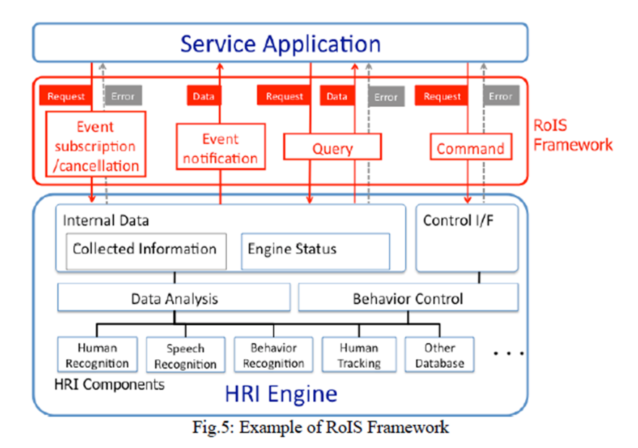

### Robot Servcie Ontology [RoSO] RFP

A new RFP of Robot Service Ontology[RoSO] currently being discussed in Robotics DTF are based on the concept of RoIS.

RoSO is aiming to define the specification (ontology) that clarifies the concept of a common vocabulary and / or a robot service in order to describe a service provided by a robot or exchange a description of a service provided by a service robot

Below is an example of HRI main component examples from this point of view.

**Table K-1 – (From RoIS 1.2) Basic HRI Components**

|  |  |
| --- | --- |
| **HRI Component Name** | **Description** |
| system information | Provides the information of the system such as status of the system and position of the physical unit. |
| person detection | Detects number of people |
| person localization | Detects position of people |
| person identification | Identifies ID (name) of people |
| face detection | Detects number of human faces |
| face localization | Detects position of human faces |
| sound detection | Detects number of sound sources |
| sound localization | Detects position of sound sources |
| speech recognition | Recognizes person’s speech |
| gesture recognition | Recognizes person’s gesture |
| speech synthesis | Generates robot speech |
| reaction | Performs specified reaction |
| navigation | Moves to specified target location |
| follow | Follows a specified target object |
| move | Moves to specified distance or curve |

**Interoperability between UPOS RCSD and RoIs**

**Rleationsihp between UPOS RCSD and RoIS**

OMG's Robotics standard provides a lower level control layer to manage Robot Device with finer granularity and higher accuracy to accommodate a wide range of industry applications.

On the other hand, the UPOS RCSD specification focuses on the functioning of robotic equipment within the retail store environment. In the UPOS RCSD specification robots are treated as peripheral equipment of the latest POS system. Therefore, the UPOS RCSD specification focuses on the definition of the interface between the POS and the robotic device.

RoIS is already existing as OMG standard and it defined a component frame service that was intended for robotic communication services with people.

Therefore, ROIS developed a general robot service framework, which is different from UPOS RCSD, but it is possible to describe the function of UPOS RCSD.

To confirm the compatibility and interoperability of the RCSD functions of RoIS and UPOS, both DTFs created and confirmed the function mapping table.

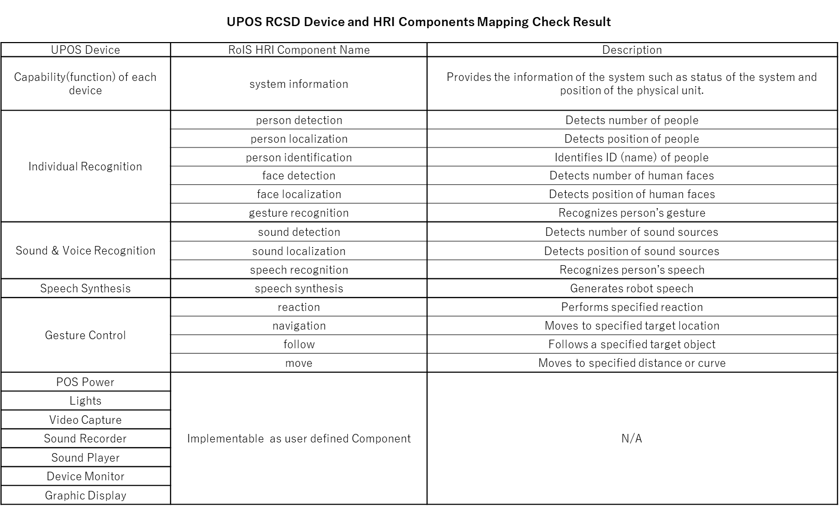For this purpose, we use the general RoIS HRI component defined in the RoIS 1.2 specification.

The two teams continue to collaborate between the part of their separate RFP’s and standards that will be established.

For that purpose, it is very necessary to understand the common vocabulary of the robot service and the needs of the ontology.

If each team’s specification satisfies the above mapping table, it is confirmed that the standard can be maintained independently.

In addition, the figure below shows a typical scenario where RCSD and RoIS work independently or in conjunction.

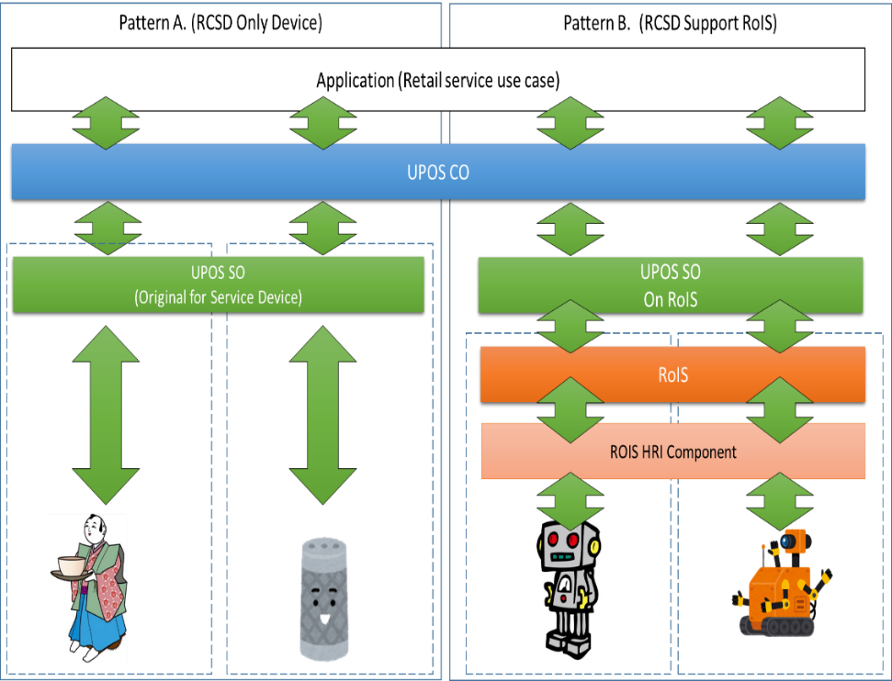

# 

# Document History

## Version History

|  |  |  |  |
| --- | --- | --- | --- |
| Ver | Date | Sections | Description of Change |
| 1.0 | 2019-2-18 |  | Initial Version – additions and updates to UPOS v1.15 |
| 1.1 | 2019-7-04 |  | Issues and Upates were included & corrected verion description |
| 1.2 | 2020-2-15 |  | Issues,Suggestion,Updates ware included & corrected version |

# Glossary

|  |  |
| --- | --- |
|  | |
| Term | Definition |
| **EVRW** | Electronic Value Reader Writer |
| **CAT** | Credit Authorization Terminal |
|  |  |