Annex C — Conventions for Representing an SBVR-Style Vocabulary as a Concept Model Diagram
(informative)

C.1 Introduction
The purpose of the diagrams in Clauses 7 through 21 is to display the vocabulary graphically in a manner that is directly and fully consistent with SBVR's approach to specifying the semantics of business vocabularies and business rules. This kind of diagram is commonly called a concept model diagram (or vocabulary diagram). A concept model diagram is used to convey a business vocabulary (e.g., the SBVR vocabulary) in a visual way that is easily understood by its audience.
NOTE: The concept model diagrams contained in Clauses 7–21 do not add any semantics whatsoever to the SBVR specification. They merely picture the semantics already stated in the terminological entries in these clauses, which are the normative source of the semantics.
Some of the conventions used for concept model diagramming in Clauses 7–21 of the SBVR specification may appear familiar to users of UML, but they do not represent UML and carry absolutely no UML semantics. Thus, the diagrams should not be interpreted through UML eyes.
The meaning of each graphic convention used in Clauses 7–21 is exactly and entirely as explained in this Annex and in the terminological entries in Clauses 7–21 for terms used in this Annex (e.g., some diagramming conventions are specified by reference to 'general noun concept' which is defined in Clause 11.1.3). These diagramming conventions and their use in Clauses 7–21 have absolutely nothing to do with Clause 23, which builds entirely on the semantics of the text in the Clause 7–21 terminological entries without reference to the diagrams.

C.2 General Noun Concepts
Each terminological entry for a fundamental concept (i.e., a general noun concept that has a term-styled headword and does not show "situational role" or "aspect" as a Concept Type) is depicted as follows.
In a concept model diagram, the primary term for the concept is shown as a rectangle, labeled with the concept's primary term. If there are additional terms for the concept (i.e., synonyms) they can be shown within the rectangle, identified as such using the prefix 'also:', as depicted in Figure C.1.
Terminological entry (box on the left):
community
group of people having a particular unifying characteristic in common
Terminological entry (box on the right):
note
representation that annotates or explains
remark
comment
Depicted as:
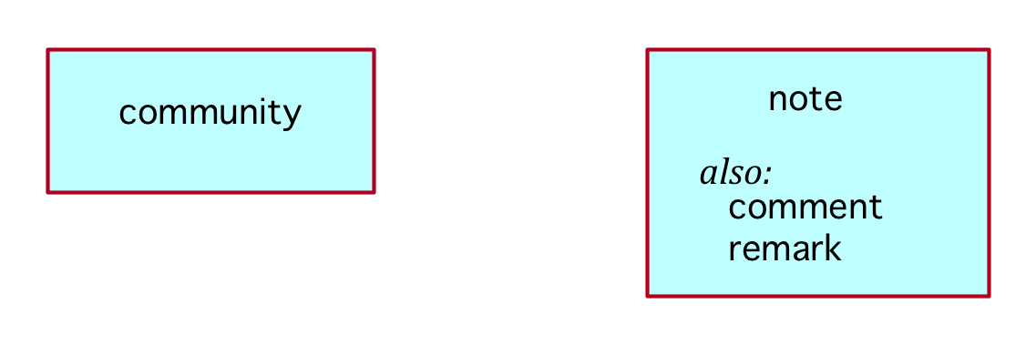
Figure C.1 — Two general concepts

C.3 Individual Noun Concepts
Each terminological entry for an individual noun concept (i.e., an entry that has a name-styled headword) is depicted as follows.
The name given to an individual noun concept is shown as a rectangle with rounded corners. Optionally, the name may be followed by the term for its general concept, surrounded by curly braces.
While it is possible to have additional names for a given individual noun concept (i.e., names that are synonyms) as terminological entries in a vocabulary, the nonprimary names of an individual noun concept are not typically reflected in a concept model diagram. Figure C.2 depicts two individual noun concepts.
Terminological entry (box on the left):
Kind of Guidance Statement
the categorization scheme of the concept 'guidance statement' that classifies a guidance statement based on the surface syntax of the guidance statement
Terminological entry (box on the right):
Euro
the unit of money used in most European Union countries
currency unit
unit of some currency
Euro, GB Pound, US Dollar
Depicted as:
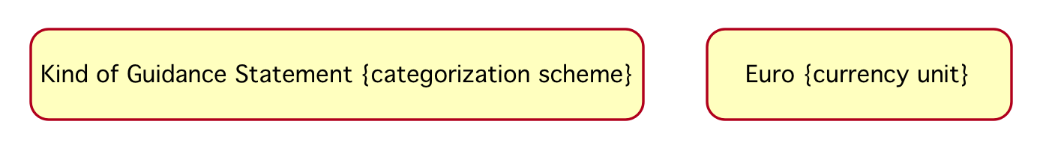
Figure C.2 — Two individual noun concepts
Alternatively, an individual noun concept can be depicted as a distinct kind of specialization of its related general concept (noun concept), as in Figure C.3.
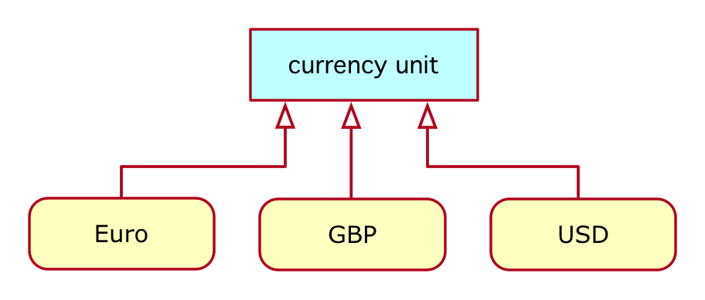
Figure C.3 — Three individual noun concepts, each as a distinct kind of specialization of a related general concept

C.4 Verb Concepts
Each terminological entry for a verb concept (i.e., an entry that has a verb-concept-wording-styled headword) is depicted as shown in one of the following sub clauses.

C.4.1 Binary Verb Concepts
Each terminological entry for a verb concept with exactly two verb concept roles — and no preferred verb concept wording with 'has' as its verb symbol — is depicted as follows.
The wording of a binary verb concept, other than one using 'has' (see C.4.2), is shown as a labeled line between rectangles. For clarity, the direction of the reading of the verb phrase is indicated with a solid arrowhead.
The wording of synonymous form(s) can also be shown in a concept model diagram. Figure C.4 illustrates two alternative presentations of a binary verb concept.
Terminological entry:
semantic community shares understanding of concept
concept has shared understanding by semantic community
Depicted (alternatively) as:
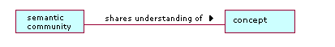
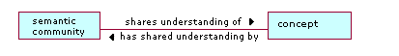
Figure C.4 — Three alternatives for presenting a binary verb concept
A 'starburst' symbol can be optionally used to emphasize that a line represents a verb concept. However, this symbol is usually omitted for binary verb concepts since their representation is straightforward except where objectified (see C.9). An explicit 'starburst' symbol is always used for nary and unary verb concepts (see C.4.3 and C.4.4).

C.4.2 Binary Verb Concepts using 'has'
Each terminological entry for a verb concept with exactly two verb concept roles and a preferred wording with 'has' as its verb symbol is depicted as follows.
For each verb concept wording that uses ‘has’, the verb symbol 'has' is omitted from the concept model diagram and the second role name is shown annotated on the end of the connection line. By this convention, a line with only an end term and no verb symbol (as shown in Figure C.5) is read as the verb symbol ‘has’ in the wording.
Terminological entries:
concept has necessary characteristic
necessary characteristic
role
characteristic that is always true of each instance of a given concept
Depicted as:
Figure C.5 — Depicting the verb concept 'concept has necessary characteristic'
Even when there is no specialized second role in a binary verb concept using 'has', the second role term is still reflected on the diagram adjacent to the rectangle, as illustrated in Figure C.6. This gives a consistent interpretation to an unlabeled line in a concept model diagram.
Terminological entries:
behavioral business rule has enforcement level
enforcement level
position in a graded or ordered scale of values that specifies the severity of action imposed in order to put or keep a behavioral business rule in force
Depicted as:
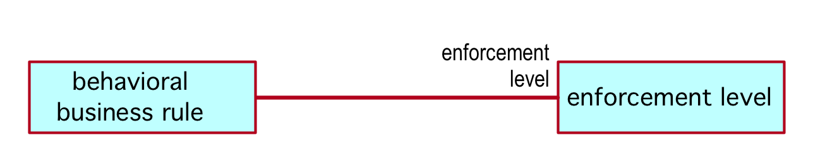
Figure C.6 — Depicting the verb concept 'behavioral business rule has enforcement level'

C.4.3 Verb Concepts with Arity of 3 or more
Each terminological entry for a verb concept with three or more verb concept roles is depicted as follows.
The diagramming convention used for a verb concept with more than two roles is a starburst with solid lines from its points to each noun concept rectangle. The full text of the primary verb concept wording is shown on the concept model diagram, adjacent to the starburst, with the placeholders underlined as shown in Figure C.7.
Terminological entry:
speech community adopts adopted definition citing reference
the speech community agrees that the definition identified by the reference can serve as the adopted definition
Depicted as:
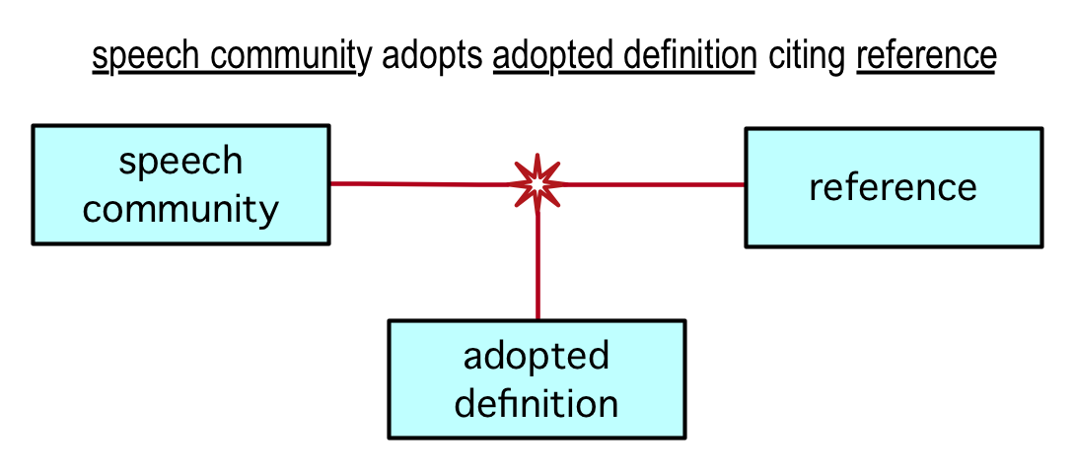
Figure C.7 — Depicting a verb concept with arity of three

C.4.4 Unary Verb Concepts
Each terminological entry for a verb concept with exactly one verb concept role (i.e., a unary verb concept) is depicted as follows.
The diagramming convention used for a verb concept with one role is a starburst with a solid line from one of its points to the subject noun concept rectangle and the verb phrase annotated adjacent to the starburst, as shown in Figure C.8.
Terminological entry:
element of governance is directly enforceable
violations of the element of governance can be detected without the need for additional interpretation of the element of governance
Depicted as:
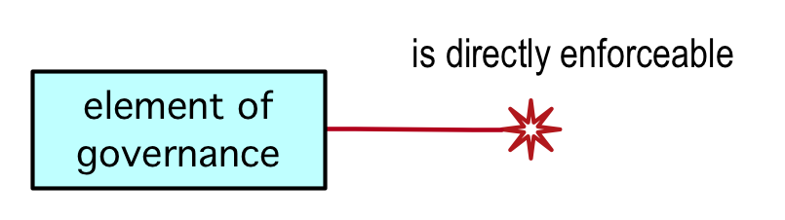
Figure C.8 — Depicting the unary verb concept 'element of governance is directly enforceable'

C.5 Roles
In SBVR, a 'role' is a kind of noun concept. Multiple appearances of the same role term annotated adjacent to a concept rectangle is interpreted as meaning the same role concept.

C.5.1 Role depicted as a Connection End Term
In a concept model diagram, a role concept's term is most often shown as a label at one end of the verb concept's connection line. Figure C.9 shows a verb concept wording that uses the role 'signifier' (which ranges over the noun concept 'expression').
Terminological entries:
speech community regulates its usage of signifier
signifier
role
expression that is a linguistic unit or pattern, such as a succession of speech sounds, written symbols or gestures, used in a designation of a concept
Depicted as:
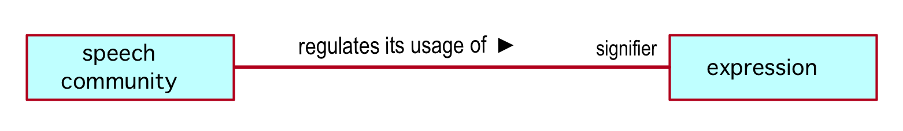
Figure C.9 — Depicting a role as a connection end term

C.5.2 Role depicted as a Concept Rectangle
Since a 'role' in SBVR is a concept in its own right it can also be depicted in a concept model diagram as a concept rectangle, with a «role» tag used to denote that its concept type is 'role', as illustrated in Figure C.10.
Terminological entry:
unitary noun concept
role
noun concept that corresponds to at most one thing at a time
Depicted as:
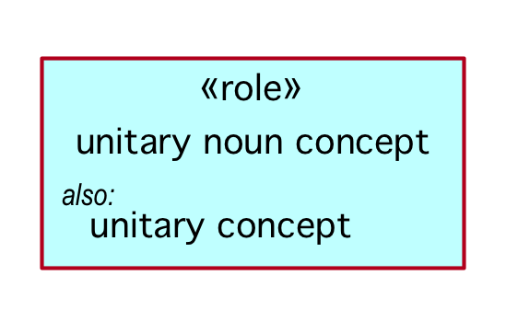
Figure C.10 — Depicting a role as a concept rectangle using the «role» tag

C.5.3 Term for a Role in a Verb Concept Wording
When a term for a role is used in a verb concept wording, and that wording is not an attributive form (e.g., "a has b"), then the term for the role needs to be shown as part of the text on the verb concept line. It is not shown as an association end because that would imply an attribute form (e.g., "has"). Instead, the term for the role is underlined and shown, along with the verbal part of the verb concept wording, as illustrated in Figure C.11.
Terminological entry:
variable is free within semantic formulation
semantic formulation includes variable without binding
the semantic formulation employs the variable, but does not introduce it
Depicted as:
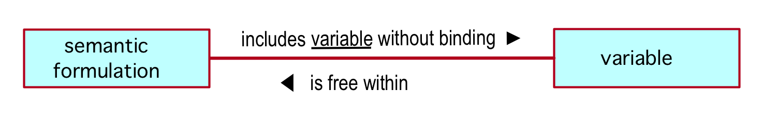
Figure C.11 — Example of a term for a role in a verb concept wording

C.6 Generalization / Specialization
The terminological entry for a concept that is a specialization (category) of a more general concept is depicted as follows.

C.6.1 Noun Concept Generalization / Specialization
The terminological entry for a noun concept can specify the concept's more general concept (the concept with the broader extension) in one of two forms:
- style the first term of the Definition text, which means that that designated concept is the defined concept's 'more general concept'
- use the 'General Concept' caption to specify a term that means the defined concept's 'more general concept'
In a concept model diagram, noun concept generalization is shown with the 'more general concept' and 'category' concept rectangles connected by a line with an arrowhead at the 'more general concept' end, as shown in Figure C.12.
Terminological entry (Form 1):
semantic community
community whose unifying characteristic is a shared understanding (perception) of the things that they have to deal with
Terminological entry (Form 2):
concept
unit of knowledge created by a unique combination of characteristics
meaning
Depicted as (for both Forms):
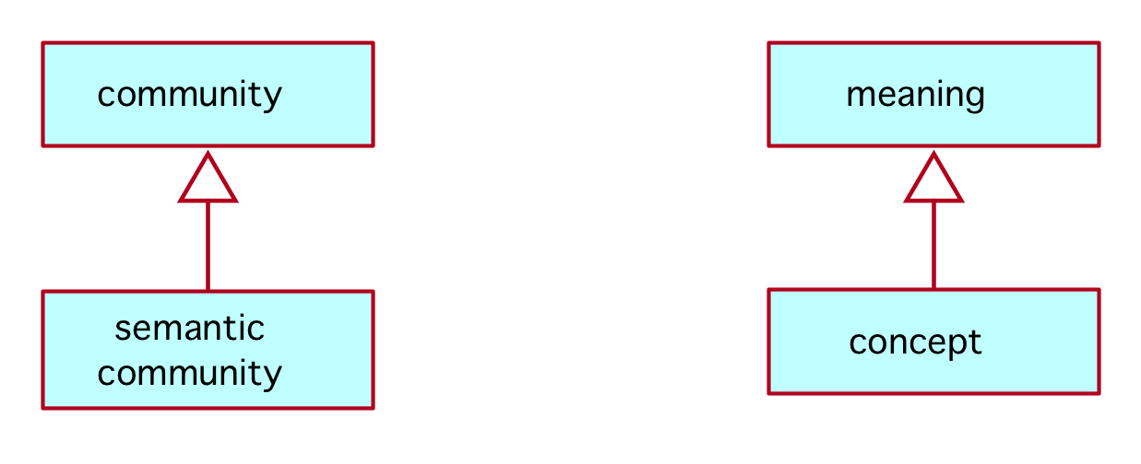
Figure C.12 — Two examples of noun concept generalization / specialization

C.6.2 Role Concept Generalization / Specialization
A role noun concept can be defined as a specialization of another role concept as follows.
As a noun concept, a role concept can be defined as a terminological entry using one of the two forms described in C.6.1. In a concept model diagram, role concept generalization is depicted by annotating the more specialized role as subsetting its more generalized concept, as shown in Figure C.13.
Terminological entries (Form 1):
implied characteristic
role
necessary characteristic of a given concept that is not incorporated by the concept
necessary characteristic
role
characteristic that is always true of each instance of a given concept
Depicted as:
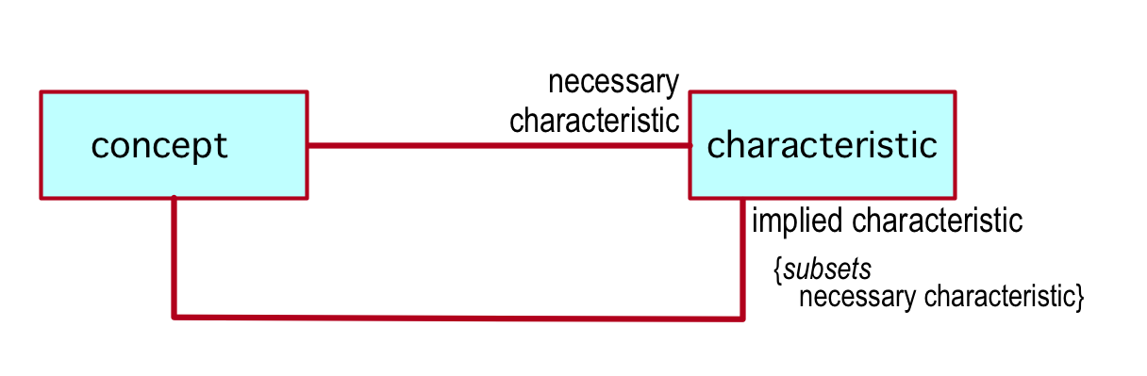
Figure C.13 — One role concept that specializes another

C.6.3 Verb Concept Generalization / Specialization
A verb concept can be defined as a specialization of another verb concept as follows.
The terminological entry for a verb concept can specify that it is a specialization of another verb concept by using the verb symbol of the more generalized verb concept in a fully-formal definition, as illustrated below. In a concept model diagram, verb concepts generalization is depicted by annotating the more specialized verb concept as subsetting its more generalized verb concept, as shown in Figure C.14.
Terminological entries:
closed semantic formulation formulates meaning
the meaning is structured by the closed semantic formulation
closed logical formulation means proposition
the closed logical formulation formulates the proposition
Depicted as:
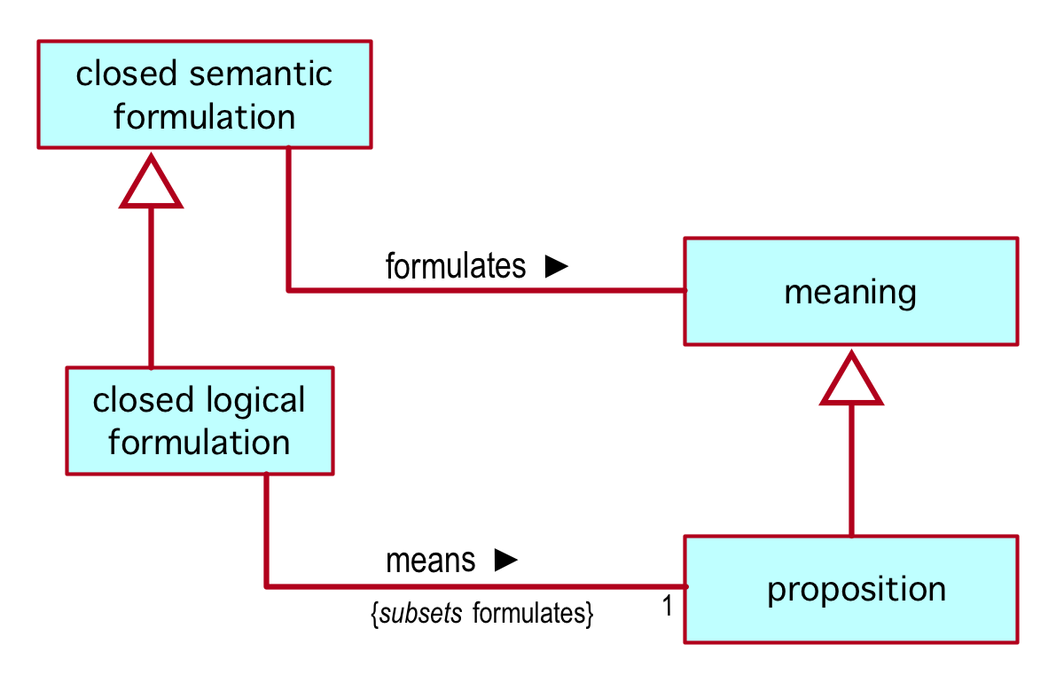
Figure C.14 — One verb concept that specializes another

C.7 Categorization
The terminological entry for a concept that specifies a scheme for organizing a set of concepts whose instances are partitioned based on some criterion is depicted as follows.

C.7.1 Categorization Schemes and Categories
Each terminological entry for a categorization scheme is presented as an entry that has a Name-styled headword that reflects the name of the scheme. The wording of the Definition text uses the pattern illustrated below. Each concept that is part of the scheme is specified using a Necessity, which is either part of the scheme's entry or the entry for the category concept.
In a concept model diagram, the name of a categorization scheme is annotated adjacent to the set of categories, e.g., 'Kind of Guidance Statement'.
Terminological entry:
Kind of Guidance Statement
the categorization scheme of the concept 'guidance statement' that classifies a guidance statement based on the surface syntax of the guidance statement
The concept 'business policy statement' is included in Kind of Guidance Statement.
The concept 'rule statement' is included in Kind of Guidance Statement.
The concept 'advice statement' is included in Kind of Guidance Statement.
Depicted as:
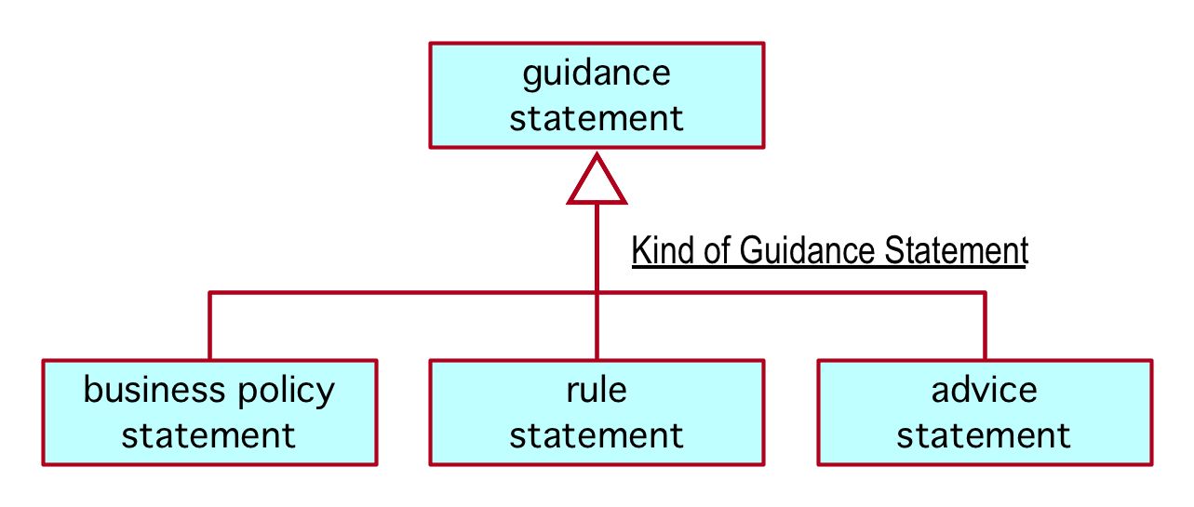
Figure C.15 — Depicting a categorization scheme
A set of categories specified as disjoint via definitional rules can be depicted as being mutually exclusive by bringing the generalization lines together, as shown in Figure C.16. Contrast this with the diagram on the right in Figure C.16, which reflects two independent specializations — i.e., a community can be both a semantic community and a speech community. There is no restriction indicated.
Terminological entries for a set of mutually-exclusive categories (diagram on the left):
term
verbal designation of a general concept that is in a given subject field
designation
name
verbal designation of an individual noun concept
designation
No name is a term.
Terminological entries for a set of independent specializations (diagram on the right):
designation
representation of a concept by a sign which denotes it
definition
representation of a concept by a descriptive statement [expression] which serves to differentiate it from related concepts
Depicted as:
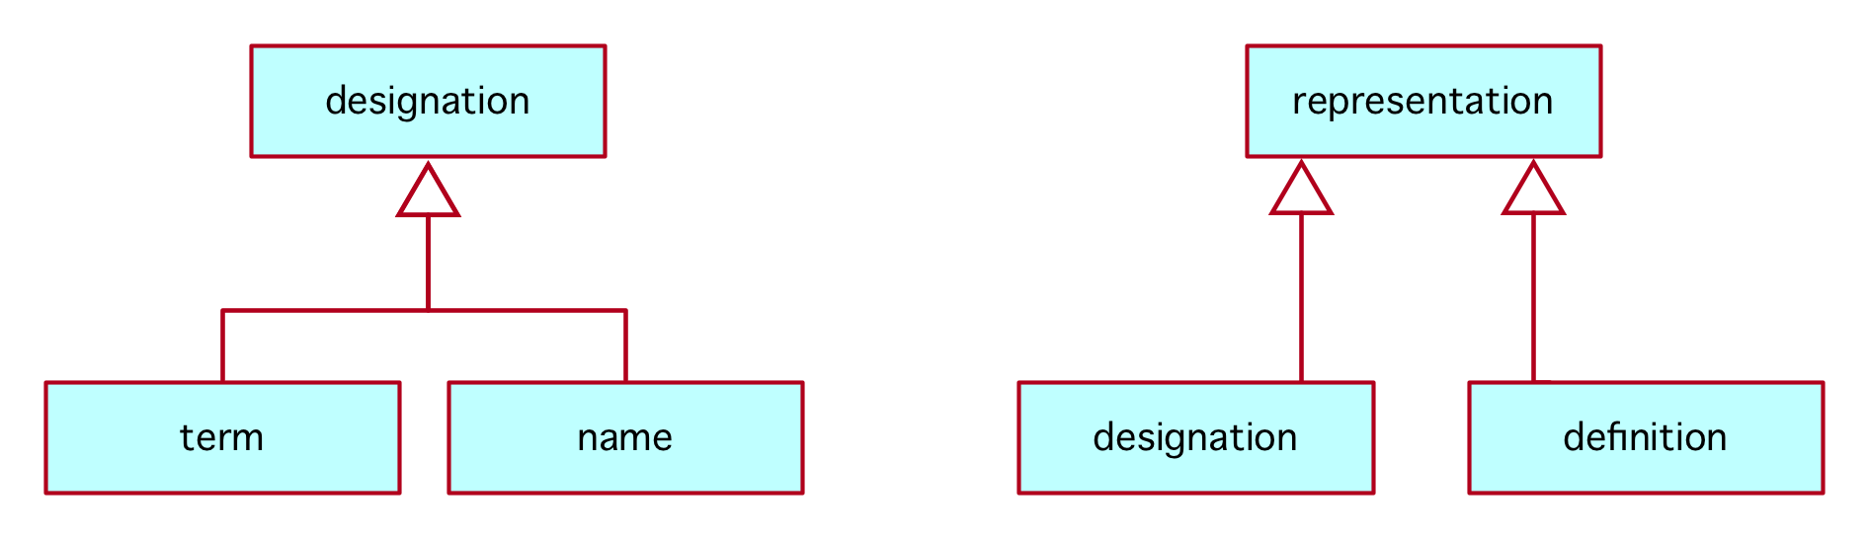
Figure C.16 — Depicting mutually-exclusive categories (diagram on the left) vs. independent specializations (diagram on the right)

C.7.2 Categories and Categorization Types (Concept Types)
It is not typical to show categorization types (concept types) in a concept model diagram but, when needed, a variation of the diagramming conventions described in C.7.1 has been adapted, as shown in C.17. The categories of the more general concept are shown in the typical way, with the addition of the categorization type term (surrounded by curly braces) annotated adjacent to the categorization line. The more general concept also reflects its 'has' verb concept connection to the categorization type concept.
Terminological entries:
rental rate type
categorization type
concept that specializes the concept 'rental rate' and that classifies a rental rate by its unit
rental rate
number of some currency unit that is used for calculating rental prices
rental rate has rental rate type
cash rental rate
rental rate that is a currency amount
rental rate type
points rental rate
rental rate that is a number of club points
rental rate type
Depicted as:
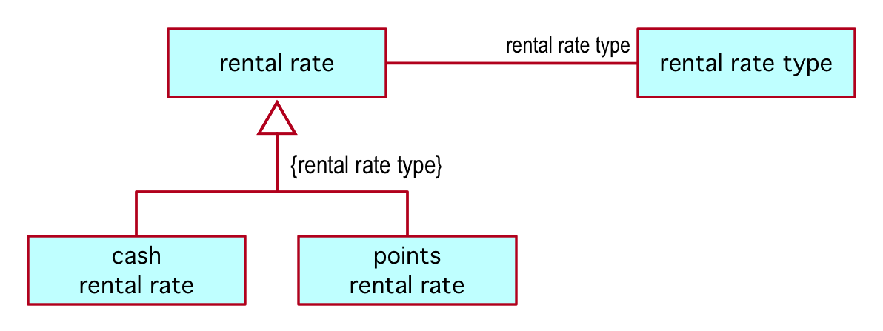
Figure C.17 — One example of depicting the categories specified by a categorization type

C.8 Partitive Verb Concept
Concept model diagrams depict concepts related by composition (a part/whole relationship) using a line connecting the part/whole boxes, annotated with a verb symbol conveying which concept is the 'part' and which the 'whole' in the relationship. SBVR specifies no particular verb symbol to mean part/whole, but some typical verb symbols used are 'includes', 'contains', 'is in', 'is composed of'.
The diagram on the left of Figure C.18 shows the verb symbols for the partitive verb concepts that 'body of shared meanings' is involved in. The left diagram also illustrates the use of a different the verb symbol, 'contains', for a partitive connection.
Note that the subscripts in the verb concept wording of the terminological entry are not reflected on the diagram.
The diagram on the right of Figure C.18 shows a third verb symbol often used for a partitive connection.
Terminological entries (for the diagram on the left):
body of shared meanings includes body of shared concepts
body of shared meanings includes body of shared guidance
body of shared meanings₁ contains body of shared meanings₂
Terminological entry (for the diagram on the right):
thing is in set
Depicted as:
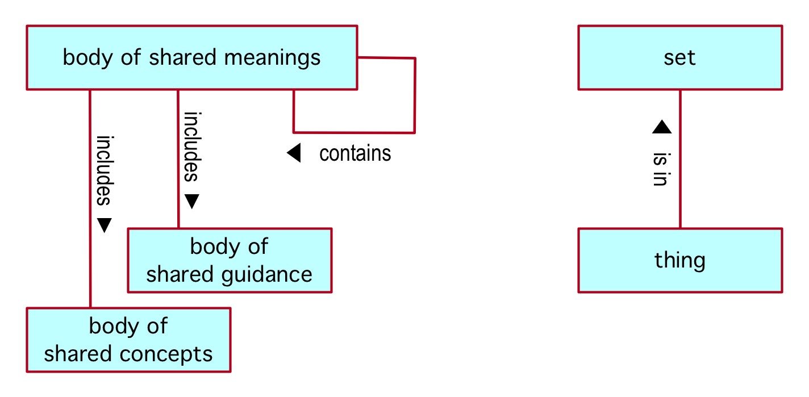
Figure C.18 — Two examples of partitive verb concept

C.9 Verb Concept Objectification
Verb concept objectification pairs two terminological entries, one for a verb concept and the second for the general noun concept that objectifies the verb concept. These two entries are for coextensive concepts; even though these are distinct entries in the vocabulary, they have the same instances.
The verb concept starburst is used to depict objectification in a concept model diagram as follows: A starburst is connected by solid lines to the noun concepts involved in the verb concept; a dashed line connects the verb concept starburst to the related noun concept (the objectification). This is shown in Figure C.19.
Terminological entries:
rented car is recovered from recovery location to branch
the rented car of a rental is reclaimed from the recovery location and taken to the nearest convenient branch
car recovery
actuality that a given rented car is recovered from a given recovery location to a given branch
Depicted as:
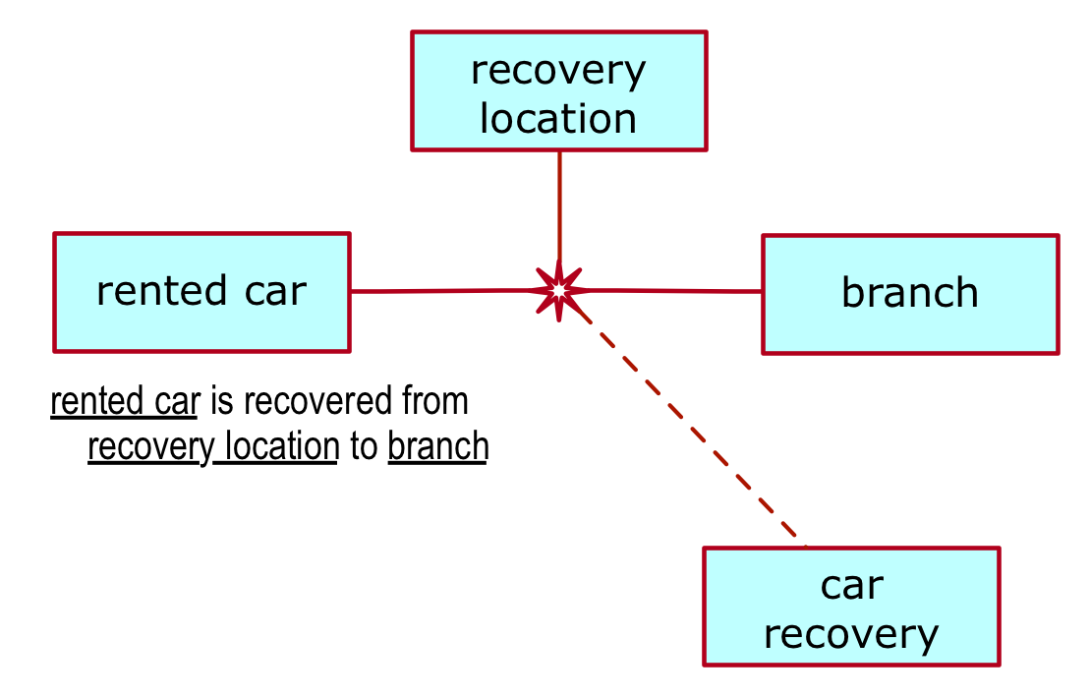
Figure C.19 — Depicting verb concept objectification
The same convention is used when the objectified verb concept is binary, as shown in Figure C.20.
Terminological entries:
expression represents meaning
the expression portrays or signifies the meaning
representation
actuality that a given expression represents a given meaning
Depicted as:
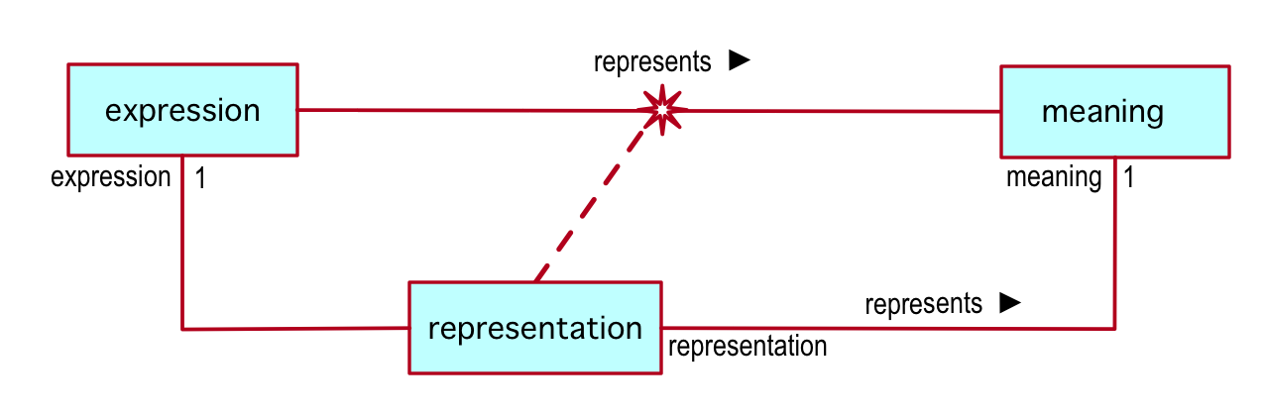
Figure C.20 — Depicting verb concept objectification of a binary verb concept

C.10 Multiplicities
Multiplicity is annotated in a diagram only to reflect a formally-stated restriction on multiplicity in a definition or a definitional rule involving a verb concept. If no multiplicity restriction appears at the end of a line representing a verb concept, the implication is that no restrictions are specified in the terminological entries being depicted. In other words, absence means no minimum and/or maximum restriction applies.
Annex A.2.1.1 documents the SBVR Structured English keywords that are used for the expression of multiplicities in terminological entries. The table in Figure 21 shows those keywords along with the corresponding text used in a concept model diagram.
SBVR Structured English Keyword | Kind of Logical Formulation | Concept Model Diagram Annotation
at least one | existential quantification | MIN 1
at least n | at-least-n quantification | MIN n
at most one | at-most-one quantification | MAX 1
at most n | at-most-n quantification | MAX n
exactly one | exactly-one quantification | 1
exactly n | exactly-n quantification | n
at least n and at most m | numeric range quantification | MIN n, MAX m
more than one | at-least-n quantification with n = 2 | MIN 2
Figure C.21 — Multiplicity keywords and their concept model diagram representation
Figure 22 illustrates the use of keywords in three definitional rules and the corresponding annotations in a concept model diagram.
Terminological entry:
Each placeholder is in exactly one verb concept wording.
Each verb concept wording has at least one placeholder.
Each placeholder has at most one starting character position.
Depicted (alternatively) as:
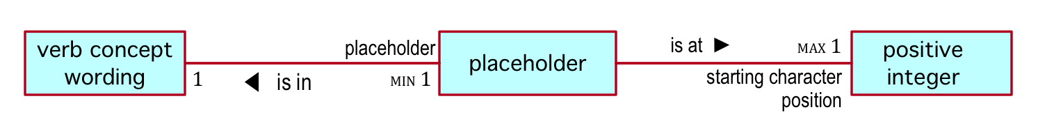
Figure C.22 — Multiplicities in a concept model diagram

