OMG Document bmi/2008-02-XX

6.1 Introduction
Add a bullet point after “DRDs may also contain any number of artifacts representing annotations of the diagram:”
A Group is a visual mechanism to group elements of a diagram informally.

6.2 Notation
Add a row to the end of Table 1
Artifacts | Group | A Group consists of a rounded corner rectangle drawn with a solid dashed line that groups element together informally.

6.3.2 Definitions Metamodel
Replace Figure 6.11 with this figure.
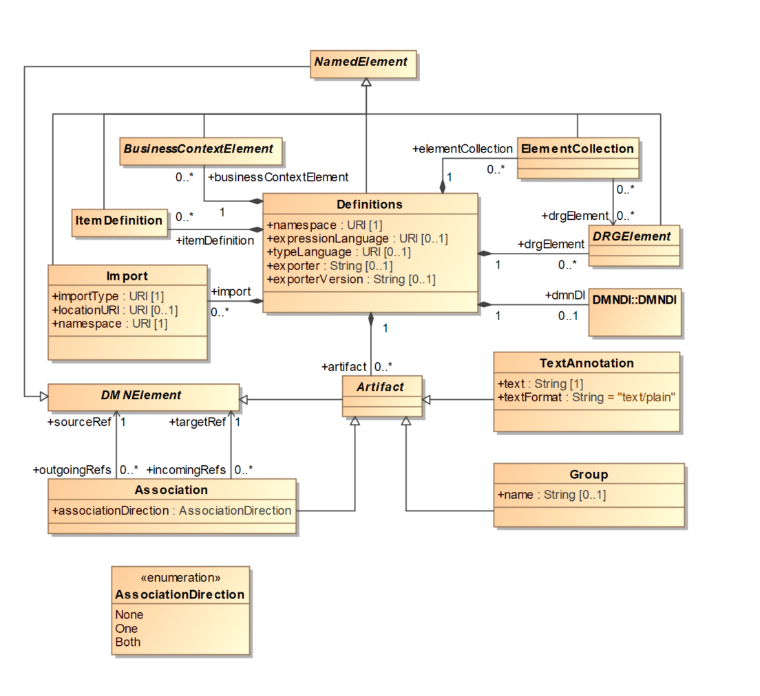
Table 5: Definitions attributes and model associations:
Row 11 (Artifact): Replace Description with “Artifacts include text annotations, groups, and associations among DMN elements.”

6.3.6 Artifacts Metamodel
First paragraph of section. Replace second sentence with “DMN provides three standard Artifacts: Association, Group, and Text Annotation.”
Add new section after the Association Section.

6.3.6.2 Group
The Group object is an Artifact that provides a visual mechanism to group elements of a diagram informally. Groups are often used to highlight certain sections of a Diagram without adding additional constraints for performance. The highlighted (grouped) section of the Diagram can be separated for reporting and analysis purposes. Groups do not affect the execution of the Decisions.
As an Artifact, a Group is not a DRGElement, and, therefore, cannot be connected to/from an Information Requirement, Knowledge Requirement, or Authority Requirement. It can only be connected to/from an Association.
The Group element inherits the attributes and model associations of Artifact. Table XX presents the additional attributes and model associations for an Association.
Table XX: Group model associations:
Attribute | Description
name: String[0..1] | The descriptive name of the element.

13.4.6 DMNShape [Class]
Table 80: DMNShape attributes:
Row 2 (dmnElementRef): Replace Description with “A reference to a Decision, a Business Knowledge Model, an Input Data element, a Knowledge Source, a Decision Service, Group or a Text Annotation MUST be specified.”

13.5.2 DMNShape Resolution
Replace the first paragraph with
DMNShape can be used to represent a Decision, a Business Knowledge Model, an Input Data element, a Knowledge Source, a Text Annotation, a Group and a Decision Service.

13.5.2.5 Artifacts
Table 88: Depiction Resolution of Artifacts
Add the following row to the table (after the first row).
Group | None | Group

Schemas

Group
<xsd:element name="group" type="tGroup" substitutionGroup="artifact"/>
<xsd:complexType name="tGroup">
<xsd:complexContent>
<xsd:extension base="tArtifact">
<xsd:attribute name="name" type="xsd:string" use="optional"/>
</xsd:extension>
</xsd:complexContent>
</xsd:complexType>

