Disposition: Resolved

OMG Issue No: SBVR 15-46
Legacy Issue Number: 18890
Title: Missing "Concept Type" in 'at least n quantification'
Source:
NIST (Mr. Edward J. Barkmeyer, edbark(at)nist.gov)
Summary:
In SBVR clause 8.x, in the entry for 'at least n quantification', the Definition ends with the term ‘logical fomulation kind’, which makes no sense in the context.
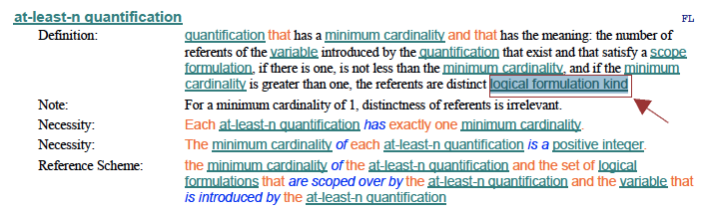
What was intended is a new paragraph:
Concept Type: logical formulation kind
Resolution:
Remove the errant text from the end of the Definition, and add a new line for "Concept Type: logical formulation kind".
Revised Text:
In SBVR 1.4, Clause 21.3.6 (pg. 161), in the entry for 'at-least-n quantification'
• remove the text "logical formulation kind" from the end of the Definition text
• add the following, immediately after the Definition:
logical formulation kind
Disposition: Resolved

