Disposition: Resolved

OMG Issue No: SBVR 15-11
Legacy Issue Number: 19519
Title: Role: Ranges Over Vs. Specializes, Generalizes
Source:
USoft (Mr. Rob van Haarst, rob.van.haarst(at)usoft.com)
Summary:
Clause 8, entry for ‘role’. Should the addition at the end of the second Example text: "(which generalizes the role)" read: "(which the role ranges over)"?
As I understand it, you mean to say that the role shipment ranges over the general concept shipment. The reverse reading of "ranges over" is not "generalizes" (there is a specific Note at the lemma "role ranges over general concept" that warns against this confusion).
Resolution:
In the second example given for 'role', change the end from reading "(which generalizes the role)" to "(which the role ranges over)"
Revised Text:
In SBVR 1.4, Clause 11.1.3 (pg. 48), replace "(which generalizes the role)” with "(which the role ranges over)".
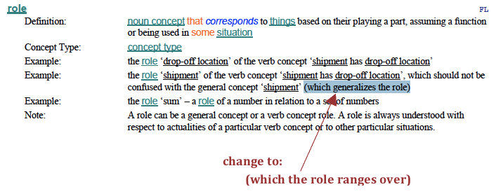
Disposition: Resolved

