Proposal:

Summary
- Editorial clean-up
- Remove quotes from context names
- Content of Figure 10.16 FEEL latice type
- Grammar change to support more types in instanceof

Details
The changes are baselined on DMN 1.2/Beta1 dtc-18-06-01.pdf.

Position:
Page 116 Paragraph 10.3.2.9

Replace reference

(see Figure <***> )

with

(see Figure 10.16)

Position:
Page 117 Table 39

Replace table

e | type(e)
123 | number
True | boolean
"abc" | string
date("2017-01-01") | date
["a", "b", "c"] | list<string>
["a", true, 123] | list<Any>
{"name": "Peter", "age": 30} | context<”age”:number, “name”:string>
function f(x: number, y: number) x + y | (number, number) → number
DecisionA  where the typeRef of DecisionA is  <itemDefinition name="Employee">  <itemComponent name="id">  <typeRef>number</typeRef>  </itemComponent>  <itemComponentname="name">  <typeRef>string</typeRef>  </itemComponent>  </itemDefinition> | context<”id”:number, “name”:string>
BkmA  where the encapsulated logic is  <encapsulatedLogic>  <formalParameter name="x" typeRef="number"/>  <formalParameter name="y" typeRef="number"/>  <literalExpression typeRef="number">  <text>x + y</text>  </literalExpression>  </encapsulatedLogic> | (number, number) → number

with table

e | type(e)
123 | number
true | boolean
"abc" | string
date("2017-01-01") | date
["a", "b", "c"] | list<string>
["a", true, 123] | list<Any>
{name: "Peter", age: 30} | context<age:number, name:string>
function f(x: number, y: number) x + y | (number, number) → number
DecisionA  where the typeRef of DecisionA is  <itemDefinition name="Employee">  <itemComponent name="id">  <typeRef>number</typeRef>  </itemComponent>  <itemComponentname="name">  <typeRef>string</typeRef>  </itemComponent>  </itemDefinition> | context<id:number, name:string>
BkmA  where the encapsulated logic is  <encapsulatedLogic>  <formalParameter name="x" typeRef="number"/>  <formalParameter name="y" typeRef="number"/>  <literalExpression typeRef="number">  <text>x + y</text>  </literalExpression>  </encapsulatedLogic> | (number, number) → number

Position:
Page 118 Paragraph 10.3.2.9.1

Replace paragraph (remove quotes from names)

- Two context types context<”k₁”: T₁, …, ”k_{n}”: T_{n}> and context<”l₁”: S₁, …, ”l_{m}”: S_{m}> are equivalent iff n = m and for every k_{i} :T_{i} there is a unique l_{j} :S_{j} such that k_{i} = l_{j} and T_{i} ≡ S_{j} for i = 1, n. Context types are the types defined via ItemDefinitions or the types associated to FEEL context literals such as { “name”: “John”, “age”: 25}.

with

- Two context types context<k₁: T₁, …, k_{n}: T_{n}> and context<l₁: S₁, …, l_{m}: S_{m}> are equivalent iff n = m and for every k_{i} :T_{i} there is a unique l_{j} :S_{j} such that k_{i} = l_{j} and T_{i} ≡ S_{j} for i = 1, n. Context types are the types defined via ItemDefinitions or the types associated to FEEL context literals such as { name: “John”, age: 25}.

Position:
Page 118 Paragraph 10.3.2.9.2

Replace paragraph (remove quotes from names)

- Two context types context<”k₁”: T₁, …, ”k_{n}”: T_{n}> and context<”l₁”: S₁, …, ”l_{m}”: S_{m}> are equivalent iff n = m and for every k_{i} :T_{i} there is a unique l_{j} :S_{j} such that k_{i} = l_{j} and T_{i} ≡ S_{j} for i = 1, n. Context types are the types defined via ItemDefinitions or the types associated to FEEL context literals such as { “name”: “John”, “age”: 25}.

with

- Two context types context<k₁: T₁, …, k_{n}: T_{n}> and context<l₁: S₁, …, l_{m}: S_{m}> are equivalent iff n = m and for every k_{i} :T_{i} there is a unique l_{j} :S_{j} such that k_{i} = l_{j} and T_{i} ≡ S_{j} for i = 1, n. Context types are the types defined via ItemDefinitions or the types associated to FEEL context literals such as { name: “John”, age: 25}.

Position:
Page 118 Figure 10.16

Replace content of figure

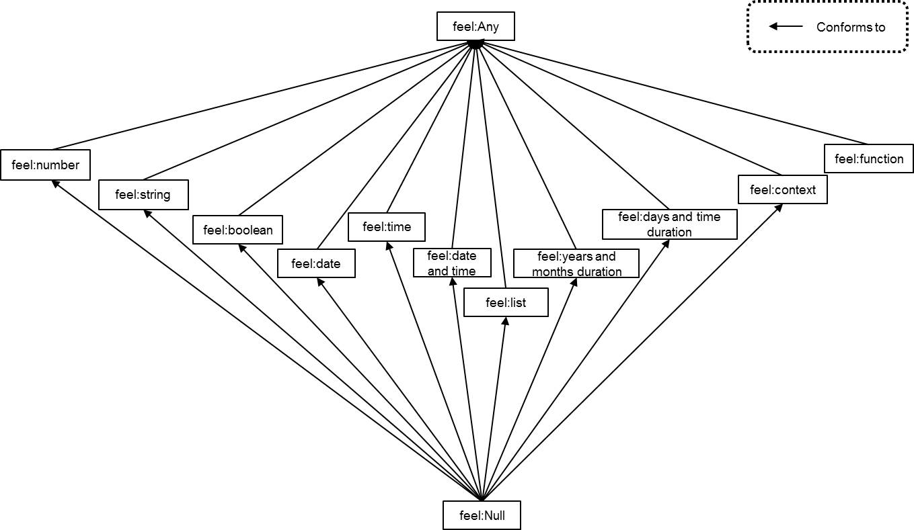

with

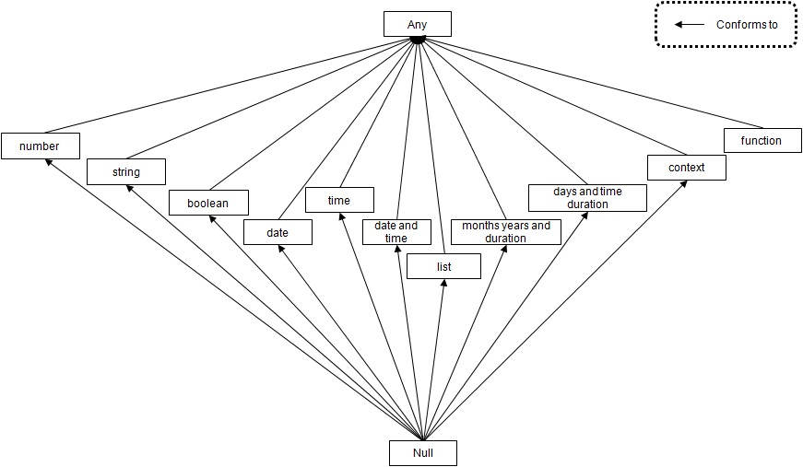

Position:
Page 134

Replace paragraph
Type-checking is defined in Table 56. Note that type is not mapped to the domain, and null is not the name of a type, and null is not an instance of any type.

with

Type-checking is defined in Table 56. Note that type is not mapped to the domain, and null is the only value in the Null type (see 10.3.2.1).

Position:
Page 111

Replace production

54. type = qualified name ;

with

54. type =
qualified name |
'list' '<' type '>' |
'context' '<' name ':' type { ',' name ':' type } '>' |
'function' '<' [ type { ', ' type } ] '>' '->' type
;

