Disposition: Resolved

OMG Issue No: SBVR 15-98
Legacy Issue Number: 19901
Title: Correct the styling errors in Definition text
Source:
Keri Anderson Healy (keri_ah@mac.com)
Summary:
Correctly style the text at the end of the Definition text of two entries on p. 36. The styling should not be all in ’keyword’ style.
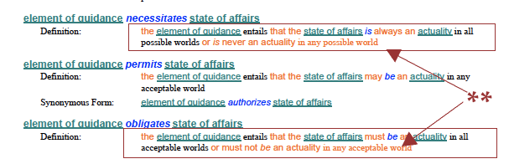
Resolution:
The Definition text for the entries "element of guidance necessitates state of affairs" and "element of guidance obligates state of affairs" has some incorrect styling. Make the corrections.
Revised Text:
On printed p. 36, REPLACE the Definition for the entry “element of guidance necessitates state of affairs” — from:
the element of guidance entails that the state of affairs is always an actuality in all possible worlds or is never an actuality in any possible world
with
the element of guidance entails that the state of affairs is always an actuality in all possible worlds or is never an actuality in any possible world
On printed p. 36, REPLACE the Definition for the entry “element of guidance obligates state of affairs” — from:
the element of guidance entails that the state of affairs must be an actuality in all acceptable worlds or must not be an actuality in any acceptable world
with
the element of guidance entails that the state of affairs must be an actuality in all acceptable worlds or must not be an actuality in any acceptable world
Disposition: Resolved

