May 2018


Decision Model and Notation
Version 1.2 DRAFT
__________________________________________________
OMG Document Number: formal/2016-06-01
Standard document URL: http://www.omg.org/spec/DMN/1.1
Normative Machine Consumable File(s):
http://www.omg.org/spec/DMN/20151101/dmn.xmi
http://www.omg.org/spec/DMN/20151101/dmn.xsd
Informative Machine Consumable File(s):
http://www.omg.org/spec/DMN/20151101/ch11example.xml
________________________________________________

Copyright © 2013, Decision Management Solutions
Copyright © 2013, Escape Velocity LLC
Copyright © 2013, Fair Isaac Corporation
Copyright © 2013, International Business Machines Corporation
Copyright © 2013, Knowledge Partners International
Copyright © 2013, KU Leuven
Copyright © 2013, Model Systems Limited
Copyright © 2013, Oracle Incorporated
Copyright © 2013, TIBCO Software Inc.
Copyright © 2016, Object Management Group, Inc.

USE OF SPECIFICATION - TERMS, CONDITIONS & NOTICES
The material in this document details an Object Management Group specification in accordance with the terms, conditions and notices set forth below. This document does not represent a commitment to implement any portion of this specification in any company's products. The information contained in this document is subject to change without notice.

LICENSES
The companies listed above have granted to the Object Management Group, Inc. (OMG) a nonexclusive, royalty-free, paid up, worldwide license to copy and distribute this document and to modify this document and distribute copies of the modified version. Each of the copyright holders listed above has agreed that no person shall be deemed to have infringed the copyright in the included material of any such copyright holder by reason of having used the specification set forth herein or having conformed any computer software to the specification.

Subject to all of the terms and conditions below, the owners of the copyright in this specification hereby grant you a fully-paid up, non-exclusive, nontransferable, perpetual, worldwide license (without the right to sublicense), to use this specification to create and distribute software and special purpose specifications that are based upon this specification, and to use, copy, and distribute this specification as provided under the Copyright Act; provided that: (1) both the copyright notice identified above and this permission notice appear on any copies of this specification; (2) the use of the specifications is for informational purposes and will not be copied or posted on any network computer or broadcast in any media and will not be otherwise resold or transferred for commercial purposes; and (3) no modifications are made to this specification. This limited permission automatically terminates without notice if you breach any of these terms or conditions. Upon termination, you will destroy immediately any copies of the specifications in your possession or control.

PATENTS
The attention of adopters is directed to the possibility that compliance with or adoption of OMG specifications may require use of an invention covered by patent rights. OMG shall not be responsible for identifying patents for which a license may be required by any OMG specification, or for conducting legal inquiries into the legal validity or scope of those patents that are brought to its attention. OMG specifications are prospective and advisory only. Prospective users are responsible for protecting themselves against liability for infringement of patents.

GENERAL USE RESTRICTIONS
Any unauthorized use of this specification may violate copyright laws, trademark laws, and communications regulations and statutes. This document contains information which is protected by copyright. All Rights Reserved. No part of this work covered by copyright herein may be reproduced or used in any form or by any means--graphic, electronic, or mechanical, including photocopying, recording, taping, or information storage and retrieval systems--without permission of the copyright owner.

DISCLAIMER OF WARRANTY

WHILE THIS PUBLICATION IS BELIEVED TO BE ACCURATE, IT IS PROVIDED "AS IS" AND MAY CONTAIN ERRORS OR MISPRINTS. THE OBJECT MANAGEMENT GROUP AND THE COMPANIES LISTED ABOVE MAKE NO WARRANTY OF ANY KIND, EXPRESS OR IMPLIED, WITH REGARD TO THIS PUBLICATION, INCLUDING BUT NOT LIMITED TO ANY WARRANTY OF TITLE OR OWNERSHIP, IMPLIED WARRANTY OF MERCHANTABILITY OR WARRANTY OF FITNESS FOR A PARTICULAR PURPOSE OR USE. IN NO EVENT SHALL THE OBJECT MANAGEMENT GROUP OR ANY OF THE COMPANIES LISTED ABOVE BE LIABLE FOR ERRORS CONTAINED HEREIN OR FOR DIRECT, INDIRECT, INCIDENTAL, SPECIAL, CONSEQUENTIAL, RELIANCE OR COVER DAMAGES, INCLUDING LOSS OF PROFITS, REVENUE, DATA OR USE, INCURRED BY ANY USER OR ANY THIRD PARTY IN CONNECTION WITH THE FURNISHING, PERFORMANCE, OR USE OF THIS MATERIAL, EVEN IF ADVISED OF THE POSSIBILITY OF SUCH DAMAGES.

The entire risk as to the quality and performance of software developed using this specification is borne by you. This disclaimer of warranty constitutes an essential part of the license granted to you to use this specification.

RESTRICTED RIGHTS LEGEND

Use, duplication or disclosure by the U.S. Government is subject to the restrictions set forth in subparagraph (c) (1) (ii) of The Rights in Technical Data and Computer Software Clause at DFARS 252.227-7013 or in subparagraph (c)(1) and (2) of the Commercial Computer Software - Restricted Rights clauses at 48 C.F.R. 52.227-19 or as specified in 48 C.F.R. 227-7202-2 of the DoD F.A.R. Supplement and its successors, or as specified in 48 C.F.R. 12.212 of the Federal Acquisition Regulations and its successors, as applicable. The specification copyright owners are as indicated above and may be contacted through the Object Management Group, 109 Highland Avenue, Needham, MA 02494, U.S.A.

TRADEMARKS

CORBA®, CORBA logos®, FIBO®, Financial Industry Business Ontology®, FINANCIAL INSTRUMENT GLOBAL IDENTIFIER®, IIOP®, IMM®, Model Driven Architecture®, MDA®, Object Management Group®, OMG®, OMG Logo®, SoaML®, SOAML®, SysML®, UAF®, Unified Modeling Language®, UML®, UML Cube Logo®, VSIPL®, and XMI® are registered trademarks of the Object Management Group, Inc.
For a complete list of trademarks, see: http://www.omg.org/legal/tm_list.htm. All other products or company names mentioned are used for identification purposes only, and may be trademarks of their respective owners.

COMPLIANCE

The copyright holders listed above acknowledge that the Object Management Group (acting itself or through its designees) is and shall at all times be the sole entity that may authorize developers, suppliers and sellers of computer software to use certification marks, trademarks or other special designations to indicate compliance with these materials.

Software developed under the terms of this license may claim compliance or conformance with this specification if and only if the software compliance is of a nature fully matching the applicable compliance points as stated in the specification. Software developed only partially matching the applicable compliance points may claim only that the software was based on this specification, but may not claim compliance or conformance with this specification. In the event that testing suites are implemented or approved by Object Management Group, Inc., software developed using this specification may claim compliance or conformance with the specification only if the software satisfactorily completes the testing suites.

OMG’s Issue Reporting Procedure

All OMG specifications are subject to continuous review and improvement. As part of this process we encourage readers to report any ambiguities, inconsistencies, or inaccuracies they may find by completing the Issue Reporting Form listed on the main web page http://www.omg.org, under Documents, Report a Bug/Issue.

Contents

1 Scope 11
2 Conformance 13
2.1 Conformance levels 13
2.2 General conformance requirement 13
2.2.1 Visual appearance 13
2.2.2 Decision semantics 14
2.2.3 Attributes and model associations 14
3 References 15
3.1 Normative 15
3.2 Non-normative 16
4 Additional Information 19
4.1 Acknowledgements 19
4.2 IPR and Patents 19
4.3 Guide to the Specification 19
5 Introduction to DMN 21
5.1 Context 21
5.2 Scope and uses of DMN 23
5.2.1 Modeling human decision-making 24
5.2.2 Modeling requirements for automated decision-making 24
5.2.3 Implementing automated decision-making 25
5.2.4 Combining applications of modeling 25
5.3 Basic concepts 26
5.3.1 Decision requirements level 26
5.3.2 Decision logic level 28
5.3.3 Decision services 29
6 Requirements (DRG and DRD) 33
6.1 Introduction 33
6.2 Notation 33
6.2.1 DRD Elements 35
6.2.2 DRD Requirements 36
6.2.3 Connection rules 38
6.2.4 Partial views and hidden information 39
6.2.5 Decision service 40
6.3 Metamodel 43
6.3.1 DMN Element metamodel 43
6.3.2 Definitions metamodel 44
6.3.3 Import metamodel 46
6.3.4 Element Collection metamodel 47
6.3.5 DRG Element metamodel 47
6.3.6 Artifact metamodel 48
6.3.7 Decision metamodel 49
6.3.8 Business Context Element metamodel 52
6.3.9 Business Knowledge Model metamodel 54
6.3.10 Decision service metamodel 56
6.3.11 Input Data metamodel 58
6.3.12 Knowledge Source metamodel 59
6.3.13 Information Requirement metamodel 60
6.3.14 Knowledge Requirement metamodel 61
6.3.15 Authority Requirement metamodel 61
6.3.16 Extensibility 62
6.4 Examples 63
7 Relating Decision Logic to Decision Requirements 65
7.1 Introduction 65
7.2 Notation 67
7.2.1 Expressions 67
7.2.2 Boxed literal expression 68
7.2.3 Boxed invocation 69
7.3 Metamodel 69
7.3.1 Expression metamodel 70
7.3.2 ItemDefinition metamodel 71
7.3.3 InformationItem metamodel 73
8 Decision Table 77
8.1 Introduction 77
8.2 Notation 80
8.2.1 Line style and color 81
8.2.2 Table orientation 81
8.2.3 Input expressions 83
8.2.4 Input values 84
8.2.5 Information Item names, output labels, and output component names 84
8.2.6 Multiple outputs 84
8.2.7 Input entries 85
8.2.8 Merged input entry cells 85
8.2.9 Output entry 86
8.2.10 Hit policy 87
8.2.11 Default output values 89
8.3 Metamodel 90
8.3.1 Decision Table metamodel 90
8.3.2 Decision Table Input and Output metamodel 92
8.3.3 Decision Rule metamodel 93
8.4 Examples 94
9 Simple Expression Language (S-FEEL) 98
9.1 Introduction 98
9.2 S-FEEL syntax 98
9.3 S-FEEL data types 99
9.4 S-FEEL semantics 100
9.5 Use of S-FEEL expressions 101
9.5.1 Item definitions 101
9.5.2 Invocations 101
9.5.3 Decision tables 101
10 Expression Language (FEEL) 102
10.1 Introduction 102
10.2 Notation 102
10.2.1 Boxed Expressions 102
10.2.2 FEEL 109
10.3 Full FEEL Syntax and Semantics 110
10.3.1 Syntax 111
Symbol S is defined in terms of symbol S₁ 111
10.3.2 Semantics 116
10.3.3 XML Data 142
10.3.4 Built-in functions 145
10.4 Execution Semantics of Decision Services 151
10.5 Metamodel 153
10.5.1 Context metamodel 153
10.5.2 ContextEntry metamodel 154
10.5.3 FunctionDefinition metamodel 154
10.5.4 List metamodel 155
10.5.5 Relation metamodel 155
10.6 Examples 155
10.6.1 Context 156
10.6.2 Calculation 156
10.6.3 If, In 157
10.6.4 Sum entries of a list 157
10.6.5 Invocation of user-defined PMT function 157
10.6.6 Sum weights of recent credit history 157
10.6.7 Determine if credit history contain a bankruptcy event 158
11 DMN Example 159
11.1 Introduction 159
11.2 The business process model 159
11.3 The decision requirements level 160
11.4 The decision logic level 166
11.5 Executing the Decision Model 178
12 Exchange formats 181
12.1 Interchanging Incomplete Models 181
12.2 Machine Readable Files 181
12.3 XSD 181
12.3.1 Document Structure 181
12.3.2 References within the DMN XSD 181
13 DMN Diagram Interchange (DMN DI) 183
13.1 Scope 183
13.2 Diagram Definition and Interchange 183
13.3 How to read this chapter 183
13.4 DMN Diagram Interchange Meta-Model 183
13.4.1 Overview 183
13.4.2 Measurement Unit 184
13.4.3 DMNDI [Class] 184
13.4.4 DMNDiagram [Class] 185
13.4.5 DMNDiagramElement [Class] 186
13.4.6 DMNShape [Class] 187
13.4.7 DMNEdge [Class] 188
13.4.8 DMNLabel [Class] 189
13.4.9 DMNStyle [Class] 190
13.5 Notational Depiction Library and Abstract Element Resolutions 191
13.5.1 Labels 192
13.5.2 DMNShape Resolution 192
13.5.3 DMNEdge Resolution 195

Preface
OMG
Founded in 1989, the Object Management Group, Inc. (OMG) is an open membership, not-for-profit computer industry standards consortium that produces and maintains computer industry specifications for interoperable, portable, and reusable enterprise applications in distributed, heterogeneous environments. Membership includes Information Technology vendors, end users, government agencies, and academia.
OMG member companies write, adopt, and maintain its specifications following a mature, open process. OMG’s specifications implement the Model Driven Architecture® (MDA®), maximizing ROI through a full-lifecycle approach to enterprise integration that covers multiple operating systems, programming languages, middleware and networking infrastructures, and software development environments. OMG’s specifications include: UML® (Unified Modeling Language™); CORBA® (Common Object Request Broker Architecture); CWM™ (Common Warehouse Metamodel); and industry-specific standards for dozens of vertical markets.
More information on the OMG is available at http://www.omg.org/.
OMG Specifications
As noted, OMG specifications address middleware, modeling and vertical domain frameworks. All OMG Specifications are available from the OMG website at:
http://www.omg.org/spec
All of OMG’s formal specifications may be downloaded without charge from our website. (Products implementing OMG specifications are available from individual suppliers.) Copies of specifications, available in PostScript and PDF format, may be obtained from the Specifications Catalog cited above or by contacting the Object Management Group, Inc. at:

OMG Headquarters
109 Highland Avenue
Needham, MA 02494
USA
Tel: +1-781-444-0404
Fax: +1-781-444-0320
Email: pubs@omg.org
Certain OMG specifications are also available as ISO standards. Please consult http://www.iso.org
Issues
All OMG specifications are subject to continuous review and improvement. As part of this process we encourage readers to report any ambiguities, inconsistencies, or inaccuracies they may find by completing the Issue Reporting Form listed on the main web page http://www.omg.org, under Documents, Report a Bug/Issue.

Scope
The primary goal of DMN is to provide a common notation that is readily understandable by all business users, from the business analysts needing to create initial decision requirements and then more detailed decision models, to the technical developers responsible for automating the decisions in processes, and finally, to the business people who will manage and monitor those decisions. DMN creates a standardized bridge for the gap between the business decision design and decision implementation. DMN notation is designed to be useable alongside the standard BPMN business process notation.
Another goal is to ensure that decision models are interchangeable across organizations via an XML representation.
The authors have brought forth expertise and experience from the existing decision modeling community and have sought to consolidate the common ideas from these divergent notations into a single standard notation.

This page intentionally left blank.

Conformance

Conformance levels
Software may claim compliance or conformance with DMN 1.1 if and only if the software fully matches the applicable compliance points as stated in the specification. Software developed only partially matching the applicable compliance points may claim that the software was based on this specification, but may not claim compliance or conformance with this specification.
The specification defines three levels of conformance, namely Conformance Level 1, Conformance Level 2 and Conformance Level 3.
An implementation claiming conformance to Conformance Level 1 is not required to support Conformance Level 2 or Conformance Level 3. An implementation claiming conformance to Conformance Level 2 is not required to support Conformance Level 3.
An implementation claiming conformance to Conformance Level 1 SHALL comply with all of the specifications set forth in clauses 6 (Decision Requirements), 7 (Decision Logic) and 8 (Decision Table) of this document. An implementation claiming conformance to Conformance Level 1 is never required to interpret expressions (modeled as an Expression elements) in decision models. However, to the extent that an implementation claiming conformance to Conformance Level 1 provides an interpretation to an expression, that interpretation SHALL be consistent with the semantics of expressions as specified in clause 7.
An implementation claiming conformance to Conformance Level 2 SHALL comply with all of the specifications set forth in clauses 6 (Decision Requirements), 7 (Decision Logic) and 8 (Decision Table) of this document. In addition it is required to interpret expressions in the simple expression language (S-FEEL) specified in clause 9.
An implementation claiming conformance to Conformance Level 3 SHALL comply with all of the specifications set forth in clauses 6 (Decision Requirements), 7 (Decision Logic), 8 (Decision Table) and 10 (Expression language) of this document. Notice that the simple expression language that is specified in clause 9 is a subset of FEEL, and that, therefore, an implementation claiming conformance to Conformance Level 3 can also claim conformance to Conformance Level 2 (and to Conformance Level 1).
In addition, an implementation claiming conformance to any of the three DMN 1.1 conformance levels SHALL comply with all of the requirements set forth in Clause 2.2.

General conformance requirement

Visual appearance
A key element of DMN is the choice of shapes and icons used for the graphical elements identified in this specification. The intent is to create a standard visual language that all decision modelers will recognize and understand. An implementation that creates and displays decision model diagrams SHALL use the graphical elements, shapes, and markers illustrated in this specification.
There is flexibility in the size, color, line style, and text positions of the defined graphical elements, except where otherwise specified.
The following extensions to a DMN Diagram are permitted:
- New markers or indicators MAY be added to the specified graphical elements. These markers or indicators could be used to highlight a specific attribute of a DMN element or to represent a new subtype of the corresponding concept.
- A new shape representing a new kind of artifact MAY be added to a Diagram, but the new shape SHALL NOT conflict with the shape specified for any other DMN element or marker.
- Graphical elements MAY be colored, and the coloring may have specified semantics that extend the information conveyed by the element as specified in this standard.
- The line style of a graphical element MAY be changed, but that change SHALL NOT conflict with any other line style required by this specification.
An extension SHALL NOT change the specified shape of a defined graphical element or marker (e.g., changing a dashed line into a plain line, changing a square into a triangle, or changing rounded corners into squared corners).

Decision semantics
This specification defines many semantic concepts used in defining decisions and associates them with graphical elements, markers, and connections.
To the extent that an implementation provides an interpretation of some DMN diagram element as a semantic specification of the associated concept, the interpretation SHALL be consistent with the semantic interpretation herein specified.

Attributes and model associations
This specification defines a number of attributes and properties of the semantic elements represented by the graphical elements, markers, and connections. Some attributes are specified as mandatory, but have no representation or only optional representation. And some attributes are specified as optional.
For every attribute or property that is specified as mandatory, a conforming implementation SHALL provide some mechanism by which values of that attribute or property can be created and displayed. This mechanism SHALL permit the user to create or view these values for each DMN element specified to have that attribute or property.
Where a graphical representation for that attribute or property is specified as required, that graphical representation SHALL be used. Where a graphical representation for that attribute or property is specified as optional, the implementation MAY use either a graphical representation or some other mechanism.
If a graphical representation is used, it SHALL be the representation specified. Where no graphical representation for that attribute or property is specified, the implementation MAY use either a graphical representation or some other mechanism. If a graphical representation is used, it SHALL NOT conflict with the specified graphical representation of any other DMN element.

References

Normative
BMM
- Business Motivation Model (BMM),Version 1.2, OMG Document number: formal/2014-05-01, May 2014
http://www.omg.org/spec/BMM/1.2
BPMN 2.0
- Business Process Model and Notation, version 2.0, OMG Document Number: formal/2011-01-03, January 2011
http://www.omg.org/spec/BPMN/2.0
IEEE 754
- IEEE 754-2008, IEEE Standard for Floating-Point Arithmetic, International Electrical and Electronics Engineering Society, December, 2008
http://www.techstreet.com/ieee/searches/5835853
ISO 8601
- ISO 8601:2004, Data elements and interchange formats -- Information interchange -- Representation of dates and times, International Organization for Standardization, 2004
http://www.iso.org/iso/home/store/catalogue_tc/catalogue_detail.htm?csnumber=40874
ISO EBNF
- ISO/IEC 14977:1996, Information technology -- Syntactic metalanguage -- Extended BNF, International Organization for Standardization, 1996
http://standards.iso.org/ittf/PubliclyAvailableStandards/s026153_ISO_IEC_14977_1996(E).zip
Java
- The Java Language Specification, Java SE 7 Edition, Oracle Corporation, February 2013
http://docs.oracle.com/javase/specs/jls/se7/jls7.pdf
PMML
- Predictive Model Markup Language (PMML), Data Mining Group, May, 2014
http://www.dmg.org/v4-2-1/GeneralStructure.html
RFC 3986
- RFC 3986: Uniform Resource Identifier (URI): Generic Syntax. Berners-Lee, T., Fielding, R., and Masinter, L, editors. Internet Engineering Task Force, 2005. http://www.ietf.org/rfc/rfc3986.txt
UML
- Unified Modeling Language (UML), v2.4.1, OMG Document Number formal/2011-08-05, August 2011
http://www.omg.org/spec/UML/2.4.1
XBASE
- XML Base (Second Edition). Jonathan Marsh and Richard Tobin, editors. World Wide Web Consortium, 2009.
http://www.w3.org/TR/xmlbase/
XML
- Extensible Markup Language (XML) 1.0 (Fifth Edition), W3C Recommendation 26 November 2008
http://www.w3.org/TR/xml/
XML Schema
- XML Schema Part 2: Datatypes Second Edition, W3C Recommendation 28 October 2004
http://www.w3.org/TR/xmlschema-2/
XPath Data Model
- XQuery 1.0 and XPath 2.0 Data Model (XDM) (Second Edition), W3C Recommendation 14 December 2010
http://www.w3.org/TR/xpath-datamodel/
XQuery and XPath Functions and Operators
- XQuery 1.0 and XPath 2.0 Functions and Operators (Second Edition), W3C Recommendation 14 December 2010
http://www.w3.org/TR/xpath-functions/XQuery

Non-normative
JSON
- ECMA-404 The JSON Data Interchange Standard, European Computer Manufacturers Association, October, 2013
http://www.ecma-international.org/publications/files/ECMA-ST/ECMA-404.pdf
PRR
- Production Rule Representation (PRR), Version 1.0, December 2009, OMG document number formal/2009-12-01
http://www.omg.org/spec/PRR/1.0/
RIF
- RIF production rule dialect, Ch. de Sainte Marie et al. (Eds.) , W3C Recommendation, 22 June 2010.
http://www.w3.org/TR/rif-prd/
SBVR
- Semantics of Business Vocabulary and Business Rules (SBVR), V1.2, OMG document number formal/2013-11-04, November 2013
http://www.omg.org/spec/SBVR/1.2/
SQL
- ISO/IEC 9075-11:2011, Information technology -- Database languages -- SQL -- Part 11: Information and Definition Schemas (SQL/Schemata), International Organization for Standardization, 2011
http://www.iso.org/iso/home/store/catalogue_tc/catalogue_detail.htm?csnumber=5368
XPath
- XML Path Language (XPath) Version 1.0, W3C Recommendation 16 November 1999
http://www.w3.org/TR/xpath

This page intentionally left blank.

Additional Information

Acknowledgements
The following companies submitted version 1.0 of this specification:
- Decision Management Solutions
- Escape Velocity
- FICO
- International Business Machines
- Oracle
The following companies supported this specification:
- KU Leuven
- Knowledge Partners International
- Model Systems
- TIBCO
The following persons were members of the core team that contributed to the content specification: Martin Chapman, Bob Daniel, Alan Fish, Larry Goldberg, John Hall, Barbara von Halle, Gary Hallmark, Dave Ings, Christian de Sainte Marie, James Taylor, Jan Vanthienen, Paul Vincent. In addition, the following persons contributed valuable ideas and feedback that improved the content and the quality of this specification: Bas Janssen, Robert Lario, Pete Rivett.
Version 1.1 was developed by the following persons and companies: Elie Abi-Lahoud, University College Cork; Justin Brunt, TIBCO; Alan Fish, FICO; John Hall, Rule ML Initiative; Denis Gagne, Trisotech; Gary Hallmark, Oracle; Elisa Kendall, Thematix Partners LLC; Manfred Koethe, 88solutions; Falko Menge, Camunda Services GmbH; Zbigniew Misiak, BOC Information Technologies Consulting; Sjir Nijssen, PNA Group; Mihail Popov, MITRE; Pete Rivett, Adaptive; Bruce Silver, Bruce Silver Associates; Bastian Steinert, Signavio GmbH; Tim Stephenson, Omny Link; James Taylor, Decision Management Solutions; Jan Vanthienen, K.U. Leuven; Paul Vincent, Knowledge Partners, Inc.
Version 1.2 was developed by the following persons and companies: Alan Fish, FICO; Denis Gagne, Trisotech; Gary Hallmark, Oracle; Elisa Kendall, Thematix Partners LLC; Manfred Koethe, 88solutions; Falko Menge, Camunda Services GmbH; Zbigniew Misiak, BOC Products & Services AG; Sjir Nijssen, PNA Group; Octavian Patrascoiu, Goldman Sachs; Bruce Silver, Bruce Silver Associates; Gil Ronen, Sapiens Decision; Caroline Scharf, Tom Sawyer Software; Bastian Steinert, Signavio GmbH; James Taylor, Decision Management Solutions; Edson Tirelli, Red Hat; Jan Vanthienen, K.U. Leuven; Stephen White, Department of Veterans Affairs

IPR and Patents
The submitters contributed this work to OMG on a RF on RAND basis.

Guide to the Specification
Clause 1 summarizes the goals of the specification.
Clause 2 defines three levels of conformance with the specification: Conformance Level 1, Conformance Level 2 and Conformance Level 3.
Clause 3 lists normative references.
Clause 4 provides additional information useful in understanding the background to and structure of the specification.
Clause 5 discusses the scope and uses of DMN and introduces the principal concepts, including the two levels of DMN: the decision requirements level and the decision logic level.
Clause 6 defines the decision requirements level of DMN: the Decision Requirements Graph (DRG) and its notation as a Decision Requirements Diagram (DRD).
Clause 7 introduces the principles by which decision logic may be associated with elements in a DRG: i.e. how the decision requirements level and decision logic level are related to each other.
Clauses 8, 9 and 10 then define the decision logic level of DMN:
- Clause 8 defines the notation and syntax of Decision Tables in DMN
- Clause 9 defines S-FEEL: a subset of FEEL to support decision tables
- Clause 10 defines the full syntax and semantics of FEEL: the default expression language used for the Decision Logic level of DMN.
Clause 11 provides an example of DMN used to model human and automated decision-making in a simple business process.
Clause 12 addresses exchange formats and provides references to machine-readable files (XSD and XMI).
The Annexes provide non-normative background information:
- Annex A. discusses the relationship between DMN and BPMN
- Annex B. provides a glossary of terms.

Introduction to DMN

Context
The purpose of DMN is to provide the constructs that are needed to model decisions, so that organizational decision-making can be readily depicted in diagrams, accurately defined by business analysts, and (optionally) automated.
Decision-making is addressed from two different perspectives by existing modeling standards:
- Business process models (e.g. BPMN) can describe the coordination of decision-making within business processes by defining specific tasks or activities within which the decision-making takes place.
- Decision logic (e.g. PRR, PMML) can define the specific logic used to make individual decisions, for example as business rules, decision tables, or executable analytic models.
However, a number of authors (including members of the submission team) have observed that decision-making has an internal structure which is not conveniently captured in either of these modeling perspectives. Our intention is that DMN will provide a third perspective – the Decision Requirements Diagram – forming a bridge between business process models and decision logic models:
- Business process models will define tasks within business processes where decision-making is required to occur
- Decision Requirements Diagrams will define the decisions to be made in those tasks, their interrelationships, and their requirements for decision logic
- Decision logic will define the required decisions in sufficient detail to allow validation and/or automation.
Taken together, Decision Requirements Diagrams and decision logic can provide a complete decision model which complements a business process model by specifying in detail the decision-making carried out in process tasks. The relationships between these three aspects of modeling are shown in Figure 5.1.

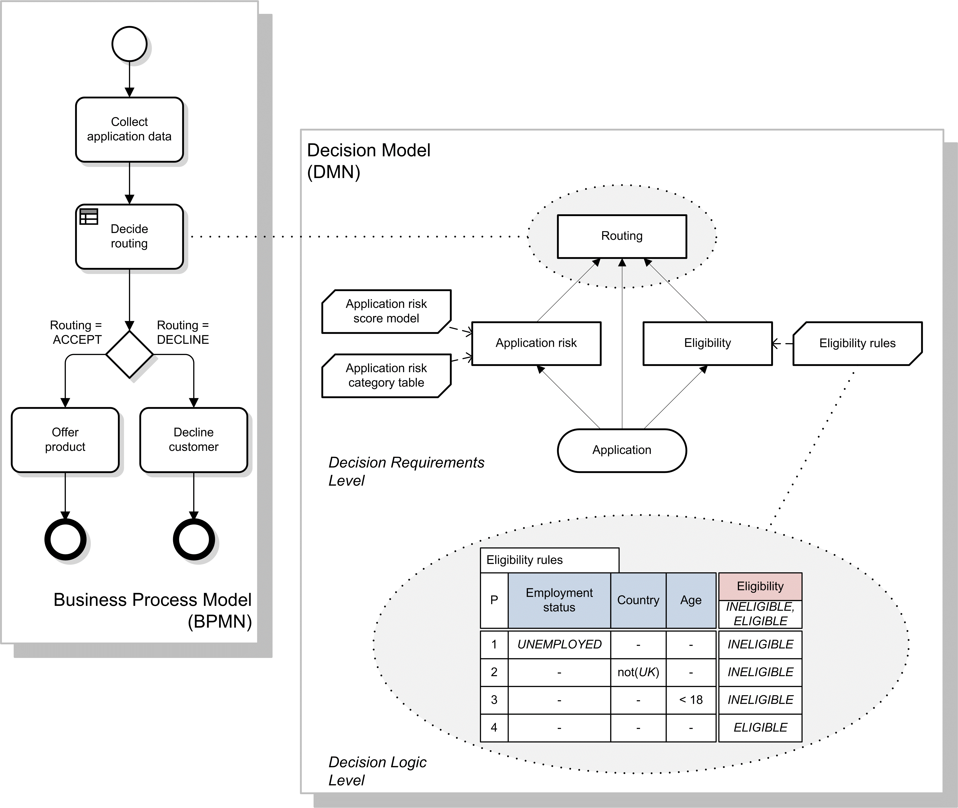Figure 5.1 - Aspects of Modeling
The resulting connected set of models will allow detailed modeling of the role of business rules and analytic models in business processes, cross-validation of models, top-down process design and automation, and automatic execution of decision-making (e.g. by a business process management system calling a decision service deployed from a business rules management system).
Although Figure 5.1 shows a linkage between a business process model and a decision model for the purposes of explaining the relationship between DMN and other standards, it must be stressed that DMN is not dependent on BPMN, and its two levels – decision requirements and decision logic – may be used independently or in conjunction to model a domain of decision-making without any reference to business processes (see clause 5.2).
DMN will provide constructs spanning both decision requirements and decision logic modeling. For decision requirements modeling, it defines the concept of a Decision Requirements Graph (DRG) comprising a set of elements and their connection rules, and a corresponding notation: the Decision Requirements Diagram (DRD). For decision logic modeling it provides a language called FEEL for defining and assembling decision tables, calculations, if/then/else logic, simple data structures, and externally defined logic from Java and PMML into executable expressions with formally defined semantics. It also provides a notation for decision logic (“boxed expressions”) allowing components of the decision logic level to be drawn graphically and associated with elements of a Decision Requirements Diagram. The relationship between these constructs is shown in Figure 5.2.

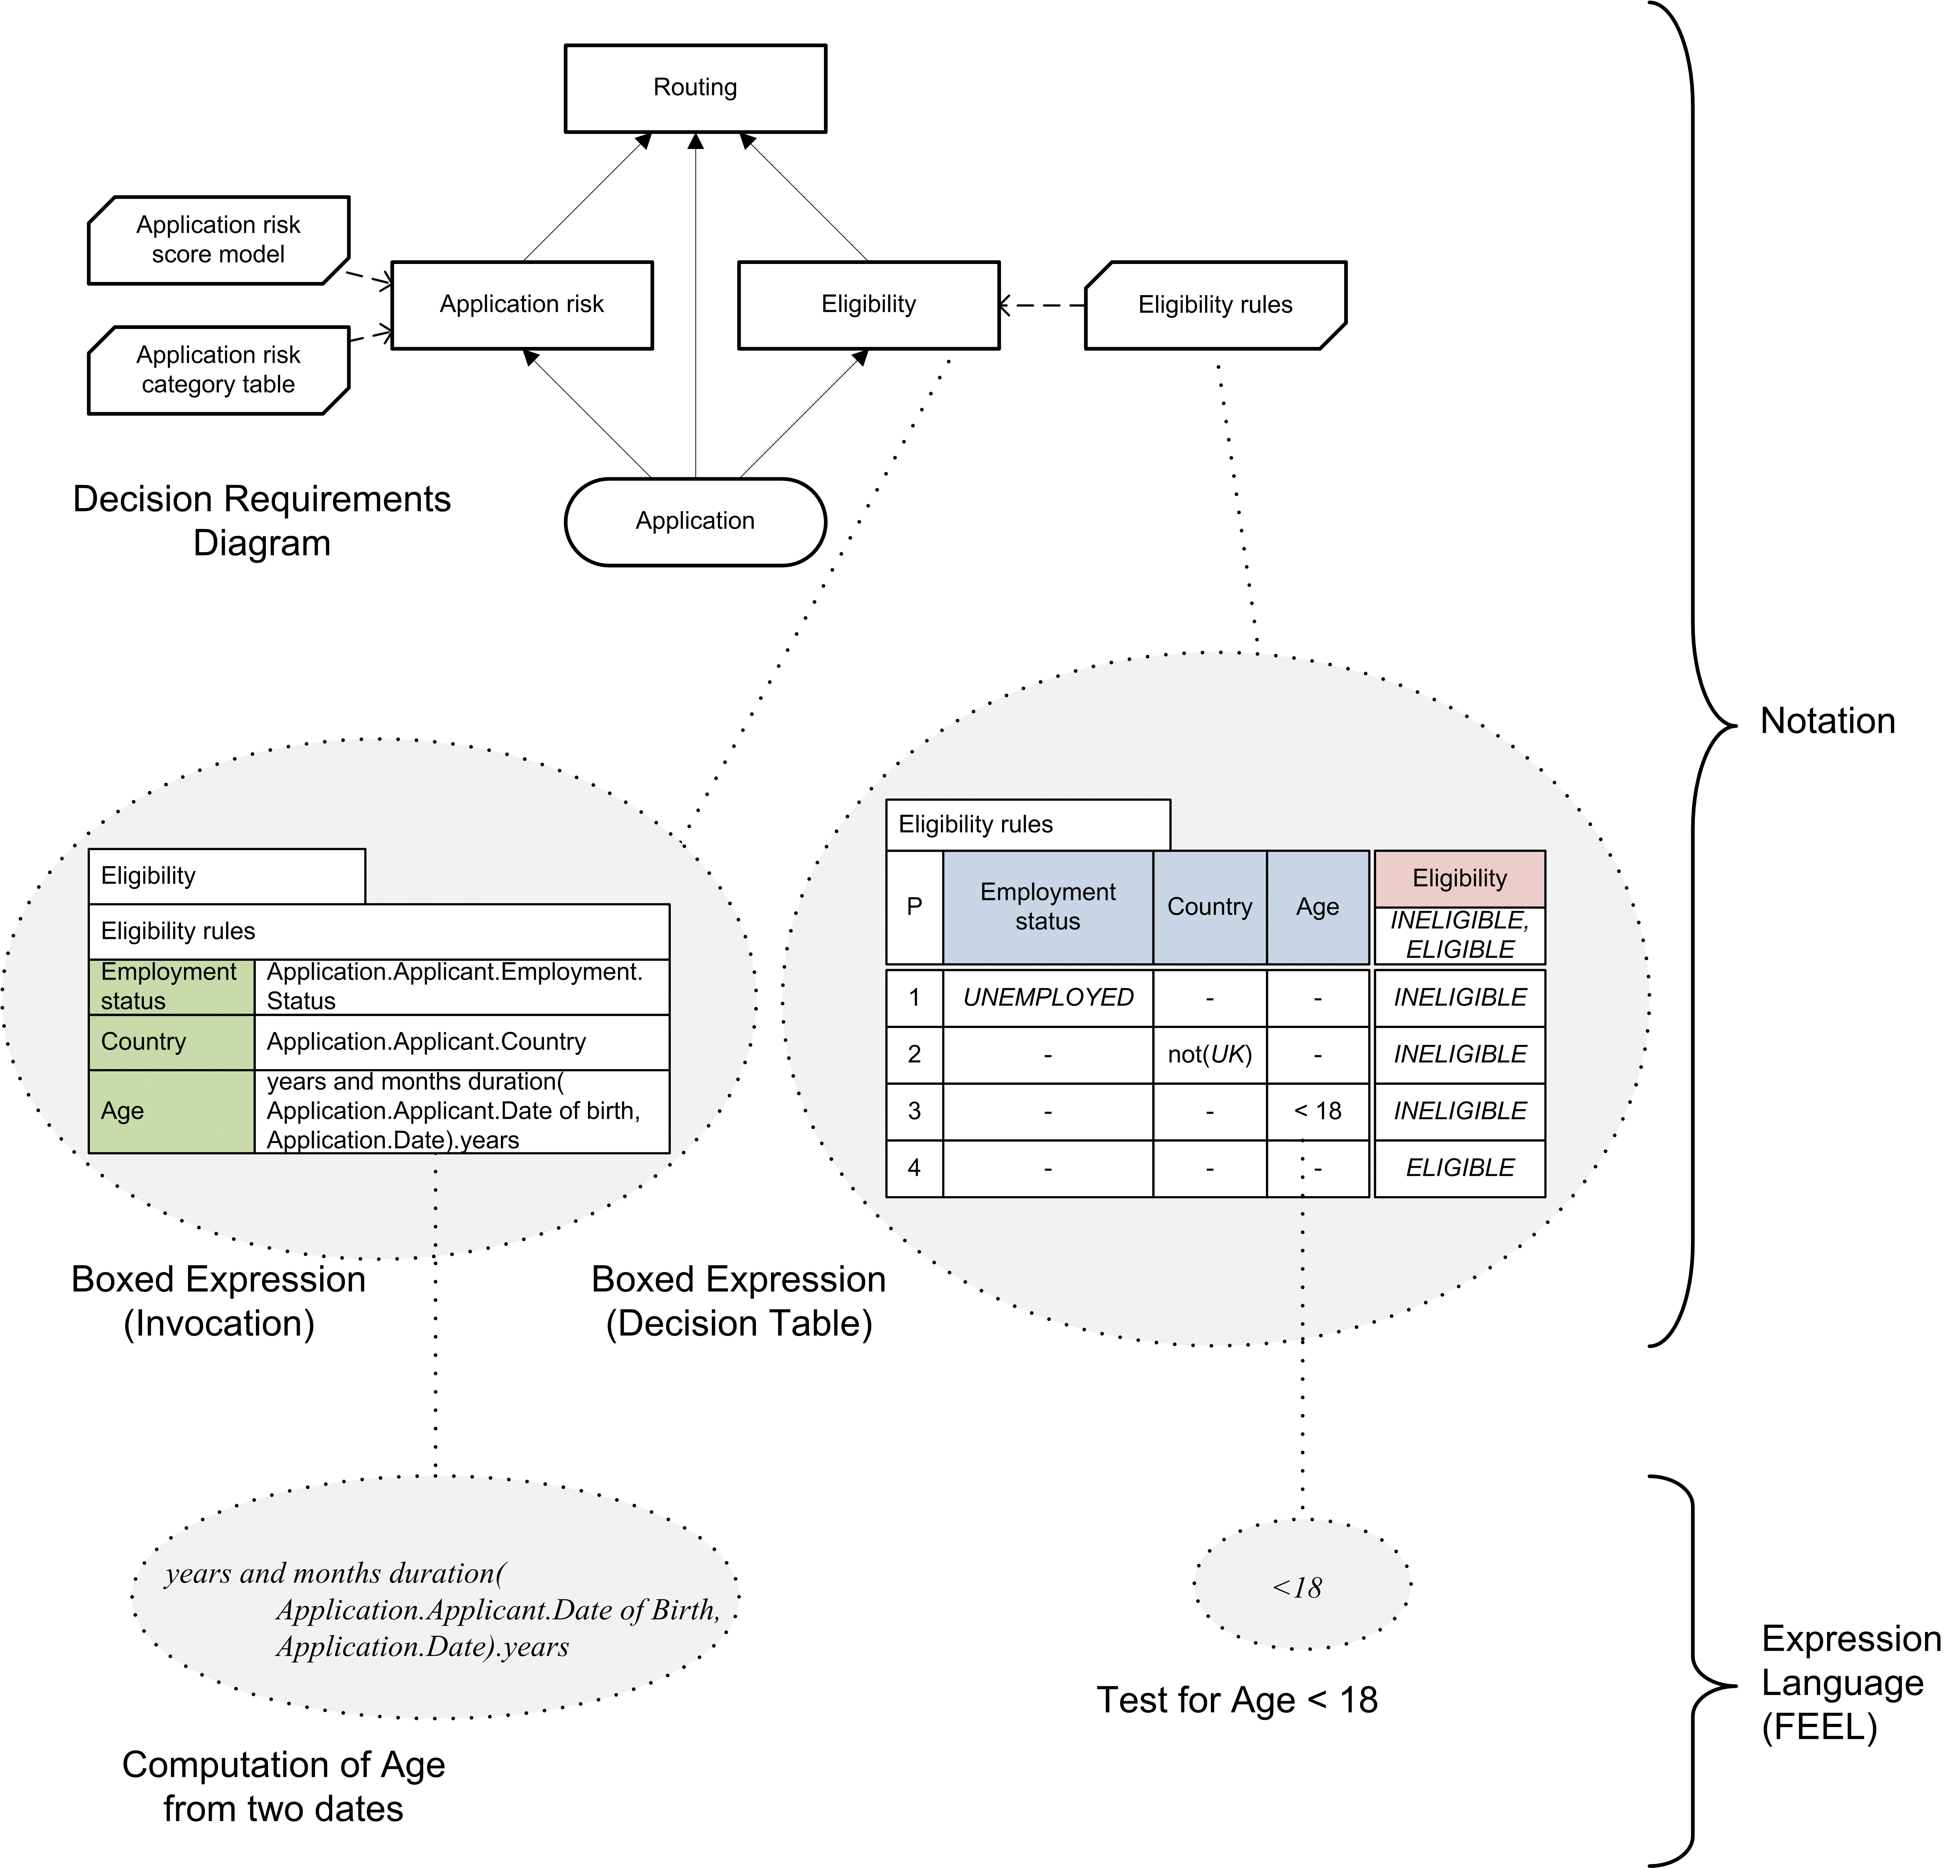
Figure 5.2: DMN Constructs

Scope and uses of DMN
Decision modeling is carried out by business analysts in order to understand and define the decisions used in a business or organization. Such decisions are typically operational decisions made in day-to-day business processes, rather than the strategic decision-making for which fewer rules and representations exist.
Three uses of DMN can be discerned in this context:
- For modeling human decision-making
- For modeling the requirements for automated decision-making
- For implementing automated decision-making.

Modeling human decision-making
DMN may be used to model the decisions made by personnel within an organization. Human decision-making can be broken down into a network of interdependent constituent decisions, and modeled using a DRD. The decisions in the DRD would probably be described at quite a high level, using natural language rather than decision logic.
Knowledge sources may be defined to model governance of decision-making by people (e.g. a manager), regulatory bodies (e.g. an ombudsman), documents (e.g. a policy booklet) or bodies of legislation (e.g. a government statute). These knowledge sources may be linked together, for example to show that a decision is governed (a) by a set of regulations defined by a regulatory body, and (b) by a company policy document maintained by a manager.
Business knowledge models may be used to represent specific areas of business knowledge drawn upon when making decisions. This will allow DMN to be used as a tool for formal definition of requirements for knowledge management. Business knowledge models may be linked together to show the interdependencies between areas of knowledge (in a manner similar to that used in the existing technique of Knowledge Structure Mapping). Knowledge sources may be linked to the business knowledge models to indicate how the business knowledge is governed or maintained, for example to show that a set of business policies (the business knowledge model) is defined in a company policy document (the knowledge source).
In some cases it may be possible to define specific rules or algorithms for the decision-making. These may be modeled using decision logic (e.g. business rules or decision tables) to specify business knowledge models in the DRD, either descriptively (to record how decisions are currently made, or how they were made during a particular period of observation) or prescriptively (to define how decisions should be made, or will be made in the future).
Decision-making modeled in DMN may be mapped to tasks or activities within a business process modeled using BPMN. At a high level, a collaborative decision-making task may be mapped to a subset of decisions in a DRD representing the overall decision-making behavior of a group or department. At a more detailed level, it is possible to model the interdependencies between decisions made by a number of individuals or groups using BPMN collaborations: each participant in the decision-making is represented by a separate pool in the collaboration and a separate DRD in the decision model. Decisions in those DRDs are then mapped to tasks in the pools, and input data in the DRDs are mapped to the content of messages passing between the pools.
The combined use of BPMN and DMN thus provides a graphical language for describing multiple levels of human decision-making within an organization, from activities in business processes down to a detailed definition of decision logic. Within this context DMN models will describe collaborative organizational decisions, their governance, and the business knowledge required for them.

Modeling requirements for automated decision-making
The use of DMN for modeling the requirements for automated decision-making is similar to its use in modeling human decision-making, except that it is entirely prescriptive, rather than descriptive, and there is more emphasis on the detailed decision logic.
For full automation of decisions, the decision logic must be complete, i.e. capable of providing a decision result for any possible set of values of the input data.
However, partial automation is more common, where some decision-making remains the preserve of personnel. Interactions between human and automated decision-making may be modeled using collaborations as above, with separate pools for human and automated decision-makers, or more simply by allocating the decision-making to separate tasks in the business process model, with user tasks for human decision-making and business rule tasks for automated decision-making. So, for example, an automated business rules task might decide to refer some cases to a human reviewer; the decision logic for the automated task needs to be specified in full but the reviewer’s decision-making could be left unspecified.
Once decisions in a DRD are mapped to tasks in a BPMN business process flow, it is possible to validate across the two levels of models. For example, it is possible to verify that all input data in the DRDs are provided by previous tasks in the business process, and that the business process uses the results of decisions only in subsequent tasks or gateways. DMN models the relationships between Decisions and Business Processes so that the Decisions that must be made for a Business Process to complete can be identified and so that the specific decision-making tasks that perform or execute a Decision can be specified. No formal mapping of DMN ItemDefinition or DMN InputData to BPMN DataObject is proposed but an implementation could include such a check in a situation where such a mapping could be determined.
Together, BPMN and DMN therefore allow specification of the requirements for automated decision-making and its interaction with human decision making within business processes. These requirements may be specified at any level of detail, or at all levels. The three-tier mapping between business process models, DRDs and decision logic will allow the definition of these requirements to be supported by model-based computer-aided design tools.

Implementing automated decision-making
If all decisions and business knowledge models are fully specified using decision logic, it becomes possible to execute decision models.
One possible scenario is the use of “decision services” deployed from a Business Rules Management System (BRMS) and called by a Business Process Management System (BPMS). A decision service encapsulates the decision logic supporting a DRD, providing interfaces that correspond to subsets of input data and decisions within the DRD. When called with a set of input data, the decision service will evaluate the specified decisions and return their results. The constraint in DMN that all decision logic is free of side-effects means that decision services will comply with SOA principles, simplifying system design. Note that decision services may also be invoked internal to the decision model, a trait that they share with business knowledge models.
The structure of a decision model, as visualized in the DRD, may be used as a basis for planning an implementation project. Specific project tasks may be included to cover the definition of decision logic (e.g. rule discovery using human experts, or creation of analytic models), and the implementation of components of the decision model.
Some decision logic representing the business knowledge encapsulated in decision services needs to be maintained over time by personnel responsible for the decisions, using special “knowledge maintenance interfaces”. DMN supports the effective design and implementation of knowledge maintenance interfaces: any business knowledge requiring maintenance should be modeled as business knowledge models in the DRD, and the responsible personnel as knowledge sources. DRDs then provide a specification of the required knowledge maintenance interfaces and their users, and the decision logic specifies the initial configuration of the business knowledge to be maintained.
Other decision logic needs to be refreshed by regular analytic modeling. The representation of business knowledge models as functions in DMN makes the use of analytic models in decision services very simple: any analytic model capable of representation as a function may be directly called by or imported into a decision service.

Combining applications of modeling
The three contexts described above are not mutually exclusive alternatives; a large process automation project might use DMN in all three ways.
First, the decision-making within the existing process might be modeled, to identify the full extent of current decision making and the areas of business knowledge involved. This “as-is” analysis provides the baseline for process improvement.
Next, the process might be redesigned to make the most effective use of both automated and human decision-making, often using collaboration between the two (e.g. using automated referrals to human decision-makers, or decision support systems which advise or constrain the user). Such a redesign involves modeling the requirements for the decision-making to occur in each process task and the roles and responsibilities of individuals or groups in the organization. This model provides a “to-be” specification of the required process and the decision-making it coordinates.
Comparison of the “as-is” and “to-be” models will indicate requirements not just for automation technology, but for change management: changes in the roles and responsibilities of personnel, and training to support new or modified business knowledge.
Finally, the “to-be” model will be implemented as executable system software. Provided the decision logic is fully specified in FEEL and/or other external logic (e.g. externally defined Java methods or PMML models), components of the decision model may be implemented directly as software components.
DMN does not prescribe any particular methodology for carrying out the above activities; it only supports the models used for them.

Basic concepts

Decision requirements level
The word “decision” has two definitions in common use: it may denote the act of choosing among multiple possible options; or it may denote the option that is chosen. In this specification, we adopt the former usage: a decision is the act of determining an output value (the chosen option), from a number of input values, using logic defining how the output is determined from the inputs. This decision logic may include one or more business knowledge models which encapsulate business know-how in the form of business rules, analytic models, or other formalisms. This basic structure, from which all decision models are built, is shown in Figure 5.3.

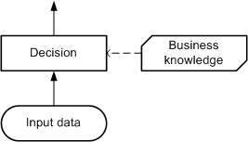
Figure 5.3: Basic elements of a decision model

For simplicity and generality, many of the figures in this specification show each decision as having a single associated business knowledge model, but it should be noted that DMN does not require this to be the case. The use of business knowledge models to encapsulate decision logic is a matter of style and methodology, and decisions may be modeled with no associated business knowledge models, or with several. Similar to business knowledge models, decision services may also be used to encapsulate decision logic for reuse inside the decision model, but for simplicity such examples will be presented starting in the section describing decision services.
Authorities may be defined for decisions or business knowledge models, which might be (for example) domain experts responsible for defining or maintaining them, or source documents from which business knowledge models are derived, or sets of test cases with which the decisions must be consistent. These are called knowledge sources (see Figure 5.4).

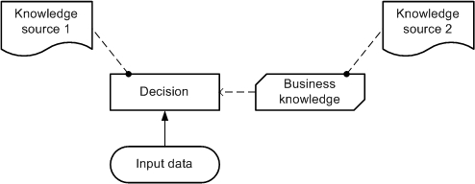
Figure 5.4: Knowledge sources

A decision is said to “require” its inputs in order to determine its output. The inputs may be input data, or the outputs of other decisions. (In either case they may be data structures, rather than just simple data items.) If the inputs of a decision Decision1 include the output of another decision Decision2, Decision1 “requires” Decision2. Decisions may therefore be connected in a network called a Decision Requirements Graph (DRG), which may be drawn as a Decision Requirements Diagram (DRD). A DRD shows how a set of decisions depend on each other, on input data, and on business knowledge models. A simple example of a DRD with only two decisions is shown in Figure 5.5.

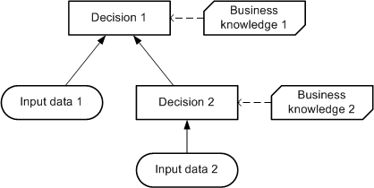
Figure 5.5: A simple Decision Requirements Diagram (DRD)

A decision may require multiple business knowledge models, and a business knowledge model may require multiple other business knowledge models, as shown in Figure 5.6. This will allow (for example) the modeling of complex decision logic by combining diverse areas of business knowledge, and the provision of alternative versions of decision logic for use in different situations.

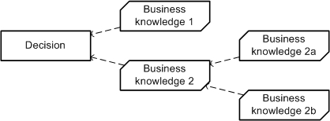
Figure 5.6: Combining business knowledge models

DRGs and their notation as DRDs are specified in detail in clause 6.

Decision logic level
The components of the decision requirements level of a decision model may be described, as they are above, using only business concepts. This level of description is often sufficient for business analysis of a domain of decision-making, to identify the business decisions involved, their interrelationships, the areas of business knowledge and data required by them, and the sources of the business knowledge. Using decision logic, the same components may be specified in greater detail, to capture a complete set of business rules and calculations, and (if desired) to allow the decision-making to be fully automated.
Decision logic may also provide additional information about how to display elements in the decision model. For example, the decision logic element for a decision table may specify whether to show the rules as rows or as columns. The decision logic element for a calculation may specify whether to line up terms vertically or horizontally.
The correspondence between concepts at the decision requirements level and the decision logic level is described below. Please note that in the figures below, as in Figure 5.1 and Figure 5.2 , the grey ellipses and dotted lines are drawn only to indicate correspondences between concepts in different levels for the purposes of this introduction. They do not form part of the notation of DMN, which is formally defined in clauses 6.2, 8.2, and 10.2. It is envisaged that implementations will provide facilities for moving between levels of modeling, such as “opening”, “drilling down” or “zooming in”, but DMN does not specify how this should be done.
At the decision logic level, every decision in a DRG is defined using a value expression which specifies how the decision’s output is determined from its inputs. At that level, the decision is considered to be the evaluation of the expression. The value expression may be notated using a boxed expression, as shown in Figure 5.7.

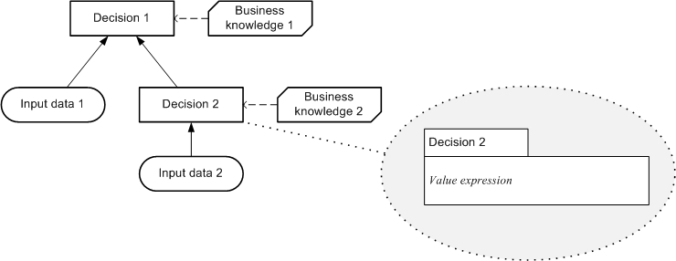
Figure 5.7: Decision and corresponding value expression

In the same way, at the decision logic level, a business knowledge model is defined using a value expression that specifies how an output is determined from a set of inputs. In a business knowledge model, the value expression is encapsulated as a function definition, which may be invoked from a decision's value expression. The interpretation of business knowledge models as functions in DMN means that the combination of business knowledge models as in Figure 5.6 has the clear semantics of functional composition. The value expression of a business knowledge model may be notated using a boxed function definition, as shown in Figure 5.8. Similar to a business knowledge model, the decision service element can also be invoked from a decision’s value expression (see clause 5.3.3).

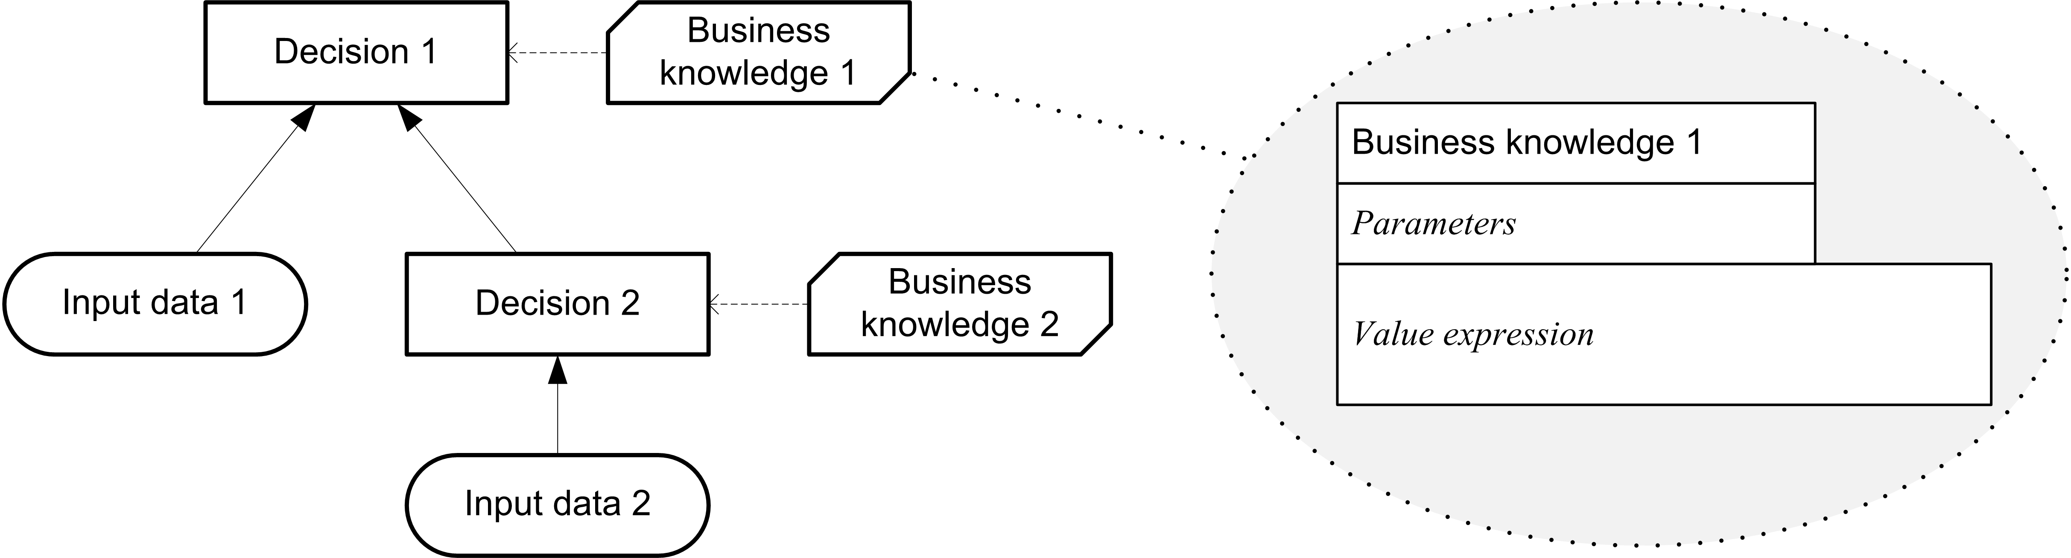
Figure 5.8: Business knowledge model and corresponding value expression

A business knowledge model may contain any decision logic which is capable of being represented as a function. This will allow the import of many existing decision logic modeling standards (e.g. for business rules and analytic models) into DMN. An important format of business knowledge, specifically supported in DMN, is the Decision Table. Such a business knowledge model may be notated using a Decision Table, as shown in Figure 5.9.

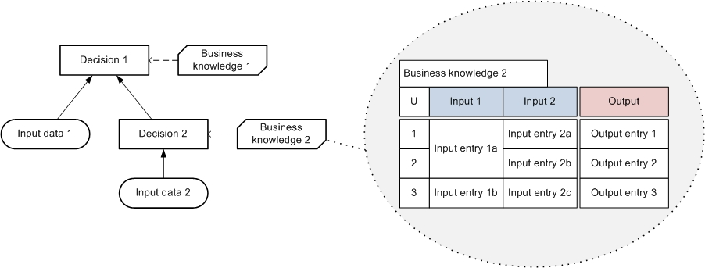
Figure 5.9: Business knowledge model and corresponding decision table

In most cases, the logic of a decision is encapsulated into business knowledge models, and the value expression associated with the decision specifies how the business knowledge models are invoked, and how the results of their invocations are combined to compute the output of the decision. The decision’s value expression may also specify how the output is determined from its input entirely within itself, without invoking a business knowledge model: in that case, no business knowledge model is associated with the decision (neither at the decision requirements level nor at the decision logic level).
An expression language for defining decision logic in DMN, covering all the above concepts, is specified fully in clause 10. This is FEEL: the Friendly Enough Expression Language. The notation for Decision Tables is specified in detail in clause 8.

Decision services
A decision service defines reusable logic within the decision model. A decision service exposes one or more decisions from a decision model as a reusable element, a service, which might be consumed (for example) internally by another decision in the decision model, or externally by a task in a BPMN process model. When the service is called with the necessary input data and decision results, it returns the outputs of the exposed decisions. Any decision service encapsulating a DMN decision model will be stateless and have no side effects.
One important use of DMN will be to define decision-making logic to be automated using decision services. When the decision service is invoked externally, it might be implemented, for example, as a web service. DMN does not specify how such services should be implemented, but it allows the functionality of a service to be defined against a decision model. The decision service therefore must be defined in a DRD. When invoked internally from a decision the decision service is invoked, similar to a BKM, by binding expressions in the logic of the calling decision to parameters in the invoked decision service.
It is assumed that the client requires a certain set of decisions to be made, and that the service is created to meet that requirement. The sole function of the decision service is to return the results of evaluating that set of decisions (the “output decisions”). The service may be provided with the results of decisions evaluated externally to the service (the “input decisions”). The service must encapsulate not just the output decisions but also any decisions in the DRG directly or indirectly required by the output decisions which are not provided in the input decisions (the “encapsulated decisions”).
The interface to the decision service will consist of:
- Input data: instances of all the input data required by the encapsulated decisions
- Input decisions: instances of the results of all the input decisions
- Output decisions: the results of evaluating (at least) all the output decisions, using the provided input decisions and input data.
When the service is called, providing the input data and input decisions, it returns the output decisions.
Note that to define a decision service it is only necessary to specify the output decisions and either the input decisions or the encapsulated decisions. The remaining attributes (the required input data, and whichever of the encapsulated or input decisions was not specified) may then be inferred from the decision model against which the service is defined. Alternatively, if more attributes are defined than are strictly necessary, they may be validated against the decision model.
Figure 5.10 shows a decision service defined against a decision model that includes three decisions. The output decisions for this service are {Decision 1}, and the input decisions are {}, that is, the service returns the result of Decision 1 and is not provided with the results of any external decisions. Since Decision 1 requires Decision 2, which is not provided to the service as input, the service must also encapsulate Decision 2. Decision 3 is not required to be encapsulated. The encapsulated decisions are therefore {Decision 1, Decision 2}. The service requires Input data 1 and Input data 2, but not Input data 3.

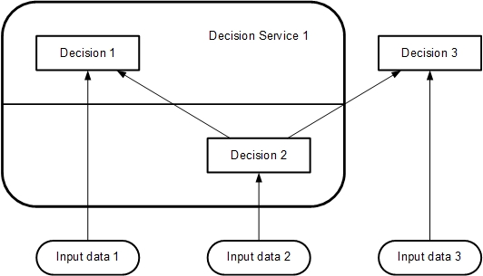
Figure 5.10: A decision service

Multiple decision services may be defined against the same decision model. Figure 5.11 shows a decision service defined against the same decision model, whose output decisions are {Decision 1} and whose input decisions are {Decision 2}. The encapsulated decisions for this service are {Decision 1}. The service requires Input data 1, but not Input data 2 or Input data 3.

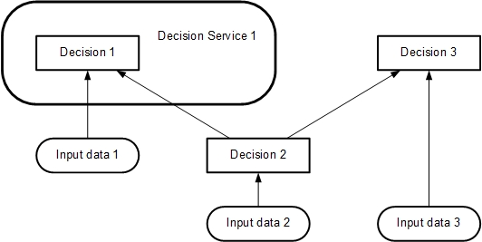
Figure 5.11: A decision service taking a decision as input

In its simplest form a decision service would always evaluate all the decisions in the output set set and return all their results.
For computational efficiency various improvements to this basic interpretation can be imagined, e.g.
- An optional input parameter specifying a list of “requested decisions” (a subset of the minimal output set). Only the results of the requested decisions would be returned in the output context.
- An optional input parameter specifying a list of “known decisions” (a subset of the encapsulation set), with their results. The decision service would not evaluate these decisions, but would use the provided input values directly.
All such implementation details are left to the software provider.
A decision service is “complete” if it contains decision logic for evaluating all the encapsulated decisions on all possible input data values. A request to the service is “valid” if instances are provided for all the input decisions and input data required by those decisions which need to be evaluated, i.e. (in the simple case) all the encapsulated decisions, or (assuming the optional parameters above) any requested decisions and their required sub-decisions which are not already known.

This page intentionally left blank.

Requirements (DRG and DRD)

Introduction
The decision requirements level of a decision model in DMN consists of a Decision Requirements Graph (DRG) depicted in one or more Decision Requirements Diagrams (DRDs).
A DRG models a domain of decision-making, showing the most important elements involved in it and the dependencies between them. The elements modeled are decisions, areas of business knowledge, sources of business knowledge, input data and decision services:
- A Decision element denotes the act of determining an output from a number of inputs, using decision logic which may reference one or more Business Knowledge Models.
- A Business Knowledge Model element denotes a function encapsulating business knowledge, e.g. as business rules, a decision table, or an analytic model.
- An Input Data element denotes information used as an input by one or more Decisions.
- A Knowledge Source element denotes an authority for a Business Knowledge Model or Decision.
- A Decision Service element denotes a set of reusable decisions that can be invoked internally or externally.
The dependencies between these elements express three kinds of requirements: information, knowledge and authority:
- An Information Requirement denotes Input Data or Decision output being used as input to a Decision.
- A Knowledge Requirement denotes the invocation of a Business Knowledge Model or Decision Service by the decision logic of a Decision.
- An Authority Requirement denotes the dependence of a DRG element on another DRG element that acts as a source of guidance or knowledge.
DRDs may also contain any number of artifacts representing annotations of the diagram:
- A Text Annotation is modeler-entered text used for comment or explanation.
- An Association is a dotted connector used to link a Text Annotation to a DRG Element.
These components are summarized in Table 1 and described in more detail in clause 6.2.
A DRG is a graph composed of elements connected by requirements, and is self-contained in the sense that all the modeled requirements for any Decision in the DRG (its immediate sources of information, knowledge and authority) are present in the same DRG. It is important to distinguish this complete definition of the DRG from a DRD presenting any particular view of it, which may be a partial or filtered display: see clause 6.2.4.

Notation
The notation for all components of a DRD is summarized in Table 1 and described in more detail below.

Table 1: DRD components
Component |  | Description | Notation
Elements | Decision | A decision denotes the act of determining an output from a number of inputs, using decision logic which may reference one or more business knowledge models. | 
Elements | Business Knowledge Model | A business knowledge model denotes a function encapsulating business knowledge, e.g. as business rules, a decision table, or an analytic model. | 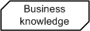
Elements | Input Data | An input data element denotes information used as an input by one or more decisions. When enclosed within a knowledge model, it denotes the parameters to the knowledge model. | 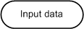
Elements | Knowledge Source | A knowledge source denotes an authority for a business knowledge model or decision. | 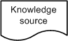
Elements | Decision Service (expanded) | A decision service may enclose a set of reusable decisions (not shown in the element to the right) that can be invoked internally by another decision or externally, e.g. by a BPMN process. | 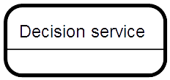
Elements | Decision Service (collapsed) | A decision service denotes a set of reusable decisions (that may be hidden using the element to the right). | 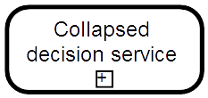
Requirements | Information Requirement | An information requirement denotes input data or a decision output being used as one of the inputs of a decision
Requirements | Knowledge Requirement | A knowledge requirement denotes the invocation of a business knowledge model
Requirements | Authority Requirement | An authority requirement denotes the dependence of a DRD element on another DRD element that acts as a source of guidance or knowledge
Artifacts | Text Annotation | A Text Annotation consists of a square bracket followed by modeler-entered explanatory text or comment | 
Artifacts | Association | An Association connector links a Text Annotation to the DRG Element it explains or comments on

DRD Elements

Decision notation
A Decision is represented in a DRD as a rectangle, normally drawn with solid lines, as shown in Table 1. The Name of the Decision MUST be displayed inside the shape unless it is overridden by the text attribute of the associated DMNDI:DMNLabel element, which MUST be displayed instead.
If the Listed Input Data option is exercised (see 6.2.1.3), all the Decision’s requirements for Input Data SHALL be listed beneath the Decision’s Name and separated from it by a horizontal line, as shown in Figure 6.1. The listed Input Data names SHALL be clearly inside the shape of the DRD element.

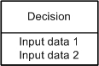
Figure 6.1: Decision with Listed Input Data option

The properties of a Decision are listed and described in 6.3.6.

Business Knowledge Model notation
A Business Knowledge Model is represented in a DRD as a rectangle with two clipped corners, normally drawn with solid lines, as shown in Table 1. The Name of the Business Knowledge Model MUST be displayed inside the shape unless it is overridden by the text attribute of the associated DMNDI:DMNLabel element, which MUST be displayed instead.
The properties of a Business Knowledge Model are listed and described in 6.3.8.

Input Data notation
An Input Data element is represented in a DRD as a shape with two parallel straight sides and two semi-circular ends, normally drawn with solid lines, as shown in Table 1. The Name of the Input Data element MUST be displayed inside the shape unless it is overridden by the text attribute of the associated DMNDI:DMNLabel element, which MUST be displayed instead.
An alternative compliant way to display requirements for Input Data, especially useful when DRDs are large or complex, is that Input Data are not drawn as separate notational elements in the DRD, but are instead listed on those Decision elements which require them. For convenience in this specification this is called the “Listed Input Data” option. Implementations MAY offer this option. Figure 6.2 shows two equivalent DRDs, one drawing Input Data elements, the other exercising the Listed Input Data option. Note that if an Input Data element is not displayed it SHALL be listed on all Decisions which require it (unless it is deliberately hidden as discussed in 6.2.4).

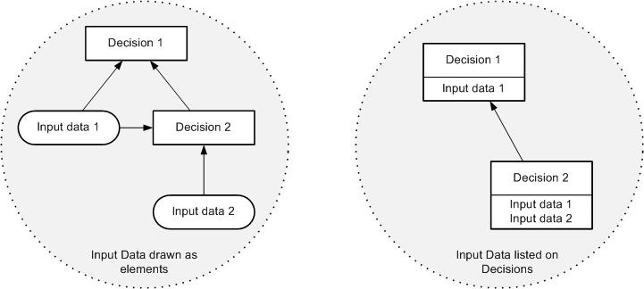
Figure 6.2: The Listed Input Data option

The properties of an Input Data element are listed and described in 6.3.11.

Knowledge Source notation
A Knowledge Source is represented in a DRD as a shape with three straight sides and one wavy one, normally drawn with solid lines, as shown in Table 1. The Name of the Knowledge Source MUST be displayed inside the shape unless it is overridden by the text attribute of the associated DMNDI:DMNLabel element, which MUST be displayed instead.
The properties of a Knowledge Source element are listed and described in 6.3.12.

DRD Requirements

Information Requirement notation
Information Requirements may be drawn from Input Data elements to Decisions, and from Decisions to other Decisions. They represent the dependency of a Decision on information from input data or the results of other Decisions. They may also be interpreted as data flow: a DRD displaying only Decisions, Input Data and Information Requirements is equivalent to a dataflow diagram showing the communication of information between those elements at evaluation time. The Information Requirements of a valid DRG form a directed acyclic graph.
An Information Requirement is represented in a DRD as an arrow drawn with a solid line and a solid arrowhead, as shown in Table 1. The arrow is drawn in the direction of information flow, i.e. towards the Decision that requires the information.

Knowledge Requirement notation
Knowledge Requirements may be drawn from invocable elements (Business Knowledge Models or Decision Services) to Decisions and from invocable elements to Business Knowledge Models. They represent the invocation of an invocable element when making a decision. If e is a decision or a BKM in some DRD, and e contains a knowledge requirement on some invocable element b, then the logic of e must contain an invocation expression of b, including expressions for each of b's parameters.
A Knowledge Requirement is represented in a DRD as an arrow drawn with a dashed line and an open arrowhead, as shown in Table 1. The arrows are drawn in the direction of the information flow of the result of evaluating the function, i.e. toward the element that requires the business knowledge.

Authority Requirement notation
Authority Requirements may be used in two ways:
- They may be drawn from Knowledge Sources to Decisions, Business Knowledge Models and other Knowledge Sources, where they represent the dependence of the DRD element on the knowledge source. This might be used to record the fact that a set of business rules must be consistent with a published document (e.g. a piece of legislation or a statement of business policy), or that a specific person or organizational group is responsible for defining some decision logic, or that a decision is managed by a person or group. An example of this use of Knowledge Sources is shown in Figure 6.3: in this case the Business Knowledge Model requires two sources of authority – a policy document and legislation – and the policy document requires the authority of a policy group.

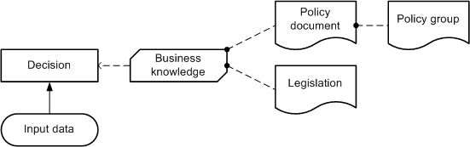
Figure 6.3: Knowledge Sources representing authorities

- They may be drawn from Input Data and Decisions to Knowledge Sources, where, in conjunction with use (a), they represent the derivation of Business Knowledge Models from instances of Input Data and Decision results, using analytics. The Knowledge Source typically represents the analytic model (or modeling process); the Business Knowledge Model represents the executable logic generated from or dependent on the model. An example of this use of a Knowledge Source is shown in Figure 6.4: in this case a business knowledge model is based on an analytic model which is derived from input data and the results of a dependent decision.

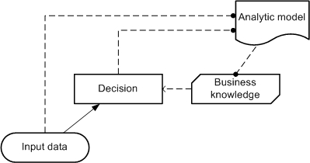
Figure 6.4: Knowledge source representing predictive analytics

However, the figures above are only examples. There are many other possible use cases for Authority Requirements (and since Knowledge Sources and Authority Requirements have no execution semantics their interpretation is necessarily vague), so this specification leaves the details of their application to the implementer.
An Authority Requirement is represented in a DRD as an arrow drawn with a dashed line and a filled circular head, as shown in Table 1. The arrows are drawn from the source of authority to the element governed by it.

Connection rules
The rules governing the permissible ways of connecting elements with requirements in a DRD are described in Clause 6.2.2 above and summarized in Table 2. For clarity, a simple DRD is shown for each permissible connection. In each of these diagrams, the upper (“to”) element requires the lower (“from”) element.
Note that no requirements may be drawn terminating in Input Data, that is, input data may have no requirements. Note also that the type of the requirement is uniquely determined by the types of the two elements connected.

Table 2: Requirements connection rules
From | To (Required by) | Requirement | Diagram
Decision | Decision | Information | 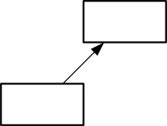
Decision | Knowledge Source | Authority | 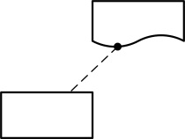
Business Knowledge Model | Decision | Knowledge | 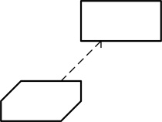
Business Knowledge Model | Business Knowledge Model | Knowledge | 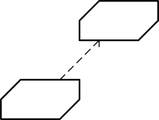
Decision Service | Decision | Knowledge | 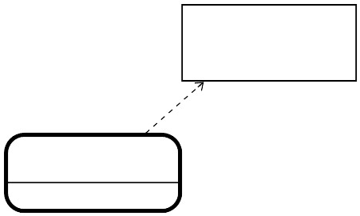  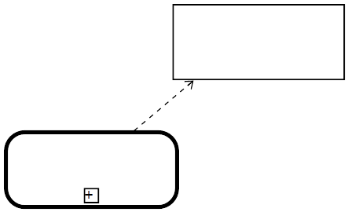
Decision Service | Business Knowledge Model | Knowledge | 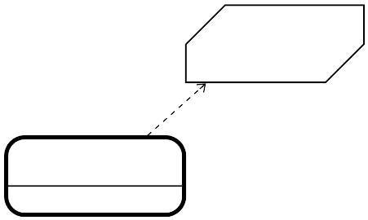  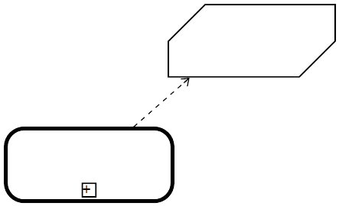
Input data | Decision | Information | 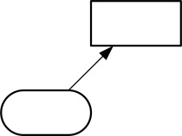
Input data | Knowledge Source | Authority | 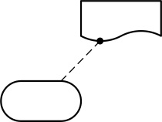
Knowledge Source | Decision | Authority | 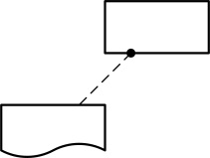
Knowledge Source | Business Knowledge Model | Authority | 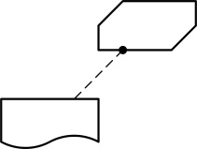
Knowledge Source | Knowledge Source | Authority | 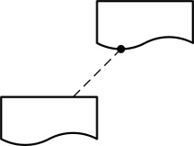

Partial views and hidden information
The metamodel (see clause 6.3) provides properties for each of the DRG elements which would not normally be displayed on the DRD, but provide additional information about their nature or function. For example, for a Decision these include properties specifying which BPMN processes and tasks make use of the Decision. Implementations SHALL provide facilities for specifying and displaying such properties.
For any significant domain of decision-making a DRD representing the complete DRG may be a large and complex diagram. Implementations MAY provide facilities for displaying DRDs which are partial or filtered views of the DRG, e.g. by hiding categories of elements, or hiding or collapsing areas of the network. DRG Elements with requirements not displayed on the current DRD SHOULD be notated with an ellipsis (...) to show that this is the case. For example, see Figure 11.5.
Two examples of DRDs providing partial views of a DRG are shown in Figure 6.5: DRD 1 shows only the immediate requirements of a single decision; DRD 2 shows only Information Requirements and the elements they connect.

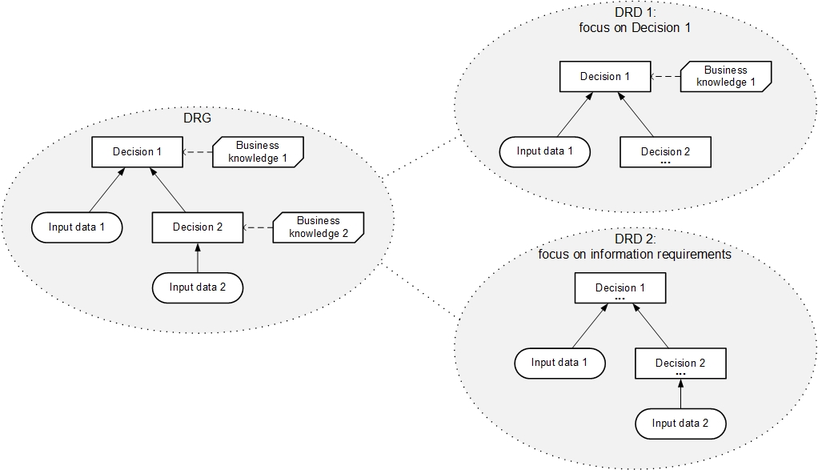
Figure 6.5: DRDs as partial views of a DRG

DRDs can be interchanged using the Diagram Interchange mechanism defined in section 13.

Decision service
A Decision Service is represented in a DRD as rectangle with rounded corners, drawn with a heavy solid border. The Name of the Decision Service MUST be displayed inside the shape unless it is overridden by the text attribute of the associated DMNDI:DMNLabel element, which MUST be displayed instead. The border SHALL enclose all the encapsulated decisions, and no other decisions or input data. The border MAY enclose other DRG elements but these will not form part of the definition of the Decision Service.
If the set of output decisions is smaller than the set of encapsulated decisions, the Decision Service SHALL be divided into two parts with a straight solid line. One part SHALL enclose only the output decisions and the Decision Service's Name; the other part SHALL enclose all the encapsulated decisions which are not in the set of output decisions. Either part MAY enclose other DRG elements but these will not form part of the definition of the Decision Service.
Figure 6.6 shows a Decision Service with two output decisions; other examples (with a single output decision) are shown in Figure 5.10 and Figure 5.11.

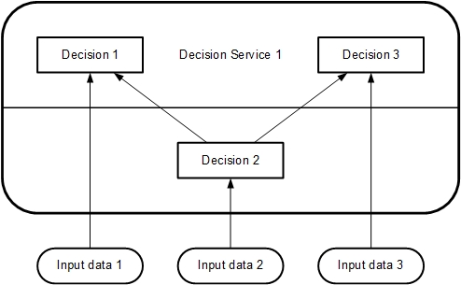
Figure 6.6: Decision Service notation

A decision service may be defined in one DRD and then shown in a different DRD when invoked internally within the decision model by another decision. In the case of a decision service invocation internal to the decision model, a decision service may also be shown without the details of its definition, as in a “collapsed state”. Figure 6.7 consists of two separate diagrams: DRD 1 shows the definition of Decision service 1. In DRD 2, the same Decision service 1 is shown as invoked by Decision 5. In DRD 2, Decision service 1 is shown in a collapsed form.

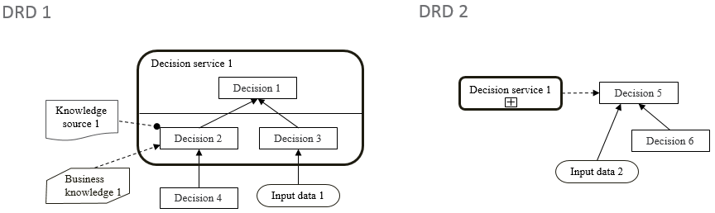
Figure 6.7: A decision service in expanded and collapsed form
DRD 1 in Figure 6.7 shows that Decision service 1 has 2 inputs: Decision 4 and Input data 1. It is therefore inferred that Decision Service 1 has 2 input parameters with matching characteristics to Decision 4 and Input data 1. DRD 2 in Figure 6.7 shows that Decision 5 has 2 dependencies but whether these are mapped as parameters for the invocation of Decision Service 1 cannot be determined from the diagram.
The information and authority requirements defined on Decision 2 in DRD 1 are not depicted in the collapsed form of Decision Service 1 shown in DRD 2.

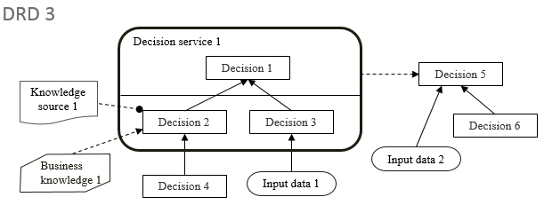
Figure 6.8: A decision service invoked in an expanded form
DRDs 1 and 2 in Figure 6.7 and DRD 3 in Figure 6.8 are all congruent within the same DRG. They all show different aspects of Decision Service 1. DRD 3 shows an expanded form Decision service 1 being invoked by Decision 5.
The constraint imposed on the rendering of decision services within a DRD is that the same decision service MUST NOT be rendered both expanded and collapsed within the same DRD. This stems from the general restriction disallowing the same DMN Element to be present twice in the same diagram.

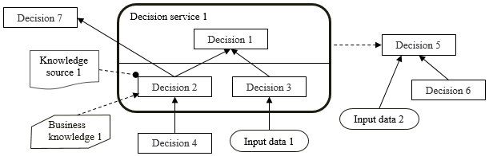
Figure 6.9: A decision service defined as an overlay
Decision services are defined as overlays and therefore do not encapsulate the decisions within them. Therefore, the richness of connections depicted in Figure 6.9 is allowed. In this DRD, Decision 7 is dependent on Decision 2 and Decision 5 is dependent on Decision 3.

Metamodel

DMN Element metamodel

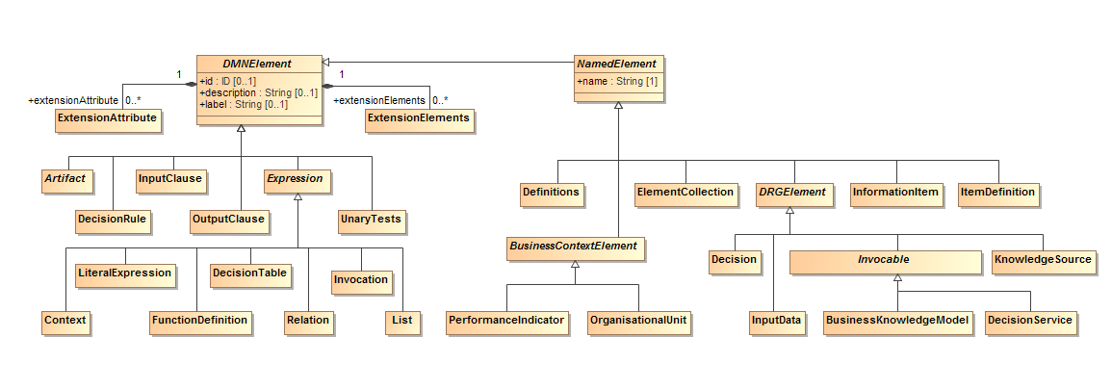
Figure 6.10: DMNElement Class Diagram

DMNElement is the abstract superclass for the decision model elements. It provides the optional attributes id, description and label, which are Strings which other elements will inherit. The id of a DMNElement is further restricted to the syntax of an XML ID (http://www.w3.org/TR/2004/REC-xmlschema-2-20041028/datatypes.html#ID), and SHALL be unique within the decision model.
DMNElement has abstract specializations NamedElement and Expression, and concrete specialization UnaryTests. NamedElement adds the required attribute name, and includes the abstract specializations BusinessContextElement and DRGElement, as well as concrete specializations Definitions, ItemDefinition, InformationItem, ElementCollection and DecisionService.
Table 3 presents the attributes and model associations of the DMNElement element.

Table 3: DMNElement attributes and model associations
Attribute | Description
id: ID [0..1] | Optional identifier for this element. SHALL be unique within its containing Definitions element.
description: String [0..1] | A description of this element.
label: String [0..1] | An alternative short description of this element. It should primarily be used on elements that do not have a name attribute, e.g. an Input Expression. Similar to the description attribute, it has no notation defined and is neither related to the DMNLabel element that is used in Diagram Interchange nor to the outputLabel attribute of a Decision Table.
extensionElements: ExtensionElement [0..1] | This attribute is used as a container to attach additional elements to any DMN Element. See 6.3.16 for additional information on extensibility.
extensionAttributes: ExtensionAttribute [0..*] | This attribute is used to attach named extended attributes and model associations. This association is not applicable when the XML schema interchange is used, since the XSD mechanism for supporting "anyAttribute" from other namespaces already satisfies this requirement. See 6.3.16 for additional information on extensibility.

Table 4: NamedElement attributes and model associations
Attribute | Description
name: string | The name of this element.

Definitions metamodel

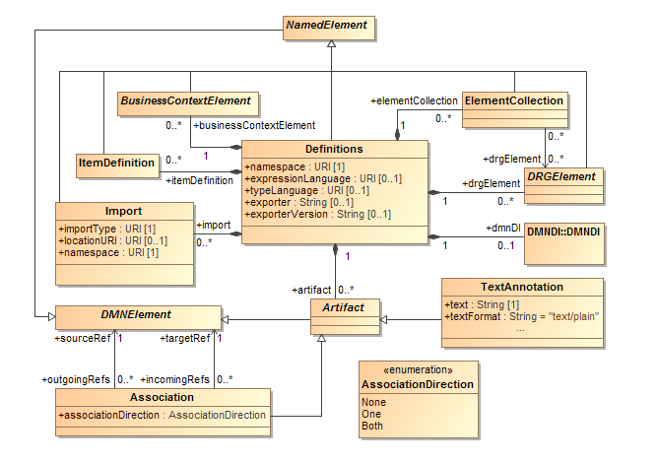
Figure 6.11: Definitions Class Diagram

The Definitions class is the outermost containing object for all elements of a DMN decision model. It defines the scope of visibility and the namespace for all contained elements. Elements that are contained in an instance of Definitions have their own defined life-cycle and are not deleted with the deletion of other elements. The interchange of DMN files will always be through one or more Definitions.
Definitions is a kind of NamedElement, from which an instance of Definitions inherits the name and optional id, description and label attributes, which are Strings.
An instance of Definitions has a namespace, which is a String. The namespace identifies the default target namespace for the elements in the Definitions and follows the convention established by XML Schema.
An instance of Definitions may specify an expressionLanguage, which is a URI that identifies the default expression language used in elements within the scope of this Definitions. This value may be overridden on each individual LiteralExpression. The language SHALL be specified in a URI format. The default expression language is FEEL (clause 10), indicated by the URI: “http://www.omg.org/spec/DMN/20180521/FEEL/”. The simple expression language S-FEEL (clause 9), being a subset of FEEL, is indicated by the same URI. DMN provides a URI for expression languages that are not meant to be interpreted automatically (e.g. pseudo-code that may resemble FEEL but is not): "http://www.omg.org/spec/DMN/uninterpreted/20140801".
An instance of Definitions may specify a typeLanguage, which is a URI that identifies the default type language used in elements within the scope of this Definitions. For example, a typeLanguage value of “http://www.w3.org/2001/XMLSchema” indicates that the data structures defined within that Definitions are, by default, in the form of XML Schema types. If unspecified, the default typeLanguage is FEEL. This value may be overridden on each individual ItemDefinition. The typeLanguage SHALL be specified in a URI format (the URI for FEEL is “http://www.omg.org/spec/DMN/20180521/FEEL/”; the URI "http://www.omg.org/spec/DMN/uninterpreted/20140801" can be used to indicate that a type definition is not meant to be interpreted)).
An instance of Definitions may specify an exporter and exporterVersion, which are Strings naming the tool and version used to create the XML serialization. In standards such as BPMN, this has been found to aid in model interchange between tools.
An instance of Definitions is composed of zero or more drgElements, which are instances of DRGElement, zero or more elementCollections, which are instances of ElementCollection, zero or more itemDefinitions, which are instances of ItemDefinition and of zero or more businessContextElements, which are instances of BusinessContextElement.
It may contain any number of associated import, which are instances of Import. Imports are used to import elements defined outside of this Definitions, e.g. in other Definitions elements, and to make them available for use by elements in this Definitions.
Definitions inherits all the attributes and model associations from NamedElement. Table 5 presents the additional attributes and model associations of the Definitions element.

Table 5: Definitions attributes and model associations
Attribute | Description
namespace: anyURI [1] | This attribute identifies the namespace associated with this Definitions and follows the convention established by XML Schema.
expressionLanguage: anyURI [0..1] | This attribute identifies the expression language used in LiteralExpressions within the scope of this Definitions. The Default is FEEL (clause 10). This value MAY be overridden on each individual LiteralExpression. The language SHALL be specified in a URI format.
typeLanguage: anyURI [0..1] | This attribute identifies the type language used in LiteralExpressions within the scope of this Definitions. The Default is FEEL (clause 10). This value MAY be overridden on each individual ItemDefinition. The language SHALL be specified in a URI format.
exporter: string [0..1] | This attribute names the tool used to export the XML serialization.
exporterVersion: string [0..1] | This attribute names the version of the tool used to export the XML serialization.
itemDefinition: ItemDefinition [*] | This attribute lists the instances of ItemDefinition that are contained in this Definitions.
drgElement: DRGElement [*] | This attribute lists the instances of DRGElement that are contained in this Definitions.
businessContextElement: BusinessContextElement [*] | This attribute lists the instances of BusinessContextElement that are contained in this Definitions.
elementCollection: ElementCollection [*] | This attribute lists the instances of ElementCollection that are contained in this Definitions.
import: Import [*] | This attribute is used to import externally defined elements and make them available for use by elements in this Definitions.
artifact: Artifact [0..*] | Artifacts include text annotations and associations among DMN elements.
dmnDI: DMNDI [0..1] | This attribute contains the Diagram Interchange information contained within this Definitions (see Clause 13 for more information on the DMN Diagram Interchange).

Import metamodel
The Import class is used when referencing external elements, either DMN DRGElement or ItemDefinition instances contained in other Definitions elements, or non-DMN elements, such as an XML Schema or a PMML file. Imports SHALL be explicitly defined.
An instance of Import has an importType, which is a String that specifies the type of import associated with the element. For example, a value of “http://www.w3.org/2001/XMLSchema” indicates that the imported element is an XML schema. The DMN namespace indicates that the imported element is a DMN Definitions element.
The location of the imported element may be specified by associating an optional locationURI with an instance of Import. The locationURI is a URI.
An instance of Import has a namespace, which is a URI that identifies the namespace of the imported element, and also a name, inherited from NamedElement, which is a string that serves as a prefix in namespace-qualified names, such as typeRefs specifying imported ItemDefinitions and expressions referencing imported InformationItems. The namespace value should be globally unique, but the import name, which is typically a short business-friendly name,must be distinct from the names of other imports, decisions, input data, business knowledge models, decision services, and item definitions within the importing model only.
Table 6 presents the attributes and model associations of the Import element.

Table 6: Import attributes and model associations
Attribute | Description
importType: anyURI | Specifies the style of import associated with this Import.
locationURI: anyURI [0..1] | Identifies the location of the imported element.
namespace: anyURI | Identifies the namespace of the imported element.

Element Collection metamodel
The ElementCollection class is used to define named groups of DRGElement instances. ElementCollections may be used for any purpose relevant to an implementation, for example:
- To identify the requirements subgraph of a set one or more decisions (i.e. all the elements in the closure of the requirements of the set)
- To identify the elements to be depicted on a DRD.
ElementCollection is a kind of NamedElement, from which an instance of ElementCollection inherits the name and optional id, description and label attributes, which are Strings. The id of an ElementCollection element SHALL be unique within the containing instance of Definitions.
An ElementCollection element has any number of associated drgElements, which are the instances of DRGElement that this ElementCollection defines together as a group. Notice that an ElementCollection element must reference the instances of DRGElement that it collects, not contain them: instances of DRGElement can only be contained in Definitions elements.
ElementCollection inherits all the attributes and model associations from NamedElement. Table 7 presents the additional attributes and model associations of the ElementCollection element.

Table 7: ElementCollection attributes and model associations
Attribute | Description
drgElement: DRGElement [*] | This attribute lists the instances of DRGElement that this ElementCollection groups.

DRG Element metamodel
DRGElement is the abstract superclass for all DMN elements that are contained within Definitions and that have a graphical representation in a DRD. All the elements of a DMN decision model that are not contained directly in a Definitions element (specifically: all three kinds of requirement, bindings, clause and decision rules, import, and objective)SHALL be contained in an instance of DRGElement, or in a model element that is contained in an instance of DRGElement, recursively.
The specializations of DRGElement are Decision, InputData, Invocable, and
KnowledgeSource. Invocable is further specialized into BusinessKnowledgeModel and DecisionService.
DRGElement is a specialization of NamedElement, from which it inherits the name and optional id, description and label attributes. The id of a DRGElement element SHALL be unique within the containing instance of Definitions.
A Decision Requirements Diagram (DRD) is the diagrammatic representation of one or more instances of DRGElement and their information, knowledge and authority requirement relations. The instances of DRGElement are represented as the vertices in the diagram; the edges represent instances of InformationRequirement, KnowledgeRequirement or AuthorityRequirement (see clauses 6.3.13, 6.3.14 and 6.3.15). The connection rules are specified in clause 6.2.3).
DRGElement inherits all the attributes and model associations of NamedElement. It does not define additional attributes and model associations of the DRGElement element.

Artifact metamodel
Artifacts are used to provide additional information about a Decision Model. DMN provides two standard Artifacts: Association and Text Annotation. Associations can be used to link Artifacts to any DMNElement.

Association
An Association is used to link information and Artifacts with DMN graphical elements. Text Annotations and other Artifacts can be associated with the graphical elements. An arrowhead on the Association indicates a direction of flow (e.g., data), when appropriate.
The Association element inherits the attributes and model associations of DMNElement (see Table 3). Table 8 presents the additional attributes and model associations for an Association.

Table 8: Association attributes and model associations:
Attribute | Description
associationDirection: AssociationDirection = None  {None | One | Both} | associationDirection is an attribute that defines whether or not the Association shows any directionality with an arrowhead. The default is None (no arrowhead). A value of One means that the arrowhead SHALL be at the Target Object. A value of Both means that there SHALL be an arrowhead at both ends of the Association line.
sourceRef: DMNElement [1] | The DMNElement that the Association is connecting from.
targetRef: DMNElement [1] | The DMNElement that the Association is connecting to.

Text Annotation
Text Annotations are a mechanism for a modeler to provide additional text information for the reader of a DMN Diagram
The TextAnnotation element inherits the attributes and model associations of DMNElement (see Table 3). Table 9 presents the additional attributes for a TextAnnotation.

Table 9: TextAnnotation attributes
Attribute | Description
text: string | Text is an attribute that is text that the modeler wishes to communicate to the reader of the Diagram.
textFormat: string = "text/plain" | This attribute identifies the format of the text. It SHALL follow the mime-type format. The default is "text/plain."

Decision metamodel

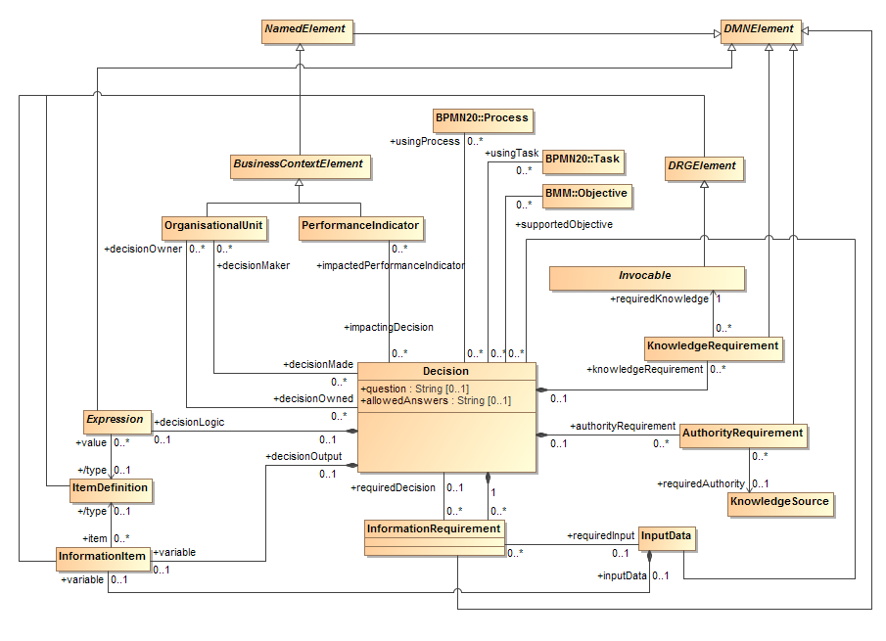
Figure 6.12: Decision Class Diagram

The class Decision is used to model a decision.
Decision is a concrete specialization of DRGElement and it inherits the name and optional id, description and label attributes from NamedElement The name of an Invocable must be different from the name of any other invocable, input data, decision, or import in the decision model.
In addition, it may have a question and allowedAnswers, which are all strings. The optional description attribute is meant to contain a brief description of the decision-making embodied in the Decision. The optional question attribute is meant to contain a natural language question that characterizes the Decision such that the output of the Decision is an answer to the question. The optional allowedAnswers attribute is meant to contain a natural language description of the answers allowed for the question such as Yes/No, a list of allowed values, a range of numeric values etc.
In a DRD, an instance of Decision is represented by a decision diagram element.
A Decision element is composed of an optional decisionLogic, which is an instance of Expression, and of zero or more informationRequirement, knowledgeRequirement and authorityRequirement elements, which are instances of InformationRequirement, KnowledgeRequirement and AuthorityRequirement, respectively.

In addition, a Decision defines an InformationItem representing its output. This InformationItem may include an optional typeRef, which references an ItemDefinition or other type definition specifying the datatype of the possible outcomes of the Decision.
The requirement subgraph of a Decision element is the directed graph composed of the Decision element itself , its informationRequirements, its knowledgeRequirements, and the union of the requirement subgraphs of each requiredDecision or requiredKnowledge element: that is, the requirement subgraph of a Decision element is the closure of the informationRequirement, requiredInput, requiredDecision, knowledgeRequirement and requiredKnowledge associations starting from that Decision element.
An instance of Decision – that is, the model of a decision – is said to be well-formed if and only if all of its informationRequirement and knowledgeRequirement elements are well-formed, That condition entails, in particular, that the requirement subgraph of a Decision element SHALL be acyclic, that is, that a Decision element SHALL not require itself, directly or indirectly.
Besides its logical components: information requirements, decision logic etc, the model of a decision may also document a business context for the decision (see clause 6.3.8 and Figure 6.13).
The business context for an instance of Decision is defined by its association with any number of supportedObjectives, which are instances of Objective as defined in OMG BMM, any number of impactedPerformanceIndicators, which are instances of PerformanceIndicator, any number of decisionMaker and any number of decisionOwner, which are instances of OrganisationalUnit.
In addition, an instance of Decision may reference any number of usingProcess, which are instances of Process as defined in OMG BPMN 2.0, and any number of usingTask, which are instances of Task as defined in OMG BPMN 2.0, and which are the Processes and Tasks that use the Decision element.
Decision inherits all the attributes and model associations from DRGElement. Table 10 presents the additional attributes and model associations of the Decision class.

Table 10: Decision attributes and model associations
Attribute | Description
question: string [0..1] | A natural language question that characterizes the Decision such that the output of the Decision is an answer to the question.
allowedAnswers: string [0..1] | A natural language description of the answers allowed for the question such as Yes/No, a list of allowed values, a range of numeric values etc.
variable: InformationItem | The instance of InformationItem that stores the result of this Decision.
decisionLogic: Expression [0..1] | The instance of Expression that represents the decision logic for this Decision.
informationRequirement: InformationRequirement [*] | This attribute lists the instances of InformationRequirement that compose this Decision.
knowledgeRequirement: KnowledgeRequirement [*] | This attribute lists the instances of KnowledgeRequirement that compose this Decision.
authorityRequirement: AuthorityRequirement [*] | This attribute lists the instances of AuthorityRequirement that compose this Decision.
supportedObjective: BMM::Objective [*] | This attribute lists the instances of BMM::Objective that are supported by this Decision.
impactedPerformanceIndicator: PerformanceIndicator [*] | This attribute lists the instances of PerformanceIndicator that are impacted by this Decision.
decisionMaker: OrganisationalUnit [*] | The instances of OrganisationalUnit that make this Decision.
decisionOwner: OrganisationalUnit [*] | The instances of OrganisationalUnit that own this Decision.
usingProcesses: BPMN::process [*] | This attribute lists the instances of BPMN::process that require this Decision to be made.
usingTasks: BPMN::task [*] | This attribute lists the instances of BPMN::task that make this Decision.

Business Context Element metamodel

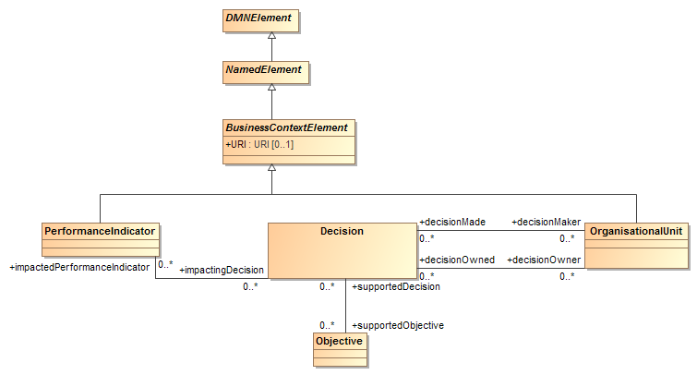
Figure 6.13: BusinessContextElement class diagram

The abstract class BusinessContextElement, and its concrete specializations PerformanceIndicator and OrganizationUnit are placeholders, anticipating a definition to be adopted from other OMG meta-models, such as OMG OSM when it is further developed.
BusinessContextElement is a specialization of NamedElement, from which it inherits the name and optional id, description and label attributes.
In addition, instances of BusinessContextElements may have a URI, which is a URI, and
- an instance of PerformanceIndicator references any number of impactingDecision, which are the Decision elements that impact it;
- an instance of OrganisationalUnit references any number of decisionMade and of decisionOwned, which are the Decision elements that model the decisions that the organization unit makes or owns.
BusinessContextElement inherits all the attributes and model associations from NamedElement. Table 11 presents the additional attributes and model associations of the BusinessContextElement class.

Table 11: BusinessContextElement attributes and model associations
Attribute | Description
URI: anyURI [0..1] | The URI of this BusinessContextElement.

PerformanceIndicator inherits all the attributes and model associations from BusinessContextElement. Table 12 presents the additional attributes and model associations of the PerformanceIndicator class.

Table 12: PerformanceIndicator attributes and model associations
Attribute | Description
impactingDecision: Decision [*] | This attribute lists the instances of Decision that impact this PerformanceIndicator.

OrganisationalUnit inherits all the attributes and model associations from BusinessContextElement. Table 13 presents the additional attributes and model associations of the OrganisationalUnit class.

Table 13: OrganisationalUnit attributes and model associations
Attribute | Description
decisionMade: Decision [*] | This attribute lists the instances of Decision that are made by this OrganisationalUnit.
decisionOwned: Decision [*] | This attribute lists the instances of Decision that are owned by this OrganisationalUnit.

Business Knowledge Model metamodel

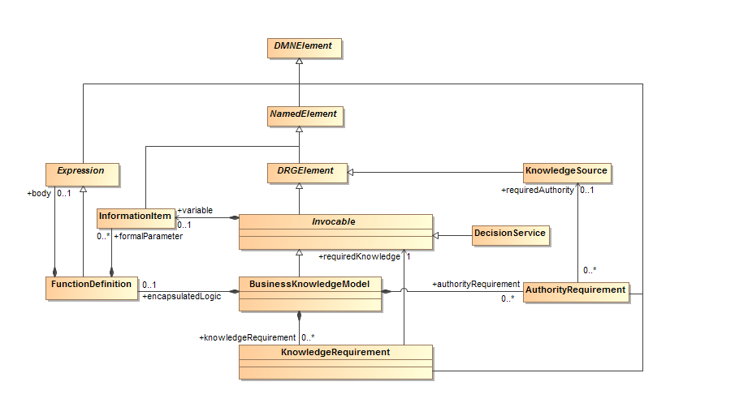
Figure 6.14: BusinessKnowledgeModel class diagram

A business knowledge model has an abstract part, representing reusable, invocable decision logic, and a concrete part, which mandates that the decision logic must be a single FEEL boxed function definition. A decision service is also an invocable element, and thus can be invoked as required knowledge from other decisions and business knowledge models.
The class Invocable is used to model an invocable element and the class BusinessKnowledgeModel is used to model a business knowledge model.
Invocable is a specialization of DRGElement and it inherits the name and optional id, description, and label attributes from NamedElement. The name of an Invocable must be different from the name of any other invocable, input data, decision, or import in the decision model. BusinessKnowledgeModel is a specialization of Invocable from which it additionally inherits the variable attribute.
A BusinessKnowledgeModel element may have zero or more knowledgeRequirement, which are instance of KnowledgeRequirement, and zero or more authorityRequirement, which are instances of AuthorityRequirement. These model elements are described below.
The requirement subgraph of a BusinessKnowledgeModel element is the directed graph composed of the BusinessKnowledgeModel element itself, its knowledgeRequirement elements, and the union of the requirement subgraphs of all the requiredKnowledge elements that are referenced by its knowledgeRequirements.
An instance of BusinessKnowledgeModel is said to be well-formed if and only if, either it does not have any knowledgeRequirement, or all of its knowledgeRequirement elements are well-formed. That condition entails, in particular, that the requirement subgraph of a BusinessKnowledgeModel element SHALL be acyclic, that is, that a BusinessKnowledgeModel element SHALL not require itself, directly or indirectly.
At the decision logic level, a BusinessKnowledgeModel element contains a FunctionDefinition, which is an instance of Expression containing zero or more parameters, which are instances of InformationItem. The FunctionDefinition that is contained in a BusinessKnowledgeModel element is the reusable module of decision logic that is represented by this BusinessKnowledgeModel element. An Invocable element contains an InformationItem that holds an invocable reference to the abstract business knowledge, which allows a Decision to invoke it by name. The name of that InformationItem SHALL be the same as the name of the Invocable element. Invocable inherits all the attributes and model associations from DRGElement.Table 14 presents the additional attributes and model associations of the Invocable class. Table 15 presents the additional attributes and model associations of the BusinessKnowledgeModel class.

Table 14: Invocable attributes and model associations
Attribute | Description
variable: InformationItem | This attribute defines a variable that is bound to the function defined by the FunctionDefinition, allowing decision logic to invoke the function by name.

Table 15: BusinessKnowledgeModel attributes and model associations
Attribute | Description
encapsulatedLogic: FunctionDefinition [0..1] | The function that encapsulates the logic encapsulated by this BusinessKnowledgeModel.
knowledgeRequirement: KnowledgeRequirement [*] | This attribute lists the instances of KnowledgeRequirement that compose this BusinessKnowledgeModel.
authorityRequirement: AuthorityRequirement [*] | This attribute lists the instances of AuthorityRequirement that compose this BusinessKnowledgeModel.

Decision service metamodel

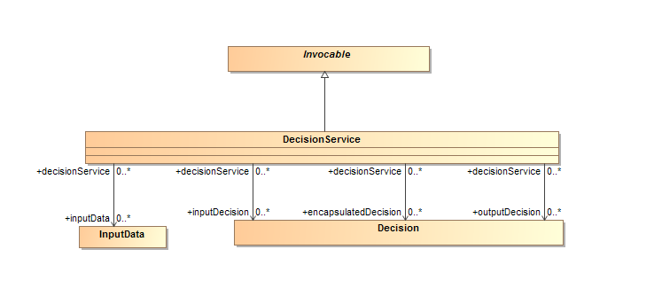
Figure 6.15: DecisionService class diagram
The DecisionService class is used to define named decision services against the decision model contained in an instance of Definitions.
DecisionService is a kind of Invocable element, from which an instance of DecisionService inherits the name and optional id, description, and label attributes, which are Strings, and a variable, which is an InformationItem. The id of a DecisionService element SHALL be unique within the containing instance of Definitions. The name of the variable and the name of the DecisionService SHALL be the same. This name may be used to invoke a DecisionService from the decision logic of another decision or business knowledge model.
A DecisionService element has one or more associated outputDecisions, which are the instances of Decision required to be output by this DecisionService, i.e. the Decisions whose results the Decision Service must return when called.
A DecisionService element has zero or more encapsulatedDecisions, which are the instances of Decision required to be encapsulated by this DecisionService, i.e. the Decisions to be evaluated by the Decision Service when it is called.
A DecisionService element has zero or more inputDecisions, which are the instances of Decision required as input by this DecisionService, i.e. the Decisions whose results will be provided to the Decision Service when it is called.
A DecisionService element has zero or more inputData, which are the instances of InputData required as input by this DecisionService, i.e. the Input Data which will be provided to the Decision Service when it is called.
The encapsulatedDecisions, inputDecisions and inputData attributes are optional. At least one of the encapsulatedDecisions and inputDecisions attributes SHALL be specified.
The requirement subgraph of a DecisionService element is the directed graph composed of the DecisionService element itself and the union of the requirement subgraphs of all the Decision elements that are referenced by its encapsulatedDecisions and outputDecisions.
An instance of DecisionService is said to be well-formed if and only if its requirement subgraph is acyclic, that is, that a DecisionService element SHALL not require itself, directly or indirectly.
DecisionService inherits all the attributes and model associations from Invocable. Table 16 presents the additional attributes and model associations of the DecisionService element.

Table 16: DecisionService attributes and model associations
Attribute | Description
outputDecisions: Decision [1..*] | This attribute lists the instances of Decision required to be output by this DecisionService.
encapsulatedDecisions: Decision [0..*] | If present, this attribute lists the instances of Decision to be encapsulated in this DecisionService
inputDecisions: Decision [0..*] | If present, this attribute lists the instances of Decision required as input by this DecisionService.
inputData: InputData [0..*] | If present, this attribute lists the instances of InputData required as input by this DecisionService

Input Data metamodel

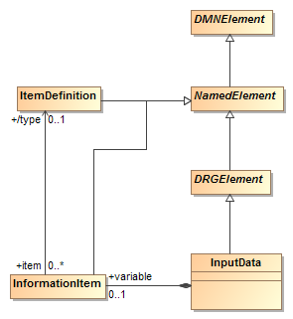
Figure 6.16: InputData class diagram

DMN 1.1 uses the class InputData to model the inputs of a decision whose values are defined outside of the decision model.
InputData is a concrete specialization of DRGElement and it inherits the name and optional id, description and label attributes from NamedElement. The name of an InputData must be different from the name of any other decision, input data, business knowledge model, decision service, or import in the decision model.
An instance of InputData defines an InformationItem that stores its value. This InformationItem may include a typeRef that specifies the type of data that is this InputData represents, either an ItemDefinition, base type in the specified expressionLanguage, or imported type.
In a DRD, an instance of InputData is represented by an input data diagram element. An InputData element does not have a requirement subgraph, and it is always well-formed.
InputData inherits all the attributes and model associations from DRGElement. Table 17 presents the additional attributes and model associations of the InputData class.

Table 17: InputData attributes and model associations
Attribute | Description
variable: InformationItem | The instance of InformationItem that stores the result of this InputData.

Knowledge Source metamodel

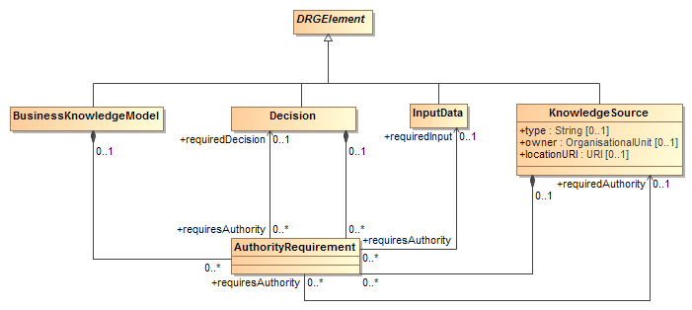
Figure 6.17: KnowledgeSource class diagram

The class KnowledgeSource is used to model authoritative knowledge sources in a decision model.
In a DRD, an instance of KnowledgeSource is represented by a knowledge source diagram element.
KnowledgeSource is a concrete specialization of DRGElement, and thus of NamedElement, from which it inherits the name and optional id, description and label attributes. In addition, a KnowledgeSource has a locationURI, which is a URI. It has a type, which is a string, and an owner, which is an instance of OrganisationalUnit. The type is intended to identify the kind of the authoritative source, e.g. Policy Document, Regulation, Analytic Insight.
A KnowledgeSource element is also composed of zero or more authorityRequirement elements, which are instances of AuthorityRequirement.
KnowledgeSource inherits all the attributes and model associations from DRGElement. Table 18 presents the attributes and model associations of the KnowledgeSource class.

Table 18: KnowledgeSource attributes and model associations
Attribute | Description
locationURI: anyURI [0..1] | The URI where this KnowledgeSource is located. The locationURI SHALL be specified in a URI format.
type: string [0..1] | The type of this KnowledgeSource.
owner: OrganisationalUnit [0..1] | The owner of this KnowledgeSource.
authorityRequirement: AuthorityRequirement [*] | This attribute lists the instances of AuthorityRequirement that contribute to this KnowledgeSource.

Information Requirement metamodel
The class InformationRequirement is used to model an information requirement, as represented by a plain arrow in a DRD. InformationRequirement is a specialization of DMNElement, from which it inherits the optional id, description, and label attributes.
An InformationRequirement element is a component of a Decision element, and it associates that requiring Decision element with a requiredDecision element, which is an instance of Decision, or a requiredInput element, which is an instance of InputData.
An InformationRequirement element references an instance of either a Decision or InputData, which defines a variable. That variable, which is an instance of InformationItem, represents the InformationRequirement element at the decision logic level.
Notice that an InformationRequirement element must reference the instance of Decision or InputData that it associates with the requiring Decision element, not contain it: instances of Decision or InputData can only be contained in Definitions elements.
An instance of InformationRequirement is said to be well-formed if and only if all of the following are true:
- it references a requiredDecision or a requiredInput element, but not both,
- the referenced requiredDecision or requiredInput element is well-formed,
- the Decision element that contains the instance of InformationRequirement is not in the requirement subgraph of the referenced requiredDecision element, if this InformationRequirement element references one.
- the referenced requiredDecision or requiredInput element is defined in the same decision model or in an imported decision model.
Table 19 presents the attributes and model associations of the InformationRequirement element.

Table 19: InformationRequirement attributes and model associations
Attribute | Description
requiredDecision: Decision [0..1] | The instance of Decision that this InformationRequirement associates with its containing Decision element.
requiredInput: InputData [0..1] | The instance of InputData that this InformationRequirement associates with its containing Decision element.

Knowledge Requirement metamodel
The class KnowledgeRequirement is used to model a knowledge requirement, as represented by a dashed arrow in a DRD. KnowledgeRequirement is a specialization of DMNElement, from which it inherits the optional id, description, and label attributes.
A KnowledgeRequirement element is a component of a Decision element or of a BusinessKnowledgeModel element, and it associates that requiring Decision or BusinessKnowledgeModel element with a requiredKnowledge element, which is an instance of Invocable.
Notice that a KnowledgeRequirement element must reference the instance of Invocable that it associates with the requiring Decision or BusinessKnowledgeModel element, not contain it: instances of BusinessKnowledgeModel can only be contained in Definitions elements.
An instance of KnowledgeRequirement is said to be well-formed if and only if all of the following are true:
- it references a requiredKnowledge element,
- the referenced requiredKnowledge element is well-formed,
- if the KnowledgeRequirement element is contained in an instance of BusinessKnowledgeModel, that BusinessKnowledgeModel element is not in the requirement subgraph of the referenced requiredKnowledge element.
- the referenced requiredKnowledge element is defined in the same decision model or in an imported decision model
Table 20 presents the attributes and model associations of the KnowledgeRequirement element.

Table 20: KnowledgeRequirement attributes and model associations
Attribute | Description
requiredKnowledge: Invocable | The instance of Invocable that this KnowledgeRequirement associates with its containing Decision or BusinessKnowledgeModel element.

Authority Requirement metamodel
The class AuthorityRequirement is used to model an authority requirement, as represented by an arrow drawn with a dashed line and a filled circular head in a DRD. AuthorityRequirement is a specialization of DMNElement, from which it inherits the optional id, description, and label attributes.
An AuthorityRequirement element is a component of a Decision, BusinessKnowledgeModel or KnowledgeSource element, and it associates that requiring Decision, BusinessKnowledgeModel or KnowledgeSource element with a requiredAuthority element, which is an instance of KnowledgeSource, a requiredDecision element, which is an instance of Decision, or a requiredInput element, which is an instance of InputData.
Notice that an AuthorityRequirement element must reference the instance of KnowledgeSource, Decision or InputData that it associates with the requiring element, not contain it: instances of KnowledgeSource, Decision or InputData can only be contained in Definitions elements.
Table 21 presents the attributes and model associations of the AuthorityRequirement element.

Table 21: AuthorityRequirement attributes and model associations
Attribute | Description
requiredAuthority: KnowledgeSource [0..1] | The instance of KnowledgeSource that this AuthorityRequirement associates with its containing KnowledgeSource, Decision or BusinessKnowledgeModel element.
requiredDecision: Decision [0..1] | The instance of Decision that this AuthorityRequirement associates with its containing KnowledgeSource element.
requiredInput: InputData [0..1] | The instance of InputData that this AuthorityRequirement associates with its containing KnowledgeSource element.

Extensibility

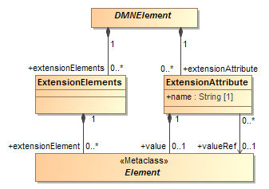
Figure 6.18: Extensibility class diagram

The DMN metamodel is aimed to be extensible. This allows DMN adopters to extend the specified metamodel in a way that allows them to be still DMN-compliant. It provides a set of extension elements, which allows DMN adopters to attach additional attributes and elements to standard and existing DMN elements. This approach results in more interchangeable models, because the standard elements are still intact and can still be understood by other DMN adopters. It's only the additional attributes and elements that MAY be lost during interchange.
A DMN extension can be done using two different elements:
- ExtensionElements
- ExtensionAttribute
ExtensionElements is a container for attaching arbitrary elements from other metamodels to any DMN element. ExtensionAttribute allows these attachments to also have name. This allows DMN adopters to integrate any metamodel into the DMN metamodel and reuse already existing model elements.

ExtensionElements
The ExtensionElements element is a container to aggregate elements from other metamodels inside any DMNElement. Table 22 presents the attributes and model associations for the ExtensionElements element.

Table 22: ExtensionElements attributes and model associations
Attribute | Description
extensionElement: Element [0..*] | The contained Element. This association is not applicable when the XML schema interchange is used, since the XSD mechanism for supporting "any" elements from other namespaces already satisfies this requirement.

ExtensionAttribute
The ExtensionAttribute element contains an Element or a reference to an Element from another metamodel. An ExtensionAttribute also has a name to define the role or purpose of the associated element. This type is not applicable when the XML schema interchange is used, since the XSD mechanism for supporting "anyAttribute" from other namespaces already satisfies this requirement. Table 23 presents the model associations for the ExtensionAttribute element.

Table 23: ExtensionAttribute attributes and model associations
Attribute | Description
name: string | The name of the extension attribute.
value: Element [0..1] | The contained Element. This attribute SHALL NOT be used together with valueRef.
valueRef: Element [0..1] | A reference to the associated Element. This attribute SHALL NOT be used together with value.

Examples
Examples of DRDs are provided in clause 11.3.

This page intentionally left blank.

Relating Decision Logic to Decision Requirements

Introduction
Clause 6 described how the decision requirements level of a decision model – a DRG represented in one or more DRDs – may be used to model the structure of an area of decision making. However, the details of how each decision's outcome is derived from its inputs must be modeled at the decision logic level. This section introduces the principles by which decision logic may be associated with elements in the DRG. Specific representations of decision logic (decision tables and FEEL expressions) are then defined in clauses 8, 9 and 10.
The decision logic level of a decision model in DMN consists of one or more value expressions. The elements of decision logic modeled as value expressions include tabular expressions such as decision tables and invocations, and literal (text) expressions such as age > 30.
- A literal expression represents decision logic as text that describes how an output value is derived from its input values. The expression language may, but need not, be formal or executable: examples of literal expressions include a plain English description of the logic of a decision, a first order logic proposition, a Java computer program and a PMML document. Clause 10 specifies an executable expression language called FEEL. Clause 9 specifies a subset of FEEL (S-FEEL) that is the default language for literal expressions in DMN decision tables (clause 8).
- A decision table is a tabular representation of decision logic, based on a discretization of the possible values of the inputs of a decision, and organized into rules that map discretized input values onto discrete output values (see clause 8).
- An invocation is a tabular representation of how decision logic that is represented by a business knowledge model or a decision service is invoked by a decision, or by another business knowledge model. An invocation may also be represented as a literal expression, but usually the tabular representation will be more understandable.
Tabular representations of decision logic are called boxed expressions in the remainder of this specification.
All three DMN conformance levels include all the above expressions. At DMN Conformance Level 1, literal expressions are not interpreted and, therefore, free. At DMN Conformance Level 2, literal expressions are restricted to S-FEEL. Clause 10 specifies additional boxed expressions available at DMN Conformance Level 3.
Decision logic is added to a decision model by including a value expression component in some of the decision model elements in the DRG:
- From a decision logic viewpoint, a decision is a piece of logic that defines how a given question is answered, based on the input data. As a consequence, each decision element in a decision model may include a value expression that describes how a decision outcome is derived from its required input, possibly invoking a business knowledge model;
- From a decision logic viewpoint, a business knowledge model is a piece of decision logic that is defined as a function allowing it to be re-used in multiple decisions. As a consequence, each business knowledge model element may include a value expression, which is the body of that function.
Another key component of the decision logic level is the variable: Variables are used to store values of Decisions and InputData for use in value expressions. InformationRequirements specify variables in scope via reference to those Decisions and InputData, so that value expressions may reference these variables. Variables link information requirements in the DRG to the value expressions at the decision logic level:
- From a decision logic viewpoint, an information requirement is a requirement for an externally provided value to be assigned to a free variable in the decision logic, so that a decision can be evaluated. As a consequence, each information requirement in a decision model points to a Decision or InputData, which in turn defines a variable that represents the associated data input in the decision’s expression.
- The variables that are used in the body of the function defined by a business knowledge model element in the DRG must be bound to the information sources in each of the requiring decisions. As a consequence, each business knowledge model includes zero or more variables that are the parameters of the function.
The third key element of the decision logic level are the item definitions that describe the types and structures of data items in a decision model: input data elements in the DRG, and variables and value expressions at the decision logic level, may reference an associated item definition that describes the type and structure of the data expected as input, assigned to the variable or resulting from the evaluation of the expression.
Notice that knowledge sources are not represented at the decision logic level: knowledge sources are part of the documentation of the decision logic, not of the decision logic itself.
The dependencies between decisions, required information sources and business knowledge models, as represented by the information and knowledge requirements in a DRG, constrain how the value expressions associated with these elements relate to each other.
As explained above, every decision, input data, and business knowledge model at the DRG level is associated with a variable used at the decision logic level. Each variable that is referenced by a decision’s expression must be associated with a required decision, required input data, or required knowledge. Also, each variable associated with the required decisions, required input data, and required knowledge must be referenced in the decision’s expression.
- If a decision requires another decision, the value expression of the required decision assigns the value to the variable for use in evaluating the requiring decision. This is the generic mechanism in DMN for composing decisions at the decision logic level.
- If a decision requires an input data, the value of the variable is assigned the value of the data source attached to the input data at execution time. This is the generic mechanism in DMN for instantiating the data requirements for a decision.
The input variables of a decision's decision logic must not be used outside that value expression or its component value expressions: the decision element defines the lexical scope of the input variables for its decision logic. To avoid name collisions and ambiguity, the name of a variable must be unique within its scope. When DRG elements are mapped to FEEL, the name of a variable is the same as the (possibly qualified) name of its associated input data or decision, which guarantees its uniqueness.
When DRG elements are mapped to FEEL, all the decisions and input data in a DRG define a context, which is the literal expression that represents the logic associated with the decision element and that represents that scope (see 9.3.2.8). The information requirement elements in a decision are context entries in the associated context, where the key is the name of the variable that the information requirement defines, and where the expression is the context that is associated with the required decision or input data element that the information requirement references. The value expression that is associated with the decision as its decision logic is the expression in the context entry that specifies what is the result of the context.
In the same way, a business knowledge model element defines the lexical scope of its parameters, that is, of the input variables for its body.
In FEEL, the literal expression and scoping construct that represents the logic associated with a business knowledge model element is a function definition (see 10.3.2.13), where the formal parameters are the names of the parameters in the business knowledge model element, and the expression is the value expression that is the body of the business knowledge model element.
If a business knowledge model element requires one or more other business knowledge models, it must have an explicit value expression that describes how the required business knowledge models are invoked and their results combined or otherwise elaborated.
At the decision logic level, a decision invokes a required business knowledge model by evaluating the business knowledge model's value expression with the parameters bound to its own input value. How this may be achieved depends on how the decision logic is partitioned between the decision and business knowledge models:
- If a decision element requires more than one business knowledge element, its value expression must be a literal expression that specifies how the business knowledge model elements are invoked and how their results are combined into the decision's outcome.
- If a decision does not require any business knowledge models, its value expression must be a literal expression or decision table that specifies the entire decision logic for deriving the output from the inputs.
- Similarly, if a decision element requires only one business knowledge model element, but the logic of the decision elaborates on the logic of its required business knowledge model, the decision element must have a literal expression that specifies how the business knowledge model's value expression is invoked, and how its result is elaborated to provide the decision's outcome.
- In all other cases (i.e. when a decision requires exactly one business knowledge model and does not elaborate the logic), the value expression of a decision element may be a value expression of type invocation. In a value expression of type invocation, only the bindings of the business knowledge model parameters to the decisions input data need be specified: the outcome of the decision is the result returned by the business knowledge model's value expression for the values passed to its parameters.
The binding of a business knowledge model's parameter is a value expression that specifies how the value passed to that parameter is derived from the values of the input variables of the invoking decision.

Notation

Expressions
We define a graphical notation for decision logic called boxed expressions. This notation serves to decompose the decision logic model into small pieces that can be associated with DRG artifacts. The DRD plus the boxed expressions form a complete, mostly graphical language that completely specifies Decision Models.
In addition to the generic notion of boxed expression, this section specifies two kinds of boxed expressions:
- boxed literal expression,
- boxed invocation.
The boxed expression for a decision table is defined in clause 8. Further types of boxed expressions are defined for FEEL, in clause 10.
Boxed expressions are defined recursively, i.e. boxed expressions can contain other boxed expressions. The top-level boxed expression corresponds to the decision logic of a single DRG artifact. This boxed expression SHALL have a name box that contains the name of the DRG artifact. The name box may be attached in a single box on top, as shown in Figure 7.1:

Name
top-level boxed expression
Figure 7.1: Boxed expression

Alternatively, the name box and expression box can be separated by white space and connected on the left side with a line, as shown in Figure 7.2:

Name
top-level boxed expression
Figure 7.2: Boxed expression with separated name and expression boxes

Name is the only visual link defined between DRD elements and boxed expressions. Graphical tools are expected to support appropriate graphical links, for example, clicking on a decision shape opens a decision table. How the boxed expression is visually associated with the DRD element is left to the implementation.

Boxed literal expression
In a boxed expression, a literal expression is represented by its text. However, two notational conventions are provided to improve the readability of boxed literal expressions: typographical string literals and typographical date and time literals.

Typographical string literals
A string literal such as "DECLINED" can be represented alternatively as the italicized literal DECLINED. For example, Figure 7.3 is equivalent to Figure 7.4:

Credit contingency factor table
U | Risk Category |  | Credit Contingency Factor
1 | HIGH, DECLINE |  | 0.6
2 | MEDIUM |  | 0.7
3 | LOW, VERY LOW |  | 0.8
Figure 7.3: Decision table with italicized literals

Credit contingency factor table
U | Risk Category |  | Credit Contingency Factor
1 | “HIGH”, “DECLINE” |  | 0.6
2 | “MEDIUM” |  | 0.7
3 | “LOW”, “VERY LOW” |  | 0.8
Figure 7.4: Decision table with string literals

To avoid having to discern whether (e.g.) HIGH, DECLINE is "HIGH", "DECLINE" or "HIGH, DECLINE", typographical string literals SHALL be free of commas ("," characters). FEEL typographical string literals SHALL conform to grammar rule 22 (name).

Typographical date and time literals
A date, time, date and time, or duration expression such as date("2013-08-09") can be represented alternatively as the bold italicized literal 2013-08-09. The literal SHALL obey the syntax specified in clauses 10.3.2.3.4, 10.3.2.3.5 and 10.3.2.3.7.

Boxed invocation
An invocation is a container for the parameter bindings that provide the context for the evaluation of the body of a business knowledge model.
The representation of an invocation is the name of the business knowledge model with the parameters’ bindings explicitly listed.
As a boxed expression, an invocation is represented by a box containing the name of the business knowledge model to be invoked, and boxes for a list of bindings, where each binding is represented by two boxed expressions on a row: the box on the left contains the name of a parameter, and the box on the right contains the binding expression, that is the expression whose value is assigned to the parameter for the purpose of evaluating the invoked business knowledge model (see Figure 7.5).

Name
invoked business knowledge model
parameter 1 | Binding expression 1
…
parameter 2 | Binding expression 2
parameter n | Binding expression n
Figure 7.5: Boxed invocation

The invoked business knowledge model is represented by the name of the business knowledge model. Any other visual linkage is left to the implementation.

Metamodel
An important characteristic of decisions and business knowledge models is that they may contain an expression that describes the logic by which a modeled decision shall be made, or pieces of that logic.
The class Expression is the abstract superclass for all expressions that are used to describe complete or parts of decision logic in DMN models and that return a single value when interpreted (clause 7.3.1). Here “single value” possibly includes structured data, such as a decision table with multiple output clauses.
DMN defines three concrete kinds of Expression: LiteralExpression, DecisionTable (see clause 8) and Invocation.
An expression may reference variables, such that the value of the expression, when interpreted, depends on the values assigned to the referenced variables. The class InformationItem is used to model variables in expressions.
The value of an expression, like the value assigned to a variable, may have a structure and a range of allowable values. The class ItemDefinition is used to model data structures and ranges.

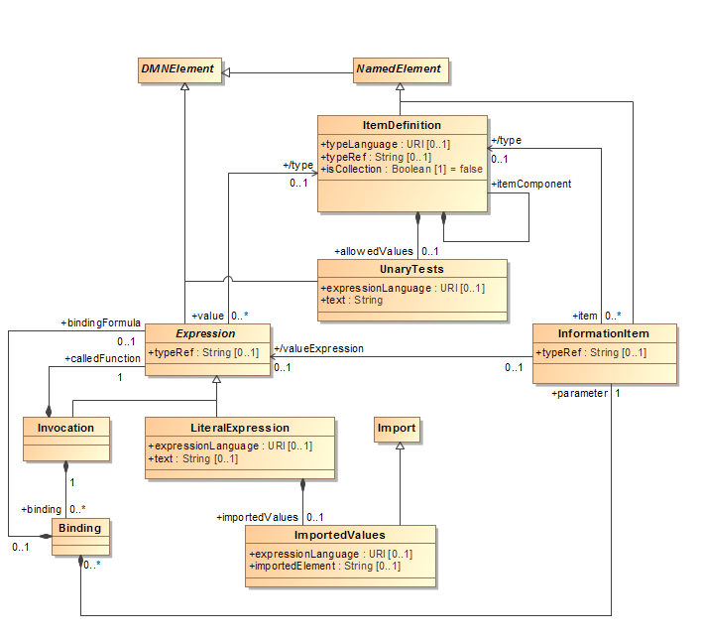
Figure 7.6: Expression class diagram

Expression metamodel
An important characteristic of decisions and business knowledge models, is that they may contain an expression that describes the logic by which a modeled decision shall be made, or pieces of that logic.
Expression is an abstract specialization of DMNElement, from which it inherits the optional id, description and label attributes.
An instance of Expression is a component of a Decision element, of a BusinessKnowledgeModel element, or of an ItemDefinition element, or it is a component of another instance of Expression, directly or indirectly.
An Expression references zero or more variables implicitly by using their names in its expression text. These variables, which are instances of InformationItem, are lexically scoped, depending on the Expression type. If the Expression is the logic of a Decision, the scope is includes that Decision's requirements. If the Expression is the body of the encapsulatedLogic of a BusinessKnowledgeModel, the scope includes the FunctionDefinition's parameters and the BusinessKnowledgeModel's requirements. If the Expression is the value of a ContextEntry, the scope includes the previous entries in the Context.An instance of Expression references an optional typeRef, which points to either a base type in the default typeLanguage, a custom type specified by an ItemDefinition, or an imported type. The referenced type specifies the Expression's range of possible values. If an instance of Expression that defines the output of a Decision element includes a typeRef, the referenced type SHALL be the same as the type of the containing Decision element.
An instance of Expression can be interpreted to derive a single value from the values assigned to its variables. How the value of an Expression element is derived from the values assigned to its variablesdepends on the concrete kind of the Expression. The ItemDefinition element specializes NamedElement and it inherits its attributes and model associations. Table 24 presents the additional attributes and model associations of the ItemDefinition element.
Expression inherits from the attributes and model associations of DMNElement.

7.3.2 ItemDefinition metamodel
The inputs and output of decisions are data items whose value, at the decision logic level, is assigned to variables or represented by value expressions.
An important characteristic of data items in decision models is their structure. DMN does not require a particular format for this data structure, but it does designate a subset of FEEL as its default.
The class ItemDefinition is used to model the structure and the range of values of the input and the outcome of decisions.
As a concrete specialization of NamedElement, an instance of ItemDefinition has a name and an optional id and description. The name of an ItemDefinition element SHALL be distinct from the names of other ItemDefinitions and Imports within the same model.
The default type language for all elements can be specified in the Definitions element using the typeLanguage attribute. For example, a typeLanguage value of http://www.w3.org/2001/XMLSchema” indicates that the data structures used by elements within that Definitions are in the form of XML Schema types. If unspecified, the default is FEEL.
Notice that the data types that are built-in in the typeLanguage that is associated with an instance of Definitions need not be redefined by ItemDefinition elements contained in that Definitions element: they are considered imported and can be referenced in DMN elements within the Definitions element.
The type language can be overridden locally using the typeLanguage attribute in the ItemDefinition element.
Notice, also, that the data types and structures that are defined at the top level in a data model that is imported using an Import element that is associated with an instance of Definitions need not be redefined by ItemDefinition elements contained in that Definitions element: they are considered imported and can be referenced in DMN elements within the Definitions element.
An ItemDefinition element MAY have a typeRef, which is a string that references, as a qualified name, either an ItemDefinition in the current instance of Definitions or a built-in type in the specified typeLanguage or a type defined in an imported DMN, XSD, or other document. In the latter case, the external document SHALL be imported in the Definitions element that contains the instance of ItemDefinition, using an Import element specifying both the namespace value and its name when used a qualifier. For example, in the case of data structures contributed by an XML schema, an Import would be used to specify the file location of that schema, and the typeRef attribute would reference the type or element definition in the imported schema. If the type language is FEEL the built-in types are the FEEL built-in data types: number, string, boolean, days and time duration, years and months duration, time, and date and time. A typeRef referencing a built-in type SHALL omit the prefix.
An ItemDefinition element may restrict the values that are allowed from typeRef, using the allowedValues attribute. The allowedValues are an instance of unaryTests that specifies the allowed values or ranges of allowed values within the domain of the typeRef. The type of the allowed values SHALL be consistent with the containing ItemDefinition element. If an ItemDefinition element contains one or more allowedValues, the allowedValues specifies the complete range of values that this ItemDefinition represents. If an ItemDefinition element does not contain allowedValues, its range of allowed values is the full range of the referenced typeRef. In cases where the values that an ItemDefinition element represents are collections of values in the allowed range, the multiplicity can be projected into the attribute isCollection. The default value for this attribute is false.
An alternative way to define an instance of ItemDefinition is as a composition of ItemDefinition elements. An instance of ItemDefinition may contain zero or more itemComponent, which are themselves ItemDefinitions. Each itemComponent in turn may be defined by either a typeRef and allowedValues or a nested itemComponent. In this way, complex types may be defined within DMN. The name of an itemComponent (nested ItemDefinition) must be unique within its containing ItemDefinition or itemComponent. An ItemDefinition element SHALL be defined using only one of the alternative ways:
- reference to a built-in or imported typeRef, possibly restricted with allowedValues;
- composition of ItemDefinition elements.
The ItemDefinition element specializes NamedElement and it inherits its attributes and model associations. Table 24 presents the additional attributes and model associations of the ItemDefinition element.

Table 24: ItemDefinition attributes and model associations
Attribute | Description
typeRef: String [1] | This attribute identifies by namespace-prefixed name the base type of this ItemDefinition.
typeLanguage: String [0..1] | This attribute identifies the type language used to specify the base type of this ItemDefinition. This value overrides the type language specified in the Definitions element. The language SHALL be specified in a URI format.
allowedValues: UnaryTests [0..1] | This attribute lists the possible values or ranges of values in the base type that are allowed in this ItemDefinition.
itemComponent: ItemDefinition[*] | This attribute defines zero or more nested ItemDefinitions that compose this ItemDefinition.
IsCollection: Boolean | Setting this flag to true indicates that the actual values defined by this ItemDefinition are collections of allowed values. The default is false.

7.3.3 InformationItem metamodel
The class InformationItem is used to model variables at the decision logic level in decision models.
InformationItem is a concrete subclass of NamedElement, from which it inherits the id, and optional name, description, and label attributes, except that an InformationItem element SHALL have a name attribute, which is the name that is used to represent it in other Expression elements. The name of an InformationItem element SHALL be unique within its scope.
Variables represent values that result from a decision, are assigned to input data by an external data source, or are passed to a module of decision logic that is defined as a function (and that is represented by a business knowledge model element). In the first or second case, a variable may be referenced by other dependent decisions by means of their information requirements. In the third case, a variable is one of the parameters of the function that is the realization, at the decision logic level, of a business knowledge model element.
A variable representing an instance of Decision or InputData referenced by an InformationRequirement SHALL be referenced by the value expression of the decision logic in the Decision element that contains the InformationRequirement element. A parameter in an instance of BusinessKnowledgeModel SHALL be a variable in the value expression of that BusinessKnowledgeModel element.
An InformationItem element contained in a Decision is assigned the value of the Decision's value expression.
- An InformationItem element that is a parameter in a FunctionDefinition is assigned a value by a Binding element as part of an instance of Invocation.
- An InformationItem element contained in an InputData is assigned a value by an external data source that is attached at runtime.
- An InformationItem element contained in a ContextEntry is assigned a value by the ContextEntry's value expression.
In any case, the datatype indicated by the typeRef that is associated with an instance of InformationItem SHALL be compatible with the datatype that is associated with the DMN model element from which it takes its value. InformationItem inherits all of the attributes and model associations of NamedElement. Table 25 presents the additional attributes and model associations of the InformationItem element.
Table 25: InformationItem attributes and model associations
Attribute | Description
/valueExpression: Expression [0..1] | The Expression whose value is assigned to this InformationItem. This is a derived attribute.
typeRef: String [1] | Qualified name of the type of this InformationItem.

7.3.4 Literal expression metamodel
The class LiteralExpression is used to model a value expression whose value is specified by text in some specified expression language.
LiteralExpression is a concrete subclass of Expression, from which it inherits the id and typeRef attributes.

An instance of LiteralExpression has an optional text, which is a String, and an optional expressionLanguage, which is a String that identifies the expression language of the text. If no expressionLanguage is specified, the expression language of the text is the expressionLanguage that is associated with the containing instance of Definitions. The expressionLanguage SHALL be specified in a URI format. The default expression language is FEEL.
As a subclass of Expression, each instance of LiteralExpression has a value. The text in an instance of LiteralExpression determines its value, according to the semantics of the LiteralExpression’s expressionLanguage. The semantics of DMN 1.1 decision models as described in this specification applies only if the text of all the instances of LiteralExpression in the model are valid expressions in their associated expression language.
An instance of LiteralExpression may include importedValues, which is an instance of a subclass Import that identifies where the text of the LiteralExpression is located. importedValues is an expression that selects text from an imported document. An instance of LiteralExpression SHALL NOT have both a text and importedValues. The importType of the importedValues identifies the type of document containing the imported text and SHALL be consistent with the expressionLanguage of the LiteralExpression element. The expressionLanguage of the importedValues element identifies how the imported text is selected from the imported document. For example, if the importType indicates an XML document, the expressionLanguage of importedValues could be XPATH 2.0.
LiteralExpression inherits of all the attributes and model associations of Expression. Table 26 presents the additional attributes and model associations of the LiteralExpression element.

Table 26: LiteralExpression attributes and model associations
Attribute | Description
text: string [0..1] | The text of this LiteralExpression. It SHALL be a valid expression in the expressionLanguage.
expressionLanguage: anyURI [0..1] | This attribute identifies the expression language used in this LiteralExpression. This value overrides the expression language specified for the containing instance of DecisionRequirementDiagram. The language SHALL be specified in a URI format.
importedValues: ImportedValues [0..1] | The instance of ImportedValues that specifies where the text of this LiteralExpression is located.

7.3.5 Invocation metamodel
Invocation is a mechanism that permits the evaluation of one value expression – the invoked expression – inside another value expression – the invoking expression – by binding locally the input variables of the invoked expression to values inside the invoking expression. In an invocation, the input variables of the invoked expression are usually called: parameters. Invocation permits the same value expression to be re-used in multiple expressions, without having to duplicate it as a sub-expression in all the using expressions.
The class Invocation is used to model invocations as a kind of Expression: Invocation is a concrete specialization of Expression.
An instance of Invocation is made of zero or more binding, which are instances of Binding, and model how the bindingFormulas are bound to the formalParameters of the invoked function. The formalParameters of a FunctionDefinition are InformationItems and the parameters of the Bindings are InformationItems. The binding is by matching the InformationItem names.
An Invocation contains a calledFunction, an Expression, which must evaluate to a function. Most commonly, it is a LiteralExpression naming a BusinessKnowledgeModel.
The value of an instance of Invocation is the value of the associated calledFunction's body, with its formalParameters assigned values at runtime per the bindings in the Invocation.
Invocation MAY be used to model invocations in decision models, when a Decision element has exactly one knowledgeRequirement element, and when the decisionLogic in the Decision element consists only in invoking the BusinessKnowledgeModel element that is referenced by that requiredKnowledge and a more complex value expression is not required.
Using Invocation instances as the decisionLogic in Decision elements permits the re-use of the encapsulatedLogic of a BusinessKnowledgeModel as the logic for any instance of Decision that requires that BusinessKnowledgeModel, where each requiring Decision element specifies its own bindings for the encapsulatedLogic's parameters.
The calledFunction that is associated with the Invocation element SHALL BE the encapsultedLogic of the BusinessKnowledgeModel element that is required by the Decision element that contains the Invocation. The Invocation element SHALL have exactly one binding for each parameter in the BusinessKnowledgeModel's encapsulatedLogic.
Invocation inherits of all the attributes and model associations of Expression. Table 27 presents the additional attributes and model associations of the Invocation element.

Table 27: Invocation attributes and model associations
Attribute | Description
calledFunction: Expression [1] | An expression whose value is a function.
binding: Binding [*] | This attribute lists the instances of Binding used to bind the formalParameters of the calledFunction in this Invocation.

7.3.6 Binding metamodel
The class Binding is used to model, in an Invocation element, the binding of the calledFunction's formalParameters to values.
A Binding is made of one bindingFormula, which is an Expression, and of one parameter, which is an InformationItem.
The parameter names in the Binding elements SHALL be a subset of the formalParameters of the calledFunction.
When the Invocation element is executed, each InformationItem element that is referenced as a parameter by a binding in the Invocation element is assigned, at runtime, the value of the bindingFormula.
Table 28 presents the attributes and model associations of the Binding element.

Table 28: Binding attributes and model associations
Attribute | Description
parameter: InformationItem | The InformationItem on which the calledFunction of the owning instance of Invocation depends that is bound by this Binding.
bindingFormula: Expression [0..1] | The instance of Expression to which the parameter in this Binding is bound when the owning instance of Invocation is evaluated.

Decision Table

Introduction
One of the ways to express the decision logic corresponding to the DRD decision artifact is as a decision table. A decision table is a tabular representation of a set of related input and output expressions, organized into rules indicating which output entry applies to a specific set of input entries. The decision table contains all (and only) the inputs required to determine the output. Moreover, a complete table contains all possible combinations of input values (all the rules).
Decision tables and decision table hierarchies have a proven track record in decision logic representation. It is one of the purposes of DMN to standardize different forms and types of decision tables.
A decision table consists of:
- An information item name: the name of an InformationItem, if any, for which the decision table is its value expression. This will usually be the name of the Decision or Business Knowledge Model for which the decision table provides the decision logic.
- A list of input clauses (zero or more). Each input clause is made of an input expression and optional allowed values for the input entries that correspond to the clause. The input entries are contained in the rules, and the i^{th} input entry corresponds to the i^{th} input clause.
- A list of output clauses (one or more). Each output clause is made of a name and optional allowed values for the output entries that correspond to the clause. The output entries are contained in the rules, and the ith output entry corresponds to the ith output clause. A single output clause has no name. Two or more output clauses describe a decision table that returns a context for each hit with an entry for each output clause. Each of the multiple output clauses SHALL be named.
- A set of outputs (one or more). A single output has no name, only a value. Two or more outputs are called output components. Each output component SHALL be named. Each output (component) SHALL specify an output entry for each rule. The specification of output component name (if multiple outputs) and all output entries is referred to as an output clause.
- A list of annotation clauses (zero or more). Each annotation clause is made of a name. Each annotation SHALL be named as part of a rule annotation clause. The annotation entries are contained in the rules, and the i^{th} annotation entry corresponds to the i^{th} annotation clause.
- A list of rules (one or more) in rows or columns of the table (depending on orientation), where each rule is composed of the specific input entries, output entries and optional rule annotations of the table row (or column). If the rules are expressed as rows, the columns are clauses, and vice versa.

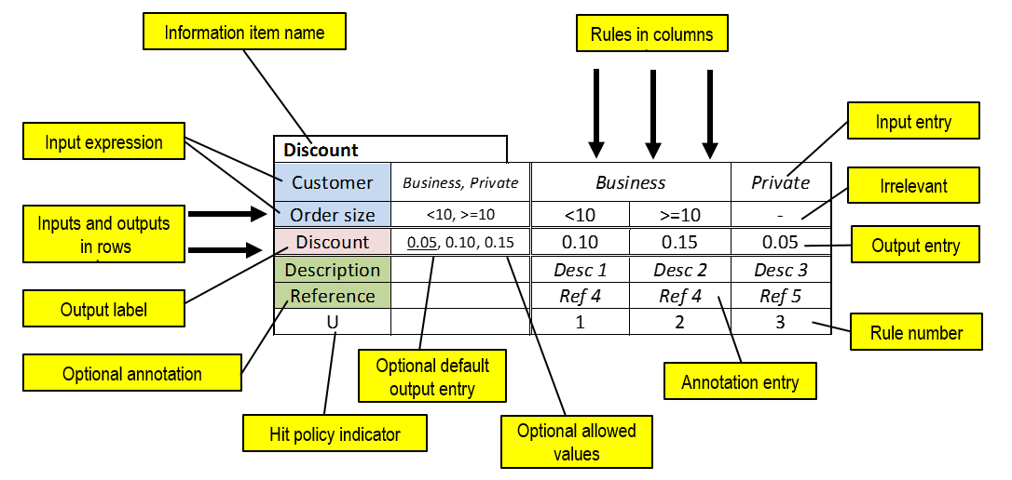
Figure 8.1: Decision table example (vertical orientation: rules as columns)
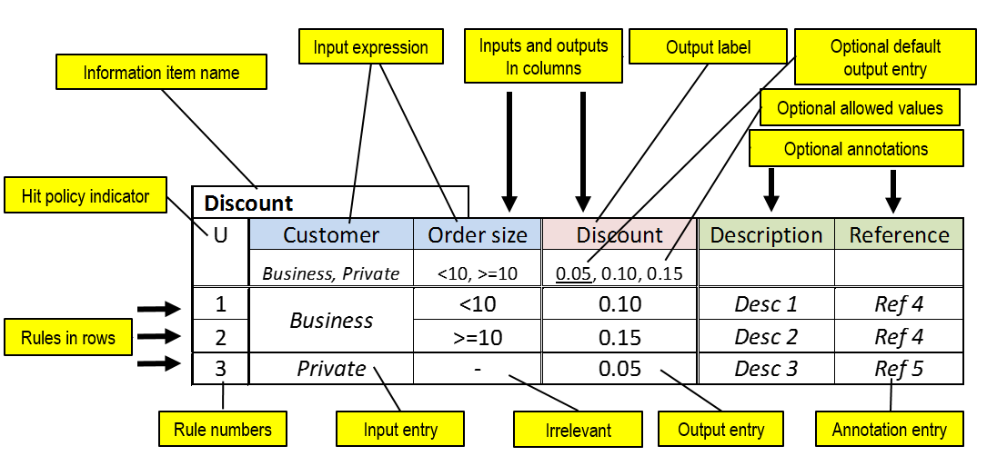
Figure 8.2: Decision table example (horizontal orientation: rules as rows)

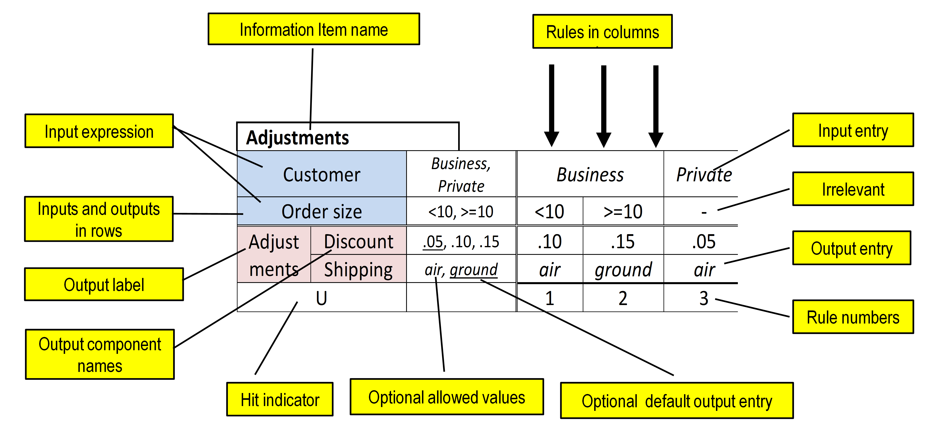
Figure 8.3: Decision table example (vertical orientation, multiple output components)

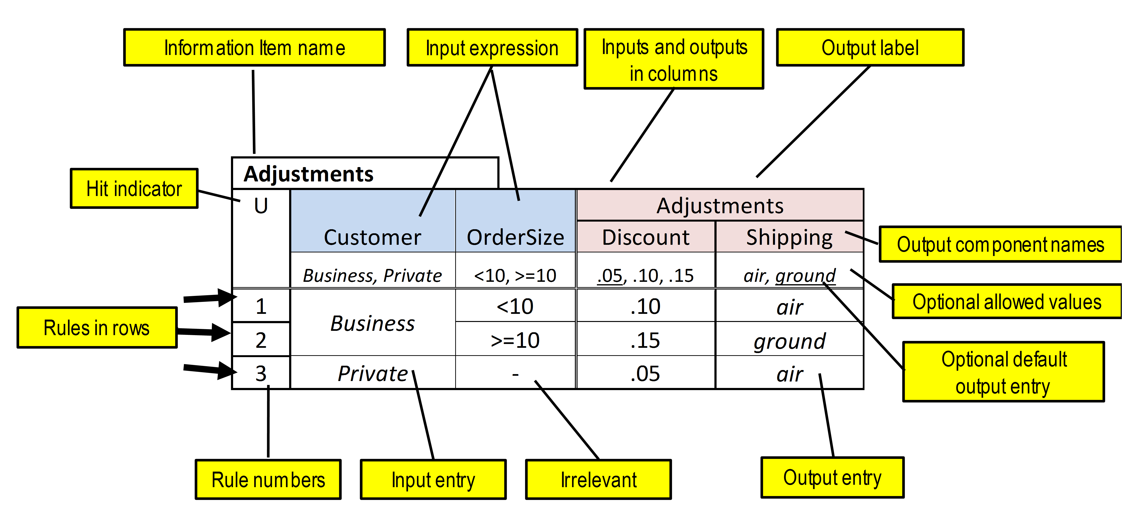
Figure 8.4: Decision table example (horizontal orientation, multiple output components)

The decision table shows the rules in a shorthand notation by arranging the entries in table cells. This shorthand notation shows all inputs in the same order in every rule and therefore has a number of readability and verification advantages.
For example:
Customer | OrderSize | Discount
Business | <10 | 0.10
reads as:
If Customer = “Business” and OrderSize < 10 then Discount = 0.10

In general, this is expressed as:
input expression 1 | input expression 2 | Output label
input entry a | input entry b | output entry c

The three highlighted cells in the decision table fragment above represent the following rule:
If the value of input expression 1 satisfies input entry a
and the value of input expression 2 satisfies input entry b
then the rule matches and the result of the decision table is output entry c.
An input expression value satisfies an input entry if the value is equal to the input entry, or belongs to the list of values indicated by the input entry (e.g. a list or a range), or one of the expressions in the input entry evaluates to true. For the complete specification of the input entry satisfaction conditions, please refer to section 8.3.3. If the input entry is ‘-’ (meaning irrelevant), every value of the input expression satisfies the input entry and that particular input is irrelevant in the specified rule.
A rule matches if the value of every input expression satisfies the corresponding input entry. If there are no input entries, any rule matches.
The list of rules expresses the logic of the decision. For a given set of input values, the matching rule (or rules) indicate the resulting value for the output name. If rules overlap, multiple rules can match and a hit policy indicates how to handle the multiple matches.
If two input entries of the same input expression share no values, the entries (cells) are called disjoint. If there is an intersection, the entries are called overlapping (or even equal). ‘Irrelevant’ (‘-’) overlaps with any input entry of the input expression.
Two rules are overlapping if all corresponding input entries are overlapping. A specific configuration of input data may then match the two rules.
Two rules are disjoint (non-overlapping) if at least one pair of corresponding input expressions is disjoint. No specific configuration of input data will match the two rules.
If tables are allowed to contain overlapping rules, the table hit policy indicates how overlapping rules have to be handled and which is the resulting value(s) for the output name, in order to avoid inconsistency.

Notation
This section builds on the generic notation for decision logic and boxed expressions defined in clause 7.2.
A decision table representation standardizes:
- the orientation (rules as rows, columns or crosstab), as shown by the table
- placement of inputs, outputs and (optional) allowed values in standard locations on a grid of cells. Each input expression is optionally associated with unary tests restricting the allowed input values. In this text the optional cells with allowed values are indicated in inverse. Each output (component) is optionally associated with allowed values. In this text the optional allowed output values are indicated in inverse..
- line style and optional use of color
- the contents of specific rule input and output entry cells
- the hit policy, indicating how to interpret overlapping input combinations
- placement of information item name, hit policy (H) and rule numbers as indicated in Figure 8.5, Figure 8.7 and Figure 8.9 Rule numbers are consecutive natural numbers starting at 1. Rule numbering is required for tables with hit indicator F (first) or R (rule order), because the meaning depends on rule sequence. Crosstab tables have no rule numbers. Rule numbering is optional for other table types.
Input expressions, input values, output values, input entries and output entries can be any text (e.g. natural language, formal language, pseudo-code). Implementations claiming level 2 or 3 conformance SHALL support (S-)FEEL syntax. Implementations claiming level 1 conformance are not required to interpret the expressions. To avoid misinterpretation (e.g. when expressions are not meant to be valid (S-)FEEL but may conflict with the look and feel of (S-)FEEL syntax), conformant implementations SHOULD indicate when the input expression is not meant to be interpreted by using the URI: "http://www.omg.org/spec/DMN/uninterpreted/20140801".

Line style and color
Line style is normative. There is a double line between the input clauses and output clauses, continuing between the input entries and the output entries. There is also a double line between the output clauses and the annotation clauses, continuing between the output entries and the annotation entries. These two double lines are parallel to each other. There is a third double line, that intersects at right angles with the previous two, between input clauses and the input entries, continuing between the output clauses and the output entries, and continuing between the annotation clauses and the annotation entries. All other cells are separated by a single line.
Color is suggested, but does not influence the meaning. It is considered good practice to use different colors for the input clauses, the output clauses, and the annotation clauses, and another (or no) color for the input, output, and annotation entries.

Table orientation
Depending on size, a decision table can be presented horizontally (rules as rows), vertically (rules as columns), or crosstab (rules composed from two input dimensions). Crosstab tables can only have the default hit policy (see later).
Decision table inputs and outputs should not be mixed. In a horizontal table, all input columns SHALL be represented on the left of all output columns. In a vertical table, all the input rows SHALL be represented above all output rows. In a crosstab, all the output cells SHALL be in the bottom-right part of the table.
The table SHALL be arranged in one of the following ways (see Figure 8.5, Figure 8.7, Figure 8.9). Cells indicated in inverse are optional.
The input cell entry ‘-’ means ‘irrelevant’. HC is a placeholder for hit policy indicator (e.g. U, A, F, ...).

information item name
H | input expression 1 | input expression 2 |  | Output label
H | input value 1a,  input value 1b | input value 2a,  input value 2b |  | output value 1a,  output value 1b
1 | input entry 1.1 | input entry 2.1 |  | output entry 1.1
2 | input entry 1.1 | input entry 2.2 |  | output entry 1.2
3 | input entry 1.2 | - |  | output entry 1.3
Figure 8.5: Rules as rows – schematic layout

Discount
U | Customer | OrderSize |  | Delivery | Discount
U | Business, Private, Government | <10, >=10 |  | sameday, slow | 0, 0.05, 0.10, 0.15
1 | Business | <10 |  | - | 0.05
2 | Business | >=10 |  | - | 0.10
3 | Private | - |  | sameday | 0
4 | Private |  |  | slow | 0.05
5 | Government | - |  | - | 0.15
Figure 8.6: Rules as rows – example

information item name
input expression 1 | value 1a, value 1b | input entry 1.1 |  | input entry 1.2
input expression 2 | value 2a, value 2b | input entry 2.1 | input entry 2.2 | -
Output label | value 1a, value 1b | output entry 1.1 | output entry 1.2 | output entry 1.3
H |  | 1 | 2 | 3
Figure 8.7: Rules as columns – schematic layout

Discount
Customer | Business, Private, Government | Business |  | Private |  | Government
Ordersize | <10, >=10 | <10 | >=10 | - |  | -
Delivery | sameday, slow | - | - | sameday | slow | -
Discount | 0, 0.05, 0.10, 0.15 | 0.05 | 0.10 | 0 | 0.05 | 0.15
U |  | 1 | 2 | 3 | 4 | 5
Figure 8.8: Rules as columns – example

Figure 8.9: Rules as crosstab - schematic layout (optional input and output values not shown)

Figure 8.10: Rules as crosstab - simplified example with only two inputs

Figure 8.11: Rules as crosstab - example with three inputs

Crosstab tables with more than two inputs are possible (as shown in Figure 8.11).

Input expressions
Input expressions are usually simple, for example, a name (e.g. CustomerStatus) or a test (e.g. Age<25).
The order of input expressions is not related to any execution order in implementation.

Input values
Input expressions may be expected to result in a limited number or a limited range of values. It is important to model these expected input values, because a decision table will be considered complete if its rules cover all combinations of expected input values for all input expressions.
Regardless of how the expected input values are modeled, input values SHOULD be exclusive and complete. Exclusive means that input values are disjoint. Complete means that all relevant input values from the domain are present.
For example, the following two input value ranges overlap: <5, <10. The following two ranges are incomplete: <5, >5.
The list of input values is optional. If provided, it is a list of unary tests that must be satisfied by the corresponding input.

Information Item names, output labels, and output component names
A decision table with multiple output components SHALL specify a name for each output component.
A decision table that is the value expression of an InformationItem (e.g. a Decision's logic or a boxed Invocation's binding formula) SHALL specify the name of the InformationItem as its Information Item name. A decision table that is not contained in another boxed expression shall place the Information Item name in a name box just above and adjoining the table.
A decision table that is contained in another boxed expression may use the containing expression for its Information Item name. For example, the Information Item name for a decision table bound to a function parameter is the name of the function parameter. Or, to save space, the Information Item name box may be omitted and the Output label used instead.
Output values
The output entries of a decision table are often drawn from a list of output values.
The list of output values is optional. If provided, it is a list restricting output entries to the given list of values.
When the hit policy is P (priority), meaning that multiple rules can match, but only one hit should be returned, the ordering of the list of output values is used to specify the (decreasing) priority.
The ordering of the list of output values is also used when the hit policy is output order.

Multiple outputs
The decision table can show a compound output (see Figure 8.12, Figure 8.13, and Figure 8.14).

Figure 8.12: Horizontal table with multiple output components

Figure 8.13: Vertical table with multiple output components

Figure 8.14: Crosstab with multiple output components

Input entries
Rule input entries are unary tests (grammar rule 17).
A dash symbol (‘-’) can be used to mean any input value, i.e., the input is irrelevant for the containing rule.
The input entries in a unary test SHOULD be ‘-’ or a subset of the input values specified. For example, if the input values for input ‘Age’ are specified as [0..120], then an input entry of <0 SHOULD be reported as invalid.
Tables containing at least one ‘-’ input entry are called contracted tables. The others are called expanded.
Tables where every input entry is true, false, or ‘-’ are historically called limited-entry tables, but there is no need to maintain this restriction.
Evaluation of the input expressions in a decision table does not produce side-effects that influence the evaluation of other input expressions. This means that evaluating an expression or executing a rule should not change the evaluation of other expressions or rules of the same table. This is particularly important in first hit tables where the rules are evaluated in a predefined sequence: evaluating or executing a rule should not influence other rules.

Merged input entry cells
Adjacent input entry cells from different rules, with the same content and same (or no) prior cells can be merged, as shown in Figure 8.15 and Figure 8.16. Rule output cells cannot be merged (except in crosstabs).

information item name
H | input expression 1 | input expression 2 |  | Output label
H | input value 1a,  input value 1b | input value 2a,  input value 2b |  | output value 1a, output value 1b
1 | input entry 1a | input entry 2a |  | output entry 1.1
2 | input entry 1a | input entry 2b |  | output entry 1.2
3 | input entry 1b | - |  | output entry 1.3
Figure 8.15: Merged rule input cells allowed

information item name
H | input expression 1 | input expression 2 |  | Output label
H | input value 1a,  input value 1b | input value 2a,  input value 2b |  | output value 1a, output value 1b
1 | input entry 1a | input entry 2a |  | output entry 1.1
2 | input entry 1a | input entry 2b |  | output entry 1.2
3 | input entry 1b | input entry 2b |  | output entry 1.3
4 | input entry 1b | input entry 2a |  | output entry 1.4
Figure 8.16: Merged rule input cells not allowed

Output entry
A rule output entry is an expression.
Rule output cells cannot be merged (except in crosstabs, where adjacent output cells with the same content can be merged).
Shorthand notation
In vertical (rules as columns) tables with a single output name (equal to the information item name), a shorthand notation may be used to indicate: output value applies (‘X’) or does not apply (‘-’), as is common practice in decision tables.
Because there can be only one output entry for an output name, every rule must indicate no more than one ‘X’. The other output entries must contain ‘-’.
The table in Figure 8.17 is shorthand notation for the table in Figure 8.18. It is called shorthand , because the output entries need not be (re-)written in every column, but are indicated with a one-character notation (‘X’ or ‘-’), thereby saving space in vertical tables, which tend to expand in width as the number of rules increases. The output values are written only once, before the rules, in the output expression part.
If an information item name is provided, and there is only one output name (which has to be equal to the information item name), the output name is optional.

Applicant Risk Rating
Applicant Age | < 25 |  | [25..60] |  | > 60
Medical History | good | bad | - |  | good | bad
Low | X | - | - |  | - | -
Medium | - | X | X |  | X | -
High | - | - | - |  | - | X
U | 1 | 2 | 3 |  | 4 | 5
Figure 8.17: Shorthand notation for vertical tables (rules as columns)

Applicant Risk Rating
Applicant Age | < 25 |  |  | [25..60] | > 60
Medical History | good | bad |  | - | good | bad
Applicant Risk Rating | Low | Medium |  | Medium | Medium | High
U | 1 | 2 |  | 3 | 4 | 5
Figure 8.18: Full notation for vertical tables (rules as columns)

Hit policy
A decision table normally has several rules. As a default, rules do not overlap. If rules overlap, meaning that more than one rule may match a given set of input values, the hit policy indicator is required in order to recognize the table type and unambiguously understand the decision logic. The hit policy can be used to check correctness at design-time.
The hit policy specifies what the result of the decision table is in cases of overlapping rules, i.e. when more than one rule matches the input data. For clarity, the hit policy is summarized using a single character in a particular decision table cell. In horizontal tables this is the top-left cell (Figure 8.2) and in vertical tables this is the bottom-left cell (Figure 8.1). The character is the initial letter of the defined hit policy (Unique, Any, Priority, First, Collect, Output order or Rule order). Crosstab tables are always Unique and need no indicator.
The hit policy SHALL default to Unique, in which case the hit indicator is optional. Decision tables with the Unique hit policy SHALL NOT contain overlapping rules.
Tools may support only a nonempty subset of hit policies, but the table type SHALL be clear and therefore the hit policy indication is mandatory, except for the default unique tables. Unique tables SHALL always be supported.
Single and multiple hit tables
A single hit table shall return the output of one rule only; a multiple hit table may return the output of multiple rules (or a function of the outputs, e.g. sum of values). If rules are allowed to overlap, the hit policy indicates how overlapping rules have to be interpreted.
The initial letter for hit policy also identifies if a table is single hit or multiple hit.
A single hit table may or may not contain overlapping rules, but returns the output of one rule only. In case of overlapping rules, the hit policy indicates which of the matching rules to select. Some restrictions apply to tables with compound outputs.
Single hit policies for single output decision tables are:
- Unique: no overlap is possible and all rules are disjoint. Only a single rule can be matched. This is the default.
- Any: there may be overlap, but all the matching rules show equal output entries for each output (ignoring rule annotations), so any match can be used. If the output entries are non-equal (ignoring rule annotations), the hit policy is incorrect and the result is undefined.
- Priority: multiple rules can match, with different output entries. This policy returns the matching rule with the highest output priority. Output priorities are specified in the ordered list of output values, in decreasing order of priority. Note that priorities are independent from rule sequence.
- First: multiple (overlapping) rules can match, with different output entries. The first hit by rule order is returned (and evaluation can halt). This is still a common usage, because it resolves inconsistencies by forcing the first hit. However, first hit tables are not considered good practice because they do not offer a clear overview of the decision logic. It is important to distinguish this type of table from others because the meaning depends on the order of the rules. The last rule is often the catch-remainder. Because of this order, the table is hard to validate manually and therefore has to be used with care.
A multiple hit table may return output entries from multiple rules. The result will be a list of rule outputs or a simple function of the outputs.
Multiple hit policies for single output decision tables can be:
- Output order: returns all hits in decreasing output priority order. Output priorities are specified in the ordered list of output values in decreasing order of priority.
- Rule order: returns all hits in rule order. Note: the meaning may depend on the sequence of the rules.
- Collect: returns all hits in arbitrary order. An operator (‘+’, ‘<’, ‘>’, ‘#’) can be added to apply a simple function to the outputs. If no operator is present, the result is the list of all the output entries.
Collect operators are:
- + (sum): the result of the decision table is the sum of all the outputs.
- < (min): the result of the decision table is the smallest value of all the outputs.
- > (max): the result of the decision table is the largest value of all the outputs.
- # (count): the result of the decision table is the number of outputs.
Other policies, such as more complex manipulations on the outputs, can be performed by post-processing the output list (outside the decision table).

Decision tables with compound outputs support only the following hit policies: Unique, Any, Priority, First, Output order, Rule order and Collect without operator, because the collect operator is undefined over multiple outputs. This restriction ignores rule annotations of which there may be multiple regardless of the hit policy specified.
For the Priority and Output order hit policies, priority is decided in compound output tables over all the outputs for which output values have been provided (ignoring rule annotations). The priority for each output is specified in the ordered list of output values in decreasing order of priority, and the overall priority is established by considering the ordered outputs from left to right in horizontal tables (i.e. columns to the left take precedence over columns to the right), or from top to bottom in vertical tables. Outputs for which no output values are provided are not taken into account in the ordering, although their output entries are included in the ordered compound output.
So, for example, if called with Age = 17, Risk category = “HIGH” and Debt review = true, the Routing rules table in Figure 8.19 would return the outputs of all four rules, in the order 2, 4, 3, 1.

Routing rules
O | Age | Risk category | Debt review | Routing | Review level | Reason
O |  | LOW, MEDIUM, HIGH |  | DECLINE, REFER, ACCEPT | LEVEL 2,  LEVEL 1, NONE
1 | - | - | - | ACCEPT | NONE | Acceptable
2 | < 18 | - | - | DECLINE | NONE | Applicant too young
3 | - | HIGH | - | REFER | LEVEL 1 | High risk application
4 | - | - | true | REFER | LEVEL 2 | Applicant under debt review
Figure 8.19: Output order with compound output

Note 1
Crosstab tables are unique and complete by definition and therefore do not need a hit policy.
Note 2
The sequence of the rules in a decision table does not influence the meaning, except in First tables (single hit) and Rule order tables (multiple hit). These tables should be used with care.

Default output values
Tables may specify a default output. The default value is underlined in the list of output values.

Metamodel

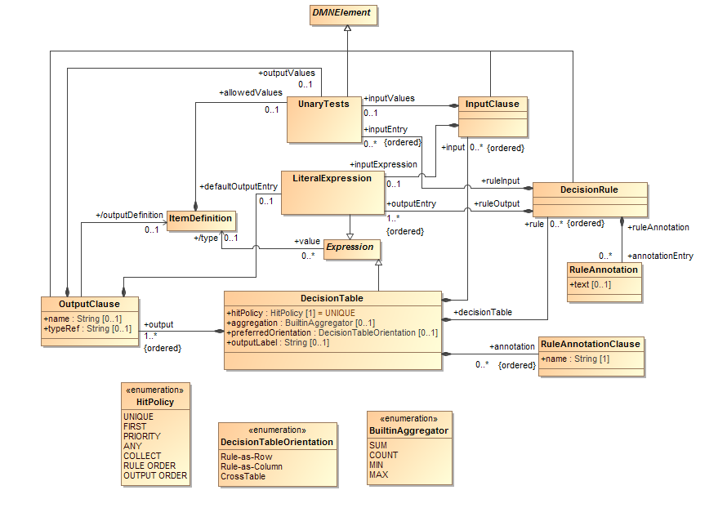
Figure 8.20: DecisionTable class diagram

Decision Table metamodel
The class DecisionTable is used to model a decision table.
DecisionTable is a concrete specialization of Expression.
An instance of DecisionTable contains a list of rules which are instances of DecisionRule, a list of inputs which are instances of InputClause, a list of outputs which are instances of OutputClause, and a list of annotations which are instances of RuleAnnotationClause.
It has a preferredOrientation, which SHALL be one of the enumerated DecisionTableOrientation: Rule-as-Row, Rule-as-Column or CrossTable. An instance of DecisionTable SHOULD BE represented as specified by its preferredOrientation, as defined in clause 8.2.2.
An instance of DecisionTable has an associated hitPolicy, which SHALL be one of the enumerated HitPolicy: UNIQUE, FIRST, PRIORITY, ANY, COLLECT, RULE ORDER, OUTPUT ORDER. The default value for the hitPolicy attribute is: UNIQUE. In the diagrammatic representation of an instance of DecisionTable, the hitPolicy is represented as specified in clause 8.2.10.
The semantics that is associated with an instance of DecisionTable depends on its associated hitPolicy, as specified below and in clause 8.2.10. The hitPolicy attribute of an instance of DecisionTable is represented as specified in clause 8.2.10.
If the hitPolicy associated with an instance of DecisionTable is FIRST or RULE ORDER, the rules that are associated with the DecisionTable SHALL be ordered. The ordering is represented by the explicit numbering of the rules in the diagrammatic representation of the DecisionTable.
If the hitPolicy associated with an instance of DecisionTable is PRIORITY or OUTPUT ORDER, the outputValues determine the result as specified in clause 8.2.10.
If the hitPolicy that is associated with an instance of DecisionTable is COLLECT, the DecisionTable MAY have an associated aggregation, which is one of the enumerated BuiltinAggregator (see clause 8.2.10).
As a kind of Expression, an instance of DecisionTable has a value, which depends on the outputs of the associated rules, the associated hitPolicy and the associated aggregration, if any. The value of an instance of DecisionTable is determined according to the specification in clause 10.3.2.10.
DecisionTable inherits all the attributes and model associations from Expression. Table 29 presents the additional attributes and model associations of the DecisionTable element.

Table 29: DecisionTable attributes and model associations
Attribute | Description
input: InputClause [*] | This attributes lists the instances of InputClause that compose this DecisionTable.
output: OutputClause [*] | This attributes lists the instances of OutputClause that compose this DecisionTable.
annotation: RuleAnnotationClause [*] | This attribute lists the instances of RuleAnnotationClause that compose this DecisionTable.
rule: DecisionRule [*] | This attributes lists the instances of DecisionRule that compose this DecisionTable.
hitPolicy: HitPolicy | The hit policy that determines the semantics of this DecisionTable. Default is: UNIQUE.
aggregation: BuiltinAggregator | If present, this attribute specifies the aggregation function to be applied to the unordered set of values of the applicable rules to determine the value of this DecisionTable when the hitPolicy is COLLECT.
preferredOrientation: DecisionTableOrientation [0..1] | The preferred orientation for the diagrammatic representation of this DecisionTable. This DecisionTable SHOULD BE represented as specified by this attribute.
outputLabel: string[0..1] | This attribute gives a description of the decision table output, and is often the same as the name of the InformationItem for which the decision table is the value expression.

Decision Table Input and Output metamodel
In a DecisionTable, an input specifies an inputExpression (the subject) and a number of inputEntries. An output specifies the name and the domain of definition of an output value, a number of outputEntries.
The class InputClause is used to model a decision table input, and the class OutputClause is used to model a decision table output, and the class RuleAnnotationClause is used to model a decision table annotation.
An instance of InputClause is made of an optional inputExpression and an ordered list of inputEntry, which are instances of UnaryTests. An instance of OutputClause optionally references a typeRef, specifying its datatype, and it is made of an ordered list of outputEntry, which are instances of LiteralExpression, and an optional defaultOutputEntry, which is also an instance of LiteralExpression. An instance of RuleAnnotationClause contains a name of type String.
When a DecisionTable contains more than one OutputClause, each OutputClause SHALL have a name. When a DecisionTable has a single OutputClause, the OutputClause SHALL NOT have a name. A RuleAnnotationClause SHALL have a name.
Table 30, Table 31 and Table 32 present the attributes and model associations of InputClause, OutputClause and RuleAnnotationClause respectively.

Table 30: InputClause attributes and model associations
Attribute | Description
inputExpression: Expression [0..1] | The subject of this InputClause.
inputValues: UnaryTests [0..1] | This attribute contains UnaryTests that constrain the result of the inputExpression of this InputClause.

Table 31: OutputClause attributes and model associations
Attribute | Description
typeRef: String [1] | The OutputClause of a single output decision table SHALL NOT specify a typeRef. OutputClauses of a multiple output decision table MAY specify a typeRef. A typeRef is the name of the datatype of the output, either an ItemDefinition, a base type in the specified expressionLanguage, or an imported type.
name: string [0..1] | The OutputClause of a single output decision table SHALL NOT specify a name. OutputClauses of a multiple output decision table SHALL specify a name.
outputValues: UnaryTests [0..1] | This attribute contains UnaryTests that constrain the result of the outputEntrys of the DecisionRules corresponding to this OutputClause.
defaultOutputEntry: Expression [0..1] | In an Incomplete table, this attribute lists an instance of Expression that is selected when no rules match for the decision table.

Table 32: RuleAnnotationClause attributes and model associations
Attribute | Description
name: string [1] | RuleAnnotationClause SHALL specify a name that is used as the name of the rule annotation column of the containing decision table.

Decision Rule metamodel
The class DecisionRule is used to model the rules in a decision table (see clause 8.2).
An instance of DecisionRule has an ordered list of inputEntry instances which are instances of UnaryTests, an ordered list of outputEntry instances, which are instances of LiteralExpression, and an ordered list of ruleAnnotations.
In a tabular representation of the containing instance of DecisionTable, the representation of an instance of DecisionRule depends on the orientation of the decision table. For instance, if the decision table is represented horizontally (rules as row, see clause 8.2.2), instances of DecisionRule are represented as rows, with all the inputEntrys represented on the left of all the outputEntrys, and all the ruleAnnotations represented to their right.
By definition, a DecisionRule element that has no inputEntrys is always applicable. Otherwise, an instance of DecisionRule is said to be applicable if and only if, all of the DecisionTable’s inputExpression values satisfy their corresponding inputEntry.
An inputExpression satisfies its corresponding inputEntry if and only if one of the following alternatives is true:
- One of the expressions in the inputEntry evaluates to a value, and the inputExpression value is equal to that value;
- One of the expressions in the inputEntry evaluates to a list of values, and the inputExpression value is equal to at least one of the values in that list;
- One of the expressions in the inputEntry is a unary test, and the unary test evaluates to true when the inputExpression value is applied to it
- One of the expressions in the inputEntry is a boolean expressions using the special ‘?’ variable and that expression evaluates to true when the inputExpression value is assigned to ‘?’
The inputEntrys are matched in arbitrary order.
The inputEntry elements SHALL be in the same order as the containing DecisionTable's inputs. The i^{th} inputExpression must satisfy the i^{th} inputEntry for all inputEntrys in order for the DecisionRule to match, as defined in section 8.1.
The outputEntry elements SHALL be in the same order as the containing DecisionTable's outputs. The i^{th} outputEntry SHALL be consistent with the typeRef of the i^{th} OutputClause.
The ruleAnnotation elements SHALL be in the same order as the containing DecisionTable's annotations. The i^{th} ruleAnnotation refers to the i^{th} RuleAnnotationClause.
Table 33 presents the attributes and model associations of the DecisionRule element; Table 33 presents the attributes and model associations of the RuleAnnotation element.

Table 33: DecisionRule attributes and model associations
Attribute | Description
inputEntry: UnaryTests[0..*] | The instances of UnaryTests that specify the input conditions that this DecisionRule must match for the corresponding (by index) inputExpression.
outputEntry: LiteralExpression [1..*] | A list of the instances of LiteralExpression that compose the output components of this DecisionRule.
annotationEntry: RuleAnnotation [0..*] | A list of the instances of RuleAnnotation that compose the annotations of this DecisionRule and match the corresponding (by index) instances of RuleAnnotationClause.

Table 34: RuleAnnotation attributes and model associations
Attribute | Description
text: string [0..1] | The text of the RuleAnnotation.

Examples
Table 35 provides examples for the various types of decision table discussed in this section. Further examples may be found in clause 11.4, in the context of a complete example of a DMN decision model.

Table 35: Examples of decision tables
Single Hit  Unique
  Applicant Risk Rating
  U | Applicant Age | Medical History |  | Applicant Risk Rating
  1 | > 60 | good |  | Medium
  2 | > 60 | bad |  | High
  3 | [25..60] | - |  | Medium
  4 | < 25 | good |  | Low
  5 | < 25 | bad |  | Medium
  Applicant Risk Rating
  Applicant Age | < 25 |  |  | [25..60] | > 60
  Medical History | good | bad |  | - | good | bad
  Applicant Risk Rating | Low | Medium |  | Medium | Medium | High
  U | 1 | 2 |  | 3 | 4 | 5
  Applicant Risk Rating
  Applicant Age | < 25 |  |  | [25..60] | > 60
  Medical History | good | bad |  | - | good | bad
  Low | X | - |  | - | - | -
  Medium |  | X |  | X | X
  High |  |  |  |  |  | X
  U | 1 | 2 |  | 3 | 4 | 5
Single Hit  Any | Example case: not A, >= $10K, >= 50K -> Not Compliant (rules 2,3,4)
  Person Loan Compliance
  A | Persons Credit Rating from Bureau | Person Credit Card Balance |  | Person Education Loan Balance | Person Loan Compliance
  1 | A | < 10000 |  | < 50000 | Compliant
  2 | Not(A) | - |  | - | Not Compliant
  3 | - | >= 10000 |  | - | Not Compliant
  4 | - | - |  | >= 50000 | Not Compliant
Single Hit  Priority
  Applicant Risk Rating
  P | Applicant Age | Medical History |  | Applicant Risk Rating
   |  |  |  | High, Medium, Low
  1 | >= 25 | good |  | Medium
  2 | > 60 | bad |  | High
  3 | - | bad |  | Medium
  4 | < 25 | good |  | Low
Single Hit  First | Example case: Web, non-US, Retailer -> 0 (rule 3)
  Special Discount
  F | Type of Order | Customer Location |  | Type of Customer | Special Discount %
  1 | Web | US |  | Wholesaler | 10
  2 | Phone | - |  | - | 0
  3 | - | Non-US |  | - | 0
  4 | - | - |  | Retailer | 5
  Special Discount
  Type of Order | Web |  |  | -
  Customer Location | US |  |  | -
  Type of Customer | Wholesaler |  | Retailer | -
  Special Discount % | 10 |  | 5 | 0
  F | 1 |  | 2 | 3
Multiple Hit  No order | Example case: Age=58, Service=31 -> Result=sum(22, 5, 3)=30
  Holidays
  Age | - | <18 |  | >=60 | - | [18..60) | >=60 | -
  Years of Service | - | - |  | - | >=30 | [15..30) | - | >=30
  Holidays | 22 | 5 |  | 5 | 5 | 2 | 3 | 3
  C+ | 1 | 2 |  | 3 | 4 | 5 | 6 | 7
Multiple Hit  Output order | Example case: Age=58, Service=31 -> Result=(22, 5, 3)
  Holidays
  O | Age | Years of Service |  | Holidays
   |  |  |  | 22, 5, 3, 2
  1 | - | - |  | 22
  2 | >= 60 | - |  | 3
  3 | - | >= 30 |  | 3
  4 | < 18 | - |  | 5
  5 | >= 60 | - |  | 5
  6 | - | >= 30 |  | 5
  7 | [18..60) | [15..30) |  | 2
  8 | [45..60) | < 30 |  | 2
Multiple Hit  Rule order | Example case: For GPA=3.6, EC Activities=4, NHS Membership -> result = (20% scholarship, 30% loan)
  Student Financial Package Eligibility
  R | Student GPA | Student Extra-Curricular Activities Count | Student National Honor Society Membership |  | Student Financial Package Eligibility List
  1 | > 3.5 | >= 4 | Yes |  | 20% Scholarship
  2 | > 3.0 | - | Yes |  | 30% Loan
  3 | > 3.0 | >= 2 | No |  | 20% Work-On-Campus
  4 | <= 3.0 | - | - |  | 5% Work-On-Campus

Simple Expression Language (S-FEEL)

Introduction
DMN 1.1 defines the friendly enough expression language (FEEL) for the purpose of giving standard executable semantics to many kinds of expressions in decision model (see clause 10).
This section defines a simple subset of FEEL, S-FEEL, for the purpose of giving standard executable semantics to decision models that use only simple expressions: in particular, decision models where the decision logic is modeled mostly or only using decision tables.
Experience with DMN since its release has shown that few if any complete decision models can be defined using S-FEEL. Individual decision tables can be defined using only S-FEEL but within a decision model there is generally at least one decision that requires FEEL. Developers and users are therefore encouraged to use and implement the full FEEL specification rather than the S-FEEL subset.

S-FEEL syntax
The syntax for the S-FEEL expressions used in this section is specified in the EBNF below: it is a subset of the FEEL syntax specified in clause 10.3.1.2.
Grammar rules:
- expression = simple expression ;
- arithmetic expression =
  - addition | subtraction |
  - multiplication | division |
  - exponentiation |
  - arithmetic negation ;
- simple expression = arithmetic expression | simple value | comparison ;
- simple expressions = simple expression , { "," , simple expression } ;
- simple positive unary test =
  - [ "<" | "<=" | ">" | ">=" ] , endpoint |
  - interval ;
- interval = ( open interval start | closed interval start ) , endpoint , ".." , endpoint , ( open interval end | closed interval end ) ;
- open interval start = "(" | "]" ;
- closed interval start = "[" ;
- open interval end = ")" | "[" ;
- closed interval end = "]" ;
- simple positive unary tests = simple positive unary test , { "," , simple positive unary test } ;
- simple unary tests =
  - simple positive unary tests |
  - "not", "(", simple positive unary tests, ")" |
  - "-";
- endpoint = simple value ;
- simple value = qualified name | simple literal ;
- qualified name = name , { "." , name } ;
- addition = expression , "+" , expression ;
- subtraction = expression , "-" , expression ;
- multiplication = expression , "*" , expression ;
- division = expression , "/" , expression ;
- exponentiation = expression, "**", expression ;
- arithmetic negation = "-" , expression ;
- name = name start , { name part | additional name symbols } ;
- name start = name start char, { name part char } ;
- name part = name part char , { name part char } ;
- name start char = "?" | [A-Z] | "_" | [a-z] | [\uC0-\uD6] | [\uD8-\uF6] | [\uF8-\u2FF] | [\u370-\u37D] | [\u37F-\u1FFF] | [\u200C-\u200D] | [\u2070-\u218F] | [\u2C00-\u2FEF] | [\u3001-\uD7FF] | [\uF900-\uFDCF] | [\uFDF0-\uFFFD] | [\u10000-\uEFFFF] ;
- name part char = name start char | digit | \uB7 | [\u0300-\u036F] | [\u203F-\u2040] ;
- additional name symbols = "." | "/" | "-" | "’" | "+" | "*" ;
- simple literal = numeric literal | string literal | Boolean literal | date time literal ;
- string literal = """, { character – (""" | vertical space) | string escape sequence}, """ ;
- Boolean literal = "true" | "false" ;
- numeric literal = [ "-" ] , ( digits , [ ".", digits ] | "." , digits ) ;
- digit = [0-9] ;
- digits = digit , {digit} ;
- date time literal = ("date" | "time" | "duration" ) , "(" , string literal , ")" ;
- comparison = expression , ( "=" | "!=" | "<" | "<=" | ">" | ">=" ) , expression ;
- white space = vertical space | \u0009 | \u0020 | \u0085 | \u00A0 | \u1680 | \u180E | [\u2000-\u200B] | \u2028 | \u2029 | \u202F | \u205F | \u3000 | \uFEFF ;
- vertical space = [\u000A-\u000D];
- string escape sequence = "\'" | "\"" | "\\" | "\n" | "\r" | "\t" | "\u", hex digit, hex digit, hex digit, hex digit;

S-FEEL data types
S-FEEL supports all FEEL data types: number, string, boolean, days and time duration, years and months duration, time and date, although with a simplified definition for some of them.
S-FEEL number has the same literal and values spaces as the XML Schema decimal datatype. Implementations are allowed to limit precision to 34 decimal digits and to round toward the nearest neighbor with ties favoring the even neighbor. Notice that “precision is not reflected in this value space: the number 2.0 is not distinct from the number 2.00” [XML Schema]. Notice, also, that this value space is totally ordered. The definition of S-FEEL number is a simplification over the definition of FEEL number.
S-FEEL supports FEEL string and FEEL Boolean: FEEL string has the same literal and values spaces as the Java String and XML Schema string datatypes. FEEL boolean has the same literal and values spaces as the Java Boolean and XML Schema Boolean datatypes.
S-FEEL supports the FEEL time data type. The lexical and value spaces of FEEL time are the literal and value spaces of the XML Schema time datatype. Notice that, “since the lexical representation allows an optional time zone indicator, time values are partially ordered because it may not be able to determine the order of two values one of which has a time zone and the other does not. Pairs of time values with or without time zone indicators are totally ordered” [XSD].
S-FEEL does not support FEEL date and time. However, it supports the date type, which is like FEEL date and time with hour, minute, and second required to be absent. The lexical and value spaces of FEEL date are the literal and value spaces of the XML Schema date datatype.
S-FEEL supports the FEEL days and time duration and years and months duration datatypes. FEEL days and time duration and years and months duration have the same literal and value spaces as the XPath Data Model dayTimeDuration and yearMonthDuration datatypes, respectively. That is, FEEL days and time duration is derived from the XML Schema duration datatype by restricting its lexical representation to contain only the days, hours, minutes and seconds components, and FEEL years and months duration is derived from the XML Schema duration datatype by restricting its lexical representation to contain only the year and month components.
The FEEL data types are specified in details in clause 10.3.2.2.

S-FEEL semantics
S-FEEL contains only a limited set of basic features that are common to most expression and programming languages, and on the semantics of which most expression and programming languages agree.
The semantics of S-FEEL expressions are defined in this section, in terms of the semantics of the XML Schema datatypes and the XQuery 1.0 and XPath 2.0 Data Model datatypes, and in terms of the corresponding functions and operators defined by XQuery 1.0 and XPath 2.0 Functions and Operators (prefixed by “op:” below). A complete stand-alone specification of the semantics is to be found in clause 10.3.2, as part of the definition of FEEL. Within the scope of S-FEEL, the two definitions are equivalent and equally normative.
Arithmetic addition and subtraction (grammar rule 4a) have the same semantics as:
- op:numeric-add and op:numeric-subtract, when its two operands are numbers;
- op:add-yearMonthDurations and op:subtract-yearMonthDurations, when the two operands are years and months durations;
- op:add-dayTimeDuration and subtract:dayTimeDurations, when the two operands are days and time durations;
- op:add-yearMonthDuration-to-date and op:subtract-yearMonthDuration-from-date, when the first operand is a years and months duration and the second operand is a date;
- op:add-dayTimeDuration-to-date and op:subtract-dayTimeDuration-from-date, when the first operand is a days and time duration and the second operand is a date;
- op:add-dayTimeDuration-to-time and op:subtract-dayTimeDuration-from-time, when the first operand is a days and time duration and the second operand is a time.
In addition, arithmetic subtraction has the semantics of op:subtract-dates or op:subtract-times, when the two operands are dates or times, respectively.
Arithmetic addition and subtraction are not defined in other cases.
Arithmetic multiplication and division (grammar rule 4b) have the same semantics as defined for op:numeric-multiply and op:numeric-divide, respectively, when the two operands are numbers. They are not defined otherwise. Arithmetic exponentiation (grammar rule 4c) is defined as the result of raising the first operand to the power of the second operand, when the two operands are numbers. It is not defined in other cases.
Arithmetic negation (grammar rule 4d) is defined only when its operand is a number: in that case, its semantics is according to the specification of op:numeric-unary-minus.
Comparison operators (grammar rule 7.a) between numbers are defined according to the specification of op:numeric-equal, op-numeric-less-than and op:numeric-greater-than, comparisons between dates are defined according to the specification of op:date-equal, op:date-less-than and op:date-greater-than; comparisons between times are defined according to the specification of op:time-equal, op:time-less-than and op:time-greater-than; comparisons between years and months durations are defined according to the specification of op:duration-equal, op:yearMonthDuration-less-than and op:year-MonthDuration-greater-than; comparisons between days and time durations are defined according to the specification of op:duration-equal, op:dayTimeDuration-less-than and op:dayTimeDuration-greater-than.
String and Booleans can only be compared for equality: the semantics of strings and Booleans equality is as defined in the specification of fn:codepoint-equal and op:Boolean-equal, respectively.
Comparison operators are defined only when the two operands have the same type, except for years and months duration and days and time duration, which can be compared for equality. Notice, however, that “with the exception of the zero-length duration, no instance of xs:dayTimeDuration can ever be equal to an instance of xs:yearMonthDuration.” [XFO].
Given an expression o to be tested and two endpoint e1 and e2:
- is in the interval (e1..e2), also notated ]e1..e2[, if and only if o > e1 and o < e1
- is in the interval (e1..e2], also notated ]e1..e2], if and only if o > e1 and o ≤ e2
- is in the interval [e1..e2] if and only if o ≥ e1 and o ≤ e2
- is in the interval [e1..e2), also notated [e1..e2[, if and only if o ≥ e1 and o < e2
An expression to be tested satisfies an instance of simple unary tests (grammar rule 12) if and only if, either the expression is a list and the expression satisfies at least one simple unitary test in the list, or the simple unitary tests is “-”.

Use of S-FEEL expressions
This section summarizes which kinds of S-FEEL expressions are allowed in which role, when the expression language is S-FEEL.

Item definitions
The expression that defines an allowed value SHALL be an instance of simple unary tests (grammar rule 14), where only the values in the defined or referenced type that satisfy the test are allowed values.

Invocations
In the bindings of an invocation, the binding formula SHALL be a simple expression (grammar rule 5).

Decision tables
Each input expression SHALL be a simple expression (grammar rule 5).
Each list of input values SHALL be an instance of simple unary tests (grammar rule 14).
Each list of output values SHALL be an instance of simple unary tests (grammar rule 14).
Each input entry SHALL be an instance of simple unary tests (grammar rule 14).
Each output entry SHALL be a simple expression (grammar rule 5).

Expression Language (FEEL)

Introduction
In DMN, all decision logic is represented as boxed expressions. Clause 7.2 introduced the concept of the boxed expression and defined two simple kinds: boxed literal expressions and boxed invocations. Clause 8 defined decision tables, a very important kind of boxed expression. This section completes the graphical notation for decision logic, by defining other kinds of boxed expressions.
The expressions 'in the boxes' are FEEL expressions. FEEL stands for Friendly Enough Expression Language and it has the following features:
- Side-effect free
- Simple data model with numbers, dates, strings, lists, and contexts
- Simple syntax designed for a wide audience
- Three-valued logic (true, false, null) based on SQL and PMML
This section also completely specifies the syntax and semantics of FEEL. The syntax is specified as a grammar (10.3.1). The subset of the syntax intended to be rendered graphically as a boxed expression is also specified as a meta-model (10.5).
FEEL has two roles in DMN:
- As a textual notation in the boxes of boxed expressions such as decision tables,
- As a slightly larger language to represent the logic of expressions and DRGs for the main purpose of composing the semantics in a simple and uniform way

Notation

Boxed Expressions
This section builds on the generic notation for decision logic and boxed expressions defined in clause 7.2.
We define a graphical notation for decision logic called boxed expressions. This notation serves to decompose the decision logic model into small pieces that can be associated with DRG artifacts. The DRG plus the boxed expressions form a complete, mostly graphical language that completely specifies Decision Models.
A boxed expression is either
- a decision table,
- a boxed FEEL expression,
- a boxed invocation,
- a boxed context,
- a boxed list,
- a relation, or
- a boxed function.
Boxed expressions are defined recursively, i.e. boxed expressions can contain other boxed expressions. The top-level boxed expression corresponds to the decision logic of a single DRG artifact. This boxed expression SHALL have a name box that contains the name of the DRG artifact. The name box may be attached in a single box on top, as shown in Figure 10.1:

Name
top-level boxed expression
Figure 10.1: Boxed expression

Alternatively, the name box and expression box can be separated by white space and connected on the left side with a line, as shown in Figure 10.2:

Name
top-level boxed expression
Figure 10.2: Boxed expression with separated name and expression boxes

Graphical tools are expected to support appropriate graphical links, for example, clicking on a decision shape opens a decision table.

Decision Tables
The executable decision tables defined here use the same notation as the decision tables defined in Clause 8. Their execution semantics is defined in clause 10.3.2.10.

Boxed FEEL expression
A boxed FEEL expression is any FEEL expression e, as defined by the FEEL grammar (clause 10.3.1), in a table cell, as shown in Figure 10.3:

e
Figure 10.3: Boxed FEEL expression

The meaning of a boxed expression containing e is FEEL(e, s), where s is the scope. The scope includes the context derived from the containing DRD as described in 10.4, and any boxed contexts containing e.
It is usually good practice to make e relatively simple, and compose small boxed expressions into larger boxed expressions.

Boxed Invocation
The syntax for boxed invocation is described in clause 7.2.3. This syntax may be used to invoke any function (e.g. business knowledge model, FEEL built-in function, boxed function definition).
The box labeled 'invoked business knowledge model' can be any boxed expression whose value is a function, as shown in Figure 10.4:

Name
function-valued expression
parameter 1 | binding expression 1
parameter 2 | binding expression 2
…
parameter n | binding expression n
Figure 10.4: Boxed invocation

The boxed syntax maps to the textual syntax defined by grammar rules 40, 41, 42, 43. Boxed invocation uses named parameters. Positional invocation can be achieved using a boxed expression containing a textual positional invocation.
The boxed syntax requires at least one parameter. A parameterless function must be invoked using the textual syntax, e.g. as shown in Figure 10.5.

function-valued expression()
Figure 10.5: Parameterless function

Formally, the meaning of a boxed invocation is given by the semantics of the equivalent textual invocation, e.g., function-valued expression(parameter₁: binding expression₁, parameter₂: binding expression₂, …).

Boxed Context
A boxed context is a collection of n (name, value) pairs with an optional result value. Each pair is called a context entry. Context entries may be separated by whitespace and connected with a line on the left (top). The intent is that all the entries of a context should be easily identified by looking down the left edge of a vertical context or across the top edge of a horizontal context. Cells SHALL be arranged in one of the following ways (see Figure 10.6, Figure 10.7):

Name 1 | Value 1
Name 2 | Value 2
Name n | Value n
Result
Figure 10.6: Vertical context

Name 1 | Name 2 | Name n |  | Result
Value 1 | Value 2 | Value n |  | Result
Figure 10.7: Horizontal context

The context entries in a context are often used to decompose a complex expression into simpler expressions, each with a name. These context entries may be thought of as intermediate results. For example, contexts without a final Result box are useful for representing case data (see Figure 10.8 ).

Applicant Data
Age | 51
MaritalStatus | "M"
EmploymentStatus | "EMPLOYED"
ExistingCustomer | false
Monthly | Income |  | 10000.00
Monthly | Repayments |  | 2500.00
Monthly | Expenses |  | 3000.00
Figure 10.8: Use of context entries

Contexts with a final result box are useful for representing calculations (see Figure 10.9).

Eligibility
Age | Applicant. Age
Monthly Income | Applicant. Monthly. Income
Pre-Bureau Risk Category | Affordability. Pre-Bureau Risk Category
Installment Affordable | Affordability. Installment Affordable
if Pre-Bureau Risk Category = "DECLINE" or
Installment Affordable = false or
Age < 18 or
Monthly Income < 100
then "INELIGIBLE"
else "ELIGIBLE"
Figure 10.9: Use of final result box

When decision tables are (non-result) context entries, the output cell can be used to name the entry, thus saving space. Any format decision table can be used in a vertical context. A jagged right edge is allowed. Whitespace between context entries may be helpful. See Figure 10.10.

Name 1 | Value 1
 |  | Name 2
Name n | Value n
Result
Figure 10.10: Vertical context with decision table entry

Color is suggested.
The names SHALL be legal FEEL names. The values and optional result are boxed expressions.
Boxed contexts may have a decision table as the result, and use the named context entries to compute the inputs, and give them names. For example (see Figure 10.11):

Post-Bureau Risk Category
Existing Customer |  |  | Applicant. ExistingCustomer
Credit Score |  |  | Report. CreditScore
Application Risk Score |  |  | Affordability Model(Applicant, Product).  Application Risk Score
U | Existing Customer | Application Risk Score |  | Credit Score |  | Post-Bureau Risk Category
1 | true | <=120 |  | <590 |  | “HIGH”
2 | true |  |  | [590..610] |  | “MEDIUM”
3 | true |  |  | >610 |  | “LOW”
4 | true | >120 |  | <600 |  | “HIGH”
5 | true |  |  | [600..625] |  | “MEDIUM”
6 | true |  |  | >625 |  | “LOW”
7 | false | <=100 |  | <580 |  | “HIGH”
8 | false |  |  | [580..600] |  | “MEDIUM”
9 | false |  |  | >600 |  | “LOW”
10 | false | >100 |  | <590 |  | “HIGH”
11 | false |  |  | [590..615] |  | “MEDIUM”
12 | false |  |  | >615 |  | “LOW”
Figure 10.11: Use of boxed expressions with a decision table

Formally, the meaning of a boxed context is { “Name 1”: Value 1, “Name 2”: Value 2, …, “Name n”: Value n } if no Result is specified. Otherwise, the meaning is { “Name 1”: Value 1, “Name 2”: Value 2, …, “Name n”: Value n, “result”: Result }.result. Recall that the bold face indicates elements in the FEEL Semantic Domain. The scope includes the context derived from the containing DRG as described in 10.4.
Boxed context entries for contexts that do not have a result box are accessible outside the context (as QNs), subject to the scope rules defined in clause 10.3.2.11. Boxed context entries for contexts that have a result box are not accessible outside the context.

Boxed List
A boxed list is a list of n items. Cells SHALL be arranged in one of the following ways (see Figure 10.12, Figure 10.13):

Item 1
Item 2
Item n
Figure 10.12: Vertical list

Item 1, Item 2, Item n
Figure 10.13: Horizontal list

Line styles are normative. The items are boxed expressions. Formally, the meaning of a boxed list is just the meaning of the list, i.e. [ Item 1, Item 2, …, Item n ]. The scope includes the context derived from the containing DRG as described in 10.4.

Relation
A vertical list of homogeneous horizontal contexts (with no result cells) can be displayed with the names appearing just once at the top of the list, like a relational table, as shown in Figure 10.14:

Name 1 | Name 2 | Name n
Value 1a | Value 2a | Value na
Value 1b | Value 2b | Value nb
Value 1m | Value 2m | Value nm
Figure 10.14: Relation

Boxed Function
A Boxed Function Definition is the notation for parameterized boxed expressions.
The boxed expression associated with a Business Knowledge Model SHALL be a boxed function definition or a decision table whose input expressions are assumed to be the parameter names.
A boxed function has 3 cells:
- Kind, containing the initial letter of one of the following:
  - FEEL
  - PMML
  - Java
The Kind box can be omitted for Feel functions, including decision tables.
- Parameters: 0 or more comma-separated names, in parentheses
- Body: a boxed expression
The 3 cells SHALL be arranged as shown in Figure 10.15:

K | (Parameter1, Parameter2, …)
Body
Figure 10.15: Boxed function definition

For FEEL functions, denoted by Kind FEEL or by omission of Kind, the Body SHALL be a FEEL expression that references the parameters. For externally defined functions denoted by Kind Java, the Body SHALL be a context as described in 10.3.2.13.2 and the form of the mapping information SHALL be the java form. For externally defined functions denoted by Kind PMML, the Body SHALL be a context as described in 10.3.2.13.2 and the form of the mapping information SHALL be the pmml form.
Formally, the meaning of a boxed function is just the meaning of the function, i.e., FEEL(function(Parameter1, Parameter2, …) Body) if the Kind is FEEL, and FEEL(function(Parameter1, Parameter2, …) external Body) otherwise. The scope includes the context derived from the containing DRG as described in 10.4.

FEEL
A subset of FEEL, defined in the next section, serves as the notation "in the boxes" of boxed expressions. A FEEL object is a number, a string, a date, a time, a duration, a function, a context, or a list of FEEL objects (including nested lists).
Note: A JSON object is a number, a string, a context (JSON calls them maps) or a list of JSON objects. So FEEL is an extension of JSON in this regard. In addition, FEEL provides friendlier syntax for literal values, and does not require context keys to be quoted.
Here we give a "feel" for the language by starting with some simple examples.

Comparison of ranges
Ranges and lists of ranges appear in decision table input entry, input value, and output value cells. In the examples in Table 36, this portion of the syntax is shown underlined. Strings, dates, times, and durations also may be compared, using typographical literals defined in section 7.2.2.1.

Table 36: FEEL range comparisons
FEEL Expression | Value
5 in ( <=5 ) | true
5 in ( (5..10] ) | false
5 in ( [5..10] ) | true
5 in ( 4, 5, 6 ) | true
5 in ( <5, >5 ) | false
2012-12-31 in ( (2012-12-25..2013-02-14) ) | true

Numbers
FEEL numbers and calculations are exemplified in Table 37.

Table 37: FEEL numbers and calculations
FEEL Expression | Value
decimal(1, 2) | 1.00
.25 + .2 | 0.45
.10 * 30.00 | 3.0000
1 + 3/2*2 - 2**3 | -4.0
1/3 | 0.3333333333333333333333333333333333
decimal(1/3, 2) | 0.33
1 = 1.000 | true
1.01/2 | 0.505
decimal(0.505, 2) | 0.50
decimal(0.515, 2) | 0.52
1.0*10**3 | 1000.0

Full FEEL Syntax and Semantics
Clause 9 introduced a subset of FEEL sufficient to support decision tables for Conformance Level 2 (see clause 2). The full DMN friendly-enough expression language (FEEL) required for Conformance Level 3 is specified here. FEEL is a simple language with inspiration drawn from Java, JavaScript, XPath, SQL, PMML, Lisp, and many others.
The syntax is defined using grammar rules that show how complex expressions are composed of simpler expressions. Likewise, the semantic rules show how the meaning of a complex expression is composed from the meaning of constituent simper expressions.
DMN completely defines the meaning of FEEL expressions that do not invoke externally-defined functions. There are no implementation-defined semantics. FEEL expressions (that do not invoke externally-defined functions) have no side-effects and have the same interpretation in every conformant implementation. Externally-defined functions SHOULD be deterministic and side-effect free.

Syntax
FEEL syntax is defined as grammar here and equivalently as a UML Class diagram in the meta-model (10.5)

Grammar notation
The grammar rules use the ISO EBNF notation. Each rule defines a non-terminal symbol S in terms of some other symbols S₁, S₂, … The following table summarizes the EBNF notation.

Table 38: EBNF notation
Example | Meaning
S = S₁ ; | Symbol S is defined in terms of symbol S₁
S₁ | S₂ | Either S₁ or S₂
S₁, S₂ | S₁ followed by S₂
[S₁] | S₁ occurring 0 or 1 time
{S₁} | S₁ repeated 0 or more times
k * S₁ | S₁ repeated k times
"and" | literal terminal symbol
We extend the ISO notation with character ranges for brevity, as follows:
A character range has the following EBNF syntax:
character range = "[", low character, "-", high character, "]" ;
low character = unicode character ;
high character = unicode character ;
unicode character = simple character | code point ;
code point = "\u", hexadecimal digit, 4 * [hexadecimal digit] ;
hexadecimal digit = "0" | "1" | "2" | "3" | "4" | "5" | "6" | "7" | "8" | "9" |
"a" | "A" | "b" | "B" | "c" | "C" | "d" | "D" | "e" | "E" | "f" | "F" ;
A simple character is a single Unicode character, e.g. a, 1, $, etc. Alternatively, a character may be specified by its hexadecimal code point value, prefixed with \u.
Every Unicode character has a numeric code point value. The low character in a range must have numeric value less than the numeric value of the high character.
For example, hexadecimal digit can be described more succinctly using character ranges as follows:
hexadecimal digit = [0-9] | [a-f] | [A-F] ;
Note that the character range that includes all Unicode characters is [\u0-\u10FFF].

Grammar rules
The complete FEEL grammar is specified below. Grammar rules are numbered, and in some cases alternatives are lettered, for later reference. Boxed expression syntax (rule 55) is used to give execution semantics to boxed expressions.
- expression =
  - boxed expression |
  - textual expression ;
- textual expression =
  - for expression | if expression | quantified expression |
  - disjunction |
  - conjunction |
  - comparison |
  - arithmetic expression |
  - instance of |
  - path expression | filter expression | function invocation |
  - literal | simple positive unary test | name | "(" , textual expression , ")" ;
- textual expressions = textual expression , { "," , textual expression } ;
- arithmetic expression =
  - addition | subtraction |
  - multiplication | division |
  - exponentiation |
  - arithmetic negation ;
- simple expression = arithmetic expression | simple value ;
- simple expressions = simple expression , { "," , simple expression } ;
- simple positive unary test =
  - [ "<" | "<=" | ">" | ">=" ] , endpoint |
  - interval ;
- interval = ( open interval start | closed interval start ) , endpoint , ".." , endpoint , ( open interval end | closed interval end ) ;
- open interval start = "(" | "]" ;
- closed interval start = "[" ;
- open interval end = ")" | "[" ;
- closed interval end = "]" ;
- simple positive unary tests = simple positive unary test , { "," , simple positive unary test } ;
- simple unary tests =
  - simple positive unary tests |
  - "not", "(", simple positive unary tests, ")" |
  - "-";
- positive unary test = expression ;
- positive unary tests = positive unary test , { "," , positive unary test } ;
- unary tests =
  - positive unary tests |
  - "not", " (", positive unary tests, ")" |
  - "-"
- endpoint = simple value ;
- simple value = qualified name | simple literal ;
- qualified name = name , { "." , name } ;
- addition = expression , "+" , expression ;
- subtraction = expression , "-" , expression ;
- multiplication = expression , "*" , expression ;
- division = expression , "/" , expression ;
- exponentiation = expression, "**", expression ;
- arithmetic negation = "-" , expression ;
- name = name start , { name part | additional name symbols } ;
- name start = name start char, { name part char } ;
- name part = name part char , { name part char } ;
- name start char = "?" | [A-Z] | "_" | [a-z] | [\uC0-\uD6] | [\uD8-\uF6] | [\uF8-\u2FF] | [\u370-\u37D] | [\u37F-\u1FFF] | [\u200C-\u200D] | [\u2070-\u218F] | [\u2C00-\u2FEF] | [\u3001-\uD7FF] | [\uF900-\uFDCF] | [\uFDF0-\uFFFD] | [\u10000-\uEFFFF] ;
- name part char = name start char | digit | \uB7 | [\u0300-\u036F] | [\u203F-\u2040] ;
- additional name symbols = "." | "/" | "-" | "’" | "+" | "*" ;
- literal = simple literal | "null" ;
- simple literal = numeric literal | string literal | Boolean literal | date time literal ;
- string literal = """, { character – (""" | vertical space) | string escape sequence}, """ ;
- Boolean literal = "true" | "false" ;
- numeric literal = [ "-" ] , ( digits , [ ".", digits ] | "." , digits ) ;
- digit = [0-9] ;
- digits = digit , {digit} ;
- function invocation = expression , parameters ;
- parameters = "(" , ( named parameters | positional parameters ) , ")" ;
- named parameters = parameter name , ":" , expression ,
{ "," , parameter name , ":" , expression } ;
- parameter name = name ;
- positional parameters = [ expression , { "," , expression } ] ;
- path expression = expression , "." , name ;
- for expression = "for" , name , "in" , iteration context { "," , name , "in" , iteration context } , "return" , expression ;
- if expression = "if" , expression , "then" , expression , "else" expression ;
- quantified expression = ("some" | "every") , name , "in" , expression , { "," , name , "in" , expression } , "satisfies" , expression ;
- disjunction = expression , "or" , expression ;
- conjunction = expression , "and" , expression ;
- comparison =
  - expression , ( "=" | "!=" | "<" | "<=" | ">" | ">=" ) , expression |
  - expression , "between" , expression , "and" , expression |
  - expression , "in" , positive unary test ;
  - expression , "in" , " (", positive unary tests, ")" ;
- filter expression = expression , "[" , expression , "]" ;
- instance of = expression , "instance" , "of" , type ;
- type = qualified name ;
- boxed expression = list | function definition | context ;
- list = "[" , [ expression , { "," , expression } ] , "]" ;
- function definition = "function" , "(" , [ formal parameter { "," , formal parameter } ] , ")" ,
[ "external" ] , expression ;
- formal parameter = parameter name [":" type ] ;
- context = "{" , [context entry , { "," , context entry } ] , "}" ;
- context entry = key , ":" , expression ;
- key = name | string literal ;
- date time literal = function invocation;
- white space = vertical space | \u0009 | \u0020 | \u0085 | \u00A0 | \u1680 | \u180E | [\u2000-\u200B] | \u2028 | \u2029 | \u202F | \u205F | \u3000 | \uFEFF ;
- vertical space = [\u000A-\u000D]
- iteration context = expression, [ “..”, expression ];
- string escape sequence = "\'" | "\"" | "\\" | "\n" | "\r" | "\t" | "\u", hex digit, hex digit, hex digit, hex digit;
Additional syntax rules:
- Operator precedence is given by the order of the alternatives in grammar rules 1, 2 and 4, in order from lowest to highest. E.g., (boxed) invocation has higher precedence than multiplication, multiplication has higher precedence than addition, and addition has higher precedence than comparison. Addition and subtraction have equal precedence, and like all FEEL infix binary operators, are left associative.
- Java-style comments can be used, i.e. '//' to end of line and /* … */.
- In rule 62, the only permitted functions are the builtins date, time, date and time. and duration.

Literals, data types, built-in functions
FEEL supports literal syntax for numbers, strings, booleans, and null. (See grammar rules, clause 10.3.1.2). Literals can be mapped directly to values in the FEEL semantic domain (clause 10.3.2.1).
FEEL supports the following datatypes:
- number
- string
- boolean
- days and time duration
- years and months duration
- time
- date and time
Duration and date/time datatypes have no literal syntax. They must be constructed from a string representation using a built-in function (10.3.4.1).

Tokens, Names, and White space
A FEEL expression consists of a sequence of tokens, possibly separated with white space (grammar rule 63). A token is a sequence of Unicode characters, either
- A literal terminal symbol in any grammar rule other than grammar rule 30. Literal terminal symbols are enclosed in double quotes in the grammar rules, e.g. “and”, “+”, “=”, or
- A sequence conforming to grammar rule 28, 29, 35, or 37
White space (except inside strings) acts as token separators. Most grammar rules act on tokens, and thus ignore white space (which is not a token).
A name (grammar rule 27) is defined as a sequence of tokens. I.e. the name Income Taxes Amount is defined as the list of tokens [ Income, Taxes, Amount ]. The name Income+Expenses is defined as the list of tokens [ Income, + , Expenses ]. A consequence of this is that a name like Phone Number with one space in between the tokens is the same as Phone Number with several spaces in between the tokens.
A name start (grammar rule 28) SHALL NOT be a literal terminal symbol.
A name part (grammar rule 29) MAY be a literal terminal symbol.

Contexts, Lists, Qualified Names, and Context Lists
A context is a map of key-value pairs called context entries, and is written using curly braces to delimit the context, commas to separate the entries, and a colon to separate key and value (grammar rule 59). The key can be a string or a name. The value is an expression.
A list is written using square brackets to delimit the list, and commas to separate the list items (grammar rule 56).
Contexts and lists can reference other contexts and lists, giving rise to a directed acyclic graph. Naming is path based. The qualified name (QN) of a context entry is of the form N₁.N₂ … N_{n} where N₁ is the name of an in-scope context.
Nested lists encountered in the interpretation of N₁.N₂ … N_{n} are preserved. E.g.,
[{a: [{b: 1}, {b: [2.1, 2.2]}]}, {a: [{b: 3}, {b: 4}, {b: 5}]}].a.b =
[[{b: 1}, {b: [2.1, 2.2]}], [{b: 3}, {b: 4}, {b: 5}]].b =
[[1, [2.1, 2.1]],[ 3, 4, 5]]
Nested lists can be flattened using the flatten() built-in function (10.3.4).

Ambiguity
FEEL expressions reference InformationItems by their qualified name (QN), in which name parts are separated by a period. For example, variables containing components are referenced as [varName].[componentName]. Imported elements such as InformationItems and ItemDefinitions are referenced by namespace-qualified name, in which the first name part is the name specified by the Import element importing the element. For example, an imported variable containing components is referenced as [import name].[varName].[componentName].
Because names are a sequence of tokens, and some of those tokens can be FEEL operators and keywords, context is required to resolve ambiguity. For example, the following could be names or other expressions:
- a-b
- a - b
- what if?
- Profit and loss
Ambiguity is resolved using the scope. Name tokens are matched from left to right against the names in-scope, and the longest match is preferred. In the case where the longest match is not desired, parenthesis or other punctuation (that is not allowed in a name) can be used to disambiguate a FEEL expression. For example, to subtract b from a if a-b is the name of an in-scope context entry, one could write (a)-(b). Notice that it does not help to write a - b, using space to separate the tokens, because the space is not part of the token sequence and thus not part of the name.

Semantics
FEEL semantics is specified by mapping syntax fragments to values in the FEEL semantic domain. Literals (clause 10.3.1.3) can be mapped directly. Expressions composed of literals are mapped to values in the semantic domain using simple logical and arithmetic operations on the mapped literal values. In general, the semantics of any FEEL expression are composed from the semantics of its sub-expressions.

Semantic Domain

The FEEL semantic domain D consists of an infinite number of typed values. The types are organized into a lattice.
The types include
- simple datatypes such as number, boolean, string, date, time, and duration
- constructed datatypes such as functions, lists, and contexts
- the Null type, which includes only the null value
- the special type Any, which includes all values in D

A function is a lambda expression with lexical closure or is externally defined by Java or PMML. A list is an ordered collection of domain elements, and a context is a partially ordered collection of (string, value) pairs called context entries.
We use italics to denote syntactic elements and boldface to denote semantic elements. For example,
FEEL([1+1, 2+2]) is [2, 4]
Note that we use bold [] to denote a list in the FEEL semantic domain, and bold numbers 2, 4 to denote those decimal values in the FEEL semantic domain.

Equality, Identity and Equivalence
The semantics of equality are specified in the semantic mappings in clause 10.3.2.15. In general, the values to be compared must be of the same kind, for example, both numbers, to obtain a non-null result.
Identity simply compares whether two objects in the semantic domain are the same object. We denote the test for identity using infix is, and its negation using infix is not. For example, FEEL("1" = 1) is null. Note that is never results in null.
Every FEEL expression e in scope s can be mapped to an element e in the FEEL semantic domain. This mapping defines the meaning of e in s. The mapping may be written e is FEEL(e,s). Two FEEL expressions e1 and e2 are equivalent in scope s if and only if FEEL(e1,s) is FEEL(e2,s). When s is understood from context (or not important), we may abbreviate the equivalence as e1 is e2.

Semantics of literals and datatypes
FEEL datatypes are described in the following sub-sections. The meaning of the datatypes includes
- a mapping from a literal form (which in some cases is a string) to a value in the semantic domain
- a precise definition of the set of semantic domain values belonging to the datatype, and the operations on them.
Each datatype describes a (possibly infinite) set of values. The sets for the datatypes defined below are disjoint.
We use italics to indicate a literal and boldface to indicate a value in the semantic domain.

number
FEEL Numbers are based on IEEE 754-2008 Decimal128 format, with 34 decimal digits of precision and rounding toward the nearest neighbor with ties favoring the even neighbor. Numbers are a restriction of the XML Schema type precisionDecimal, and are equivalent to Java BigDecimal with MathContext DECIMAL128.
Grammar rule 37 defines literal numbers. Literals consist of base 10 digits and an optional decimal point. –INF, +INF, and NaN literals are not supported. There is no distinction between
-0 and 0. The number(from, grouping separator, decimal separator) built-in function supports a richer literal format. E.g. FEEL(number("1.000.000,01", ".", ",")) = 1000000.01.
FEEL does not support a literal scientific notation. E.g., 1.2e3 is not valid FEEL syntax. Use 1.2*10**3 instead.
A FEEL number is represented in the semantic domain as a pair of integers (p,s) such that p is a signed 34 digit integer carrying the precision information, and s is the scale, in the range [−6111..6176]. Each such pair represents the number p/10^{s}. To indicate the numeric value, we write value(p,s). E.g. value(100,2) = 1. If precision is not of concern, we may write the value as simply 1. Note that many different pairs have the same value. For example, value(1,0) = value(10,1) = value(100,2).
There is no value for notANumber, positiveInfinity, or negativeInfinity. Use null instead.

string
Grammar rule 35 defines literal strings as a double-quoted sequence of characters, e.g. "abc".
The literal string "abc" is mapped to the semantic domain as a sequence of three Unicode characters a, b, and c, written "abc".

boolean
The Boolean literals are given by grammar rule 36. The values in the semantic domain are true and false.

time
FEEL does not have time literals, although we use boldface time literals to represent values in the semantic domain. Times can be expressed using a string literal and the time() built-in function. (See 10.3.4.1.)
A time in the semantic domain is a value of the XML Schema time datatype. It can be represented by a sequence of numbers for the hour, minute, second, and an optional time offset from Universal Coordinated Time (UTC). If a time offset is specified, including time offset = 00:00, the time value has a UTC form and is comparable to all time values that have UTC forms. If no time offset is specified, the time is interpreted as a local time of day at some location, whose relationship to UTC time is dependent on time zone rules for that location, and may vary from day to day. A local time of day value is only sometimes comparable to UTC time values, as described in XML Schema Part 2 Datatypes.
A time t can also be represented as the number of seconds since midnight. We write this as value_{t}(t). E.g., value_{t}(01:01:01) = 3661.
The value_{t} function is one-to-one, but its range is restricted to [0..86400]. So, it has an inverse function value_{t} ⁻¹(x) that returns: the corresponding time value for x, if x is in [0..86400]; and value_{t} ⁻¹(y), where y = x – floor(x/86400) * 86400, if x is not in [0..86400].
Note: That is, value_{t} ⁻¹(x) is always actually applied to x modulo 86400. For example, value_{t} ⁻¹(3600) will return the time of day that is “01:00:00”, value_{t} ⁻¹(90000) will also return “T01:00:00”, and value_{t}⁻¹(-3600) will return the time of day that is “23:00:00”, treating -3600 seconds as one hour before midnight.

date
FEEL does not have date literals, although it uses boldface date literals to represent values in the semantic domain. Dates can be expressed using a string literal and the date() built-in function (see 10.3.4.1). A date in the semantic domain is a sequence of numbers for the year, month, day of month. The year must be in the range [-999,999,999..999,999,999].
Where necessary, including the value_{dt} function (see 10.3.2.3.6), a date value is considered to be equivalent to a date time value in which the time of day is UTC midnight (00:00:00).

date-time
FEEL does not have date-time literals, although it uses boldface date-time literals to represent values in the semantic domain. Date-times can be expressed using a string literal and the date and time() built-in function (see 10.3.4.1).
A date and time in the semantic domain is a sequence of numbers for the year, month, day, hour, minute, second, and optional time offset from Universal Coordinated Time (UTC). The year must be in the range [-999,999,999..999,999,999]. If there is an associated time offset, including 00:00, the date-time value has a UTC form and is comparable to all other date-time values that have UTC forms. If there is no associated time offset, the time is taken to be a local time of day at some location, according to the time zone rules for that location. When the time zone is specified, e.g., using the IANA tz form (see 10.3.4.1), the date-time value may be converted to a UTC form using the time zone rules for that location, if applicable.
Note: projecting timezone rules into the future may only be safe for near-term date-time values.
A date and time d that has a UTC form can be represented as a number of seconds since a reference date and time (called the epoch). We write value_{dt}(d) to represent the number of seconds between d and the epoch. The value_{dt} function is one-to-one and so it has an inverse function value_{dt}⁻¹. E.g., value_{dt}⁻¹(value_{dt}(d)) = d. value_{dt}⁻¹ returns null rather than a date with a year outside the legal range.

days and time duration
FEEL does not have duration literals although we use boldface duration literals to represent values in the semantic domain.. Durations can be expressed using a string literal and the duration() built-in function. The literal format of the characters within the quotes of the string literal is defined by the lexical space of the XPath Data Model dayTimeDuration datatype. A days and time duration in the semantic domain is a sequence of numbers for the days, hours, minutes, and seconds of duration, normalized such that the sum of these numbers is minimized. For example, FEEL(duration("P0DT25H")) = P1DT1H.
The value of a days and time duration can be expressed as a number of seconds. E.g., value_{dtd}(P1DT1H) = 90000. The value_{dtd} function is one-to-one and so it has an inverse function value_{dtd}⁻¹. E.g., value_{dtd}⁻¹(90000) = P1DT1H.

years and months duration
FEEL does not have duration literals, although we use boldface duration literals to represent values in the semantic domain. Durations can be expressed using a string literal and the duration() built-in function. The literal format of the characters within the quotes of the string literal is defined by the lexical space of the XPath Data Model yearMonthDuration datatype. A years and months duration in the semantic domain is a pair of numbers for the years and months of duration, normalized such that the sum of these numbers is minimized. For example, FEEL(duration("P0Y13M")) = P1Y1M.
The value of a years and months duration can be expressed as a number of months. E.g., value_{ymd}(P1Y1M) = 13. The value_{ymd} function is one-to-one and so it has an inverse function value_{ymd}⁻¹. E.g., value_{ymd}⁻¹(13) = P1Y1M.

Ternary logic
FEEL, like SQL and PMML, uses of ternary logic for truth values. This makes and and or complete functions from D x D → D. Ternary logic is used in Predictive Modeling Markup Language to model missing data values.

Lists and filters
Lists are immutable and may be nested. The first element of a list L can be accessed using L[1] and the last element can be accessed using L[-1]. The n^{th} element from the beginning can be accessed using L[n], and the n^{th} element from the end can be accessed using L[-n].
If FEEL(L) = L is a list in the FEEL semantic domain, the first element is FEEL(L[1]) = L[1]. If L does not contain n items, then L[n] is null.
L can be filtered with a Boolean expression in square brackets. The expression in square brackets can reference a list element using the name item, unless the list element is a context that contains the key "item". If the list element is a context, then its context entries may be referenced within the filter expression without the 'item.' prefix. For example:
[1, 2, 3, 4][item > 2] = [3, 4]
[ {x:1, y:2}, {x:2, y:3} ][x=1] = {x:1, y:2}
The filter expression is evaluated for each item in list, and a list containing only items where the filter expression is true is returned. E.g:
[ {x:1, y:2}, {x:null, y:3} ][x < 2] = [{x:1, y:2}]
For convenience of notation, a singleton list L, when used in an expression where a list is not expected, behaves as if L[1] is written.
For instance, a filter can be written as R[id=1].v + 1 instead of R[id=1][1].v + 1 for the common case where id is unique and thus R[id=1] is a singleton. Similarly, on a function f( p ) where the domain of the formal parameter p does not include lists, but on an invocation f( pa ) the actual parameter pa is a singleton list where the type of pa[1] belongs to the domain of p, then pa[1] should be used instead.
For convenience, a selection using the "." operator with a list of contexts on its left hand side returns a list of selections, i.e. FEEL(e.f, c) = [ FEEL(f, c'), FEEL(f, c''), … ] where FEEL(e) = [ e', e'', … ] and c' is c augmented with the context entries of e', c'' is c augmented with the context entries of e'', etc. For example,
[ {x:1, y:2}, {x:2, y:3} ].y = [2,3]

Context
A FEEL context is a partially ordered collection of (key, expression) pairs called context entries. In the syntax, keys can be either names or strings. Keys are mapped to strings in the semantic domain. These strings are distinct within a context. A context in the domain is denoted using bold FEEL syntax with string keys, e.g. { "key₁" : expr₁, "key₂" : expr₂, … }.
The syntax for selecting the value of the entry named key₁ from context-valued expression m is m.key₁.
If key₁ is not a legal name or for whatever reason one wishes to treat the key as a string, the following syntax is allowed: get value(m, "key₁"). Selecting a value by key from context m in the semantic domain is denoted as m.key₁ or get value(m, "key₁")
To retrieve a list of key,value pairs from a context m, the following built-in function may be used: get entries(m).
For example, the following is true:
get entries({key₁: "value₁"})[key="key₁"].value = "value₁"
An expression in a context entry may not reference the key of the same context entry, but may reference keys (as QNs) from previous context entries in the same context, as well as other values (as QNs) in scope. These references SHALL be acyclic and form a partial order. The expressions in a context SHALL be evaluated consistent with this partial order.

Ranges
FEEL supports a compact syntax for a range of values, useful in decision table test cells and elsewhere. A range maps to the semantic domain as a single comparable value (number, date/time/duration, or string) or a pair of comparable endpoint values and an endpoint inclusivity code that indicates whether one or both endpoints are included in the range.
The range syntax supports literal and symbolic endpoints, but not arbitrary expressions. Because date/time/duration values have no literal syntax, symbolic endpoints must be used for ranges of these types. E.g., the following context defines a range of duration named soon from one to two minutes, inclusive.
{
one min: duration("PT1M"),
two min: duration("PT2M"),
soon: [one min..two min]
}

Functions
The FEEL function literal is given by grammar rule 57. Functions can also be specified in DMN via Function Definitions (see 6.3.9). The constructed type (T1, . . . , Tn) → U contains the function values that take arguments of types T1, . . . , Tn and yield results of type U, regardless of the way the function syntax (e.g. FEEL literal or DMN Function Definition). In the case of exactly one argument type T → U is a shorthand for (T ) → U.

Relations between types
Every FEEL expression executed in a certain context has a value in D, and every value has a type. The FEEL types are organized as a lattice (see Figure <***>), with upper type Any and lower type Null. The lattice determines the conformance of the different types to each other. For example, because comparison is defined only between values with conforming types, you cannot compare a number with a boolean or a string.
We define type(e) as the type of the domain element FEEL(e, c). For example, see Table 39.
Table 39: Examples of types of domain elements
e | type(e)
123 | number
True | boolean
"abc" | string
date("2017-01-01") | date
["a", "b", "c"] | list<string>
["a", true, 123] | list<Any>
{"name": "Peter", "age": 30} | context<”age”:number, “name”:string>
function f(x: number, y: number) x + y | (number, number) → number
DecisionA  where the typeRef of DecisionA is  <itemDefinition name="Employee">  <itemComponent name="id">  <typeRef>feel:number</typeRef>  </itemComponent>  <itemComponentname="name">  <typeRef>feel:string</typeRef>  </itemComponent>  </itemDefinition> | context<”id”:number, “name”:string>
BkmA  where the encapsulated logic is  <encapsulatedLogic>  <formalParameter name="x" typeRef="feel:number"/>  <formalParameter name="y" typeRef="feel:number"/>  <literalExpression typeRef="feel:number">  <text>x + y</text>  </literalExpression>  </encapsulatedLogic> | (number, number) → number

We define two relations between types:
- Equivalence (T ≡ S): Types T and S are interchangeable in all contexts
- Conformance (T <:S): An instance of type T can be substituted at each place where an instance of type S is expected.

Type Equivalence
The equivalence relationship (≡) between types is defined as follows:
- Primitive datatypes are equivalent to themselves, e.g., string ≡ string.
- Two list types list<T> and list<S> are equivalent iff T is equivalent to S. For example, the types of [“a”, “b”] and [“c”] are equivalent.
- Two context types context<”k1”: T1, …, ”kn”: Tn> and context<”l1”: S1, …, ”lm”: Sm> are equivalent iff n = m and for every ki :Ti there is a unique lj :Sj such that ki = lj and Ti ≡ Sj for i = 1, n. Context types are the types defined via ItemDefinitions or the types associated to FEEL context literals such as { “name”: “John”, “age”: 25}.
- Two function types (T1, …, Tn) →U and (S1, …, Sm) →V are equivalent iff n = m, Ti ≡ Sj for i = 1, n and U ≡ V.
Type equivalence is transitive: if type1 is equivalent to type2, and type2 is equivalent to type3, then type1 is equivalent to type3.

Type Conformance
The conformance relation (<:) is defined as follows:
- Conformance includes equivalence. If T ≡ S then T <: S
- For every type T, Null <: T <: Any, where Null is the lower type in the lattice and Any the upper type in the lattice.
- The list type list<T> conforms to list<S> iff T conforms to S.
- The context type context<”k1”: T1, …, ”kn”: Tn> conforms to context<”l1”: S1, …, ”lm”: Sm> iff n ≥ m and for every li : Si there is a unique kj:Tj such that li = kj and Tj <: Si for i = 1, m
- The function type (T1, …, Tn) →U conforms to type (S1, …, Sm) →V iff n = m, Si <: Ti for i = 1, n and U <: V. The FEEL functions follow the “contravariant function argument type” and “covariant function return type” principles to provide type safety.
Type conformance is transitive: if type1 conforms to type2, and type2 conforms to type3, then type1 conforms to type3.

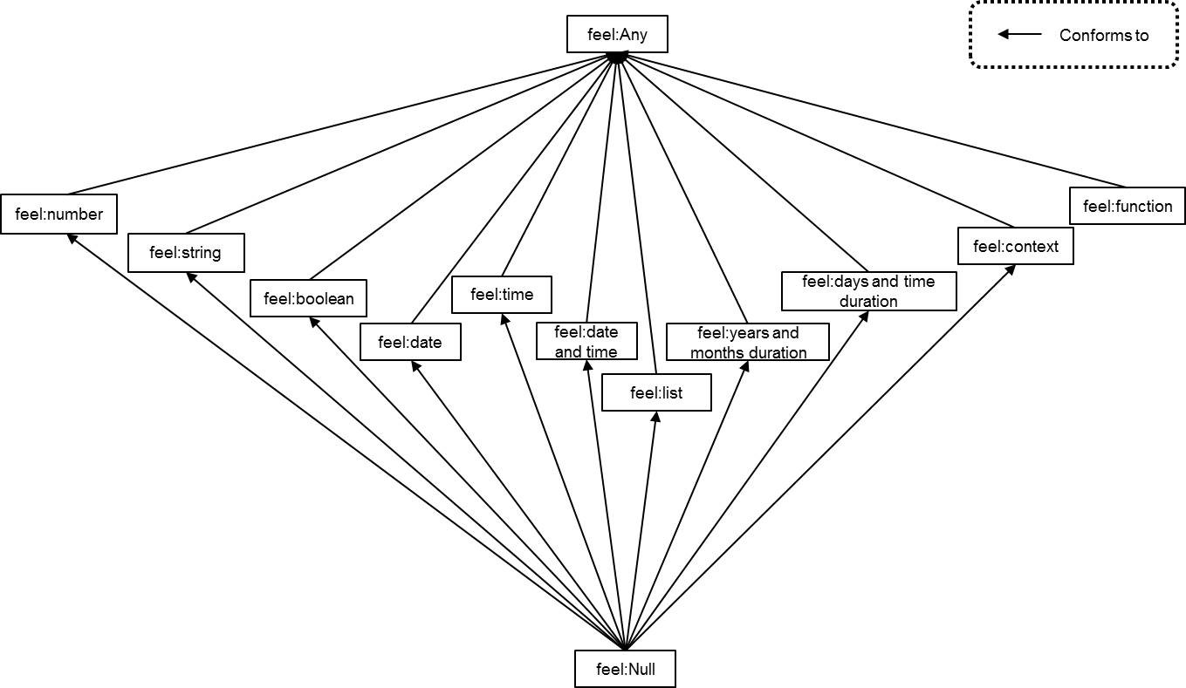
Figure 10.16: FEEL lattice type

Examples
Let us consider the following ItemDefinitions

<itemDefinition name="Employee1">
<itemComponent name="id">
<typeRef>feel:number</typeRef>
</itemComponent>
<itemComponent name="name">
<typeRef>feel:string</typeRef>
</itemComponent>
</itemDefinition>

<itemDefinition name="Employee2">
<itemComponent name="name">
<typeRef>feel:string</typeRef>
</itemComponent>
<itemComponent name="id">
<typeRef>feel:number</typeRef>
</itemComponent>
</itemDefinition>

<itemDefinition name="Employee3">
<itemComponent name="id">
<typeRef>feel:number</typeRef>
</itemComponent>
<itemComponent name="name">
<typeRef>feel:string</typeRef>
</itemComponent>
<itemComponent name="age">
<typeRef>feel:number</typeRef>
</itemComponent>
</itemDefinition>

<itemDefinition isCollection=”true” name="Employee3List">
<itemComponent name="id">
<typeRef>feel:number</typeRef>
</itemComponent>
<itemComponent name="name">
<typeRef>feel:string</typeRef>
</itemComponent>
<itemComponent name="age">
<typeRef>feel:number</typeRef>
</itemComponent>
</itemDefinition>

and the decisions Decision1, Decision2, Decision3 and Decision4 with corresponding typeRefs Employee1, Employee2, Employee3 and Employee3List.
Table 40 provides examples for equivalence to and conforms to relations.

Table 40: Examples of equivalence and conformance relations
type1 | type2 | equivalent to | conforms to
number | number | True | True
string | string | True | True
string | date | False | False
date | date and time | False | True
type(Decision1) | type(Decision2) | True | True
type(Decision1) | type(Decision3) | False | False
type(Decision3) | type(Decision1) | False | True
type(Decision1) | type({"id": 1, "name":"Peter"}) | True | True
type({"id": 1, "name":"Peter"}) | type(Decision3) | False | False
type({"id": 1, "name":"Peter", "age": 45}) | type(Decision1) | False | True
type({"id": 1, "name":"Peter", "age": 45}) | type(Decision3) | True | True
type([1, 2, 3]) | type(["1", "2", "3"]) | False | False
type([1, 2, 3]) | type(Decision3) | False | False
type([{"id": 1, "name":"Peter", "age": 45}]) | type(Decision3) | True | True
type(Decision4) | type(Decision3) | True | True
type(function(x:Employee1) →Employee1) | type(function(x:Employee1) →Employee1) | True | True
type(function(x:Employee1) →Employee1) | type(function(x:Employee1) →Employee2) | True | True
type(function(x:Employee1) →Employee3) | type(function(x:Employee1) →Employee1) | False | True
type(function(x:Employee1) →Employee1) | type(function(x:Employee1) →Employee1) | False | False

Decision Table
The normative notation for decision tables is specified in Clause 8. Each input expression SHALL be a textual expression (grammar rule 2). Each list of input values SHALL be an instance of unary tests (grammar rule 17). The value that is tested is the value of the input expression of the containing InputClause. Each list of output values SHALL be an instance of unary tests (grammar rule 17). The value that is tested is the value of a selected output entry of the containing OutputClause. Each input entry SHALL be an instance of unary tests (grammar rule 17). Rule annotations are ignored in the execution semantics.
The decision table components are shown in Figure 8.5: Rules as rows – schematic layout, and also correspond to the metamodel in clause 8.3 For convenience, Figure 8.5 is reproduced here.

information item name
H | input expression 1 | input expression 2 | Output label
H | input value 1a,  input value 1b | input value 2a,  input value 2b | output value 1a,  output value 1b
1 | input entry 1.1 | input entry 2.1 | output entry 1.1
2 | input entry 1.1 | input entry 2.2 | output entry 1.2
3 | input entry 1.2 | - | output entry 1.3

The semantics of a decision table is specified by first composing its literal expressions and unary tests into Boolean expressions that are mapped to the semantic domain, and composed into rule matches then rule hits. Finally some of the decision table output expressions are mapped to the semantic domain and comprise the result of the decision table interpretation. Decision table components are detailed in Table 41.

Table 41: Semantics of decision table
Component name (* means optional) | Description
input expression | One of the N>=0 input expressions, each a literal expression
input values* | One of the N input values, corresponding to the N input expressions. Each is a unary tests literal (see below).
output values* | A unary tests literal for the output.  (In the event of M>1 output components (see Figure 8.12), each output component may have its own output values)
rules | a list of R>0 rules. A rule is a list of N input entries followed by M output entries. An input entry is a unary tests literal. An output entry is a literal expression.
hit policy* | one of: "U", "A", “P”, “F”, "R", "O", "C", "C+", "C#", "C<", “C>” (default is "U")
default output value* | The default output value is one of the output values. If M>1, then default output value is a context with entries composed of output component names and output values.

Unary tests (grammar rule 17) are used to represent both input values and input entries. An input expression e is said to satisfy an input entry t (with optional input values v), depending on the syntax of t, as follows:
- grammar rule 17.a: FEEL(e in (t))=true
- grammar rule 17.b: FEEL(e in (t))=false
- grammar rule 17.c when v is not provided: e != null
- grammar rule 17.c when v is provided: FEEL(e in (v))=true
A rule with input entries t₁,t₂,…,t_{N} is said to match the input expression list [e₁,e₂,…,e_{N}] (with optional input values list [v₁,v₂,…v_{N}]) if e_{i} satisfies t_{i} (with optional input values v_{i}) for all i in 1..N.
A rule is hit if it is matched and the hit policy indicates that the matched rule's output value should be included in the decision table result. Each hit results in one output value (multiple outputs are collected into a single context value). Therefore, multiple hits require aggregation.
The hit policy is specified using the initial letter of one of the following boldface policy names.
Single hit policies:
- Unique – only a single rule can be matched.
- Any – multiple rules can match, but they all have the same output,
- Priority – multiple rules can match, with different outputs. The output that comes first in the supplied output values list is returned,
- First – return the first match in rule order,
Multiple hit policies:
- Collect – return a list of the outputs in arbitrary order,
- Rule order – return a list of outputs in rule order,
- Output order – return a list of outputs in the order of the output values list
The Collect policy may optionally specify an aggregation, as follows:
- C+ – return the sum of the outputs
- C# – return the count of the outputs
- C< – return the minimum-valued output
- C> – return the maximum-valued output
The aggregation is defined using the following built-in functions specified in clause 10.3.4.4: sum, count, minimum, maximum. To reduce complexity, decision tables with compound outputs do not support aggregation and support only the following hit policies: Unique, Any, Priority, First, Collect without operator, and Rule order.
A decision table may have no rule hit for a set of input values. In this case, the result is given by the default output value, or null if no default output value is specified. A complete decision table SHALL NOT specify a default output value.
The semantics of a decision table invocation DTI are as follows:
1. Every rule in the rule list is matched with the input expression list. Matching is unordered.
2. If no rules match,
a. if a default output value d is specified, DTI=FEEL(d)
b. else DTI=null.
3. Else let m be the sublist of rules that match the input expression list. If the hit policy is "First" or "Rule order", order m by rule number.
a. Let o be a list of output expressions, where the expression at index i is the output expression from rule m[i]. The output expression of a rule in a single output decision table is simply the rule's output entry. The output expression of a multiple output decision table is a context with entries composed from the output names and the rule's corresponding output entries. If the hit policy is "Output order", the decision table SHALL be single output and o is ordered consistent with the order of the output values. Rule annotations are ignored for purposes of determining the expression value of a decision table.
b. If a multiple hit policy is specified, DTI=FEEL(aggregation(o)), where aggregation is one of the built-in functions sum, count, minimum as specified in clause 10.3.4.4
c. else DTI=FEEL(o[1]).

Scope and context stack
A FEEL expression e is always evaluated in a well-defined set of name bindings that are used to resolve QNs in e. This set of name bindings is called the scope of e. Scope is modeled as a list of contexts. A scope s contains the contexts with entries that are in scope for e. The last context in s is the built-in context. Next to last in s is the global context. The first context in s is the context immediately containing e (if any). Next are enclosing contexts of e (if any).
The QN of e is the QN of the first context in s appended with .N, where N is the name of entry in the first context of s containing e. QNs in e are resolved by looking through the contexts in s from first to last.

Local context
If e denotes the value of a context entry of context m, then m is the local context for e, and m is the first element of s. Otherwise, e has no local context and the first element of s is the global context, or in some cases explained later, the first element of s is a special context.
All of the entries of m are in-scope for e, but the depends on graph SHALL be acyclic. This provides a simple solution to the problem of the confusing definition above: if m is the result of evaluating the context expression m that contains e, how can we know it in order to evaluate e? Simply evaluate the context entries in depends on order.

Global context
The global context is a context provided for convenience and 'pre-compilation'. Any number of expressions can be named and represented in a FEEL context m. The syntactic description m of this context can be evaluated once, that is, mapped to the FEEL domain as m, and then re-used to evaluate many expressions.

Built-in context
The built-in context contains all the built-in functions.

Special context
Some FEEL expressions are interpreted in a special context that is pushed on the front of s. For example, a filter expression is repeatedly executed with special first context containing the name 'item' bound to successive list elements. A function is executed with a special first context containing argument name->value mappings.
Qualified names (QNs) in FEEL expressions are interpreted relative to s. The meaning of a FEEL expression e in scope s is denoted as FEEL(e, s). We can also say that e evaluates to e in scope s, or e = FEEL(e, s). Note that e and s are elements of the FEEL domain. s is a list of contexts.

Mapping between FEEL and other domains
A FEEL expression e denotes a value e in the semantic domain. Some kinds of values can be passed between FEEL and external Java methods, between FEEL and external PMML models, and between FEEL and XML, as summarized in Table 42. An empty cell means that no mapping is defined.

Table 42: Mapping between FEEL and other domains
FEEL value | Java | XML | PMML
number | java.math.BigDecimal | decimal | decimal, PROB-NUMBER, PERCENTAGE-NUMBER
number | java.math.BigDecimal | integer | integer , INT-NUMBER
number | java.math.BigDecimal | double | double, REAL-NUMBER
string | java.lang.String | string | string, FIELD-NAME
date and time, time | javax.xml.datatype.  XMLGregorianCalendar | date, dateTime, time, dateTimestamp | date, dateTime, time  conversion required for dateDaysSince, et. al.
duration | javax.xml.datatype.  Duration | yearMonthDuration,  dayTimeDuration
boolean | java.lang.Boolean | boolean | boolean
list | java.util.List | contain multiple child elements | array (homogeneous)
context | java.util.Map | contain attributes and child elements

Sometimes we do not want to evaluate a FEEL expression e, we just want to know the type of e. Note that if e has QNs, then a context may be needed for type inference. We write type(e) as the type of the domain element FEEL(e, c).

Function Semantics
FEEL functions can be
- built-in, e.g.,
sum (see clause 10.3.4.4), or
- user-defined, e.g.,
function(age) age < 21, or
- externally defined, e.g.,
function(angle) external {
java: {
class: “java.lang.Math”,
method signature: “cos(double)”
}}
FEEL built-ins are specified in 10.3.4.

User-defined functions
User-defined functions have the form
function(X₁, … X_{n}) e
The terms X₁, … X_{n} are parameter names. The function body is e. The meaning of FEEL(function(X₁, … X_{n}) e, s) is an element in the FEEL semantic domain that we denote as function(argument list: [X₁, … X_{n}], body: e, scope: s) (shortened to f below). FEEL functions are lexical closures, i.e., the body is an expression that references the formal parameters and any other names in scope s.
The invocation of a FEEL user-defined function f is denoted as f(Y₁, … Y_{n}). The meaning FEEL(f(Y₁, … Y_{n}), S), where f has already been interpreted, is computed as follows:
- the parameter names X₁, … X_{n} and corresponding values Y₁, … Y_{n} are paired in a context c = {X₁ : Y₁, … X_{n} : Y_{n}}. Y_{i} = FEEL(Y_{i}, S).
- e is interpreted in s', where s' = insert before(s, 1, c) (see 10.3.4.4)

Externally-defined functions
FEEL externally-defined functions have the following form
function(X₁, … X_{n}) external mapping-information
Mapping-information is a context that SHALL have one of the following forms:
{
java: {class: class-name, method signature: method-signature}
}
or
{
pmml: {document: IRI, model: model-name}
}
The meaning of an externally defined function is an element in the semantic domain that we denote as function(argument list: [X₁, … X_{n}], external: mapping-information).
The java form of the mapping information indicates that the external function is to be accessed as a method on a Java class. The class-name SHALL be the string name of a Java class on the classpath. Classpath configuration is implementation-defined. The method-signature SHALL be a string consisting of the name of a public static method in the named class, followed by an argument list containing only Java argument type names. The argument type information SHOULD be used to resolve overloaded methods and MAY be used to detect out-of-domain errors before runtime.
The pmml form of the mapping information indicates that the external function is to be accessed as a PMML model. The IRI SHALL be the resource identifier for a PMML document. The model-name is optional. If the model-name is specified, it SHALL be the name of a model in the document to which the IRI refers. If no model-name is specified, the external function SHALL be the first model in the document.
When an externally-defined function is invoked, actual argument values and result value are converted when possible using the type mapping table for Java or PMML [ref to this table in Types and Inference]. When a conversion is not possible, null is substituted. If a result cannot be obtained, e.g. an exception is thrown, the result of the invocation is null.
Passing parameter values to the external method or model requires knowing the expected parameter types. For Java, this information is obtained using reflection. For PMML, this information is obtained from the mining schema and data dictionary elements associated with independent variables of the selected model.
Note that DMN does not completely define the semantics of a Decision Model that uses externally-defined functions. Externally-defined functions SHOULD have no side-effects and be deterministic.

Function name
To name a function, define it as a context entry. E.g.
{
isPositive : function(x) x > 0,
isNotNegative : function(x) isPositive(x+1),
result: isNotNegative(0)
}

Positional and named parameters
An invocation of any FEEL function (built-in, user-defined, or externally-defined) can use positional parameters or named parameters. If positional, all parameters SHALL be supplied. If named, unsupplied parameters are bound to null.

For loop expression
The for loop expression iterates over lists of elements or ranges of numbers. The general syntax is:
for i1 in ic1 [, i2 in ic2 [, …]] return e
where:
- ic1, ic2, …, icn are iteration contexts
- i1, i2, …, in are variables bound to each element in the iteration context
- e is the return expression
An iteration context may either be an expression that returns a list of elements, or two expressions that return integers connected by “..”. Examples of valid iteration contexts are:

- [ 1, 2, 3]
- a list
- 1..10
- 50..40
- x..x+10
A for loop expression will iterate over each element in the iteration context, binding the element to the corresponding variable in and evaluating the expression e in that scope.
When the iteration context is a range of numbers, the for loop expression will iterate over the range incrementing or decrementing the value of in by 1, depending if the range is ascendant (when the resulting integer from the first expression is lower than the second) or descendant (when the resulting integer from the first expression is higher than the second).
The result of the for loop expression is a list containing the result of the evaluation of the expression e for each individual iteration in order.
The expression e may also reference an implicitly defined variable called “partial” that is a list containing all the results of the previous iterations of the expression. The variable “partial” is immutable. E.g.: to calculate the factorial list of numbers, from 0 to N, where N is a non-negative integer, one may write:
for i in 0..N return if i = 0 then 1 else i * partial[-1]
When multiple iteration contexts are defined in the same for loop expression, the resulting iteration is a cross-product of the elements of the iteration contexts. The iteration order is from the inner iteration context to the outer iteration context.
E.g. the result of the following for loop expression is:
for i in [i1,i2], j in [j1,j2] return e = [ r1, r2, r3, r4 ]
Where:
r1 = FEEL( e, { i: i1, j: j1, partial:[], … } )
r2 = FEEL( e, { i: i1, j: j2, partial:[r1], … )
r3 = FEEL( e, { i: i2, j: j1, partial:[r1,r2], … } )
r4 = FEEL( e, { i: i2, j: j2, partial:[r1,r2,r3], … } )

Semantic mappings
The meaning of each substantive grammar rule is given below by mapping the syntax to a value in the semantic domain. The value may depend on certain input values, themselves having been mapped to the semantic domain. The input values may have to obey additional constraints. The input domain(s) may be a subset of the semantic domain. Inputs outside of their domain result in a null value, unless that input is a singleton list, whose single element belongs to the domain; in which case, the single element should be unwrapped and used instead of the list.
Table 43: Semantics of FEEL functions
Grammar Rule | FEEL Syntax | Mapped to Domain
57 | function(n₁,…n_{N}) e | function(argument list: [n₁, … n_{N}], body: e, scope: s)
57 | function(n₁,…n_{N}) external e | function(argument list: [n₁, … n_{N}],  external: e)

See 10.3.2.7.

Table 44: Semantics of other FEEL expressions
Grammar Rule | FEEL Syntax | Mapped to Domain
46 | for i1 in ic1, i2 in ic2, … return e | [ FEEL(e, s'), FEEL(e, s''), … ]
47 | if e₁ then e₂ else e₃ | if FEEL(e₁) is true then FEEL(e₂) else FEEL(e₃)
48 | some n₁ in e₁, n₂ in e₂, … satisfies e | false or FEEL(e, s') or FEEL(e, s'') or …
48 | every n1 in e1, n2 in e2, … satisfies e | true and FEEL(e, s') and FEEL(e, s'') and …
49 | e₁ or e₂ or … | FEEL(e₁) or FEEL(e₂) or …
50 | e₁ and e₂ and … | FEEL(e₁) and FEEL(e₂) and …
51.a | e = null | FEEL(e) is null
51.a | null = e | FEEL(e) is null
51.a | e != null | FEEL(e) is not null
51.a | null != e | FEEL(e) is not null

Notice that we use bold syntax to denote contexts, lists, conjunctions, disjunctions, conditional expressions, true, false, and null in the FEEL domain.
The meaning of the conjunction a and b and the disjunction a or b is defined by ternary logic. Because these are total functions, the input can be true, false, or otherwise (meaning any element of D other than true or false).

Table 45: Semantics of conjunction and disjunction
a | b | a and b | a or b
true | true | true | true
true | false | false | true
true | otherwise | null | true
false | true | false | true
false | false | false | false
false | otherwise | false | null
otherwise | true | null | true
otherwise | false | false | null
otherwise | otherwise | null | null

Negation is accomplished using the built-in function not. The ternary logic is as shown in Table 46.

Table 46: Semantics of negation
a | not(a)
true | false
false | true
otherwise | null

A conditional if a then b else c is equal to b if a is true, and equal to c otherwise.
s' is the scope s with a special first context containing keys n₁, n₂, etc. bound to the first element of the Cartesian product of FEEL(e₁) x FEEL(e₂) x …, s'' is s with a special first context containing keys bound to the second element of the Cartesian product, etc. When the Cartesian product is empty, the some ... satisfies quantifier returns false and the every ... satisfies quantifier returns true.
Equality and inequality map to several kind- and datatype-specific tests, as shown in Table 47, Table 48 and Table 49. By definition, FEEL(e₁ != e₂) is FEEL(not(e₁=e₂)). The other comparison operators are defined only for the datatypes listed in Table 49. Note that Table 49 defines only ‘<’; ‘>’ is similar to ‘<’ and is omitted for brevity; e₁<=e₂ is defined as e₁<e₂ or e₁=e_{2.}

Table 47: General semantics of equality and inequality
Grammar Rule | FEEL Syntax | Input Domain | Result
51.a | e1 = e2 | e1 and e2 must both be of the same kind/datatype – both numbers, both strings, etc. | See below
51.a | e₁ < e₂ | e₁ and e₂ must both be of the same kind/datatype – both numbers, both strings, etc. | See below

Table 48: Specific semantics of equality
kind/datatype | e₁ = e₂
list | lists must be same length N and e₁[i] = e₂[i] for 1 ≤ i ≤ N.
context | contexts must have same set of keys K and e₁.k = e₂.k for every k in K
range | the ranges must specify the same endpoints and the same endpoint inclusivity code.
function | internal functions must have the same parameters, body, and scope. Externally defined functions must have the same parameters and external mapping information.
number | value(e₁) = value(e₂). Value is defined in 10.3.2.3.1. Precision is not considered.
string | e₁ is the same sequence of characters as e₂
date | all 3 components (10.3.2.3.5) must be equal
date and time | all 7 components (10.3.2.3.5), treating unspecified optional components as null, must be equal
time | all 4 components (10.3.2.3.4), treating unspecified optional components as null, must be equal
days and time duration | value(e₁) = value(e₂). Value is defined in 10.3.2.3.7.
years and months duration | value(e₁) = value(e₂). Value is defined in 10.3.2.3.8.
boolean | e₁ and e₂ must both be true or both be false

Table 49: Specific semantics of inequality
datatype | e₁ < e₂
number | value(e₁) < value(e₂). value is defined in 10.3.2.3.1. Precision is not considered.
string | sequence of characters e₁ is lexicographically less than the sequence of characters e₂. I.e., the sequences are padded to the same length if needed with \u0 characters, stripped of common prefix characters, and then the first character in each sequence is compared.
date | e1 < e2 if the year value of e1 < the year value of e2  e1 < e2 if the year values are equal and the month value of e1 < the month value of e2  e1 < e2 if the year and month values are equal and the day value of e1 < the day value of e2
date and time | value_{dt}(e₁) < value_{dt}(e₂). value_{dt} is defined in 10.3.2.3.5. If one input has a null timezone offset, that input uses the timezone offset of the other input.
time | value_{t}(e₁) < value_{t}(e₂). value_{t} is defined in 10.3.2.3.4. If one input has a null timezone offset, that input uses the timezone offset of the other input.
days and time duration | value_{dtd}(e₁) < value_{dtd}(e₂). value_{dtd} is defined in 10.3.2.3.7.
years and months duration | value_{ymd}(e₁) < value_{ymd}(e₂). value_{ymd} is defined in 10.3.2.3.8.

FEEL supports additional syntactic sugar for comparison. Note that Grammar Rules (clause 10.3.1.2) are used in decision table condition cells. These decision table syntaxes are defined in Table 50.

Table 50: Semantics of decision table syntax
Grammar Rule | FEEL Syntax | Equivalent FEEL Syntax | applicability
51.b | e₁ between e₂ and e₃ | e₁ >= e₂ and e₁ <= e₃
51.c | e₁ in [e₂,e₃,…] | e₁ = e₂ or e₁ = e₃ or… | e₂ and e₃ are endpoints
51.c | e₁ in [e₂,e₃,…] | e₁ in e₂ or e₁ in e₃ or… | e₂ and e₃ are ranges
51.c | e₁ in <=e₂ | e₁ <= e₂
51.c | e₁ in <e₂ | e₁ < e₂
51.c | e₁ in >=e₂ | e₁ >= e₂
51.c | e₁ in <e₂ | e₁ < e₂
51.c | e₁ in (e₂..e₃) | e₁ > e₂ and e₁<e₃
51.c | e₁ in (e₂..e₃] | e₁ > e₂ and e₁<=e₃
51.c | e₁ in [e₂..e₃) | e₁ >= e₂ and e₁<e₃
51.c | e₁ in [e₂..e₃] | e₁ >= e₂ and e₁<=e₃
51.c | e1 in e2 | e1 = e2 | e2 is a qualified name that does not evaluate to a list
51.c | e1 in e2 | list contains( e2, e1 ) | e1 is a simple value that is not a list and e2 is a qualified name that evaluates to a list
51.c | e1 in e2 | { ? : e1, r : e2 }.r | e2 is a boolean expression that uses the special variable “?”

Addition and subtraction are defined in Table 51 and Table 52. Note that if input values are not of the listed types, the result is null.

Table 51: General semantics of addition and subtraction
Grammar Rule | FEEL | Input Domain and Result
21 | e₁ + e₂ | See below
22 | e₁ – e₂ | See below

Table 52: Specific semantics of addition and subtraction
type(e₁) | type(e₂) | e₁ + e₂, e₁ – e₂ | result type
number | number | Let e₁=(p₁,s₁) and e₂=(p₂,s₂) as defined in 10.3.2.3.1. If value(p₁,s₁) +/- value(p₂,s₂) requires a scale outside the range of valid scales, the result is null. Else the result is (p,s) such that  - value(p,s) = value(p₁,s₁) +/- value(p₂,s₂) + ε  - s ≤ max(s₁,s₂)  - s is maximized subject to the limitation that p has 34 digits or less  - ε is a possible rounding error. | number
date and time | date and time | Addition is undefined. Subtraction is defined as  value_{dtd}⁻¹(value_{dt}(e₁)-value_{dt}(e₂)), where value_{dt} is defined in 10.3.2.3.5 and value_{dtd}⁻¹ is defined in 10.3.2.3.7. In case either value is of type date, it is implicitly converted into a date and time with time of day of UTC midnight ("00:00:00") as defined in 10.3.2.3.6. Subtraction requires either both values to have a timezone or both not to have a timezone. Subtraction is undefined for the case where only one of the values has a timezone. | days and time duration
time | time | Addition is undefined. Subtraction is defined as  value_{dtd}⁻¹(value_{t}(e₁)-value_{t}(e₂)) where value_{t} is defined in 10.3.2.3.4 and value_{dtd}⁻¹ is defined in 10.3.2.3.7. | days and time duration
years and months duration | years and months duration | value_{ymd}⁻¹(value_{ymd}(e₁) +/- value_{ymd}(e₂)) where value_{ymd} and value_{ymd}⁻¹ is defined in 10.3.2.3.8. | years and months duration
days and time duration | days and time duration | value_{dtd}⁻¹(value_{dtd}(e₁) +/- value_{dtd}(e₂)) where value_{dtd} and value_{dtd}⁻¹ is defined in 10.3.2.3.7 | days and time duration
date and time | years and months duration | date and time (date(e₁.year +/– e₂.years + floor((e₁.month +/– e₂.months)/12),  e₁.month +/– e₂.months – floor((e₁.month +/– e₂.months)/12) * 12, e₁.day), time(e₁)),  where the named properties are as defined in Table 60 below, and the date, date and time, time and floor functions are as defined in 10.3.4, value_{dt} and value_{dt}⁻¹ is defined in 10.3.2.3.5 and value_{ymd} is defined in 10.3.2.3.8. | date and time
years and months duration | date and time | Subtraction is undefined. Addition is commutative and is defined by the previous rule. | date and time
date and time | days and time duration | value_{dt}⁻¹(value_{dt}(e₁) +/- value_{dtd}(e₂)) where value_{dt} and value_{dt}⁻¹ is defined in 10.3.2.3.5 and value_{dtd} is defined in 10.3.2.3.7. | date and time
days and time duration | date and time | Subtraction is undefined. Addition is commutative and is defined by the previous rule. | date and time
time | days and time duration | value_{t}⁻¹(value_{t}(e₁) +/- value_{dtd}(e₂)) where value_{t} and value_{t}⁻¹ are defined in 10.3.2.3.4 and value_{dtd} is defined in 10.3.2.3.7. | time
days and time duration | time | Subtraction is undefined. Addition is commutative and is defined by the previous rule. | time
string | string | Subtraction is undefined. Addition concatenates the strings. The result is a string containing the sequence of characters in e1 followed by the sequence of characters in e2. | string
date | years and months duration | date( e₁.year +/– e₂.years + floor((e₁.month +/– e₂.months)/12), e₁.month +/– e₂.months – floor((e₁.month +/– e₂.months)/12) * 12, e₁.day ), where the named properties are as defined in Table 60 below, and the date and floor functions are as defined in 10.3.4 | date
years and months duration | date | Subtraction is undefined. Addition is commutative and is defined by the previous rule. | date
date | days and time duration | date(value_{dt}⁻¹ (value_{dt}(e₁) +/- value_{dtd}(e₂))) where value_{dt} and value_{dt}⁻¹ is defined in 10.3.2.3.5 and value_{dtd} is defined in 10.3.2.3.7 | date
days and time duration | date | Subtraction is undefined. Addition is commutative and is defined by the previous rule. | date

Multiplication and division are defined in Table 53 and Table 54. Note that if input values are not of the listed types, the result is null.

Table 53: General semantics of multiplication and division
Grammar Rule | FEEL | Input Domain and Result
23 | e₁ * e₂ | See below
24 | e₁ / e₂ | See below

Table 54: Specific semantics of multiplication and division
type(e₁) | type(e₂) | e₁ * e₂ | e₁ / e₂ | result type
number  e₁=(p₁,s₁) | number  e₂=(p₂,s₂) | If value(p₁,s₁) * value(p₂,s₂) requires a scale outside the range of valid scales, the result is null. Else the result is (p,s) such that  - value(p,s) = value(p₁,s₁) * value(p₂,s₂) + ε  - s ≤ s₁+s₂  - s is maximized subject to the limitation that p has 34 digits or less  - ε is a possible rounding error | If value(p₂,s₂)=0 or value(p₁,s₁) / value(p₂,s₂) requires a scale outside the range of valid scales, the result is null. Else the result is (p,s) such that  - value(p,s) = value(p₁,s₁) / value(p₂,s₂) + ε  - s ≤ s₁-s₂  - s is maximized subject to the limitation that p has 34 digits or less  - ε is a possible rounding error | number
years and months duration | number | value_{ymd}⁻¹(value_{ymd}(e₁) * value(e₂)) where value_{ymd} and value_{ymd}⁻¹ are defined in 10.3.2.3.8. | If value(e₂)=0, the result is null. Else the result is value_{ymd}⁻¹(value_{ymd}(e₁) / value(e₂)) where value_{ymd} and value_{ymd}⁻¹ are defined in 10.3.2.3.8. | years and months duration
number | years and months duration | See above, reversing e₁ and e₂ | Not allowed | years and months duration
years and months duration | years and months duration | Not allowed | If value_{ymd}(e₂)=0, the result is null. Else the result is  value_{ymd}(e₁) / value_{ymd}(e₂)  where value_{ymd} is defined in 10.3.2.3.8. | number
days and time duration | number | value_{dtd}⁻¹(value_{dtd}(e₁) * value(e₂)) where value_{dtd} and value_{dtd}⁻¹ are defined in 10.3.2.3.7. | If value(e₂)=0, the result is null. Else the result is value_{dtd}⁻¹(value_{dtd}(e₁) * value(e₂)) where value_{dtd} and value_{dtd}⁻¹ are defined in 10.3.2.3.7. | days and time duration
number | days and time duration | See above, reversing e₁ and e₂ | Not allowed | days and time duration
days and time duration | days and time duration | Not allowed | If value_{dtd}(e₂)=0, the result is null. Else the result is  value_{dtd}(e₁) / value_{dtd}(e₂)  where value_{dtd} is defined in  10.3.2.3.7. | number

Table 55: Semantics of exponentiation
Grammar Rule | FEEL Syntax | Input Domain | Result
25 | e₁ ** e₂ | type(e₁) is number. value(e₂) is an integer in the range  [-999,999,999..999,999,999]. | If value(e₁)^{value(e}₂⁾ requires a scale that is out of range, the result is null. Else the result is (p,s) such that  - value(p,s)= value(e₁)^{value(e}₂⁾ + ε  - p is limited to 34 digits  - ε is rounding error

Type-checking is defined in Table 56. Note that type is not mapped to the domain, and null is not the name of a type, and null is not an instance of any type.

Table 56: Semantics of type-checking
Grammar Rule | FEEL Syntax | Mapped to Domain
53 | e instance of type | true iff type(e) conforms to type (see section 10.3.2.9) and e is not null

Negative numbers are defined in Table 57.

Table 57: Semantics of negative numbers
Grammar Rule | FEEL Syntax | Equivalent FEEL Syntax
26 | -e | 0-e

Invocation is defined in Table 58. An invocation can use positional arguments or named arguments. If positional, all arguments must be supplied. If named, unsupplied arguments are bound to null. Note that e can be a user-defined function, a user-defined external function, or a built-in function.

Table 58: Semantics of invocation
Grammar Rule | FEEL | Mapped to Domain | Applicability
40, 41, 44 | e(e₁,..) | e(e₁,…) | e is a function with matching arity
40, 41, 42, 43 | e(n₁:e₁,…) | e(n₁:e₁,…) | e is a function with matching parameter names

Properties are defined in Table 59 and Table 60. If type(e) is date and time, time, or duration, and name is a property name, then the meaning is given by Table 60 and Table 61. For example, FEEL(date and time("2012-03-07Z").year) = 2012.

Table 59: General semantics of properties
Grammar Rule | FEEL | Mapped to Domain | Applicability
20 | e.name | e."name" | type(e) is a context
20 | e.name | see below | type(e) is a date/time/duration

Table 60: List of properties per type
type(e) | e . name | name =
date | result is the named component of the date object e. Valid names are shown to the right. | year, month, day, weekday
date and time | result is the named component of the date and time object e. Valid names are shown to the right. | year, month, day, weekday, hour, minute, second, time offset, timezone
time | result is the named component of the time object e. Valid names are shown to the right | hour, minute, second, time offset, timezone
years and months duration | result is the named component of the years and months duration object e. Valid names are shown to the right. | years, months
days and time duration | result is the named component of the days and time duration object e. Valid names are shown to the right. | days, hours, minutes, seconds

Table 61: Specific semantics of date, time and duration properties
name | type(name) | description
year | number | The year number as an integer in the interval [-999,999,999 .. 999,999,999]
month | number | The month number as an integer in the interval [1..12], where 1 is January and 12 is December
day | number | The day of the month as an integer in the interval [1..31]
weekday | number | The day of the week as an integer in the interval [1..7] where 1 is Monday and 7 is Sunday (compliant with the definition in ISO 8601)
hour | number | The hour of the day as an integer in the interval [0..23]
minute | number | The minute of the hour as an integer in the interval [0..59]
second | number | The second of the minute as a decimal in the interval [0..60)
time offset | days and time duration | The duration offset corresponding to the timezone the date or date and time value represents. The time offset duration must be in the interval [duration(“-PT14H”)..duration(“PT14H”)] as per the XML Schema Part 2 dateTime datatype. The time offset property returns null when the object does not have a time offset set.
timezone | string | The timezone identifier as defined in the IANA Time Zones database. The timezone property returns null when the object does not have an IANA timezone defined.
years | number | The normalized years component of a years and months duration value as an integer. This property returns null when invoked on a days and time duration value.
months | number | The normalized months component of a years and months duration value. Since the value is normalized, this property must return an integer in the interval [0..11]. This property returns null when invoked on a days and time duration value.
days | number | The normalized days component of a days and time duration value as an integer. This property returns null when invoked on a years and months duration value.
hours | number | The normalized hours component of a days and time duration value. Since the value is normalized, this property must return an integer in the interval [0..23]. This property returns null when invoked on a years and months duration value.
minutes | number | The normalized minutes component of a days and time duration value. Since the value is normalized, this property must return an integer in the interval [0..59]. This property returns null when invoked on a years and months duration value.
seconds | number | The normalized minutes component of a days and time duration value. Since the value is normalized, this property must return a decimal in the interval [0..60). This property returns null when invoked on a years and months duration value.

Lists are defined in Table 62.

Table 62: Semantics of lists
Grammar Rule | FEEL Syntax | Mapped to Domain (scope s) | Applicability
56 | e₁[e₂] | e₁[e₂] | e₁ is a list and e₂ is an integer (0 scale number)
56 | e₁[e₂] | e₁ | e₁ is not a list and not null and value(e₂) = 1
56 | e₁[e₂] | list of items e such that i is in e iff i is in e₁ and FEEL(e₂, s') is true, where s' is the scope s with a special first context containing the context entry ("item", i) and if i is a context, the special context also contains all the context entries of i. | e₁ is a list and type(FEEL(e₂, s')) is boolean
56 | e₁[e₂] | [e₁] if FEEL(e₂, s') is true, where s' is the scope s with a special first context containing the context entry ("item", e₁) and if e₁ is a context, the special context also contains all the context entries of e₁. Else []. | e₁ is not a list and not null and type(FEEL(e₂, s')) is boolean

Contexts are defined in Table 63.

Table 63: Semantics of contexts
Grammar Rule | FEEL Syntax | Mapped to Domain (scope s)
59 | { n₁ : e₁, n₂ : e₂, …} | { "n₁": FEEL(e₁, s₁), "n2": FEEL(e₂, s₂), …} such that the s_{i} are all s with a special first context c_{i} containing a subset of the entries of this result context. If c_{i} contains the entry for n_{j}, then c_{j} does not contain the entry for n_{i}.
59 | { "n₁" : e₁, "n₂" : e₂, …}
56 | [e₁, e₂, …] | [ FEEL(e₁), FEEL(e₂), …]

Error Handling
When a built-in function encounters input that is outside its defined domain, the function SHOULD report or log diagnostic information if appropriate, and SHALL return null.

XML Data
FEEL supports XML Data in the FEEL context by mapping XML Data into the FEEL Semantic Domain. Let XE(e, p) be a function mapping an XML element e and a parent FEEL context p to a FEEL context , as defined in the following tables. XE makes use of another mapping function, XV(v), that maps an XML value v to the FEEL semantic domain.
XML namespace semantics are not supported by the mappings. For example, given the namespace prefix declarations xmlns:p1="http://example.org/foobar" and xmlns:p2="http://example.org/foobar", the tags p1:myElement and p2:myElement are the same element using XML namespace semantics but are different using XML without namespace semantics.

Semantic mapping for XML elements (XE)
Table 64, e is the name of an XML element, a is the name of one of its attributes, c is a child element, and v is a value. The parent context p is initially empty.

Table 64: Semantics of XML elements
XML | context entry in p | Remark
<e /> | "e" : null | empty element → null-valued entry in p
<q:e /> | "e" : null | namespaces are ignored.
<e>v</e> | "e":XV(v) | unrepeated element without attributes
<e>v₁</e> <e>v₂</e> | "e": [ XV(v₁), XV(v₂) ] | repeating element without attributes
<e a="v"/>  <c₁>v₁</c₁>  <c_{n}>v₂</c_{n}><c_{n}>v₃</c_{n}>  </e> | "e": { "a": XV(v),  "c₁": XV(v₁),  "cn": [ XV(v₂), XV(v₃) ]  } | An element containing attributes or child elements → context
<e a="v₁">v₂</e> | "e": { "@a": XV(v₁), "$content": XV(v₂) } | v₂ is contained in a generated $content entry

An entry in the context entry in p column such as "e" : null indicates a context entry with string key "e" and value null. The context entries are contained by context p that corresponds to the containing XML element, or to the XML document itself.
The mapping does not replace namespace prefixes with the namespace IRIs. FEEL requires only that keys within a context be distinct, and the namespace prefixes are sufficient.

Semantic mapping for XML values (XV)
If an XML document was parsed with a schema, then some atomic values may have a datatype other than string. Table 65 defines how a typed XML value v is mapped to FEEL.

Table 65: Semantics of XML values
Type of v | FEEL Semantic Domain
number | FEEL(v)
string | FEEL("v")
date | FEEL(date("v"))
dateTime | FEEL(date and time("v"))
time | FEEL(time("v"))
duration | FEEL(duration("v"))
list, e.g. "v₁ v₂" | [ XV(v₁), XV(v₂) ]
element | XE(v)

XML example
The following schema and instance are equivalent to the following FEEL:

schema
<xsd:schema xmlns:xsd="http://www.w3.org/2001/XMLSchema"
xmlns="http://www.example.org"
targetNamespace="http://www.example.org"
elementFormDefault="qualified">
<xsd:element name="Context">
<xsd:complexType>
<xsd:sequence>
<xsd:element name="Employee">
<xsd:complexType>
<xsd:sequence>
<xsd:element name="salary" type="xsd:decimal"/>
</xsd:sequence>
</xsd:complexType>
</xsd:element>
<xsd:element name="Customer" maxOccurs="unbounded">
<xsd:complexType>
<xsd:sequence>
<xsd:element name="loyalty_level" type="xsd:string"/>
<xsd:element name="credit_limit" type="xsd:decimal"/>
</xsd:sequence>
</xsd:complexType>
</xsd:element>
</xsd:sequence>
</xsd:complexType>
</xsd:element>
</xsd:schema>

instance
<Context xmlns:tns="http://www.example.org"
xmlns="http://www.example.org">
<tns:Employee>
<tns:salary>13000</tns:salary>
</tns:Employee>
<Customer>
<loyalty_level>gold</loyalty_level>
<credit_limit>10000</credit_limit>
</Customer>
<Customer>
<loyalty_level>gold</loyalty_level>
<credit_limit>20000</credit_limit>
</Customer>
<Customer>
<loyalty_level>silver</loyalty_level>
<credit_limit>5000</credit_limit>
</Customer>
</Context>

equivalent FEEL boxed context
Context
Employee | salary | 13000
Customer | loyalty_level | credit_limit
Customer | gold | 10000
Customer | gold | 20000
Customer | silver | 5000

When a decision model is evaluated, its input data described by an item definition such as an XML Schema element (clause 7.3.2) is bound to case data mapped to the FEEL domain. The case data can be in various formats, such as XML. We can notate case data as an equivalent boxed context, as above. Decision logic can reference entries in the context using expressions such as Context.tns$Employee.tns$salary, which has a value of 13000.

Built-in functions
To promote interoperability, FEEL includes a library of built-in functions. The syntax and semantics of the built-ins are required for a conformant FEEL implementation.
In all of the tables in this section, a superscript refers to an additional domain constraint stated in the corresponding footnote to the table. Whenever a parameter is outside its domain, the result of the built-in is null.

Conversion functions
FEEL supports many conversions between values of different types. Of particular importance is the conversion from strings to dates, times, and durations. There is no literal representation for date, time, or duration. Also, formatted numbers such as 1,000.00 must be converted from a string by specifying the grouping separator and the decimal separator.
Built-ins are summarized in Table 66. The first column shows the name and parameters. A question mark (?) denotes an optional parameter. The second column specifies the domain for the parameters. The parameter domain is specified as one of
- a type, e.g. number, string
- any – any element from the semantic domain, including null
- not null – any element from the semantic domain, excluding null.
- date string – a string value in the lexical space of the date datatype specified by XML Schema Part 2 Datatypes
- time string – either
a string value in the lexical space of the time datatype specified by XML Schema Part 2 Datatypes; or
a string value that is the extended form of a local time representation as specified by ISO 8601, followed by the character "@", followed by a string value that is a time zone identifier in the IANA Time Zones Database (http://www.iana.org/time-zones)
- date time string – a string value consisting of a date string value, as specified above, optionally followed by the character "T" followed by a time string value as specified above
- duration string – a string value in the lexical space of the xs:dayTimeDuration or xs:yearMonthDuration datatypes specified by the XQuery 1.0 and XPath 2.0 Data Model.

Table 66: Semantics of conversion functions
Name(parameters) | Parameter Domain | Description | Example
date(from) | date string | convert from to a date | date("2012-12-25") – date("2012-12-24") =  duration("P1D")
date(from) | date and time | convert from to a date (set time components to null) | date(  date and time("2012-12-25T11:00:00Z")) = date("2012-12-25")
date(year, month, day) | year, month, day are numbers | creates a date from year, month, day component values | date(2012, 12, 25) = date("2012-12-25")
date and time(date, time) | date is a date or date time; time is a time | creates a date time from the given date (ignoring any time component) and the given time | date and time ("2012-12-24T23:59:00") = date and time (date("2012-12-24”), time(“23:59:00"))
date and time(from) | date time string | convert from to a date and time | date and time("2012-12-24T23:59:00") + duration("PT1M") = date and time("2012-12-25T00:00:00")
time(from) | time string | convert from to time | time("23:59:00z") + duration("PT2M") = time("00:01:00@Etc/UTC")
time(from) | time, date and time | convert from to time (ignoring date components) | time(  date and time("2012-12-25T11:00:00Z")) =  time("11:00:00Z")
time(hour, minute, second, offset) | hour, minute, second, are numbers, offset is a days and time duration, or null | creates a time from the given component values | time(“23:59:00z") =  time(23, 59, 0, duration(“PT0H”))
number(from, grouping separator, decimal separator) | string¹, string, string | convert from to a number | number("1 000,0", " ", ",") = number("1,000.0", ",", ".")
string(from) | non-null | convert from to a string | string(1.1) = "1.1"  string(null) = null
duration(from) | duration string | convert from to a days and time or years and months duration | date and time("2012-12-24T23:59:00") - date and time("2012-12-22T03:45:00") = duration("P2DT20H14M")  duration("P2Y2M") = duration("P26M")
years and months duration(from, to) | both are date or both are date and time | return years and months duration between from and to | years and months duration(  date("2011-12-22"), date("2013-08-24") ) = duration("P1Y8M")
- grouping SHALL be one of space (' '), comma (','), period ('.'), or null.
decimal SHALL be one of period, comma, or null, but SHALL NOT be the same as the grouping separator unless both are null.
from SHALL conform to grammar rule 37, after removing all occurrences of the grouping separator, if any, and after changing the decimal separator, if present, to a period.

Boolean function
Table 67 defines Boolean functions.

Table 67: Semantics of Boolean functions
Name(parameters) | Parameter Domain | Description | Example
not(negand) | boolean | logical negation | not(true) = false  not(null) = null

String functions
Table 68 defines string functions.

Table 68: Semantics of string functions
Name(parameters) | Parameter Domain | Description | Example
substring(string, start position, length?) | string, number¹ | return length (or all) characters in string, starting at start position.  1st position is 1, last position is -1 | substring("foobar",3) = "obar"  substring("foobar",3,3) = "oba"  substring("foobar", -2, 1) = "a"
string length(string) | string | return length of string | string length("foo") = 3
upper case(string) | string | return uppercased string | upper case("aBc4") = "ABC4"
lower case(string) | string | return lowercased string | lower case("aBc4") = "abc4"
substring before  (string, match) | string, string | return substring of string before the match in string | substring before("foobar", "bar") = "foo"  substring before("foobar", "xyz") = ""
substring after  (string, match) | string, string | return substring of string after the match in string | substring after("foobar", "ob") = "ar"  substring after("", "a") = ""
replace(input, pattern, replacement, flags?) | string² | regular expression pattern matching and replacement | replace("abcd", "(ab)|(a)", "[1=$1][2=$2]") = "[1=ab][2=]cd"
contains(string, match) | string | does the string contain the match? | contains("foobar", "of") = false
starts with(string, match) | string | does the string start with the match? | starts with("foobar", "fo") = true
ends with(string, match) | string | does the string end with the match? | ends with("foobar", "r") = true
matches(input, pattern, flags?) | string² | does the input match the regexp pattern? | matches("foobar", "^fo*b") = true
split( string, delimiter ) | string is a string, delimiter is a pattern2 | Splits the string into a list of substrings, breaking at each occurrence of the delimiter pattern. | split( “John Doe”, “\\s” ) = [“John”, “Doe”]  split( “a;b;c;;”, “;” ) = [“a”,”b”,”c”,””,””]
- start position must be a non-zero integer (0 scale number) in the range [-L..L], where L is the length of the string. length must be in the range [1..E], where E is L – start position + 1 if start position is positive,
and –start position otherwise.
- pattern, replacement, and flags SHALL conform to the syntax and constraints specified in clause 7.6 of XQuery 1.0 and XPath 2.0 Functions and Operators. Note that where XPath specifies an error result, FEEL specifies a null result.

List functions
Table 69 defines list functions.

Table 69: Semantics of list functions
Name(parameters) | Parameter Domain | Description | Example
list contains(list, element) | list, any element of the semantic domain including null | does the list contain the element? | list contains([1,2,3], 2) = true
count(list) | list | return size of list, or zero if list is empty | count([1,2,3]) = 3  count([]) = 0  count([1,[2,3]]) = 2
min(list)  min(c₁,…, c_{N}), N >0  max(list)  max(c₁,…, c_{N}), N >0 | non-empy list of comparable items or argument list of one or more comparable items | return minimum(maximum) item, or null if list is empty | min([1,2,3]) = 1  max(1,2,3) = 3  min(1) = min([1]) = 1  max([]) = null
sum(list)  sum(n₁,…, n_{N}), N >0 | list of 0 or more numbers or argument list of one or more numbers | return sum of numbers, or null if list is empty | sum([1,2,3]) = 6  sum(1,2,3) = 6  sum(1) = 1  sum([]) = null
mean(list)  mean(n₁,…, n_{N}), N >0 | non-empty list of numbers or argument list of one or more numbers | return arithmetic mean (average) of numbers | mean([1,2,3]) = 2  mean(1,2,3) = 2  mean(1) = 1  mean([]) = null
all(list)  all(b₁,…, b_{N}), N >0 | list of Boolean items or argument list of one or more Boolean items | return false if any item is false, else true if empty or all items are true, else null | all([false,null,true]) = false  all(true) = all([true]) = true  all([]) = true  all(0) = null
any(list)  any(b₁,…, b_{N}), N >0 | list of Boolean items or argument list of one or more Boolean items | return true if any item is true, else false if empty or all items are false, else null | any([false,null,true]) = true  any(false) = false  any([]) = false  any(0) = null
sublist(list, start position, length?) | list, number¹, number² | return list of length (or all) elements of list, starting with list[start position]. 1st position is 1, last position is -1 | sublist([4,5,6], 1, 2) = [4,5]
append(list, item…) | list, any element including null | return new list with items appended | append([1], 2, 3) = [1,2,3]
concatenate(list…) | list | return new list that is a concatenation of the arguments | concatenate([1,2],[3]) = [1,2,3]
insert before(list, position, newItem) | list, number¹, any element including null | return new list with newItem inserted at position | insert before([1,3],1,2) = [2,1,3]
remove(list, position) | list, number¹ | list with item at position removed | remove([1,2,3], 2) = [1,3]
reverse(list) | list | reverse the list | reverse([1,2,3]) = [3,2,1]
index of(list, match) | list, any element including null | return ascending list of list positions containing match | index of([1,2,3,2],2) = [2,4]
union(list…) | list | concatenate with duplicate removal | union([1,2],[2,3]) = [1,2,3]
distinct values(list) | list | duplicate removal | distinct values([1,2,3,2,1] = [1,2,3]
flatten(list) | list | flatten nested lists | flatten([[1,2],[[3]], 4]) = [1,2,3,4]
product( list )  product( n1, …, nn) | list is a list of numbers. n1 … nn are numbers. | Returns the product of the numbers | product( 2, 3, 4) = 24
median( list )  median( n1, …, nn ) | list is a list of number. n1 … nn are numbers. | Returns the median element of the list of numbers. I.e., after sorting the list, if the list has an odd number of elements, it returns the middle element. If the list has an even number of elements, returns the average of the two middle elements. If the list is empty, returns null. | median( 8, 2, 5, 3, 4 ) = 4  median( [6, 1, 2, 3] ) = 2.5  median( [ ] ) = null
stddev( list )  stddev( n1, …, nn ) | list is a list of number. n1 … nn are numbers. | Returns the standard deviation of the list of numbers. If the list is empty, returns null. | stddev( 2, 4, 7, 5 ) = 2.0816659994661  stddev( [ ] ) = null
mode( list )  mode( n1, …, nn ) | list is a list of number. n1 … nn are numbers. | Returns the mode of the list of numbers. If the result contains multiple elements, they are returned in ascending order. If the list is empty, an empty list is returned. | mode( 6, 3, 9, 6, 6 ) = [ 6 ]  mode( [6, 1, 9, 6, 1] ) = [ 1, 6 ]  mode( [ ] ) = [ ]
- position must be a non-zero integer (0 scale number) in the range [-L..L], where L is the length of the list
- length must be in the range [1..E], where E is L – start position + 1 if start position is positive,
and –start position otherwise.

Numeric functions
Table 70 defines numeric functions.

Table 70: Semantics of numeric functions
Name(parameters) | Parameter Domain | Description | Example
decimal(n, scale) | number, number¹ | return n with given scale | decimal(1/3, 2) = .33  decimal(1.5, 0) = 2  decimal(2.5, 0) = 2
floor(n) | number | return greatest integer <= n | floor(1.5) = 1  floor(-1.5) = -2
ceiling(n) | number | return smallest integer >= n | ceiling(1.5) = 2  ceiling(-1.5) = -1
abs( number ) | number is a number. | Returns the absolute value of the given number. | abs( 10 ) = 10  abs( -10 ) = 10
modulo( dividend, divisor ) | dividend and divisor are numbers. | Returns the remainder of the division of dividend by divisor. | modulo( 12, 5 ) = 2
sqrt( number ) | number is a number. | Returns the square root of the given number. If number is negative it returns null. | sqrt( 16 ) = 4
log( number ) | number is a number | Returns the natural logarithm (base e) of the number parameter. | log( 10 ) = 2.30258509299
exp( number ) | number is a number | Returns the Euler’s number e raised to the power of number. | exp( 5 ) = 148.413159102577
odd( number ) | number is a number | Returns true if number is odd, false if it is even. | odd( 5 ) = true  odd( 2 ) = false
even( number ) | number is a number | Returns true if number is even, false if it is odd. | even( 5 ) = false  even ( 2 ) = true
- Scale is in the range [−6111..6176]

Sort
Sort a list using an ordering function. For example,
sort(list: [3,1,4,5,2], precedes: function(x,y) x < y) = [1,2,3,4,5]

Table 71: Semantics of sort functions
Parameter name (* means optional) | Domain
list | list of any element, be careful with nulls
precedes | boolean function of 2 arguments defined on every pair of list elements

Execution Semantics of Decision Services
FEEL gives execution semantics to decision services defined in decision models where FEEL is the expression language. A decision service is semantically equivalent to a FEEL function whose parameters are the decision service inputs, and whose logic is a context assembled from the decision service's decisions and knowledge requirements.
Decision service implementations SHALL return a result as described above, and MAY return additional information such as intermediate results, log records, debugging information, error messages, rule annotations, etc. The format of any additional information is left unspecified.
Every FEEL expression in a decision model has execution semantics. LiteralExpression (FEEL text) semantics is defined in 10.3. Boxed expressions described in 10.2.2 can be mapped to FEEL text and thus also have execution semantics.
Recall that a DecisionService is defined by four lists: inputData, inputDecisions, outputDecisions, and encapsulatedDecisions. The lists are not independent and thus not all required to be specified, e.g. each required decision (direct and indirect) of the outputDecisions must be an encapsulatedDecision, an inputDecision, or required by an inputDecision. For simplicity in the following, we assume that all four lists are correctly and completely specified.
A DecisionService is given execution semantics by mapping it to a FEEL function F. Let S be a DecisionService with input data id₁, id₂, ..., input decisions di₁, di₂, ..., encapsulated decisions de₁, de₂, ..., and output decisions do₁, do₂, .... Each input data id_{i} has a qualified name nidi. Each decision d_{i} has a qualified name nd_{i} and a decision logic expression e_{d}. The decisions may have knowledge requirements. In particular the decisions may require BusinessKnowledgeModels bkm₁, bkm₂, ... and DecisionServices s₁, s₂, .... BusinessKnowledgeModels have qualified names nbkm_{i} and encapsulatedLogic bkm_{i}.f. DecisionServices have qualified names nsi and equivalent logic fs_{i}, where the equivalent logic is defined recursively, binding s_{i} to S.
The syntax for FEEL function F is function(nid₁, nid₂, ..., ndi₁, ndi₂, ... ) C.result, where C is the context
{
ns₁ : fs₁, ns₂ : fs₂, ...,
nbkm₁ : fbkm₁, nbkm₂ : fbkm₂, ...,
nde₁ : ede₁, nde₂ : ede₂, ...,
result: { ndo₁ : edo₁, ndo₂ : edo₂, ...}
},
such that s_{i}, bkm_{i}, de_{i} and do_{i} are partially ordered by requirements (e.g. the context entry for a required decision comes before a decision that requires it).
The qualified name of an element named E (decision, input data, decision service, or BKM) that is defined in the same decision model as S is simply E. Otherwise, the qualified name is I.E, where I is the name of the import element that refers to the model where E is defined.
The execution semantics of S is FEEL(F): a function that when invoked with values from the FEEL semantic domain bound to the parameters representing input data and input decisions, returns a context consisting of all the output decisions' output values.
XML elements SHALL map to the FEEL semantic domain as specified in section 10.3.3. Otherwise, details of the syntax of input/output data values and mapping to/from FEEL are undefined.

Metamodel

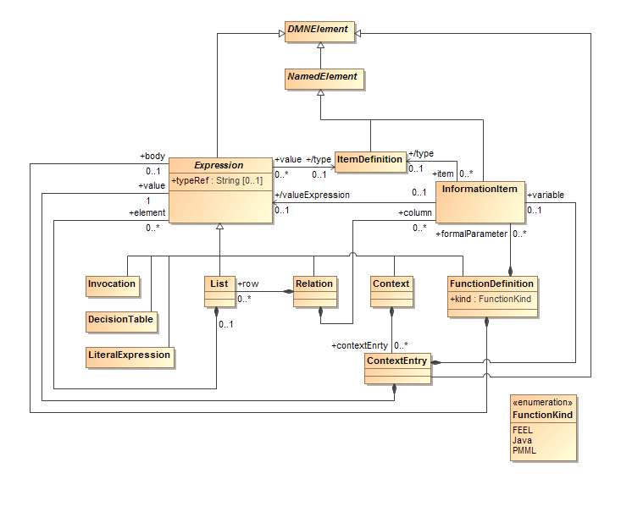
Figure 10.17 - Expression class diagram
The class Expression is extended to support the four new kinds of boxed expressions introduced by FEEL, namely: Context, FunctionDefinition, Relation and List.
Boxed expressions are Expressions that have a standard diagrammatic representation (see clauses 7.2.1 and 10.2.1). FEEL contexts, function definitions, relations and lists SHOULD be modeled as Context, FunctionDefinition, Relation and List elements, respectively, and represented as a boxed expression whenever possible; that is, when they are top-level expressions, since an instance of LiteralExpression cannot contain another Expression element.

Context metamodel
A Context is composed of any number of contextEntrys, which are instances of ContextEntry.
A Context element is represented diagrammatically as a boxed context (clause 10.2.1.4). A FEEL context (grammar rule 59 and clause 10.3.2.6) SHOULD be modeled as a Context element whenever possible.
Context inherits all the attributes and model associations from Expression. Table 72 presents the additional attributes and model associations of the Context element.

Table 72: Context attributes and model association
Attribute | Description
contextEntry: ContextEntry [*] | This attributes lists the instances of ContextEntry that compose this Context.

ContextEntry metamodel
The class ContextEntry is used to model FEEL context entries when a context is modeled as a Context element. ContextEntry is a specialization of DMNElement, from which it inherits the optional id, description, and label attributes.
An instance of ContextEntry is composed of an optional variable, which is an InformationItem element whose name is the key in the context entry, and of a value, which is the instance of Expression that models the expression in the context entry.
Table 73 presents the attributes and model associations of the ContextEntry element.

Table 73: ContextEntry attributes and model associations
Attribute | Description
variable: InformationItem [0..1] | The instance of InformationItem that is contained in this ContextEntry, and whose name is the key in the modeled context entry
value: Expression | The instance of Expression that is the expression in this ContextEntry

FunctionDefinition metamodel
A FunctionDefinition has formalParameters and a body. A FunctionDefinition element is represented diagrammatically as a boxed function, as described in clause . A FEEL function definition (grammar rule 57 and clause 10.3.2.15) SHOULD be modeled as a FunctionDefinition element whenever possible.
FunctionDefinition inherits all the attributes and model associations from Expression. Table 74 presents the additional attributes and model associations of the FunctionDefinition element.

Table 74: FunctionDefinition attributes and model associations
Attribute | Description
FormalParameter: InformationItem [*] | This attributes lists the instances of InformationItem that are the parameters of this Context.
body: Expression [0..1] | The instance of Expression that is the body in this FunctionDefinition
kind: FunctionKind = FEEL  { FEEL | Java | PMML } | The kind attribute defines the type of the FunctionDefinition. The default value is FEEL. Supported values also include Java and PMML

List metamodel
A List is simply a list of element, which are instances of Expressions. A List element is represented diagrammatically as a boxed list, as described in clause 10.2.1.5. A FEEL list (grammar rule 56 and clause 10.3.2.15) SHOULD be modeled as a List element whenever possible.
List inherits all the attributes and model associations from Expression. Table 75 presents the additional attributes and model associations of the List element.

Table 75: List attributes and model associations
Attribute | Description
element: Expression [*] | This attributes lists the instances of Expression that are the elements in this List.

Relation metamodel
A Relation is convenient shorthand for a list of similar contexts. A Relation has a column instead of repeated ContextEntrys, and a List is used for every row, with one of the List’s expression for each column value.
Relation inherits all the attributes and model associations from Expression. Table 76 presents the additional attributes and model associations of the Relation element.

Table 76: Relation attributes and model associations
Attribute | Description
row: List [*] | This attributes lists the instances of List that compose the rows of this Relation.
column: InformationItem [*] | This attributes lists the instances of InformationItem that define the columns in this Relation.

Examples
A good way to get a quick overview of FEEL is by example.
FEEL expressions may reference other FEEL expressions by name. Named expressions are contained in a context. Expressions are evaluated in a scope, which is a list of contexts in which to resolve names. The result of the evaluation is an element in the FEEL semantic domain.

Context
Figure 10.2 shows the boxed context used for the examples. Such a context could arise in several ways. It could be part of the decision logic for a single, complex decision. Or, it could be a context that is equivalent to part of a DRG as defined in clause 10.4, where applicant, requested product, and credit history are input data instances, monthly income and monthly outgoings are sub-decisions, and PMT is a business knowledge model.

applicant | age | 51
applicant | maritalStatus | "M"
applicant | existingCustomer | false
applicant | monthly | income |  |  | 10000
applicant | monthly | repayments |  |  | 2500
applicant | monthly | expenses |  |  | 3000
requested product | product type |  |  | "STANDARD LOAN"
requested product | rate |  |  | 0.25
requested product | term |  |  | 36
requested product | amount |  |  | 100000.00
monthly income | applicant.monthly.income
monthly outgoings | applicant.monthly.repayments, applicant.monthly.expenses
credit history | record date |  | event |  |  | weight
credit history | date("2008-03-12") |  | "home mortgage" |  |  | 100
credit history | date("2011-04-01") |  | "foreclosure warning" |  |  | 150
PMT | (rate, term, amount)
PMT | (amount *rate/12) / (1 – (1 + rate/12)**-term)
Figure 10.18: Example context

Notice that there are 6 top-level context entries, represented by the six rows of the table. The value of the context entry named 'applicant' is itself a context, and the value of the context entry named 'monthly' is itself a context. The value of the context entry named 'monthly outgoings' is a list, the value of the context entry named 'credit history' is a relation, i.e. a list of two contexts, one context per row. The value of the context entry named 'PMT' is a function with parameters 'rate', 'term', and 'amount'.
The following examples use the above context. Each example has a pair of equivalent FEEL expressions separated by a horizontal line. Both expressions denote the same element in the semantic domain. The second expression, the ‘answer’, is a literal value.

Calculation
monthly income * 12
120000
The context defines monthly income as applicant.monthly.income, which is also defined in the context as 10,000. Twelve times the monthly income is 120,000.

If, In
if applicant.maritalStatus in ("M","S") then "valid" else "not valid"
"valid"
The in test determines if the left hand side expression satisfies the list of values or ranges on the right hand side. If satisfied, the if expression returns the value of the then expression. Otherwise, the value of the else expression is returned.

Sum entries of a list
sum(monthly outgoings)
5500
Monthly outgoings is computed in the context as the list [applicant.monthly.repayments, applicant.monthly.expenses], or [2500, 3000]. The square brackets are not required to be written in the boxed context.

Invocation of user-defined PMT function
The PMT function defined in the context computes the monthly payments for a given interest rate, number of months, and loan amount.
PMT(requested product . rate,
requested product . term,
requested product . amount)
3975.982590125562
A function is invoked textually using a parenthesized argument list after the function name. The arguments are defined in the context, and are 0.25, 36, and 100,000, respectively.

Sum weights of recent credit history
sum(credit history[record date > date("2011-01-01")].weight)
150
This is a complex "one-liner" that will be useful to expand into constituent sub-expressions:
- built-in: sum
  - path expression ending in .weight
    - filter: [record date > date("2011-01-01")]
      - name resolved in context: credit history
An expression in square brackets following a list expression filters the list. Credit history is defined in the context as a relation, that is, a list of similar contexts. Only the last item in the relation satisfies the filter. The first item is too old. The path expression ending in .weight selects the value of the weight entry from the context or list of contexts satisfied by the filter. The weight of the last item in the credit history is 150. This is the only item that satisfies the filter, so the sum is 150 as well.

Determine if credit history contain a bankruptcy event
some ch in credit history satisfies ch.event = "bankruptcy"
false
The some expression determines if at least one element in a list or relation satisfies a test. There are no bankruptcy events in the credit history in the context.

DMN Example

Introduction
In this clause we present an example of the use of DMN to model and execute decision-making in a simple business process modeled in BPMN, including decisions to be automated in decision services called from the business process management system.

The business process model
Figure 11.1 shows a simple process for loan originations, modeled in BPMN 2.0. The process handles as application for a loan, obtaining data from a credit bureau only if required for the case, and automatically deciding whether the application should be accepted, declined, or referred for human review. If referred, documents are collected from the applicant and a credit officer adjudicates the case. It consists of the following components:
- The Collect application data task collects data describing the Requested product and the Applicant (e.g. through an on-line application form).
- The Decide bureau Strategy task calls a decision service, passing Requested product and Applicant data. The service returns two decisions: Strategy and Bureau call type.
- A gateway uses the value of Strategy to route the case to Decline application, Collect bureau data or Decide routing.
- The Collect bureau data task collects data from a credit bureau according to the Bureau call type decision, then the case is passed to Decide routing.
- The Decide routing task calls a decision service, passing Requested product, Applicant data and Bureau data (if the Collect bureau data task was not performed, the Bureau data are set to null). The service returns a single decision: Routing.
- A gateway uses the value of Routing to route the case to Accept application, Review application or Decline application.
- The Collect documents task requests and uploads documents from the applicant in support of their application.
- The Review application task allows a credit officer to review the case and decide whether it should be accepted or declined.
- A gateway uses the credit officer’s Adjudication to route the case to Accept application or Decline application.
- The Accept application task informs the applicant that their application is accepted and initiates the product.
- The Decline application task informs the applicant that their application is declined.
Note that in this example two decision points (automated as calls to decision services) are represented in BPMN 2.0 as business rule tasks; the third decision point (which is human decision-making) is represented as a user task.

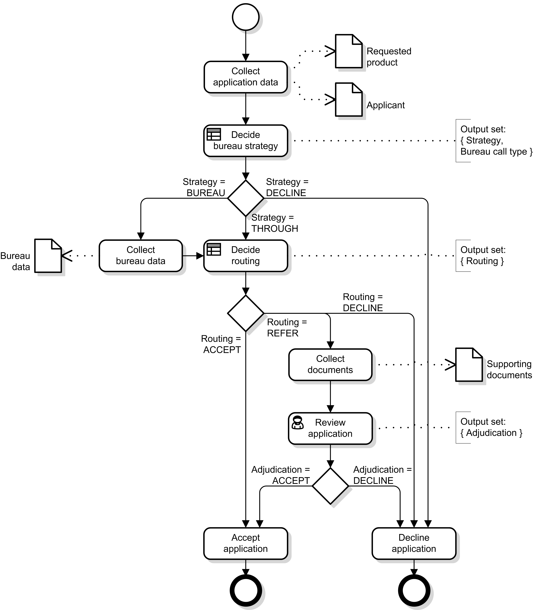
Figure 11.1: Example business process

The decision requirements level
The examples in this chapter were developed using a software that adds icons to the elements. Although adding these icons is allowable by this document it is not normative.
Figure 11.2 shows a DRD of all the decision-making in this business process. There are four sources of input data for the decision-making (Requested product, Applicant data, Bureau data and Supporting documents), and four decisions whose results are used in the business process (Strategy, Bureau call type, Routing and Adjudication). Between the two are intermediate decisions: evaluations of risk, affordability and eligibility. Notable features of this DRD include:
- It covers both automated and human decision-making
- Some decisions (e.g. Pre-bureau risk category) and input data (e.g. Applicant data) are required by multiple decisions, i.e. the information requirements network is not a tree
- Business knowledge models (see Affordability calculation) may be invoked by multiple decisions
- Business knowledge models (see Credit contingency factor) may be invoked by other business knowledge models
- Some decisions do not have associated business knowledge models
- Knowledge sources may provide authority for multiple decisions and/or business knowledge models.

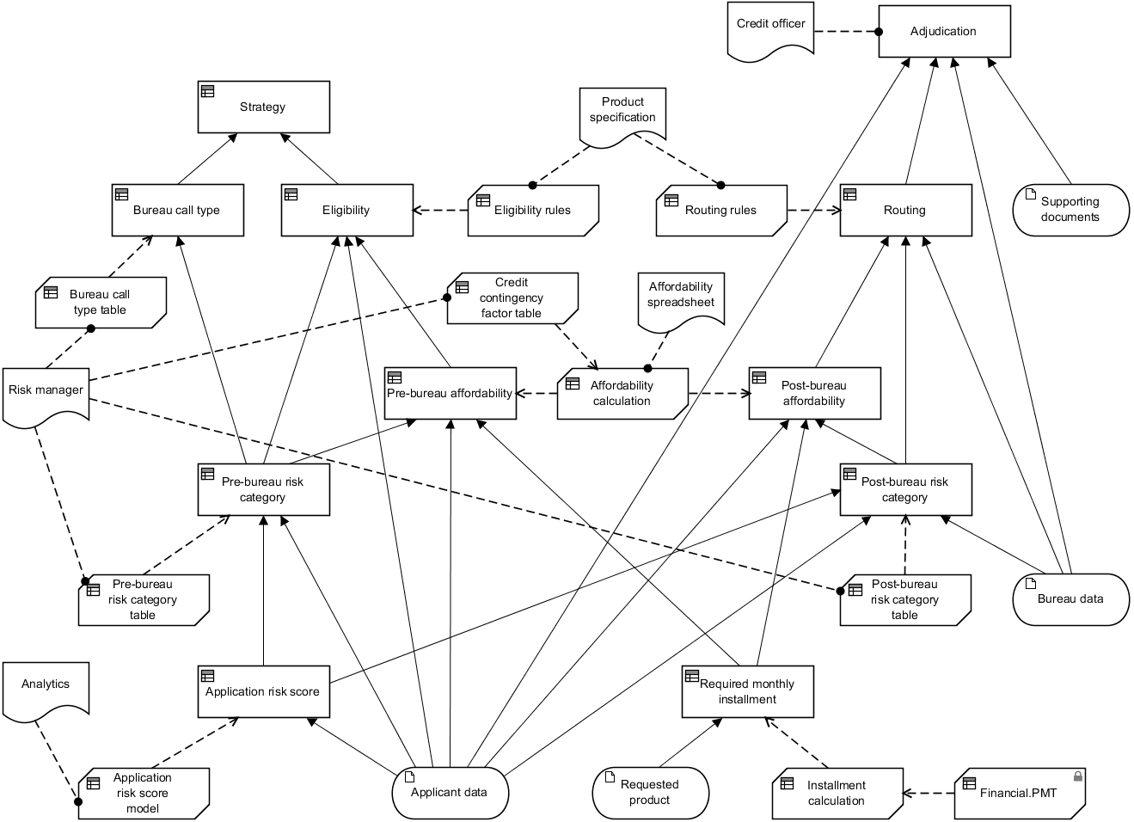
Figure 11.2: DRD of all automated decision-making

It might be considered more convenient to draw separate (but overlapping) DRDs for the three decision points:
- Figure 11.3 shows the DRD of the decisions required for the Decide bureau strategy decision point, i.e. the requirements subgraph of the Strategy and Bureau call type decisions. These are decisions to be automated through encapsulation in a decision service called at this point, and therefore need their logic to be specified completely.
- Figure 11.4 shows the DRD for the Decide routing decision point, i.e. the requirements subgraph of the Routing decision. These are also decisions automated with a decision service, and therefore need their logic to be specified completely. Note that some elements appear in both Figure 11.3 and Figure 11.4.
- Figure 11.5 shows the DRD for the Review application decision point, i.e. the requirements subgraph of the Adjudication decision. This is a human decision and has no associated specification of decision logic, but the DRD indicates that the Credit officer takes into account the results of the automated Routing decision along with the case data, including the Supporting documents. (The requirements subgraph of the Routing decision has been hidden in this DRD as shown by the ellipsis (…) marker.)
All four DRDs – Figure 11.2, Figure 11.3, Figure 11.4 and Figure 11.5 – are views of the same DRG.

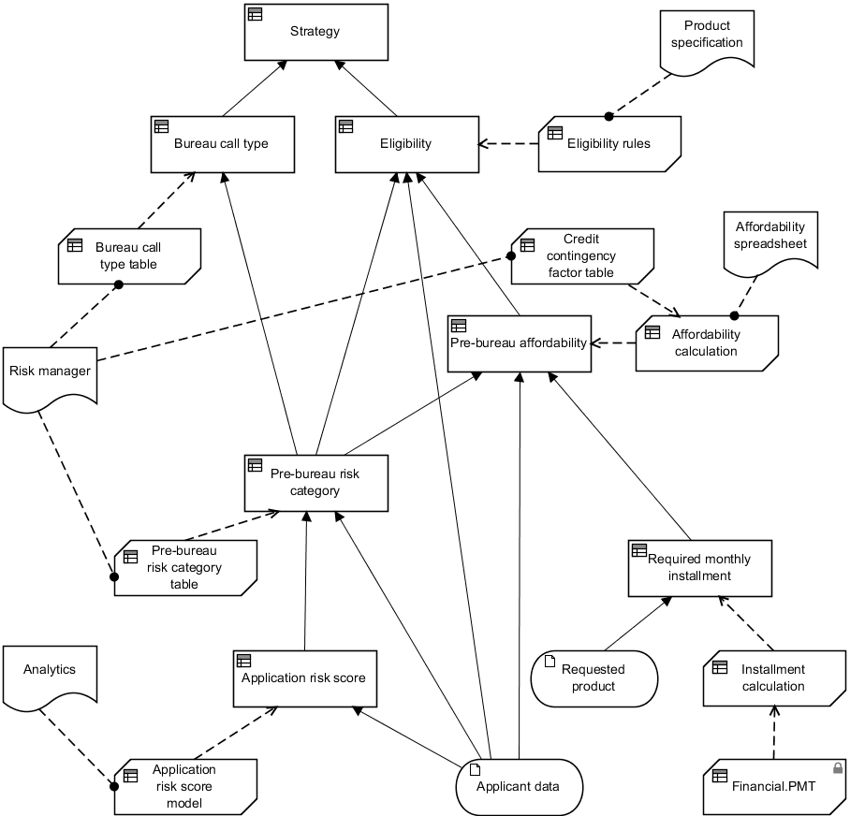
Figure 11.3: DRD for Decide bureau strategy decision point

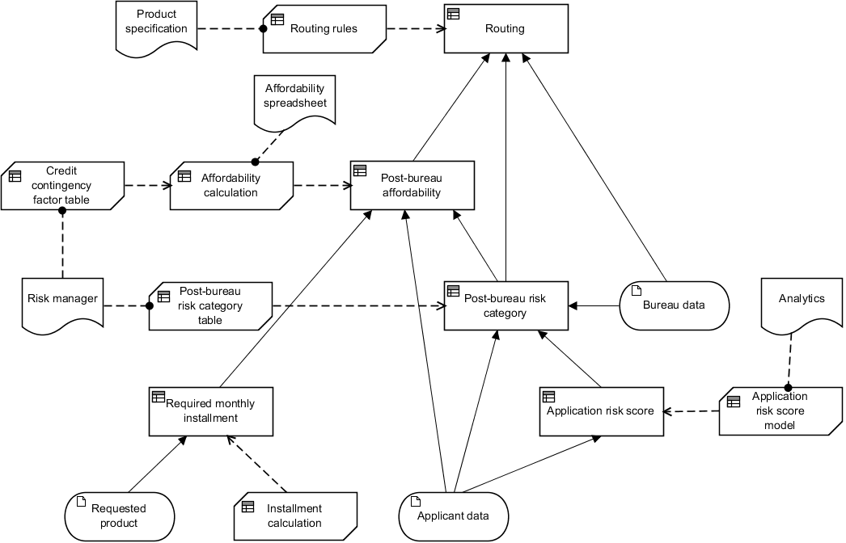
Figure 11.4: DRD for Decide routing decision point

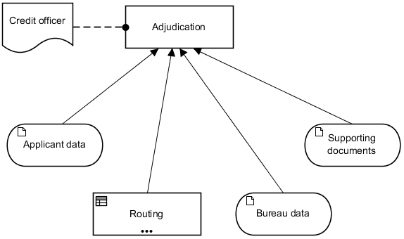
Figure 11.5: DRD for Review application decision point

The DRG depicted in these DRDs shows dependencies between the following decisions:
- The Strategy decision, requiring the Bureau call type and Pre-bureau eligibility decisions, invokes the Strategy table shown in Figure 11.8 (without that table being encapsulated in a business knowledge model)
- The Bureau call type decision, requiring the Pre-bureau risk category decision, invokes the Bureau call type table shown in Figure 11.10
- The Eligibility decision, requiring Applicant data and the Pre-bureau risk category and Pre-bureau affordability decisions, invokes the Eligibility rules shown in Figure 11.12
- The Pre-bureau affordability decision, requiring Applicant data and the Pre-bureau risk category and Required monthly installment decisions, invokes the Affordability calculation boxed expression shown in Figure 11.23, which in turn invokes the Credit contingency factor table shown in Figure 11.24
- The Pre-bureau risk category decision, requiring Applicant data and the Application risk score decision, invokes the Pre-bureau risk category table shown in Figure 11.14
- The Application risk score decision, requiring Applicant data, invokes the Application risk score model shown in Figure 11.16
- The Routing decision, requiring Bureau data and the Post-bureau affordability and Post-bureau risk category decisions, invokes the Routing rules shown in Figure 11.18
- The Post-bureau affordability decision, requiring Applicant data and the Post-bureau risk score and Required monthly installment decisions, invokes the Affordability calculation boxed expression shown in Figure 11.23, which in turn invokes the Credit contingency factor table shown in Figure 11.24
- The Post-bureau risk category decision, requiring Applicant and Bureau data and the Application risk score decision, invokes the Post-bureau risk category table shown in Figure 11.20.
- The Required monthly installment decision, requiring Requested product data, invokes the Installment calculation boxed expression shown in Figure 11.26.
- The Adjudication decision requiring Applicant data, Bureau data, Supporting documents, and the Routing decision, has no associated decision logic.
The two decision services required by the business process model may now be defined against the decision model. The Bureau Strategy Decision Service, called by the Decide bureau strategy task, has output decisions {Bureau call type, Strategy}, and is shown in Figure 11.6. The Routing Decision Service, called by the Decide routing task, has output decisions {Routing}, and is shown in Figure 11.7.

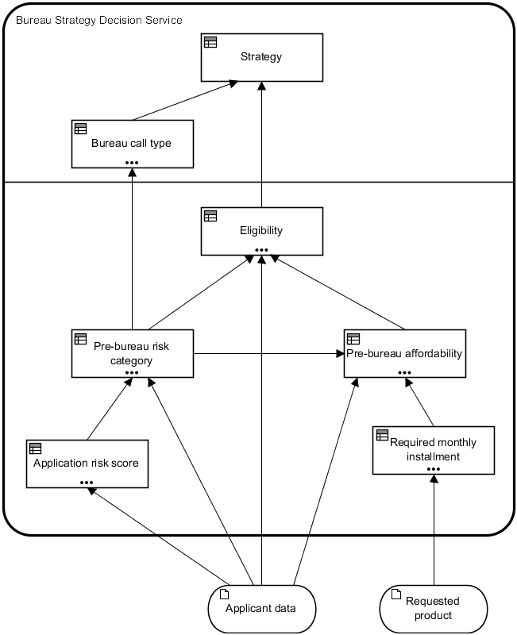
Figure 11.6: Bureau Strategy Decision Service

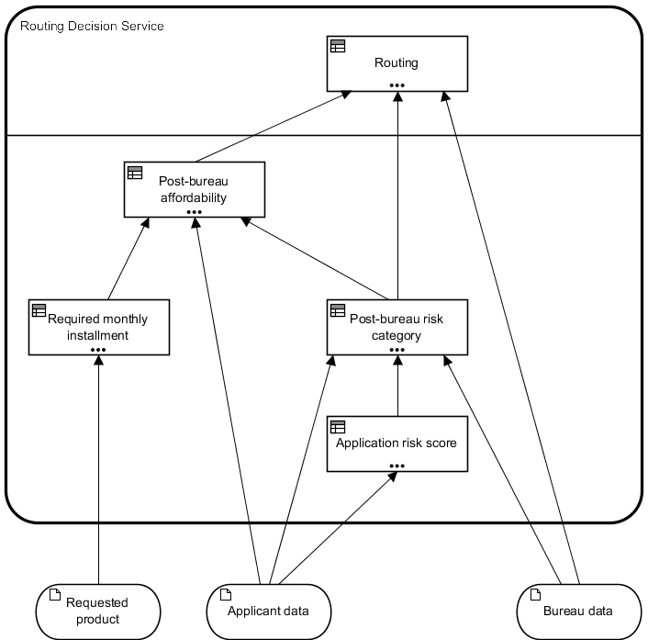
Figure 11.7: Routing Decision Service

The decision logic level
The DRG in Figure 11.2 is defined in more detail in the following specifications of the value expressions associated with decisions and business knowledge models:
- The Strategy decision logic (Figure 11.8) defines a complete, unique-hit decision table deriving Strategy from Eligibility and Bureau call type.
- The Bureau call type decision logic (shown as a boxed invocation in Figure 11.9) invokes the Bureau call type table, passing the output of the Pre-bureau risk category decision as the Pre-Bureau Risk Category parameter.
- The Bureau call type table decision logic (Figure 11.10) defines a complete, unique-hit decision table deriving Bureau Call Type from Pre-Bureau Risk Category.
- The Eligibility decision logic (shown as a boxed invocation in Figure 11.11) invokes the Eligibility rules business knowledge model, passing Applicant data . Age as the Age parameter, the output of the Pre-bureau risk category decision as the Pre-Bureau Risk Category parameter, and the output of the Pre-bureau affordability decision as the Pre-Bureau Affordability parameter.
- The Eligibility rules decision logic (Figure 11.12) defines a complete, priority-ordered single hit decision table deriving Eligibility from Pre-Bureau Risk Category, Pre-Bureau Affordability and Age.
- The Pre-bureau risk category decision logic (shown as a boxed invocation in Figure 11.13) invokes the Pre-bureau risk category table business knowledge model, passing Applicant data . ExistingCustomer as the Existing Customer parameter and the output of the Application risk score decision as the Application Risk Score parameter.
- The Pre-bureau risk category table decision logic (Figure 11.14) defines a complete, unique-hit decision table deriving Pre-Bureau Risk Category from Existing Customer and Application Risk Score.
- The Application risk score decision logic (shown as a boxed invocation in Figure 11.15) invokes the Application risk score model business knowledge model, passing Applicant data . Age as the Age parameter, Applicant data . MaritalStatus as the Marital Status parameter and Applicant data . EmploymentStatus as the Employment Status parameter.
- The Application Risk Score Model decision logic (Figure 11.16) defines a complete, no-order multiple-hit table with aggregation, deriving Application risk score from Age, Marital Status and Employment Status, as the sum of the Partial scores of all matching rows (this is therefore a predictive scorecard represented as a decision table).
- The Routing decision logic (shown as a boxed invocation in Figure 11.17) invokes the Routing rules business knowledge model, passing Bureau data . Bankrupt as the Bankrupt parameter, Bureau data . CreditScore as the Credit Score parameter, the output of the Post-bureau risk category decision as the Post-Bureau Risk Category parameter, and the output of the Post-bureau affordability decision as the Post-Bureau Affordability parameter. Note that if Bureau data is null (due to the THROUGH strategy bypassing the Collect bureau data task) the Bankrupt and Credit Score parameters will be null.
- The Routing rules decision logic (Figure 11.18) defines a complete, priority-ordered single hit decision table deriving Routing from Post-Bureau Risk Category, Post-Bureau Affordability, Bankrupt and Credit Score.
- The Post-bureau risk category decision logic (shown as a boxed invocation in Figure 11.19) invokes the Post-bureau risk category business knowledge model, passing Applicant data . ExistingCustomer as the Existing Customer parameter, Bureau data . CreditScore as the Credit Score parameter, and the output of the Application risk score decision as the Application Risk Score parameter. Note that if Bureau data is null (due to the THROUGH strategy bypassing the Collect bureau data task) the Credit Score parameter will be null.
- The Post-bureau risk category table decision logic (Figure 11.20) defines a complete, unique-hit decision table deriving Post-Bureau Risk Category from Existing Customer, Application Risk Score and Credit Score.
- The Pre-bureau affordability decision logic (shown as a boxed invocation in Figure 11.21) invokes the Affordability calculation business knowledge model, passing Applicant data . Monthly . Income as the Monthly Income parameter, Applicant data . Monthly . Repayments as the Monthly Repayments parameter, Applicant data . Monthly . Expenses as the Monthly Expenses parameter, the output of the Pre-bureau risk category decision as the Risk Category parameter, and the output of the Required monthly installment decision as the Required Monthly Installment parameter.
- The Post-bureau affordability decision logic (shown as a boxed invocation in Figure 11.22) invokes the Affordability calculation business knowledge model, passing Applicant data . Monthly . Income as the Monthly Income parameter, Applicant data . Monthly . Repayments as the Monthly Repayments parameter, Applicant data . Monthly . Expenses as the Monthly Expenses parameter, the output of the Post-bureau risk category decision as the Risk Category parameter, and the output of the Required monthly installment decision as the Required Monthly Installment parameter.
- The Affordability calculation decision logic (Figure 11.23) defines a boxed function deriving Affordability from Monthly Income, Monthly Repayments, Monthly Expenses and Required Monthly Installment. One step in this calculation derives Credit contingency factor by invoking the Credit contingency factor table business knowledge model, passing the output of the Risk category decision as the Risk Category parameter.
- The Credit contingency factor table decision logic (Figure 11.24) defines a complete, unique-hit decision table deriving Credit contingency factor from Risk Category.
- The Required monthly installment decision logic (shown as a boxed invocation in Figure 11.25) invokes the Installment calculation business knowledge model, passing Requested product . ProductType as the Product Type parameter, Requested product . Rate as the Rate parameter, Requested product . Term as the Term parameter, and Requested product . Amount as the Amount parameter.
- The Installment calculation decision logic (Figure 11.26) defines a boxed function deriving monthly installment from Product Type, Rate, Term and Amount. One step in this calculation invokes an external function PMT, imported from a DMN XML file as “Financial”. Figure 11.27 shows the decision logic of PMT function.

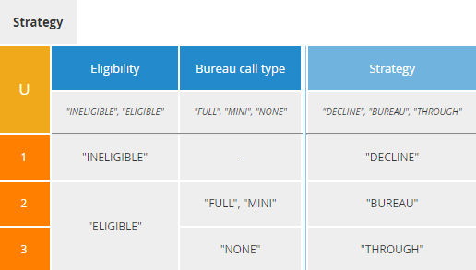
Figure 11.8: Strategy decision logic

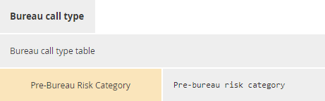
Figure 11.9: Bureau call type decision logic

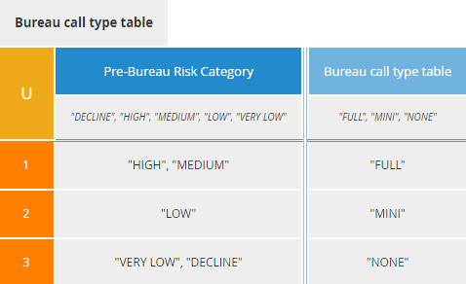
Figure 11.10: Bureau call type table decision logic

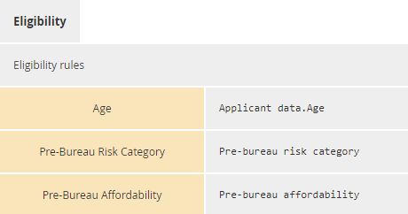
Figure 11.11: Eligibility decision logic

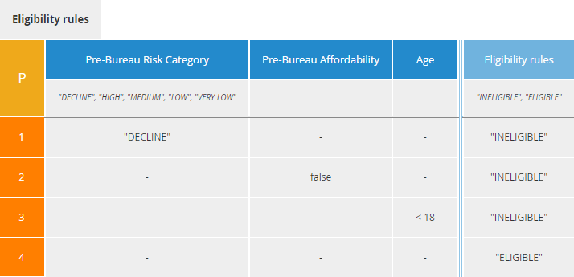
Figure 11.12: Eligibility rules decision logic

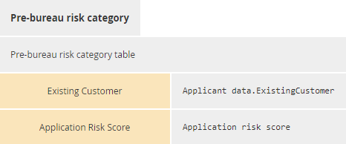
Figure 11.13: Pre-bureau risk category decision logic

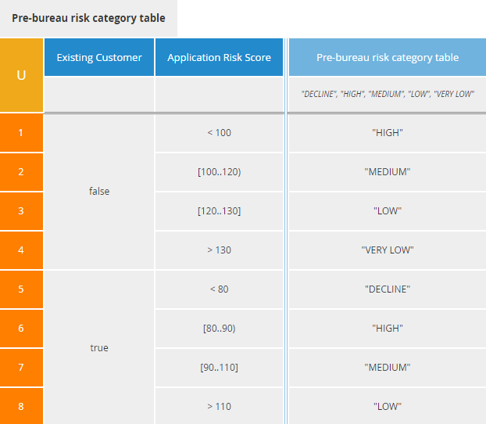
Figure 11.14: Pre-bureau risk category table decision logic

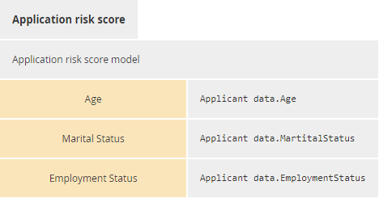
Figure 11.15: Application risk score decision logic

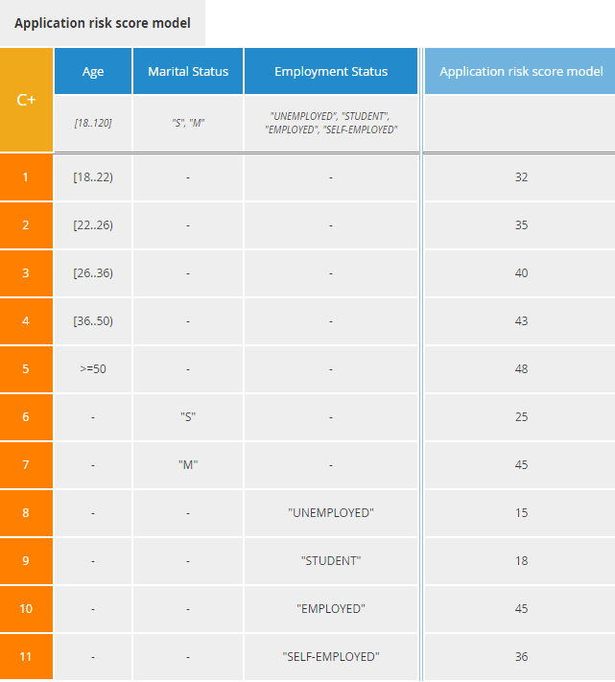
Figure 11.16: Application risk score model decision logic

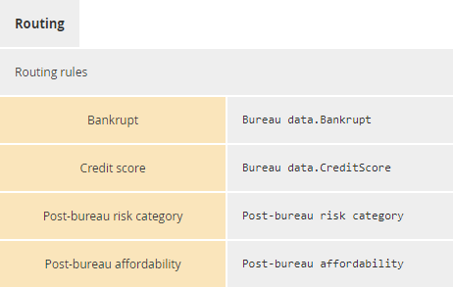
Figure 11.17: Routing decision logic

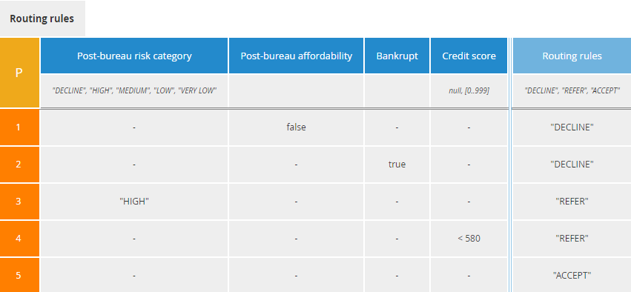
Figure 11.18: Routing rules decision logic

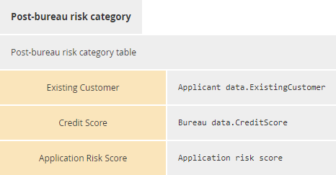
Figure 11.19: Post-bureau risk category decision logic

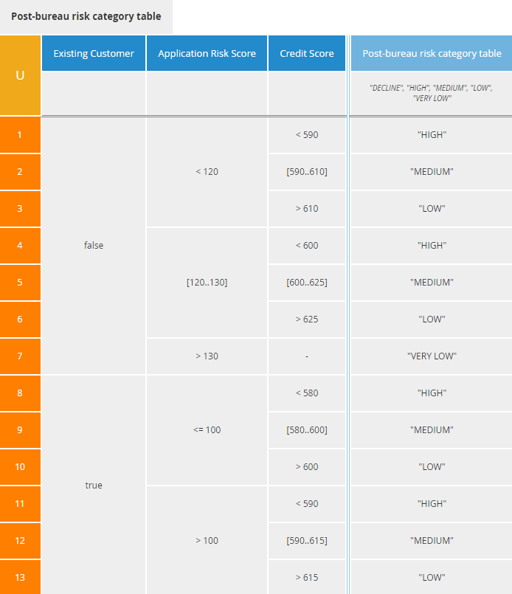
Figure 11.20: Post-bureau risk category table decision logic

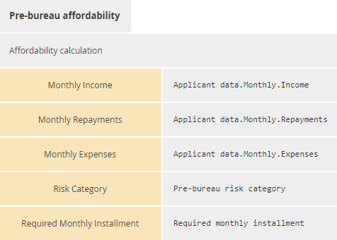
Figure 11.21: Pre-bureau affordability decision logic

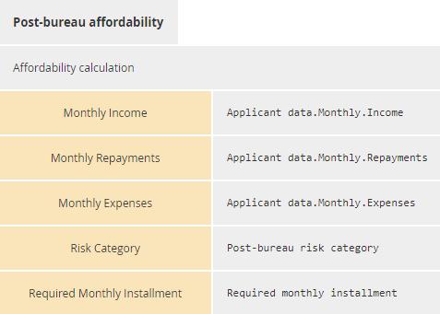
Figure 11.22: Post-bureau affordability decision logic

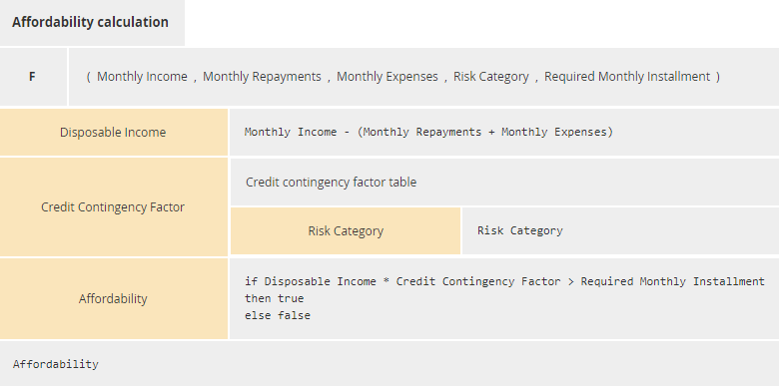
Figure 11.23: Affordability calculation decision logic

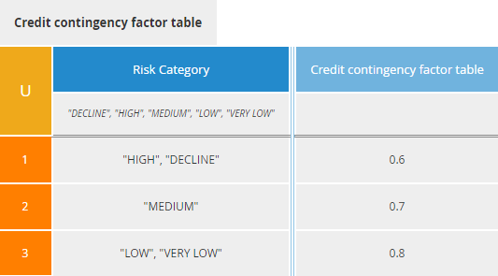
Figure 11.24: Credit contingency factor table decision logic

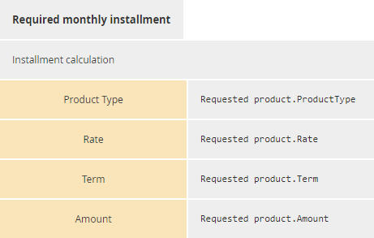
Figure 11.25: Required monthly installment decision logic

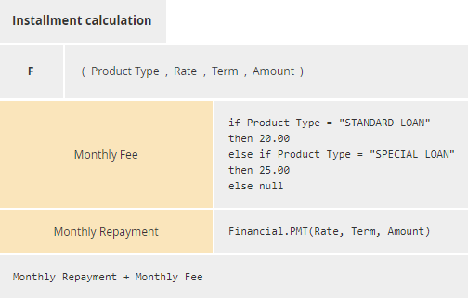
Figure 11.26: Installment calculation decision logic

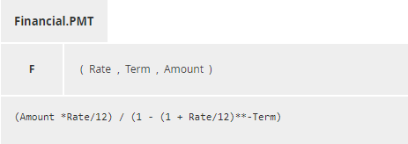
Figure 11.27: Financial.PMT decision logic

Executing the Decision Model
In order to execute a decision model (in this case, by calling two decision services), case data must be bound to the input data, much as an invocation binds arguments to function parameters. The binding of case data to input data, however, is not part of the decision model, unlike the invocation that specifies how a decision’s requirement inputs bind to the parameters of that decision’s required knowledge.
FEEL allows contexts and other expressions to be used to represent case data (see also clauses 10.3.3.3 and 10.6.1). Input data is associated with an item definition (clause )7.3.2, and the case data must have the same type and other constraints specified by the item definition. Case data must be mapped to the FEEL domain. For example, XML instance data is mapped to the FEEL domain as described in clause 10.3.3.
For convenience, we will specify case data using boxed expressions instead of XML. Figure 11.28, Figure 11.29 and Figure 11.30 show boxed contexts defining case data for Applicant data, Requested product and Bureau data.

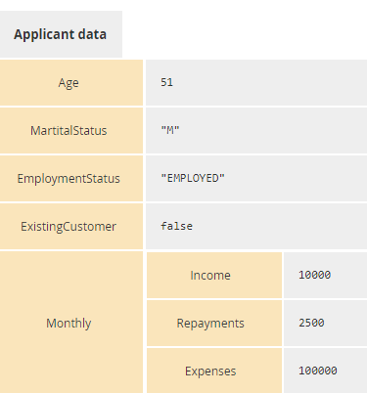
Figure 11.28: Applicant data input data sample

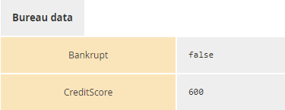
Figure 11.29: Requested Product input data sample


Figure 11.30: Bureau Data input data sample

When the Bureau Strategy Decision Service is called with the Applicant data and Requested product case data, it returns the context shown in Figure 11.31:


Figure 11.31: Output of the Bureau Strategy Decision Service

When the Routing Decision Service is called with the Applicant data, Requested product and Bureau data case data, it returns the context shown in Figure 11.32.

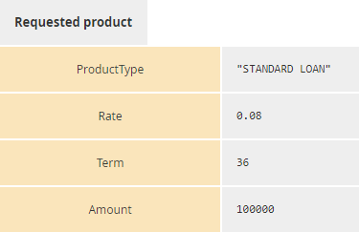
Figure 11.32: Output of the Routing decision Service

Exchange formats

Interchanging Incomplete Models
It is common for DMN models to be interchanged before they are complete. This occurs frequently when doing iterative modeling, where one user (such as a knowledge source expert or business user) first defines a high-level model and then passes it on to another person to complete or refine the model.
Such "incomplete" models are ones in which not all of the mandatory model attributes have been filled in yet or the cardinality of the lower bound of attributes and associations has not been satisfied.
XMI allows for the interchange of such incomplete models. In DMN, we extend this capability to interchange of XML files based on the DMN XML-Schema. In such XML files, implementers are expected to support this interchange by:
- Disregarding missing attributes that are marked as "required" in the DMN XML-Schema.
- Reducing the lower bound of elements with "minOccurs" greater than 0.

Machine Readable Files
All machine-readable files, including XSD, XMI and XML files, can be found in OMG Document dtc/15-11-12 , which is a flat zip file.
- For the DMN XMI Model, the main file is DMN.xmi.
- For the DMN XSD Interchange (supporting Conformance Levels 1, 2 and 3), the main file is DMN.xsd.
- A serialization of the example in clause 11 is provided in ch11example

XSD

Document Structure
A domain-specific set of model elements is interchanged in one or more DMN files. The root element of each file SHALL be <DMN:Definitions>. The set of files SHALL be self-contained, i.e. all definitions that are used in a file SHALL be imported directly or indirectly using the <DMN:Import> element.
Each file SHALL declare a “namespace” that MAY differ between multiple files of one model.
DMN files MAY import non-DMN files (such as XSDs and PMMLs) if the contained elements use external definitions.

References within the DMN XSD
Many DMN elements that may need to be referenced contain IDs and within the BPMN XSD, references to elements are expressed via these IDs. The XSD IDREF type is the traditional mechanism for referencing by IDs, however it can only reference an element within the same file. DMN elements of type DMNElementReference support referencing by ID, across files, by utilizing an href attribute whose value must be a valid URI reference [RFC 3986] where the path components may be absolute or relative, the reference has no query component, and the fragment consists of the value of the id of the referenced DMN element.
For example, consider the following Decision:
<decision name="Pre-Bureau Risk Category" id="prebureauriskDec01">…</decision>
When this Decision is referenced, e.g. by an InformationRequirement in a Decision that is defined in another file, the reference could take the following form:
<requiredDecision href=”http://www.example.org/Definitions01.xml#prebureauriskDec01”/>
where “http://www.example.org/Definitions01.xml” is an URI reference to the XML document in which the “Pre-Bureau Risk Category” Decision is defined (e.g. the value of the locationURI attribute in the corresponding Import element), and “prebureauriskDec01” is the value of the id attribute for the Decision.
If the path component in the URI reference is relative, the base URI against which the relative reference is applied is determined as specified in [RFC 3986]. According to that specification, “if no base URI is embedded and the representation is not encapsulated within some other entity, then, if a URI was used to retrieve the representation, that URI shall be considered the base URI” ([RFC 3986], section 5.1.3). That is, if the reference is not in the scope of an xml:base attribute [XBASE], a value of the href attribute that contains only a fragment and no path component references a DMN element that is defined in the same instance of XML file as the referencing element. In the example below, assuming that the requiredDecision element is not in the scope of an xml:base attribute, the DMN element whose id is “prebureauriskDec01” must be defined in the same XML document:
<requiredDecision href=”#prebureauriskDec01” />
Notice that the BPMN processes and tasks that use a decision are referenced using the href attribute as well: indeed, it is compatible with the system to reference external Process and Task instances in BPMN 2.0 Definitions, which is also based on IDs.
Attribute typeRef references ItemDefinitions and built-in types by name not ID. In order to support imported types, typeRef uses the namespace-qualified name syntax [qualifer].[local-name], where qualifier is specified by the name attribute of the Import element for the imported type. If the referenced type is not imported, the prefix SHALL be omitted.

DMN Diagram Interchange (DMN DI)

Scope
This chapter specifies the meta-model and schema for DMN 1.2 Diagram Interchange (DMN DI). The DMN DI is meant to facilitate the interchange of DMN diagrams between tools rather than being used for internal diagram representation by the tools. The simplest interchange approach to ensure the unambiguous rendering of a DMN diagram was chosen for DMN DI. As such, DMN DI does not aim to preserve or interchange any “tool smarts” between the source and target tools (e.g., layout smarts, efficient styling, etc.).
DMN DI does not ascertain that the DMN diagram is syntactically or semantically correct.
This version of DMN DI focuses on the interchange of Decision Requirements Diagrams (DRDs). Diagram Interchange for boxed expressions and decision tables might be added in future versions.

Diagram Definition and Interchange
The DMN DI meta-model, similar to the DMN abstract syntax meta-model, is defined as a MOF-based meta-model. As such, its instances can be serialized and interchanged using XMI. DMN DI is also defined by an XML schema. Thus its instances can also be serialized and interchanged using XML.
Both, DMN DI meta-model and schema are harmonized with the OMG Diagram Definition (DD) standard version 1.1. The referenced DD contains two main parts: the Diagram Commons (DC) and the Diagram Interchange (DI). The DC defines common types like bounds and points, while the DI provides a framework for defining domain-specific diagram models. As a domain-specific DI, DMN DI defines a few new meta-model classes that derive from the abstract classes from DI.
The focus of DMN DI is the interchange of laid out shapes and edges that constitute a DMN diagram. Each shape and edge references a particular DMN model element. The referenced DMN model elements are all part of the actual DMN model. As such, DMN DI is meant to only contain information that is neither present nor derivable, from the DMN model whenever possible. Simply put, to render a DMN diagram both the DMN DI instance(s) and the referenced DMN model are REQUIRED.
From the DMN DI perspective, a DMN diagram is a particular snapshot of a DMN model at a certain point in time. Multiple DMN diagrams can be exchanged referencing model elements from the same DMN model. Each diagram may provide an incomplete or partial depiction of the content of the DMN model. As described in clause 12, a DMN model package consists of one or more files. Each file may contain any number of DMN diagrams. The exporting tool is free to decide how many diagrams are exported and the importing tool is free to decide if and how to present the contained diagrams to the user.

How to read this chapter
Clause 13.4 describes in details the meta-model used to keep the layout and the look of DMN Diagrams. Clause 13.5 presents in tables a library of the DMN element depictions and an unambiguous resolution between a referenced DMN model element and its depiction.

DMN Diagram Interchange Meta-Model

Overview
The DMN DI is an instance of the OMG DI meta-model. The basic concept of DMN DI, as with DI in general, is that serializing a diagram [DMNDiagram] for interchange requires the specification of a collection of shapes [DMNShape] and edges [DMNEdge].
The DMN DI classes only define the visual properties used for depiction. All other properties that are REQUIRED for the unambiguous depiction of the DMN element are derived from the referenced DMN element [dmnElementRef].
DMN diagrams may be an incomplete or partial depiction of the content of the DMN model. Some DMN elements from a DMN model may not be present in any of the diagram instances being interchanged.
DMN DI does not directly provide for any containment concept. The DMNDiagram is an ordered collection of mixed DMNShape(s) and DMNEdge(s). The order of the DMNShape(s) and DMNEdge(s) inside a DMNDiagram determines their Z-order (i.e., what is in front of what). DMNShape(s) and DMNEdge(s) that are meant to be depicted “on top” of other DMNShape(s) and DMNEdge(s) MUST appear after them in the DMNDiagram. Thus, the exporting tool MUST order all DMNShape(s) and DMNEdge(s) such that the desired depiction can be rendered.

Measurement Unit
As per OMG DD, all coordinates and lengths defined by DMN DI are assumed to be in user units, except when specified otherwise. A user unit is a value in the user coordinate system, which initially (before any transformation is applied) aligns with the device’s coordinate system (for example, a pixel grid of a display). A user unit, therefore, represents a logical rather than physical measurement unit. Since some applications might specify a physical dimension for a diagram as well (mainly for printing purposes), a mapping from a user unit to a physical unit can be specified as a diagram’s resolution. Inch is chosen in this specification to avoid variability but tools can easily convert from/to other preferred physical units. Resolution specifies how many user units fit within one physical unit (for example, a resolution of 300 specifies that 300 user units fit within 1 inch on the device).

DMNDI [Class]

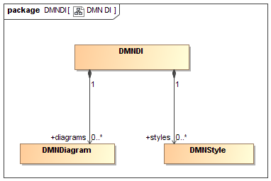
Figure 13.1: DMNDI

The class DMNDI is a container for the shared DMNStyle and all the DMNDiagram defined in a Definitions.

Table 77: DMNDI attributes
Attribute | Description
styles: DMNStyle [0..*] | A list of shared DMNStyle that can be referenced by all DMNDiagram and DMNDiagramElement.
diagrams: DMNDiagram [0..*] | A list of DMNDiagram.

DMNDiagram [Class]

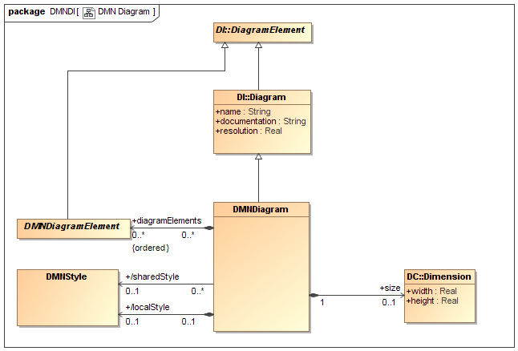
Figure 13.2: DMNDiagram

The class DMNDiagram specializes DI::Diagram. It is a kind of Diagram that represents a depiction of all or part of a DMN model.
DMNDiagram is the container of DMNDiagramElement (DMNShape(s) and DMNEdge(s)). DMNDiagram cannot include other DMNDiagram.
A DMNDiagram can define a DMNStyle locally and/or it can refer to a shared one defined in the DMNDI. Properties defined in the local style overrides the one in the referenced shared style. That combined style (shared and local) is the default style for all the DMNDiagramElement contained in this DMNDiagram.
The DMNDiagram class represents a two-dimensional surface with an origin of (0, 0) at the top left corner. This means that the x and y axes have increasing coordinates to the right and bottom. Only positive coordinates are allowed for diagram elements that are nested in a DMNDiagram.
The DMNDiagram has the following attributes.

Table 78: DMNDiagram attributes
Attribute | Description
name: String | The name of the diagram. Default is empty String.
documentation: String | The documentation of the diagram. Default is empty String.
resolution: Real | The resolution of the diagram expressed in user units per inch. Default is 300
diagramElements: DMNDiagramElement [0..*] | A list of DMNDiagramElement (DMNShape and DMNEdge) that are depicted in this diagram.
sharedStyle: DMNStyle[0..1] | A reference to a DMNStyle defined in the DMNDI that serves as the default styling of the DMNDiagramElement in this DMNDiagram.
localStyle: DMNStyle [0..1] | A DMNStyle that defines the default styling for this diagram. Properties defined in that style override the ones in the sharedStyle.
size: DC::Dimension [0..1] | The size of this diagram. If not specified, the DMNDiagram is unbounded.

DMNDiagramElement [Class]

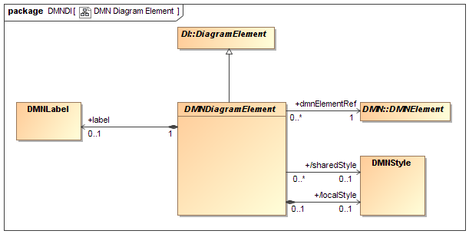
Figure 13.3: DMNDiagramElement

The DMNDiagramElement class is contained by the DMNDiagram and is the base class for DMNShape and DMNEdge.
DMNDiagramElement inherits its styling from its parent DMNDiagram. In addition, it can refer to one of the shared DMNStyle defined in the DMNDI and/or it can define a local style. See clause 13.4.9 for more details on styling.
DMNDiagramElement MAY also contain a DMNLabel when it has a visible text label. If no DMNLabel is defined, the DMNDiagramElement should be depicted without a label.
DMNDiagramElement has the following attributes:

Table 79: DMNDiagramElement attributes
Attribute | Description
dmnElementRef: DMNElement [1] | A reference to the DMNElement that is being depicted.
sharedStyle: DMNStyle [0..1] | A reference to a DMNStyle defined in the DMNDI.
localStyle: DMNStyle [0..1] | A DMNStyle that defines the styling for this element.
label: DMNLabel [0..1] | An optional label when this DMNElement has a visible text label.

DMNShape [Class]

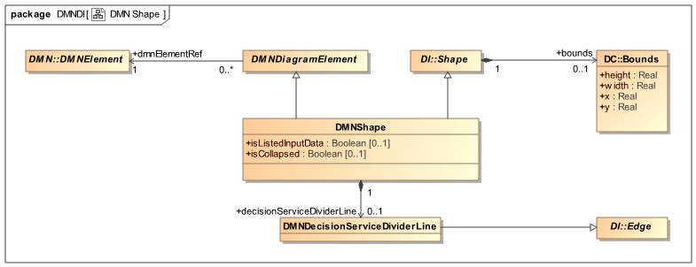
Figure 13.4: DMNShape
The DMNShape class specializes DI::Shape and DMNDiagramElement. It is a kind of Shape that depicts a DMNElement from the DMN model.
DMNShape represents a Decision, a Business Knowledge Model, an Input Data element, a Knowledge Source, a Decision Service or a Text Annotation that is depicted on the diagram.
DMNShape has three additional properties (isListedInputData, isCollapsed and decisionServiceDividerLine) that are used to further specify the appearance of some shapes that cannot be deduced from the DMN model.
DMNShape extends DI::Shape and DMNDiagramElement and has the following attributes:

Table 80: DMNShape attributes
Attribute | Description
bounds: DC::Bounds [1] | The Bounds of the shape relative to the origin of its parent DMNDiagram. The Bounds MUST be specified.
dmnElementRef: DMNElement [1] | A reference to a Decision, a Business Knowledge Model, an Input Data element, a Knowledge Source, a Decision Service or a Text Annotation MUST be specified.
isListedInputData: Boolean [0..1] | If the DMNShape depicts an Input Data element then this attribute is used to determine if the Input Data is listed on the Decision element (true) or drawn as separate notational elements in the DRD (false).
decisionServiceDividerLine: DMNDecisionServiceDividerLine [0..1] | If the DMNShape depicts a Decision Service, this attribute references a DMNDecisionServiceDividerLine which is a DI::Edge that defines s where the DMNShape is divided into two parts by a straight solid line. This can be the case when a DMNShape depicts a Decision Service, where the set of output decisions is smaller than the set of encapsulated decisions. The start and end waypoints of the decisionServiceDividerLine MUST be on the border of the DMNShape.
isCollapsed Boolean [0..1] = false | If the DMNShape depicts a DecisionService, this attribute indicates if it should be depicted expanded (false) or collapsed (true). Default is false

DMNEdge [Class]

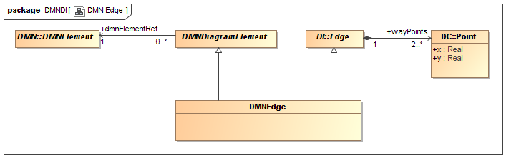
Figure 13.5: DMNEdge
The DMNEdge class specializes DI::Edge and DMNDiagramElement. It is a kind of Edge that can depict a relationship between two DMN model elements.
DMNEdge are used to depict Requirements or Associations in the DMN model.
DMNEdge extends DI::Edge and has the following properties:

Table 81: DMNEdge attributes
Attribute | Description
wayPoints: DC::Point [2..*] | A list of points relative to the origin of its parent DMNDiagram that specifies the connected line segments of the edge. At least two (2) waypoints MUST be specified.
dmnElementRef: DMNElement [1] | A reference to an InformationRequirement, KnowledgeRequirement, AuthorityRequirement or Association.

DMNLabel [Class]

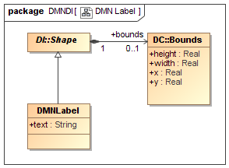
Figure 13.6: DMNLabel
DMNLabel represents the depiction of some textual information about a DMN element.
A DMN label is not a top-level element but is always nested inside either a DMNShape or a DMNEdge. It does not have its own reference to a DMN element but rather inherits that reference from its parent DMNShape or DMNEdge. The textual information depicted by the label is derived from the name attribute of the referenced DMNElement.
DMNLabel extends DI::Shape and has the following properties:

Table 82: DMNLabel attributes
Attribute | Description
bounds: Bounds [0..1] | The bounds of the DMNLabel. When not specified, the label is positioned at its default position as determined in clause 13.5
text: String[0..1] | An optional pretty printed text that MUST be displayed instead of the DMNElement’s name if it is present.

DMNStyle [Class]

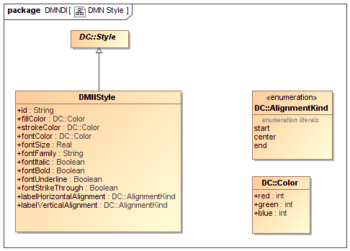
Figure 13.7: DMNStyle
DMNStyle specializes DC::Style. It is a kind of Style that provides appearance options for a DMNDiagramElement.
DMNStyle is used to keep some non-normative visual attributes such as colors and font. DMN doesn’t give any semantic to color and font styling, but tools can decide to use them and interchange them.
DMNDiagramElement style is calculated by percolating up DMNStyle attributes defined at a different level of the hierarchy. Each attribute is considered independently (meaning that a DMNStyle attribute can be individually overloaded). The precedence rules are as follow:
- The DMNStyle defined by the localStyle attribute of the DMNDiagramElement
- The DMNStyle referenced by the sharedStyle attribute of the DMNDiagramElement
- The DMNStyle defined by the localStyle attribute of the parent DMNDiagram
- The DMNStyle referenced by the sharedStyle attribute of the parent DMNDiagram
The default attribute value defined in Table 83 (DMNStyle attributes).
For example, let’s say we have the following:
- DMNDiagramElement has a local DMNStyle that specifies the fillColor and strokeColor
- Its parent DMNDiagram defines a local DMNStyle that specifies the fillColor and fontColor
Then the resulting DMNDiagramElement should use:
- The fillColor and strokeColor defined at the DMNDiagramElement level (as they are defined locally).
- The fontColor defined at the DMNDiagram level (as the fillColor was overloaded locally).
- All other DMNStyle attributes would have their default values.
DMNStyle extends DC::Style and has the following properties:

Table 83: DMNStyle attributes
Attribute | Description
id: String [0..1] | A unique id for this style so it can be referenced. Only styles defined in the DMNDI can be referenced by DMNDiagramElement and DMNDiagram.
fillColor: DC::Color [0..1] | The color use to fill the shape. Doesn’t apply to DMNEdge. Default is white.
strokeColor: DC::Color [0..1] | The color use to draw the shape borders. Default is black.
fontColor: DC::Color [0..1] | The color use to write the label. Default is black.
fontFamily: String [0..1] | A comma-separated list of Font Name that can be used to display the text. Default is Arial.
fontSize: Real [0..1] | The size in points of the font to use to display the text. Default is 8.
fontItalic: Boolean [0..1] | If the text should be displayed in Italic. Default is false.
fontBold: Boolean [0..1] | If the text should be displayed in Bold. Default is false.
fontUnderline: Boolean [0..1] | If the text should be underlined. Default is false.
fontStrikeThrough: Boolean [0..1] | If the text should be stroke through. Default is false.
labelHorizontalAlignement: AlignmentKind [0..1] | How text should be positioned horizontally within the Label bounds. Default depends of the DMNDiagramElement the label is attached to (see clause 13.5).
labelVerticalAlignment: AlignmentKind [0..1] | How the text should be positioned vertically inside the Label bounds. Default depends of the DMNDiagramElement the label is attached to (see clause 13.5). Start means “top” and end means “bottom”.

Notational Depiction Library and Abstract Element Resolutions
As a notation, DMN specifies the depiction for each of the DMN elements.
Serializing a DMN diagram for interchange requires the specification of a collection of DMNShape(s) (see clause 13.4.6) and DMNEdge(s) (see clause 13.4.7) in the DMNDiagram (see clause 13.4.4). The DMNShape(s) and DMNEdge(s) attributes must be populated in such a way as to allow the unambiguous rendering of the DMN diagram by the receiving party. More specifically, the DMNShape(s) and DMNEdge(s) MUST reference DMN model elements. If no DMNElement is referenced or if the reference is invalid, it is expected that this shape or edge should not be depicted.
When rendering a DMN diagram, the correct depiction of a DMNShape or DMNEdge depends mainly on the referenced DMN model element and its particular attributes and/or references. The purpose of this clause is to: provide a library of the DMN element depictions, and to provide an unambiguous resolution between the referenced DMN model element [DMNElement] and their depiction. Depiction resolution tables are provided below for both DMNShape (clause 13.5.2) and DMNEdge (clause 13.5.3).

Labels
Both DMNShape and DMNEdge may have labels (its name attribute) placed on the shape/edge, or above or below the shape/edge, in any direction or location, depending on the preference of the modeler or modeling tool vendor.
Labels are optional for DMNShape and DMNEdge. When there is a label, the position of the label is specified by the bounds of the DMNLabel of the DMNShape or DMNEdge. Simply put, label visibility is defined by the presence of the DMNLabel element.
The bounds of the DMNLabel are optional and always relative to the containing DMNDiagram's origin point. The depiction resolution tables provided below exemplify default label positions if no bounds are provided for the DMNLabel (for DMNShape kinds (clause 13.5.2) and DMNEdge kinds (clause 13.5.3)).
When the DMNLabel is contained in a DMNShape, the text to display is the name of the DMNElement.

DMNShape Resolution
DMNShape can be used to represent a Decision, a Business Knowledge Model, an Input Data element, a Knowledge Source, a Text Annotation and a Decision Service.

Decision
A Decision is represented in a DRD as a rectangle, normally drawn with solid lines. If the Listed Input Data option is exercised, all the Decisions requirements for Input Data shall be listed beneath the Decisions label and separated from it by a horizontal line. The listed Input Data names shall be clearly inside the shape of the DRD element.

Table 84: Depiction Resolution for Decision
DMNElement | DMNShape attributes | Depiction
Decision | None | 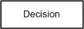
Decision and two Input Data | Shapes of Input Data have isListedInputData=true | 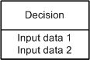

Business Knowledge Model
A Business Knowledge Model is represented in a DRD as a rectangle with two clipped corners, normally drawn with solid lines.

Table 85: Depiction Resolution for Business Knowledge Model
DMNElement | DMNShape attributes | Depiction
Business Knowledge Model | None | 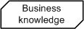

Input Data Element
An Input Data element is represented in a DRD as a shape with two parallel straight sides and two semi-circular ends, normally drawn with solid lines.

Table 86: Depiction Resolution for Input Data
DMNElement | DMNShape attributes | Depiction
Input Data | None | 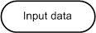

Knowledge Source
A Knowledge Source is represented as a shape with three straight sides and one wavy one, normally drawn with solid lines.

Table 87: Depiction Resolution for Knowledge Source
DMNElement | DMNShape attributes | Depiction
Knowledge Source | None | 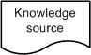

Artifacts

Table 88: Depiction Resolution of Artifacts
DMNElement | DMNShape Attributes | Depiction
TextAnnotation | None | 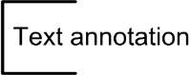

Decision Service
If the set of output decisions is smaller than the set of encapsulated decisions, the Decision Service shall be divided into two parts with a straight solid line.

Table 89: Depiction Resolution of Decision Service
DMNElement | DMNShape attributes | Depiction
Decision Service | None or isCollapsed=false | 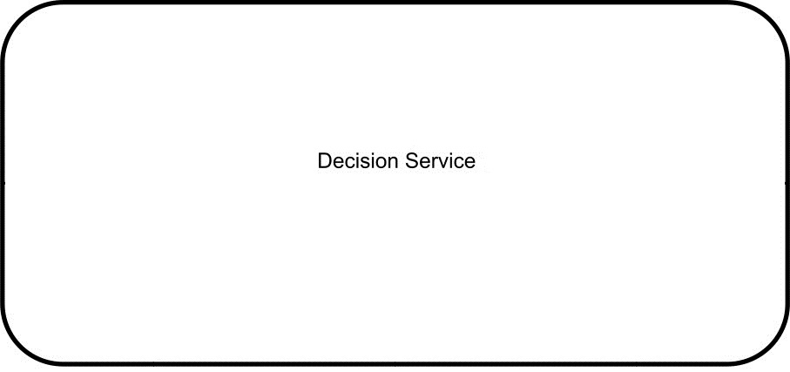
Decision Service | DecisionServiceDividerLine isCollapsed=false | 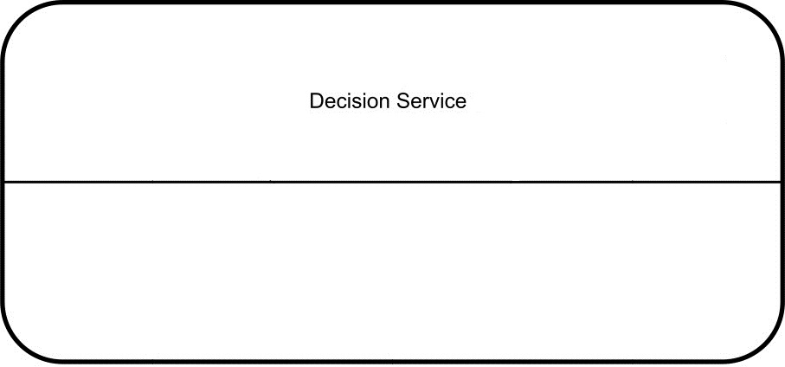
Decision Service | isCollapsed=true | 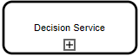

DMNEdge Resolution

Information Requirement

Table 90: Depiction Resolution of Information Requirement
DMNElement | Depiction
Information Requirement

Knowledge Requirement

Table 91: Depiction Resolution of Knowledge Requirement
DMNElement | Depiction
Knowledge Requirement

Authority Requirement

Table 92: Depiction Resolution of Authority Requirement
DMNElement | Depiction
Authority Requirement

Association
When the DMNEdge depicts an Association, its DMNElement MUST be specified.

Table 93: Depiction Resolution of Association
DMNElement | Depiction
Association where associationDirection is none. | 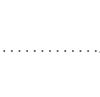
Association where associationDirection is one. | 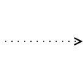
Association where associationDirection is both. | 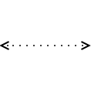

ANNEXES
All the Annexes are informative.
Annex A. discuss issues around the application of DMN in combination with BPMN. This section is intended to provide some direction to practitioners but is non-normative.
Annex B. provides a non-normative glossary to aid comprehension of the specification.

This page intentionally left blank.

- Relation to BPMN
(Informative)
- Goals of BPMN and DMN
The OMG Business Process Model and Notation standard provides a standard notation for describing business processes as orchestrations of tasks. The success of BPMN has provided a major motivation for DMN, and business decisions described using DMN are expected to be commonly deployed in business processes described using BPMN.
All statements pertaining to BPMN below are from the OMG document reference 11-01-03 unless otherwise stated.
BPMN’s goals are stated in the specification and provide easy comparisons to DMN:
- Goal 1: “The primary goal of BPMN is to provide a notation that is readily understandable by all business users, from the business analysts that create the initial drafts of the processes, to the technical developers responsible for implementing the technology that will perform those processes, and finally, to the business people who will manage and monitor those processes. Thus, BPMN creates a standardized bridge for the gap between the business process design and process implementation.”. DMN users will also be business analysts (designing decisions) and then business users (populating decision models such as decision tables). Technical developers may be responsible for mapping business terms to appropriate data technologies. Therefore DMN can also be said to bridge the decision design by a business analyst, and the decision implementation, typically using some decision execution technology,
- Goal 2: “… To ensure that XML languages designed for the execution of business processes, such as WSBPEL (Web Services Business Process Execution Language), can be visualized with a business-oriented notation.” It is not a stated goal of DMN to be able to visualize other XML languages (such as W3C RIF or OMG PRR); indeed it is expected that DMN would provide the MDA specification layer for such languages. It does not preclude however the use of DMN (such as decision tables) to represent executable forms (such as production rules).
- Goal 3: “The intent of BPMN is to standardize a business process model and notation in the face of many different modeling notations and viewpoints. In doing so, BPMN will provide a simple means of communicating process information to other business users, process implementers, customers, and suppliers.” Similarly, the intent of DMN is to standardize the decision model and notation across the many different implementations of broadly semantically similar models. In so doing, DMN will also facilitate the communication of decision information across business communities and tools.
- BPMN Tasks and DMN Decisions
Most BPMN diagrams contain some tasks which involve decision-making which can be modeled in DMN. These tasks take input data acquired or generated earlier in the process, and produce decision outputs which are used later in the process. Decision outputs may be used in two principal ways:
- They may be consumed in another process task
- They may influence the choice of sequence flows out of a gateway.
In the latter case, decisions are used to determine which subprocesses or tasks are to be executed (in the process sense). As such, DMN complements BPMN as decision modeling complements process modeling (in the sense of defining orchestrations or work tasks).
For example, Figure A.1 shows an example of a BPMN-defined process.

Figure A.1: Decision-making in BPMN

Analyzing this we see:
- a task whose title starts with “Decide…” which makes a decision on (whether to use) normal post or special shipment, and which precedes an exclusive gateway using that decision result
- a task whose title starts with “Check…” which makes a decision on whether extra insurance is necessary, which precedes an inclusive gateway for which an additional process path may be executed based on the decision result
- a task whose title starts with “Assign…” which implies a decision to select a carrier based on some selection criteria. The previous task is effectively collecting data for this decision. In an automated system this would probably be a subprocess embedding a decision and some other activities (such as “prepare paperwork”).
From this example we can see that even a simple business process in BPMN may have several decision-making tasks.
- Types of BPMN Tasks relevant to DMN
BPMN defines different types of tasks that can be considered for decision-making roles. The relevant tasks are as shown in Table 94:

Table 94: BPMN tasks relevant to DMN

A future version of BPMN may choose to clarify and extend the definitions of task to better match decision modeling requirements and DMN – to wit, to define a BPMN Decision Task as some task used to make a decision modeled with DMN. In the meantime, the Business Rule Task is the most natural way to express this functionality. However, as noted in clauses 5.2.2 and 6.3.6, a Decision in DMN can be associated with any Task, allowing for flexibility in implementation.
- Process gateways and Decisions
Process gateways can be considered of 2 types:
- A gateway that determines a process route or routes based on existing data
- A gateway that determines a process route or routes based on the outcome of one or more decisions that are determined by some previous task within the process.
In the latter case, a Decision Task (task used to make a decision using DMN) may need an extended notation to clarify the relationship of the decision task to the gateway(s) that use it.

- Linking BPMN and DMN Models
DMN offers two approaches to linking business process models in BPMN with decision models; one normative and the other non-normative:
- Associating Decisions with Tasks and Processes
As described in clause 6.3.6, in DMN 1.1, the process context for an instance of Decision is defined by its association with any number of usingProcesses, which are instances of Process as defined in OMG BPMN 2, and any number of usingTasks, which are instances of Task as defined in OMG BPMN 2. Each decision may therefore be associated with one or more business processes (to indicate that the decision is taken during those processes), and/or with one or more specific tasks (to indicate that the tasks involve making the decision). An implementation SHALL allow these associations to be defined for each decision.
An implementation MAY perform validation over the two (BPMN and DMN) models, to check, for example, that:
- A Decision is not associated with Tasks that are part of Processes not also associated with the Decision
- A Decision is not associated with Tasks that are not part of any Process associated with the Decision
During development it may be appropriate to associate a Decision only with a Process, but inconsistency between Task and Process associations is not allowed.
Note that this approach allows the relationships between business process models and decision models to be defined and validated, but does not of itself permit the decisions modeled in DMN to be executed automatically by processes modeled in BPMN.
- Decision Services
One approach to decision automation is described non-normatively in Annex A: the encapsulation of DMN Decisions in a “decision service” called from a BPMN Task (e.g. a Service Task or Business Rule Task, as discussed in Annex A..3 above). The usingProcesses and usingTasks properties allow definition and validation of associations between BPMN and DMN; the definition of decision services then provides a detailed specification of the required interface.
- Glossary
(Informative)
A
Aggregation The production of a single result from multiple hits on a decision table. DMN specifies four aggregation operators on the Collect hit policy, namely: + (sum), < (min), > (max), # (count). If no operator is specified, the results of the Collect hit policy are returned without being aggregated.
Any A hit policy for single hit decision tables with overlapping decision rules: under this policy any match may be used.
Authority Requirement The dependency of one element of a Decision Requirements Graph on another element which provides guidance to it or acts as a source of knowledge for it.
B
Binding In an invocation, the association of the parameters of the invoked expression with the input variables of the invoking expression, using a binding formula.
Boxed Context A form of boxed expression showing a collection of n (name, value) pairs with an optional result value.
Boxed Expression A notation serving to decompose decision logic into small pieces which may be associated graphically with elements of a DRD.
Boxed Function A form of boxed expression showing the kind, parameters and body of a function.
Boxed Invocation A form of boxed expression showing the parameter bindings that provide the context for the evaluation of the body of a business knowledge model.
Boxed List A form of boxed expression showing a list of n items.
Boxed Literal Expression A form of boxed expression showing a literal expression.
Business Context Element An element representing the business context of a decision: either an organisational unit or a performance indicator.
Business Knowledge Model Some decision logic (e.g. a decision table) encapsulated as a reusable function, which may be invoked by decisions or by other business knowledge models.
C
Clause In a decision table, a clause specifies a subject, which is defined by an input expression or an output domain, and the finite set of the sub-domains of the subject’s domain that are relevant for the piece of decision logic that is described by the decision table.
Collect A hit policy for multiple hit decision tables with overlapping decision rules: under this policy all matches will be returned as a list in an arbitrary order. An operator can be added to specify a function to be applied to the outputs: see Aggregation.
Context In FEEL, a map of key-value pairs called context entries.
Context Entry One key-value pair in a context.
Crosstab Table An orientation for decision tables in which two input expressions form the two dimensions of the table, and the output entries form a two-dimensional grid.
D
Decision The act of determining an output value from a number of input values, using decision logic defining how the output is determined from the inputs.
Decision Logic The logic used to make decisions, defined in DMN as the value expressions of decisions and business knowledge models and represented visually as boxed expressions.
Decision Logic Level The detailed level of modeling in DMN, consisting of the value expressions associated with decisions and business knowledge models.
Decision Model A formal model of an area of decision-making, expressed in DMN as decision requirements and decision logic.
Decision Point A point in a business process at which decision-making occurs, modeled in BPMN 2.0 as a business rule task and possibly implemented as a call to a decision service.
Decision Requirements Diagram A diagram presenting a (possibly filtered) view of a DRG.
Decision Requirements Graph A graph of DRG elements (decisions, business knowledge models and input data) connected by requirements.
Decision Requirements Level The more abstract level of modeling in DMN, consisting of a DRG represented in one or more DRDs.
Decision Rule In a decision table, a decision rule specifies associates a set of conclusions or results (output entries) with a set of conditions (input entries).
Decision Service A software component encapsulating a decision model and exposing it as a service, which might be consumed (for example) by a task in a BPMN process model.
Decision Table A tabular representation of a set of related input and output expressions, organized into decision rules indicating which output entry applies to a specific set of input entries.
Definitions A container for all elements of a DMN decision model. The interchange of DMN files will always be through one or more Definitions.
DMN Element Any element of a DMN decision model: a DRG Element, Business Context Element, Expression, Definitions, Element Collection, Information Item or Item Definition.
DRD See Decision Requirements Diagram.
DRG See Decision Requirements Graph.
DRG Element Any component of a DRG: a decision, business knowledge model, input data or knowledge source.
E
Element Collection Used to define named groups of DRG elements within a Definitions.
Expression A literal expression, decision table, invocation, list, context, function definition, or relation used to define part of the decision logic for a decision model in DMN. Returns a single value when interpreted.
F
FEEL The “Friendly Enough Expression Language” which is the default expression language for DMN.
First A hit policy for single hit decision tables with overlapping decision rules: under this policy the first match is used, based on the order of the decision rules.
Formal Parameter A named, typed value used in the invocation of a function to provide an information item for use in the body of the function.
H
Hit In a decision table, the successful matching of all input expressions of a decision rule, making the conclusion eligible for inclusion in the results.
Hit Policy Indicates how overlapping decision rules have to be interpreted. A single hit table returns the output of one rule only; a multiple hit table may return the output of multiple rules or an aggregation of the outputs.
Horizontal An orientation for decision tables in which decision rules are presented as rows; clauses as columns.
I
Information Item A DMN element used to model either a variable or a parameter at the decision logic level in DMN decision models.
Information Requirement The dependency of a decision on an input data element or another decision to provide a variable used in its decision logic.
Input Data Denotes information used as an input by one or more decisions, whose value is defined outside of the decision model.
Input Entry An expression defining a condition cell in a decision table (i.e. the intersection of a decision rule and an input clause).
Input Expression An expression defining the item to be compared with the input entries of an input clause in a decision table.
Input Value An expression defining a limited range of expected values for an input clause in a decision table.
Invocation A mechanism that permits the evaluation of one value expression another, using a number of bindings.
Item Definition Used to model the structure and the range of values of input data and the outcome of decisions, using a type language such as FEEL or XML Schema.
K
Knowledge Requirement The dependency of a decision or business knowledge model on a business knowledge model which must be invoked in the evaluation of its decision logic.
Knowledge Source An authority defined for decisions or business knowledge models, e.g. domain experts responsible for defining or maintaining them, or source documents from which business knowledge models are derived, or sets of test cases with which the decisions must be consistent.
L
Literal Expression Text that represents decision logic by describing how an output value is derived from its input values, e.g. in plain English or using the default expression language FEEL.
M
Multiple Hit A type of decision table which may return output entries from multiple decision rules.
O
Organisational Unit A business context element representing the unit of an organization which makes or owns a decision.
Orientation The style of presentation of a decision table: horizontal (decision rules as rows; clauses as columns), vertical (rules as columns; clauses as rows), or crosstab (rules composed from two input dimensions).
Output Entry An expression defining a conclusion cell in a decision table (i.e. the intersection of a decision rule and an output clause).
Output Order A hit policy for multiple hit decision tables with overlapping decision rules: under this policy all matches will be returned as a list in decreasing priority order. Output priorities are specified in an ordered list of values.
Output Value An expression defining a limited range of domain values for an output clause in a decision table.
P
Performance Indicator A business context element representing a measure of business performance impacted by a decision.
Priority A hit policy for single hit decision tables with overlapping decision rules: under this policy the match is used that has the highest output priority. Output priorities are specified in an ordered list of values.
R
Relation A form of boxed expression showing a vertical list of homogeneous horizontal contexts (with no result cells) with the names appearing just once at the top of the list, like a relational table.
Requirement The dependency of one DRG element on another: either an information requirement, knowledge requirement or authority requirement.
Requirement Subgraph The directed graph resulting from the transitive closure of the requirements of a DRG element; i.e. the sub-graph of the DRG representing all the decision-making required by a particular element.
Rule Order A hit policy for multiple hit decision tables with overlapping decision rules: under this policy all matches will be returned as a list in the order of definition of the decision rules.
S
S-FEEL A simple subset of FEEL, for decision models that use only simple expressions: in particular, decision models where the decision logic is modeled mostly or only using decision tables.
Single Hit A type of decision table which may return the output entry of only a single decision rule.
U
Unique A hit policy for single hit decision tables in which no overlap is possible and all decision rules are exclusive. Only a single rule can be matched.
V
Variable Represents a value that is input to a decision, in the description of its decision logic, or a value that is passed as a parameter to a function.
Vertical An orientation for decision tables in which decision rules are presented as columns; clauses as rows.
W
Well-Formed Used of a DRG element or requirement to indicate that it conforms to constraints on referential integrity, acyclicity etc.

Shipment Process in a Hardware Retailer example, Ch5.1, BPMN 2.0 By Example, June 2010, OMG reference 10-06-02
See ch 10.2.3 in the BPMN Specification.

