9.2.1 Block Definition Diagram
- In Table 9.1: Graphical nodes defined in Block Definition diagrams, add the following row below the InterfaceBlock row:
InterfaceBlock Conjugation | 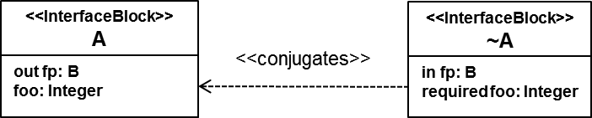 | SysML::Ports&Flows::Conjugation

9.2.2 Internal Block Diagram
- In Table 9.2: Graphical nodes defined in Internal Block diagrams, in the Port row, Concrete Syntax cell replace the text: “Conjugated Ports” with the following text: “Conjugated Ports or Ports with a Conjugated Type”

