Disposition: Resolved
OMG Issue No: FIBOFND11-14
Title: Revise the Legal Capacity Ontology as required by FIBO FBC
Source: Elisa Kendall, Thematix Partners LLC

Summary:
FBC extended the existing LegalCapacity ontology to cover licensing concepts for use in downstream FIBO ontologies, such as for operating licenses for banks. This issue and corresponding resolution integrate the changes to LegalCapacity defined in the FBC RFC into the FIBO FND specification.

Discussion:
This issue affects section 10.10.3 Ontology: Legal Capacity. The modifications are additive, i.e., this change represents new content for Foundations.
This resolution is independent of other resolutions in the FND RTF 1.1 report.

Resolution:
Revise the existing Legal Capacity ontology, defined in section 10.10.3, to support the addition of license-related concepts.
Augment the existing set of machine-readable files with (a) the revised LegalCapacity ontology, in the form of RDF/XML-serialized OWL, (b) ODM XMI (compliant with the ODM metamodels for RDF and OWL), (c) ODM UML XMI (compliant with the ODM Profiles for RDF and OWL), and (d) the corresponding Visual Ontology Modeler (VOM)/MagicDraw ancillary file.
Revised Text:

- Replace Figures 10.56, Legal Capacity Concepts and 10.57, Legal Capacity Types with the following figures, captions, and text::

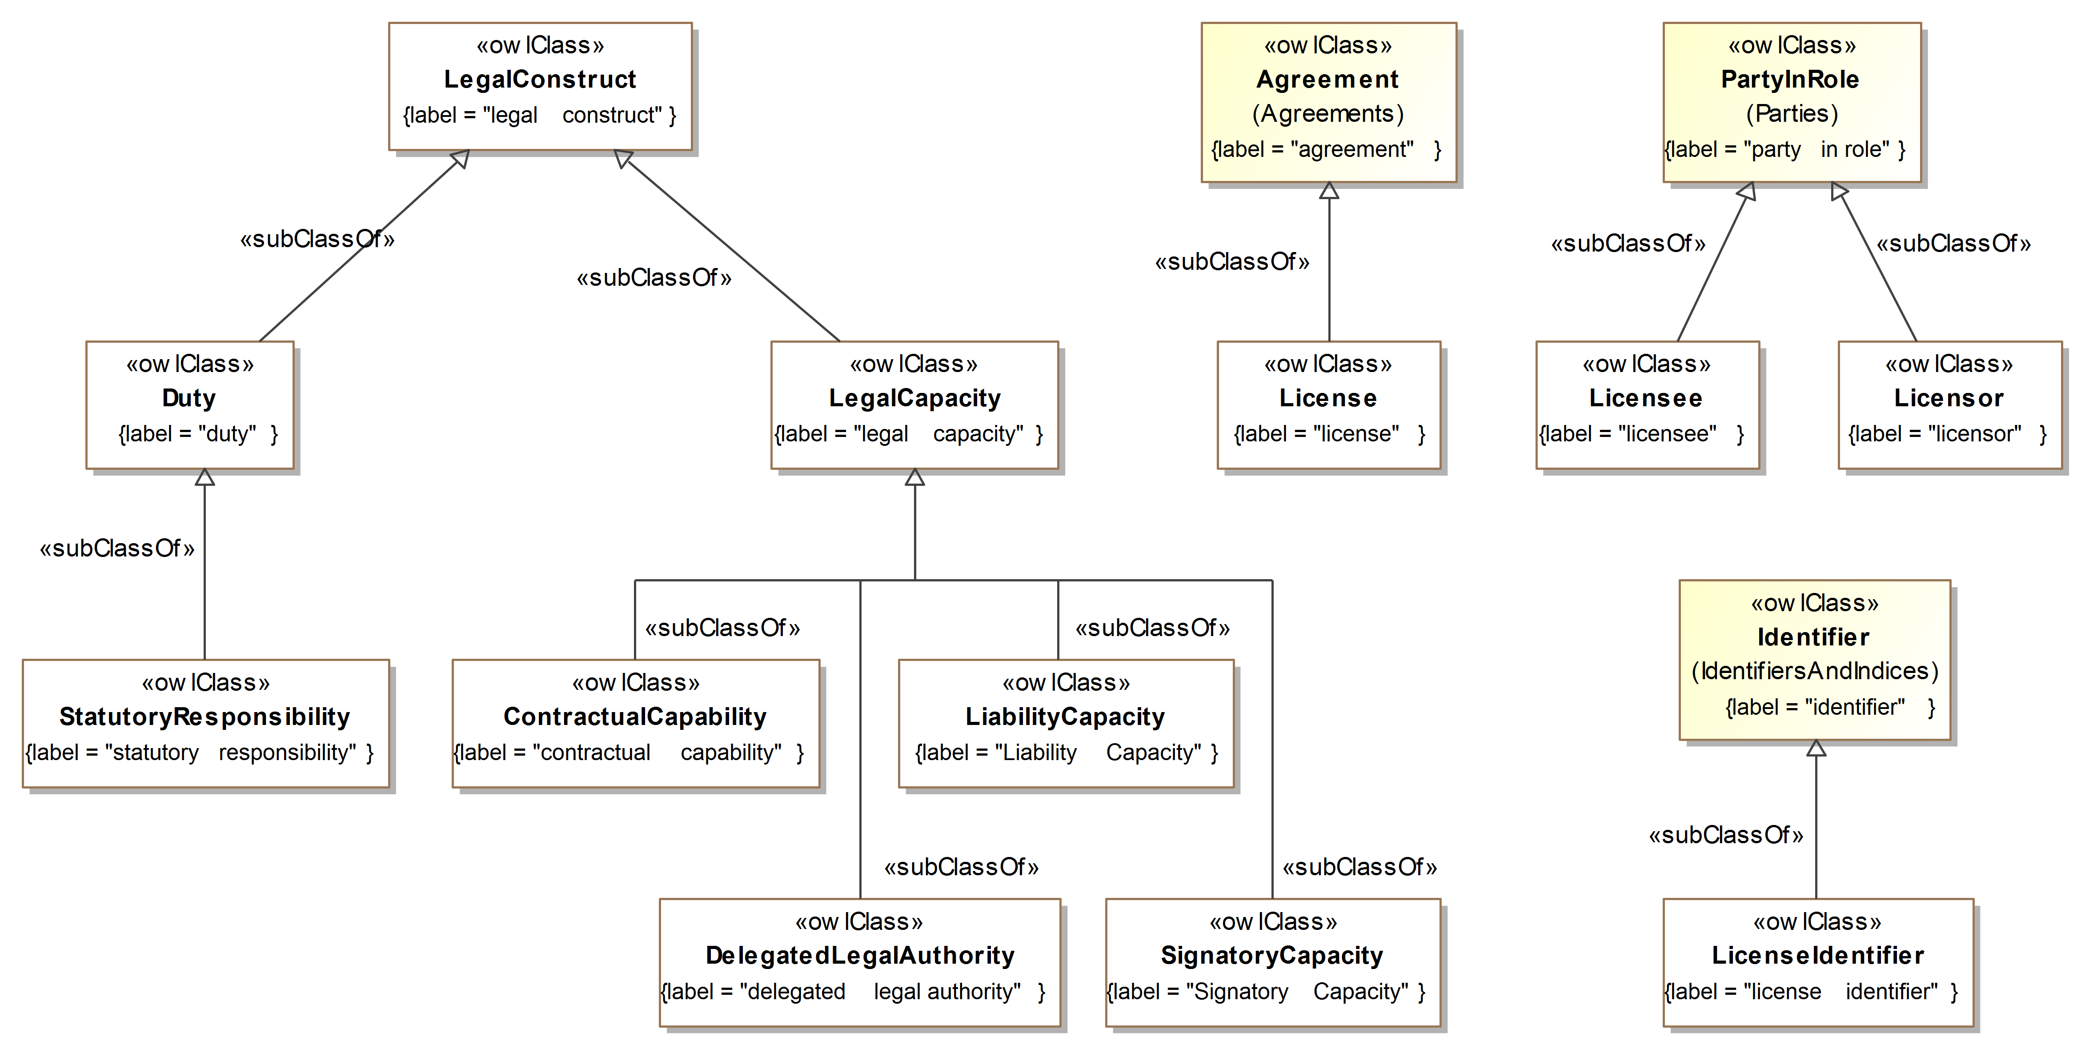
Figure 10.56 Legal Capacity Class Hierarchy

Figure 10.56 provides an overview of the concepts in the Legal Capacity ontology. Subsequent diagrams provide more detailed views on several of the concepts, with a focus on the logical restrictions that further define them.
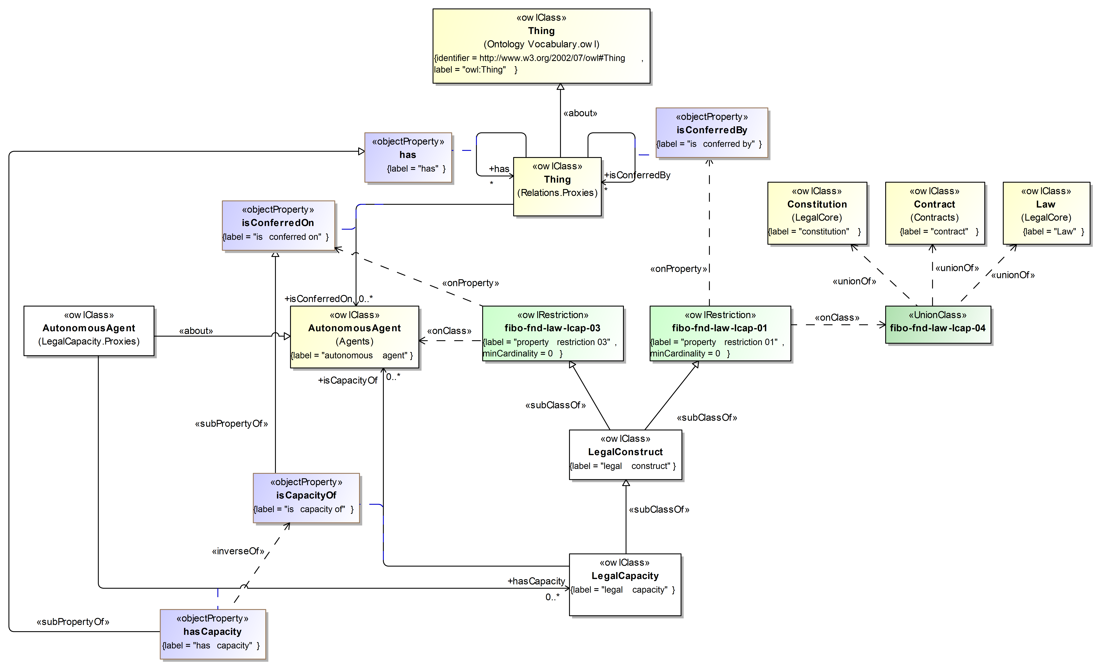
Figure 10.57 Definition of Legal Capacity
Figure 10.57 defines legal capacity in terms of who that capacity can be conferred on, who has that capacity, and the legal basis for that capacity.
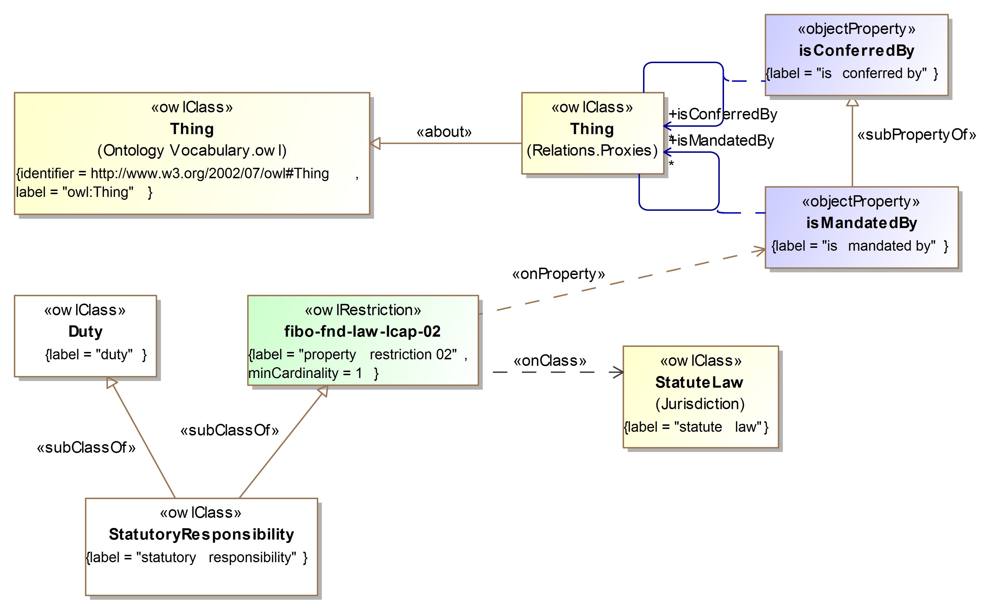
Figure 10.58 Definition of Statutory Responsibility
Figure 10.58 defines statutory responsibility as something that is mandated by at least one statute (statute law).
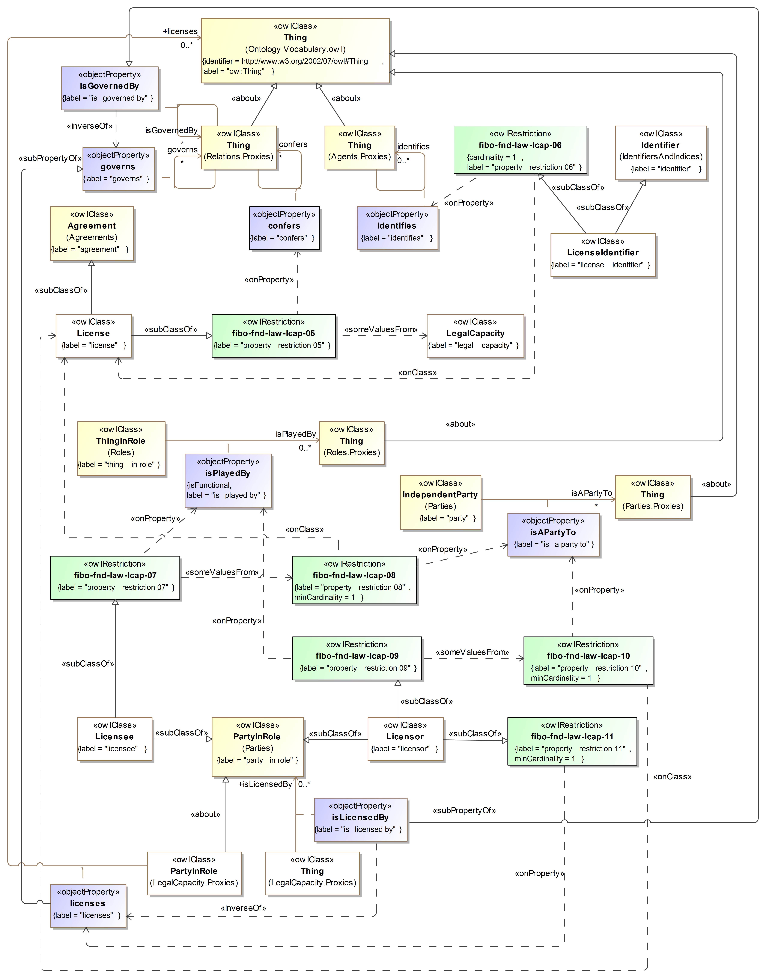
Figure 10.59 Definition of Licensing
Figure 10.59 provides the definitions for concepts and relationships for basic licensing.

- Revise Table 10-65, Legal Capacity Ontology Metadata, as follows:
Change the owl:versionIRI from http://www.omg.org/spec/EDMC-FIBO/FND/20141101/Law/LegalCapacity/ to http://www.omg.org/spec/EDMC-FIBO/FND/20150801/Law/LegalCapacity/
Add the following URIs to the sm:dependsOn section of the table:
http://www.omg.org/spec/EDMC-FIBO/FND/Arrangements/IdentifiersAndIndices/
http://www.omg.org/spec/EDMC-FIBO/FND/Parties/Roles/
http://www.omg.org/spec/EDMC-FIBO/FND/Parties/Parties/
http://www.omg.org/spec/EDMC-FIBO/FND/Agreements/Agreements/

- Replace Table 10-66, Legal Capacity Details, with the following table:

Table 10-66 Legal Capacity Details
Classes
Name | Annotations | Class Expressions
ContractualCapability (contractual capability) | Definition: the capacity to enter into legally binding contracts | Parent Class: LegalCapacity
DelegatedLegalAuthority (delegated legal authority) | Definition: institutionalized and legal power inherent in a particular job, function, or position that is meant to enable its holder to successfully carry out his or her responsibilities, where such power has been delegated through some formal means  Editorial note: This is always accompanied by an equal responsibility for one's actions or a failure to act.  Scope note: This specifically means the authority to make legally binding commitments. | Parent Class: LegalCapacity
Duty (duty) | Definition: some obligation which exists and is imposed on some individual | Parent Class: LegalConstruct
LegalCapacity (legal capacity) | Definition: the capacity to carry out certain actions or to have certain rights | Parent Class: LegalConstruct
LegalConstruct (legal construct) | Definition: something which is conferred by way of law or contract, such as a right | Property Restriction: ≥ 0 isConferredOn.AutonomousAgent  (fibo-fnd-law-lcap-03)  Property Restriction: ≥ 0 isConferredBy (Contract ∪ Constitution ∪ Law)  (fibo-fnd-law-lcap-01, fibo-fnd-law-lcap-04)
LiabilityCapacity (liability capacity) | Definition: the ability to be sued at law | Parent Class: LegalCapacity
License (license) | Definition: grant of permission needed to do something  Adapted from: Barron's Dictionary of Business and Economics Terms, Fifth Edition, 2012 | Parent Class: Agreement  Property Restriction: ∃ confers.LegalCapacity  (fibo-fnd-law-lcap-05)
Licensee (licensee) | Definition: a party to whom a license has been granted  Adapted from: Barron's Dictionary of Business and Economics Terms, Fifth Edition, 2012 | Parent Class: PartyInRole  Property Restriction: ∃ isPlayedBy (≥ 1 isAPartyTo.License)  (fibo-fnd-law-lcap-07, fibo-fnd-law-lcap-08)
LicenseIdentifier (license identifier) | Definition: an identifier associated with a license | Parent Class: Identifier  Property Restriction: = 1 identifies.License  (fibo-fnd-law-lcap-06)
Licensor (licensor) | Definition: a party who grants a license  Adapted from: Barron's Dictionary of Business and Economics Terms, Fifth Edition, 2012 | Parent Class: PartyInRole  Property Restriction: ∃ isPlayedBy (≥ 1 isAPartyTo.License)  (fibo-fnd-law-lcap-09, fibo-fnd-law-lcap-10)  Property Restriction: ≥ 1 licenses (fibo-fnd-law-lcap-11)
SignatoryCapacity (signatory capacity) | Definition: the capacity of some natural person to sign agreements on the part of some organization or legal person | Parent Class: LegalCapacity
StatutoryResponsibility (statutory responsibility) | Definition: an obligation which is defined under some body of law (statute) | Parent Class: Duty  Property Restriction: ≥ 1 isMandatedBy.StatuteLaw  (fibo-fnd-law-lcap-02)

Properties
Name | Annotations | Property Axioms
hasCapacity (has capacity) | Definition: identifies an individual or organization that has some capability to carry out certain actions, or has certain rights or obligations | Parent Property: has  Domain: AutonomousAgent  Range: LegalCapacity  Inverse: isCapacityOf
isCapacityOf (is capacity of) | Definition: identifies an individual or organization on which a given legal capacity has been conferred  Scope note: This includes capacities specific to duties at law (such as those for corporate officers) as well as the ability or capacity to incur liability. | Parent Property: isConferredOn  Domain: LegalCapacity  Range: AutonomousAgent
isLicensedBy (is licensed by) | Definition: indicates the regulatory agency that regulates something | Parent Property: isGovernedBy  Range: PartyInRole  Inverse: licenses
licenses (licenses) | Definition: issues a license required in order to perform some task, provide some service, exercise some privilege, or pursue some line of business or occupation to some party  Adapted from: http://www.merriam-webster.com/dictionary/regulate | Parent Property: governs  Domain: PartyInRole

Disposition: Resolved

