Disposition: Proposed
OMG Issue No: FBEF-12
Title: Revise the Executives ontology to reflect the modifications made to FIBO FND
Source: Elisa Kendall, Thematix Partners LLC

Summary:
The Executives ontology contains a number of properties and/or restrictions that were impacted by modifications to the FIBO FND ontologies. These include, but may not be limited to:
(1) changing the domain of the appoints relation to be an AutonomousAgent, which is incompatible with its use in a restriction on the DeFactoControllingInterestParty class in an extended definition in Executives, as well as in a restriction on BoardOfDirectors, which is an EntityControllingParty
(2) changing the domain of the elects relation to be a LegalPerson, which is incompatible with its use in a restriction on the VotingShareholder class,
(3) several uses of hasRole, which should be modified to be isPlayedBy in all cases,
(4) migration of the constrains property from Relations to LegalCore, which causes a syntax error in a restriction on an extended definition of InstrumentOfIncorporation..

Discussion:
These issues affect section 9.6.5, Executives, in the FIBO BE 1.0 Alpha specification.

In addition to the problems listed above, several others were uncovered, all of which could be traced to modifications in the domain or range of a property that was previously less constrained in Foundations. In order to address the issues related to the appoints, property for example, a new nominates property between parties-in-role was created in Executives to ensure proper semantics in restrictions. In another case with the property isConferredOn, whose range was changed to AutonomousAgent in Foundations by the FND FTF, a restriction on CorporateOfficerCapacity must be removed, which is not as onerous as it might be, given that there is another restriction on CorporateOfficer that links the two appropriately.

Policies on property modification must be established to limit the potential for these kinds of issues, which are entirely avoidable if sufficient analysis is done prior to making such changes.

Resolution:
Revise section 9.6.5, as follows.

Revised Text:
- Revise Table 9-28, Executives Ontology Metadata, to

  - Change the versionIRI from

http://www.omg.org/spec/EDMC-FIBO/BE/20131101/OwnershipAndControl/Executives/

to

http://www.omg.org/spec/EDMC-FIBO/BE/20150201/OwnershipAndControl/Executives/

  - Remove dependsOn relationships, including

http://www.omg.org/spec/EDMC-FIBO/BE/LegalEntities/FormalBusinessOrganizations/

http://www.omg.org/spec/EDMC-FIBO/BE/LegalEntities/LEIEntities/

http://www.omg.org/spec/EDMC-FIBO/BE/OwnershipAndControl/OwnershipParties/

http://www.omg.org/spec/EDMC-FIBO/BE/OwnershipAndControl/CorporateOwnership/

  - Add dependsOn relationship for

http://www.omg.org/spec/EDMC-FIBO/FND/

- Replace Figure 9.6.5.1, Executives Taxonomy, with the following figure:

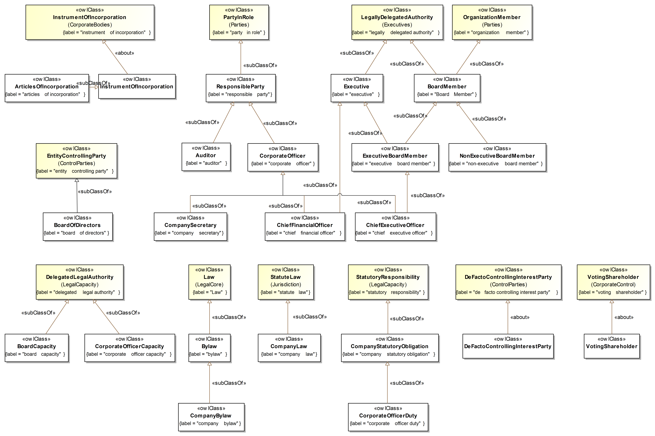

- Replace figures 9.6.5.2 and 9.6.5.3, and the captions and text below the figures, with the following figures, captions, and text.

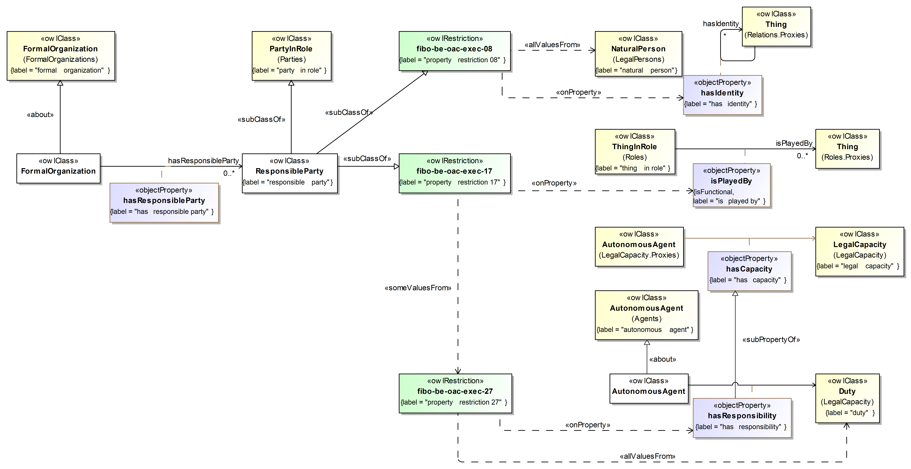

Figure 9.6.5.2 Responsible Parties

Figure 9.6.5.2 shows the set of classes, properties, and restrictions that define responsible parties. ResponsibleParty provides the basis for Auditor and CorporateOfficer.

Figure 9.6.5.3 Board of Directors and Board Capacity

Figure 9.6.5.3 provides a view of the BoardOfDirectors concept, as does Figure 9.6.5.4, below.

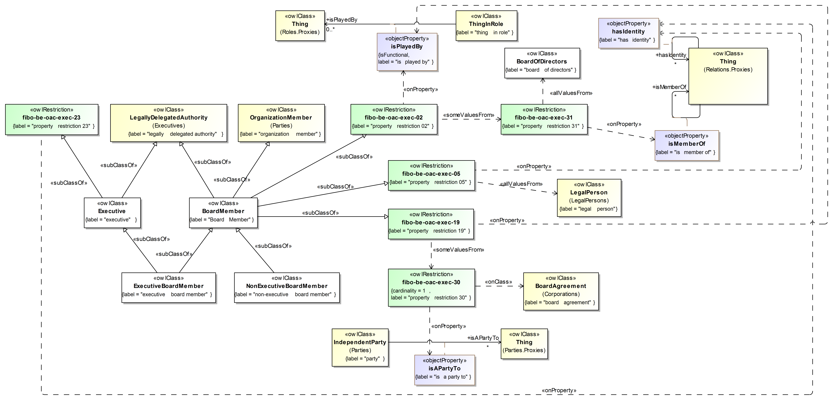

Figure 9.6.5.4 Board Membership and Authority

Primary uses for BoardOfDirectors include understanding affiliate relationships, determination of corporate control, and teasing out patterns of influence across corporations.

Figure 9.6.5.5 Corporate Officers

Figure 9.6.5.5 depicts the set of classes, properties, and restrictions that refine the concept of a corporate officer, including some of their capabilities and duties from a fiduciary perspective.

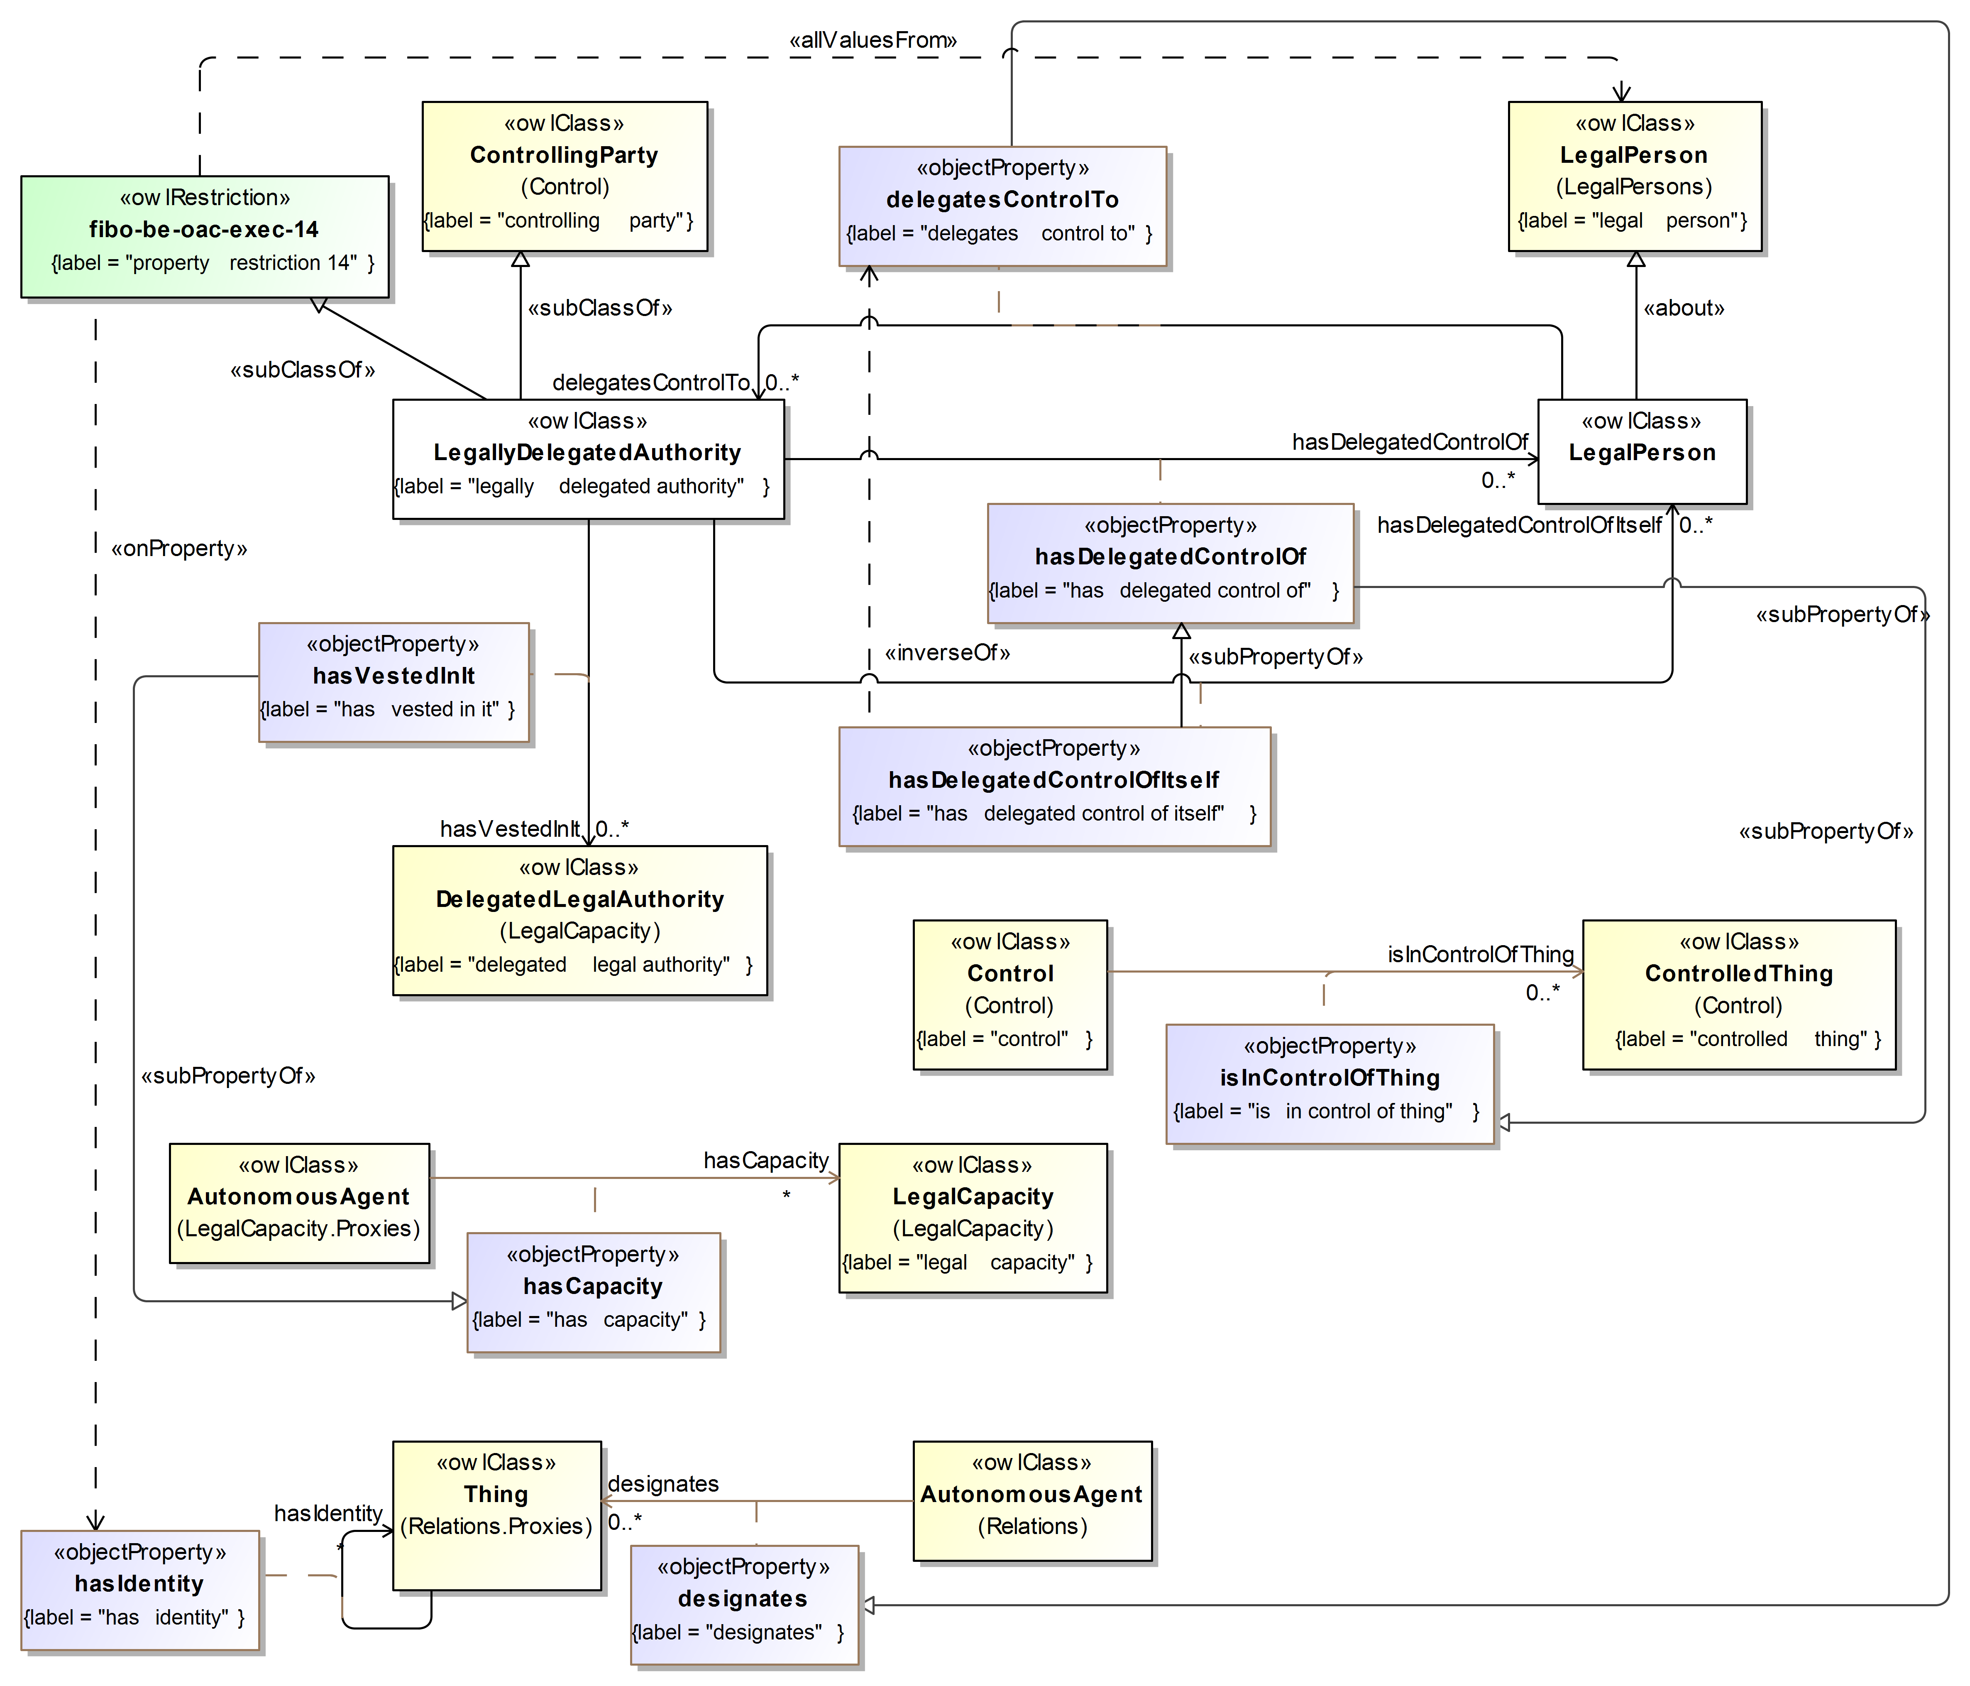

Figure 9.6.5.6 Delegation of Authority

Figure 9.6.5.6 shows the set of classes, properties, and restrictions that specify how one might follow the chain of authority over an organization, if available, at a high level.

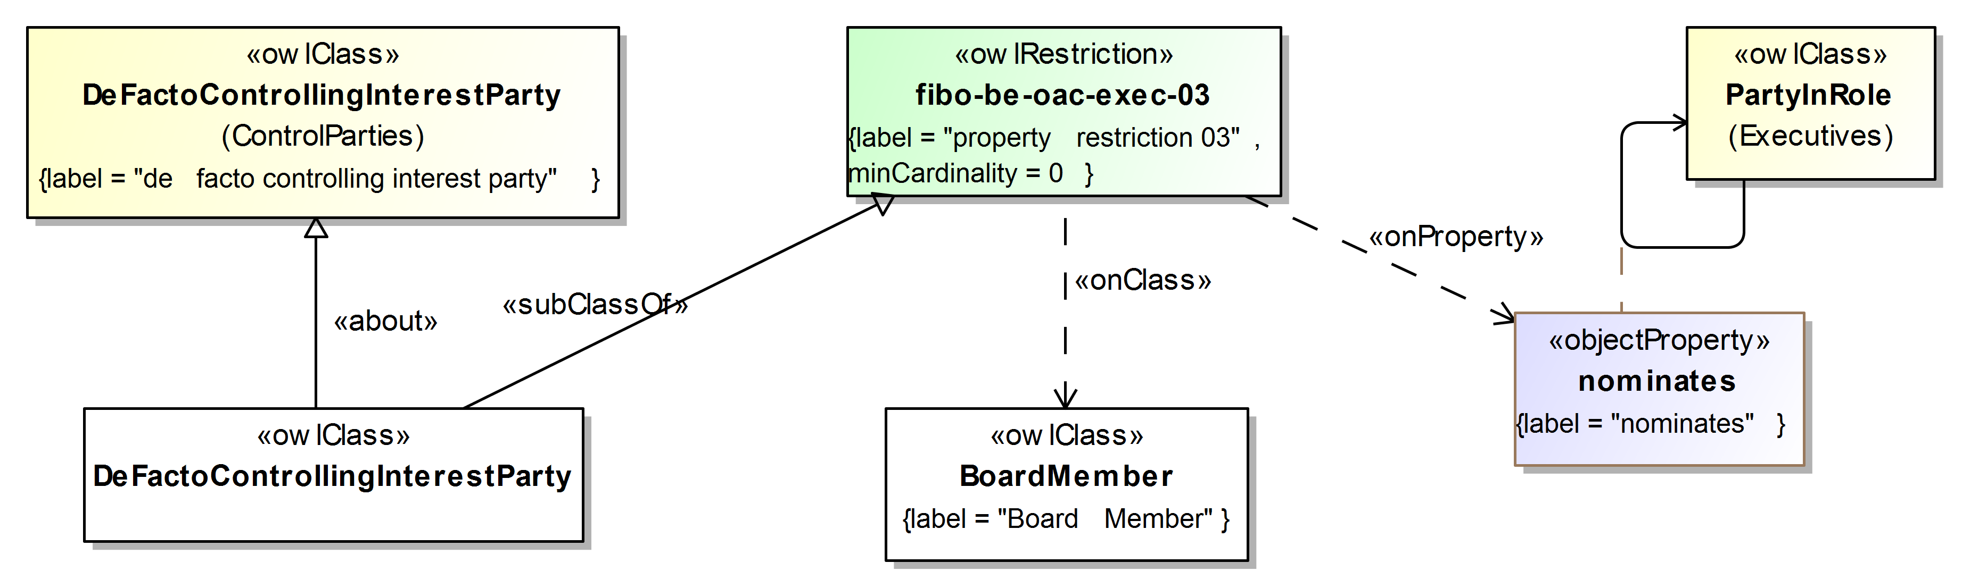

Figure 9.6.5.7 De Facto Controlling Interest

Figure 9.6.5.7 shows the relationship between a de facto controlling interest party and nomination of a board member, highlighting yet another kind of control that might be exercised over a company.

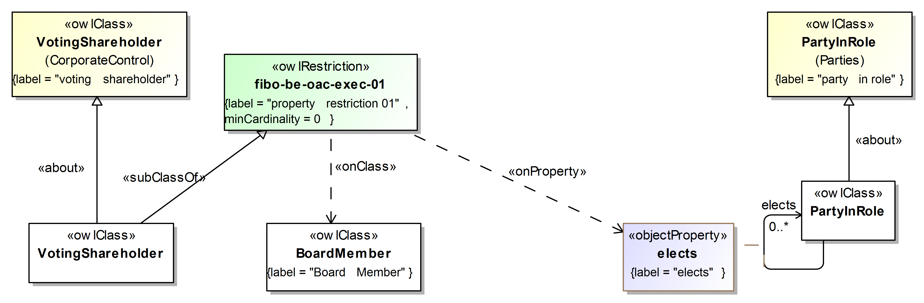

Figure 9.6.5.8 Voting Shareholder Control

Figure 9.6.5.8 shows the relationship between a voting shareholder and election of a board member, a more publicly available evidence for control over a company.

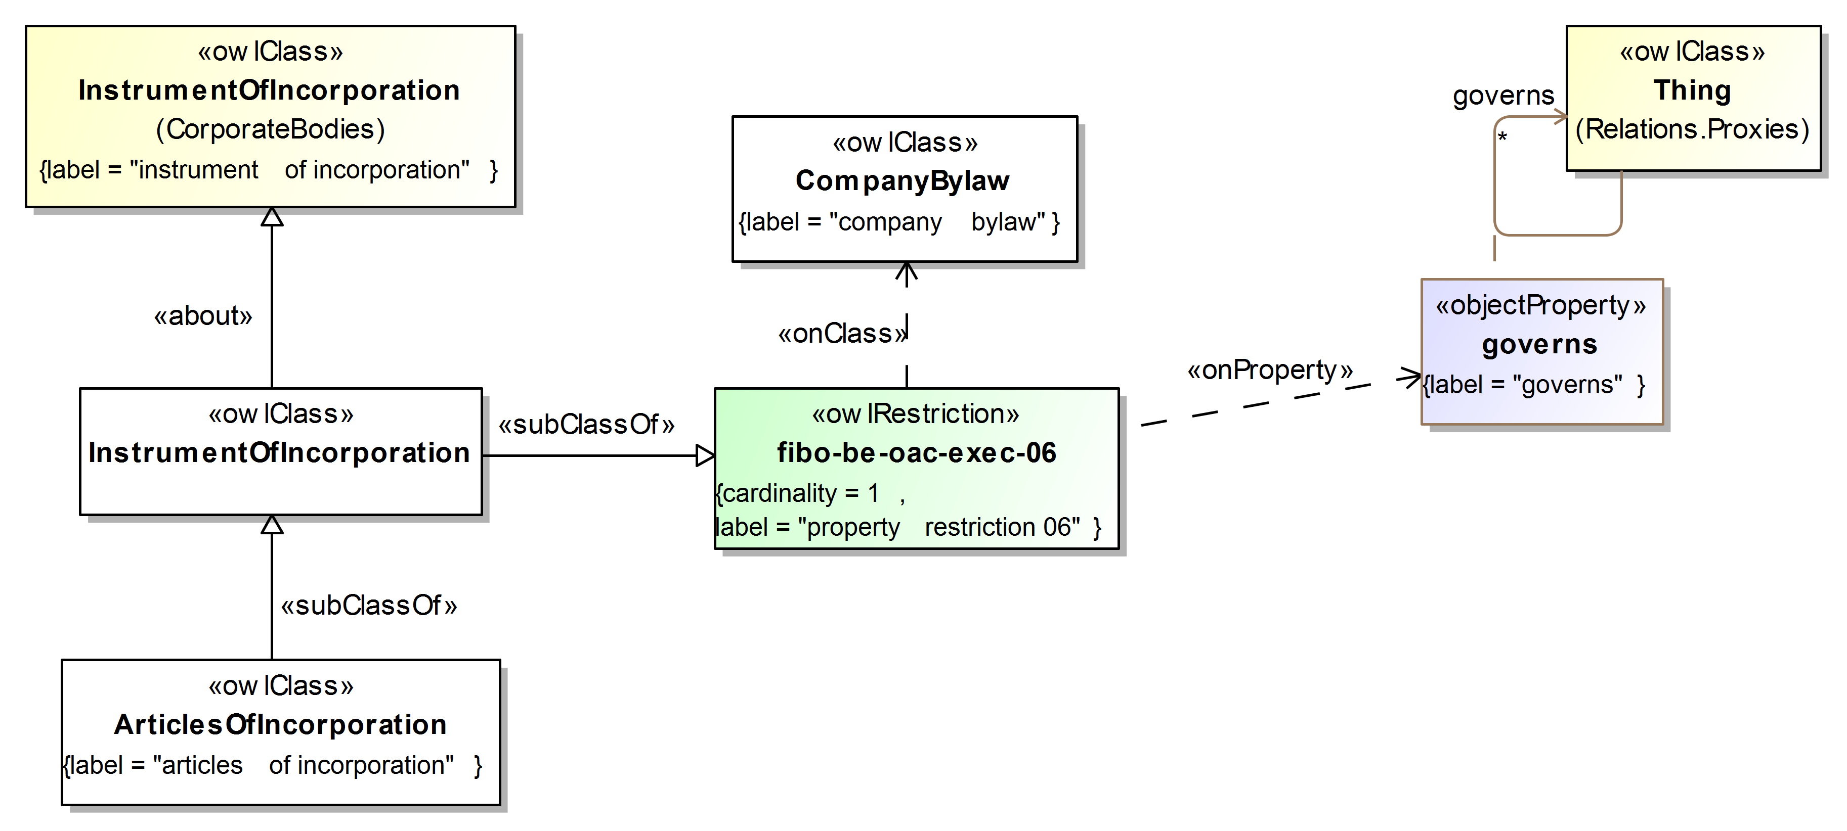

Figure 9.6.5.9 Incorporation Facilities

Figure 9.6.5.9 shows an extension of an instrument of incorporation and its relationship with corporate bylaws.

- Generate Table 9-29, Executives Ontology Details, from the ODM-compliant model used to create the diagrams, above, automatically.

Disposition: Proposed

