JIRA 11 Proposed Resolution
Issue title: “hasPercentageAmount is semantically flawed”

Discussion
This Issue Resolution covers the following issues:
Issue 11: “hasPercentageAmount is semantically flawed”
Issue 6: “Allow for percentage notional amounts” is merged with this.
Issue 6 deals with one specific impact of this (on percentage notional in the CurrencyAmounts ontology) which is described here.
In addition, the class MonetaryMeasure is to be made a child of Measure, as identified in comments to Issue FIBOFTF2-10.

Rationale
It has been pointed out that while percentage exists as a datatype on data feeds the semantics of this are incomplete – it would be more correct semantically to frame percentage in terms of what it is a percentage of
This means that references to percentage should be replaced: instead of a datatype property with the datatype percent, these should all be object properties with the range of percentage.
Percentage itself is then to be modeled as a class with an object propery whose range is Thing, identifying the thing that this is a percentage of (unless a mode specific but suitable abstract class comes to hand); and a datatype property of type “percent” being the numeric amount.
Naming is to be thought about e.g. what is percent and what is percentage, which name to apply to the datatype which contains the numeric % amount and so on.
Impact is to be assessed – there will be considerable impact in Indices and Indicator and in in future Securities, derivatives etc. models. Impact within Foundations is also to be assessed but is probably minimal. There will be impact on CurrencyAndAmount, where Issue 6 was filed. Use of the new properties should make reference to the concept of Notional Amount.
The existing percentage datatype is in BusinessFacingTypes
Change is to be carried out in the BusinessFacingTypes ontology, where these properties are already present. Note that Basis points should be subject to a similar treatment.

Model Changes

In BusinessFacingTypes
- Rename the datatype ‘percentage’ to ‘percentageValue’
  - Change the element IRI to match this
  - Change skos:definition
    - From: “in mathematics, a percentage is a number or ratio as a fraction of 100”
    - To: “the value of a percentage expressed as a number or ratio as a fraction of 100”
- Add a class called ‘Percentage’
  - Add skos:definition: “a proportion of something expressed as a percentage amount”
  - Add element IRI
- Change the domain of the datatype property ‘hasPercentageValue’ to be the class “Percentage”
  - Change the skos:definition for this property
    - From: “indicates a value expressed as a percentage”
    - To: “indicates the value of a percentage expressed as a fraction of 100”
- Add a new object property ‘isPercentageOf’ with domain of percentage and range of Thing.
  - With label ‘is percentage of’
  - Add skos:definition: “that of which the percentage is a ratio, expressed as a fraction of 100 where 100 represents the whole of that thing or quantity”
  - Add element IRI
Then for equivalent changes to restrictedPercentage:
- Rename restrictedPercentage to restrictedPercentageValue
  - Change label to ‘restricted percentage value’
  - No change to definition
  - Change element IRI
- Add a new class called RestrictedPercentage
  - Label – ‘restricted percentage’
  - Add skos:definition: “a proportion of something expressed as a percentage amount and not exceeding 100% of that of which it is the percentage”
  - Add elememnt IRI
  - Add subClassOf relation to Percentage
- Add a restriction ‘fibo-fnd-utl-bt-04’
  - Add a subClassof relation to RestrictedPerecntage
  - Add onProperty hasPercentageValue
  - Add allValuesFrom pointing to restrictedPercentageValue
Basis Points: leave this for a future phase of work. Basis points are exactly like percentages but expressed as a fraction of 10000 (for example 50bp = 0.5%) and therefore these should be treated the same as percentage. Alternatively, the class “percentage” should be allowed to be expressed either as a percentageValue (that is, a percentage out of 100) or as a basisPointsValue (that is, a ratio out of 10 000).

In CurrencyAndAmount
Refactor the way in which percentage monetary amount is expressed, as follows:
In diagram ‘Monetary Amounts and measure Concepts:

- Add the class ‘Percentage’ (BusinessFacingTypes) along with the property ‘isPercentageOf’ to the diagram
- Make the following changes to restriction fibo-fnd-acc-cur-01
  - Change the target of the ‘onProperty’ relation to point to ‘isPercentageOf
  - Change the target of the allValuesFrom relation to point to ‘MonetaryAmount’
- Include the rest of the percentage pattern from BusinessFacingTypes to assist in reading of this model
- Delete the property ‘hasPercentageAmount’ along with its element IRI and annotations
- Import the ontology ‘Analytics’

- Add subClassOf relation from MonetaryMeasure to Measure (Analytics)

Revised Text

BusinessFacingTypes
In sub-clause 10.1.2:
Diagram ‘Percentage Definitions’:
Replace Figure 10.6 Percentage Definitions’ (the figure number may change if other issue resolutions cause the addition or removal of the existing Figures 10.1 through 10.5) with the diagram attached, which has been copied directly from the source model for the BusinessFacingTypes ontology, and is identified as “Percentage Definitions”. This is attached as JIRA11-6_Percentage Definitions-2.svg

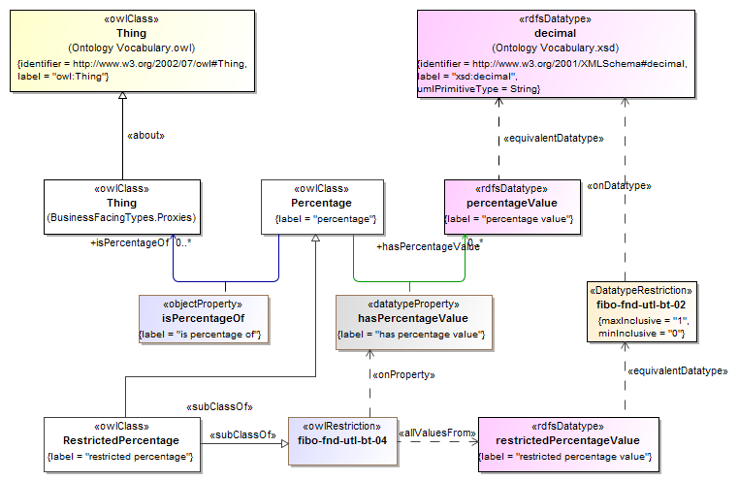
Regenerate Table 10.6, “Business Facing Types Details”. The row for percentage should show the name changed to percentageValue and the row for retricted percentage should how the name change to restricted perentage value, as in the attached table row extract. This is attached as JIRA11-2_BFTDetailsRow

Datatype | Definition | Equivalent Datatype | Concept Type | Definition Source
percentageValue | the value of a percentage expressed as a number or ratio as a fraction of 100 | decimal | Datatype
restrictedPercentageValue | A type defining a percentage specified as decimal from 0 to 1. A percentage of 5% would be represented as 0.05. The maximum value is 100%, i.e., 1. | fibo-fnd-utl-bt-02 | Datatype

An additional table will need to be added to sub-clause 10.1.2 to document the new class and the property hasPercentageValue. The details in this table should be as shown in the attached JIRA11-3_BFTClassesAndPropertiesTable-2.docx (this is version 2 of the table, replacing an earlier version)
Name | Type Of Thing | Property | Definition | Equivalent to | Parent | Mutually Exclusive With | Related Thing or Type | Inverse Of Property | Concept Type | Editorial Note | Explanatory Note | Definition Source
Percentage | percentage |  | a proportion of something expressed as a percentage amount |  |  |  |  |  | Class
hasPercentageValue | percentage | has percentage value | indicates a value expressed as a percentage |  |  |  | Percentage value |  | Simple Property
isPercentageOf | percentage | is percentage of | that of which the percentage is a ratio, expressed as a fraction of 100 where 100 represents the whole of that thing or quantity |  |  |  | anything |  | Relationship Property
RestrictedPercentage | Restricted percentage |  | a proportion of something expressed as a percentage amount and not exceeding 100% of that of which it is the percentage |  | percentage  fibo-fnd-utl-bt-04 |  |  |  | Class
fibo-fnd-utl-bt-04 | property restriction 04 |  | Set of things with property ‘has percentage value’ which may only be taken from ‘restricted percentage value’ |  |  |  |  |  | Property Restriction

CurrencyAndAmount
In sub-clause 10.12.2:
Replace Figure 10.58 (the figure number may change if other issue resolutions cause the addition or removal of the existing Figures 10.1 through 10.57) with the diagram, attached, which has been copied directly from the source model for the Currencies and Amounts ontology, and is identified as “Monetary Amounts and Measures”. This is attached as JIRA11-4_Monetary Amounts and Measures Concepts-2.svg
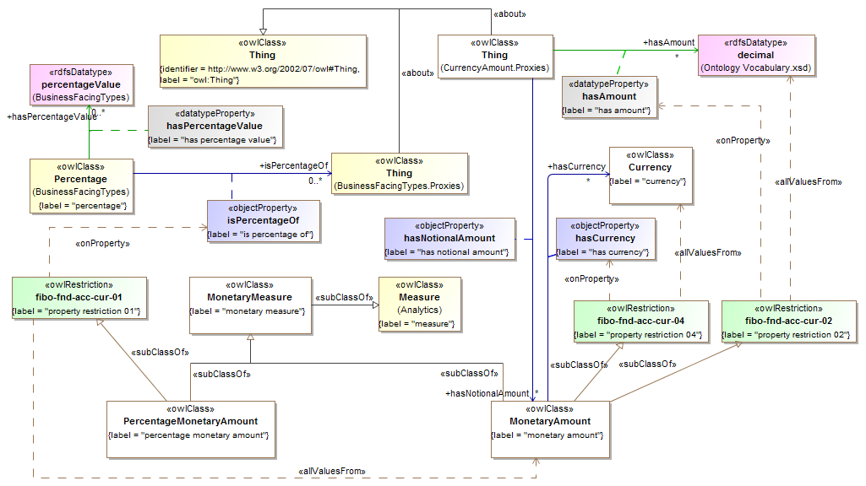
Regenerate Table 10.64, “Currency and Amount Details”. The row for the property ‘hasPercentageAmount’ will no longer appear in this table. The row for the restriction ‘property restriction 01’ will have changed as shown in the attached table row entry. This is attached as JIRA11-5_CurrencyAndAmountRow-2.docx
Name | Type Of Thing | Property | Definition | Equivalent to | Parent | Mutually Exclusive With | Related Thing or Type | Inverse Of Property | Concept Type | Editorial Note | Explanatory Note | Definition Source
fibo-fnd-acc-cur-01 | property restriction 01 |  | Set of things with property "is percentage of" may only be "monetary amount" |  |  |  |  |  | Property Restriction
MonetaryMeasure | monetary measure |  | Some measure of some sum of money. |  | measure |  |  |  | Class | This may be a measure expressed in terms of decimal plus currency, or it may be a measure expressed in terms of a percentage amount with reference to some other monetary amount or to some Money Amount (actual amount of money).

