JIRA 8 Issue Resolution v2
Issue Title: Misclassification of PartyInRole and Role

Discussion
The issue as described indicates a misclassification of roles versus parties in roles when a reasoner is run on the model as it was at Beta1. Subsequent changes in Beta2 render the original issue moot since it is unlikely that the changed model would yield the same results.
As part of the remodeling of Ownership and Control, changes were made in FTF1 which also render the property ‘hasRole’, with domain of Thing and range of Role would also either be moot, or would require a new domain and / or range.
This proposed resolution is to have hasRole with a domain of ThingInRole and Role, making effectively a terminological equivalence to the semantics of the role as defined for the ThingInRole class (e.g. Issuer)
Changes described for OrganizationMember (in the Parties ontology) remain as they were in the previous proposed resolution to this issue.

Findings:
There is a restriction on this property in the ontology Roles:
ThingInRole is sub class of fibo-fnd-pty-rl-02 onProperty hasRole min 1 onClass Role

This is retained.

Previous usages of hasRole:
In Control – property restriction 02 (this is now onProperty ‘isPlayedBy’instead of ‘hasRole’)
In Ownership: Property restriction 06 (this is now onProperty ‘isPlayedBy’ instead of ‘hasRole’)
There is one other usage of this property, in Parties:
fibo-fnd-pty-pty:OrganizationMember
In Parties: Property restriction 04 – this is a parent of OrganizationMember and forms part of a complex restriction cascade whereby OrganizationMember is necessarily a member of the class of things with property hasRole, with someValuesFrom the restriction on property isMemberOf allvalueFrom Organization.
Change: as with the previous 2 restrictions, this should now be in property isPlayedBy. This means that an organization member, as a party in a role, is played by (a kind of hasIdentity relationship), that which is a member of some organization.

Model Changes

In the Roles ontology
- Change the domain of hasRole to be ThingInrole

In the Parties ontology
(this is unchanged from the previous proposed resolution for FIBOFTF2-8 where the modeling of the semantics of organization member are framed with reference to the newer overall pattern for defining parties in roles, since this is what an organization member is defined as.
- For Property Restriction fibo-fnd-pty-pty-04, change the range of the onProperty relationship so that it refers to the property isPlayedBy (Roles)

Specification Changes

Changes in Roles ontology
In sub-clause 10.4.2
The diagram “Role Definitions” (Figure 10.20 in the Beta 2 document) is to be regenerated. With subsequent changes recorded in other issues, and with the retention of the hasRole property and the Role class, this should be as shown in the attached JIRA8v2-1_Role Definitions.svg
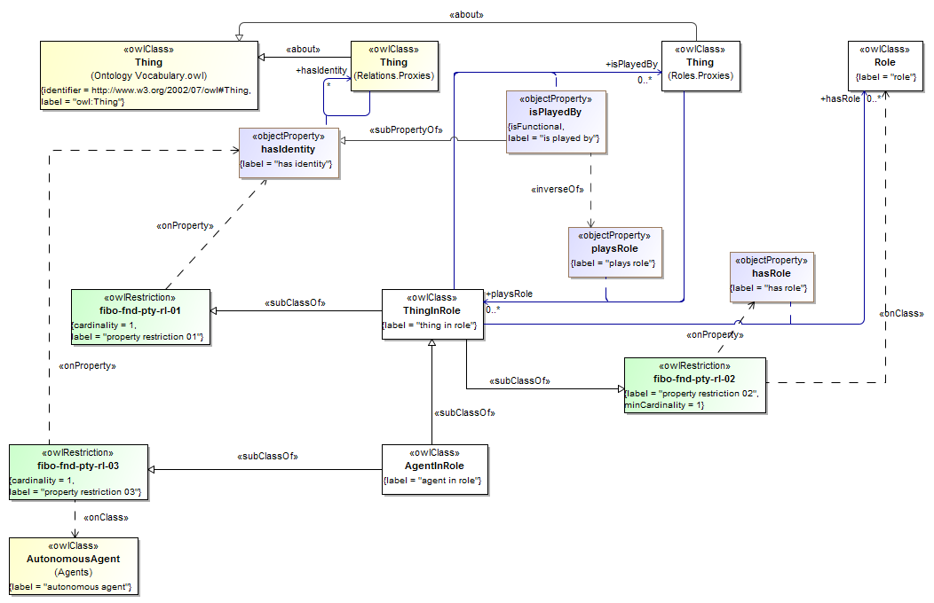
Revise Table 10.18 to update the versionIRI for the ontology to http://www.omg.org/spec/EDMC-FIBO/FND/20141101/Parties/Roles/.
Table 10:19 “Roles Details” when regenerated will show the new domain of hasRole as being ThingInRole. The amended row is shown in the attached JIRA8v2-2_RolesRow.docx
Name | Type Of Thing | Property | Definition | Equivalent to | Parent | Mutually Exclusive With | Related Thing or Type | Inverse Of Property | Concept Type | Editorial Note | Explanatory Note | Definition Source
hasRole | thing in role | has role | provides a means for relating a person, organization, group, or other entity to a role that entity plays in some relationship and context |  | has |  | role |  | Relationship Property

Changes in Parties ontology
In sub-clause 10.4.1:
The diagram “Organization Member” (Figure 10.19 in the Beta2 specification) is to be regenerated. It should indicate a restriction on OrganizationMember which refers to the property isPlayedBy (Roles).
This is attached as JIRA8v2-3 Organization Member.svg
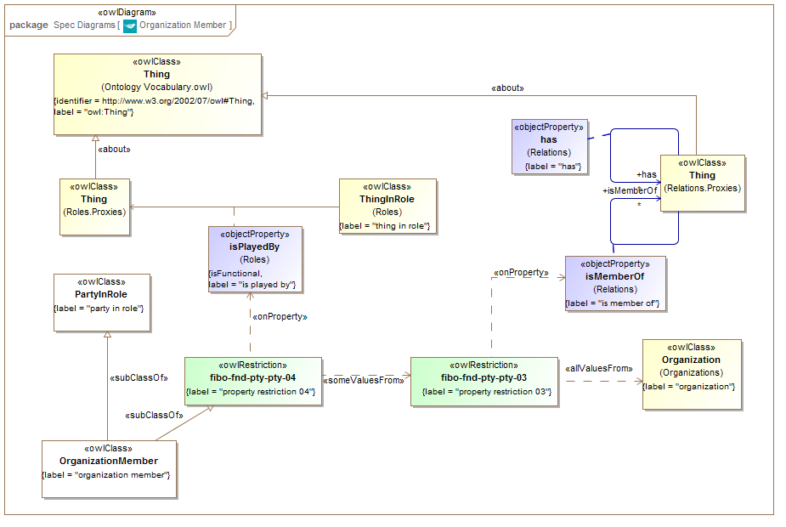
Revise Table 10.16 to update the versionIRI for the ontology to http://www.omg.org/spec/EDMC-FIBO/FND/20141101/Parties/Parties/.
Table 10:17 “Parties Details” when regenerated should indicate the modified definition for the restriction fibo-fnd-pty-pty-04. This is attached as JIRA8-4 Parties Row.docx
Name | Type Of Thing | Property | Definition | Equivalent to | Parent | Mutually Exclusive With | Related Thing or Type | Inverse Of Property | Concept Type | Editorial Note | Explanatory Note | Definition Source
fibo-fnd-pty-pty-04 | property restriction 04 |  | Set of things with property "isPlayedBy" some "property restriction 03" |  |  |  |  |  | Property Restriction

