DMNFTF-22: in the DMN Example in 11.3, Application Risk Score is poorly named and pre/post bureau risk category logic is implausible

Ballot 9

Change tracking
Change (dtc-14-02-01, section 11.3, figure 65, p.132) from
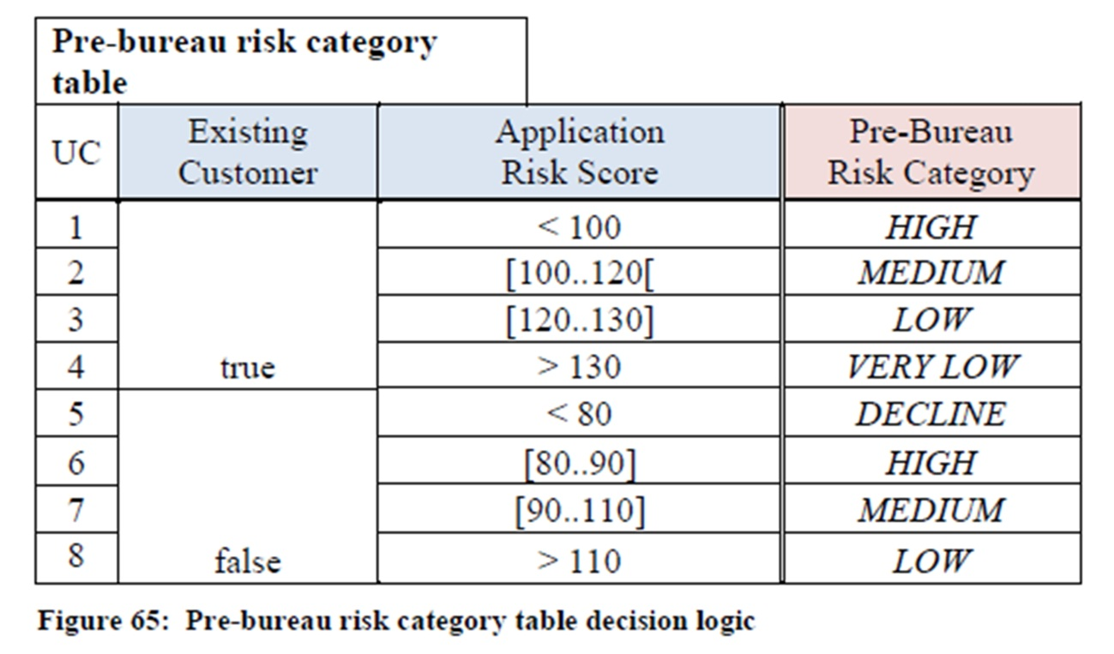
to (dtc-2014-08-17, section 11.3, figure 73, p. 177)
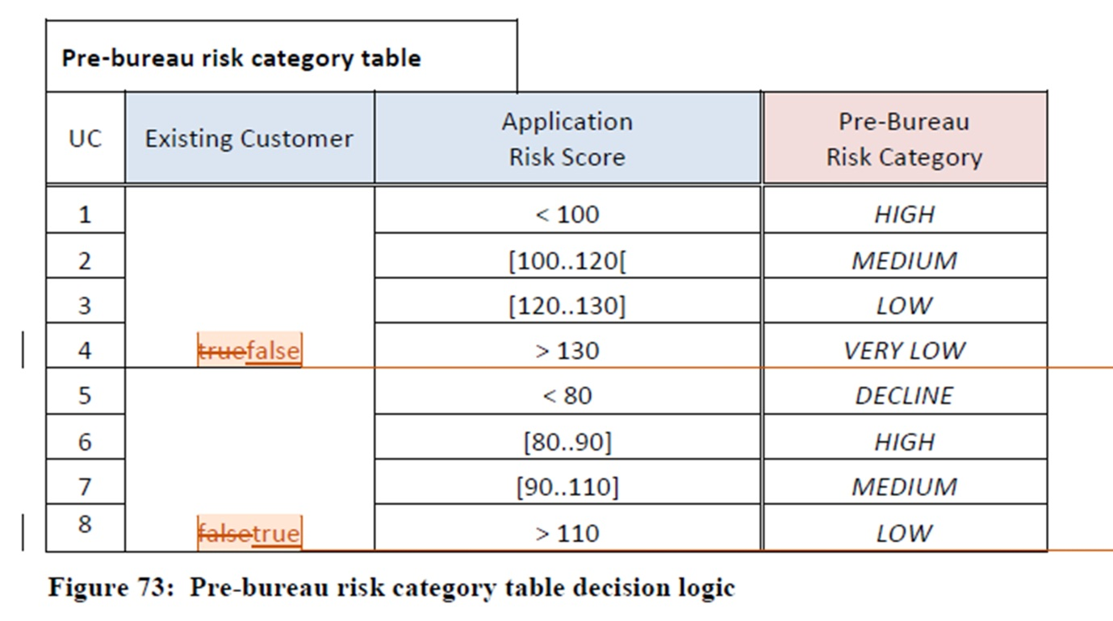
Change (dtc-14-02-01, section 11.3, figure 71, p.153) from
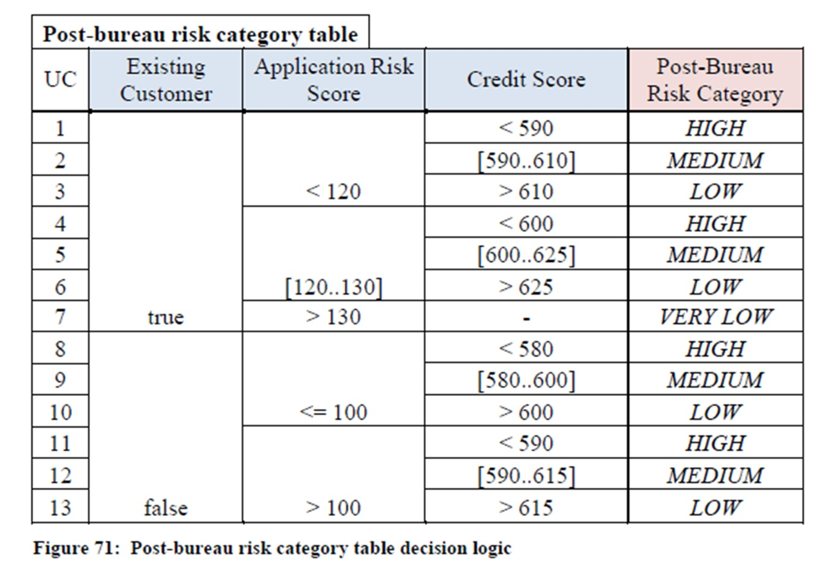
to (dtc-2014-08-17, section 11.3, figure 79, p. 180)
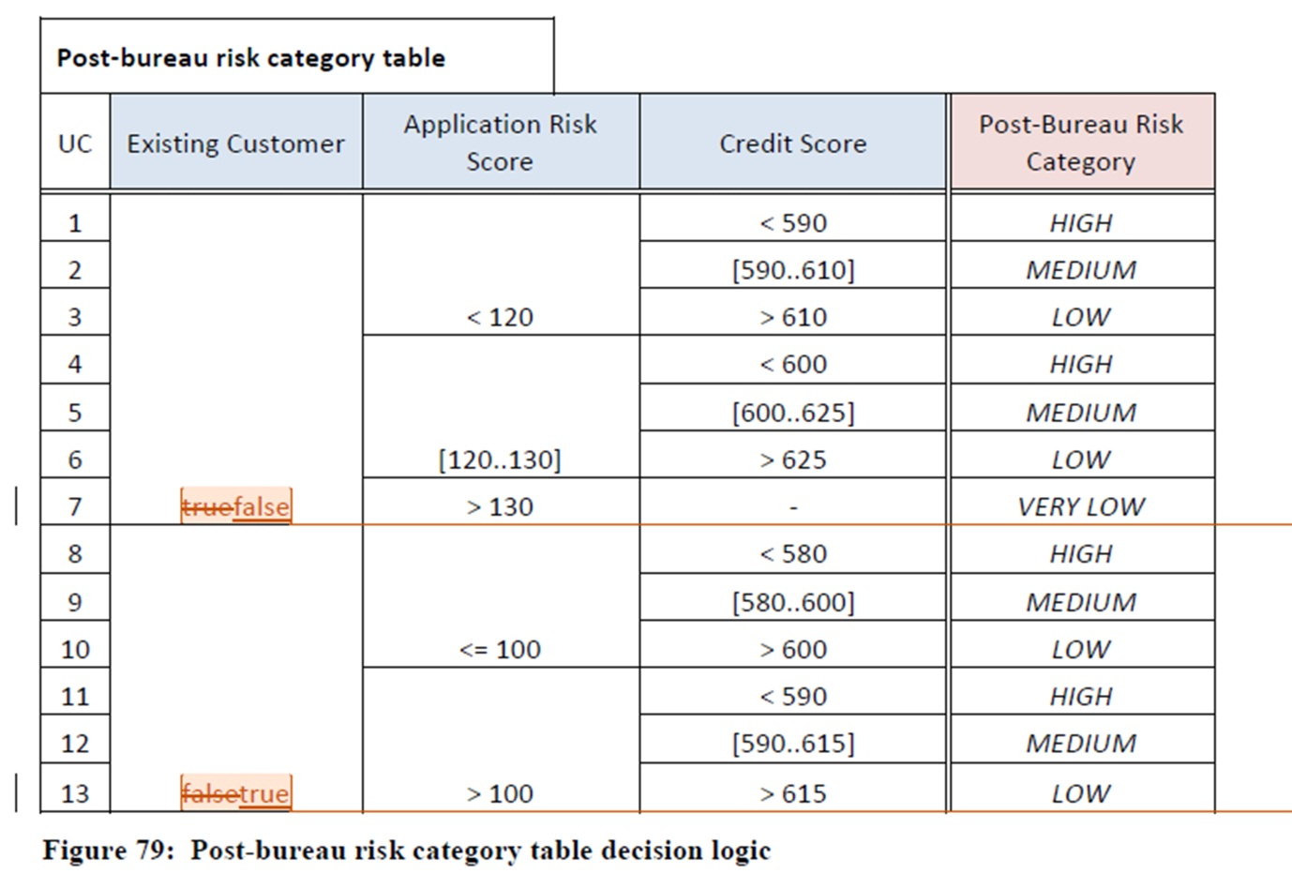

DMNFTF-88: All Decisions have BKMs though this is not necessary

Ballot 10

Change tracking
Change (dtc-14-02-01, section 5, figure 1, p.20) from
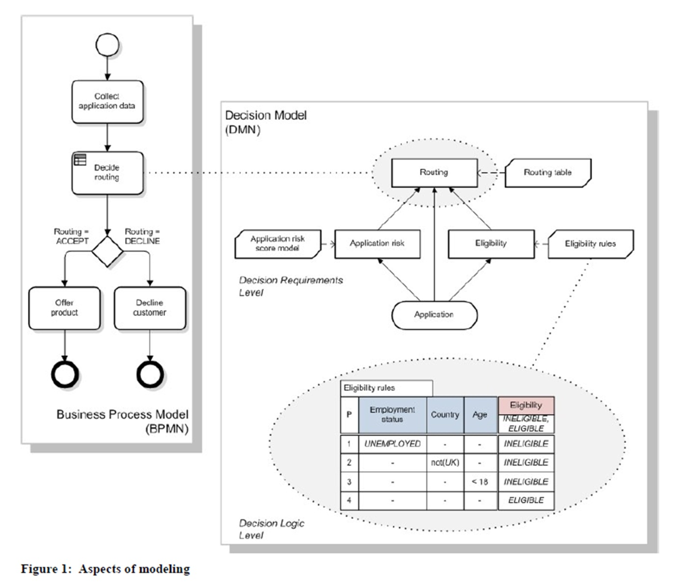
to (dtc-2014-08-17, section 5.1, figure 1, p. 23)
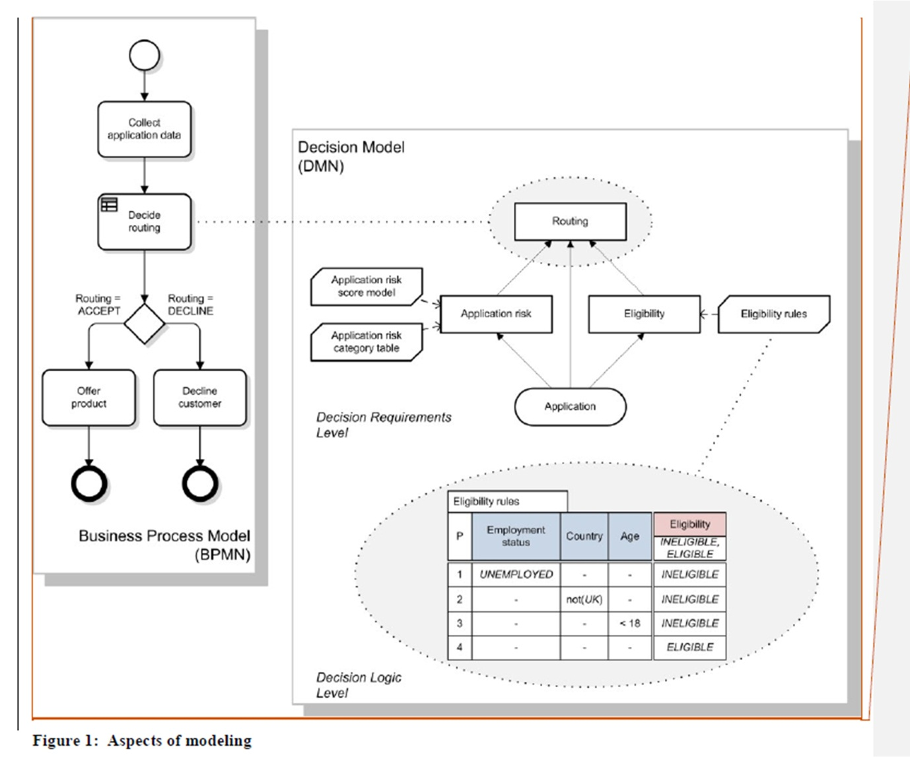
Change (dtc-14-02-01, section 5, figure 2, p.22) from
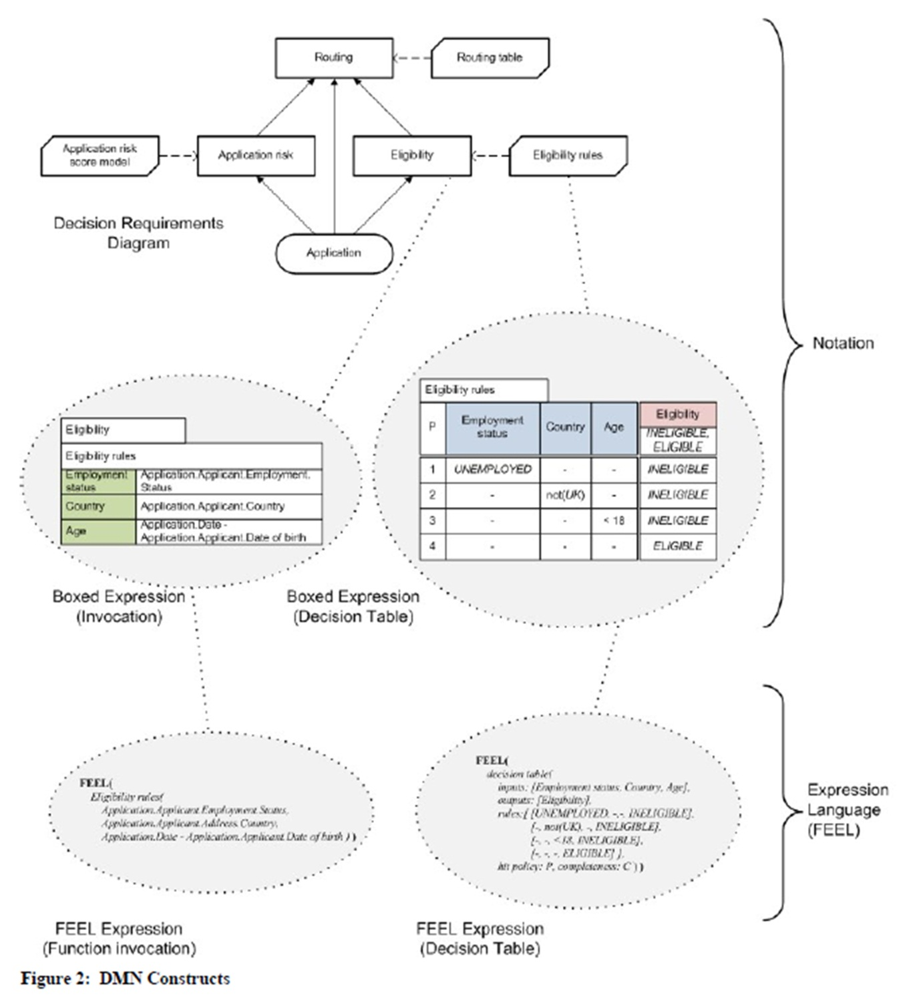
to (dtc-2014-08-17, section 5.1, figure 1, p. 23)
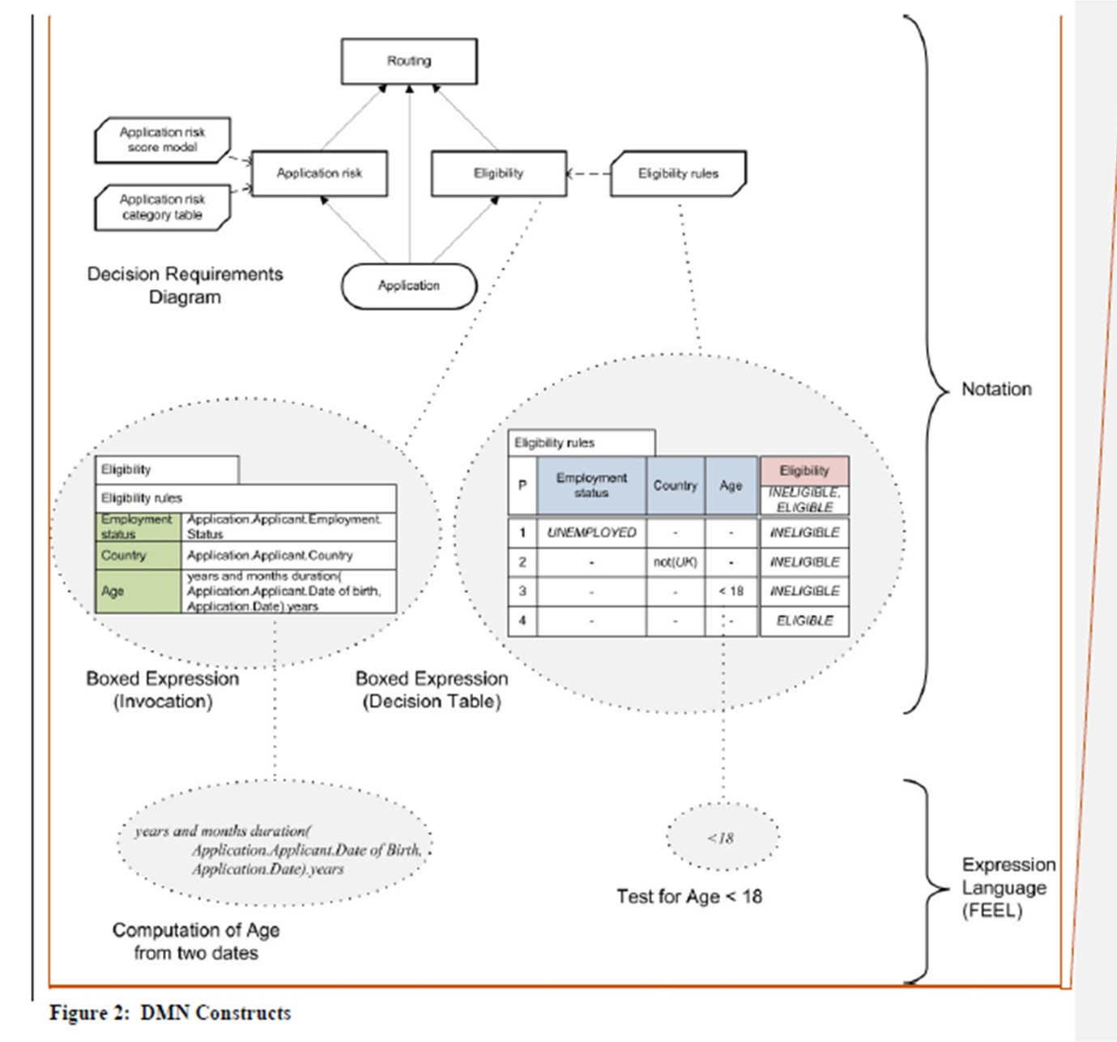
N.B. Decisions with no BKMs were also added to the example in section 11 as recorded in the resolution to issue 101:
Add one bullet point to (dtc-14-02-01, section 11.2, paragrapgh 1, p165)
Change (dtc-14-02-01, section 11.2, figure 55, p.144) from
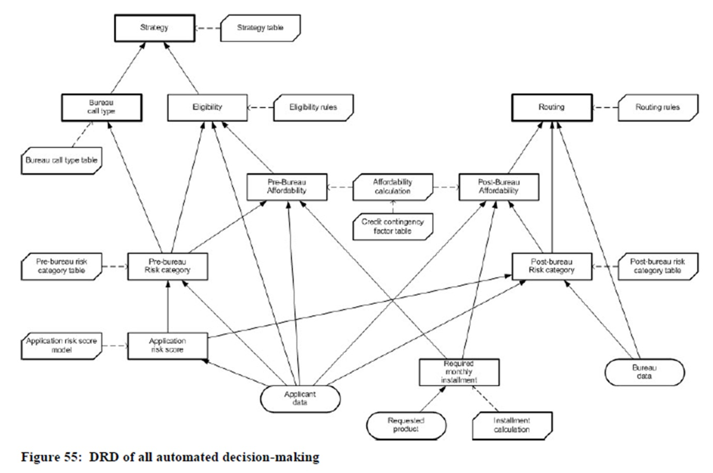
to (dtc-2014-08-17, section 11.2, figure 63, p. 167)
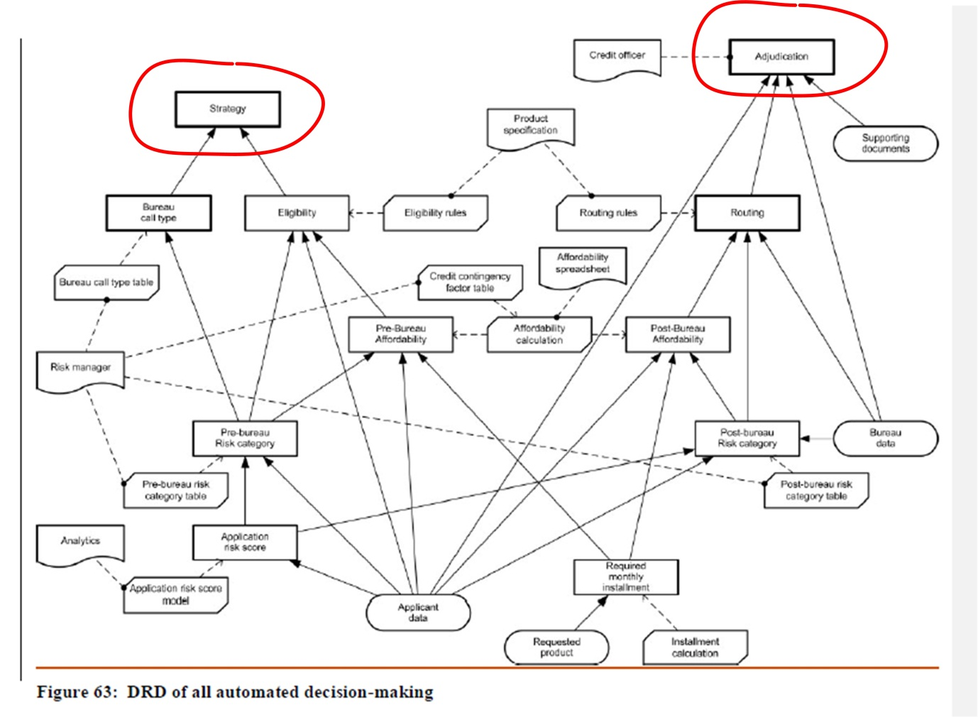
Change (dtc-14-02-01, section 11.2, figure 56, p.145) from
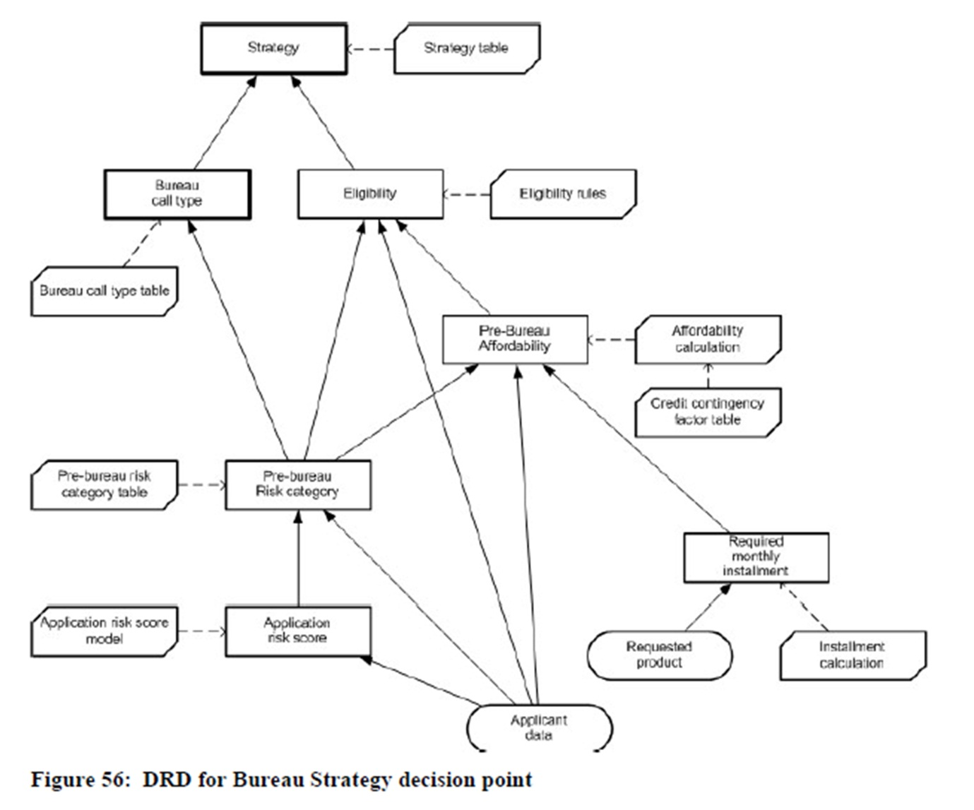
to (dtc-2014-08-17, section 11.2, figure 64, p. 170)
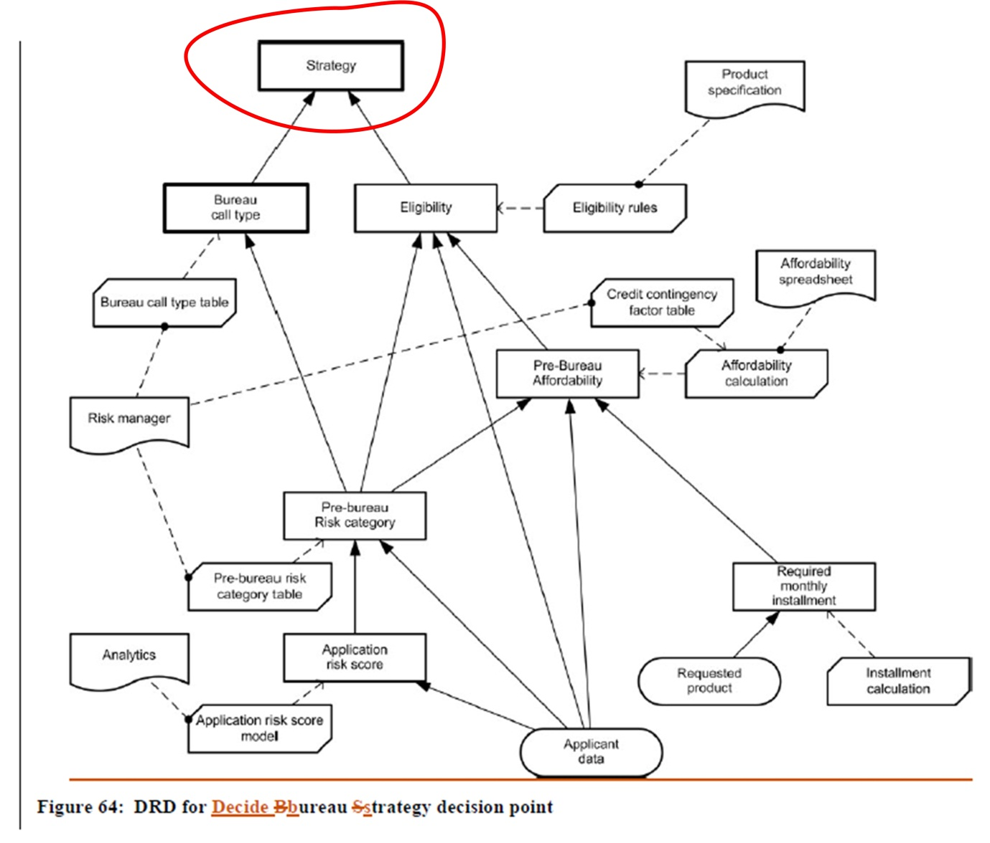
Add (dtc-2014-08-17, section 11.2, figure 66, p. 172)
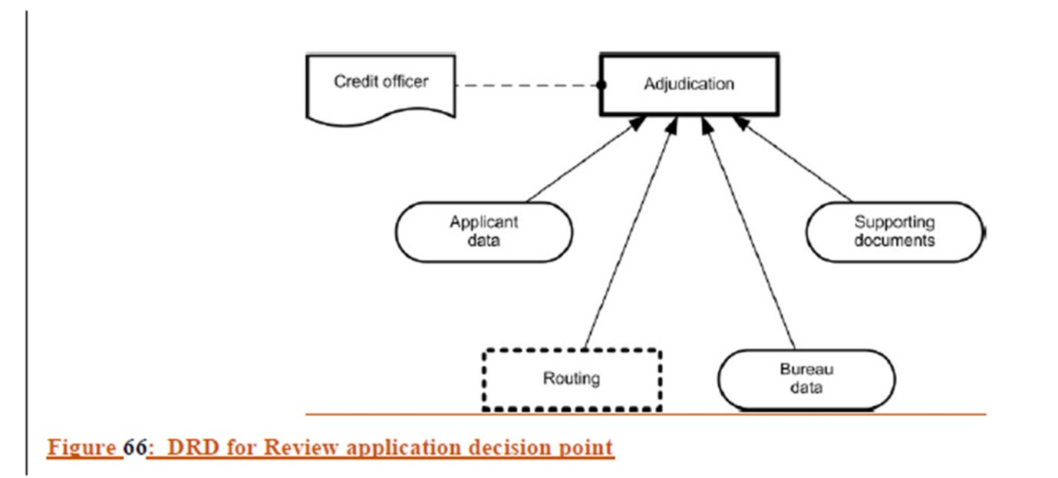
Change (dtc-14-02-01, section 11.2, final paragraph, p.146) from
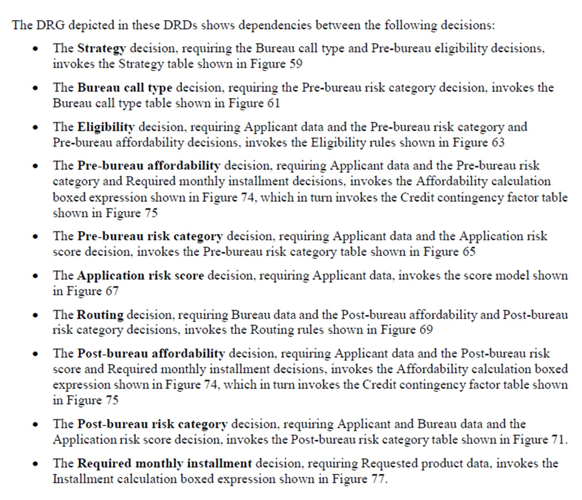
to (dtc-2014-08-17, final paragraph, section 11.2, p. 173)
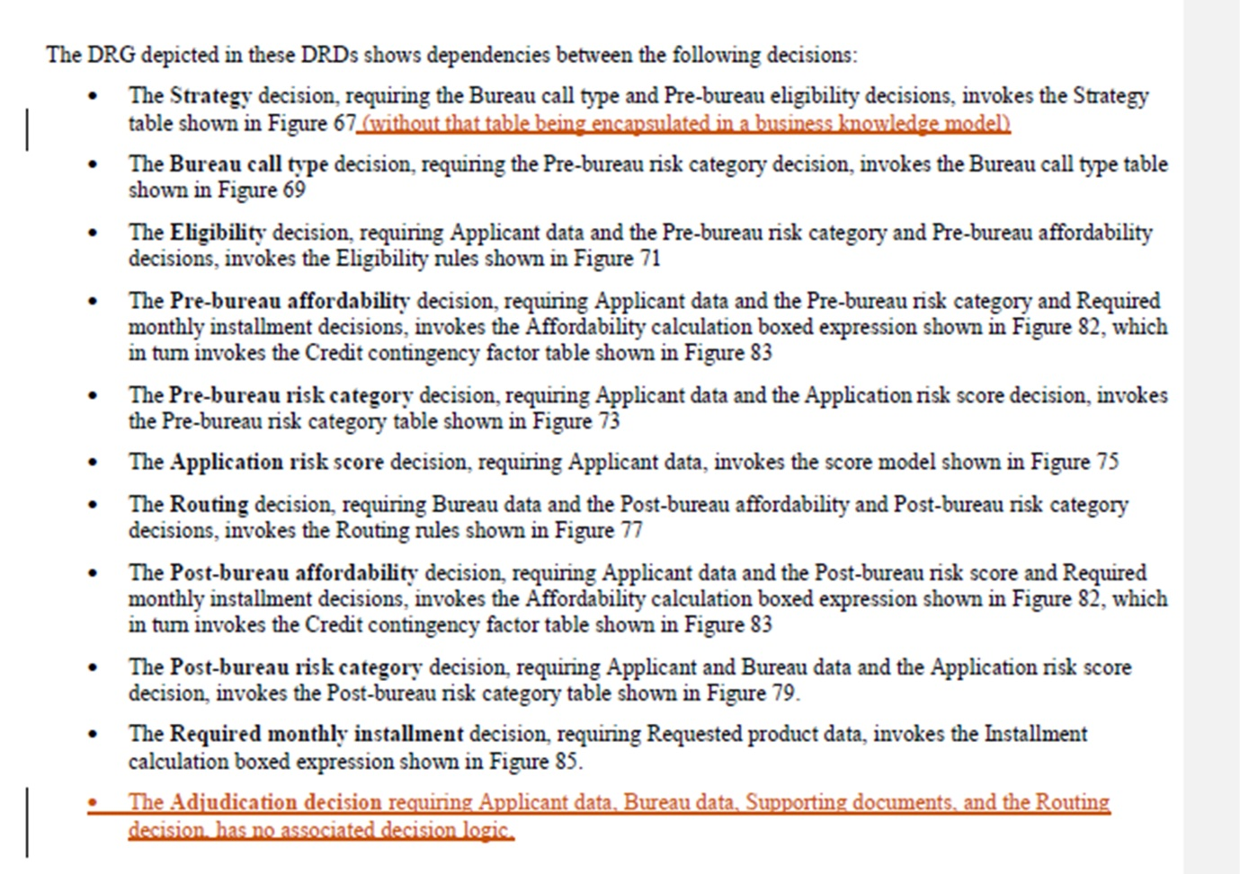
Change (dtc-14-02-01, section 11.3, p.146) from
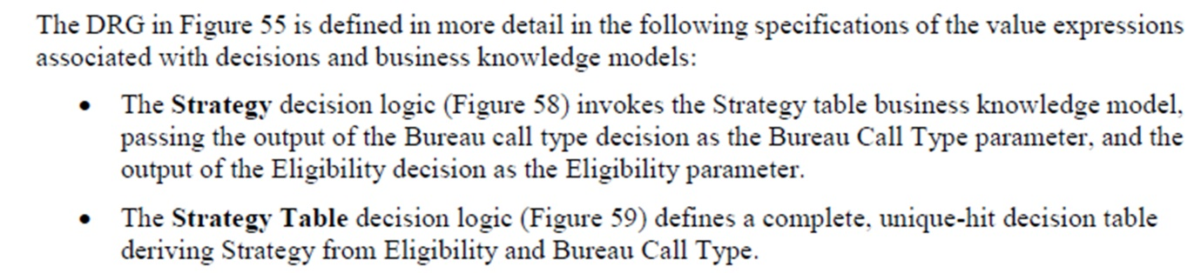
to (dtc-2014-08-17, section 11.3, p. 173)
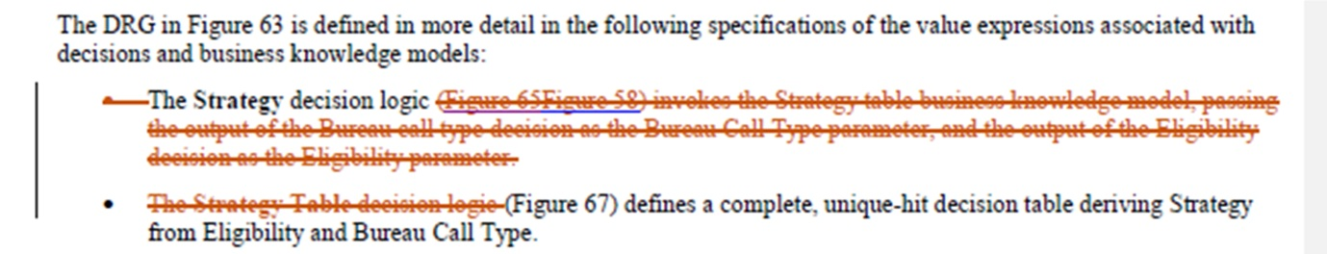
Delete (dtc-14-02-01, section 11.3, figure 58, p.148)
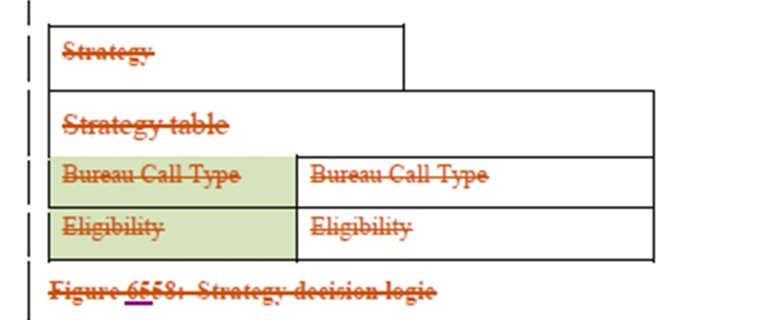
Change (dtc-14-02-01, section 11.3, figure 59, p.149) from
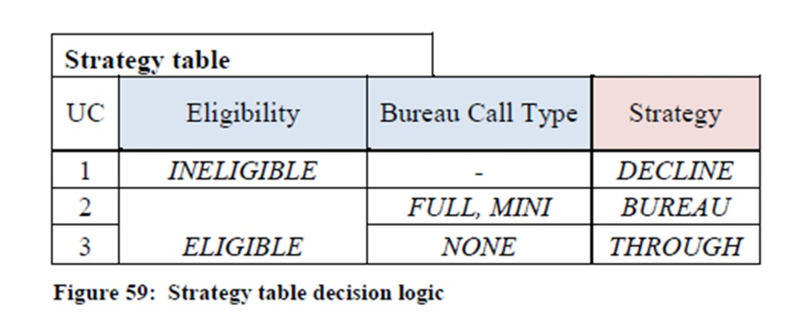
to (dtc-2014-08-17, section 11.3, figure 67, p. 175)
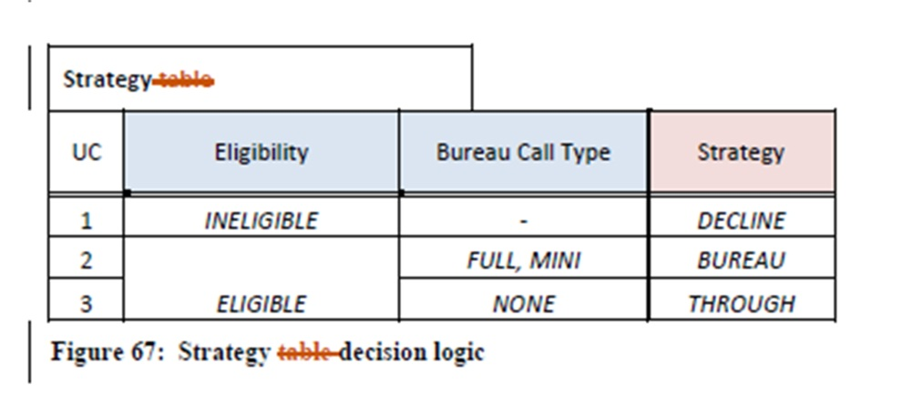

DMNFTF-89: No Knowledge Sources in example

Ballot 7

Change tracking
Add one bullet point to (dtc-14-02-01, section 11.2, paragraph 1, p165)
Change (dtc-14-02-01, section 11.2, figure 55, p.144) from
to (dtc-2014-08-17, section 11.2, figure 63, p. 167)
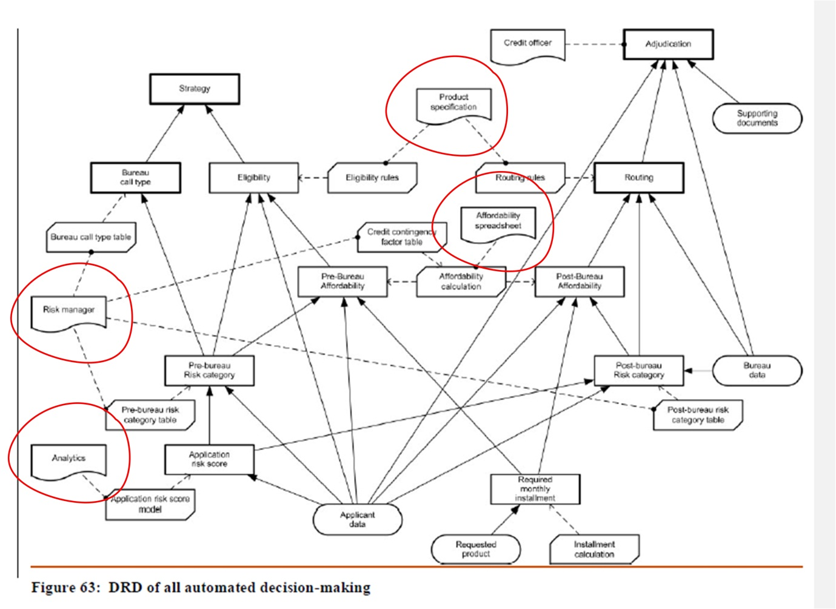
Change (dtc-14-02-01, section 11.2, figure 56, p.145) from
to (dtc-2014-08-17, section 11.2, figure 64, p. 170)
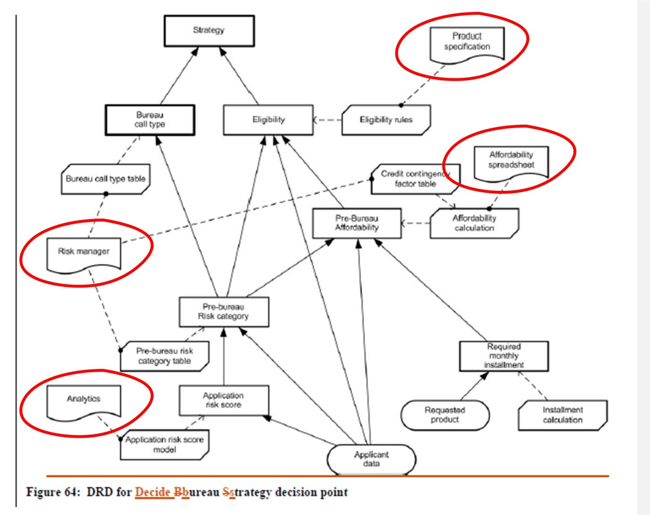
Change (dtc-14-02-01, section 11.2, figure 57, p.145) from
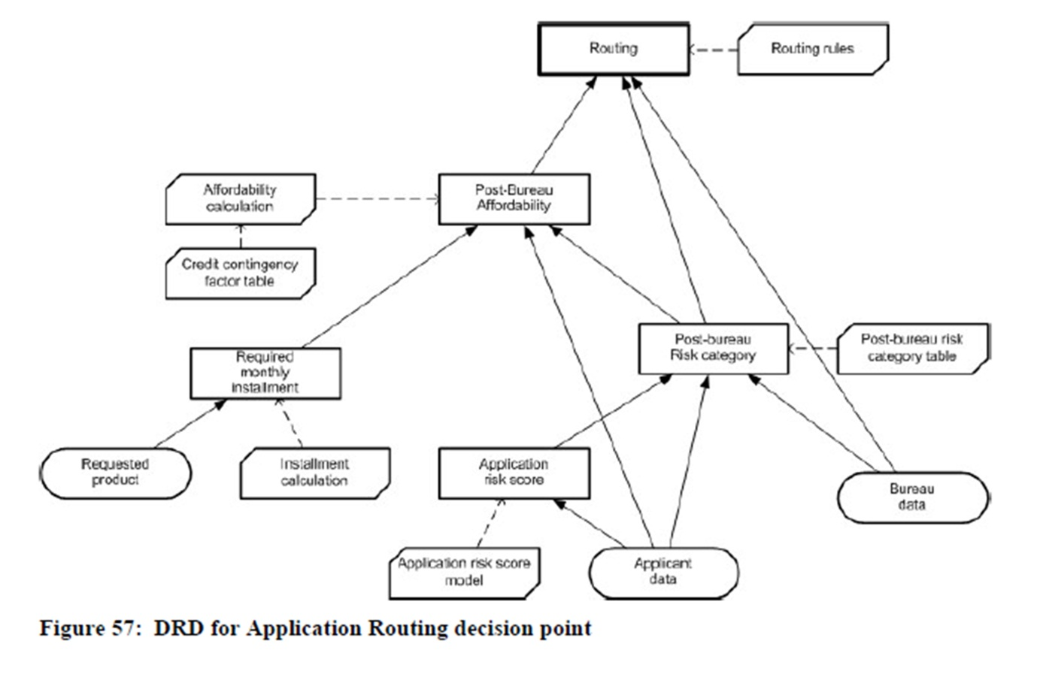
to (dtc-2014-08-17, section 11.2, figure 65, p. 172)
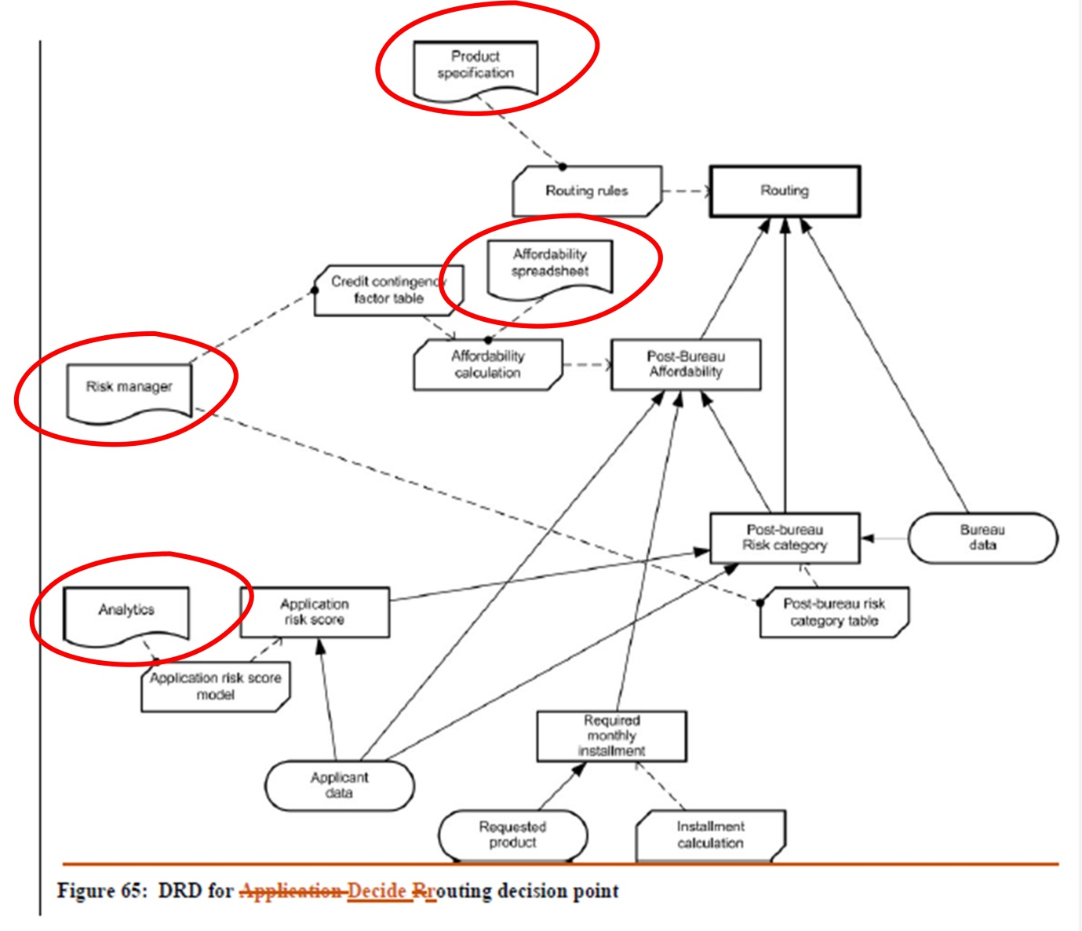
Add (dtc-2014-08-17, section 11.2, figure 66, p. 172)
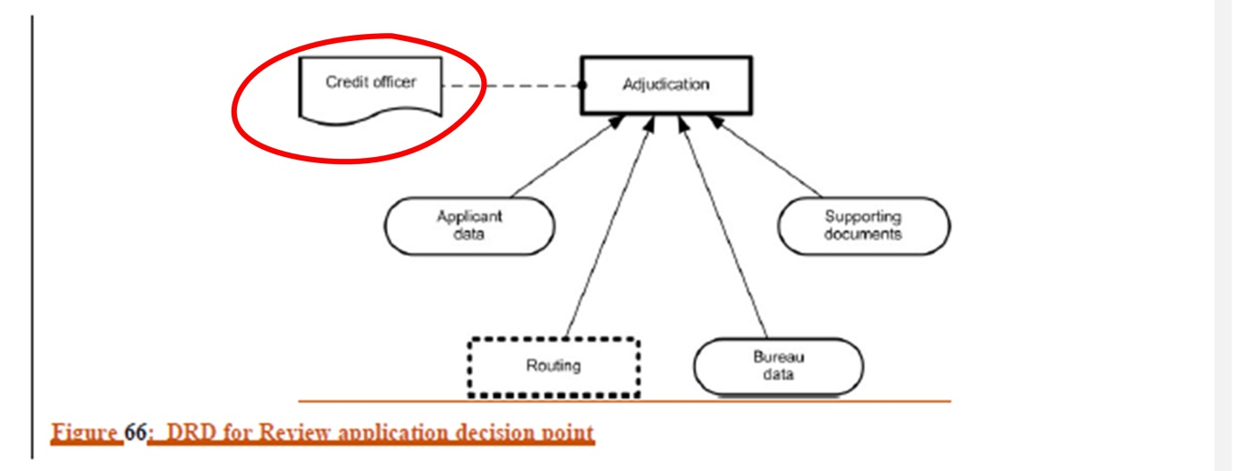

DMNFTF-93: Boxed Invocation has sparse references after definition

Ballot 12

Change tracking
N.B. For editorial reasons “change 'invokes' to 'is a boxed invocation of'” was interpreted as “add the text ‘shown as a boxed invocation’”.
Change (dtc-14-02-01, section 11.3, p.146-148) from
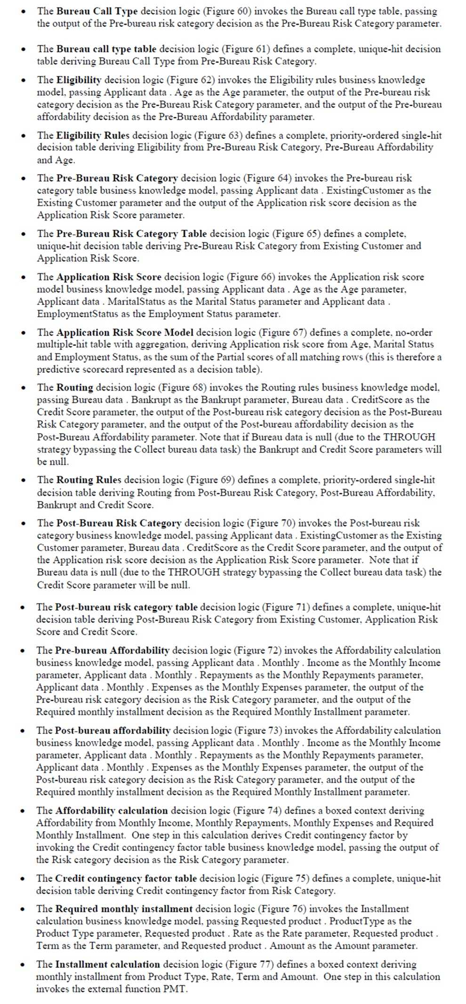
to (dtc-2014-08-17, section 11.3, p. 173-175)
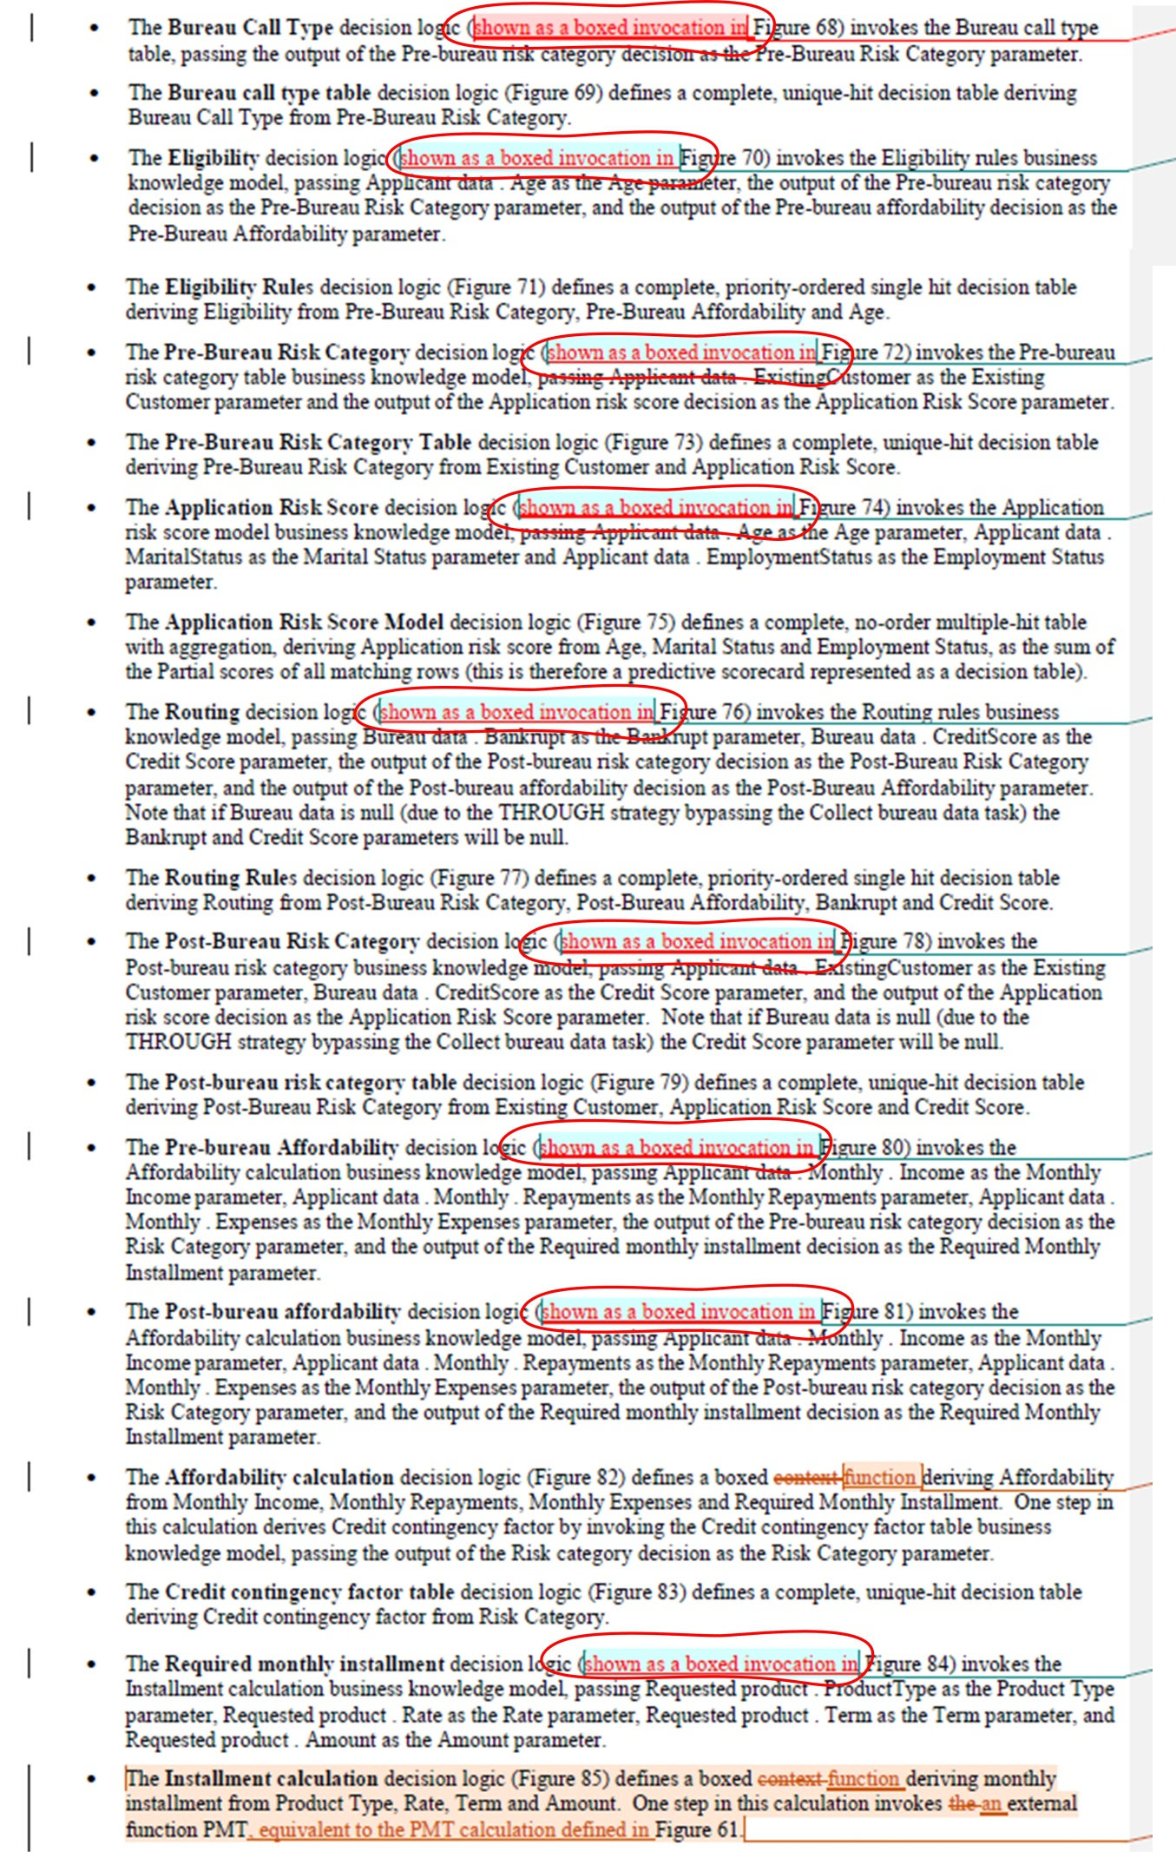

DMNFTF-94: Data Input notation specification and usage
(Section 11 changes only - Section 10 changes addressed already)

Ballot 9

Change tracking
Change (dtc-14-02-01, section 11.3, last paragraph, p.155) from
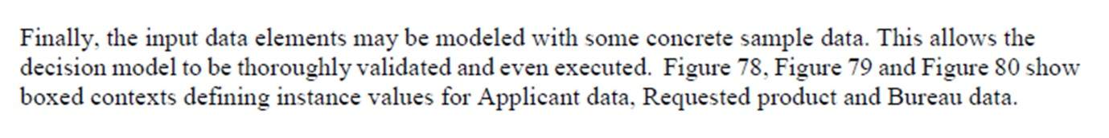
to (dtc-2014-08-17, section 11.3 and 11.4, p. 182)
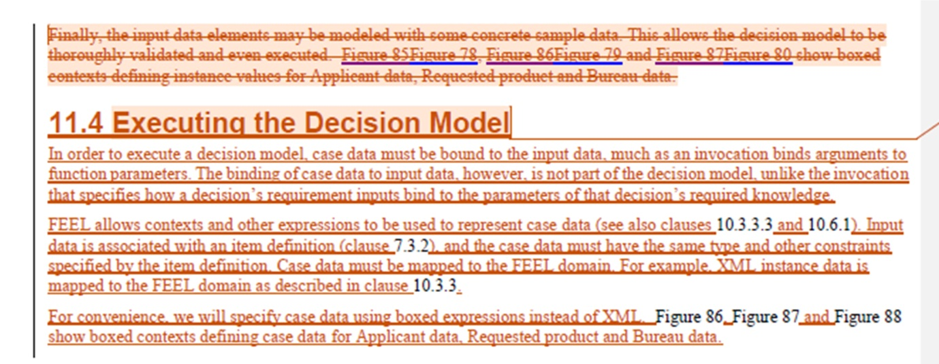
N.B. This change thus creates a new section 11.4.

DMNFTF-101: DMN Example should not be limited to automated decisions

Ballot 10

Change tracking
Change (dtc-14-02-01, sections 11 and 11.1, p.142) from
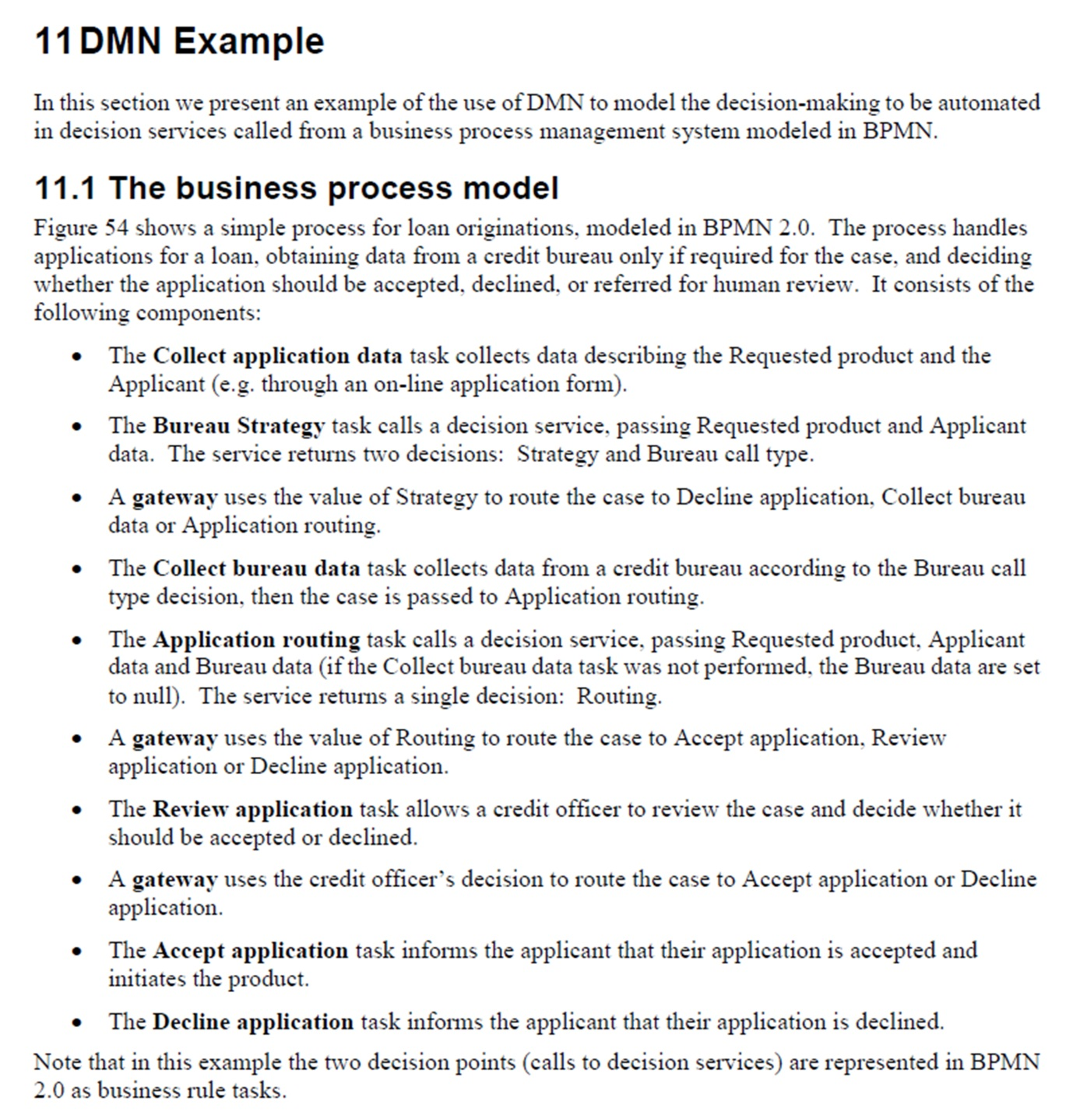
to (dtc-2014-08-17, section 11 and 11.1, p. 162)

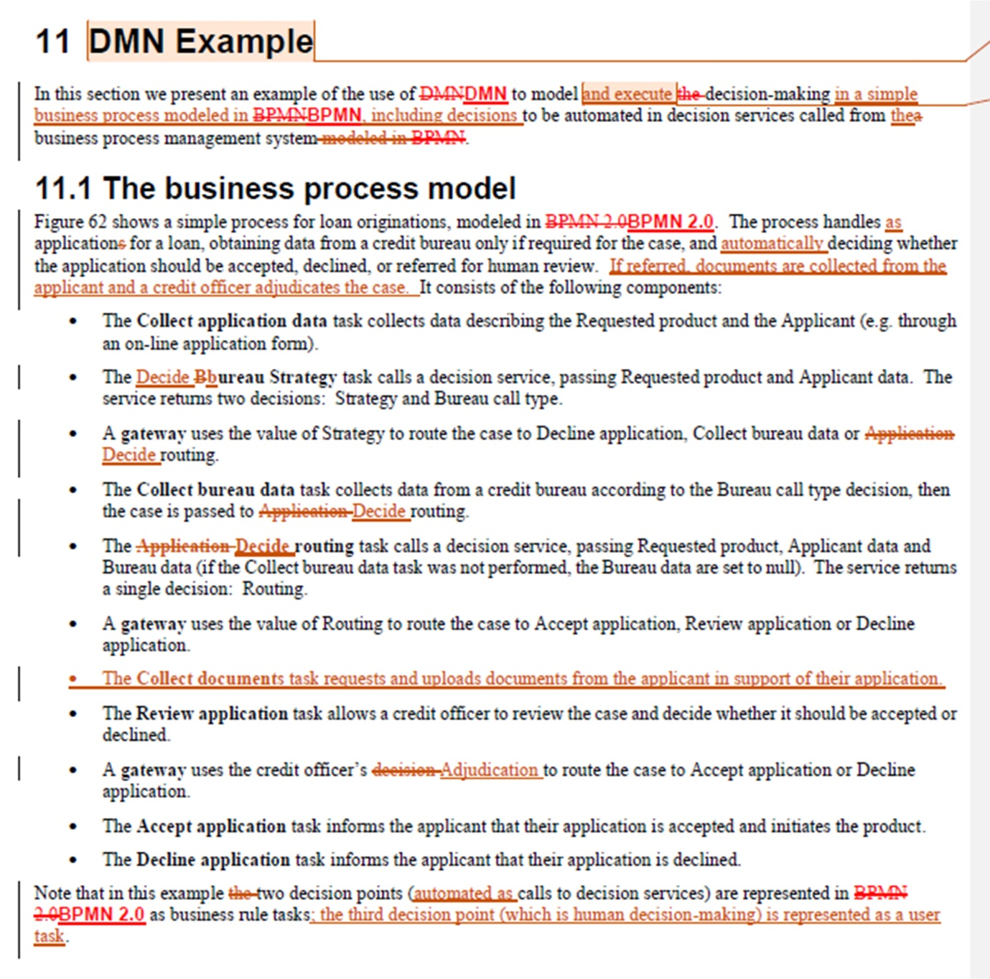
Change (dtc-14-02-01, sections 11.2, figure 54, p.142) from
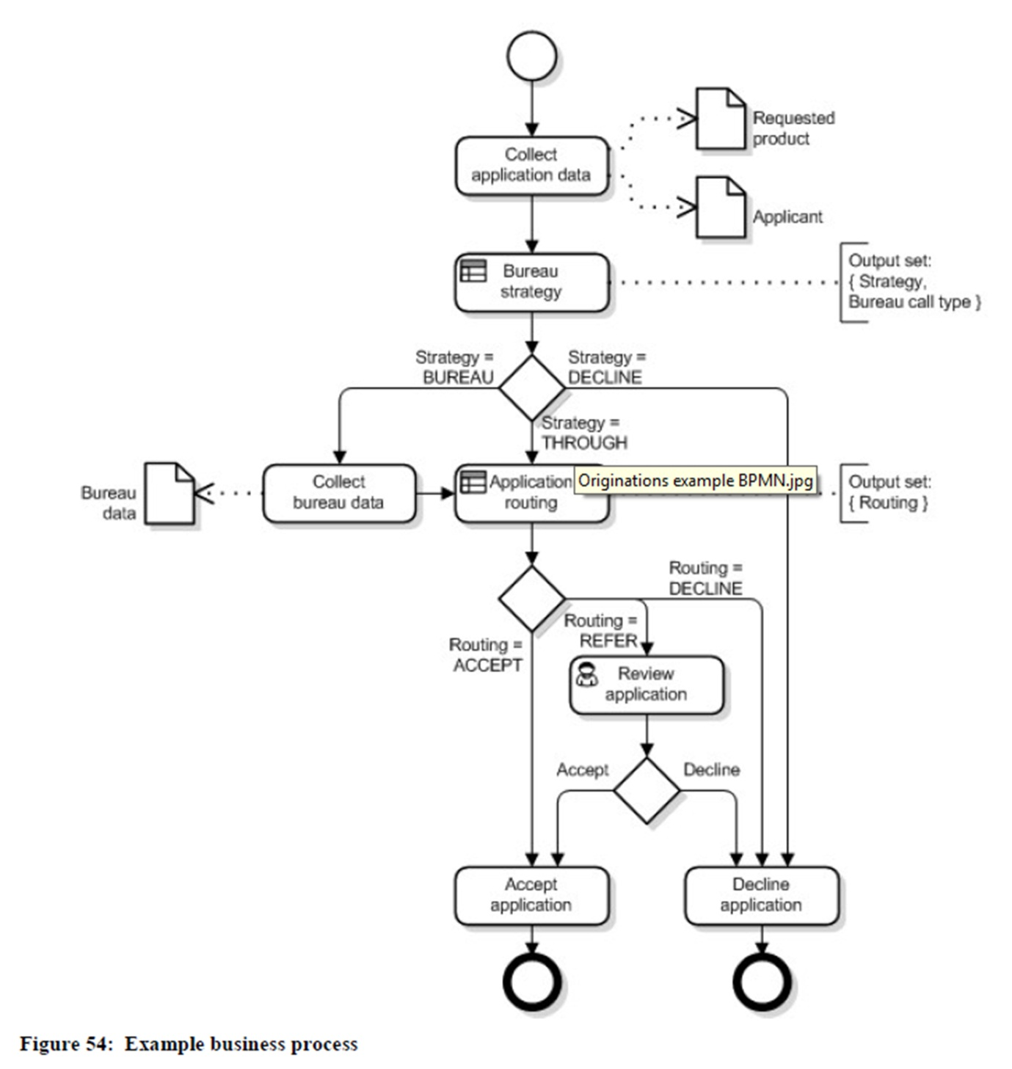
to (dtc-2014-08-17, section 11.2, figure 62, p. 164)
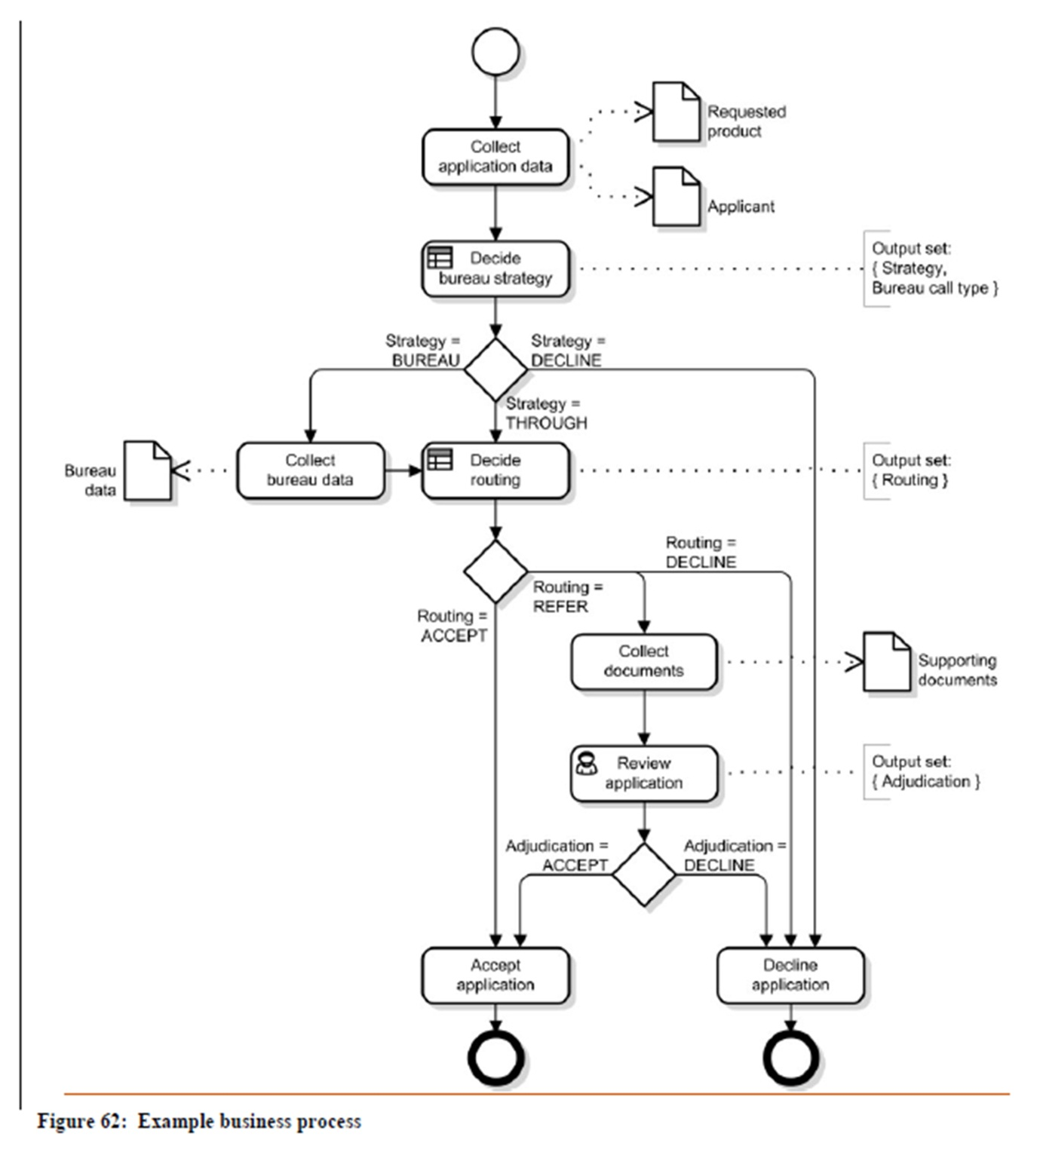
Add one bullet point to (dtc-14-02-01, section 11.2, paragraph 1, p165)
Change (dtc-14-02-01, section 11.2, paragraph 2, p.144) from
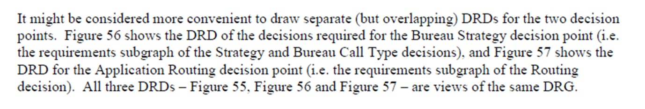
to (dtc-2014-08-17, section 11.2, paragraph 2, p. 167)
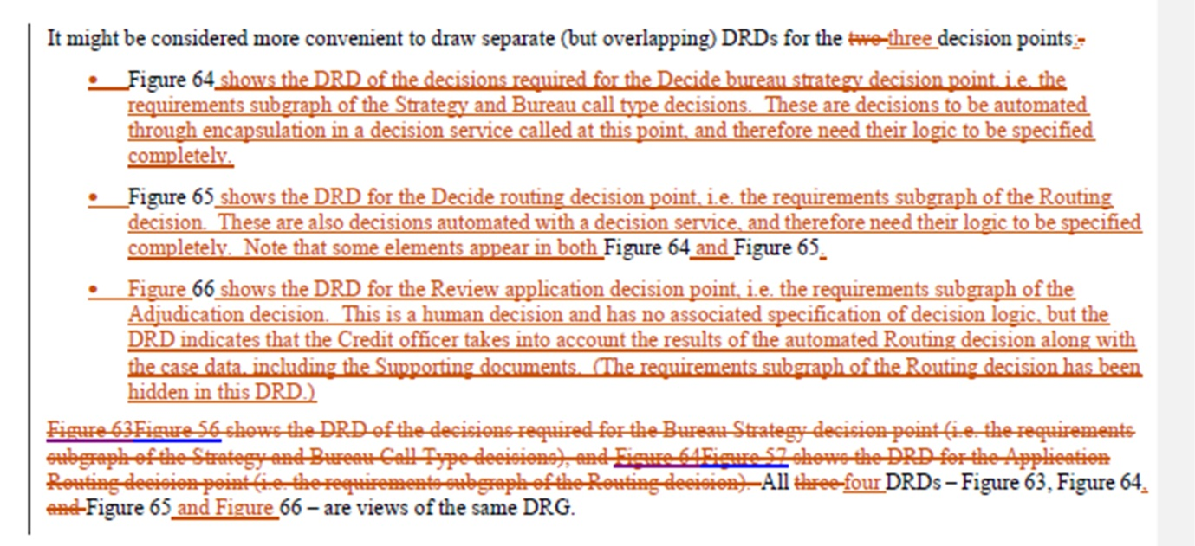
Add (dtc-2014-08-17, section 11.2, figure 66, p. 172)

DMNFTF-191: need answer for clause 11 example

Ballot 10

Change tracking
Add (dtc-2014-08-17, section 11.4 (created by DMNFTF-94), p. 183)
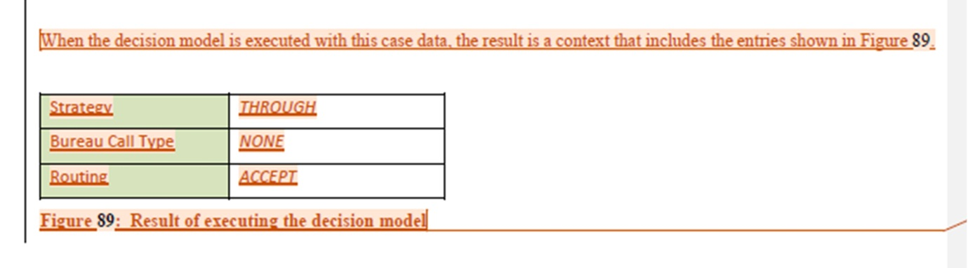

DMNFTF-205: calculation BKMs must have parameter lists

Ballot 10

Change tracking
Change (dtc-14-02-01, section 11.3, p.148) from
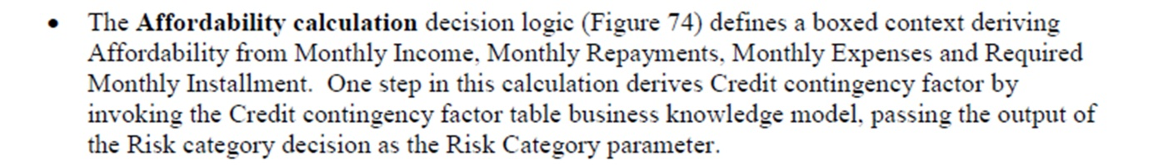
to (dtc-2014-08-17, section 11.3, p. 174)
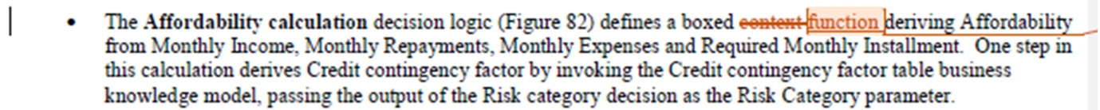
Change (dtc-14-02-01, section 11.3, p.148) from
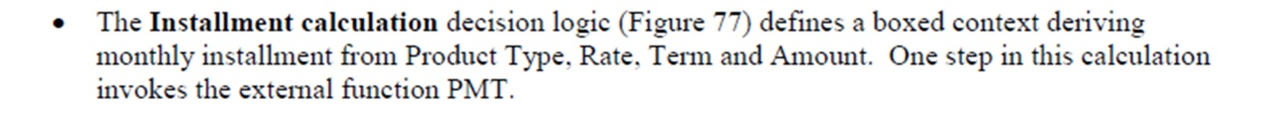
to (dtc-2014-08-17, section 11.3, p. 175)
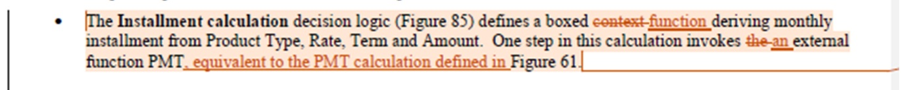
Change (dtc-14-02-01, section 11.3, figure 74, p.154) from
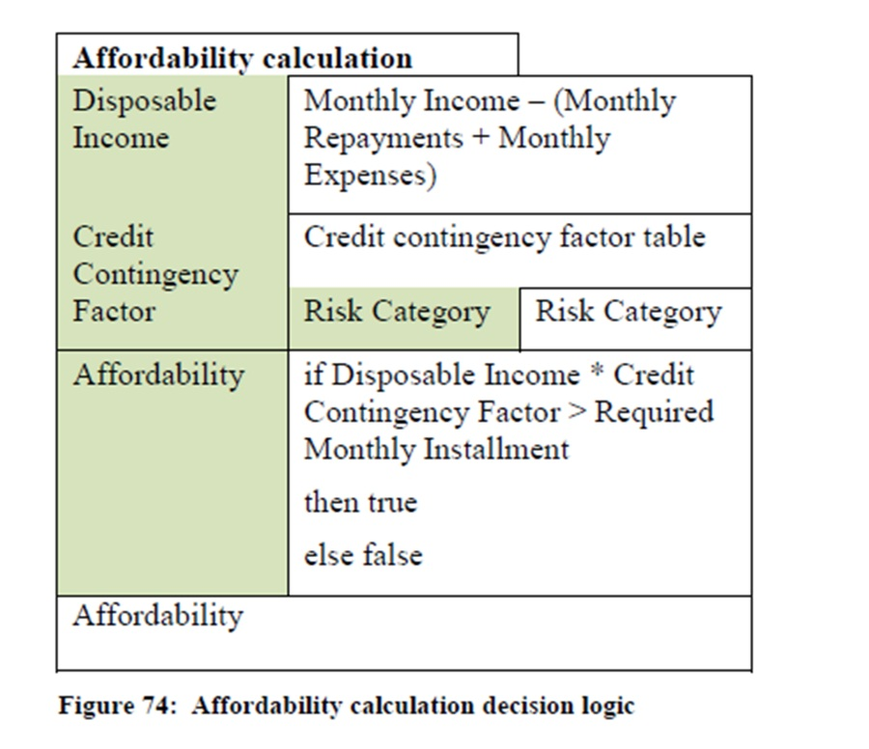
to (dtc-2014-08-17, section 11.3, figure 82, p. 181)
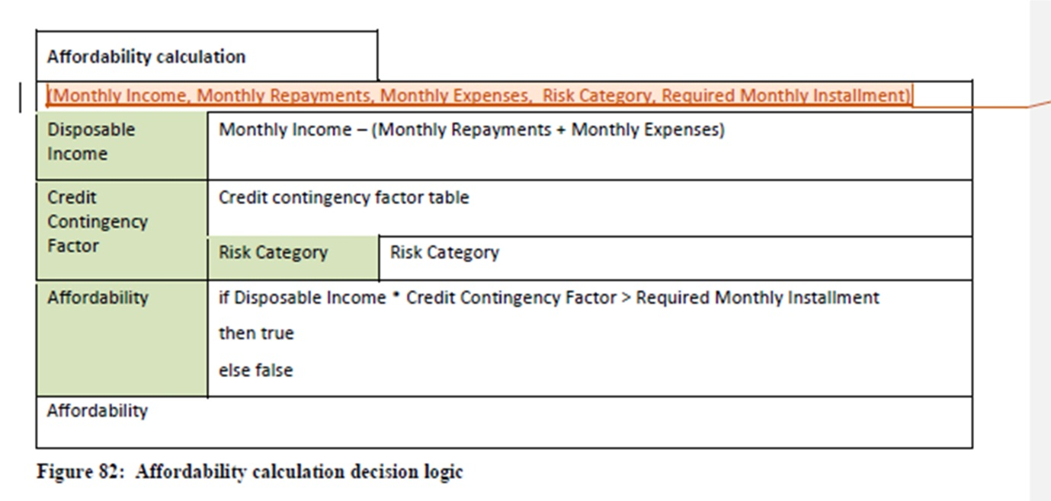
Change (dtc-14-02-01, section 11.3, figure 77, p.155) from
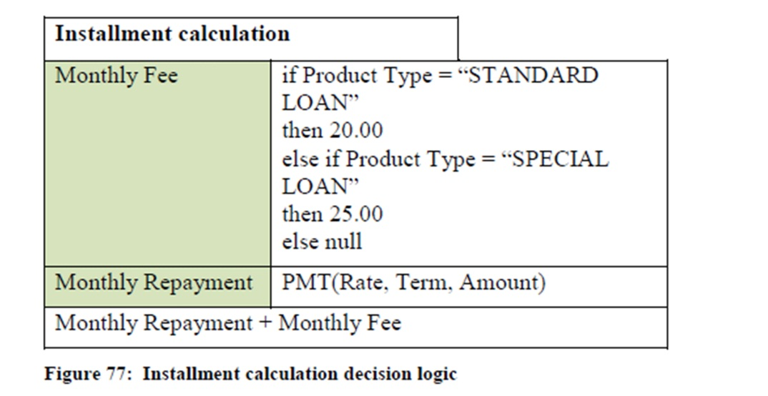
to (dtc-2014-08-17, section 11.3, figure 85, p. 182)
